Bahria University

Karachi Campus

LAB EXPERIMENT NO.

**13**

LIST OF TASKS

|  |  |
| --- | --- |
| TASK NO | OBJECTIVE |
| 1 | In this task we will write a simple Python script in LXTerminal to glow LED using GPIO 7 of Raspberry-Pi. |
| 2 | In this task we will write a simple Python script in LXTerminal to blink single LED using a GPIO 7 of Raspberry-Pi. |
| 3 | In this task we will write a simple Python script to control LED using GPIOs as PWM application. |
| 4 | In this task we will write a simple Python script for Traffic control signals using various GPIOs. |
| 5 | Write a simple Python script to drive dc motors in both directions. |

Submitted On:

5 January 2024

____________

(Date: DD/MM/YY)

**Task 1:** In this task we will write a simple Python script in LXTerminal to glow LED using GPIO 7 of Raspberry-Pi.

**Solution:**

import RPi.GPIO as GPIO

GPIO.setmode (GPIO.BOARD)

GPIO.setup (7, GPIO.OUT)

GPIO.output (7, True)

**Output:**

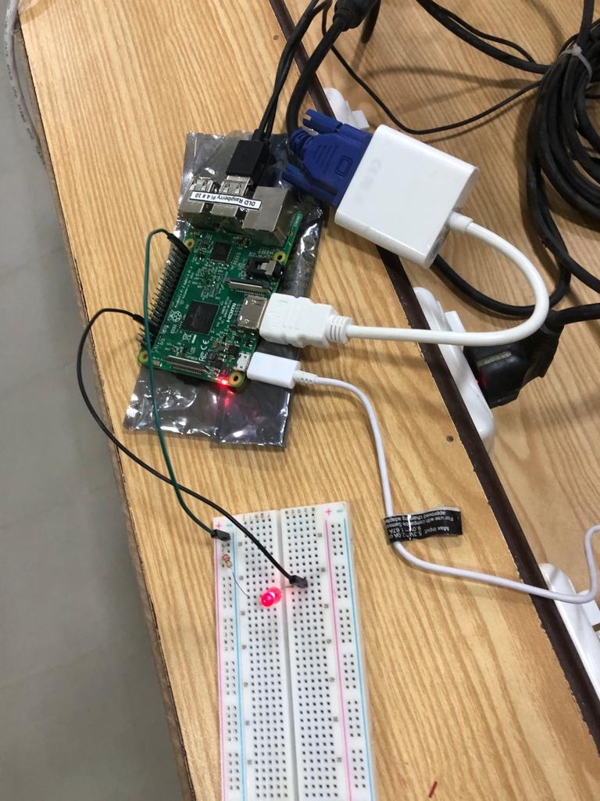

**Task 2:** In this task we will write a simple Python script in LXTerminal to blink single LED using a GPIO 7 of Raspberry-Pi.

**Solution:**

import RPi.GPIO as GPIO

import time

GPIO.setmode (GPIO.BOARD)

GPIO.setup (7, GPIO.OUT)

While True:

GPIO.output (7, True)

****time.sleep (0.5)

GPIO.output (7, False)

time.sleep (0.5)

**Output:**

**Task 3:** In this task we will write a simple Python script to control LED using GPIOs as PWM application.

**Solution:**

import RPi.GPIO as GPIO

****GPIO.setmode(GPIO.BOARD)

GPIO.setup(7, GPIO.OUT)

pwm_led = GPIO.PWM(7, 500)

pwm_led.start(100)

while True:

duty_s = input("Enter Brightness (0 to 100):")

duty = int(duty_s)

pwm_led.ChangeDutyCycle(duty)

**Output:**

**Task 4:** In this task we will write a simple Python script for Traffic control signals using various GPIOs.

**Solution:**

import RPi.GPIO as GPIO

import time

GPIO.cleanup()

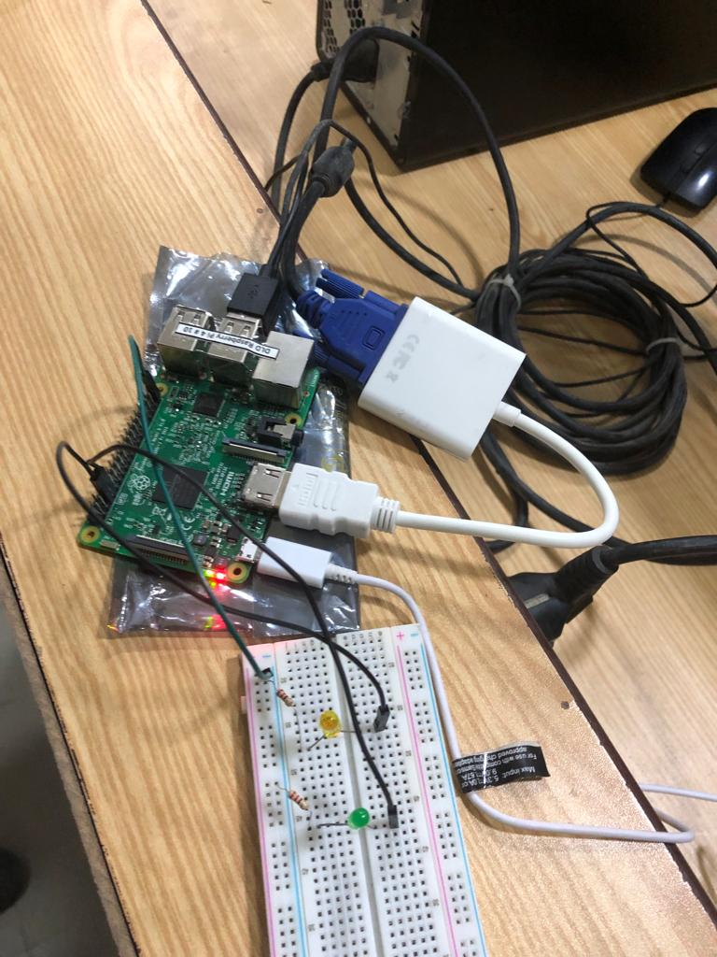 GPIO.setmode(GPIO.BOARD)

GPIO.setup(3,GPIO.OUT)

GPIO.setup(5,GPIO.OUT)

GPIO.setup(7,GPIO.OUT)

GPIO.setwarnings(False)

while True:

GPIO.output(7,GPIO.HIGH)

time.sleep(5)

GPIO.output(5,GPIO.HIGH)

time.sleep(2)

GPIO.output(7,GPIO.LOW)

GPIO.output(5,GPIO.LOW)

GPIO.output(3,GPIO.HIGH)

time.sleep(10)

GPIO.output(3,GPIO.LOW)

GPIO.output(5,GPIO.HIGH)

**Output:**

**Task 5:** Write a simple Python script to drive dc motors in both directions.

**Solution:**

import RPi.GPIO as GPIO

import time

# Define GPIO pins

motor_in1 = 17

motor_in2 = 18

# Setup GPIO

GPIO.setmode(GPIO.BCM)

GPIO.setup(motor_in1, GPIO.OUT)

GPIO.setup(motor_in2, GPIO.OUT)

def clockwise():

GPIO.output(motor_in1, GPIO.HIGH)

GPIO.output(motor_in2, GPIO.LOW)

def counterclockwise():

GPIO.output(motor_in1, GPIO.LOW)

GPIO.output(motor_in2, GPIO.HIGH)

def stop_motor():

GPIO.output(motor_in1, GPIO.LOW)

GPIO.output(motor_in2, GPIO.LOW)

try:

while True:

# Rotate clockwise for 2 seconds

clockwise()

time.sleep(2)

# Stop for 1 second

stop_motor()

time.sleep(1)

# Rotate counterclockwise for 2 seconds

counterclockwise()

time.sleep(2)

# Stop for 1 second

stop_motor()

time.sleep(1)

except KeyboardInterrupt:

print("Ctrl+C pressed. Exiting.")

finally:

GPIO.cleanup()

**Output:**