Bahria University,

Karachi Campus



LAB EXPERIMENT NO.

**02**

LIST OF TASKS

|  |  |
| --- | --- |
| TASK NO | OBJECTIVE |
| **1** | Write a sketch to interface Arduino with the Relay. The Relay should be controlled by a SPDT Switch. |
| 2 | Write a sketch to interface Arduino with Seven Segment Display. It should work as a decade counter. The Start / Stop of counting should be controlled through a SPDT Switch. |

Submitted On:

**06th October 2023**

____________

(Date: DD/MM/YY)

**Task # 01**

Write a sketch to interface Arduino with the Relay. The Relay should be controlled by a SPDT Switch.

int buttonPin = 13;

int relayPin = 3;

// Variables will change.

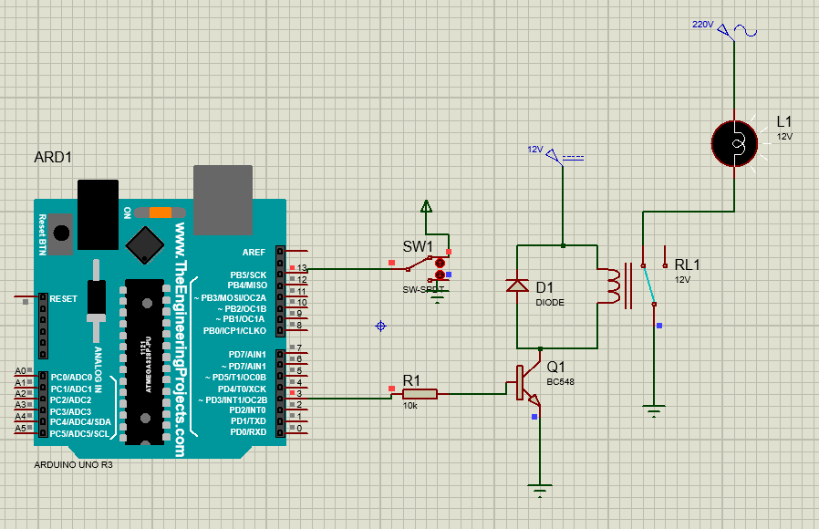int buttonState = 0;

void setup( )

{

pinMode(relayPin, OUTPUT); pinMode(buttonPin, INPUT);

}

void loop()

{

buttonState = digitalRead(buttonPin);

// Check if the Push Button is Pressed.

if (buttonState == HIGH)

{

digitalWrite(relayPin, HIGH);

}

else

{

digitalWrite(relayPin, LOW);

}

}

**Task # 02**

Write a sketch to interface Arduino with Seven Segment Display. It should work as a decade counter. The Start / Stop of counting should be controlled through a SPDT Switch.

**Code**

#define segA 2

#define segB 3

#define segC 4

#define segD 5

#define segE 6

#define segF 7

#define segG 8

#define button 10

int COUNT=0;

int ButtonState;

void setup()

{

for (int i=2;i<9;i++)

{

 pinMode(i,OUTPUT);

}

pinMode (10, INPUT);

}

void loop()

{

ButtonState=digitalRead(button);

if(ButtonState==HIGH)

{

switch (COUNT)

{

case 0:

digitalWrite(segA, HIGH);

digitalWrite(segB, HIGH);

digitalWrite(segC, HIGH);

digitalWrite(segD, HIGH);

digitalWrite(segE, HIGH);

digitalWrite(segF, HIGH);

digitalWrite(segG, LOW);

break;

case 1:

digitalWrite(segA, LOW);

digitalWrite(segB, HIGH);

digitalWrite(segC, HIGH);

digitalWrite(segD, LOW);

digitalWrite(segE, LOW);

digitalWrite(segF, LOW);

digitalWrite(segG, LOW);

break;

 case 2:

digitalWrite(segA, HIGH);

digitalWrite(segB, HIGH);

digitalWrite(segC, LOW);

digitalWrite(segD,HIGH);

digitalWrite(segE, HIGH);

digitalWrite(segF, LOW);

digitalWrite(segG, HIGH);

break;

case 3:

digitalWrite(segA, HIGH);

digitalWrite(segB, HIGH);

digitalWrite(segC, HIGH);

digitalWrite(segD, HIGH);

digitalWrite(segE, LOW);

digitalWrite(segF, LOW);

digitalWrite(segG, HIGH);

break;

case 4:

digitalWrite(segA, LOW);

digitalWrite(segB, HIGH);

digitalWrite(segC, HIGH);

digitalWrite(segD, LOW);

digitalWrite(segE, LOW);

digitalWrite(segF, HIGH);

digitalWrite(segG, HIGH);

break;

case 5:

digitalWrite(segA, HIGH);

digitalWrite(segB, LOW);

digitalWrite(segC, HIGH);

digitalWrite(segD, HIGH);

digitalWrite(segE, LOW);

digitalWrite(segF, HIGH);

digitalWrite(segG, HIGH);

break;

case 6:

digitalWrite(segA, HIGH);

digitalWrite(segB, LOW);

digitalWrite(segC, HIGH);

digitalWrite(segD, HIGH);

digitalWrite(segE, HIGH);

digitalWrite(segF, HIGH);

digitalWrite(segG, HIGH);

break;

case 7:

digitalWrite(segA, HIGH);

digitalWrite(segB, HIGH);

digitalWrite(segC, HIGH);

digitalWrite(segD, LOW);

digitalWrite(segE, LOW);

digitalWrite(segF, LOW);

digitalWrite(segG, LOW);

break;

case 8:

digitalWrite(segA, HIGH);

digitalWrite(segB, HIGH);

digitalWrite(segC, HIGH);

digitalWrite(segD, HIGH);

digitalWrite(segE, HIGH);

digitalWrite(segF, HIGH);

digitalWrite(segG, HIGH);

break;

case 9:

digitalWrite(segA, HIGH);

digitalWrite(segB, HIGH);

digitalWrite(segC, HIGH);

digitalWrite(segD, HIGH);

digitalWrite(segE, LOW);

digitalWrite(segF, HIGH);

digitalWrite(segG, HIGH);

break;

}

if (COUNT<10) {

COUNT++;

delay(1000); }

if (COUNT==10) {

COUNT=0;

delay(1000); }

}}

