Bahria University,

Karachi Campus



LAB EXPERIMENT NO.

**3**

LIST OF TASKS

|  |  |
| --- | --- |
| TASK NO | OBJECTIVE |
| **1** | Write a sketch to interface Arduino with 16x2 Liquid Crystal Display (LCD). Write the name of your course “Embedded Systems” in the 1st Line and your Section in the 2nd Line of LCD. This Text should blink with a delay of 0.5 seconds. |
| 2 | Write a sketch to interface Arduino with 16x2 Liquid Crystal Display (LCD). First line of LCD should display your name, second line of LCD should display your registration number, and text in both lines should keep moving from left to right. |

Submitted On:

22 December 2023

____________

(Date: DD/MM/YY)

**Task 1**

Write a sketch to interface Arduino with 16x2 Liquid Crystal Display (LCD). Write the name of your course “Embedded Systems” in the 1st Line and your Section in the 2nd Line of LCD. This Text should blink with a delay of 0.5 seconds.

#include <LiquidCrystal.h>

LiquidCrystal lcd(12, 11, 5, 4, 3, 2);

void setup()

{

  lcd.begin(16, 2); // Setting Up the LCD No. of Rows & Columns

}

void loop()

{

  lcd.setCursor(0, 0);

  lcd.print("Embedded Systems");

  lcd.setCursor(0, 1);

  lcd.print("BSE-5B");

  delay(500);

  lcd.clear();

  delay(500);

}

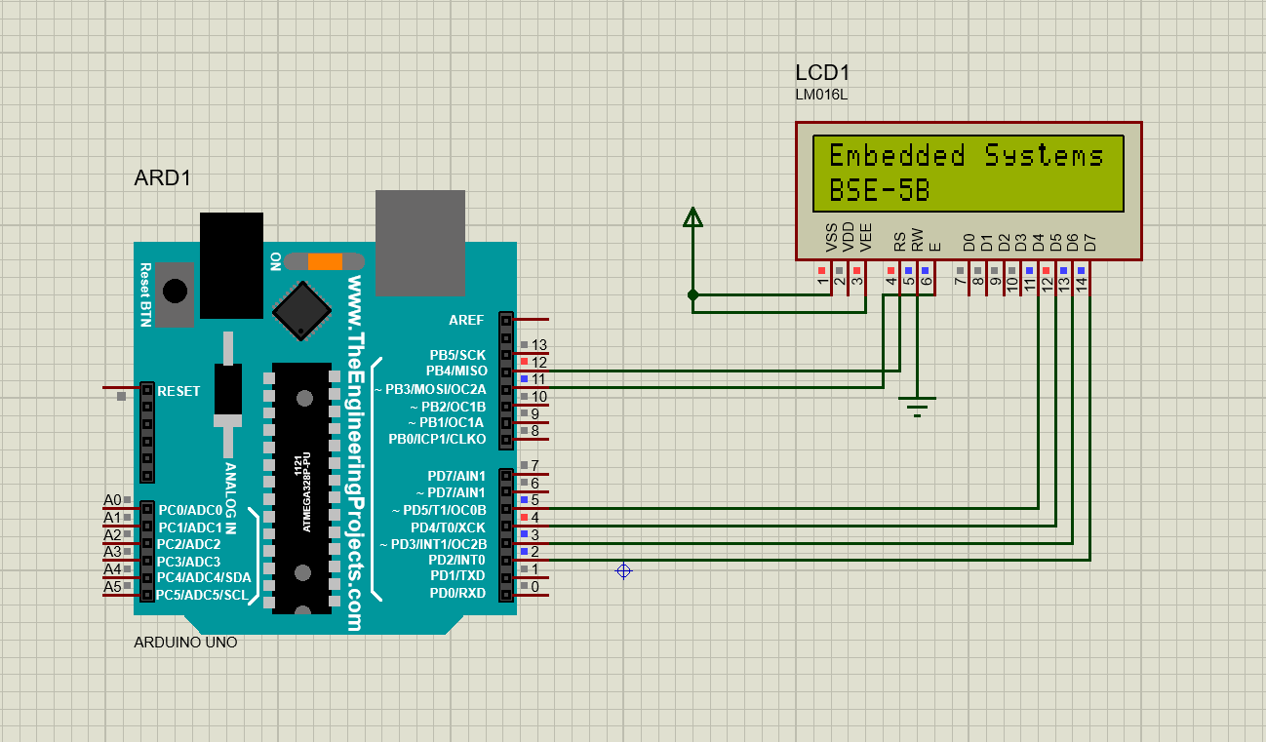

**Task 2**

Write a sketch to interface Arduino with 16x2 Liquid Crystal Display (LCD). First line of LCD should display your name, second line of LCD should display your registration number, and text in both lines should keep moving from left to right.

#include <LiquidCrystal.h>

LiquidCrystal lcd(12,11,5,4,3,2);

void setup() {

  lcd.begin(16, 2);

}

void loop() {

  lcd.setCursor(1,0);

  lcd.print("Muhammad Zain"); **CHANGE YOUR NAME**

  lcd.setCursor(1, 1);

  lcd.print("02-131212-077");

  for (int positionCounter = 0; positionCounter < 16; positionCounter++) {

    lcd.scrollDisplayLeft();

    delay(300);

  }

  lcd.clear();

  lcd.clear();

  delay(500);

}

