Bahria University

Karachi Campus

LAB EXPERIMENT NO.

**7**

LIST OF TASKS

|  |  |
| --- | --- |
| TASK NO | OBJECTIVE |
| 1 | Write a program to generate a PWM signal with duty cycles (25%, 50%, 75% & 100%) |
| 2 | Write a program to interface DC motor with Arduino Uno. |
| 3 | Write a program in Arduino Uno to control the speed of DC motor using PWM. |

Submitted On:

28 December 2023

____________

(Date: DD/MM/YY)

**Task 1:** Write a program to generate a PWM signal with duty cycles (25%, 50%, 75% & 100%)

**Solution:**

void setup() {

  pinMode(11, OUTPUT);

}

void loop() {

  analogWrite(11, 63.75); // 25 % duty cycle delay(200);

  delay(200);

  analogWrite(11, 127);  // 50 % duty cycle

  delay(200);

  analogWrite(11, 191);  // 75 % duty cycle

  delay(200);

  analogWrite(11, 255);  // 100 % duty cycle

  delay(200);

}

**Output:**

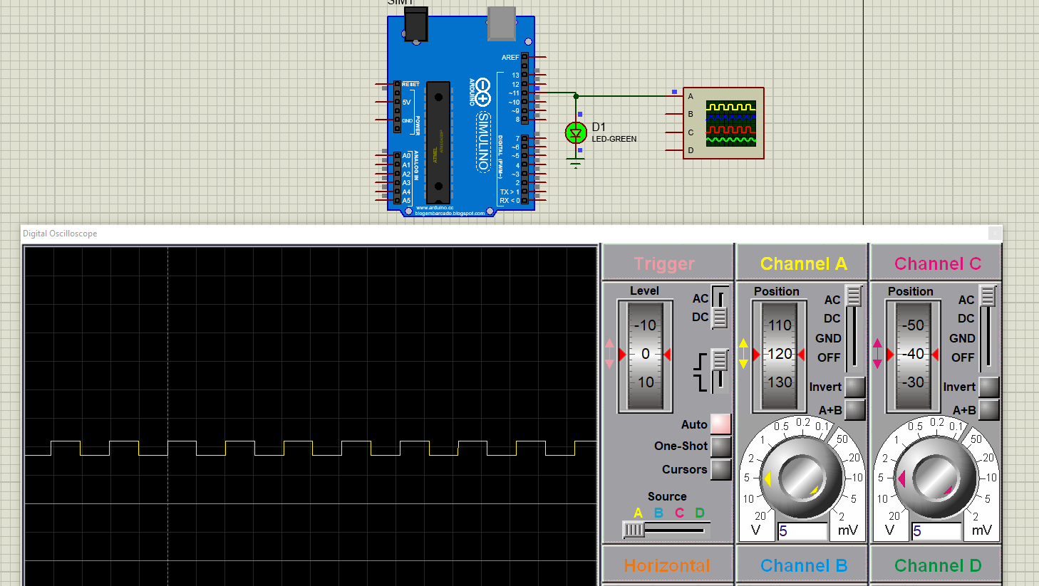



**Task 2:** Write a program to interface DC motor with Arduino Uno.

**Solution:**

int in1 = 10;

int in2 = 9;

int en = 8;

void setup() {

  pinMode(in1, OUTPUT);

  pinMode(in2, OUTPUT);

  pinMode(en, OUTPUT);

}

void loop() {

  digitalWrite(en, HIGH);

  digitalWrite(in1, HIGH);

  digitalWrite(in2, LOW);

  delay(5000);

  digitalWrite(en, LOW);

  delay(1000);

  digitalWrite(en, HIGH);

  digitalWrite(in2, HIGH);

  digitalWrite(in1, LOW);

  delay(5000);

  digitalWrite(en, LOW);

  delay(1000);

}

**Output:**

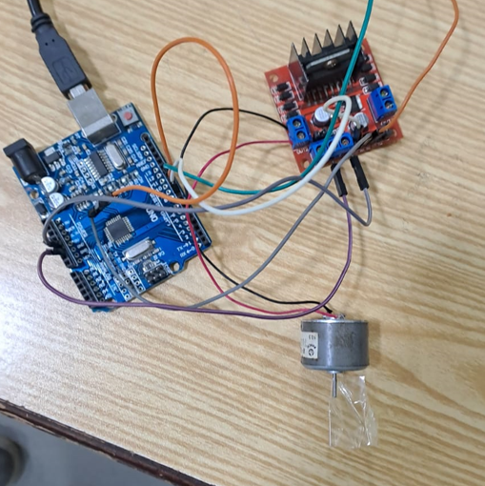

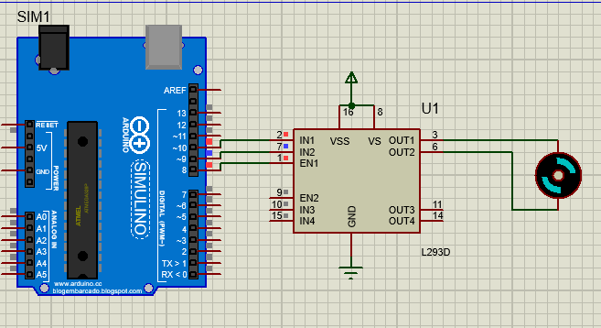

**Task 3:** Write a program in Arduino Uno to control the speed of DC motor using PWM.

**Solution:**

//Assign Names to Pins

const int Control_Pin = A0; //Control Pin

//Motor Driver Pins

const int IN1 = 13;

const int IN2 = 12;

const int ENA = 11;

void setup ()

{

  // Motor

  pinMode(IN1, OUTPUT);  // Set the pin as OUTPUT

  pinMode(IN2, OUTPUT);  // Set the pin as OUTPUT

  pinMode(ENA, OUTPUT);   //PWM Pin

}

void loop ()

{

  int Control_Value = analogRead(Control_Pin);  // read the input on pin:

  int Motor_Speed = map(Control_Value, 0,1023, 0,255);

  analogWrite(ENA, Motor_Speed); //PWM Signal to control the speed of motor. (0 - 255)

  // Start Motor

  digitalWrite(IN1, HIGH);

  digitalWrite(IN2, LOW);

}

**Output:**

