Bahria University

Karachi Campus

LAB EXPERIMENT NO.

**8**

LIST OF TASKS

|  |  |
| --- | --- |
| TASK NO | OBJECTIVE |
| 1 | Use external interrupt in Arduino UNO. |
| 2 | Write a program to use timer interrupt in Arduino Uno |
| 3 | Using the concept of interrupts you have learnt, develop a program that uses interrupt. |

Submitted On:

29 December 2023

____________

(Date: DD/MM/YY)

**Task 1:** Use external interrupt in Arduino UNO.

**Solution:**

void setup() {

  pinMode(11, OUTPUT);

  pinMode(13, OUTPUT);

  pinMode(2, INPUT);

  attachInterrupt(digitalPinToInterrupt(2), routine, CHANGE);

}

void loop() {

  digitalWrite(11, HIGH);

  delay(1000);

  digitalWrite(11, LOW);

  delay(1000);

}

void routine() {

  digitalWrite(13, HIGH);

}

**Output:**

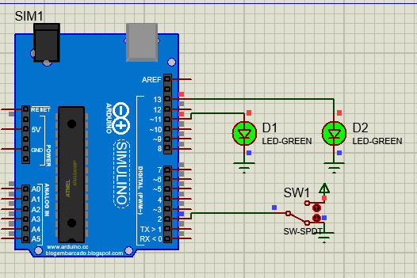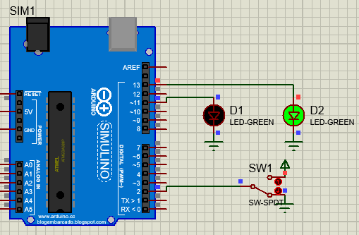

**Task 2:** Write a program to use timer interrupt in Arduino Uno.

**Solution:**

#include <LiquidCrystal.h>

#include <TimerOne.h>

int led = 2;    // led connect to pin 2 of arduino

int led_i = 3;  // led_i connect to pin 3 of arduino

int x = 0;

LiquidCrystal lcd(12, 11, 10, 9, 8, 7);  // arduino pins for lcd connections

void setup() {

  pinMode(led, OUTPUT);

  pinMode(led_i, OUTPUT);

  pinMode(4, INPUT);

  lcd.begin(16, 2);

  Timer1.initialize(4000000);  /// 4 sec timer

  Timer1.attachInterrupt(interrupt);

}

void interrupt() {

  lcd.setCursor(0, 0);

  lcd.print("Timer1 interrupt");  // ISR

  if (x == LOW) {

    digitalWrite(3, HIGH);

    x = HIGH;

  } else {

    digitalWrite(3, LOW);

    x = LOW;

  }

}

void loop() {

  delay(500);

  lcd.clearxx`x`();

  digitalWrite(2, HIGH);

  delay(1000);

  digitalWrite(2, LOW);

  delay(1000);

}

**Output:**

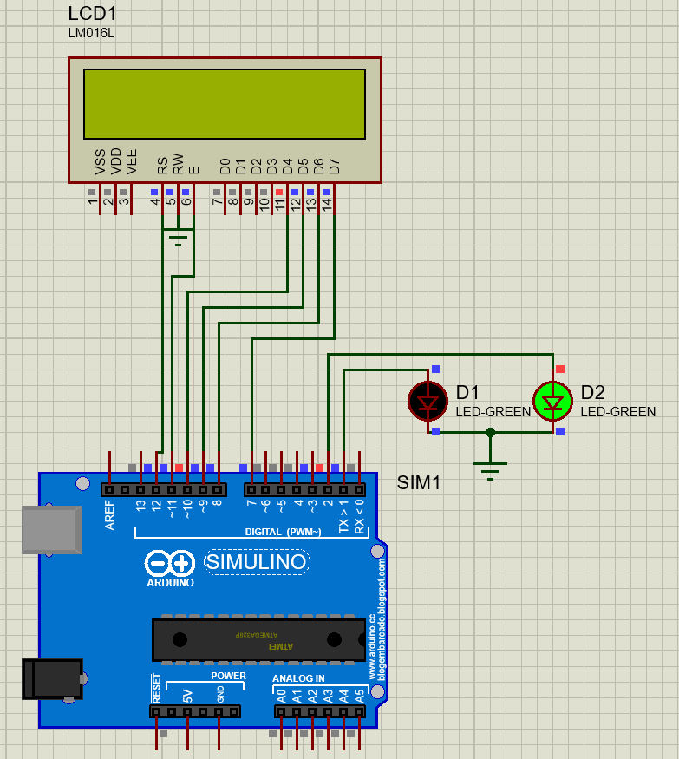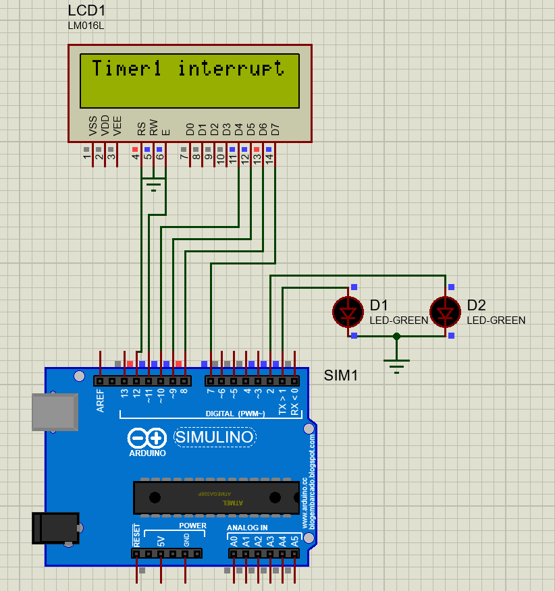

**Task 3:** Using the concept of interrupts you have learnt, develop a program that uses interrupt.

**Solution:**

#define LED_PIN 13

#define BTN_PIN 2

void INT0_ISR(void)

{

  digitalWrite(LED_PIN, !digitalRead(LED_PIN));

}

void setup()

{

  pinMode(LED_PIN, OUTPUT);

  pinMode(BTN_PIN, INPUT);

  attachInterrupt(digitalPinToInterrupt(BTN_PIN), INT0_ISR, RISING);

}

void loop()

{

  // Do Nothing

}

**Output:**

