**Young_Dev FIGMA INTERNSHIP**

**Basic level:**

**Task 1:** [**https://www.figma.com/design/YVkvvC1iWZKNn84wq4u7NX/BASIC-1?node-id=0-1&t=uCZkat8rnYhv7XaR-1**](https://www.figma.com/design/YVkvvC1iWZKNn84wq4u7NX/BASIC-1?node-id=0-1&t=uCZkat8rnYhv7XaR-1)

**Task 2:** [**https://www.figma.com/design/N8o80dbrFz9tnLRF4MFzgH/basic-2?t=uCZkat8rnYhv7XaR-1**](https://www.figma.com/design/N8o80dbrFz9tnLRF4MFzgH/basic-2?t=uCZkat8rnYhv7XaR-1)

**Task 3:** [**https://www.figma.com/design/J4H4JxdS8JeKMifYRjhPKT/basic-3?node-id=65-59&t=4Ul27QbIib0g4NSo-1**](https://www.figma.com/design/J4H4JxdS8JeKMifYRjhPKT/basic-3?node-id=65-59&t=4Ul27QbIib0g4NSo-1)

**Intermediate level:**

**Task 1:** [**https://www.figma.com/design/S6AciMyUdxXDIjoPytVTM5/inter-1?node-id=12-38&t=yfEvDKQ9OPr4MRr5-1**](https://www.figma.com/design/S6AciMyUdxXDIjoPytVTM5/inter-1?node-id=12-38&t=yfEvDKQ9OPr4MRr5-1)

**Task 2:** [**https://www.figma.com/design/S4ClzCtWGfHtEt59LvZvNz/inter-2?node-id=0-1&t=yfEvDKQ9OPr4MRr5-1**](https://www.figma.com/design/S4ClzCtWGfHtEt59LvZvNz/inter-2?node-id=0-1&t=yfEvDKQ9OPr4MRr5-1)

**Task 3:** [**https://www.figma.com/design/dZDmNaSeWtukvjSZlZsLNl/inter-3?node-id=5-2&t=yfEvDKQ9OPr4MRr5-1**](https://www.figma.com/design/dZDmNaSeWtukvjSZlZsLNl/inter-3?node-id=5-2&t=yfEvDKQ9OPr4MRr5-1)

**Expert level:**

**Task 1:** [**https://www.figma.com/design/xhhFs1f86CrHhQ14ZsN9Sf/expert-1?node-id=15-166&t=yfEvDKQ9OPr4MRr5-1**](https://www.figma.com/design/xhhFs1f86CrHhQ14ZsN9Sf/expert-1?node-id=15-166&t=yfEvDKQ9OPr4MRr5-1)

**Task 2:** [**https://www.figma.com/design/NoFNL40l8jszUt2vbkWOlN/hunger-hub-E2%2F3?node-id=55-70&t=yfEvDKQ9OPr4MRr5-1**](https://www.figma.com/design/NoFNL40l8jszUt2vbkWOlN/hunger-hub-E2%2F3?node-id=55-70&t=yfEvDKQ9OPr4MRr5-1)

**Task 3:** 

**HUNGER HUB APP DESIGN LINK:**

[**https://www.figma.com/design/NoFNL40l8jszUt2vbkWOlN/hunger-hub-E2%2F3?node-id=55-70&t=Jb5sFpA3RUTBDvod-1**](https://www.figma.com/design/NoFNL40l8jszUt2vbkWOlN/hunger-hub-E2%2F3?node-id=55-70&t=Jb5sFpA3RUTBDvod-1)

**I added interactions on my app if you want to know how it works do check the link and click on prototype it will show how it works! Thankyou.**

**----------------------------------------------------------------------------**

**Assets design:**

**Reusable Components:**

**ICONS:**



**Max to Min slider (to show the spice level):**

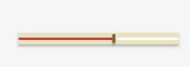

**Counter:**



**First set of variants button:**



**Second set of variants buttons:**

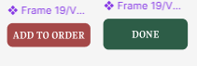

**Other buttons which is used:**

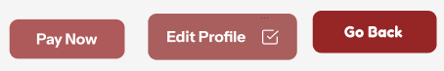

**Sliders fields:**

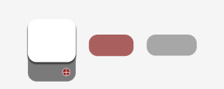

**Input fields:**

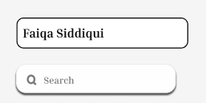

**Gifs:**

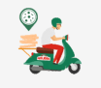

**Styling:**

**Color Styles: Primary, secondary, text, background, and hover colors,**

**Primary colors:**

   

**Secondary colors:**

   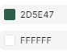 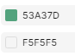    

**Text color:**

    

**Background color:**



**Click /Variant button colors:**

 

**Text Styles: Typography ke liye fonts, sizes, weights**

**Typography fonts:**

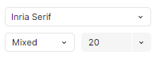 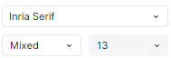 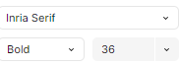 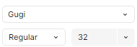 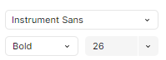 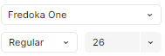 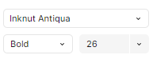 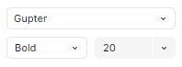

Gugi, Inria Serif, Fredoka One, Instrument Sans, Gupter, Inknut Antiqua

**Exportable Assets:**

**Icons:**

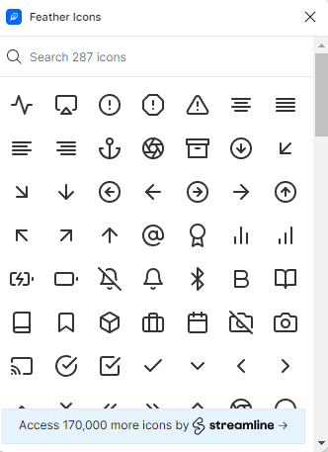

**Imported Images:**

** **       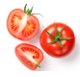 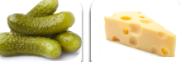

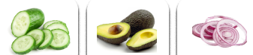  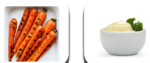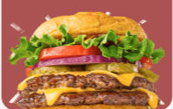

**ANNOTATIONS:**

**Home page:**

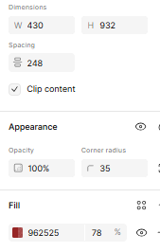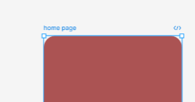

****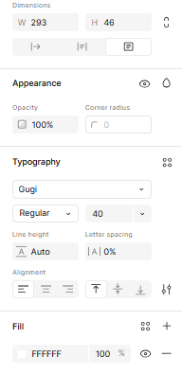

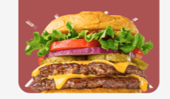 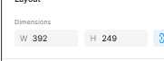

**Screen 1:**

 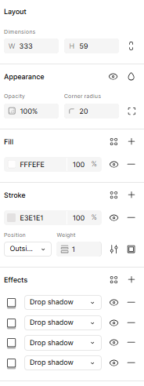

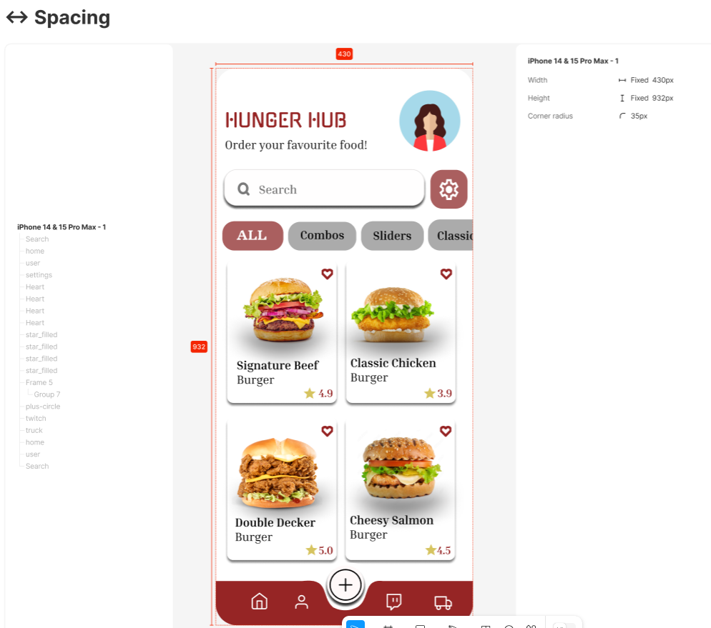

**Search icon:**

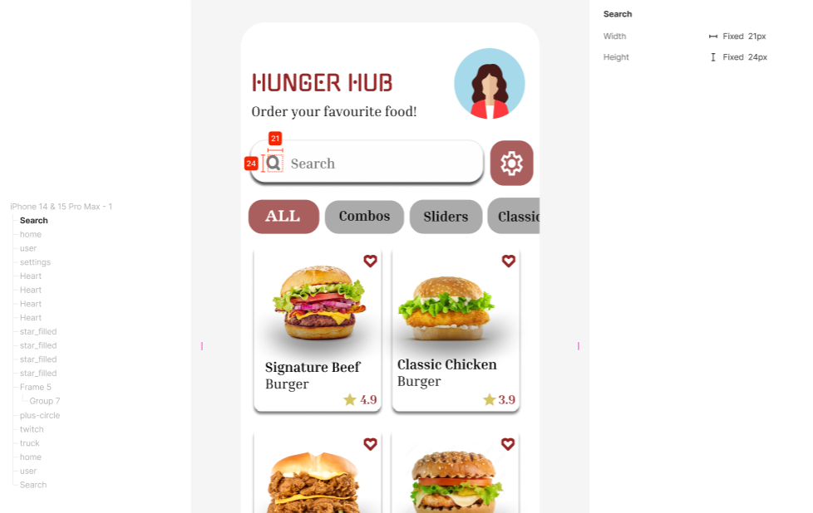

**Footer:**

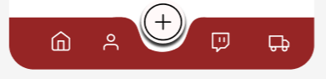

**Home icon:**

 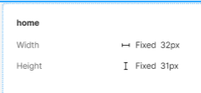

**User icon:**

 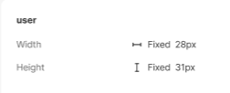

**Setting Icon:**

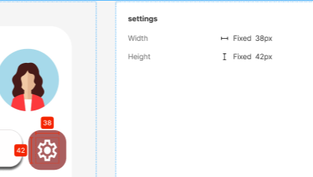

**Heart icon:**

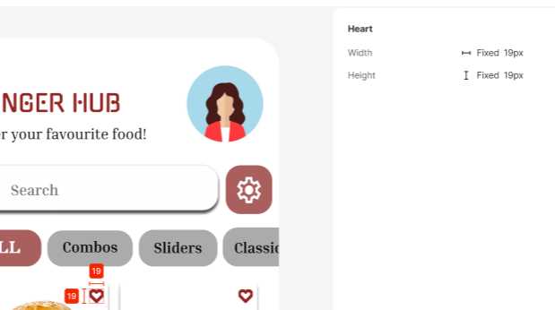

**Star icon:**

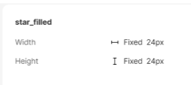

**Frame 5 (slider):**

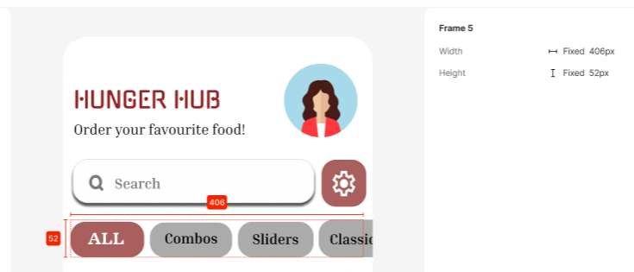

**Group 7:**

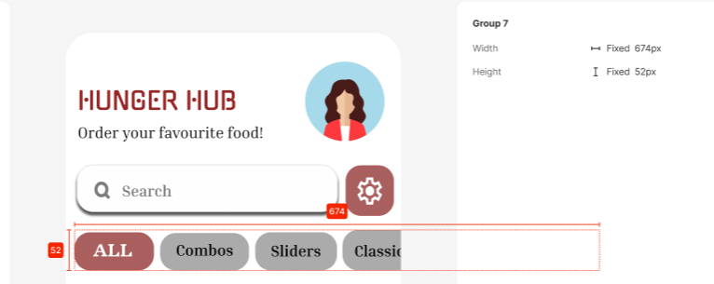

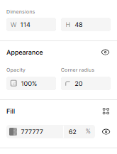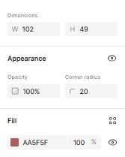

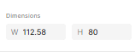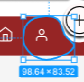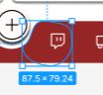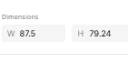

**Plus Circle:**

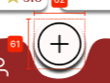 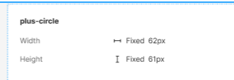

**Twitch Icon:**

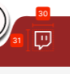 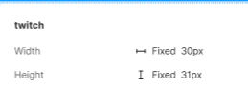

**Truck icon:**

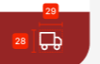

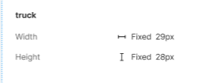

**Anatomy:**

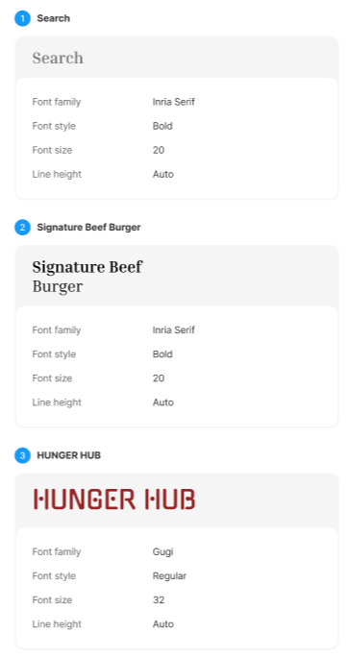

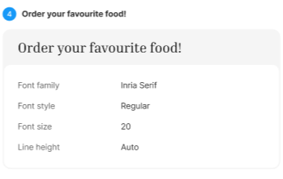

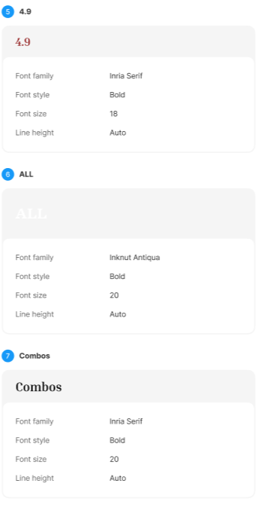

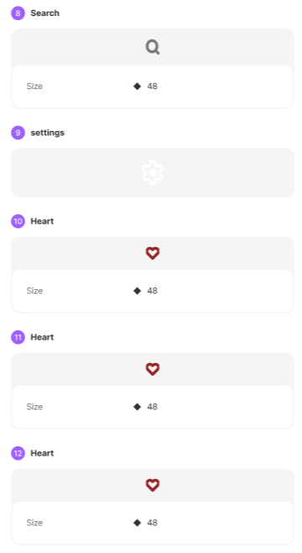

**Screen 2:**

**Spacing:**

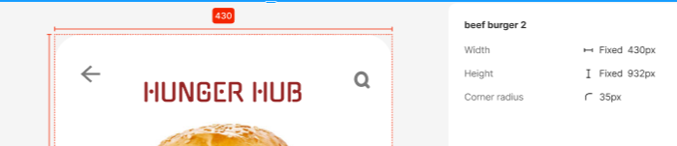

**Search icon:**

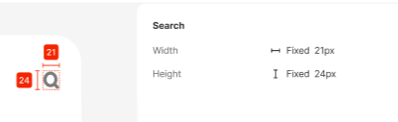

**Arrow back:**

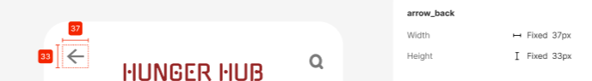

**Star icon:**

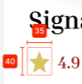 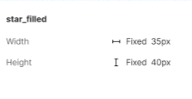

**Linear progress:**

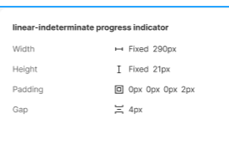 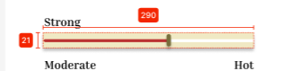

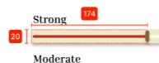 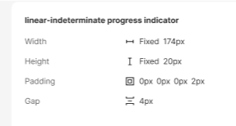

**Order now button:**

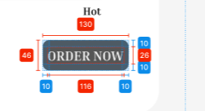 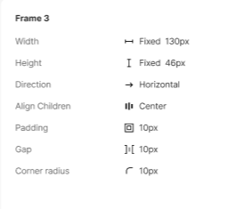

**Frame 6:**

 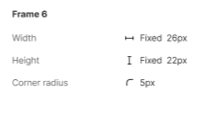

**Frame 7:**

 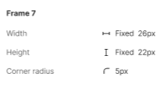

**Anatomy:**

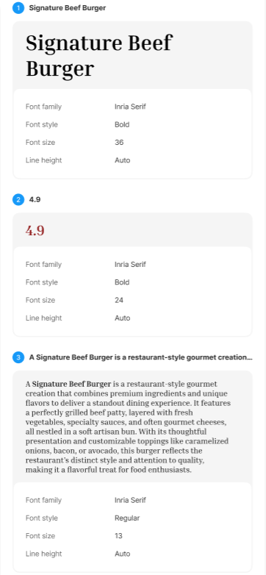

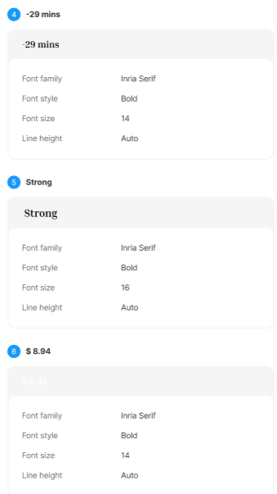

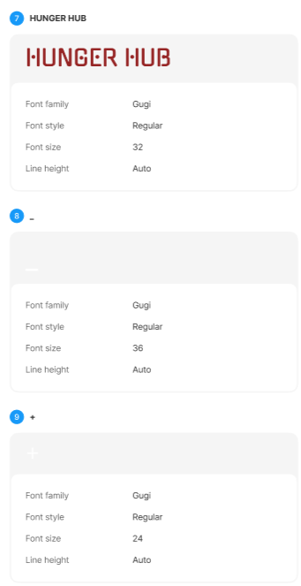

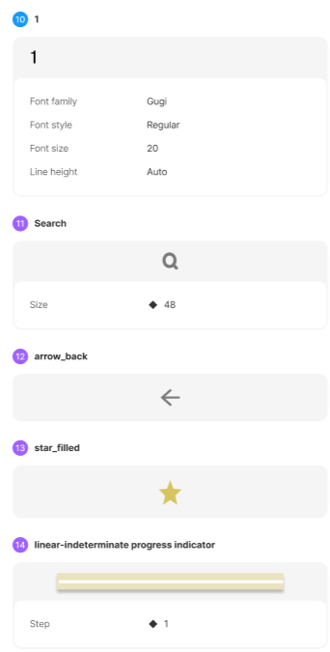

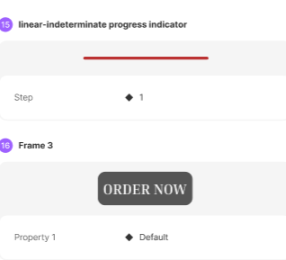

**Screen 3:**

**Spacing:**

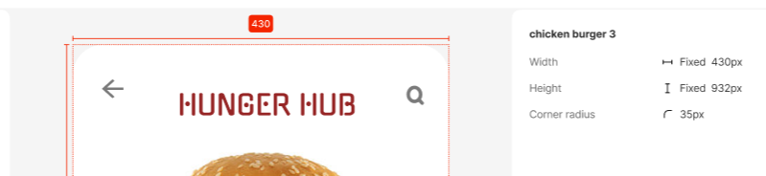

**Search icon:**

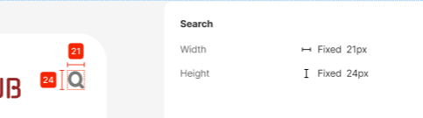

**Linear progress:**

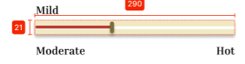 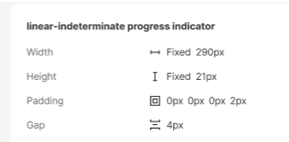

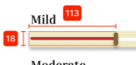 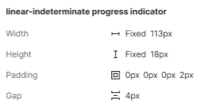

**(Arrow back, Star icon, Order now button, Frames same as screen 2)**

**Anatomy:**

**Same as screen 2!**

**Screen 4:**

**Linear progress:**

 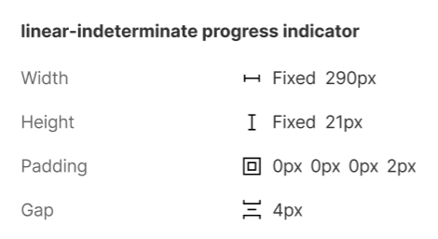

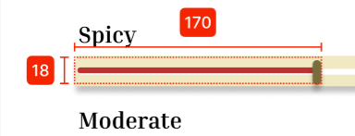 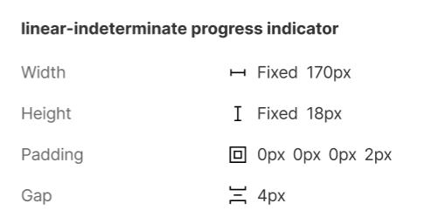

**(Spacing, Search icon, Arrow back, Star icon, Order now button, Frames same as screen 2)**

**Anatomy:**

**Same as screen 2!**

**Screen 5:**

**Linear progress:**

 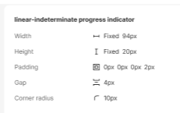

**(Spacing, Search icon, Arrow back, Star icon, Order now button, Frames same as screen 2)**

**Anatomy:**

**Same as screen 2!**

**Screen 6:**

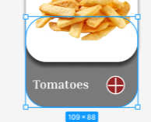 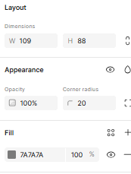 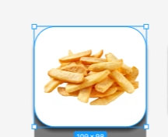 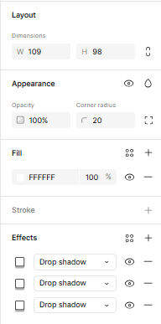

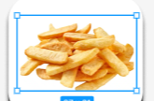 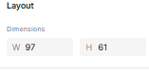  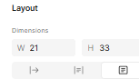

**Linear progress:**

 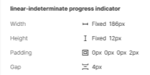

 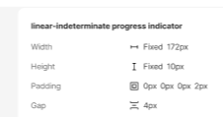

**Frame 17:**

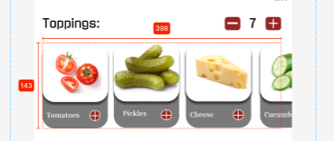 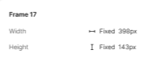

**Group 8:**

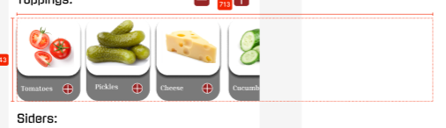 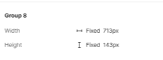

**Frame 18:**

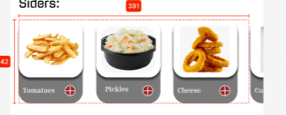 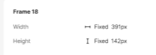

**Group 9:**

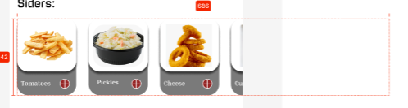 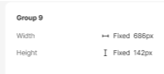

**Frame 16:**

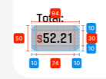 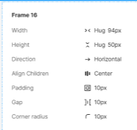

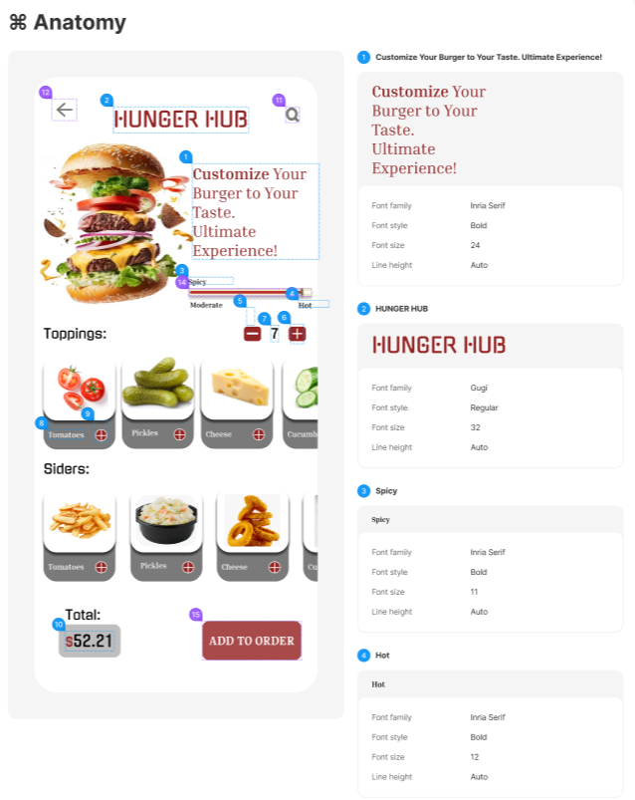

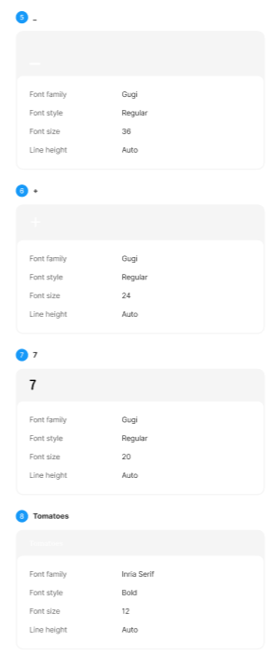

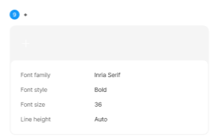

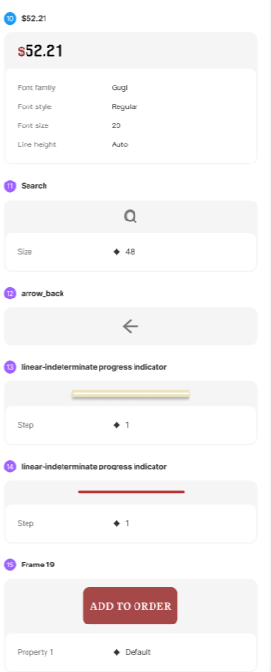

**Screen 7:**

**Check square:**

 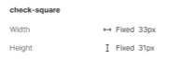

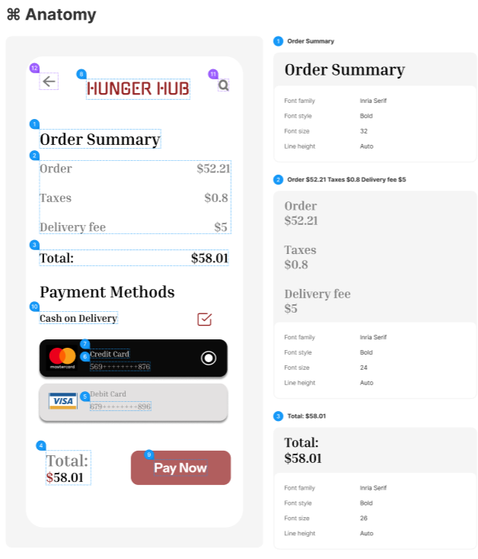

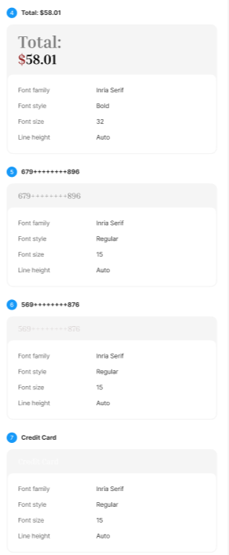

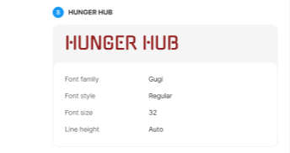

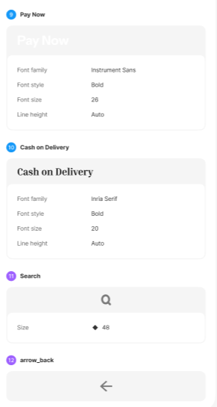

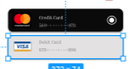 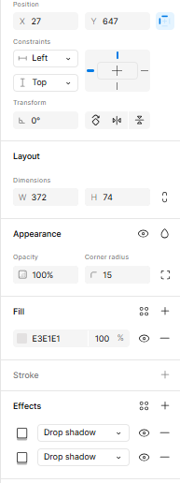

**Screen 8:**

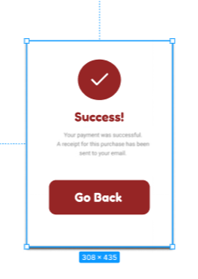 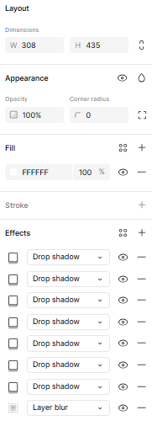

**Check:**

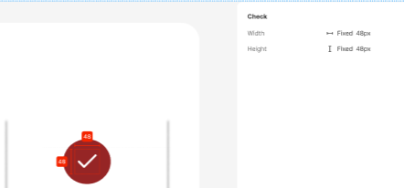

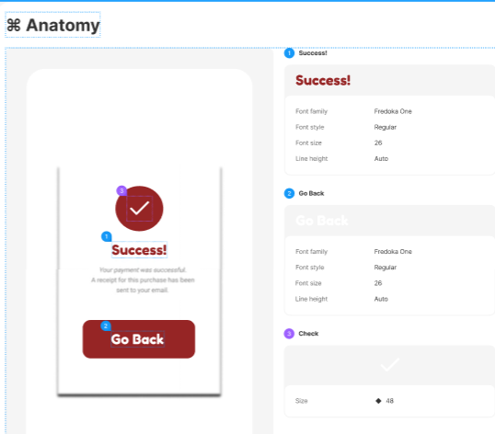

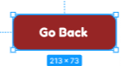 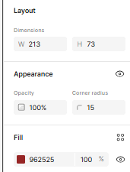

**Screen 9:**

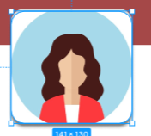 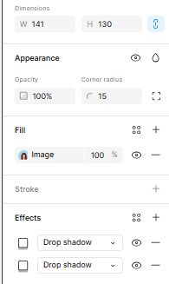

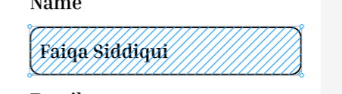 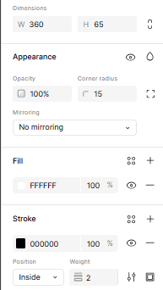

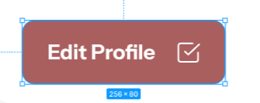 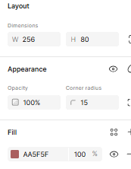

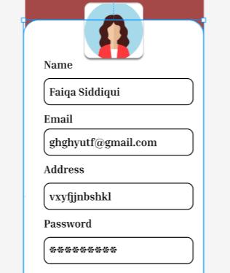 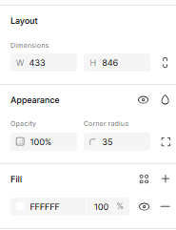

**Check:**

 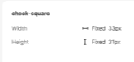

**Screen10:**

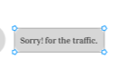 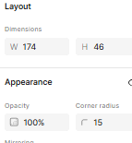

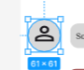 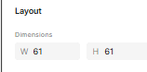

 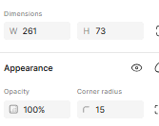

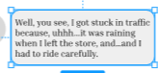 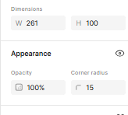

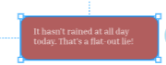 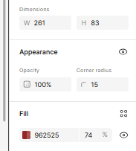

 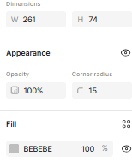

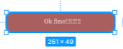 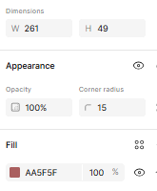

 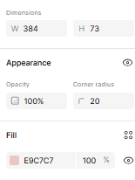

 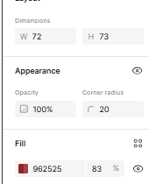

 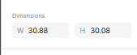

 

**Screen11:**

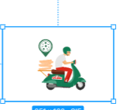 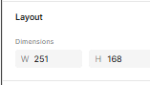

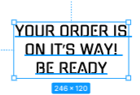 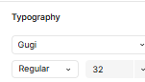

 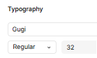

**Frame 19:**

**BUTTON:**

**(Default)**

 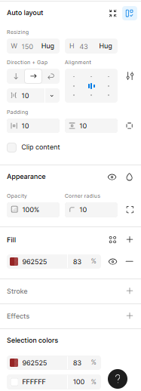

**(Variant)**

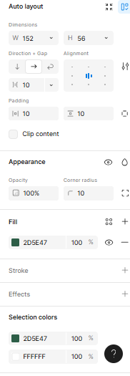

**Frame 3:**

**BUTTON:**

**(Default)**

 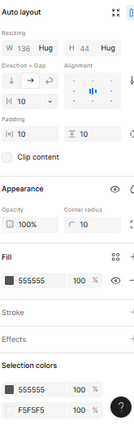

**(Variant)**

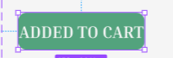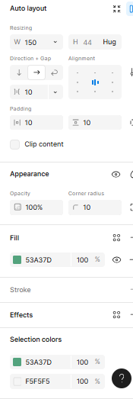

**HUNGER HUB APP DESIGN LINK:**

[**https://www.figma.com/design/NoFNL40l8jszUt2vbkWOlN/hunger-hub-E2%2F3?node-id=55-70&t=Jb5sFpA3RUTBDvod-1**](https://www.figma.com/design/NoFNL40l8jszUt2vbkWOlN/hunger-hub-E2%2F3?node-id=55-70&t=Jb5sFpA3RUTBDvod-1)

**I added interactions on my app if you want to know how it works do check the link and click on prototype it will show how it works! Thankyou.**