
Assignment 01
Cloud Computing
Submitted To: Engr.Waqas Saleem
Submitted By: Faiqa Shahzad
Date: October 10, 2026
Day: Saturday
Semester: Fifth
Registration No: 2024-BSE-26

Department of Software Engineering
(2024-2028)
Task 1:
Install Gitea and Push a Repository from the Ubuntu Server
Screenshots:
Figure 1.1 task1_gitea_running.png
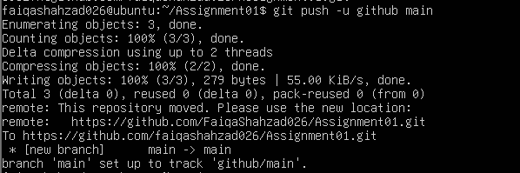
Figure 1.2 task1_gitea_push.png
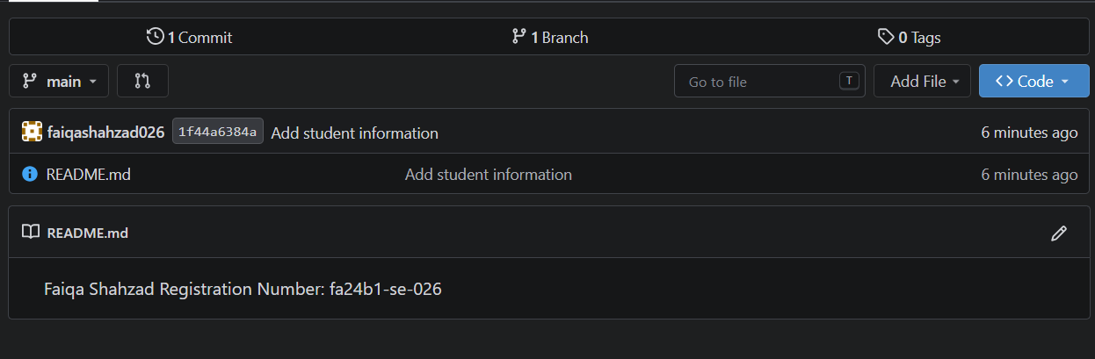
Figure 1.3 task1_gitea_repository.png
Task 2:
Push the Same Repository to GitHub
Screenshots:
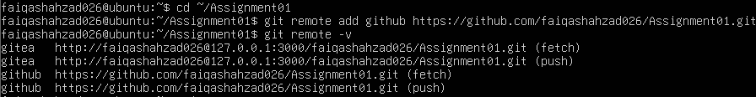
Figure 2.1 task2_remotes.png
Figure 2.2 task2_github_push.png
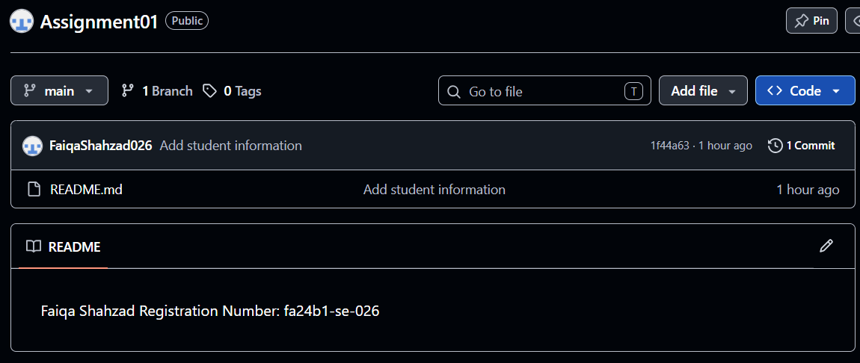
Figure 2.3 task2_github_repository.png
Task 3:
Track Three Large Files with Git LFS
Screenshots:
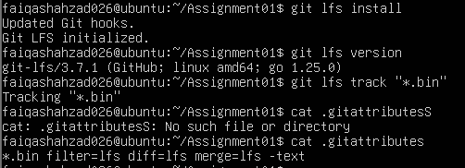
Figure 3.1 task3_lfs_setup.png
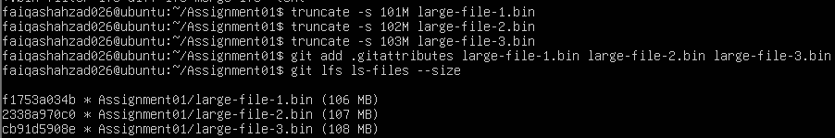
Figure 3.2 task3_lfs_files.png
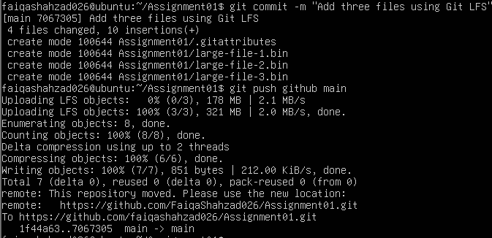
Figure 3.3 task3_lfs_push.png
Task 4:
Create a Portfolio or CV with GitHub Pages
Screenshots:
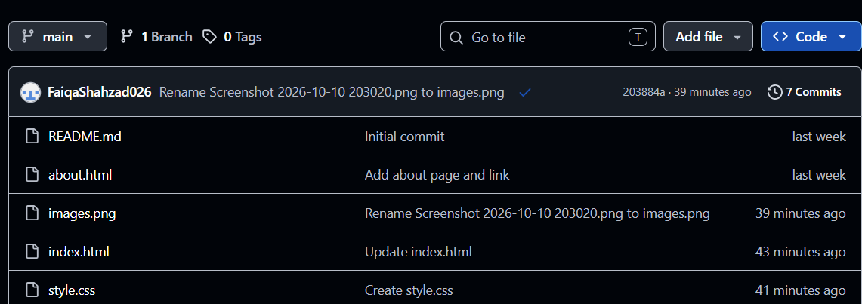
Figure 4.1 task4_pages_repository.png
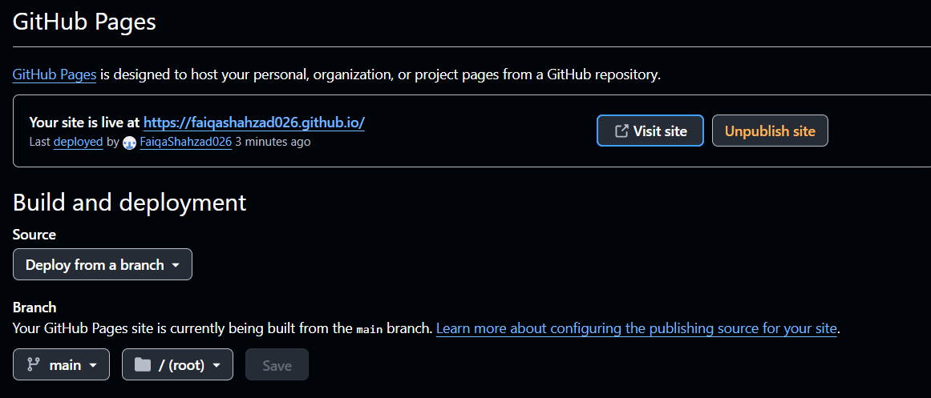
Figure 4.2 task4_pages_deployment.png
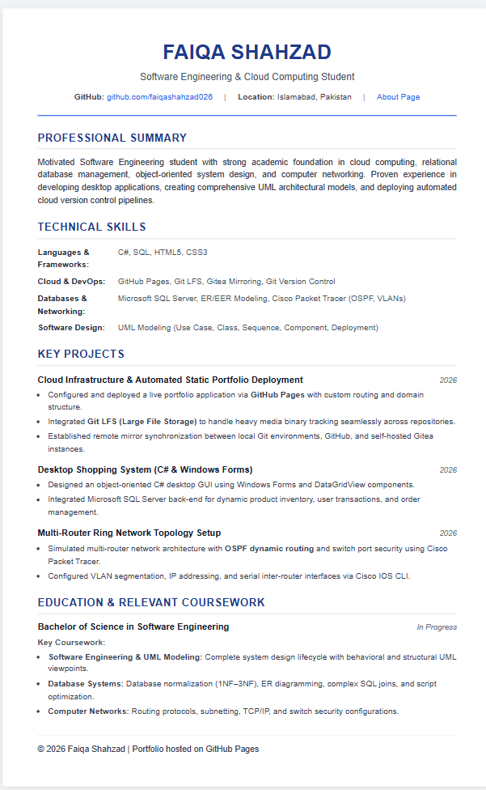
Figure 4.3 task4_portfolio_live.png

