FairHire: Deterministic and Explainable Resume Parsability Scoring with an Interactive Repair Loop
[Author names]
[Affiliation]
[Email]

ABSTRACT
Applicant tracking systems (ATS) convert resumes into structured records before any human reads them, and documents that extract poorly, through multi-column layouts, non-standard headings, decorative bullets or inconsistent dates, can be misread regardless of the applicant's qualifications. Tools that help candidates with this problem often rely on opaque models or language-model judgments, which makes their feedback hard to reproduce or contest. We present FairHire, an open web application that scores how reliably software can read a resume using only deterministic, inspectable rules. The system recovers text from PDF, DOCX, Markdown, LaTeX and plain-text inputs, including detecting and re-ordering side-by-side columns, then parses the text into a canonical structured document without discarding any line. Scoring uses eleven weighted rule dimensions in two families, parser-safe structure and field-extraction quality, and every failing check emits a recommendation anchored to a character offset or document location. The score is computed only from the resume: a job description, when supplied, contributes an informational keyword-relevance view, and an optional language model may only propose job requirements, each of which is re-validated against the literal source text and never reaches the scoring path. A structured editor re-scores the canonical rendering after each edit and exports single-column DOCX and plain-text files, so the text that is scored is the text that is exported. We describe the design and the decisions behind it; empirical evaluation is left to future work.
KEYWORDS
Applicant tracking systems; Resume parsing; Explainable scoring; Deterministic rules; Document layout analysis; Human-in-the-loop editing; Responsible use of language models

1. Introduction

1.1 Problem Statement
Many employers screen applications with applicant tracking systems that extract text from an uploaded resume and map it onto fields such as contact details, work history, education and skills [TODO: cite a source on ATS adoption and parsing behaviour]. This step happens before any human review. When extraction fails, for example because two columns of text are interleaved line by line, a heading is not recognized, or dates appear in several formats, the resulting record can be incomplete or wrong even though the underlying document is perfectly legible to a person.
Candidates have little visibility into this process. Commercial resume checkers typically return a single score without showing how it was produced, and tools built on large language models can return different judgments for the same input on different runs. Feedback that cannot be traced to a concrete property of the document is difficult to act on and impossible to audit. A further risk is scope creep: a tool that claims to measure whether a resume “fits” a job begins to approximate a hiring decision, which is a far more consequential and contestable judgment than whether a document can be read by software.

1.2 Solution
FairHire narrows the question to one that can be answered with exact rules: how cleanly can a parser read this resume? The system ingests a resume in any of several common formats, recovers its text with explicit handling for multi-column layouts, and parses it into a canonical structured document. It then evaluates the canonical text against eleven rule-based dimensions and reports a score, a grade, a per-dimension breakdown and a ranked list of recommendations, each tied to the line or section it concerns. Identical input always yields an identical score.
Around this core, FairHire provides a structured editor in which the user fixes reported problems and sees the score update, and an exporter that writes single-column DOCX and plain-text files built from the same canonical rendering that was scored. A job description is optional and is used only to show which of its concepts already appear in the resume; it never changes the score. An optional language model can suggest requirements from the job description, but every suggestion must quote the job description verbatim and is re-checked by deterministic rules before it is shown. Throughout the interface the score is described as a measure of machine readability, not of the candidate's ability or suitability.

2. Challenges

2.1 Layout-Induced Extraction Errors
PDF is a presentation format: it records where glyphs are drawn, not the order in which a reader should consume them. Two-column resume templates are common, and naive extraction reads straight across both columns, interleaving unrelated lines. A complicating factor is that single-column resumes also contain wide horizontal gaps, most often right-aligned date ranges, so the mere presence of whitespace is not evidence of a second column. The system must distinguish the two cases without a learned layout model.

2.2 Reproducibility and Explainability
For feedback to be trusted and acted on, the same document must always receive the same score, and every point lost must trace back to a specific rule and, where possible, a specific place in the document. This rules out stochastic components on the scoring path and requires that parsing preserve character offsets and line ownership through every transformation, so that a recommendation can point to the exact text that triggered it.

2.3 Constraining Language-Model Assistance
Language models are useful for reading free-form job descriptions, which vary widely in structure. They can also paraphrase, invent requirements, or mislabel a phrase, for example reporting a requirement for one programming language while quoting a sentence about another. The challenge is to obtain this assistance while guaranteeing that model output can never decide a match, alter a score, or introduce a requirement that is not literally present in the source.

2.4 Consistency Between Editing, Scoring and Export
An editor that scores one representation of a resume while exporting another can report problems that no longer exist, or miss problems the exported file still has. The system needs a single canonical document model that the parser produces, the user edits, the scorer evaluates and the exporters write, so that the checks on screen always describe the file the user will download.

3. System Design

3.1 Architecture Overview
FairHire is a two-tier web application (Figure 1). The browser tier is a Next.js and React application with an import screen, a structured editor, a checks panel and an export menu. The server tier is a Python FastAPI service packaged as a container image that bundles the Poppler PDF utilities and a pre-downloaded stopword corpus, and runs as an unprivileged user. The two tiers communicate over JSON: an import endpoint accepts an uploaded file or pasted text and returns a canonical document with its evaluation; a scoring endpoint accepts an edited document and returns a fresh evaluation; and export endpoints return DOCX or plain-text files.
On the server, a resume passes through four stages: text extraction, rule-based parsing into the canonical model, canonical rendering back to plain text, and ATS evaluation of that rendering. Two auxiliary components sit beside this path. The job-description relevance component tags concepts in a job description and looks for literal evidence of them in the resume, and the optional language-model component proposes additional job requirements. Neither feeds the score.
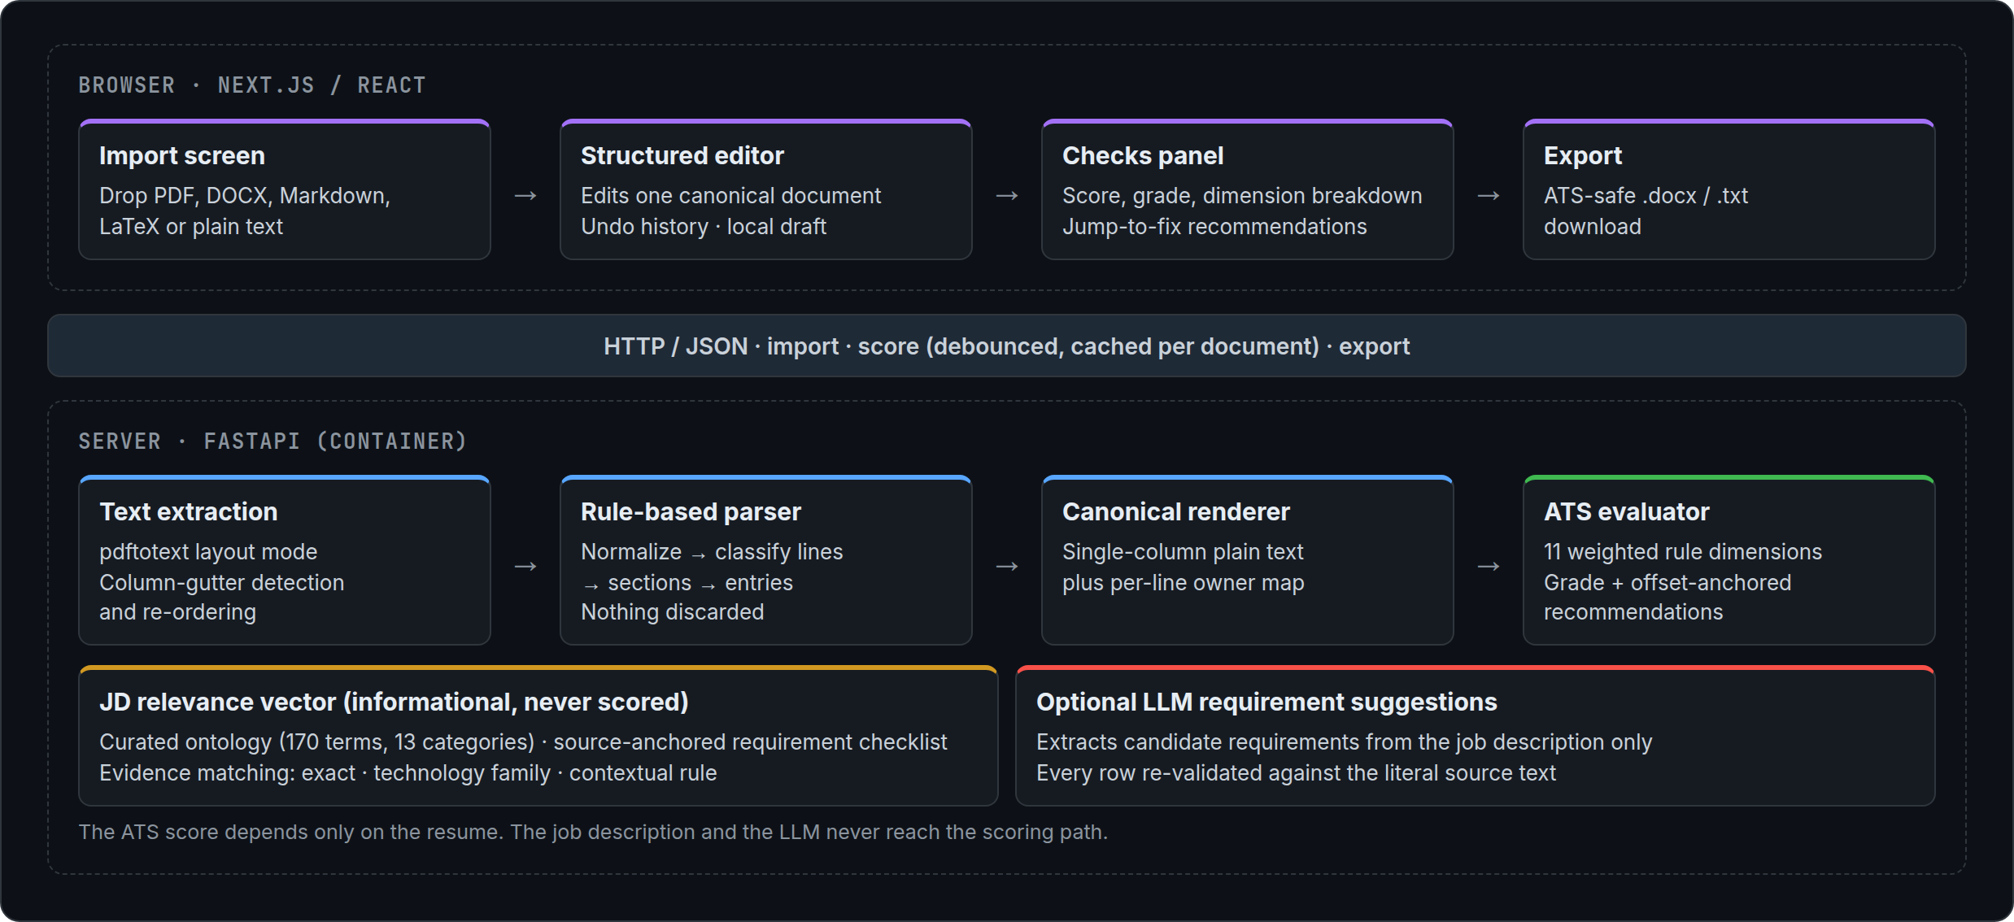
Figure 1. FairHire architecture. The ATS score is computed from the resume alone; the job-description and language-model components are informational and sit outside the scoring path.

3.2 Text Extraction and Layout Recovery
Uploads up to 10 MB are accepted in PDF, DOCX, Markdown, LaTeX and plain-text form. Markdown is reduced to text by stripping heading markers, emphasis and link syntax, and LaTeX source is reduced on a best-effort basis by converting section commands to lines and item commands to bullets before removing remaining markup. DOCX files are read in paragraph order, with list-styled paragraphs marked as bullets and table rows flattened into delimited lines.
PDFs are converted with Poppler in layout mode, which preserves the horizontal position of text. The system then searches for a column gutter (Figure 2). For every non-empty line it finds the first run of three or more spaces between two non-space characters and records the character column at which the right-hand text begins. Lines whose right-hand fragment looks like a date or a date range are ignored, because right-aligned dates start at a different column on every line, whereas a genuine second column starts at the same column on many lines. A gutter is accepted only if one column position is shared by at least three lines and by at least 20% of all content lines. When a gutter is found, the text is re-ordered so that the entire left column precedes the entire right column; lines that cross the gutter, such as a full-width name banner, are treated as breaks between column blocks. PDFs that yield fewer than 40 non-whitespace characters are rejected with a message explaining that the file appears to be a scanned image.
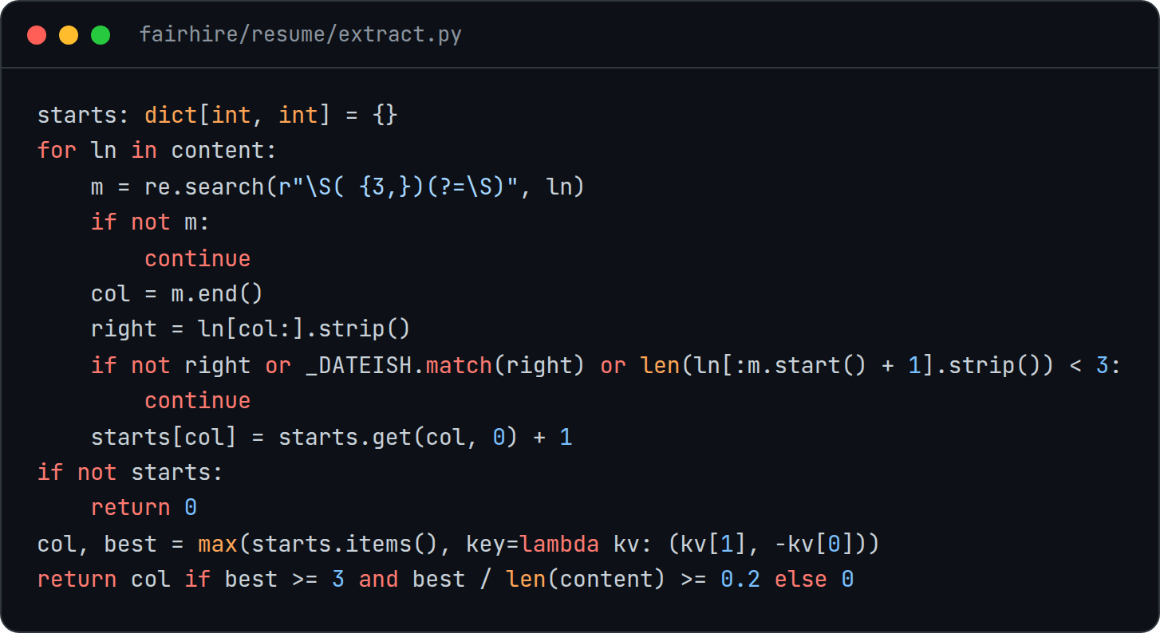
Figure 2. Column-gutter detection. Candidate column starts are counted per character position; date-like fragments are excluded so that right-aligned dates are not mistaken for a second column.

3.3 Canonical Resume Model and Rule-Based Parser
All downstream components share one canonical model. A resume consists of a contact block (name, headline, email, phone, location, links and any unclassified contact lines), a free-text summary, and an ordered list of sections. Each section has a kind, drawn from experience, education, projects, skills, publications, certifications, awards and a custom kind, and holds either skill groups (a label and a list of items) or entries. An entry carries a heading, subheading, location, detail, link, start and end dates, and a list of bullets.
The parser is a pure function of its input with no model, randomness or I/O. It proceeds in four steps. Normalization applies Unicode compatibility folding, maps private-use bullet glyphs to standard characters, removes zero-width characters, converts form feeds and tabs, and re-joins words hyphenated across line breaks. Classification labels every line as blank, heading, bullet, continuation or entry header. Segmentation splits the document into sections at recognized headings and then into entries. A style check makes heading recognition adapt to the document: if most of the known headings are written in capitals, other capitalized lines that follow a blank line are also treated as headings of custom sections. Finally, interpretation splits each entry header on wide gaps, separators and dates and assigns the fragments to role, organization, location and date fields using pattern rules.
A central design rule is that nothing is discarded. Lines that match no rule are attached to the nearest entry as a heading or bullet, or retained among the contact block's unclassified lines, so a parsing mistake is visible and correctable in the editor rather than silently losing content. The kind of a custom section is inferred from the shape of its entries.

3.4 Canonical Rendering
The canonical renderer converts a structured resume back into the plain text that a parser would read from the exported file. The output is a single column with the contact lines first, followed by a summary and the sections in order. Section titles are replaced with standard labels for every non-custom kind, entry headers are written as one line joining role, organization, location, detail, link and date range with vertical bars, and bullets are written with a plain hyphen. Skill groups become one comma-separated line each.
Alongside the text, the renderer produces an ownership map that records, for every output line, which section and entry it came from. Recommendations from the evaluator refer to line numbers in this text; the ownership map translates them into document locations, so the editor can move the user directly to the entry that needs attention. Recommendations without a line reference, such as a missing phone number or a missing skills section, are mapped by their rule code to the relevant part of the document, or to a section that does not yet exist.

3.5 ATS Parsability Evaluation
The evaluator scores the canonical text along eleven dimensions in two families (Table 1). The parser-safe structure family, with a combined weight of 0.55, captures layout properties that commonly break extraction. The field-extraction family, with a combined weight of 0.45, measures whether the fields a tracking system needs can actually be recovered. Each dimension produces a sub-score from 0 to 100 using fixed thresholds, and the overall score is the weight-normalized sum of the sub-scores (Figure 3). The score maps to one of four grades: Strong (80 and above), Good (55 and above), Needs work (35 and above) and Likely missed.
Table 1. Evaluation dimensions, families and weights.
Dimension | Family | Weight | What the rule checks
Single-column layout | Structure | 0.12 | Share of content lines with wide interior gaps
Contact placement | Structure | 0.08 | Name, email and phone within the first 15 non-empty lines
Section labels | Structure | 0.12 | Core and bonus headings present; creative headings penalized
Date consistency | Structure | 0.08 | One date style, preferably “Month YYYY”
Bullet style | Structure | 0.07 | Plain bullets rather than arrows, check marks or emoji
Text integrity | Structure | 0.08 | Alphanumeric ratio and plausible document length
Contact block | Extraction | 0.10 | Email, phone, location, profile link and name
Chronological experience | Extraction | 0.10 | Role titles and date ranges
Education | Extraction | 0.07 | A degree and an institution
Skills section | Extraction | 0.10 | Dedicated heading, bare skill tokens, recognized categories
Scannable bullets | Extraction | 0.08 | Bullet count, action verbs and quantified outcomes
Several rules guard against false positives that would unfairly penalize a document. The creative-heading check, which flags heading-shaped lines that match no known section alias, skips the header block (the name, headline and contact lines at the top), lines containing digits, lines that name a degree or institution, and lines that read as job titles, since these are frequently title-cased without being headings. Name detection accepts names in capitals or title case, allows lowercase particles such as “de”, “van” or “bin”, and rejects document titles such as “Resume” or “Curriculum Vitae”. Date-format detection assigns each date span to exactly one format so that a range is not counted twice.
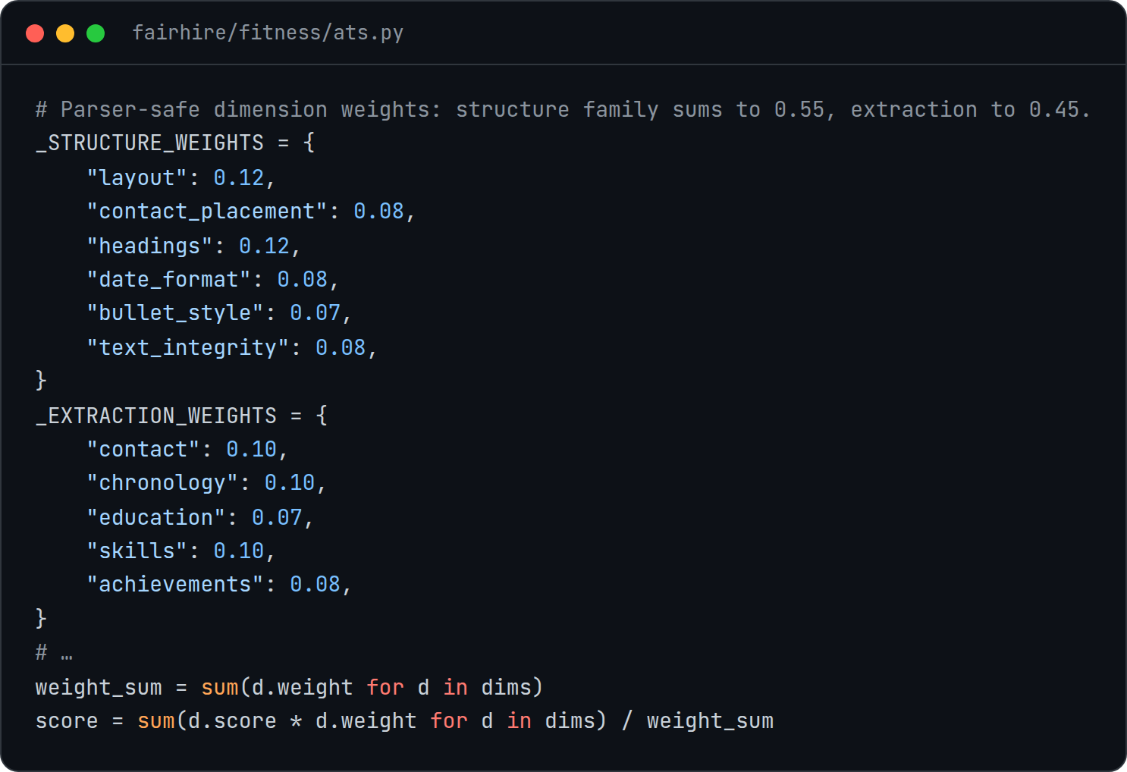
Figure 3. Dimension weights and score aggregation. The two families sum to 0.55 and 0.45, and the overall score is the weight-normalized sum of the dimension sub-scores.
Every failing check emits a recommendation with a severity (high, medium or low), a stable rule code, a short title, an explanation, a concrete action, and, where applicable, the character offsets and line number of the offending text. Recommendations are ordered by severity and the twelve most important are returned. Because the evaluator is deterministic, the same document always produces the same recommendations in the same order.

3.6 Job-Description Relevance Vector
When the user supplies a job description, FairHire treats it as a relevance vector rather than a scoring target. Terms are tagged with a curated ontology of 170 technologies and practices in 13 categories, including languages, frameworks, databases, cloud platforms and machine-learning tools. Each term lists its literal variants, and matching is case-insensitive at word boundaries against the raw text, so every tag keeps exact character offsets. Longer variants take precedence at the same position, so a two-word framework name is not also counted as the shorter name it contains, and spans are never double-counted.
A deterministic checklist extractor walks the job description sentence by sentence. Headings such as requirements or qualifications open a required zone, headings such as preferred or nice to have open an optional zone, and benefits or company boilerplate close the active zone. Sentences that simply list technologies are split into one requirement per recognized term; sentences that carry a constraint, such as a degree, a number of years, or an alternative, are kept whole so that a single technology cannot satisfy a compound requirement. Each requirement records the exact span of the job description it came from.
Evidence for each requirement is sought in the resume in three tiers: an exact match of the term or a curated alias, a reviewed technology-family relationship, and a contextual rule that finds supporting language within a single sentence, such as a degree of the required level and subject, or a stated number of years alongside the same technologies. Candidate evidence in a sentence containing negation or hedging, such as “not”, “without” or “learning”, is rejected. When no evidence is found the interface states that this does not establish that the candidate lacks the qualification. Matches are reported as keyword coverage only and never alter the ATS score.

3.7 Optional Language-Model Requirement Suggestions
If an API key is configured, FairHire can ask a language model, accessed through an OpenAI-compatible client, to propose additional requirements from a job description. The prompt instructs the model to treat the document as untrusted data, to return a normalized concept, a requirement kind and a verbatim quotation of the source for each item, and never to paraphrase or invent. The model only ever sees the job description: it does not inspect the resume, decide whether a requirement is met, or produce a score.
Every returned row is re-validated deterministically before it is shown (Figure 4). The quoted span must match the job description character for character at the stated offsets and must lie within a single sentence or bullet. For skill requirements, the concept the model names must resolve to exactly one ontology term, and that term must also be present in the quoted source. A model therefore cannot label a sentence about one language as a requirement for another while quoting real text. For other kinds of requirement the concept is replaced by the literal source span. Suggestions that duplicate the deterministic checklist are dropped. The remainder are returned from a separate endpoint and are never applied automatically: a client may submit a reviewed checklist with an analysis request, where it is validated again by the same rules. If the model is unavailable or returns invalid output, no suggestions are returned and the deterministic checklist is used unchanged. The current interface does not yet expose this review step.
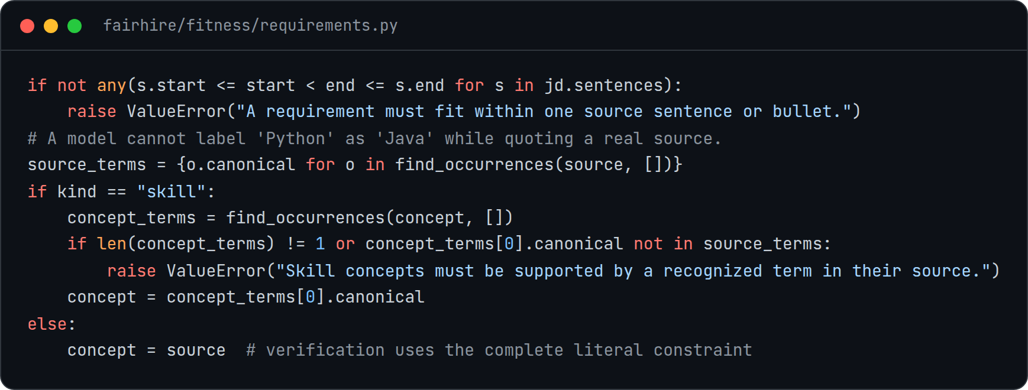
Figure 4. Validation of language-model output. A suggested skill must be grounded in a recognized term within the quoted source sentence; other requirement kinds are reduced to the literal source text.

3.8 Interactive Editor and Export
The editor holds the canonical document as its single source of truth. Each edit produces a new document, and a re-scoring request is issued 350 ms after the last change. Because scoring is a pure function of the document, results are cached in the browser keyed by the serialized document, so undoing an edit restores the earlier evaluation instantly without a network request. A sequence counter discards responses that arrive after a newer request has been issued, so the checks on screen always describe the document on screen. Edits made within 800 ms of each other are coalesced into a single undo step, with a history of up to 100 steps, and the draft is persisted in the browser's local storage so that no account is required.
The checks panel shows the score out of 100, the grade, a plain-language description of the grade, and the score of the document as first extracted, so the user can see the effect of their changes. A fine-print note states that the result describes how reliably software can read the document, is not a judgment of the person, and is the same every time. Each recommendation links to the section or entry that owns the problem (Figure 5).
SCREENSHOT PLACEHOLDER
Figure 5. [Placeholder: insert a screenshot of the editor with the checks panel, showing a recommendation linked to its entry.]
Export writes the canonical document as a DOCX file with a single column, no tables, text boxes or images, real heading styles and real list paragraphs, so that a parser reads the content in the same order a person does. A plain-text export writes the canonical rendering directly. Because both exporters, the preview and the scorer use the same canonical rendering, the score shown in the editor describes the file the user downloads.

4. Experiments
[TODO: experimental results — not yet run. No evaluation data exists in the repository; this section must be written from real experiments.]

4.1 Experimental Setup
[TODO: describe the evaluation protocol. Candidate questions the design raises: agreement between FairHire's field extraction and one or more real ATS parsers; accuracy of column-gutter detection on single- and multi-column PDFs; score change after users apply recommendations; reproducibility across runs.]

4.2 Dataset
[TODO: describe the resume and job-description corpus, its provenance, consent and licensing, and how layouts and formats are distributed. The repository includes unit-test fixtures, which are not an evaluation dataset.]

4.3 Results
[TODO: results tables and figures from the experiments above.]

5. Related Work
[TODO: related works. Suggested areas to survey: resume parsing and information extraction from semi-structured documents; PDF layout analysis and reading-order recovery; commercial and academic resume and ATS checkers; fairness, transparency and auditing in algorithmic hiring; grounding and verification of language-model extraction against source text.]

6. Conclusions

6.1 Limitations and Future Work
FairHire's score is a proxy. Its rules encode common guidance about what breaks resume parsing, but the thresholds and weights were set by hand and have not yet been calibrated against the behaviour of real applicant tracking systems; establishing that relationship is the most important item of future work. Determinism makes the score reproducible and auditable, but it does not by itself make the score fair or correct.
Several rules are tuned to English-language, North American resumes. Phone detection expects a three-three-four digit pattern, so some international numbers may not be recognized. Name detection relies on capitalization, which does not exist in many writing systems, so a name written in such a script may not be detected and the document may be penalized for a missing name. Section aliases, action verbs and the ontology are English and technology-oriented, so resumes from other fields will find fewer recognized skills. Layout recovery handles two side-by-side columns with a consistent gutter but not more complex layouts, and scanned PDFs without a text layer are rejected rather than processed with optical character recognition. Future work includes localized rule sets, broader ontologies, and an evaluation of whether the rules disadvantage resumes from particular regions or naming conventions.

6.2 Concluding Remarks
FairHire shows that useful feedback on resume parsability can be produced with deterministic, inspectable rules. By recovering layout explicitly, parsing into a single canonical document that is scored, edited and exported in the same form, anchoring every recommendation to a place in the document, and confining language models to verified suggestions outside the scoring path, the system gives candidates feedback they can reproduce, understand and act on, while being explicit that it measures machine readability and not the person behind the resume.

REFERENCES
[TODO: add literature references for Sections 1 and 5. The entries below are the software the system is built on; verify access dates before submission.]
[1] FastAPI. https://fastapi.tiangolo.com
[2] Next.js. Vercel. https://nextjs.org
[3] Poppler PDF rendering library (pdftotext). https://poppler.freedesktop.org
[4] python-docx. https://python-docx.readthedocs.io
[5] NLTK: The Natural Language Toolkit. https://www.nltk.org

