Layered representation diagnostics for ultra-short metagenomic reads
Authors: TBD
Affiliations: TBD

Abstract
Short-read metagenomic next-generation sequencing (mNGS) pipelines typically process trimmed, ambiguous, or locally perturbed reads, whose useful information may degrade before classifiers or database lookups are applied. In this context, accuracy-led evaluation is incomplete because downstream performance cannot distinguish whether losses of identity, biochemical, or positional information arise in the representation layer or only later in the classifier. Here we introduce a representation-diagnostics framework for controlled short-read (69-150 bp) mNGS settings that dissects short-read representations into four quantifiable dimensions: exact identity retention, biochemical perturbation stability, positional readability, and local mutation sensitivity. Our core compact representation, CK4P-MSP, integrates reverse-complement canonical 4-mer identity with biochemical summaries and multi-scale property pooling; it is evaluated against full-position matrices as a diagnostic upper bound and a canonical spaced-property (CSP) control as a boundary comparator. Across controlled WGS-derived perturbations, ART simulations, CAMI readout probes, and local mutation sensitivity tasks, consistent evidence shows that compact property-aware representations can improve stability while preserving low-dimensional diagnostic readability. Full-position matrices further reveal that fine-grained positional information can add readout value, but at substantially higher dimensional cost, whereas spaced-seed priors transfer to dense read-level descriptors only in scenario-specific contexts, such as particular read lengths or perturbation conditions. These results support a bounded architectural implication: short-read mNGS pipelines should retain exact k-mer, alignment, or curated database evidence as the identity backbone, while compact biochemical and position-aware summaries may serve as auxiliary channels for representation-level robustness auditing rather than as standalone deployment models.

Introduction
Metagenomic next-generation sequencing can interrogate complex or unexpected microbial mixtures without a fixed target panel, and it has become an important route for infectious-disease investigation when targeted assays are insufficient [1,2,3]. Yet the reads entering downstream analysis are often short, trimmed, ambiguous, and locally corrupted; adapter removal, quality trimming, and low-biomass contamination can all change the effective sequence evidence available to a pipeline before classification begins [4,5,6]. In controlled short-read (69-150 bp) mNGS settings, these physical constraints can cause information loss before any classifier is applied. A read representation may already have discarded local identity, biochemical regularity, or positional information long before a benchmark reports success or failure. For this reason, short-read representation is not merely a preprocessing step. It defines which categories of information remain available to any later classifier, alignment routine, or database query. In this manuscript, the 69 and 75 bp settings are used only as length conditions; the underlying clinical data are not publicly available and are not used as experimental input.
Current metagenomic workflows are strongest when they preserve exact or near-exact identity evidence. Canonical k-mer, minimizer, alignment, and database-backed systems such as Kraken-family tools, Centrifuge, CLARK, Kaiju, and related indexing frameworks have established the practical value of explicit sequence matching for taxonomic assignment and downstream biological interpretation [7,8,9,10,11]. Community benchmarks further show that performance depends on database coverage, sample composition, novelty, and evaluation context, not only on the classifier name [12,13]. These methods should therefore be acknowledged rather than displaced: exact identity evidence remains the backbone for tasks such as species discrimination, allele-sensitive interpretation, and resistance-gene calling. Spaced-seed indexing further extends this line by tuning match patterns for sensitivity under mutation, but its goal is still matching accuracy rather than layered diagnostic analysis [14]. That limitation is amplified in 69-75 bp ultra-short reads, where the number of uniquely matching k-mers drops sharply. At the same time, these systems are designed to answer a different question from the one asked here. They determine what a read matches, but they do not directly diagnose which kinds of information remain visible in the representation itself when reads are short, noisy, or partially degraded.
Vectorized k-mer representations provide the first broad alternative to explicit matching. Here the central operation is to collapse each read or fragment into a composition profile, such as count, frequency, relative-frequency, TF-IDF, or background-adjusted features. PlasFlow and the BMC Bioinformatics 2018 bacteria classifier show that this compact route can be highly competitive when the task is composition-driven rather than order-driven [15,16]. Resource-saving k-mer classification extends the same logic by showing that low-dimensional k-mer distributions plus classical machine learning can remain strong even when deep models are not the only option [17]. However, these vectorized k-mer methods rely solely on composition statistics and do not explicitly layer biochemical stability or positional information alongside identity evidence. That distinction becomes more consequential in 69-75 bp reads, where local composition survives only in compressed form. These methods are not weak baselines; they are a distinct representation family whose success depends on how much local composition survives the short-read regime.
Hashing and sketching form a separate compression family rather than a lower-rank version of SVD. MinHash, LSH, histosketch, and related sketching strategies map k-mer sets or profiles into fixed-length signatures for rapid similarity search, large-scale database indexing, or ultra-lightweight compression [18,19]. In the local literature map, Kssd and the HULK/histosketch line fill this role most clearly: they compress the representation in service of indexing or neighborhood search, not in service of preserving linear variance structure. That distinction matters here because our vector route is not asking for the cheapest signature possible; it is asking whether a sparse composition vector still contains recoverable class signal once the short-read regime and the downstream classifier are fixed. Sketching papers therefore belong in the related work, but as a neighboring compression paradigm, not as a substitute for vectorized k-mer analysis.
Biochemical and signal-based encodings add a second alternative representation family. Chaos-game and genomic-signal formulations, together with numerical mappings such as Voss, tetrahedron, and EIIP-style encodings, expose structure that is not reducible to literal token identity alone [20,21,22,23,24,25,26]. These encodings matter because they keep the question on the representation itself: what survives after a read is translated into a signal, not only what survives after it is matched. In 69-75 bp ultra-short reads, such encodings are especially relevant because they can expose stability patterns even when exact matches thin out. However, existing biochemical encodings are usually used as standalone features rather than layered alongside exact identity evidence, and their perturbation-stabilizing value under controlled ultra-short-read conditions remains largely unquantified.
Sequence-token deep learning classifiers make the neighboring problem space especially relevant. DeepMicrobes introduced deep learning for metagenomic taxonomic classification, using canonical k-mer tokenization, embedding, BiLSTM, and attention for read-level assignment [27]. MetaTransformer extended the same general family with self-attention and alternative tokenization or embedding schemes, including character-level, BPE, k-mer, and hash/LSH variants [28]. BERTax showed that a small-k Transformer can support hierarchical taxonomy if the pretraining and output heads are aligned to the task [29]. BarcodeBERT then demonstrated that barcode-scale biodiversity tasks can benefit from domain-specific pretraining and masking choices, but its setting is still a barcode-specific classification problem rather than shotgun short-read mNGS [30]. Large pre-trained DNA language models further extend this representation family as general-purpose encoders, but they matter here as background representation paradigms rather than as direct 69-75 bp comparators [31,32,33,34,35]. Their black-box optimization, reliance on long-range genomic context, and higher computational overhead make them poorly suited for front-end diagnostic auditing of ultra-short reads; moreover, their embeddings are not naturally decomposed into interpretable identity, biochemical, and positional channels. These studies motivate learned representations as powerful downstream classifiers or reusable sequence encoders, but their primary objective is predictive performance or representation transfer, not controlled decomposition of short-read evidence into identity, biochemical stability, and positional readability.
Raw-sequence and position-aware models complete the picture. GeNet learns representations directly from raw DNA while exploiting the hierarchical label structure of metagenomic classification, and it shows that deep learning can reduce memory use without eliminating the need to compare against established mappers [36]. DeepVirFinder, Virtifier, and DETIRE demonstrate that CNN or hybrid architectures can extract useful motif- and composition-level signal from viral fragments, but their target is viral detection rather than multi-class short-read taxonomy [37,38,39]. KmerAperture adds an important boundary case by showing that ordinary k-mer set comparisons can lose synteny, whereas matching k-mers back to their original lists can recover positional information about core and accessory differences [40]. Collectively, these advances matured each representation family in isolation, but they still do not provide a unified diagnostic framework that decomposes ultra-short-read representations along identity, biochemical, and positional axes under controlled perturbation.
Against this background, we study short-read representation as a diagnostics problem rather than as a single-model accuracy competition. We ask how exact identity retention, biochemical perturbation stability, positional readability, and compactness trade off across controlled short-read settings. Our compact main method, CK4P-MSP, combines reverse-complement canonical 4-mer identity with biochemical summaries and multi-scale property pooling to produce a low-dimensional auxiliary descriptor. Full-position matrices serve as diagnostic upper bounds that reveal what fine-grained positional resolution can add, whereas the canonical spaced-property (CSP) control is retained as a mechanistic boundary comparator for testing whether matching-oriented spaced-seed priors transfer to dense read-level representations. The study also incorporates same-dimension reduction controls, paired non-parametric significance tests, block-weight audits of mixed feature spaces, k-nearest-neighbor mutual-information robustness checks, dimension-matched high-k compressed k-mer baselines, and local mutation fraction sweeps. The aim is therefore not to replace exact matching systems, but to clarify what each representation family preserves, what it obscures, and where its useful operating boundary lies.

Materials and Methods

Study design
We designed the study as a representation-diagnostic analysis rather than an end-to-end clinical classification benchmark. The central question was what information remains available in short-read sequence representations after controlled perturbation, and whether biochemical and coarse positional summaries add usable evidence beyond an exact identity backbone. CK4 and CK5 were used as reverse-complement canonical k-mer identity baselines, P denoted global biochemical-property summaries, MSP denoted multi-scale positional property pooling, CK4+P, CK4+MSP and CK4P-MSP tested compact mixed representations, full-position matrices were treated as diagnostic upper bounds, and the canonical spaced-property (CSP) control served as a spaced-seed mechanism comparator.
This design makes two claims testable. First, a compact mixed representation should remain close to its clean counterpart under nuisance perturbation while retaining enough information for shallow readout. Second, any benefit of the P or MSP channels should not be reducible to dimensionality, normalization, or dilution in a mixed L2 space. We therefore evaluated compact stability, same-dimension PCA/SVD controls, dimension-matched high-k compressed k-mer baselines, block-weight sensitivity, paired non-parametric tests, k-nearest-neighbor mutual-information robustness checks, P/MSP contribution and counterfactual controls, P/MSP redundancy, feature-extraction runtime and error-aware ART strata as parts of one evidence chain. Throughout, L2 in a mixed representation is interpreted as a standardized diagnostic drift after block construction and normalization, not as a natural biophysical distance between commensurate physical units.
The 69 and 75 bp settings were chosen because they fall within the commonly reported 50-75 bp post-QC mNGS read-length regime described in the interpretation literature (Yang, Practice and Progress of mNGS Report Interpretation, p. 99). The underlying clinical reads were not used as experimental inputs and are not publicly available; only this length choice informed the experimental design. The remaining lengths were selected for sensitivity analysis: 100, 125 and 150 bp test whether the trends persist as reads become less extreme, and 300 bp is used only as an extended-read reference in selected boundary analyses.
Figure 1. Representation-diagnostic framework and read-length regime.
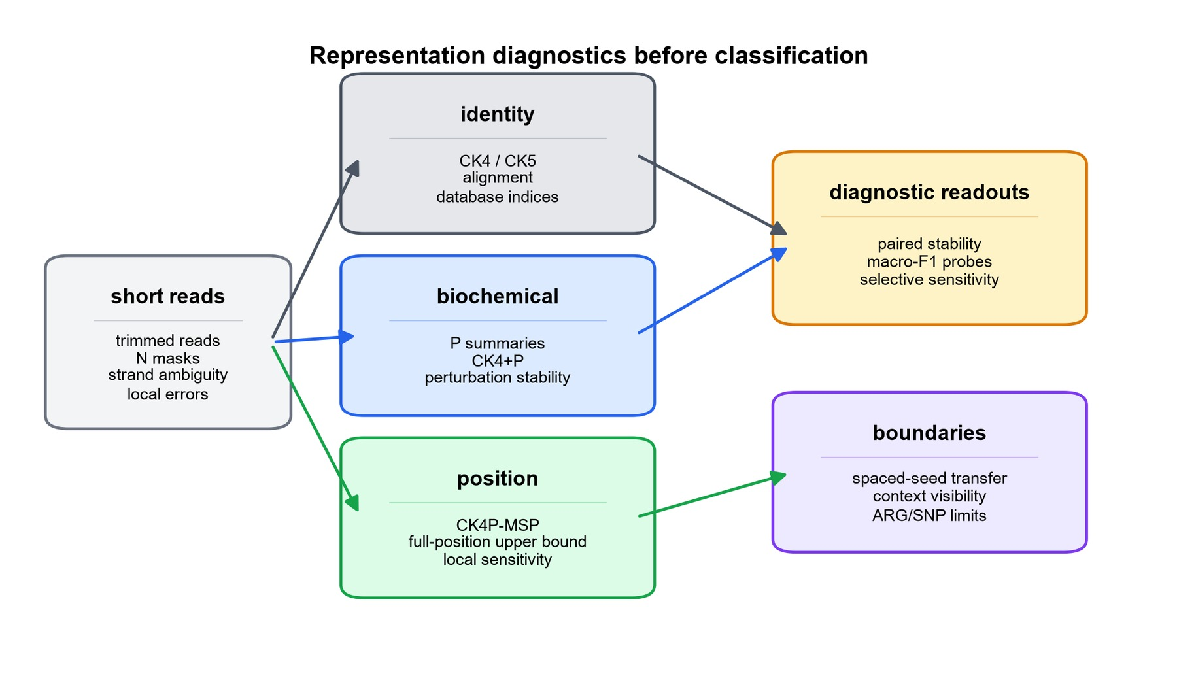

Representation families
The representation families were defined to separate identity, global biochemical summaries and coarse positional information. CK4 and CK5 count reverse-complement canonical contiguous k-mers. P summarizes hydrogen-bond class, GC content, purine content, EIIP-like values, N fraction, entropy and length-related properties at the read level. MSP applies the same property family over relative-position bins; its purpose is not to create a larger sequence vocabulary, but to return low-dimensional positional information to an otherwise order-poor k-mer frequency vector. CK4+P concatenates canonical 4-mer identity with global property summaries, CK4+MSP tests positionalized property pooling without the global P block, and CK4P-MSP combines all three blocks. Full-position identity or property matrices retain per-position information and were used only to estimate an upper bound on positional readability. CSP combines spaced-seed counts with property summaries and was used to test whether matching-oriented spaced-seed priors transfer into dense representation diagnostics.
For mixed representations, each block was computed separately and internally L2-normalized before weighted assembly. For read s_i, let K_i, P_i and M_i denote the reverse-complement canonical 4-mer identity block, the global biochemical-property block, and the multi-scale positional-property block, respectively. The internally normalized blocks were defined as
K̂ᵢ = Kᵢ / ‖Kᵢ‖₂, P̂ᵢ = Pᵢ / ‖Pᵢ‖₂, M̂ᵢ = Mᵢ / ‖Mᵢ‖₂
with zero-norm safeguards applied before normalization. The assembled compact representation was then
xᵢ = [αK̂ᵢ ; βP̂ᵢ ; γM̂ᵢ] / √(α² + β² + γ²)
where α, β and γ are block weights and [· ; ·] denotes concatenation. Because the block norms are fixed before concatenation, the denominator is a fixed scalar for a given weight setting rather than a read-specific global norm. The reported global drift metric was
d(i,j) = ‖xᵢ − xⱼ‖₂
which should be interpreted as a standardized diagnostic drift in the assembled feature space, not as a natural physical distance between commensurate biological units. This definition also gives the block-normalized distance identity
d²mix(i,j) = [α²‖K̂ᵢ − K̂ⱼ‖₂² + β²‖P̂ᵢ − P̂ⱼ‖₂²
+ γ²‖M̂ᵢ − M̂ⱼ‖₂²] / (α² + β² + γ²)
For comparison with the identity-only drift d_K(i,j)=||K_i-K_j||_2, the mixed squared drift is lower than d_K^2 when
β²(d²P − d²K) + γ²(d²M − d²K) < 0
where d_P and d_M are the corresponding blockwise drifts. Thus, lower property and MSP drift than identity drift is a sufficient, but not necessary, condition for a lower mixed drift. This explicit block construction allowed us to test whether the observed gains persisted when identity and property weights were changed. The design therefore does not assume that concatenation is intrinsically useful; it treats concatenation as a hypothesis that must survive same-dimension baselines, dimension-matched high-k compressed baselines, block-weight audits, blockwise drift decomposition and P/MSP counterfactual controls.
Table 1. Representation families and diagnostic roles.
family | information channel | main role | main-text interpretation
CK4 / CK5 | exact local identity | identity backbone and comparator | necessary for taxonomic, allele and SNP-level evidence
P | biochemical summaries | perturbation-stable side channel | adds robustness information but does not replace identity
CK4+P | identity plus global biochemical signal | global property baseline | tests whether biochemical summaries add to CK4
CK4+MSP | identity plus positionalized biochemical signal | positional property ablation | tests whether MSP returns coarse layout information without global P
CK4P-MSP | identity plus multi-scale biochemical layout | compact main representation | balances stability, readability and feature dimension
full-position matrix | per-position identity or property signal | upper-bound diagnostic | tests fine positional information at higher dimensional cost
CSP | spaced-seed prior plus biochemical summary | spaced-seed transfer comparator | delimits where matching-oriented spaced seeds transfer to dense features

Data layers and perturbation design
The experiments were organized into seven data layers, with the scale of each layer reported in Table 2. The WGS perturbation layer contained 25,200 rows from 3,600 clean templates across six genera, 21 species and six read lengths. The position-property ablation layer expanded this to 36,000 rows over the same template set and length grid. ART Illumina-like simulation contributed 75,592 paired rows from 37,796 templates across 69-150 bp reads. CAMI_TOY_low probes used a 104,166-row initial labelled subset and a 216,000-row expanded subset with 30 labels at 69, 75 and 100 bp. The local mutation layer used 250 triplets per analysis cell across 12 representations, four local modes and three read lengths. WGS-derived paired perturbations measured clean-versus-perturbed stability. ART Illumina-like simulation tested whether the same trends persisted under simulator-derived sequencing errors. A quality-stratified ART audit further split simulator outputs by read-quality strata, providing an error-aware check without claiming to model all clinical error processes. CAMI_TOY_low probes tested external metagenomic readability. Controlled position and order tasks tested whether positional information was recoverable. Local mutation sensitivity compared structured local changes with matched nuisance perturbation. Boundary probes tested spaced-seed transfer, context visibility and ARG/SNP limits.
For CAMI_TOY_low, labels were normalized to a species-level view when available, and genus-level and target-versus-background probes were derived from the same normalized label field. Background or unclassified reads were retained only for probes that explicitly required a target/background split, whereas the labelled subsets were used for lightweight external readout at 30 labels across 69, 75 and 100 bp. The initial labelled subset supported the first external probe, and the expanded subset was used when the probe required broader label coverage. This lightweight CAMI use was intended to test whether representation-level readability survives an external metagenomic probe, not to approximate production-scale community profiling.
This layered simulation design was used because each component isolates a different failure mode. The controlled WGS grid makes perturbation type, read length and representation family directly comparable. ART adds a recognized Illumina-like simulator layer, but it is retained as a consistency check rather than treated as ground-truth clinical sequencing physics. The quality-stratified ART audit adds a more explicit error-aware view of the same simulator-derived layer. It supports statements about robustness across quality strata, but it does not by itself establish clinical validation.
Table 2. Data layers, diagnostic questions, metrics and claim boundaries.
data layer | scale | diagnostic question | primary metrics | claim boundary
WGS perturbation pairs | 25,200 rows; 3,600 clean templates; 6 genera/21 species; lengths 69,75,100,125,150,300 bp | Which representations keep clean and perturbed reads close? | paired cosine, L2 drift, retrieval | controlled representation stability, not clinical validation
Position-property ablation | 36,000 rows; 3,600 templates; 6 genera/21 species; lengths 69,75,100,125,150,300 bp | What do P and MSP add to the CK4 identity backbone? | paired stability, block drift, delta-readout, MI proxies | decomposable representation audit, not a natural physical metric
ART Illumina-like simulation | 75,592 paired rows; 37,796 templates; 6 genera/21 species; lengths 69,75,100,125,150 bp | Do stability trends persist under simulator-derived read errors? | paired cosine, L2 drift, retrieval | platform-like consistency check
CAMI_TOY_low probes | 104,166-row initial subset and 216,000-row expanded subset; 30 labels; lengths 69,75,100 bp | Is information readable in an external metagenomic readout? | macro-F1, accuracy | lightweight readout, not clinical classification
controlled position tasks | controlled synthetic tasks over the short-read length grid | What does fine positional resolution add? | macro-F1, feature dimension | upper-bound diagnostic
local mutation sensitivity | 250 triplets per analysis cell; 12 representations; 4 local modes; lengths 69,100,150 bp | Can local biochemical change be detected beyond equal-count noise? | sensitivity ratio, delta-readout macro-F1 | selective sensitivity, not functional effect prediction
boundary probes | spaced-seed, context-visibility and ARG/SNP boundary screens | Where do spaced-seed, context and ARG/SNP claims stop? | seed stability, visibility threshold, macro-F1 | mechanism boundary and failure modes

Metrics and statistical analysis
Perturbation stability was quantified by paired cosine similarity, paired L2 drift and nearest-clean retrieval. Readout was quantified by macro-F1 and accuracy from shallow probes, mainly logistic regression and nearest-centroid classification. Compactness was measured by feature dimension. Local mutation analysis used selective-sensitivity ratios and delta-readout to distinguish nuisance stability from sensitivity to structured local change. Bootstrap intervals summarized cell-level variation. Paired Wilcoxon tests with Benjamini-Hochberg correction were used for matched stability comparisons. Same-dimension PCA/SVD controls addressed dimensionality effects, and block-weight audits tested whether mixed-feature conclusions were stable under reasonable reweighting of identity and property blocks.
The mixed-feature question was also tested through empirical information and counterfactual audits. For a perturbation label Y and representation-derived distance or readout features X, we estimated discretized pooled and conditional MI proxies using equal-frequency binning. The main pooled distance audits used eight bins, joint P/MSP summaries used five- or six-bin discretizations depending on the audit, and empirical permutation baselines used 200 shuffles per cell. These values are reported as estimator-dependent descriptive proxies rather than absolute physical information quantities. To test estimator sensitivity, we also ran a Ross/KSG-style k-nearest-neighbor MI robustness audit for continuous distance summaries and a discrete local-versus-noise perturbation label. This audit used k=5, 50 label permutations, 50 stratified subsampling repetitions and low-dimensional summaries including d_K, d_P, d_M, d_K+d_P, d_K+d_M, and d_K+d_P+d_M across the 69, 100 and 150 bp local-mutation cells. To separate the global and positional property layers, we additionally evaluated CK4, CK4+P, CK4+MSP and CK4P-MSP under the same block-normalized assembly rule. This direct contribution audit measured paired stability and local delta-readout, and was paired with a redundancy audit based on rank, canonical-correlation analysis and row-wise P/MSP alignment. To test whether the P/MSP contribution was more than additional dimensions, we also constructed CK4 plus permuted P/MSP blocks and CK4 plus Gaussian P/MSP blocks. These controls preserve a larger feature space but remove the sequence-linked biochemical mapping. The analysis was used as empirical support for perturbation-relevant information in the added property layers. It was not treated as a dataset-independent proof that I([CK4, P];Y) is always greater than I(CK4;Y) or that P and MSP are mathematically orthogonal.
We added a dimension-matched high-k compression audit to avoid comparing CK4P-MSP only with short contiguous k-mer baselines. Canonical k=15 signals were compressed to approximately the 222-feature CK4P-MSP budget using three controls: MinHash-style signatures, hashing-trick counts and sparse random projection. These baselines were evaluated on the same 69, 75, 100 and 150 bp perturbation grid using paired cosine similarity, L2 drift, nearest-clean retrieval and shallow readout. This audit tests whether the stability of CK4P-MSP persists against high-specificity k-mer information under a comparable compactness constraint. Finally, a feature-extraction runtime audit compared CK4P-MSP with CK4, CK4+P and dimension-matched high-k compressed controls. Runtime was treated as an engineering boundary, not as a primary performance claim.

Reproducibility
All generated results used local scripts and result tables stored under the project workspace. Main figure assets are in info/paper/figures, table assets are in info/paper/tables, the baseline supplementary figures are generated by info/scripts/generate_paper_supplementary_figures.py, the kNN MI robustness audit by info/scripts/run_knn_mi_robustness_audit.py, the high-k compressed baseline audit by info/scripts/run_high_k_compressed_baselines.py, the P/MSP contribution audit by info/scripts/run_p_msp_contribution_audit.py, the P/MSP redundancy and runtime audit by info/scripts/run_property_redundancy_and_runtime_audit.py, and the P-channel counterfactual audit by info/scripts/run_p_channel_counterfactual_audit.py. The manuscript should not be read as using restricted hospital reads, as claiming clinical validation, or as proposing a replacement for exact matching systems. Its supported scope is narrower: compact biochemical and position-aware summaries can serve as auxiliary diagnostic channels for representation-level robustness auditing in controlled short-read settings.

Results

Mixed-feature information gain under local perturbation
We first tested whether the added biochemical channel carried perturbation-relevant information rather than simply changing the scale of a mixed feature space. In the local-mutation audit, the equal-frequency MI proxy gave a higher pooled value for joint CK4+P/MSP distances than for CK4 distance alone, and the conditional proxy remained positive after conditioning on CK4 distance. Because discretized MI estimates are estimator-dependent, we treated this result as a descriptive screen and repeated the analysis with a k-nearest-neighbor MI robustness audit on low-dimensional distance summaries. Across the 12 local-mutation cells, the kNN audit estimated higher MI for the joint d_K+d_P+d_M summaries than for d_K alone, with a mean incremental estimate of approximately 0.138 bits beyond d_K and permutation support across the tested cells. This result does not establish a universal information-theoretic theorem, but it supports the narrower conclusion that, on the tested perturbation grid and estimators, P/MSP distances carried empirical perturbation information beyond a pure identity-only distance.
This audit is important for the interpretation of CK4P-MSP. A lower standardized drift could otherwise be attributed to dimensional dilution by low-variance auxiliary features. The MI robustness checks support a more specific conclusion: the property and MSP channels contributed perturbation-relevant empirical information under the tested local-change regime, while the block-weight audit separately checked that the conclusion was not tied to one arbitrary block scaling. The claim is therefore geometric and empirical, not a statement that heterogeneous L2 coordinates have identical physical units.
Supplementary Figure S2. Empirical MI and conditional-MI audit.
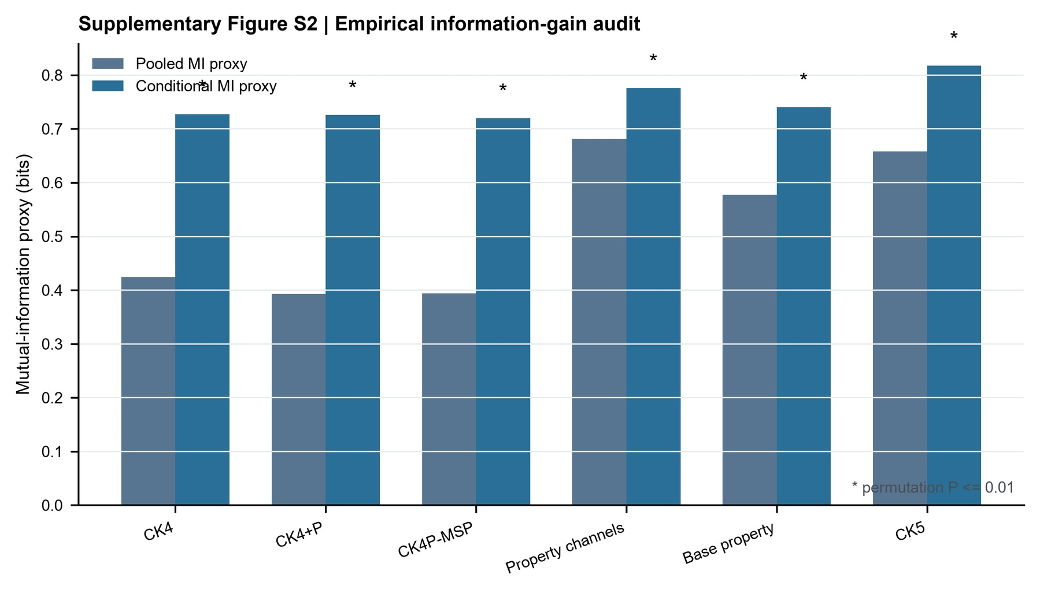

Supplementary Figure S7. kNN MI robustness and dimension-matched high-k compressed baseline audit.
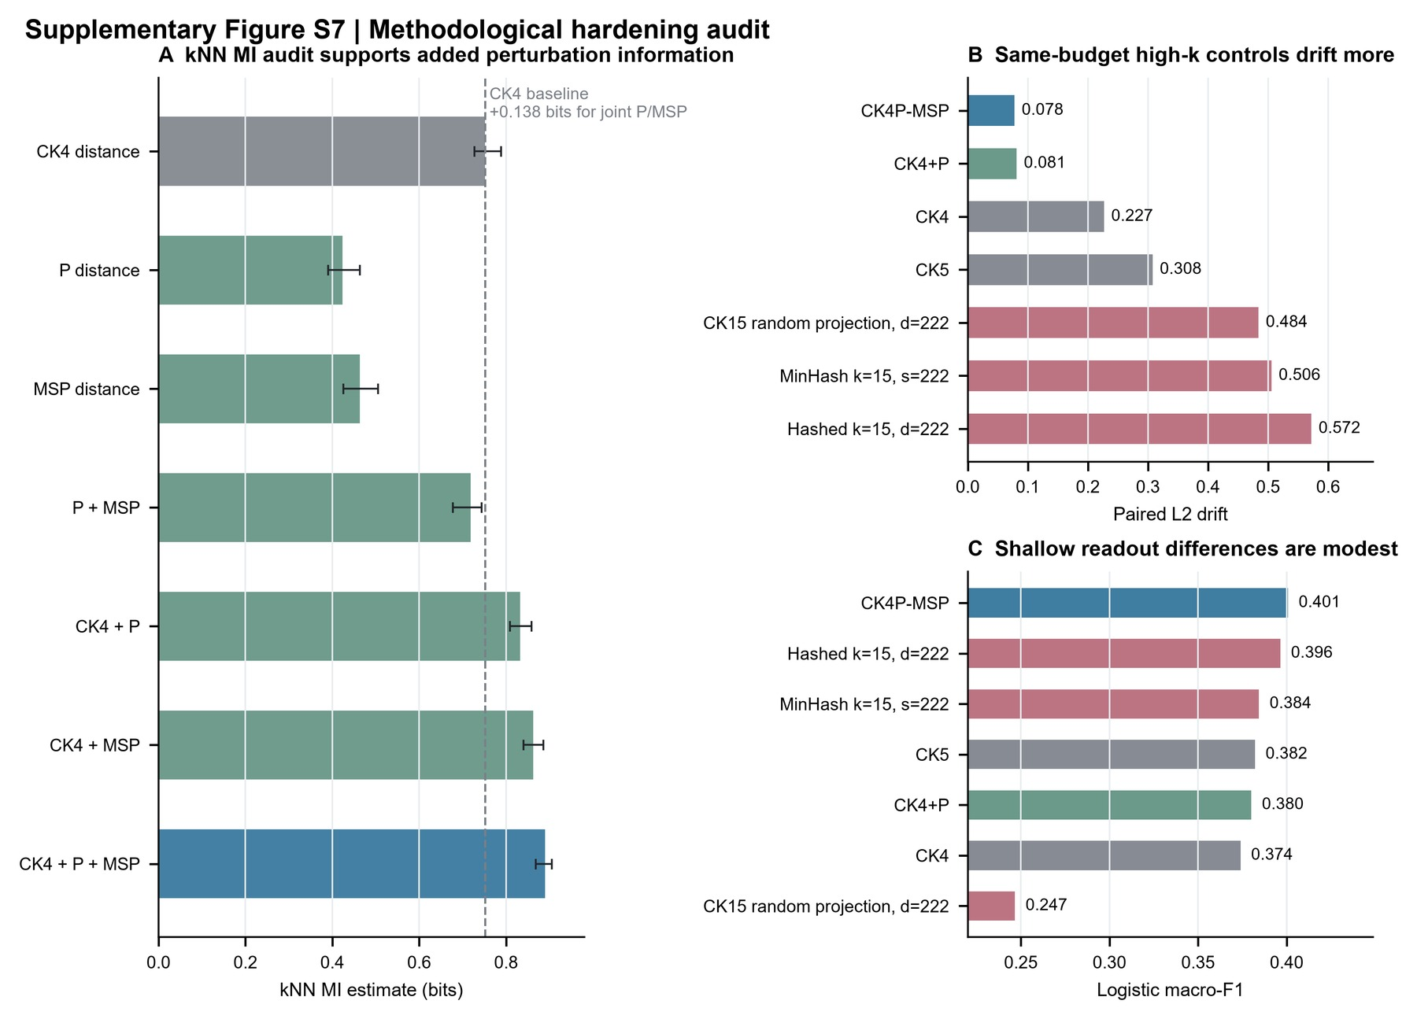

Supplementary Figure S5. P-channel counterfactual and short-bin reliability audit.
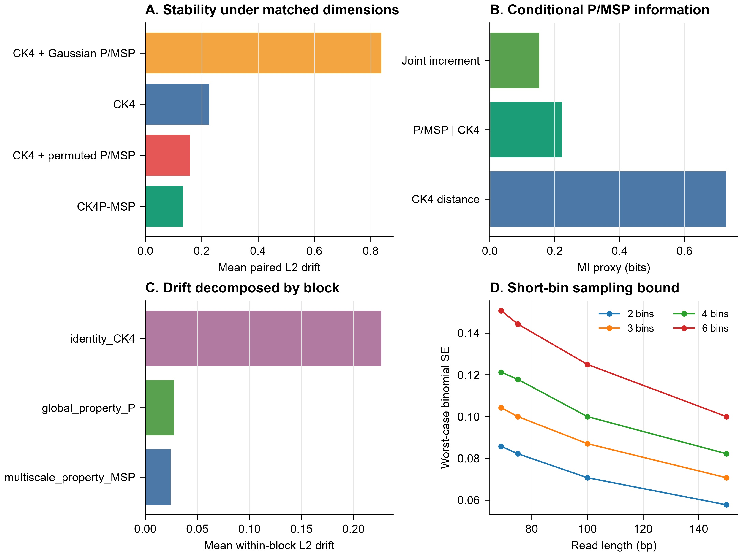

Global and positional property layers have related but distinct roles
We then separated the two property layers directly. In a matched contribution audit over 69, 75, 100 and 150 bp reads, CK4 alone had a mean paired L2 drift of 0.254. Adding either global P or MSP reduced this drift to 0.182 and 0.181, respectively, and CK4P-MSP reduced it further to 0.150. Thus, both property layers contributed to nuisance-perturbation stability under the block-normalized metric.
The local delta-readout pattern was more specific. CK4 and CK4+P achieved mean macro-F1 values of 0.888 and 0.894 for distinguishing structured local change from matched nuisance perturbation, whereas CK4+MSP reached 0.976 and CK4P-MSP reached 0.977. This indicates that the positionalized property layer, rather than the global P block alone, carried most of the coarse positional readout gain. This supports the intended design: P provides a global biochemical stability summary, whereas MSP uses the same property family to return low-dimensional positional information to a compact identity-frequency backbone.
The redundancy audit also cautions against overinterpreting P and MSP as orthogonal. Across the tested lengths, the first canonical correlation between P and MSP was near one and their first principal components were strongly aligned, as expected because both blocks are derived from the same biochemical property family. However, MSP had higher numerical rank than P, and row-wise P/MSP alignment after compression was incomplete. We therefore interpret the blocks as related layers at different scales, not as interchangeable evidence sources or as independent physical axes.
Supplementary Figure S8. P/MSP contribution, redundancy and runtime audit.
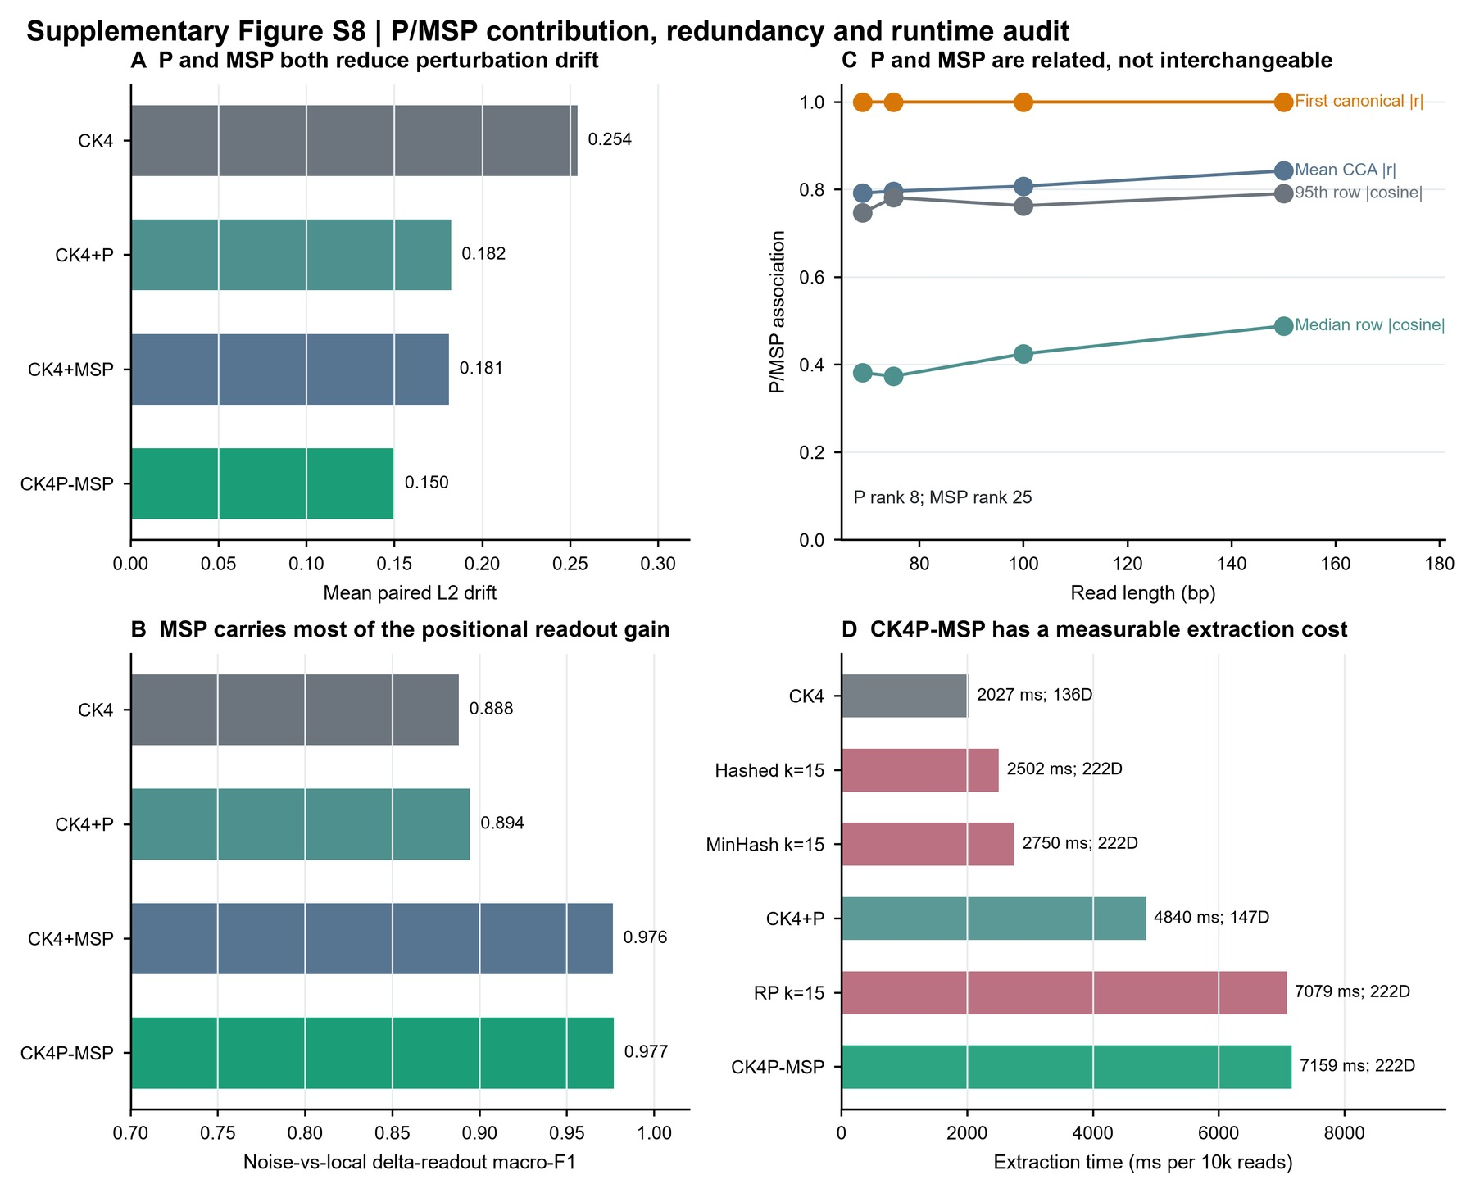

Supplementary Figure S9. P/MSP relation audit.
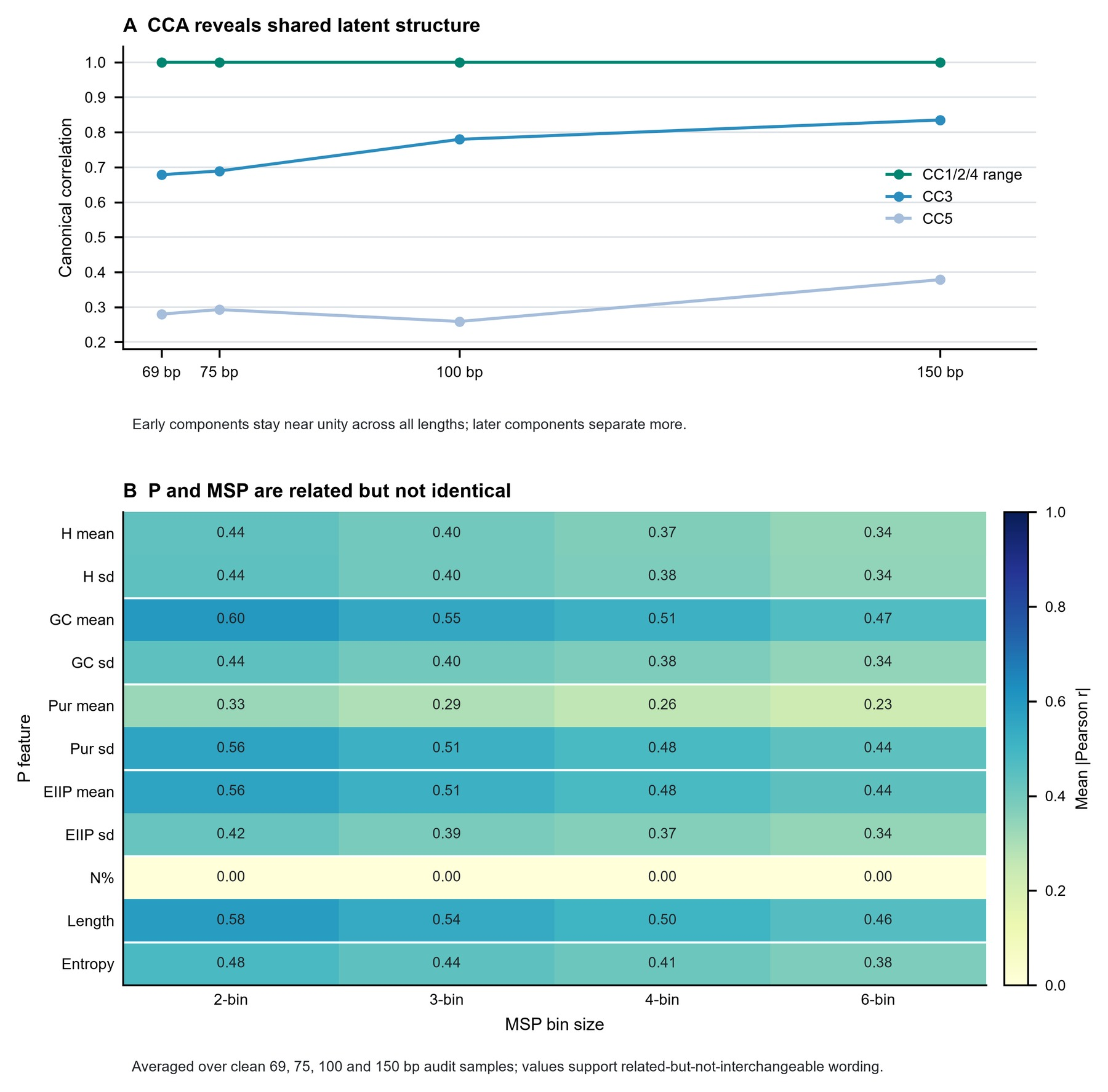

MSP short-bin reliability remains usable at 69-75 bp
We next tested whether MSP becomes noise-dominated when ultra-short reads are divided into finer relative-position bins. The short-bin audit did not show a catastrophic collapse at 69 or 75 bp. In the stability screen, moving from a 2-bin MSP to the full 2+3+4+6-bin MSP changed paired cosine and L2 drift only slightly at the default γ=1 setting: at 69 bp, paired cosine remained approximately 0.986 and L2 drift remained near 0.147; at 75 bp, paired cosine remained approximately 0.987 and L2 drift remained near 0.141. Retrieval also remained effectively saturated.
The local delta-readout audit showed the opposite of an immediate short-bin failure. Finer multi-scale pooling improved mutation readout at fixed gamma. At 69 bp and γ=1, mean macro-F1 increased from approximately 0.865 with 2 bins to approximately 0.899 with 2+3 bins, 0.946 with 2+3+4 bins and 0.953 with 2+3+4+6 bins. The same monotonic pattern persisted at 100 and 150 bp. Bootstrap widths for pooled property features remained small, whereas worst-case binomial sampling error increased as expected when bins narrowed. The combined interpretation is therefore restrained but favorable: static MSP is not catastrophically noise-dominated in the tested ultra-short-read regime, yet it should still be interpreted as a coarse positional summary rather than as an optimized variance-aware weighting model.
Supplementary Figure S6. MSP binset and gamma-sensitivity audit.
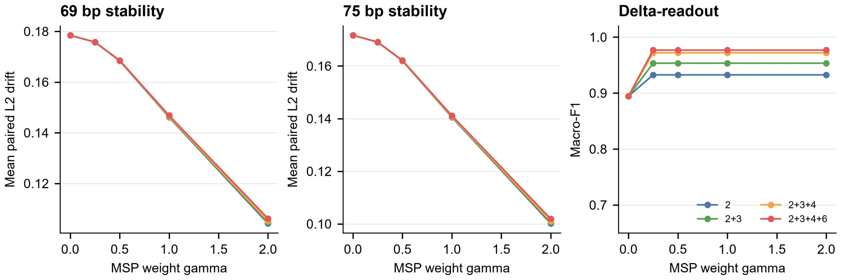

Error-aware ART perturbation audit
We next asked whether the external simulator evidence depended on treating ART as one pooled error source. In the quality-stratified ART audit, representative compact controls remained readable across low-, mid- and high-quality bins. The property-aware compact representation preserved high paired cosine and bounded L2 drift across quality strata, and the hybrid identity/spaced representation retained retrieval and readout consistency.
These results strengthen, but do not overstate, the ART evidence. They show that the main pattern is not restricted to an undifferentiated simulator summary. They do not claim that ART quality strata capture the full physical error distribution of a clinical sequencing run.
Supplementary Figure S3. Quality-stratified ART perturbation audit.
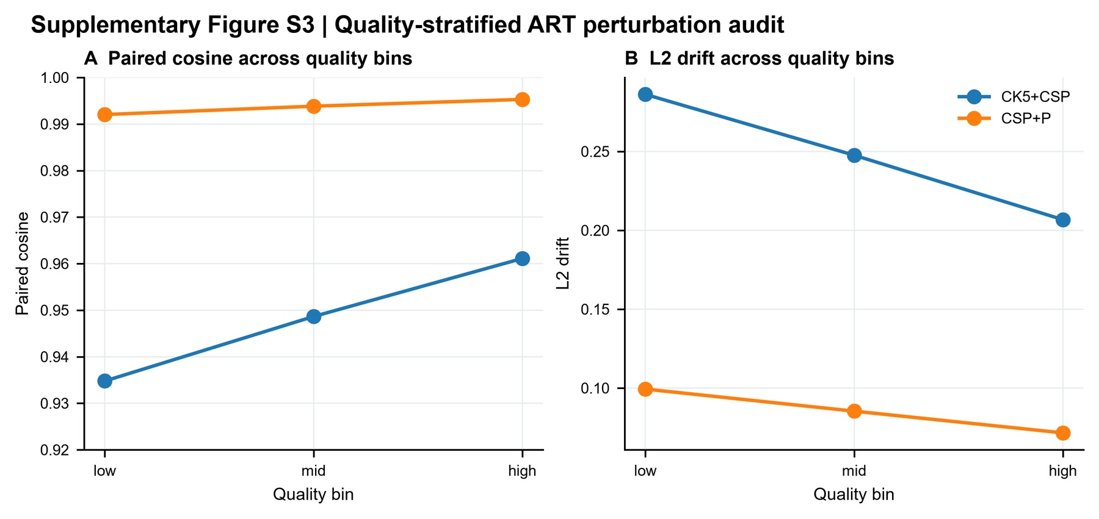

Compact biochemical summaries improve perturbation stability
The first main experimental block tested whether compact property-aware representations remained closer to their clean counterparts than identity-only baselines. Across the WGS-derived perturbation grid, CK4P-MSP and related property-aware compact representations retained high paired cosine and lower L2 drift while preserving nearest-clean retrieval. In the compact summary, CK4P-MSP achieved paired cosine around 0.991 with L2 drift around 0.116 at 222 features, whereas identity-only compact baselines showed higher drift under the same perturbation families.
The same conclusion survived several fairness checks. Same-dimension PCA/SVD controls showed that the mixed compact result was not simply a consequence of using more features. Dimension-matched high-k compression controls further addressed whether a conventional high-specificity k-mer representation could recover the same behavior under the CK4P-MSP feature budget. In that audit, CK4P-MSP retained higher paired cosine and lower L2 drift than k=15 random projection, MinHash and hashed baselines at approximately 222 features (paired cosine 0.996 and L2 drift 0.078 for CK4P-MSP, compared with paired cosine 0.848, 0.841 and 0.794 and L2 drift 0.484, 0.506 and 0.572 for the three compressed high-k controls). Shallow readout differences were modest (logistic macro-F1 0.401 for CK4P-MSP versus 0.396 for the hashed k=15 control), so this result supports a compact perturbation-stability advantage rather than an end-to-end classifier claim. Paired Wilcoxon tests over matched analysis cells supported the stability differences for key comparisons after multiple-testing correction. Block-weight audits showed that stability and readout conclusions did not depend on one fixed identity/property weighting. P/MSP counterfactual controls further separated dimensionality from sequence-linked biochemical information: CK4 plus permuted P/MSP approached the stability of CK4P-MSP but did not reproduce its local delta-readout (macro-F1 0.875 versus 0.977), while CK4 plus Gaussian P/MSP collapsed both stability and readout. The P/MSP contribution audit further showed that CK4+P and CK4+MSP both reduced drift relative to CK4, while MSP accounted for most of the positional delta-readout gain. Together, these controls show that the stability trend is not explained by feature count, a single weighting choice or random auxiliary columns.
Figure 2. Compact stability under controlled perturbation.
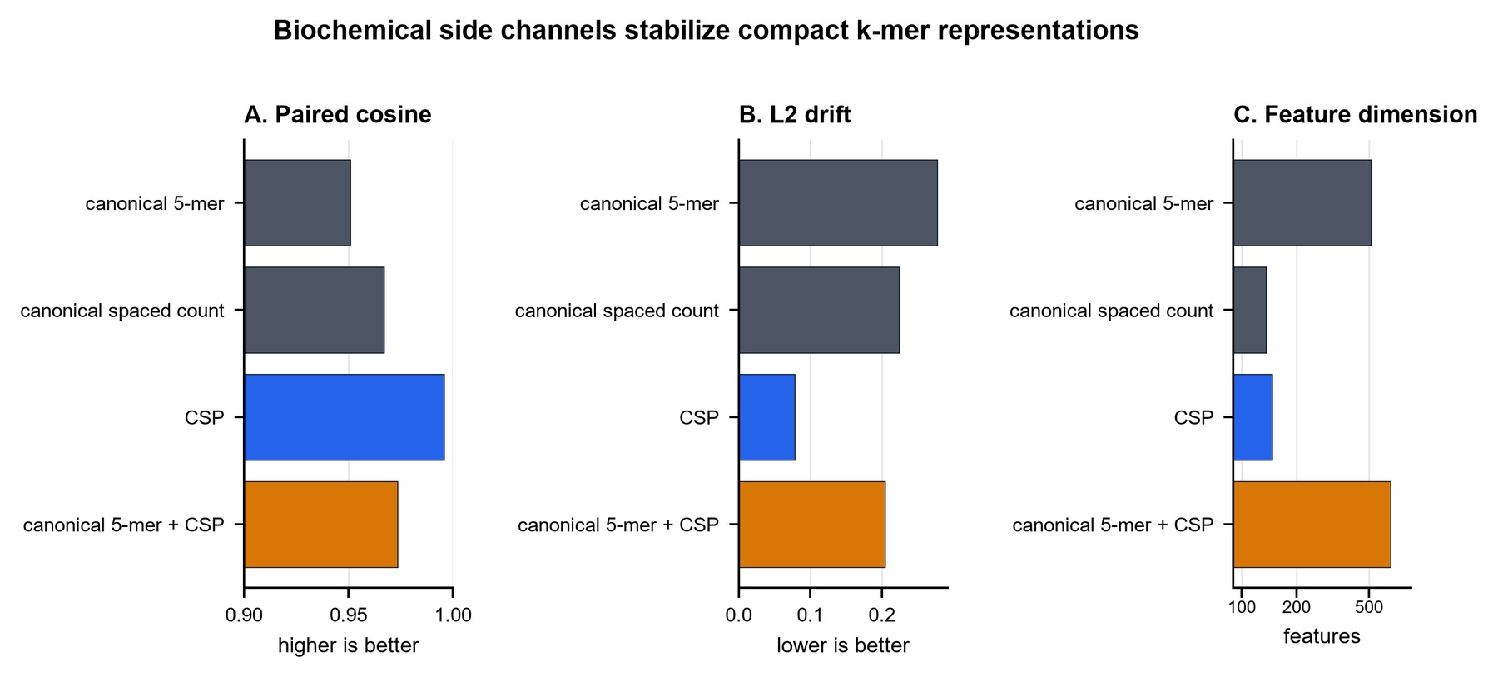

Supplementary Figure S1. Baseline and mixed-metric audit.
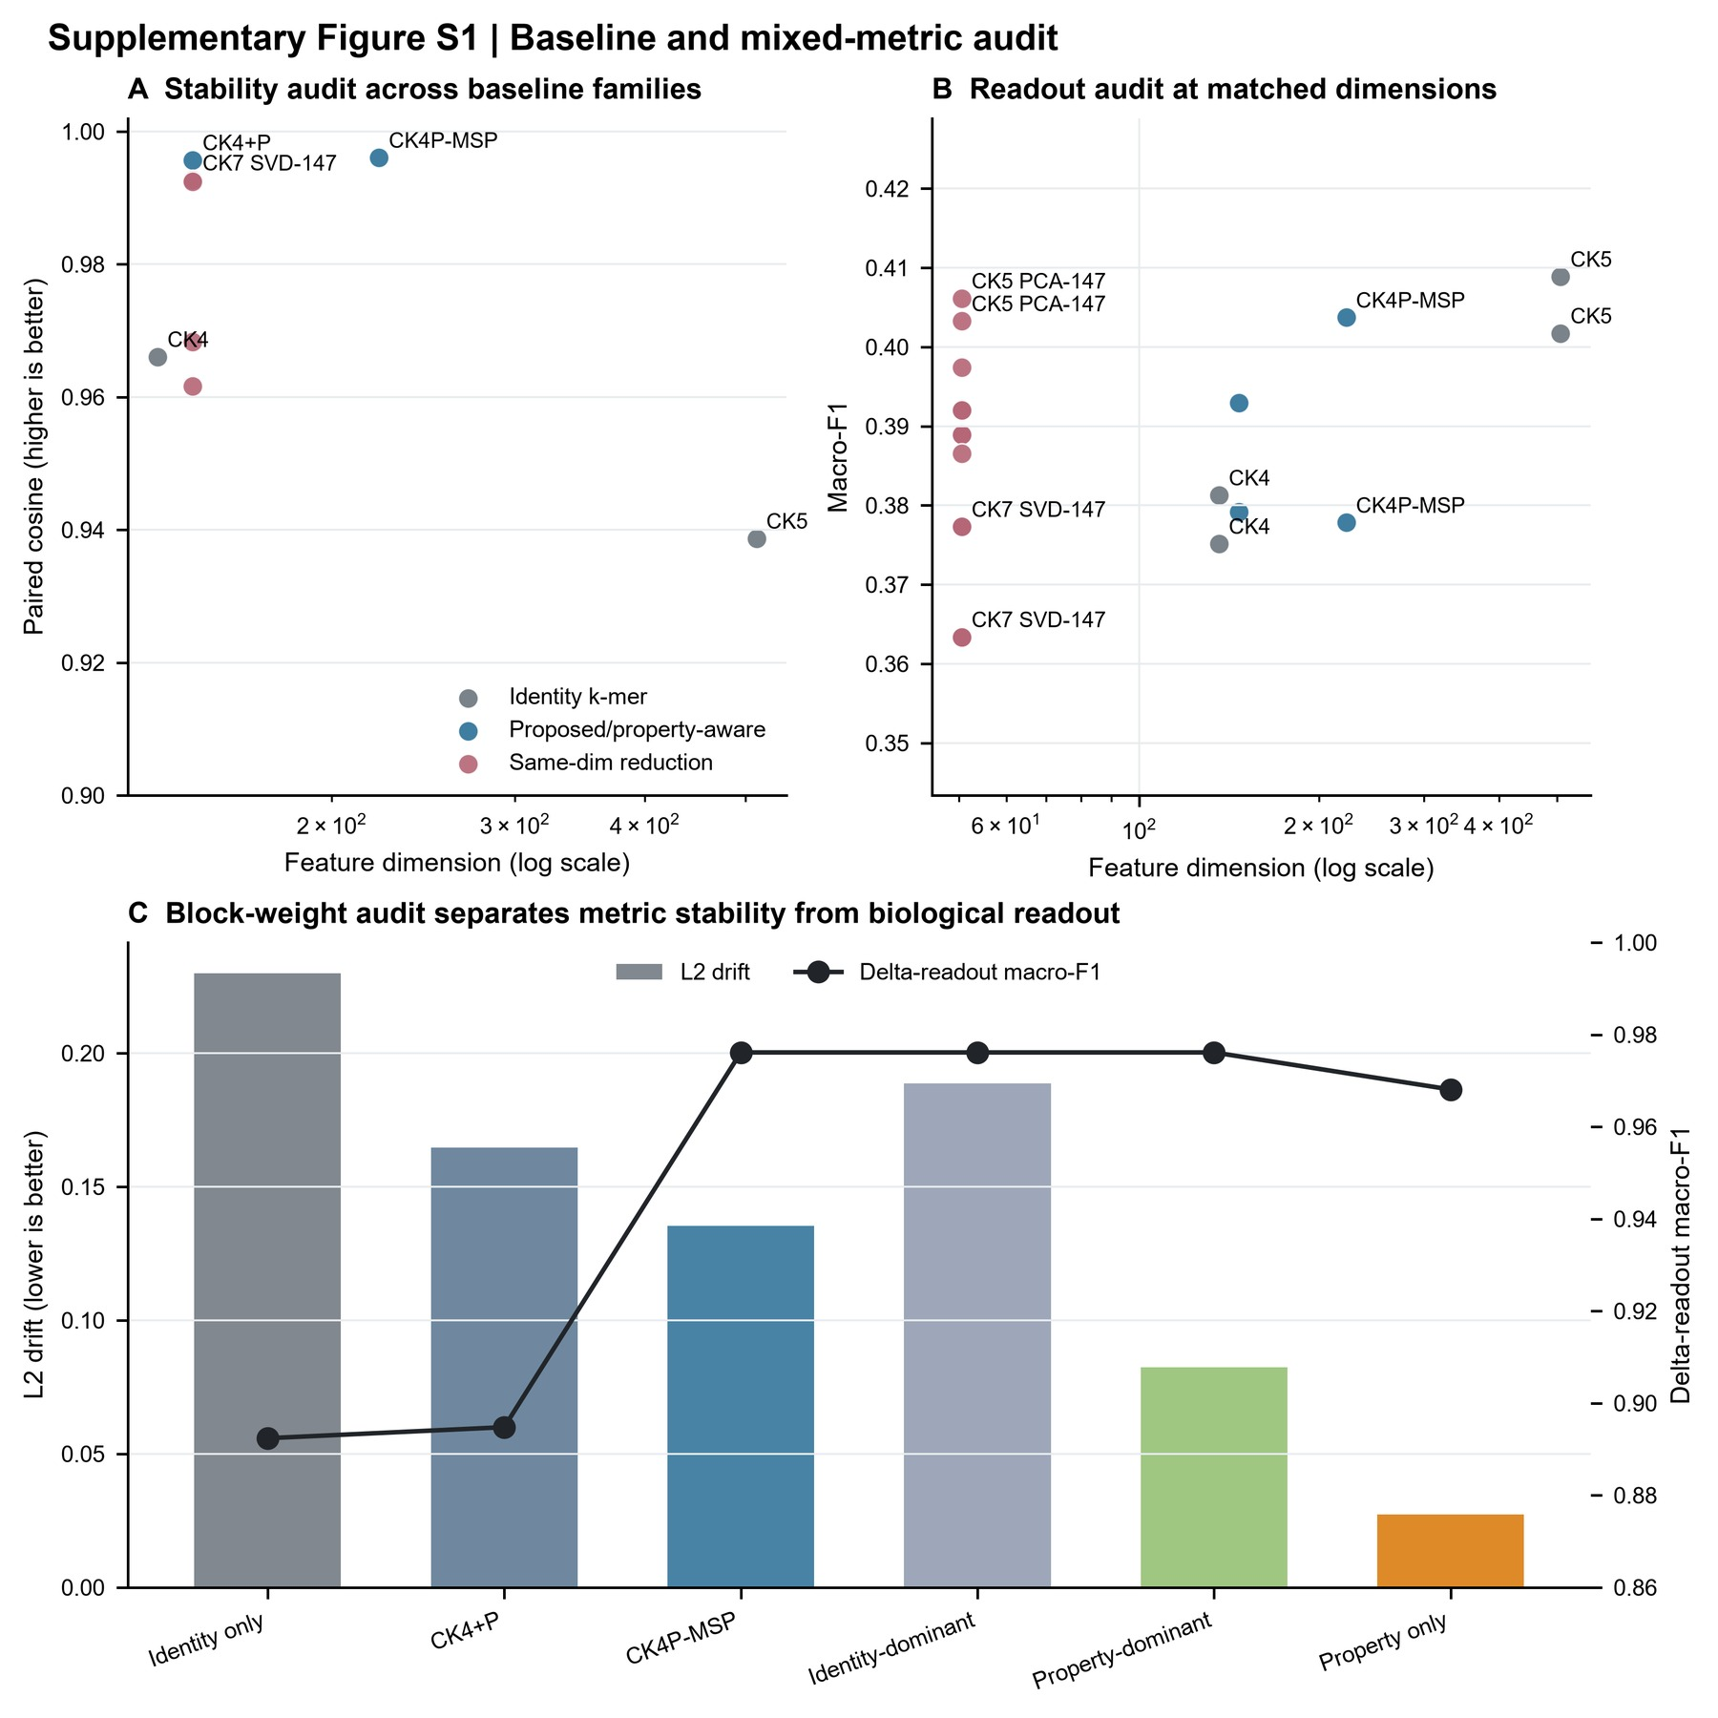

See Supplementary Figure S7.

CK4P-MSP balances compactness, stability and shallow readout
We then evaluated CK4P-MSP as a nested ablation rather than as a standalone classifier. CK4 tested compact identity alone. CK4+P tested whether global biochemical summaries were sufficient. CK4+MSP tested whether positionalized property pooling carried information beyond identity without the global P block. CK4P-MSP tested whether the global and positional property layers together improved the trade-off between stability, dimensionality and shallow readout. This hierarchy is central to the method: the representation is intended to preserve exact identity evidence while adding interpretable biochemical and positional auxiliary channels.
The resulting trade-off supported the intended role. CK4P-MSP remained compact, reduced perturbation drift relative to CK4 and CK5 identity baselines, and retained competitive macro-F1 in shallow readout. It was not designed as a standalone readout model, and the manuscript should not describe it as one. Its value is that it occupies a stable and interpretable middle ground between identity-only compact features and high-dimensional full-position matrices.
Figure 3. CK4P-MSP stability-readout-dimension trade-off.
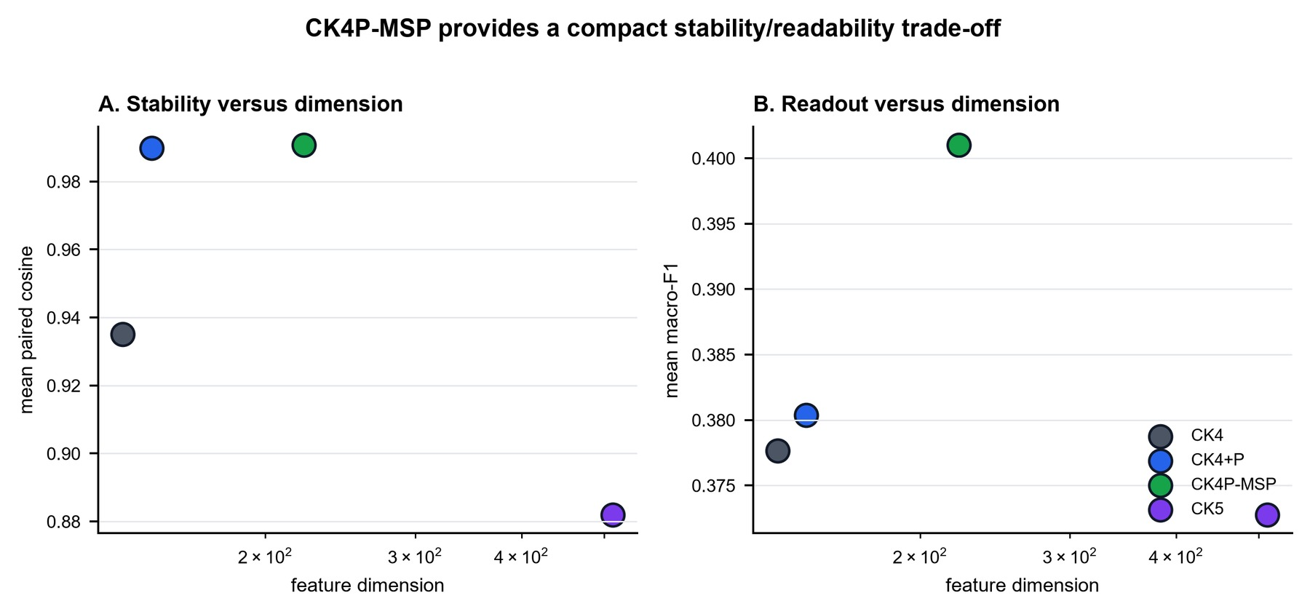

Table 3. Compact main-method metrics.
representation | paired cosine | L2 drift | readout macro-F1 | features
CK4 | 0.935 | 0.316 | 0.378 | 136
CK4+P | 0.990 | 0.122 | 0.380 | 147
CK4P-MSP | 0.991 | 0.116 | 0.401 | 222
CK5 | 0.882 | 0.433 | 0.373 | 512

External ART and CAMI probes support consistency beyond the controlled grid
ART and CAMI were used to test whether the representation trend survived outside the handcrafted perturbation grid. ART provided simulator-derived sequencing-error evidence, and CAMI_TOY_low provided an external metagenomic readout probe. In both settings, compact property-aware representations retained the broad separation between identity-only stability and property-aware stability. CAMI also showed that target/background information could remain readable even when label-probe performance was limited, reinforcing the distinction between representation readability and production-grade classification.
The quality-stratified ART audit complements this result by showing that simulator consistency persisted across read-quality bins. Together, these analyses support external consistency under controlled simulator and benchmark resources, while stopping short of any claim of clinical deployment performance.
Figure 4. External ART and CAMI consistency probes.
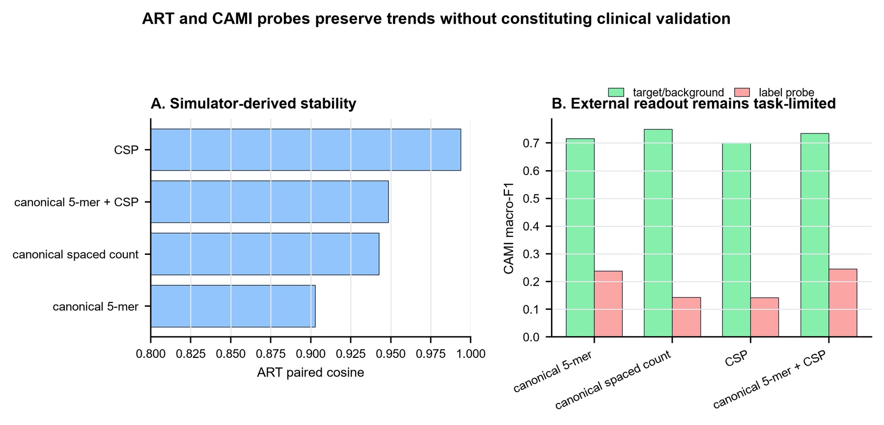

Full-position matrices define a positional upper bound rather than a deployment default
Full-position encodings were used to estimate what is gained when fine-grained layout information is retained. In controlled position and order tasks, full-position identity or property matrices improved positional readability compared with compact summaries. This was expected, because these matrices preserve per-position structure that compact summaries intentionally compress.
The result is best interpreted as an upper-bound diagnostic. Full-position matrices clarify the value of positional information, but their high dimensionality and task specificity make them unsuitable as the default representation for compact short-read auditing. CK4P-MSP therefore occupies a different role: it does not match the full positional upper bound, but it recovers part of the positional information at a much smaller feature cost.
Figure 5. Full-position diagnostic upper bound for positional information.
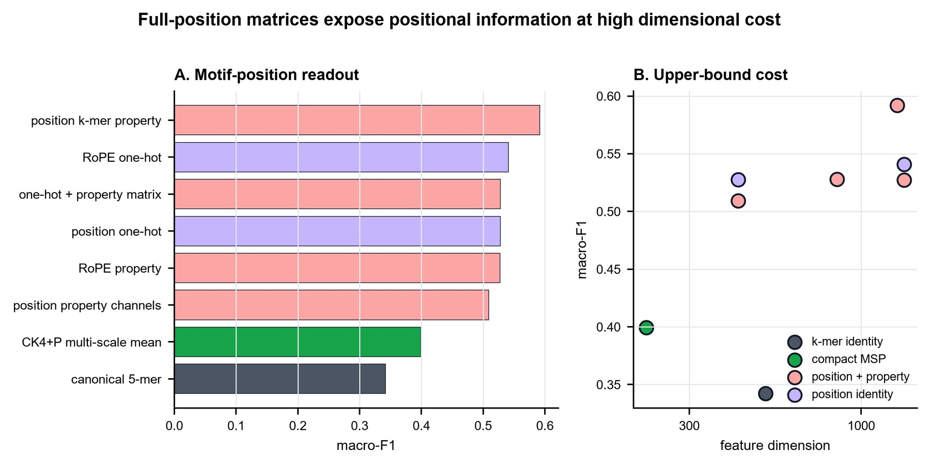

Local mutation analysis separates robustness from selective sensitivity
A robust representation should not be insensitive to all changes. We therefore tested whether local biochemical change remained distinguishable from matched nuisance perturbation. Property-aware and full-position channels showed larger response to structured local mutation than to matched noise in the relevant comparisons, while CK4P-MSP preserved delta-readout at compact dimensionality. The P/MSP counterfactual audit sharpened this result by showing that the real biochemical mapping, not only extra columns, was needed to obtain the strongest local-change readout.
This result supports a division of labor. Paired cosine and L2 drift quantify nuisance stability, whereas selective-sensitivity ratios and delta-readout quantify whether structured local changes remain readable. CK4P-MSP is therefore not merely a smoothed representation. It can remain stable under nuisance perturbation while preserving enough auxiliary information for local-change readout.
Figure 6. Local mutation sensitivity and delta-readout.
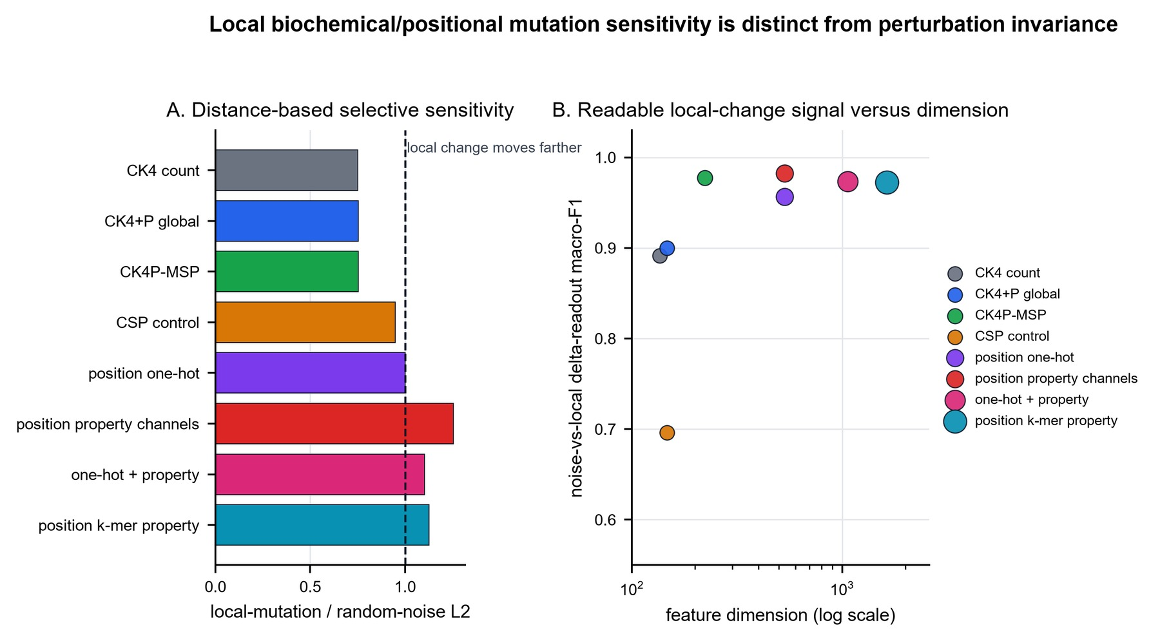

Table 4. Local mutation sensitivity metrics.
representation | noise L2 | local L2 | local - noise L2 | sensitivity ratio | delta-readout macro-F1 | features
CK4 | 0.355 | 0.266 | -0.089 | 0.750 | 0.891 | 136
CK4+P | 0.115 | 0.086 | -0.029 | 0.752 | 0.900 | 147
CK4P-MSP | 0.110 | 0.083 | -0.027 | 0.754 | 0.977 | 222
CSP | 0.116 | 0.109 | -0.006 | 0.947 | 0.696 | 147
one-hot | 0.239 | 0.239 | 0.000 | 1.000 | 0.956 | 500
P-channels | 0.086 | 0.107 | 0.020 | 1.255 | 0.983 | 500
one-hot+P | 0.188 | 0.207 | 0.019 | 1.101 | 0.973 | 1000
position k-mer P | 0.167 | 0.185 | 0.017 | 1.125 | 0.972 | 1536

Supplementary Figure S4. Local mutation-fraction sweep.
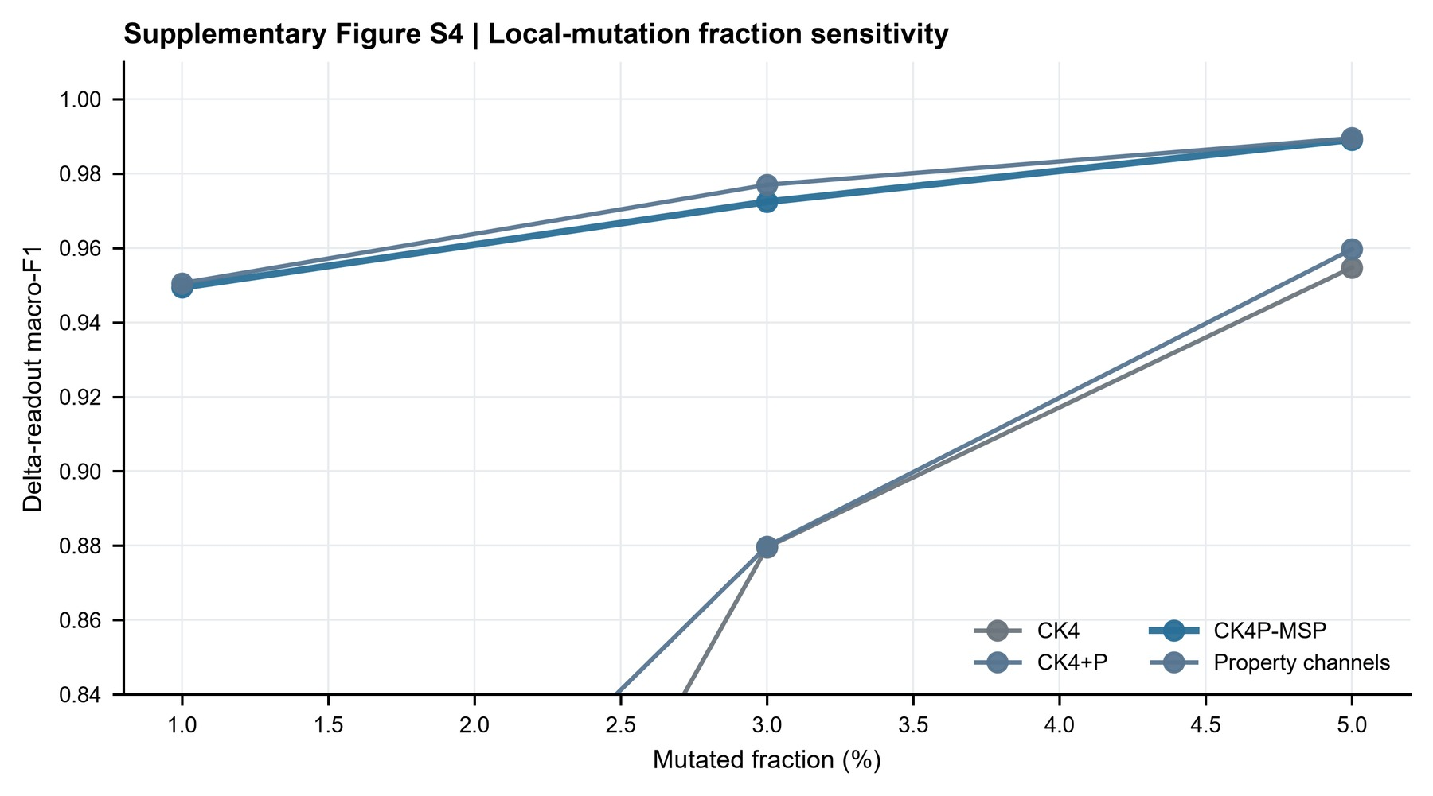

Boundary analyses constrain the interpretation
The boundary probes were included to prevent overextension of the representation claim. Spaced-seed transfer was useful as a mechanism comparator, but matching-oriented seed priors did not automatically become a universal dense-feature advantage. Context visibility depended on whether the relevant relation was present within the read. ARG/SNP interpretation required identity, annotation and allele-level evidence beyond what compact property summaries can provide.
These negative and boundary results are part of the manuscript's logic. They keep the claim focused on representation diagnostics and auxiliary robustness auditing, rather than allowing the compact feature space to be misread as a full biological interpretation system.
Table 5. Boundary and mechanism summary.
boundary | main observation | interpretation
spaced-seed transfer | The best tested 4-position dense stability pattern was contiguous 0-1-2-3 across the 69/75 bp sanity grid. | spaced seeds remain useful matching priors, but transfer is regime-specific
context visibility | motif-pair visibility thresholds depended on placement, emerging at 130, 140, 148 or 155 bp. | a representation cannot encode context absent from the read
ARG/SNP readout | stable compact features did not by themselves establish allele, resistance-SNP or functional equivalence. | identity/database evidence remains necessary for final biological calls

Discussion
This study treats short-read sequence representation as a diagnostic object rather than as a black-box prelude to classification. Across controlled short-read settings, exact identity evidence remained essential, but auxiliary biochemical and coarse positional summaries changed what could be measured under perturbation. CK4P-MSP was most informative in this role: it preserved a reverse-complement canonical 4-mer identity backbone while adding biochemical and multi-scale property pooling channels that improved perturbation stability and retained shallow readout at compact dimensionality.
The results support a division of labor between representation families. Exact k-mer features provide the identity backbone needed for database-linked interpretation. Global biochemical summaries provide an auxiliary stability channel that can remain informative when individual exact matches are weakened by trimming, ambiguity or local perturbation. Multi-scale positional property pooling uses the same biochemical property family to return coarse layout information to an otherwise order-poor k-mer frequency vector; it is not a larger k-mer vocabulary or a learned token mapping. Full-position matrices, by contrast, define what can be gained when positional information is preserved almost explicitly; they are useful diagnostic upper bounds but are not the preferred compact representation.
The additional analyses sharpen this interpretation. Same-dimension PCA/SVD controls show that the compact mixed representation is not simply benefiting from a larger feature budget. Dimension-matched high-k compressed baselines show that the stability result is not limited to comparisons with short contiguous k-mer counts: CK4P-MSP remained more stable than k=15 MinHash, hashed and random-projection controls at a comparable feature budget, although shallow readout differences were modest. Block-weight audits show that the conclusion is not tied to one arbitrary identity/property scaling. Paired Wilcoxon tests verify that the main stability contrasts are reproducible across matched analysis cells. The empirical MI and k-nearest-neighbor MI audits indicate that P/MSP distance summaries retain perturbation-relevant information beyond CK4 distance in the tested local-mutation regime. The direct P/MSP contribution audit showed that both CK4+P and CK4+MSP reduced drift relative to CK4, whereas MSP carried most of the local delta-readout gain. The redundancy audit further showed that P and MSP share a strong global property component but are not interchangeable: MSP has higher numerical rank and incomplete row-wise alignment with P. The P/MSP counterfactual audit separates sequence-linked biochemical information from feature-space expansion: permuted P/MSP blocks approach some stability behavior but do not reproduce the strongest delta-readout, whereas Gaussian auxiliary blocks fail both stability and readout. These analyses do not turn the result into a universal theorem, but they reduce the likelihood that the geometric pattern is explained only by mixed-space dilution, feature count, redundancy or a single weighting choice.
The perturbation analyses also clarify the scope of the evidence. Uniform substitutions and local mutation sweeps provide controlled tests of representation behavior. ART adds a simulator-derived Illumina-like layer, and the quality-stratified ART audit shows that the main pattern persists across read-quality strata. CAMI_TOY_low provides an external metagenomic readout probe. Together, these data form a consistent body of evidence for representation-level robustness and readability. The manuscript reports the scale of each data layer so that controlled grids, simulator checks and external probes are not conflated. These data do not constitute clinical validation, and they should not be described as such.
A useful outcome of the boundary analyses is that they prevent overgeneralization. CSP and spaced-seed controls help interpret which matching-oriented priors transfer into dense read-level representations, but they do not become universal replacements for compact identity-property features. Context and ARG/SNP probes show that compact stability is not the same as allele-level or functional interpretation. Those tasks require database identity, annotation, sufficient context and downstream biological evidence.

Limitations
The first limitation is that the study evaluates representation diagnostics, not an operational mNGS classifier. Kraken 2, Centrifuge, CLARK, Kaiju and related systems remain the appropriate reference frame for database-linked taxonomic assignment. The present work asks a different question: what information remains visible before or alongside such assignment systems. Direct integration with production classifiers, including downstream false-hit reduction or classifier-output auditing, remains future work and is not evaluated here.
The second limitation is the perturbation model. Controlled substitutions, ambiguous-base perturbations and local mutation sweeps are useful because they isolate representation behavior, but they do not reproduce every physical process in sequencing data. ART and the quality-stratified ART audit partly address this issue by adding simulator-derived and quality-aware evidence. However, the resulting conclusions remain bounded to controlled short-read and simulator-supported settings, not to unobserved clinical error distributions.
The third limitation concerns data provenance. The 69 and 75 bp settings were selected as ultra-short read lengths that fall within a commonly reported post-QC mNGS range, and the restricted clinical reads themselves were not used in this study or publicly shared. This is compliant with the manuscript's current claim because the experiments use only the length conditions, not patient-level reads or patient-derived labels. Before submission, the authors should still confirm the institutional wording for describing the data-governance boundary.
The fourth limitation is that the MI and conditional-MI analyses are empirical. They support additional perturbation information in the tested feature channels, especially after the k-nearest-neighbor robustness audit, but they are not a general proof that a property-augmented representation always has higher mutual information than an identity-only representation. Likewise, the mixed L2 distance should be read as a standardized diagnostic drift after block construction and normalization, not as a natural metric that equates biochemical properties and k-mer counts as identical physical units. The correct claim is therefore conditional: under the tested local-perturbation grid and estimators, property-aware distance summaries carried additional mutation-relevant information relative to identity-only and permutation controls.
The fifth limitation concerns MSP weighting and scale. The short-bin audit did not show catastrophic collapse at 69-75 bp, and finer multi-scale pooling improved delta-readout rather than immediately degrading it. Even so, the current MSP channel remains a static coarse summary. It is not an optimized variance-aware estimator, and the manuscript does not claim that its present binset or gamma weighting is universally optimal across read lengths, perturbation types or sequencing platforms.
The sixth limitation is computational scope. CK4P-MSP remained lightweight in absolute terms in the local implementation, but it was slower to extract than CK4 and simple high-k hashed or MinHash summaries. The method should therefore not be described as an engineering speed-up. Its value in this manuscript is interpretability and perturbation diagnostics under compact dimensionality; large-scale deployment would require optimized implementation and pipeline-level cost-benefit testing.
The seventh limitation is model scope. Large DNA language models and learned metagenomic classifiers provide powerful sequence representations, but they were not used as direct comparators here. This choice follows from the study's diagnostic goal. The paper evaluates decomposable identity, biochemical and positional channels under controlled short-read perturbation, whereas foundation-model embeddings are high-dimensional learned representations optimized for different transfer or prediction objectives. A direct comparison with such models would require a separate benchmark design.

Future work
Future work should test whether CK4P-MSP or related compact summaries improve failure-mode detection when placed alongside database-centered pipelines. Pipeline-facing false-hit reduction or classifier-output auditing would require downstream classifier outputs and explicit operating-point analysis. The most useful next step is not to replace exact matching, but to add representation-level diagnostics that report when identity evidence is fragile, when biochemical stability remains high, and when local-change sensitivity is preserved.
A second direction is to expand the perturbation model. Platform-specific error-transition matrices, explicit Q-score trajectories and larger simulator grids would make the error-aware analysis more realistic. The current controlled simulations are useful because they isolate representation behavior by read length, perturbation type and feature family; future work should test whether the same conclusions hold under richer platform-specific error processes. When ethically and legally feasible, restricted clinical read collections could then be used for external validation under controlled access, with public release limited to aggregate metadata and reproducible scripts.
A third direction is to make the positional channel more adaptive without changing the paper's current claim. Length-aware or variance-aware MSP weighting could be explored in future work, but such a step should be framed as a new model family rather than as a cosmetic parameter retune. The present results justify static MSP as a usable compact summary; they do not settle the separate optimization problem of how positional bins should be weighted under different noise and length conditions.
A fourth direction is to connect compact diagnostics with learned models. Full-position matrices and DNA foundation-model embeddings are natural candidates for follow-up studies because they may recover richer context than compact summaries. The present work suggests where such models should be audited: not only by final classification accuracy, but also by identity retention, perturbation stability, positional readability and local-change sensitivity.

Conclusion
This study shows that compact short-read representations can be evaluated as interpretable diagnostic objects. In controlled short-read settings, CK4P-MSP retained an exact identity backbone while adding global biochemical and positionalized biochemical channels that improved perturbation stability and preserved local-change readability. The evidence supports a bounded practical implication: biochemical and position-aware summaries may serve as auxiliary channels for representation-level robustness auditing alongside, rather than instead of, exact matching and curated database methods.

Data Availability
All processed data tables, figure source summaries and analysis outputs generated for this study are available in the project result folders and will be deposited in a public repository before submission. The current local source locations are info/results, info/paper/figures, info/paper/tables and info/scripts. The final public repository name, DOI/accession and licence are to be inserted before journal submission.
Publicly reused resources include simulator- and benchmark-derived materials used for ART and CAMI analyses, which should be cited through the corresponding primary publications and public resource records in the final reference list. The restricted clinical sequencing provenance was used only to motivate the 69 and 75 bp read-length conditions, and the underlying clinical sequencing reads were not used as experimental input, are not part of the study data package, and cannot be publicly shared because they derive from a restricted clinical sequencing context.

Code Availability
The analysis scripts used to generate tables, figures and reviewer-response audits are maintained under info/scripts and will be released with the processed data package before submission. Key audit scripts include run_knn_mi_robustness_audit.py, run_high_k_compressed_baselines.py, run_p_msp_contribution_audit.py, run_property_redundancy_and_runtime_audit.py, generate_supp_fig_s8_redundancy_runtime_audit.py, run_p_channel_counterfactual_audit.py and run_msp_bin_gamma_sensitivity_audit.py. The final repository URL, software licence and archived release identifier are to be inserted before journal submission.

Ethics and Data Governance
No patient-level clinical sequencing reads, patient identifiers or patient-derived labels were analyzed in this study. The authors should confirm the institutional wording for this boundary statement before submission.

Author Contributions
TBD before submission. Suggested CRediT-style roles to confirm: conceptualization; methodology; software; formal analysis; investigation; data curation; writing - original draft; writing - review and editing; visualization; supervision; funding acquisition.

Funding
TBD before submission. Insert grant numbers and funder names exactly as required by NAR/OUP.

Acknowledgements
TBD before submission. Include only contributors who meet acknowledgement criteria and do not meet authorship criteria.

Conflict of Interest
The authors should confirm the final statement before submission. If accurate, use: The authors declare no competing interests.

References
1. Wilson, Michael R.; Naccache, Samia N.; Samayoa, Erika; Biagtan, Mark; Bashir, Ali; Yu, Guixia; Salamat, S. M.; Somasekar, Sneha; Federman, Scot; Miller, Steve; Sokolic, Robert; Garabedian, Elitza; Candotti, Fabio; Buckley, Rebecca H.; Reed, Kurt D.; Meyer, Terry L.; Seroogy, Christine M.; Galloway, Renee; Henderson, Stuart L.; Gern, James E.; DeRisi, Joseph L.; Chiu, Charles Y. Actionable Diagnosis of Neuroleptospirosis by Next-Generation Sequencing. New England Journal of Medicine 2014;370:2408--2417. doi:10.1056/NEJMoa1401268
2. Wilson, Michael R.; Sample, Heather A.; Zorn, Kaitlyn C.; Arevalo, Samuel; Yu, Guixia; Neuhaus, John; Federman, Scot; Stryke, Deborah; Briggs, Brian; Langelier, Charles; Berger, Adam; Douglas, Victoria; Josephson, S. Andrew; Chow, Felicia C.; Fulton, Blair D.; DeRisi, Joseph L.; Gelfand, Jeffrey M.; Naccache, Samia N.; Bender, Jeffrey M.; Chiu, Charles Y. Clinical Metagenomic Sequencing for Diagnosis of Meningitis and Encephalitis. New England Journal of Medicine 2019;380:2327--2340. doi:10.1056/NEJMoa1803396
3. Chiu, Charles Y.; Miller, Steven A. Clinical Metagenomics. Nature Reviews Genetics 2019;20:341--355. doi:10.1038/s41576-019-0113-7
4. Martin, Marcel Cutadapt Removes Adapter Sequences from High-throughput Sequencing Reads. EMBnet.journal 2011;17:10--12. doi:10.14806/ej.17.1.200
5. Bolger, Anthony M.; Lohse, Marc; Usadel, Bjoern Trimmomatic: A Flexible Trimmer for Illumina Sequence Data. Bioinformatics 2014;30:2114--2120. doi:10.1093/bioinformatics/btu170
6. Salter, Susannah J.; Cox, Michael J.; Turek, Elina M.; Calus, Szymon T.; Cookson, William O.; Moffatt, Miriam F.; Turner, Paul; Parkhill, Julian; Loman, Nicholas J.; Walker, Alan W. Reagent and Laboratory Contamination Can Critically Impact Sequence-based Microbiome Analyses. BMC Biology 2014;12:87. doi:10.1186/s12915-014-0087-z
7. Wood, Derrick E.; Salzberg, Steven L. Kraken: Ultrafast Metagenomic Sequence Classification Using Exact Alignments. Genome Biology 2014;15:R46. doi:10.1186/gb-2014-15-3-r46
8. Wood, Derrick E.; Lu, Jennifer; Langmead, Ben Improved Metagenomic Analysis with Kraken 2. Genome Biology 2019;20:257. doi:10.1186/s13059-019-1891-0
9. Ounit, Rachid; Wanamaker, Steve; Close, Timothy J.; Lonardi, Stefano CLARK: Fast and Accurate Classification of Metagenomic and Genomic Sequences Using Discriminative k-mers. BMC Genomics 2015;16:236. doi:10.1186/s12864-015-1419-2
10. Kim, Daehwan; Song, Li; Breitwieser, Florian P.; Salzberg, Steven L. Centrifuge: Rapid and Sensitive Classification of Metagenomic Sequences. Genome Research 2016;26:1721--1729. doi:10.1101/gr.210641.116
11. Menzel, Peter; Ng, Kim Lee; Krogh, Anders Fast and Sensitive Taxonomic Classification for Metagenomics with Kaiju. Nature Communications 2016;7:11257. doi:10.1038/ncomms11257
12. Sczyrba, Alexander; Hofmann, Peter; Belmann, Peter; Koslicki, David; Janssen, Stefan; Droege, Johannes; Gregor, Ivan; Majda, Stephan; Fiedler, Jessika; Dahms, Eik; Bremges, Andreas; Fritz, Adrian; Garrido-Oter, Ruben; Jorgensen, Tue Sparholt; Shapiro, Nicole; Blood, Philip D.; Gurevich, Alexey; Bai, Yang; Turaev, Dmitrij; DeMaere, Matthew Z.; Chikhi, Rayan; Nagarajan, Niranjan; Quince, Christopher; Meyer, Fernando; Balvociute, Monika; Hansen, Lars Hestbjerg; Sorensen, Soren J.; Chia, Nicholas; Denis, Bertrand; Froula, Jeff L.; Wang, Zhong; Egan, Rob; Don Kang, Dongwan; Cook, Jeffrey J.; Deltel, Charles; Beckstette, Michael; Lemaitre, Claire; Peterlongo, Pierre; Rizk, Guillaume; Lavenier, Dominique; Wu, Yu-Wei; Singer, Steven W.; Jain, Chirag; Strous, Marc; Klingenberg, Heiner; Meinicke, Peter; Barton, Michael D.; Lingner, Thomas; Lin, Hsin-Hung; Liao, Yu-Chieh; Silva, Genivaldo Gueiros Z.; Cuevas, Daniel A.; Edwards, Robert A.; Saha, Surya; Piro, Vitor C.; Renard, Bernhard Y.; Pop, Mihai; Klenk, Hans-Peter; Goeker, Markus; Kyrpides, Nikos C.; Woyke, Tanja; Vorholt, Julia A.; Schulze-Lefert, Paul; Rubin, Edward M.; Darling, Aaron E.; Rattei, Thomas; McHardy, Alice C. Critical Assessment of Metagenome Interpretation - a Benchmark of Metagenomics Software. Nature Methods 2017;14:1063--1071. doi:10.1038/nmeth.4458
13. Meyer, Fernando; Fritz, Adrian; Deng, Zhi-Luo; Koslicki, David; Gurevich, Alexey; Robertson, Gary; Alser, Mohammed; Antipov, Dmitry; Beghini, Francesco; Bertrand, Denis; Brito, Jaqueline J.; Brown, C. Titus; Buchmann, Jan; Buluc, Aydin; Chen, Bo; Chikhi, Rayan; Clausen, Philip T. L. C.; Cristian, Alesia; Dabrowski, Piotr W.; Darling, Aaron E.; Egan, Rob; Eskin, Eleazar; Georganas, Evangelos; Goltsman, Eugene; Gray, Melissa A.; Hansen, Lars Hestbjerg; Hofmeyr, Steven; Huang, Pingqin; Irber, Luiz; Jia, Hongying; Jorgensen, Tue Sparholt; Karim, Md. Rezaul; Klemetsen, Terje; Kola, Axel; Koren, Sergey; Kwan, Jason; LaPierre, Nathan; Lemaitre, Claire; Li, Chen; Limasset, Antoine; Malcher-Miranda, Fabio; Mangul, Serghei; Marcelino, Vanessa R.; Marchet, Camille; Marijon, Pierre; Meleshko, Dmitry; Mende, Daniel R.; Milanese, Alessio; Nagarajan, Niranjan; Nissen, Jakob; Nurk, Sergey; Oliker, Leonid; Paez-Espino, David; Peterlongo, Pierre; Piro, Vitor C.; Porter, Jacob S.; Rasmussen, Simon; Rees, Evan R.; Reinert, Knut; Renard, Bernhard Y.; Robertsen, Espen M.; Rosen, Gail L.; Ruscheweyh, Hans-Joachim; Sarwal, Varuni; Segata, Nicola; Seiler, Enrico; Shi, Lizhen; Sun, Fengzhu; Sunagawa, Shinichi; Sorensen, Soren J.; Thomas, Torsten; Tong, Chengchen; Trajkovski, Mirko; Tremblay, Julien; Uritskiy, Gherman V.; Vicedomini, Riccardo; Wang, Zhong; Ye, Yuzhen; Yilmaz, Pelin; You, Ronghui; Zeller, Georg; Zhao, Sen; Zhu, Shanfeng; Zhu, Shaochun; Garrido-Oter, Ruben; Gastmeier, Petra; Hacquard, Stephane; Haussler, Susanne; Khaledi, Ariane; Maechler, Friederike; Mesny, Fantin; Radutoiu, Simona; Schulze-Lefert, Paul; Smit, Nathiana; Strowig, Till; Bremges, Andreas; Sczyrba, Alexander; McHardy, Alice C. Critical Assessment of Metagenome Interpretation: the Second Round of Challenges. Nature Methods 2022;19:429--440. doi:10.1038/s41592-022-01431-4
14. Brinda, Karel; Sykulski, Michal; Kucherov, Gregory Spaced Seeds Improve k-mer-based Metagenomic Classification. Bioinformatics 2015;31:3584--3592. doi:10.1093/bioinformatics/btv419
15. Krawczyk, Pawel S.; Lipinski, Leszek; Dziembowski, Andrzej PlasFlow: Predicting Plasmid Sequences in Metagenomic Data Using Genome Signatures. Nucleic Acids Research 2018;46:e35. doi:10.1093/nar/gkx1321
16. Fiannaca, Antonino; La Paglia, Laura; La Rosa, Massimo; Lo Bosco, Giosue'; Urso, Antonio; others Deep Learning Models for Bacteria Taxonomic Classification of Metagenomic Data. BMC Bioinformatics 2018;19:198. doi:10.1186/s12859-018-2182-6
17. Fuhl, Wolfgang; Zabel, Susanne; Nieselt, Kay Resource Saving Taxonomy Classification with k-mer Distributions and Machine Learning. 2023.
18. Ondov, Brian D.; Treangen, Todd J.; Melsted, Pall; Mallonee, Adam B.; Bergman, Nicholas H.; Koren, Sergey; Phillippy, Adam M. Mash: Fast Genome and Metagenome Distance Estimation Using MinHash. Genome Biology 2016;17:132. doi:10.1186/s13059-016-0997-x
19. Zielezinski, Andrzej; Vinga, Susana; Almeida, Jonas; Karlowski, Wojciech M. Alignment-free Sequence Comparison: Benefits, Applications, and Tools. Genome Biology 2017;18:186. doi:10.1186/s13059-017-1319-7
20. Jeffrey, H. Joel Chaos Game Representation of Gene Structure. Nucleic Acids Research 1990;18:2163--2170. doi:10.1093/nar/18.8.2163
21. Voss, Richard F. Evolution of Long-range Fractal Correlations and 1/f Noise in DNA Base Sequences. Physical Review Letters 1992;68:3805--3808. doi:10.1103/PhysRevLett.68.3805
22. Anastassiou, Dimitris Genomic Signal Processing. IEEE Signal Processing Magazine 2001;18:8--20. doi:10.1109/79.939833
23. Cristea, Paul D. Conversion of Nucleotides Sequences into Genomic Signals. Journal of Cellular and Molecular Medicine 2002;6:279--303. doi:10.1111/j.1582-4934.2002.tb00196.x
24. Mendizabal-Ruiz, Gerardo; Rom{\'a}n-God{\'i}nez, Israel; Torres-Ramos, Sulema; Salido-Ruiz, Ricardo A.; Morales, J. Alejandro On DNA Numerical Representations for Genomic Similarity Computation. PLOS ONE 2017;12:e0173288. doi:10.1371/journal.pone.0173288
25. Mendizabal-Ruiz, Gerardo; Rom{\'a}n-God{\'i}nez, Israel; Torres-Ramos, Sulema; Salido-Ruiz, Ricardo A.; Morales, J. Alejandro Genomic Signal Processing for DNA Sequence Clustering. PeerJ 2018;6:e4264. doi:10.7717/peerj.4264
26. Nair, Achuthsankar S.; Sreenadhan, Sivarama Pillai A Coding Measure Scheme Employing Electron-Ion Interaction Pseudopotential. Bioinformation 2006;1:197--202.
27. Liang, Qiaoxing; Bible, Paul W.; Liu, Youping; Zou, Bin; Wei, Li DeepMicrobes: Taxonomic Classification for Metagenomics with Deep Learning. NAR Genomics and Bioinformatics 2020;2:lqaa009. doi:10.1093/nargab/lqaa009
28. Wichmann, Felix; Zamudio, Jose R.; Eils, Roland; Schlesner, Matthias MetaTransformer: Deep Metagenomic Sequencing Read Classification Using Self-attention Models. NAR Genomics and Bioinformatics 2023;5:lqad082. doi:10.1093/nargab/lqad082
29. Mock, Florian; Kretschmer, Fleming; Kriese, Anton; B{\"o}cker, Sebastian; Marz, Manja Taxonomic Classification of DNA Sequences Beyond Sequence Similarity Using Deep Neural Networks. Proceedings of the National Academy of Sciences 2022;119:e2122636119. doi:10.1073/pnas.2122636119
30. Millan Arias, Pablo; Sadjadi, Niousha; Safari, Monireh; Gong, ZeMing; Wang, Austin T.; Haurum, Joakim Bruslund; Zarubiieva, Iuliia; Steinke, Dirk; Kari, Lila; Chang, Angel X.; Lowe, Scott C.; Taylor, Graham W. BarcodeBERT: Transformers for Biodiversity Analyses. Bioinformatics Advances 2026;6:vbag054. doi:10.1093/bioadv/vbag054
31. Zhou, Zhihan; Ji, Yanrong; Li, Weijian; Dutta, Pratik; Davuluri, Ramana V.; Liu, Han DNABERT-2: Efficient Foundation Model and Benchmark for Multi-Species Genome. 2024. doi:10.48550/arXiv.2306.15006
32. Dalla-Torre, Hugo; Gonzalez, Liam; Mendoza-Revilla, Javier; Carranza, Nicolas Lopez; Grzywaczewski, Adam H.; Oteri, Francesco; Dallago, Christian; Trop, Evan; Sirelkhatim, Hassan; Richard, Guillaume; Skwark, Marcin J.; Beguir, Karim; Lopez, Monica; Pierrot, Thomas Nucleotide Transformer: Building and Evaluating Robust Foundation Models for Human Genomics. Nature Methods 2025;22:287--297. doi:10.1038/s41592-024-02523-z
33. Nguyen, Eric; Poli, Michael; Faizi, Marjan; Thomas, Armin W.; Birch-Sykes, Camden; Wornow, Michael; Patel, Aman; Rabideau, Charles; Massaroli, Stefano; Bengio, Yoshua; Ermon, Stefano; Baccus, Stephen A.; Re, Christopher HyenaDNA: Long-Range Genomic Sequence Modeling at Single Nucleotide Resolution. 2023.
34. Nguyen, Eric; Poli, Michael; Durrant, Matthew G.; Kang, Brian; Katrekar, Dhruva; Li, David B.; Bartie, Liam J.; Thomas, Armin W.; King, Samuel H.; Brixi, Garyk; Sullivan, Jeremy; Ng, Madelena Y.; Lewis, Ashley; Lou, Aaron; Ermon, Stefano; Baccus, Stephen A.; Hernandez-Boussard, Tina; Re, Christopher; Hsu, Patrick D.; Hie, Brian L. Sequence Modeling and Design from Molecular to Genome Scale with Evo. Science 2024;386:eado9336. doi:10.1126/science.ado9336
35. Fishman, Veniamin; Kuratov, Yuri; Shmelev, Aleksei; Petrov, Maxim; Penzar, Dmitry; Shepelin, Denis; Chekanov, Nikolay; Kardymon, Olga; Burtsev, Mikhail GENA-LM: A Family of Open-source Foundational DNA Language Models for Long Sequences. Nucleic Acids Research 2025;53:gkae1310. doi:10.1093/nar/gkae1310
36. Rojas-Carulla, Mateo; Tolstikhin, Ilya; Luque, Guillermo; Youngblut, Nicholas; Ley, Ruth; Sch{\"o}lkopf, Bernhard GeNet: Deep Representations for Metagenomics. 2019.
37. Ren, Jie; Song, Kai; Deng, Chao; Ahlgren, Nathan A.; Fuhrman, Jed A.; Li, Yi; Xie, Xiaohui; Poplin, Ryan; Sun, Fengzhu Identifying Viruses from Metagenomic Data Using Deep Learning. Quantitative Biology 2020;8:64--77. doi:10.1007/s40484-019-0187-4
38. Miao, Yan; Liu, Fu; Hou, Tao; Liu, Yun Virtifier: A Deep Learning-Based Identifier for Viral Sequences from Metagenomes. Bioinformatics 2022;38:1216--1222. doi:10.1093/bioinformatics/btab845
39. Miao, Yan; Bian, Jilong; Dong, Guanghui; Dai, Tianhong DETIRE: A Hybrid Deep Learning Model for Identifying Viral Sequences from Metagenomes. Frontiers in Microbiology 2023;14:1169791. doi:10.3389/fmicb.2023.1169791
40. Moore, Matthew P.; Laager, Mirjam; Ribeca, Paolo; Didelot, Xavier KmerAperture: Retaining k-mer Synteny for Alignment-free Estimation of Within-lineage Core and Accessory Differences. 2022. doi:10.1101/2022.10.12.511870
Draft note: Author names, affiliations, funding, repository DOI/accession, licence and final reference-manager formatting must be completed before submission.

