Seller Admin API
- For connection with Sdeal Admin API, we need the admin access token from admin. 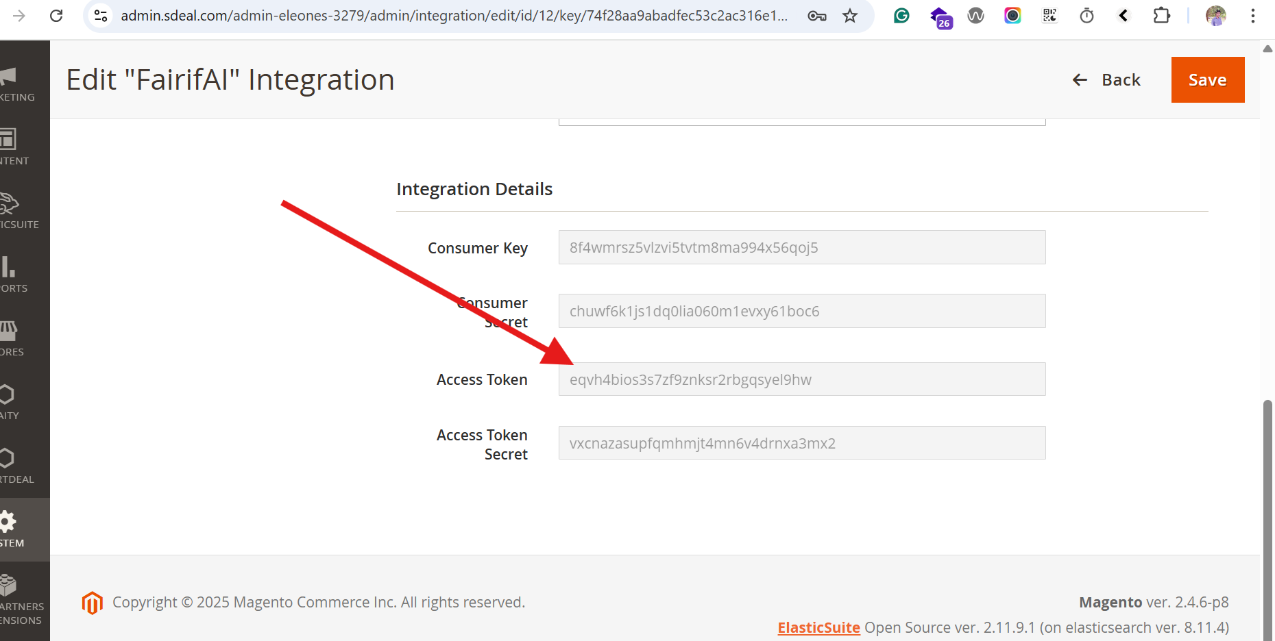

- For every API authentication we need to pass the access token as Authorization and admin as Token-Type 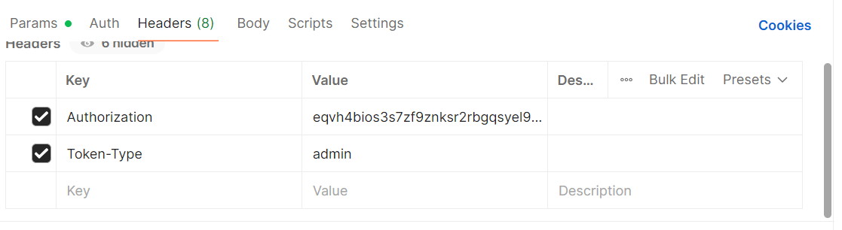\
- API Details get list of all order based on seller id. (Note: Also, we can apply the filter based on date, pagination, size, multiple seller ids, any status)
End Point: https://www.sportdeal.nl/rest/V1/supplier/orders/?searchCriteria[filter_groups][0][filters][0][field]=supplier_id&searchCriteria[filter_groups][0][filters][0][value]=1773&searchCriteria[filter_groups][0][filters][0][condition_type]=in&searchCriteria[currentPage]=1&searchCriteria[pageSize]=20
Request Type: GET
Header: We need to pass the Access Token .
Authorization : eqvh4bios3s7zf9znksr2rbgqsyel9hw
Token-Type: admin

Response:
{
"items": [
{
"id": 2919,
"supplier_id": 1773,
"supplier_quote_id": 1104,
"supplier_name": "OV Stock",
"order_type": 4,
"order_status": 25,
"finance_status": 80,
"commission_status": 10,
"supplier_invoice_number": null,
"payment_schedule": null,
"reject_reason": null,
"invoice_reminder_sent": null,
"invoice_reject_sent": null,
"invoice_accept_sent": null,
"payment_date": null,
"direct_cost_price": "0.0000",
"final_cost_price": "0.0000",
"indirect_discount": "0.0000",
"delivery_cost": "6.0000",
"expected_arrival_date": "2021-02-06",
"note": null,
"created_at": "2021-02-03 05:03:07",
"updated_at": "2024-04-30 04:27:23",
"confirmed_at": null,
"reminder_sent_at": null,
"original_expected_arrival_date": "2021-02-04",
"confirmed_expected_arrival_date": null,
"external_order_id": null,
"completely_received_date": null,
"commission": "0.000000",
"vat": "0.000000",
"order_increment_id": "",
"customer_name": "",
"settle_payment_date": null,
"track_and_trace": null,
"order_amount_org": "0.0000",
"delivery_cost_org": "0.0000",
"delivery_customer": "0.0000",
"vat_org": "0.0000",
"settle_payment_schedule": null,
"shipping_method": "",
"store_id": 0,
"deliveryfeedback_email": 1,
"sdeal_discount": "0.0000",
"internal_status": 0
},
}
],
}
Postman Screenshot:
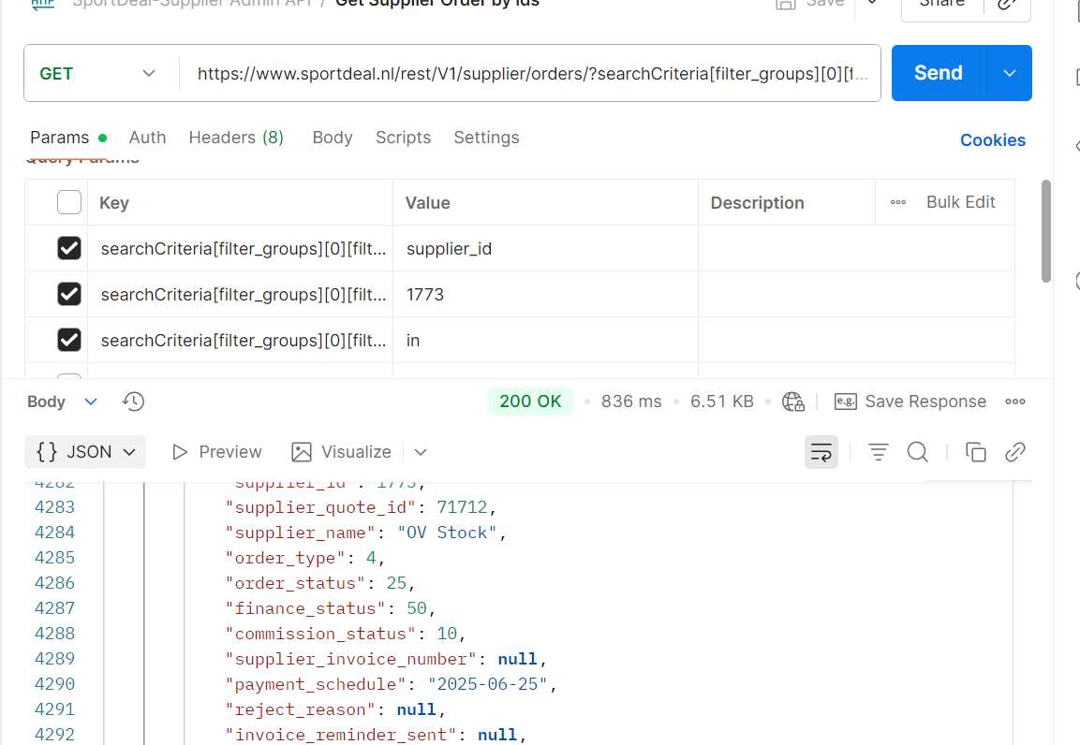

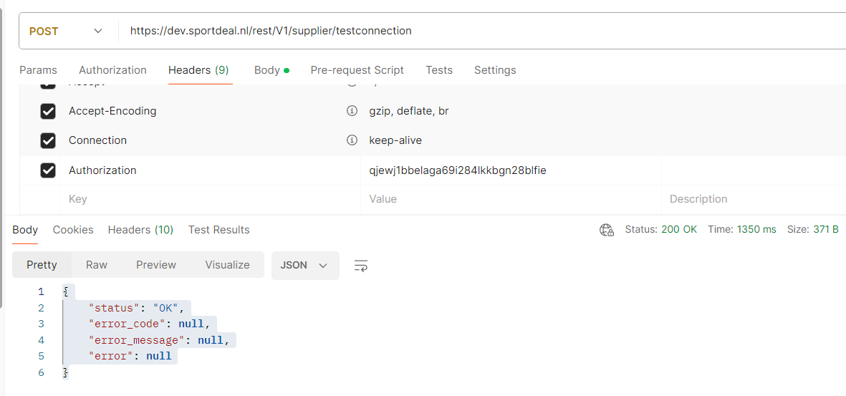

- API Details for order get based on status.

End Point: https://www.sportdeal.nl/rest/V1/supplier/orders/?searchCriteria[filter_groups][0][filters][0][field]=supplier_id&searchCriteria[filter_groups][0][filters][0][value]=1773&searchCriteria[filter_groups][0][filters][0][condition_type]=eq&searchCriteria[filter_groups][1][filters][0][field]=order_status&searchCriteria[filter_groups][1][filters][0][value]=20&searchCriteria[filter_groups][1][filters][0][condition_type]=eq&searchCriteria[currentPage]=1&searchCriteria[pageSize]=20
Request Type: GET
Header: We need to pass the Access Token .
Authorization : eqvh4bios3s7zf9znksr2rbgqsyel9hw
Token-Type: admin

Response:
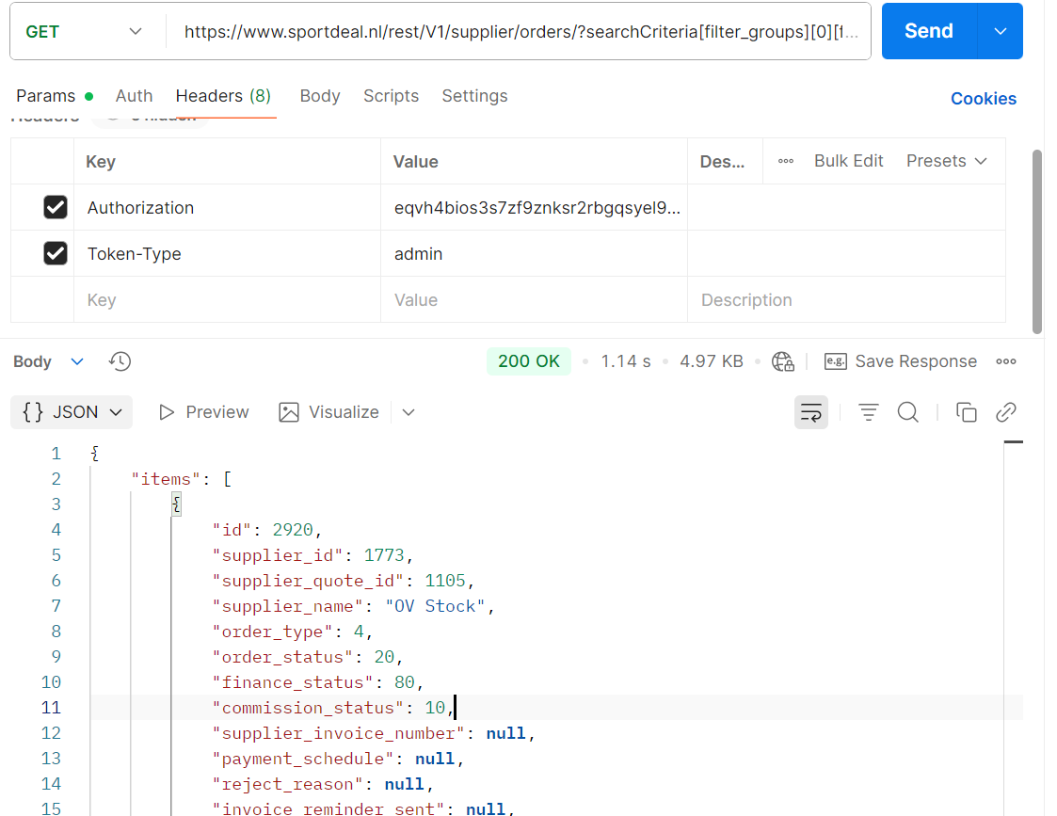

- API details for get specific order data with items and complete details of order.
End Point: https://www.sportdeal.nl/rest/V1/supplier/order/68074
Request Type: GET

Header: We need to pass the Access Token .
Authorization : eqvh4bios3s7zf9znksr2rbgqsyel9hw
Token-Type: admin

Response:
{
"id": 68074,
"supplier_id": 1773,
"supplier_quote_id": 68039,
"supplier_name": "OV Stock",
"order_type": 4,
"order_status": 20,
"reject_reason": null,
"delivery_cost": 6.95,
"created_at": [],
"external_order_id": null,
"direct_cost_price": 24.51,
"final_cost_price": 24.51,
"commission": 6.701425,
"vat": 0,
"order_amount_org": 24.51,
"delivery_cost_org": 5.6886,
"delivery_customer": 6.95,
"sdeal_discount": 0,
"vat_org": 0,
"indirect_discount": 0,
"expected_arrival_date": null,
"original_expected_arrival_date": [],
"confirmed_expected_arrival_date": null,
"payment_schedule": [],
"settle_payment_schedule": null,
"payment_date": [],
"settle_payment_date": null,
"finance_status": 50,
"commission_status": 10,
"note": null,
"customer_email": "olegrootes@hotmail.com",
"customer_phone": "0622315565",
"company": "",
"first_name": "Ole",
"last_name": "Grootes",
"shipping_street": "Oude Delft",
"shipping_house_number": "122",
"shipping_addition_address": "Oude Delft 122",
"shipping_zipcode": "2611CV",
"shipping_city": "Delft",
"shipping_region": "",
"shipping_countryid": "NL",
"order_items": "[{\"ean\":\"5708441001567\",\"quantity\":1,\"supplier_sku\":\"OVSTOCK57\",\"name\":\"Reelight Verlichtingsset SL150 Steady Light dynamo zwart\",\"price\":\"29.9500\"}]",
"customer_order_id": "SD-NL-O-000034619"
}

- API Details for Seller’s balance data.
End Point:
https://www.sportdeal.nl/rest/V1/sportdeal-balancemanagement/balance/search/?searchCriteria[filter_groups][0][filters][0][field]=supplier_id&searchCriteria[filter_groups][0][filters][0][value]=1773&searchCriteria[filter_groups][0][filters][0][condition_type]=eq
Request Type: GET

Header: We need to pass the Access Token .
Authorization : eqvh4bios3s7zf9znksr2rbgqsyel9hw
Token-Type: admin

Response:
{
"items": [
{
"balance_id": "107",
"supplier_id": "1773",
"supplier_name": "OV Stock",
"balance_total": "161.9600",
"balance_pending": "-0.0057",
"balance_commission": "-0.0001",
"balance_available": "0.0000",
"balance_pending_partner": "0.0000",
"balance_partner": "161.9600",
"balance_available_partner": "0.0000",
"date": "2025-08-07 06:22:20"
}
],
"search_criteria": {
"filter_groups": [
{
"filters": [
{
"field": "supplier_id",
"value": "1773",
"condition_type": "eq"
}
]
}
]
},
"total_count": 1
}

Postman Screenshot:
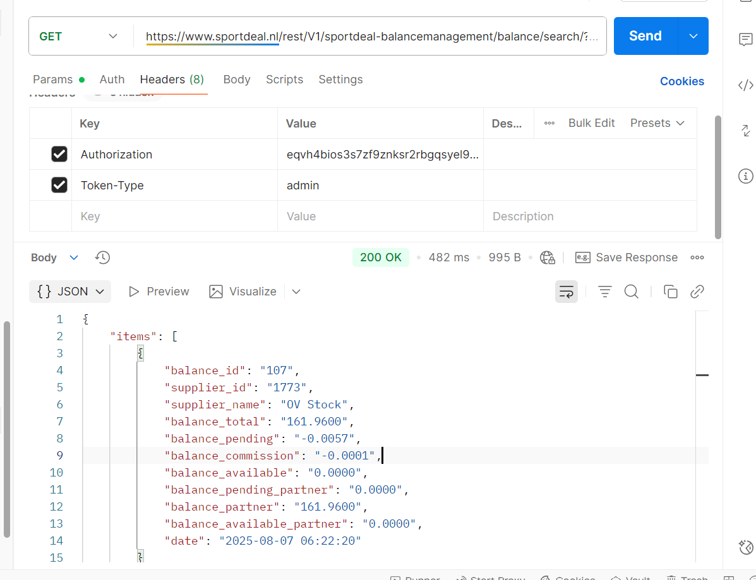

- API Details for get delivery info.
End Point: https://www.sportdeal.nl/rest/V1/sportdeal-delivery/info/?supplierId=1773
Request Type: GET
Header: We need to pass the Access Token .
Authorization : eqvh4bios3s7zf9znksr2rbgqsyel9hw
Token-Type: admin

Response:
[
{
"delivery_reliability_90_days": 100,
"total_email_sent_90_days": 0,
"answered_90_days": 0,
"not_answered_90_days": 0,
"not_received_90_days": 0,
"received_90_days": 0,
"delivery_reliability": 100,
"total_email_sent": 3,
"answered": 0,
"not_answered": 3,
"not_received": 0,
"received": 0
}
]

- Get List of Seller.
End Point: https://www.sportdeal.nl/rest/V1/supplier/list/?searchCriteria[filter_groups][1][filters][0][field]=created_at&searchCriteria[filter_groups][1][filters][0][condition_type]=from&searchCriteria[filter_groups][1][filters][0][value]=2025-03-13 00:00:00&searchCriteria[filter_groups][2][filters][0][field]=created_at&searchCriteria[filter_groups][2][filters][0][condition_type]=to&searchCriteria[filter_groups][2][filters][0][value]=2025-11-13 23:59:59
Type: GET
Header: We need to pass the Access Token .
Authorization : eqvh4bios3s7zf9znksr2rbgqsyel9hw
Token-Type: admin

Response:
{
"items": [
{
"id": 1773,
"name": "OV Stock",
"description": "<p>OV Stock is a stockholding company based in Groningen. We are a purchasing organization specialized in surplus batches of sports-related products, and we sell, distribute, and produce sports equipment, clothing, and accessories of the highest quality.</p>",
"notes": "30 dagen bedenktijd\r\nGratis retourneren\r\nDeze verkoper hanteert geen aanvullende voorwaarden.",
"service": "OV StockWesterhaven 229718 AC GroningenE-mail: sales@ov-stock.nl",
"terms": "",
"commission": "15",
"is_active": 1,
"created_at": "2021-01-15 09:46:16",
"updated_at": "2025-09-02 04:34:54",
"ext_id": null,
"url_key": "ov-stock",
"affiliate_customer": 0,
"status": 0,
"official_seller": 0
}
],
"search_criteria": {
"filter_groups": [
{
"filters": [
{
"field": "id",
"value": "1773",
"condition_type": "eq"
}
]
}
]
},
"total_count": 1
}

- Get Specific Seller Details.
End Point: https://www.sportdeal.nl/rest/V1/supplier/view/1773
Type: GET
Header: We need to pass the Access Token .
Authorization : eqvh4bios3s7zf9znksr2rbgqsyel9hw
Token-Type: admin

Response:
[
{
"supplier": {
"id": 1773,
"name": "OV Stock",
"description": "<p>OV Stock is a stockholding company based in Groningen. We are a purchasing organization specialized in surplus batches of sports-related products, and we sell, distribute, and produce sports equipment, clothing, and accessories of the highest quality.</p>",
"notes": "30 dagen bedenktijd\r\nGratis retourneren\r\nDeze verkoper hanteert geen aanvullende voorwaarden.",
"service": "OV StockWesterhaven 229718 AC GroningenE-mail: sales@ov-stock.nl",
"terms": "",
"commission": "15",
"is_active": 1,
"created_at": "2021-01-15 09:46:16",
"updated_at": "2025-09-02 04:34:54",
"ext_id": null,
"url_key": "ov-stock",
"affiliate_customer": 0,
"status": 0,
"official_seller": 0
},
"addresses": [
{
"id": 142,
"supplier_id": 1773,
"street": "Osloweg",
"housenumber": "110",
"postcode": "9723BX",
"city": "Groningen",
"region": null,
"country_code": "NL",
"type": "primary",
"is_active": 1,
"created_at": "2023-02-22 20:02:14",
"updated_at": "0000-00-00 00:00:00",
"company_name": null
},
{
"id": 251,
"supplier_id": 1773,
"street": "Osloweg",
"housenumber": "110",
"postcode": "9723BX",
"city": "Groningen",
"region": null,
"country_code": "NL",
"type": "rma",
"is_active": 1,
"created_at": "2024-07-10 05:27:20",
"updated_at": "0000-00-00 00:00:00",
"company_name": null
},
{
"id": 327,
"supplier_id": 1773,
"street": "asdasd",
"housenumber": "asdasd",
"postcode": "500090",
"city": "Hyderabd",
"region": null,
"country_code": "AT",
"type": "store_pickup",
"is_active": 1,
"created_at": "2024-12-24 05:23:31",
"updated_at": "0000-00-00 00:00:00",
"company_name": "Test"
}
],
"contacts": [
{
"id": 80,
"supplier_id": 1773,
"title": null,
"firstname": "Kamlesh",
"middlename": null,
"lastname": "Jha",
"emailaddress": "jha869@gmail.com",
"phonenumber": "0611262916",
"type": "primary",
"logo": "Profile-Male-PNG.png",
"is_active": 1,
"created_at": "2021-03-22 08:51:22",
"updated_at": "2025-10-09 06:15:05"
},
{
"id": 666,
"supplier_id": 1773,
"title": null,
"firstname": "kamlesh",
"middlename": null,
"lastname": "j",
"emailaddress": "kamlesh@sportdeal.com",
"phonenumber": "0611262916",
"type": "support",
"logo": "",
"is_active": 1,
"created_at": "2023-09-26 05:11:59",
"updated_at": "2025-10-09 06:15:40"
}
],
"packages": [
{
"id": 158,
"supplier_id": 1773,
"supplierpackages_id": 1,
"packages": null,
"packages_type": "subscription",
"created_at": "2025-11-23 14:34:22",
"updated_at": "2025-11-23 14:34:22"
}
]
}
]

- Create Seller.
End Point: https://www.sportdeal.nl/rest/V1/supplier/create
Type: POST
Header: We need to pass the Access Token .
Authorization : eqvh4bios3s7zf9znksr2rbgqsyel9hw
Token-Type: admin
Request Body:
{
"name":"Testapi Seller2",
"commission":"21.0",
"description":"Testapi description"
}

Response: "2338"

