Detailed design ( UML diagrams,  Data flow diagram)

**Class**



**Usecase**



**Seq**



**Collabrotion**

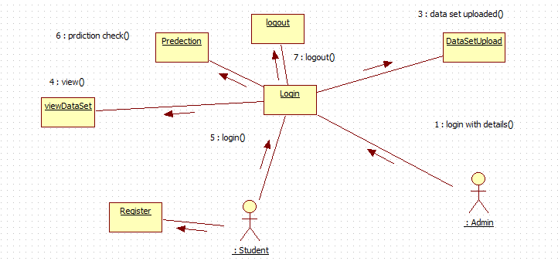

**State**



**Activity**



**Component**



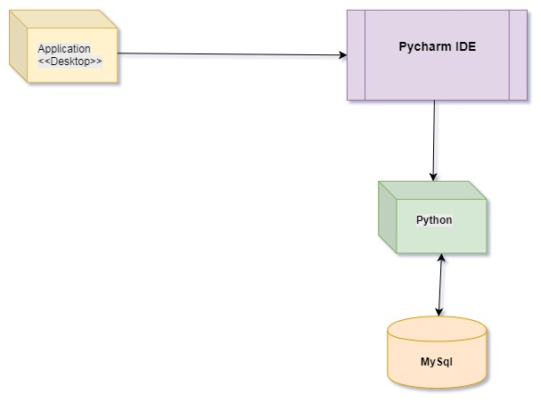

DFD

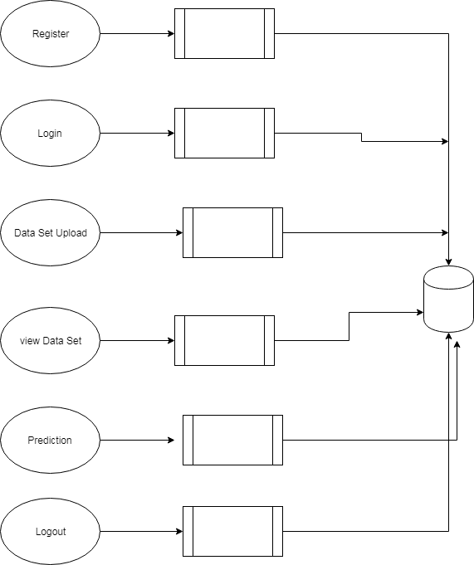

List of all the technologies used like ide, database and there connections

Operating System       :           Windows family

Technology                 :           Python 3.6

IDE : PyCharm

Data Base : MYSQL

DBConnection.py

import mysql.connector

class DBConnection:

@staticmethod

def getConnection():

database = mysql.connector.connect(host="localhost", user="root", passwd="root", db='student')

return database

if __name__=="__main__":

print(DBConnection.getConnection())

Screenshots of results ( even of its a error)

**Sample Data sets**

**student_train.xlsx**

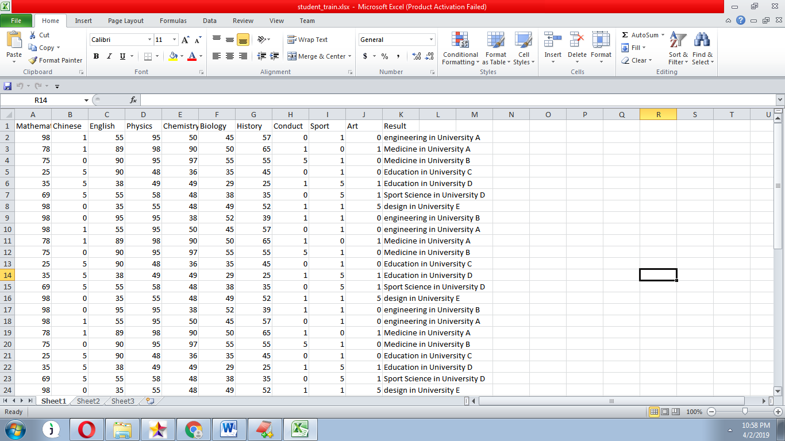

**testdata_stdnt.csv**



Result and Conclusions up to the project development

**CONCLUSIONS**

Classification and prediction is a general problem. Traditional data mining techniques such as association rules, decision tree, clustering and so on had been use for a few decades for solving this problem. The raising popularity of using Tensorflow for deep learning and artificial intelligence opened a new approach and direction for solving classification problem and prediction of non-linear results. In this research, the number of hidden layers, hidden notes, the number of iteration and the learning rate are adjusted and compared. It is discovered that it is not always true that the deep the deep learning model, i.e. the more number of hidden layer, the more accurate will the result be. There is an optimal point at are required to be tested and identified. For the learning rate, a higher learning rate could help to speed up the convergence of the trained model. However, if the learning rate is too high, the result might overshoot the optimal point. Therefore, the prediction performance could be improved with a low momentum and high learning rate. Then gradually, the momentum can be increased and the learning rate can be decreased for ensuring convergence. This study demonstrated that deep learning could be an effective tool for predicting the students’ performance. The result ranged from 80% to 91%. The prediction result is good enough to provide appropriate recommendations for students, their teachers and parents to decide their development pathway. It is believed that more applications of deep learning could be used for education and corporate staff training in the future.

**REFERENCE**

[1] Amirah Mohamed, Shahiri Wahidah, “A Review on Predicting Student's Performance Using Data Mining Techniques”, Procedia Computer Science, Volume 72, 2015, Pages 414-422,

<https://www.sciencedirect.com/science/article/pii/S18770509150361> 82

[2] G. Gray, C. McGuinness, P. Owende, An application of classification models to predict learner progression in tertiary education, in: Advance Computing Conference (IACC), 2014 IEEE International, IEEE, 2014, pp. 549–554.

[3] P. M. Arsad, N. Buniyamin, J.-l. A. Manan, A neural network students’ performance prediction model (nnsppm), in: Smart Instrumentation, Measurement and Applications (ICSIMA), 2013 IEEE International Conference on, IEEE, 2013, pp. 1–5.

[4] Joonhyuck Lee , Dongsik Jang and Sangsung Park, “Deep Learning- Based Corporate Performance Prediction Model Considering Technical Capability” MDP <http://www.mdpi.com/2071-> 1050/9/6/899/pdf

[5] Rianne Conijn, Chris Snijders, Ad Kleingeld, Uwe Matzat, “Predicting Student Performance from LMS Data: A Comparison of 17 Blended Courses Using Moodle LMS. October 2016IEEE

Transactions on Learning Technologies PP(99):1-1 106