Comprehensive Rainfall Analysis: Investigating Distribution, Skewness, and Kurtosis

The dataset analyzed consists of monthly and seasonal rainfall data from the Indian Meteorological Department (IMD) spanning the years 1981 to 2016. This comprehensive dataset includes rainfall measurements for each month, combined rainfall for selected month pairs, and total annual rainfall.

A descriptive analysis was conducted to extract meaningful insights from the data. Figure 1 presents a visualization of the monthly rainfall trends over the years, capturing the variability and patterns in the data. Despite the complexity of the graph, it is evident that the monsoon months—June, July, August, and September—exhibit significantly higher rainfall, which is characteristic of the Indian monsoon season. May and October also play crucial roles as transitional months marking the onset and retreat of the monsoon, respectively.

Figure 2 offers a more detailed comparison of individual months, providing a clearer perspective on the variations and trends observed in Figure 1. These visualizations collectively enhance our understanding of the rainfall distribution across different times of the year, emphasizing the dominant impact of the monsoon season on annual rainfall patterns.

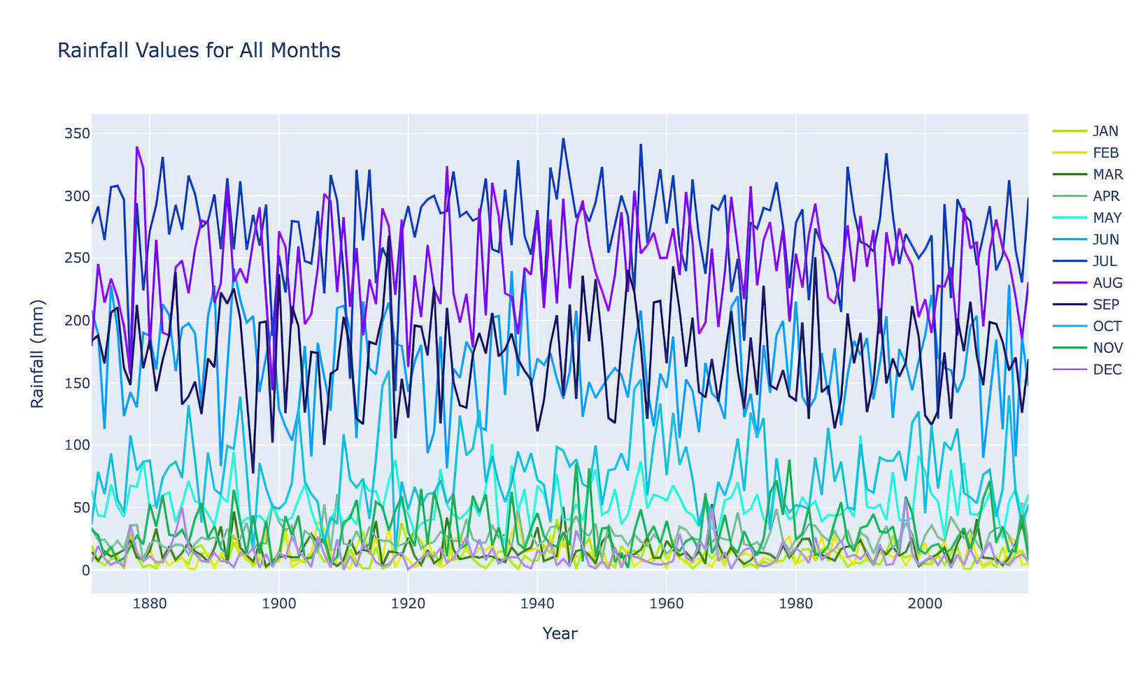

Fig 1. *Single graph* for all months for comparative analysis

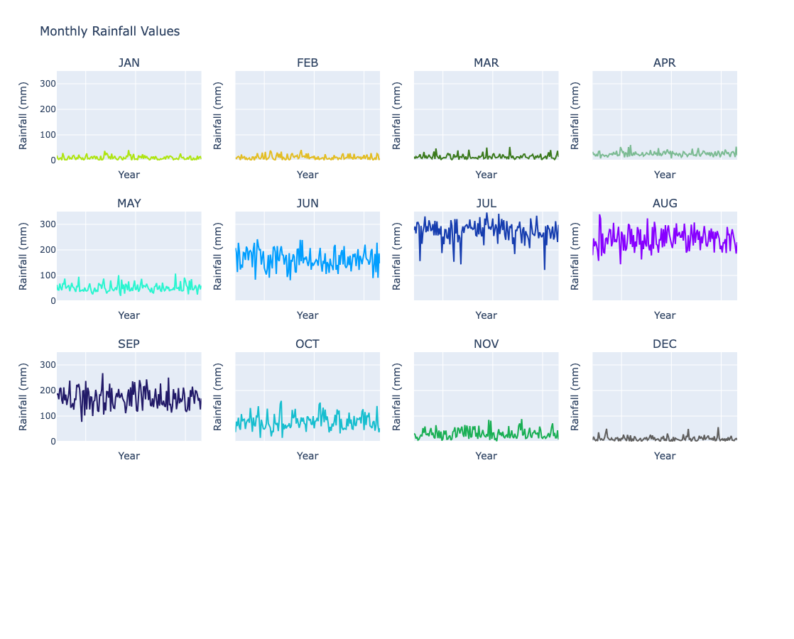

Fig 2. *Comparative graphs* for all months

**Skewness and Kurtosis Analysis of Rainfall Data (1981-2016)**

The rainfall dataset from the Indian Meteorological Department (IMD) for the period 1981-2016 was analyzed to explore skewness and kurtosis across various months and seasonal groupings. The skewness values reveal the asymmetry of rainfall distribution, while kurtosis highlights the "tailedness" or the extremity of rainfall events.

**Skewness Analysis:**

* **Positive skewness** values (greater than 0) indicate that most of the rainfall data points are clustered at the lower end, with occasional higher rainfall values pulling the average upwards. This can be seen in months like January, February, March, April, May, and December.
* **Negative skewness** values (less than 0) in months such as July and June suggest a clustering of higher rainfall values, with occasional lower values pulling the distribution down.

**Kurtosis Analysis:**

* **High positive kurtosis** (greater than 3), seen in March and December, indicates the presence of outliers or extreme rainfall events during these months.
* **Negative kurtosis** in months like June, August, and September reflects that the rainfall distribution has lighter tails compared to a normal distribution, suggesting fewer extreme rainfall events.

Below is a detailed report for each month and seasonal grouping, along with their highest and lowest recorded values:

**Monthly and Seasonal Rainfall Extremes (1981-2016):**

|  |  |  |  |  |
| --- | --- | --- | --- | --- |
| **Month/Season** | **Highest Value (mm)** | **Lowest Value (mm)** | **Skewness** | **Kurtosis** |
| January (JAN) | 40.6 | 0.9 | 1.13 | 1.59 |
| February (FEB) | 41.1 | 0.6 | 1.07 | 0.57 |
| March (MAR) | 52.8 | 2.8 | 1.01 | 4.14 |
| April (APR) | 60.6 | 8.0 | 1.06 | 1.93 |
| May (MAY) | 107.7 | 20.6 | 1.01 | 1.26 |
| June (JUN) | 241.7 | 81.6 | 0.02 | -0.68 |
| July (JUL) | 346.1 | 143.6 | -1.04 | 1.80 |
| August (AUG) | 339.4 | 144.1 | 0.03 | -0.45 |
| September (SEPT) | 267.9 | 77.3 | 0.089 | 0.59 |
| October (OCT) | 159.6 | 14.7 | 0.57 | 0.34 |
| November (NOV) | 88.3 | 1.9 | 0.83 | 0.22 |
| December (DEC) | 50.2 | 0.3 | 1.61 | 3.96 |

**Seasonal Groupings:**

|  |  |  |  |  |
| --- | --- | --- | --- | --- |
| **Month/Season** | **Highest Value (mm)** | **Lowest Value (mm)** | **Skewness** | **Kurtosis** |
| JF (Jan + Feb) | 61.1 | 3.0 | 0.7093 | 0.21 |
| MAM (Mar - May) | 166.8 | 55.5 | 0.7576 | 0.87 |
| JJAS (Jun - Sep) | 1020.3 | 604.3 | -0.5504 | -0.11 |
| OND (Oct - Dec) | 209.9 | 50.2 | 0.3945 | -0.071 |
| J to D (Jan - Dec) | 1347.7 | 811.5 | 0.0018 | 0.11 |