**A Project Report**

**On**

**“Prescription Pattern and Awareness of Diabetic**

**Patients in Rangpur District”**

**The Research Report Submitted to Department of Statistics,in fulfillment**

**of the requirements for the Degree of Bachelor of Science in Statistics.**



Supervised By:

Dr. Md Shahjaman

Professor,

Department of Statistics,

Begum Rokeya University,Rangpur.

Submitted By:

Mst. Ruhana Fairuz

ID: 1910022

Reg:000013056

Session: 2019-20

Department of Statistics,

Begum Rokeya University,Rangpur.

April 2025

#### DECLARATION BY THE CANDIDATE

I hereby declare that this dissertation entitle “**Prescription Pattern and Awareness of Diabetic Patients in Rangpur District”** is an authentic and genuine research work carried out by me under the supervision of **Dr. Md Shahjaman,** Professor, Department of Statistics, Begum Rokeya University, Rangpur, Bangladesh.

##### Mst. Ruhana Fairuz

ID: 1910022

Reg:000013056

Department of Statistics Begum Rokeya University,Rangpur,

Bangladesh.

#### CERTIFICATE BY THE SUPERVISOR

This is to certify that the dissertation entitled “**Prescription Pattern and Awareness of Diabetic Patients in Rangpur District”**.is a bona-fide research work done by **Mst. Ruhana Fairuz, ID No: 1910022, Reg No: 000013056** in partial fulfillment of the requirement for the Degree of Bachelor of Science in Statistics.

**(Dr. Md Shahjaman)** Professor

Department of Statistics Begum Rokeya University,Rangpur.

#### ACKNOWLEDGEMENT

First, all praise and glory are to the Almightyfor all the bounties granted to me and only with the guidance and help this achievement has become possible.

I would like to express my deep gratitude to my supervisor and respected teacher,

**Dr.Md Shahjaman**, Professor, Department of Statistics, BRUR, for her constant supervision, intense support, enthusiastic encouragements and constructive criticism during the thesis work. Her timely advice, encouragement, in-depth thinking and motivation to guide had provided me with the motivation to continue and complete this research.

I would like to express my deep gratitude to the chairperson and my respected teacher, **Dr. Md. Siddikur Rahman**, Associate Professor, Department of Statistics, BRUR, for his intense support, enthusiastic encouragements and constructive criticism during the project work. His timely advice, encouragement, in-depth thinking and motivation to guide had provided me with the motivation to continue and complete this research.

I wish to thank my fellow researchers namely Shyra Nujhat Urme and Partho Babu Shuvo for their endless cooperation and wholehearted inspiration throughout the period of the research work.

Finally, I would like to express my sincere gratitude to my caring parents for guiding me all through my life, including that for my research project. I am also very grateful to my friend Mofachchhar-ul-ahamed who supported and encouraged me enormously to complete my study including my research project.

***THIS RESEARCH PAPER IS DEDICATED TO***

***MY PARENTS***

***&***

***MY FRIENDS***

**INDEX:**

|  |  |
| --- | --- |
| **Contents** | **Page no.** |
| Acknowledgement | 4 |
| List of Figures | 9 |
| List of Tables | 9 |
| List of Abbreviations | 10 |
| Abstract | 10 |
| **Chapter One: Introduction** | 11-15 |
| Diabetes: an alarmingly growing disorder | 11 |
| Incidence of Diabetes | 11 |
| Increasing trend of diabetes prevalence throughout the world | 11 |
| Increasing trend of diabetes prevalence in Bangladesh | 11 |
| History of Diabetes | 12 |
| Types of Diabetes | 12 |
| Type 1 Diabetes | 12 |
| Type 2 Diabetes | 13 |
| Symptoms of Diabetes | 13 |
| Symptoms of type 1 Diabetes | 13 |
| Symptoms of type 2 Diabetes | 13 |
| Risk Factors for Diabetes | 14 |
| Risk Factors for Type 1 Diabetes | 14 |
| Risk Factors for Type 2 Diabetes | 14 |
| Complications of Diabetes | 15 |
| Treatment of Diabetes | 15 |

|  |  |
| --- | --- |
| **Chapter Two: Literature Review** |  |
| Literature Review: | 16-17 |
| **Chapter Three: Methodology** |  |
| Type of the study | 17 |
| Place of study | 17 |
| Rangpur Medical College Hospital(RMCH) | 17 |
| Rangpur Diabetic Somiti | 17 |
| Study Population | 18 |
| Study period | 18 |
| Sample size and Sampling Technique | 19 |
| Data collection method | 19 |
| Data analysis | 19 |
| **Chapter Four : Result** |  |
| Result | 20-30 |
| Diabetes distribution profile on gender. | 20 |

|  |  |
| --- | --- |
| Diabetic patients’ distribution profile on age | 21 |
| Diabetic patients distribution profile on family history | 22 |
| Distribution of the patients based on type of diabetes mellitus | 23 |
| Distribution of diabetic patients based on physical exercise | 24 |
| Distribution of diabetic patients based on types of physical exercise | 25 |
| Different types of dosage form of drugs are used in diabetic patients. | 26 |
| Mostly prescribed insulin for diabetic patients | 27 |
| Prescribed tablets for Cardiovascular patients | 28 |
| Blood sugar level average per week | 29 |
| Heart disease occured | 30 |
| **Chapter Five :Discussion** |  |
| Diabetes distribution profile on gender. | 33 |
| Diabetic patients’ distribution profile on age. | 33 |
| Distribution of the patients based on family history | 33 |
| Distribution of diabetic patients based on types of diabeties mellitus | 34 |
| Distribution based on physical exercise | 34 |
| Distribution based on types of physical exercise | 34 |
| Different Types of dosage form are used in diabetic patent | 34 |
| Mostly prescribed insulin for diabetic patients | 34 |
| Use of drugs in diabetic patients suffering from cardiovascular disease. | 34 |
| Blood sugar level average per week | 34 |
| Heart disease occured | 34 |
| **Chapter Six :Conclusion** |  |
| Conclusion | 35 |
| **Chapter Seven :References** |  |
| References | 36-37 |

### List of Figures

|  |  |
| --- | --- |
| Figure 1: Diabetes distribution profile on gender. | 20 |
| Figure 2: Diabetic patients distribution profile on age | 21 |
| Figure 3:Distribution of the patients based on family history | 22 |
| Figure 4: Distribution of diabetic patients based on types of diabetes mellitus | 23 |
| Figure 5: Distribution based on physical exercise | 24 |
| Figure 6: Distribution based on types of physical exercise | 25 |
| Figure 7: Different Types of dosage form are used in diabetic patient | 26 |
| Figure 8: Mostly prescribed insulin for diabetic patients | 27 |
| Figure 9: Use of drugs in diabetic patients suffering from cardiovascular disease. | 28 |
| Figure 10: Blood sugar level average per week | 29 |
| Figure 11: Heart disease occured | 30 |

#### List of Tables

|  |  |
| --- | --- |
| Table 1: Diabetes distribution profile on gender. | 20 |
| Table 2: Diabetic patients distribution profile on age | 21 |
| Table 3: Distribution of the patients based on family history | 22 |
| Table 4: Distribution of diabetic patients based on types of diabetes mellitus | 23 |
| Table 5: Distribution based on physical exercise | 24 |
| Table 6: Distribution based on types of physical exercise | 25 |
| Table 7: Different Types of dosage form are used in diabetic patient | 26 |
| Table 8: Mostly prescribed insulin for diabetic patients | 27 |
| Table 9: Use of drugs in diabetic patients suffering from cardiovascular disease | 28 |
| Table 10: Blood sugar level average per week | 29 |
| Table 11: Heart disease occured | 30 |

#### List of Abbreviations

##### Abbreviation Explanation

CVD Cardiovascular Disease.

CVDs… Cardiovascular Diseases.

HTN… Hypertension.

RDS… Rangpur Diabetes Somiti.

## RMCH………………..Rangpur Medical College Hospital.

## ABSTRACT

Diabetes is a major cause of disability and premature death in Bangladesh. Diabetes diseases are diseases of the blood. Patients may need lifestyle change, medications, surgery or other medical procedures as part of treatment. The objective of the present study is to find out the combination therapy pattern for the treatment of diabetes in Bangladesh. The survey of the study was conducted in Rangpur Medical College Hospital (RMCH), situated in Rangpur.Study period was 4 months commencing from February 2025 to May 2025.200 prescriptions of diabetic patients were collected from RMCH. Among them number of male patients is 86(43%) and number of female patients is 114(57%). Most commonly prescribed drugs were 22.5% used Aspirin, 28% used by Glyceryl, 28% used by Ramipil and 21.5% used by others.The result of this study focused on the prescription pattern and awareness of the patients. People those who are affected and unaffected from this diabetes disease should be more conscious about this because a little bit negligence may lead to this life threat

#### Chapter One

#### Introduction

#### Diabetes: an alarmingly growing disorder

Diabetes mellitus is an endocrinological disorder arising from insulin deficiency or due to ineffectiveness of the insulin produced by the body. This results in high blood glucose and with time, to neurological, cardiovascular, retinal and renal complications. Diabetes is the condition in which the body does not properly process carbohydrate for use as energy. Most of the food we eat is turned into glucose, or sugar, for our bodies to use for energy. The pancreas, an organ that lies near the stomach, makes a hormone called insulin to help glucose get into the cells of our bodies. When you have diabetes, your body either doesn't make enough insulin or can't use its own insulin as well as it should. This causes sugars to build up in your blood. This is why many people refer to diabetes as “sugar.”(Ahern JA, et al, 2000)

#### Incidence of diabetes

**Increasing trend of diabetes prevalence throughout the world**

The recent World Health Organization (WHO) report on the prevalence of diabetes mellitus has presented an alarming picture of a global epidemic of type-2 diabetes (1997). It is posing a serious threat to entire population of the world irrespective of stages of industrialization and development. The increasing prevalence of diabetes mellitus for South East Asian Region (SEAR) was estimated from the observed prevalence in 1995 that projected to 2000 and 2025. This trend observed two folds increase in the developed and almost three folds in the developing nations. Global comparison estimated that highest increase would be observed in SEAR and in Eastern Mediterranean Region (East-Med). (Turner RC, et al 1998)

#### Increasing trend of diabetes prevalence in Bangladesh

Although there was no large-scale national survey in Bangladesh, several small-scale surveys at intervals have been done over several years. The prevalence of IGT has increase from-O.37% in 1983 to 12.5% in 1996 and that of diabetes from 0.7 in 1983 to 5.2% in 1996. As estimated on the basis of present prevalence rates of (Type 2 diabetes -5.2% and IGT - 12.5%), in the projected population, more than ten million Bangladeshis will suffer from the disease in the year 2005. This is a conservative estimate because the trend of increasing prevalence will make this figure much higher.

#### History of Diabetes

For 2,000 years diabetes has been recognized as a devastating and deadly disease. In the first century A.D. a Greek, Aretaeus, described the destructive nature of the affliction which he named "diabetes" from the Greek word for "siphon." Eugene J. Leopold in his text Aretaeus the Cappodaciandescribes Aretaeus diagnosis: "...For fluids do not remain in the body, but use the body only as a channel through which they may flow out. Life lasts only for a time, but not very long. For they urinate with pain and painful is the emaciation. For no essential part of the drink is absorbed by the body while great masses of the flesh are liquefied into urine." symptoms of diabetes but were powerless to effectively treat it. Aretaeus recommended oil of roses, dates, raw quinces, and gruel. And as late as the 17th century, doctors prescribed "gelly of viper's flesh, broken red coral, sweet almonds, and fresh flowers of blind nettles."(Yang W, et all, 2010)

Physicians in ancient times, like Aretaeus, recognized the Despite physicians' valiant efforts to combat diabetes, their patients remained little more than human guinea pigs. In the early 20th century, diabetologists such as Dr. Frederick Allen prescribed low calorie diets-as little as 450 calories per day for his patients. His diet prolonged the life of people with diabetes but kept them weak and suffering from near starvation. In effect, the most a person afflicted with diabetes could do was blindly offer him to the medical establishment and pray for a cure. In his book, The Discovery of Insulin, Michael Bliss describes the painful wasting death of many people with diabetes before insulin: "Food and drink no longer mattered, often could not be taken. A restless drowsiness shaded into semi-consciousness. As the lungs heaved desperately to expel carbonic acid (as carbon dioxide), the dying diabetic took huge gasps of air to try to increase his capacity. 'Air hunger' the doctors called it, and the whole process was sometimes described as 'internal suffocation.' The gasping and sighing and sweet smell lingered on as the unconsciousness became a deep diabetic coma. At that point the family could make its arrangements with the undertaker, for within a few hours death would end the suffering.(Orasanu Get "all ,2008)

#### Types of diabetes

**Type 1 diabetes**

Type 1 diabetes, previously called insulin-dependent diabetes mellitus (IDDM) or juvenile-onset diabetes, may account for 5 percent to 10 percent of all diagnosed cases of diabetes. Risk factors are less well defined for Type 1 diabetes than for Type 2 diabetes, but

autoimmune, genetic, and environmental factors are involved in the development of this type of diabetes.(Yang W,et al, 2010)

#### Type 2 diabetes

Type 2 diabetes was previously called non-insulin-dependent diabetes mellitus (NIDDM) or adult-onset diabetes. Type 2 diabetes may account for about 90 percent to 95 percent of all diagnosed cases of diabetes. Risk factors for Type 2 diabetes include older age, obesity, and family history of diabetes, prior history of gestational diabetes, impaired glucose tolerance, physical inactivity, and race/ethnicity. African Americans, Hispanic/Latino Americans, American Indians, and some Asian Americans and Pacific Islanders are at particularly high risk for type 2 diabetes ( Feldman CB:et all 1998)

#### Symptoms of diabetes

High blood levels of glucose can cause several problems, including:

* Blurry vision.
* Excessive thirst.
* Fatigue.
* Frequent urination.
* Hunger.
* Weight loss.

#### Symptoms of type 1 diabetes

* + - * Fatigue.
      * Increased thirst.
      * Increased urination.
      * Nausea.

##### Vomiting.

* + - * Weight loss in spite of increased appetite.

##### Symptoms of type 2 Diabetes

* + - * Blurred vision
      * Fatigue
      * Increased appetite
      * Increased thirst
      * Increased urination

#### Risk Factors for diabetes

There are three major types of diabetes: type 1 diabetes, type 2 diabetes, and gestational diabetes. All three types of diabetes share the same basic characteristic -- the body's inability either to make or to use insulin. Your body needs insulin, a hormone, to be able to use glucose, which comes from the food you eat, for energy. Without enough insulin, glucose stays in the blood, creating high levels of blood sugar. Over time, this buildup causes damage to your kidneys, heart, nerves, eyes, and other organs.

One out of every three people with diabetes is unaware they have this chronic condition. According to the American Diabetes Association, that amounts to about 7 million Americans.

#### Risk factors for type 1 diabetes

With type 1 diabetes, which starts in childhood, the pancreas stops producing insulin. Insulin is a hormone your body needs to be able to use the energy -- glucose -- found in food. The primary risk factor for type 1 diabetes is a family history of this lifelong, chronic disease.

* + - * Genetics and family history. Having family members with diabetes is a major risk factor. The American Diabetes Association recommends that anyone with a first- degree relative with type 1 diabetes -- a mother, father, sister, or brother -- should get screened for diabetes. A simple blood test can diagnose type 1 diabetes.
      * Diseases of the pancreas. Injury or diseases of the pancreas can inhibit its ability to produce insulin and lead to type 1 diabetes.
      * Infection or illness. A range of relatively rare infections and illnesses can damage the pancreas and cause type 1 diabetes.( Little RJA, et all.2002)

#### Risk Factors for Type 2 diabetes

There are many risk factors for type 2 diabetes, including:

* + - * Age over 45 years.
      * A parent, brother, or sister with diabetes.
      * Gestational diabetes or delivering a baby weighing more than 9 pounds.
      * Heart disease.
      * High blood cholesterol level.
      * Obesity.
      * Not getting enough exercise.
      * Polycystic ovary disease (in women).
      * Previous impaired glucose tolerance.
      * Some ethnic groups (particularly African Americans, Native Americans, Asians, Pacific Islanders, and Hispanic Americans).

#### Complications of diabetes

Heart disease and stroke- Approximately 75 percent of people with diabetes will die of heart disease or stroke, and they are likely to die at a younger age than people who do not have diabetes. Blindness due to diabetic retinopathy- Each year 12,000 to 24,000 people lose their sight because of diabetes. Diabetes is the leading cause of new blindness in people 20 to 74 years of age. Kidney disease due to diabetic nephropathy- Ten to 21 percent of all people with diabetes develop kidney disease. Diabetic nephropathy is the leading cause of end-stage renal disease (kidney failure), accounting for 43 percent of new cases. Nerve disease and amputations- About 60 to 70 percent of people with diabetes have mild to severe forms of diabetes-related nerve damage, which can lead to lower limb amputations. In fact, diabetes is the most frequent cause of non-traumatic lower limb amputations. Impotence due to diabetic neuropathy or blood vessel blockage- Impotence afflicts approximately 13 percent of men who have type 1 diabetes and eight percent of men who have type 2 diabetes. It has been reported that men with diabetes, over the age of 50 have impotence rates as high as 50 to 60 percent(Boyd AE III, et all.1990)

#### Treatment of diabetes

Medications to treat diabetes include insulin and glucose-lowering pills called oral hypoglycemic drugs. People with type 1 diabetes cannot make their own insulin. They need daily insulin injections. Insulin does not come in pill form. Injections are generally needed one to four times per day. Some people use an insulin pump. It is worn at all times and delivers a steady flow of insulin throughout the day. Other people may use inhaled insulin.

[Type 1 diabetes](http://health.nytimes.com/health/guides/disease/type-1-diabetes/overview.html)-Unlike type 1 diabetes, type 2 diabetes may respond to treatment with exercise, diet, and medicines taken by mouth. There are several types of medicines used to lower blood glucose in type 2 diabetes.

[Type 2 diabetes](http://health.nytimes.com/health/guides/disease/type-2-diabetes/overview.html)- Medications may be switched to insulin during pregnancy and while breastfeeding. Gestational diabetes may be treated with exercise and changes in diet.

Exercise- Regular exercise is especially important for people with diabetes. It helps with blood sugar control, weight loss, and high blood pressure. People with diabetes who exercise are less likely to experience a heart attack or stroke than those who do not exercise regularly.

Foot care- People with diabetes are more likely to have foot problems. Diabetes can damage blood vessels and nerves and decrease the body's ability to fight infection. You may not notice a foot injury until an infection develops. Death of skin and other tissue can occur. If left untreated, the affected foot may need to be amputated. Diabetes is the most common condition leading to amputations (Bassiony M.M et all,2009

#### Chapter Two

#### LITERATURE REVIEW

#### Literature Review:

It has expanded the direct care component, incorporating aspects of both nursing and medical care while maintaining the teaching and counseling roles. Both the clinical nurse specialist and nurse practitioner (NP) models, when applied to chronic disease management, create. When people are diagnosed with diabetes, they may be treated in several different ways. Controlling risk factors that can be managed—lowering weight and quitting smoking will be the first changes they will have to make.

Exercise will become part of their lives, if possible. Drug therapy may be the next course of action.

#### Case Study: a patient with uncontrolled type 2 diabetes and complex.

The specialized role of nursing in the care and education of people with diabetes has been in existence for more than 30 years. Diabetes education carried out by nurses has moved beyond the hospital bedside into a variety of health care settings. Among the disciplines involved in diabetes education, nursing has played a pivotal role in the diabetes team management concept. This was well illustrated in the Diabetes Control and Complications Trial (DCCT) by the effectiveness of nurse managers in coordinating and delivering diabetes self- management education. These nurse managers not only performed administrative tasks crucial to the outcomes of the DCCT, but also participated directly in patient care.1

The emergence and subsequent growth of advanced practice in nursing during the past

20 years wenhanced patient-provider relationships in which self-care education and counseling is provided ithin the context of disease state management. Clement2 commented in a review of diabetes self-management education issues that unless ongoing management is part of an education program, knowledge may increase but most clinical outcomes only minimally improve. Advanced practice nurses by the very nature of their scope of practice effectively combine both education and management into their delivery of care.

#### Exercise prescription for patients with type 2 diabetes and pre-diabetes:

Exercise will become part of their lives. Exercise training improves Cardiovascular risk profile, body composition and cardiorespiratory fitness, all strongly related to better health outcomes. Minimum of 210 minutes per week of moderate intensity exercise or 250 min per week of vigorous intensity exercise with no more than two consecutive days without training.

**Awareness of diabetic patients**

Patients awareness plays a crucial role in achieving optimal diabetes outcomes.Research indicates that while many patients understand the basics of diabetes,they often lack detailed knowledge about complications such as nephropathy and retiopathy(kumar et al.,2017).High level of awareness are associated with better medication adherence and improved glycemic control(Al-Qazaz at.,2011).

Healthcare provide primarily guide patient education ,but alternative sources like the internet are gaining importance ,especially among younger patients.Challenges to awareness include low literacy ,cultural factors ,and economic barriers.

**Chapter Three**

#### METHODOLOGY

#### Type of the study

The present study was performed on a cross sectional observation which was attempted to find out the frequently prescribed drugs by the doctors in different diabetic patient.

#### Place of study

**Rangpur Medical College Hospital (RMCH)**

RMCH is a specialized medical college is a renowed in the division. It is situated at in Rangpur. It is the apex centerfor diabetic patients in the country to provide modern and scientific management of patients. It has ccu, pccu, wards, cabin and icu. Admission enter is open for 24 hours, A patient can take admission at any time of the day. The surgery department is very active in RMCH. The surgery team has successfully done almost all the operations. RMCH has many diagnostic and therapeutic equipments which are lifesaving. But a number of machines are now nonfunctioning. As the patients of this hospital are very critical in nature, so necessary lifesaving equipments should be in functioning position. Full automation system should be established for better service to the patient.

#### Rangpur Diabetic Somiti (RDS)

RDS is in Rangpur, located in Radhaballab.We were collected some information about diabetic patients from Rangpur Diabetic Somiti.

#### Study population

In the present study, all type of patients from both genders aging from 1 to 90, irrespective of their class and associated with types of diabetes diagnosed by the hospital physicians were included.

#### Study period

Study period was 4 months commencing from February 2025 to May 2025. To complete the study in time, a work schedule was prepared depending on different tasks of the study. Two months were spent for selection of topic, development of the protocol. Subsequent months were spent on official correspondence, data collection, data analysis, report writing and submission of report.

#### Sample size and sampling technique

#### In the present study, Sample size consists of 200 prescriptions which were samples by using

#### purposive sampling technique.

#### Data collection method

After explaining the purpose of the study to the respondents and obtaining their verbal consent, the researcher interviewed all the respondents by asking questions in Bangla and photocopied their prescriptions consisting of list of diseases and drugs prescribed with their dosing schedule and length.

#### Data analysis

All the data were checked after collection. Then data were entered into computer and results were calculated with SPSS. The results were shown in Column, Line, Bar, Pie & Doughnut.

**Chapter Four**

**RESULTS**

**Diabetes distribution profile on gender:**

Table 1: Diabetes distribution profile on gender:

|  |  |  |  |  |  |
| --- | --- | --- | --- | --- | --- |
| **Gender** | | | | | |
|  | | **Frequency** | **Percent** | **Valid Percent** | **Cumulative Percent** |
| **Valid** | **Female** | **114** | **57.0** | **57.0** | **57.0** |
| **Male** | **86** | **43.0** | **43.0** | **100.0** |
| **Total** | **200** | **100.0** | **100.0** |  |

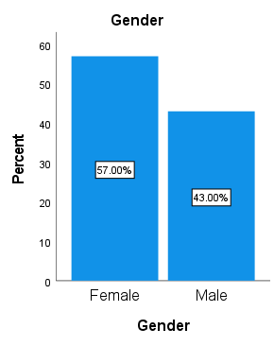

**Figure 1: Diabetes distribution profile on gender**

**Comment:** Among 200 people, 57% were female and 43% were male patients

suffering from DM.

**Diabetic patients’ distribution profile on age:**

Table 2:Diabetic patients’ distribution profile on age:

|  |  |  |  |  |  |
| --- | --- | --- | --- | --- | --- |
| **Age Group** | | | | | |
|  | | **Frequency** | **Percent** | **Valid Percent** | **Cumulative Percent** |
| Valid | 20-30 | **45** | **22.5** | **22.5** | **22.5** |
| 30-40 | **43** | **21.5** | **21.5** | **44.0** |
| 40-50 | **36** | **18.0** | **18.0** | **62.0** |
| 50-60 | **43** | **21.5** | **21.5** | **83.5** |
| 60+ | **33** | **16.5** | **16.5** | **100.0** |
| Total | **200** | **100.0** | **100.0** |  |

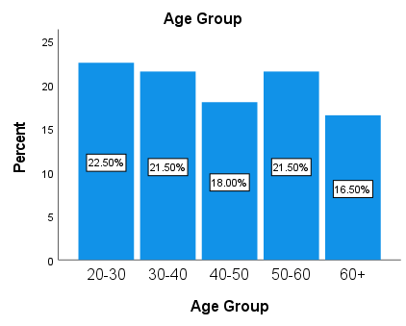

**Figure 2: Diabetic patients’ distribution profile on age**

**Comment:** Among 200 people, 22.5% were in age group 20-30, 21.5% were in

age group 30-40, 18% were in age group 40-50, 21.5% were in age group 50-60,

and remaining were above age 60.

**Diabetic patients’ distribution profile on family history:**

Table 3:Diabetic patients’ distribution profile on family history:

|  |  |  |  |  |  |
| --- | --- | --- | --- | --- | --- |
| **Family History About Diabetes** | | | | | |
|  | | **Frequency** | **Percent** | **Valid Percent** | **Cumulative Percent** |
| **Valid** | **Do not Know** | **77** | **38.5** | **38.5** | **38.5** |
| **No** | **69** | **34.5** | **34.5** | **73.0** |
| **Yes** | **54** | **27.0** | **27.0** | **100.0** |
| **Total** | **200** | **100.0** | **100.0** |  |

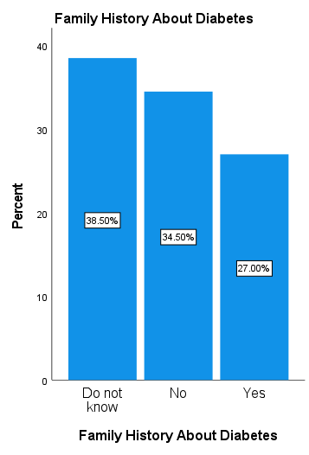

**Figure 3: Diabetic patients based on Family History**

**Comment:** Among 200 people 38.5% were do not about diabetic, 34.5% people were

non diabetic and 27% were diabetic.

**Distribution of diabetic patients based on types of diabetes:**

Table 4: Distribution of diabetic patients based on types of diabetes:

|  |  |  |  |  |  |
| --- | --- | --- | --- | --- | --- |
| **Type of Diabetes Mellitus** | | | | | |
|  | | **Frequency** | **Percent** | **Valid Percent** | **Cumulative Percent** |
| **Valid** | **Do not know** | **59** | **29.5** | **29.5** | **29.5** |
| **Type-1** | **77** | **38.5** | **38.5** | **68.0** |
| **Type-2** | **64** | **32.0** | **32.0** | **100.0** |
| **Total** | **200** | **100.0** | **100.0** |  |

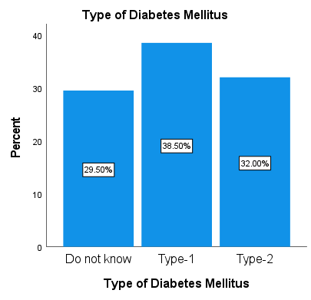

**Figure 4: Distribution based on types of diabetes**

**Comment:** Among 200 people, 29.5% were do not know about types of diabetes, 38.5% were type-1 diabetes and 32% were type-2 diabetes.

**Distribution based on exercise status:**

Table 5: Distribution based on exercise status:

|  |  |  |  |  |  |
| --- | --- | --- | --- | --- | --- |
| **Undertake Physical Exercise** | | | | | |
|  | | **Frequency** | **Percent** | **Valid Percent** | **Cumulative Percent** |
| **Valid** | **Never** | **66** | **33.0** | **33.0** | **33.0** |
| **Regularly** | **67** | **33.5** | **33.5** | **66.5** |
| **Sometimes** | **67** | **33.5** | **33.5** | **100.0** |
| **Total** | **200** | **100.0** | **100.0** |  |

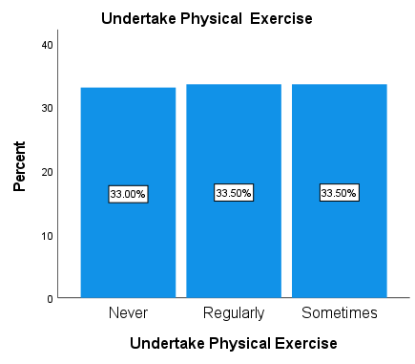

**Figure 5: Distribution based on Physical Exercise**

**Comment:** Among 200 people, 33% were the patients who didn’t take exercise, 33.5% were the patient who took exercise sometimes and 33.5% were the patients who took exercise regularly.

**Distribution based on Types of Physical exercise:**

Table 6: Distribution based on Types of Physical exercise:

|  |  |  |  |  |  |
| --- | --- | --- | --- | --- | --- |
| **Type of Physical Exercise** | | | | | |
|  | | **Frequency** | **Percent** | **Valid Percent** | **Cumulative Percent** |
| **Valid** | **Do not Take** | **47** | **23.5** | **23.5** | **23.5** |
| **Running** | **46** | **23.0** | **23.0** | **46.5** |
| **Walking** | **62** | **31.0** | **31.0** | **77.5** |
| **Weight Training** | **45** | **22.5** | **22.5** | **100.0** |
| **Total** | **200** | **100.0** | **100.0** |  |

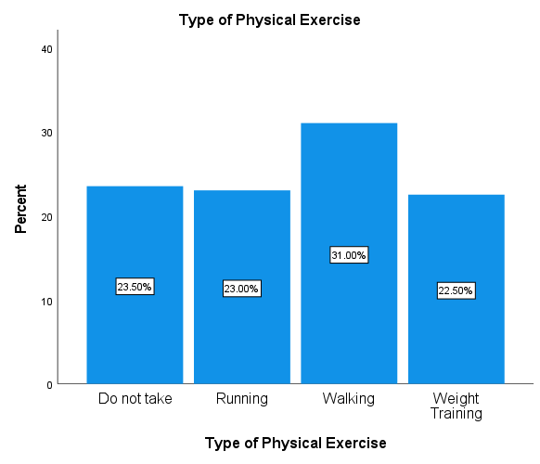

**Figure 6: Distribution based on Types of Physical Exercise**

**Comment:** Among 200 people, 23.5% were the patients who didn’t take exercise, 23% were the patient who took running exercise, 31% were the patients who took walking exercise and 22.5% who took Weight Training exercise.

**Distribution based on dosage of drugs:**

Table 7: Distribution based on dosage of drugs:

|  |  |  |  |  |  |
| --- | --- | --- | --- | --- | --- |
| **Types of Dosages Form of Drugs** | | | | | |
|  | | **Frequency** | **Percent** | **Valid Percent** | **Cumulative Percent** |
| **Valid** | **Capsules** | **62** | **31.0** | **31.0** | **31.0** |
| **Insulin** | **74** | **37.0** | **37.0** | **68.0** |
| **Tablets** | **64** | **32.0** | **32.0** | **100.0** |
| **Total** | **200** | **100.0** | **100.0** |  |

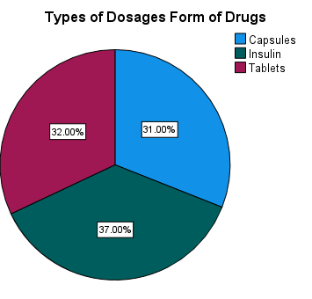

**Figure 7: Distribution based on Types of Dosages Form of Drugs**

**Comment:** Among 200 people, 31% were the patients who use Capsules, 37% were the patient who use Insulin and 32% were the patients who use Tablets.

**Distribution based on Insulin is Taken:**

Table 8: Distribution based on Insulin is Taken

|  |  |  |  |  |  |
| --- | --- | --- | --- | --- | --- |
| **Insulin is Taken Including** | | | | | |
|  | | **Frequency** | **Percent** | **Valid Percent** | **Cumulative Percent** |
| **Valid** | **Actrapid** | **48** | **24.0** | **24.0** | **24.0** |
| **Diasulin 30/70** | **42** | **21.0** | **21.0** | **45.0** |
| **Insulated** | **37** | **18.5** | **18.5** | **63.5** |
| **Novomix 70/80** | **73** | **36.5** | **36.5** | **100.0** |
| **Total** | **200** | **100.0** | **100.0** |  |

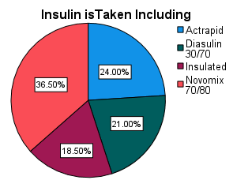

**Figure 8: Distribution based on Insulin is Taken**

**Comment:** Among 200 people, 24% were the patients who use Actrapid, 21% were the patient who use Diasulin 30/70, 18.5% were the patients who use Insulated and 36.5%

were the patients who use Novomix 70/80.

**Distribution based on Prescribed Tablets Including For CvD**

Table 9: Distribution based Prescribed Tablets Including For CvD

|  |  |  |  |  |  |
| --- | --- | --- | --- | --- | --- |
| **Prescribed Tablets Including For CvD** | | | | | |
|  | | **Frequency** | **Percent** | **Valid Percent** | **Cumulative Percent** |
| **Valid** | **Aspirin** | **45** | **22.5** | **22.5** | **22.5** |
| **Glyceryl** | **56** | **28.0** | **28.0** | **50.5** |
| **Others** | **43** | **21.5** | **21.5** | **72.0** |
| **Ramipil** | **56** | **28.0** | **28.0** | **100.0** |
| **Total** | **200** | **100.0** | **100.0** |  |

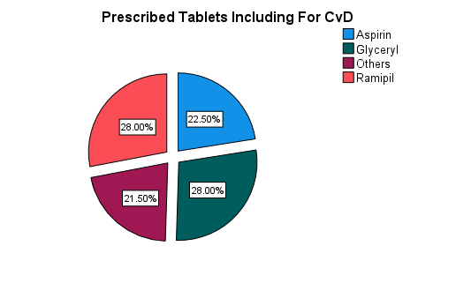

**Figure 9: Distribution based on Tablets For CvD.**

**Comment:** Among 200 people, 22.5% used Aspirin, 28% used by Glyceryl, 28%

used by Ramipil and 21.5% used by others.

**Distribution based on Blood Sugar Level**

Table 10: Distribution based on Blood Sugar Level

|  |  |  |  |  |  |
| --- | --- | --- | --- | --- | --- |
| **Blood Sugar Level Average Per Week** | | | | | |
|  | | **Frequency** | **Percent** | **Valid Percent** | **Cumulative Percent** |
| **Valid** | **10.00-15.00** | **59** | **29.5** | **29.5** | **29.5** |
| **15.00- Above** | **51** | **25.5** | **25.5** | **55.0** |
| **6.00-7.00** | **36** | **18.0** | **18.0** | **73.0** |
| **7.00-10.00** | **54** | **27.0** | **27.0** | **100.0** |
| **Total** | **200** | **100.0** | **100.0** |  |

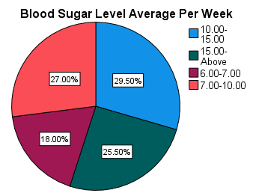

**Figure 10: Distribution based on Blood Sugar Level**

**Comment:** Among 200 people, 29.5% Average Per Week is 10-15, 25.5% Average Per Week is 15-Above, 18% Average Per Week is 6-7 and 27% Average Per Week is 7-10.

**Distribution based on Heart Disease**

Table 11: Distribution based on Heart Disease

|  |  |  |  |  |  |
| --- | --- | --- | --- | --- | --- |
| **Heart Disease Occurred** | | | | | |
|  | | **Frequency** | **Percent** | **Valid Percent** | **Cumulative Percent** |
| **Valid** | **No** | **111** | **55.5** | **55.5** | **55.5** |
| **Yes** | **89** | **44.5** | **44.5** | **100.0** |
| **Total** | **200** | **100.0** | **100.0** |  |

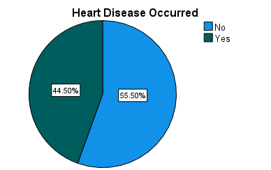

**Figure 11: Distribution based on Heart Disease**

**Comment:** Among 200 people, 55.5% were the patients who didn’t have Heart

Disease and 44.5% were the patients who did have Heart Disease.

**Analysis of CrossTabulation:**

**Age Group * Type of Diabetes Mellitus Crosstabulation**

|  |  |  |  |  |  |
| --- | --- | --- | --- | --- | --- |
|  | | Type of Diabetes Mellitus | | | Total |
| Do not Know | Type-1 | Type-2 |
| Age Group | 20-30 | 15 | 17 | 13 | 45 |
| 30-40 | 11 | 17 | 15 | 43 |
| 40-50 | 8 | 16 | 12 | 36 |
| 50-60 | 14 | 15 | 14 | 43 |
| 60+ | 11 | 12 | 10 | 33 |
| Total | | 59 | 77 | 64 | 200 |

|  |  |  |  |  |  |  |  |  |  |  |  |  |  |  |  |  |  |  |  |  |  |  |  |  |
| --- | --- | --- | --- | --- | --- | --- | --- | --- | --- | --- | --- | --- | --- | --- | --- | --- | --- | --- | --- | --- | --- | --- | --- | --- |
| |  |  |  |  | | --- | --- | --- | --- | | **Chi-Square Tests** | | | | |  | Value | df | Asymptotic Significance (2-sided) | | Pearson Chi-Square | 2.230a | 8 | .0473 | | Likelihood Ratio | 2.273 | 8 | .0371 | | N of Valid Cases | 200 |  |  | | a. 0 cells (0.0%) have expected count less than 5. The minimum expected count is 9.74. | | | | |

|  |  |  |  |  |  |
| --- | --- | --- | --- | --- | --- |
| **Prescribed Tablets Including * Types of Dosages Form of Drugs CrossTabulation** | | | | | |
|  | | | | | |
|  | | Types of Dosages Form of Drugs | | | Total |
| Capsules | Insulin | Tablets |
| Prescribed Tablets Including | Aldorin | 0 | 2 | 0 | 2 |
| Angkor 5 | 1 | 0 | 0 | 1 |
| Hypen SR | 2 | 2 | 0 | 4 |
| Linatab 2.5/500 | 0 | 0 | 1 | 1 |
| Aldorin | 18 | 12 | 14 | 44 |
| Angkor 2.5 | 10 | 18 | 16 | 44 |
| Angkor 5 | 11 | 12 | 8 | 31 |
| Hypen SR | 8 | 14 | 10 | 32 |
| Linatab 2.5/500 | 10 | 11 | 11 | 32 |
| Osartil 50 | 2 | 3 | 4 | 9 |
| Total | | 62 | 74 | 64 | 200 |

|  |  |  |  |
| --- | --- | --- | --- |
| **Chi-Square Tests** | | | |
|  | Value | df | Asymptotic Significance (2-sided) |
| Pearson Chi-Square | 15.796a | 18 | .0207 |
| Likelihood Ratio | 17.895 | 18 | .0463 |
| N of Valid Cases | 200 |  |  |
| a. 15 cells (50.0%) have expected count less than 5. The minimum  expected count is .31. | | | |

|  |  |  |  |  |  |  |
| --- | --- | --- | --- | --- | --- | --- |
| **Prescribed Tablets Including * Insulin is Taken Including Crosstabulation** | | | | | | |
|  | | | | | | |
|  | | Insulin is Taken Including | | | | Total |
| Actrapid | Diasulin 30/70 | Insulated | Novomix 70/80 |
| Prescribed Tablets Including | Aldorin | 0 | 0 | 1 | 1 | 2 |
| Angkor 5 | 0 | 1 | 0 | 0 | 1 |
| Hypen SR | 1 | 1 | 0 | 2 | 4 |
| Linatab 2.5/500 | 0 | 0 | 1 | 0 | 1 |
| Aldorin | 9 | 9 | 8 | 18 | 44 |
| Angkor 2.5 | 10 | 11 | 8 | 15 | 44 |
| Angkor 5 | 9 | 5 | 4 | 13 | 31 |
| Hypen SR | 12 | 4 | 5 | 11 | 32 |
| Linatab 2.5/500 | 5 | 8 | 9 | 10 | 32 |
| Osartil 50 | 2 | 3 | 1 | 3 | 9 |
| Total | | 48 | 42 | 37 | 73 | 200 |

|  |  |  |  |
| --- | --- | --- | --- |
| **Chi-Square Tests** | | | |
|  | Value | Df | Asymptotic Significance (2-sided) |
| Pearson Chi-Square | 21.266a | 27 | .0174 |
| Likelihood Ratio | 20.598 | 27 | .0205 |
| N of Valid Cases | 200 |  |  |
| a. 20 cells (50.0%) have expected count less than 5. The minimum expected count is .19. | | | |

**Comment:**

**Age Group VS Type of diabetes mellitus:**

The significance (p) value for Age Group is 0.04 which is less than P value 0.05.Hence Age

Group have significant impact on affecting by any type of diabetes mellitus.

**Prescribed Tablets Including VS Types of Dosages Form of Drugs:**

The significance (p) value for Prescribed Tablets Including is 0.02 which is less than P value 0.05.

Hence Prescribed Tablets Including have significant impact on affecting by any type of

Types of Dosages Form of Drugs.

**Prescribed Tablets Including VS Insulin is Taken Including:**

The significance (p) value for Prescribed Tablets Including is 0.01 which is less than P value 0.05.

Hence Prescribed Tablets Including have significant impact on affecting by any type of

Insulin is Taken.

***Chapter Five***

# DISCUSSION

#### Diabetes distribution profile on gender.

Among 200 people, 57% were female and 43% were male patients suffering from DM.

#### Diabetic patients’ distribution profile on age.

Among 200 people, 22.5% were in age group 20-30, 21.5% were in age group 30-40, 18%

were in age group 40-50, 21.5% were in age group 50-60, and remaining were above age 60.

**Diabetic patients based on Family History**

Among 200 people 38.5% were do not about diabetic, 34.5% people were non diabetic

and 27% were diabetic.

**Distribution based on types of diabetes**

Among 200 people, 29.5% were do not know about types of diabetes, 38.5% were

type-1 diabetes and 32% were type-2 diabetes.

**Distribution based on Physical Exercise**

Among 200 people, 33% were the patients who didn’t take exercise, 33.5% were

the patient who took exercise sometimes and 33.5% were the patients who took exercise regularly.

**Distribution based on Types of Physical Exercise**

Among 200 people, 23.5% were the patients who didn’t take exercise, 23%

were the patient who took running exercise, 31% were the patients who took walking exercise

and 22.5% who took Weight Training exercise.

#### Mostly prescribed insulin for the diabetic patients.

Among 200 people, 24% were the patients who use Actrapid, 21% were the patient who use

Diasulin 30/70, 18.5% were the patients who use Insulated and 36.5% were the patients who

use Novomix 70/80.

#### Different Types of dosage form are used in diabetic patients.

Among 200 people, 31% were the patients who use Capsules, 37% were the patient who use

Insulin and 32% were the patients who use Tablets.

#### Use of drugs in diabetic patients suffering from cardiovascular disease.

Among 200 people, 22.5% used Aspirin, 28% used by Glyceryl, 28% used by

Ramipil and 21.5% used by others.

**Distribution based on Blood Sugar Level**

Among 200 people, 29.5% Average Per Week is 10-15, 25.5% Average Per Week

is 15-Above, 18% Average Per Week is 6-7 and 27% Average Per Week is 7-10

**Distribution based on Heart Disease**

Among 200 people, 55.5% were the patients who didn’t have Heart Disease

and 44.5% were the patients who did have Heart Disease.

***Chapter Six***

# CONCLUSION

#### Conclusion:

The leading cause of deaths in Bangladeshi people is diabetes. In my current study 44.5% were the patients who did have Heart disease and many patients suffering from Cardiovascular diseases. Combination therapy pattern for the treatment of diabetic patients suffering from cardiovascular diseases is stated in this study.We can reduce the risk of diabetes and cardiovascular disease by avoiding of tobacco use, reducing of salt in the diet, doing regular physical exercise, avoiding harmful use of alcohol. We can also prevent heart disease & stroke through healthy diet, choosing a diet rich in fruits and vegetables, maintaining a healthy body weight, avoiding obesity and avoiding foods that are high in fat, sugar and salt. Preventing or treating hypertension and raised blood lipids are also helpful to reduce the diabetic risk. In coming days, pharmacogenomics capabilities will help to understand diseases in terms of specific genetic contributors. This plaque may be under control in near future by the development of effective new drugs based on pharmacogenomics capabilities.

***Chapter Seven***

# REFERENCES

# 

#### References:

Agarwal G, Kaczorowski J, and Hanna S,2012 “Care for patients with type 2 diabetes in a random sample of community family practices in Ontario, Canada,” *International Journal of Family Medicine, vol. 2012, Article ID 734202,*2011, Saudi Hypertension Management Society Guidelines, : *Synopsis, Saudi Hypertension Management Society, Riyadh, Saudi Arabia, 3rd edition*, 2012, Healthcare Quality Improvement Partnership (HQIP), “National Diabetes Audit 2010-2011 Report 1: *Care Processes and Treatment Targets,” United Kingdom, Health and Social Care Information Centre*,

Ahern JA, Ramchandani N, Cooper J, Himmel A, Silver D, Tamborlane WV: 2000 Using a primary nurse manager to implement DCCT recommendations in a large pediatric program. *Diabetes Educ*26:990–994,

Ahmann AJ, Riddle MC: . Leahy JL, Clarck NG, Cefalu WT, 2000,Oralhypoglycemic agents. In Medical Management of Diabetes Mellitus *Eds. NewYorkInc, p. 267–283*

Ahmann AJ, Riddle MC: 2002 Current oral agents for type 2 diabetes. *Post Grad Med 111:32–34, 37–40, 43–46,*

Al-Daghri N.M, Al-Attas O.S, Alokail M.S.et al.2011. , “Diabetes mellitus type 2 and other chronic non-communicable diseases in the central region, *Saudi Arabia (riyadh cohort 2): a decade of an epidemic,” BMC Medicine, vol. 9, article 76*

Alhyas L, McKay A, Balasanthiran A, and Majeed A,2011. “Prevalences of overweight, obesity, hyperglycaemia, hypertension and dyslipidaemia in the Gulf: systematic review,” *Journal of the Royal Society of Medicine, vol. 2, no. 7, article 55,*

Al-Khaldi Y.M 2011, “Quality of hypertension care in the family practice center, Aseer Region, Saudi Arabia,” *Journal of Family and Community Medicine, vol. 18, no. 2,*

*pp. 45–48,*

Al-Maatouq M, Al-Arouj M, Assaad S.H et al.2010, “Optimising the medical management of hyperglycaemia in type 2 diabetes in the Middle East: pivotal role of metformin,” *International Journal of Clinical Practice, vol. 64, no. 2, pp. 149–159,*

Al-Maatouq M. and Aftab S.A, Maatouq A, 2010 Manual of Diabetes Practice, *Author House, Milton Keynes, UK*,.

Al-Nozha M.M, Al-Maatouq M.A, Al-Mazrou Y.Y et al.2004, “Diabetes mellitus in Saudi Arabia,” *Saudi Medical Journal, vol. 25, no. 11, pp. 1603–1610.*

Alqurashi K.A., Aljabri K.S., and Bokhari S.A, “Prevalence of diabetes mellitus in a Saudi community*,” Annals of Saudi Medicine, vol. 31, no. 1, pp. 19–23, 2011. View at Publisher ·*

Al-Turki Y.A,2000 “The prevalence of overweight and obesity amongst hypertensive and diabetic adult patients in primary health care,” *Saudi Medical Journal, vol. 21, no. 4,*

*pp. 340–343*

American Diabetes Association. Standards of medical care in diabetes—2007. *Diabetes Care;30:S4-41.*

Barton S.2000 Which clinical studies provide the best evidence? *BMJ;321:255-6.*.

Bassiony M.M,2009, “Smoking in Saudi Arabia,” *Saudi Medical Journal, vol. 30, no. 7, pp.*

*876–881,* 2012 Action on Smoking and Health, “*ASH fact: smoking and diabetes*,”

Bell DSH.2006, Do sulfonylurea drugs increase the risk of cardiac events? *Can Med Assoc J;174:185-6.*

Betteridge DJ, DeFronzo RA, Chilton RJ.2008, PROactive: time for a critical appraisal. *Eur Heart J;29:969-83*.

Boyc K.S., Yurgin N, and Lage M.J .2007, “Trends in the prescription of antidiabetic medications in France: *evidence from primary care physicians,” Advances in Therapy, vol. 24, no. 4, pp. 803–813*.