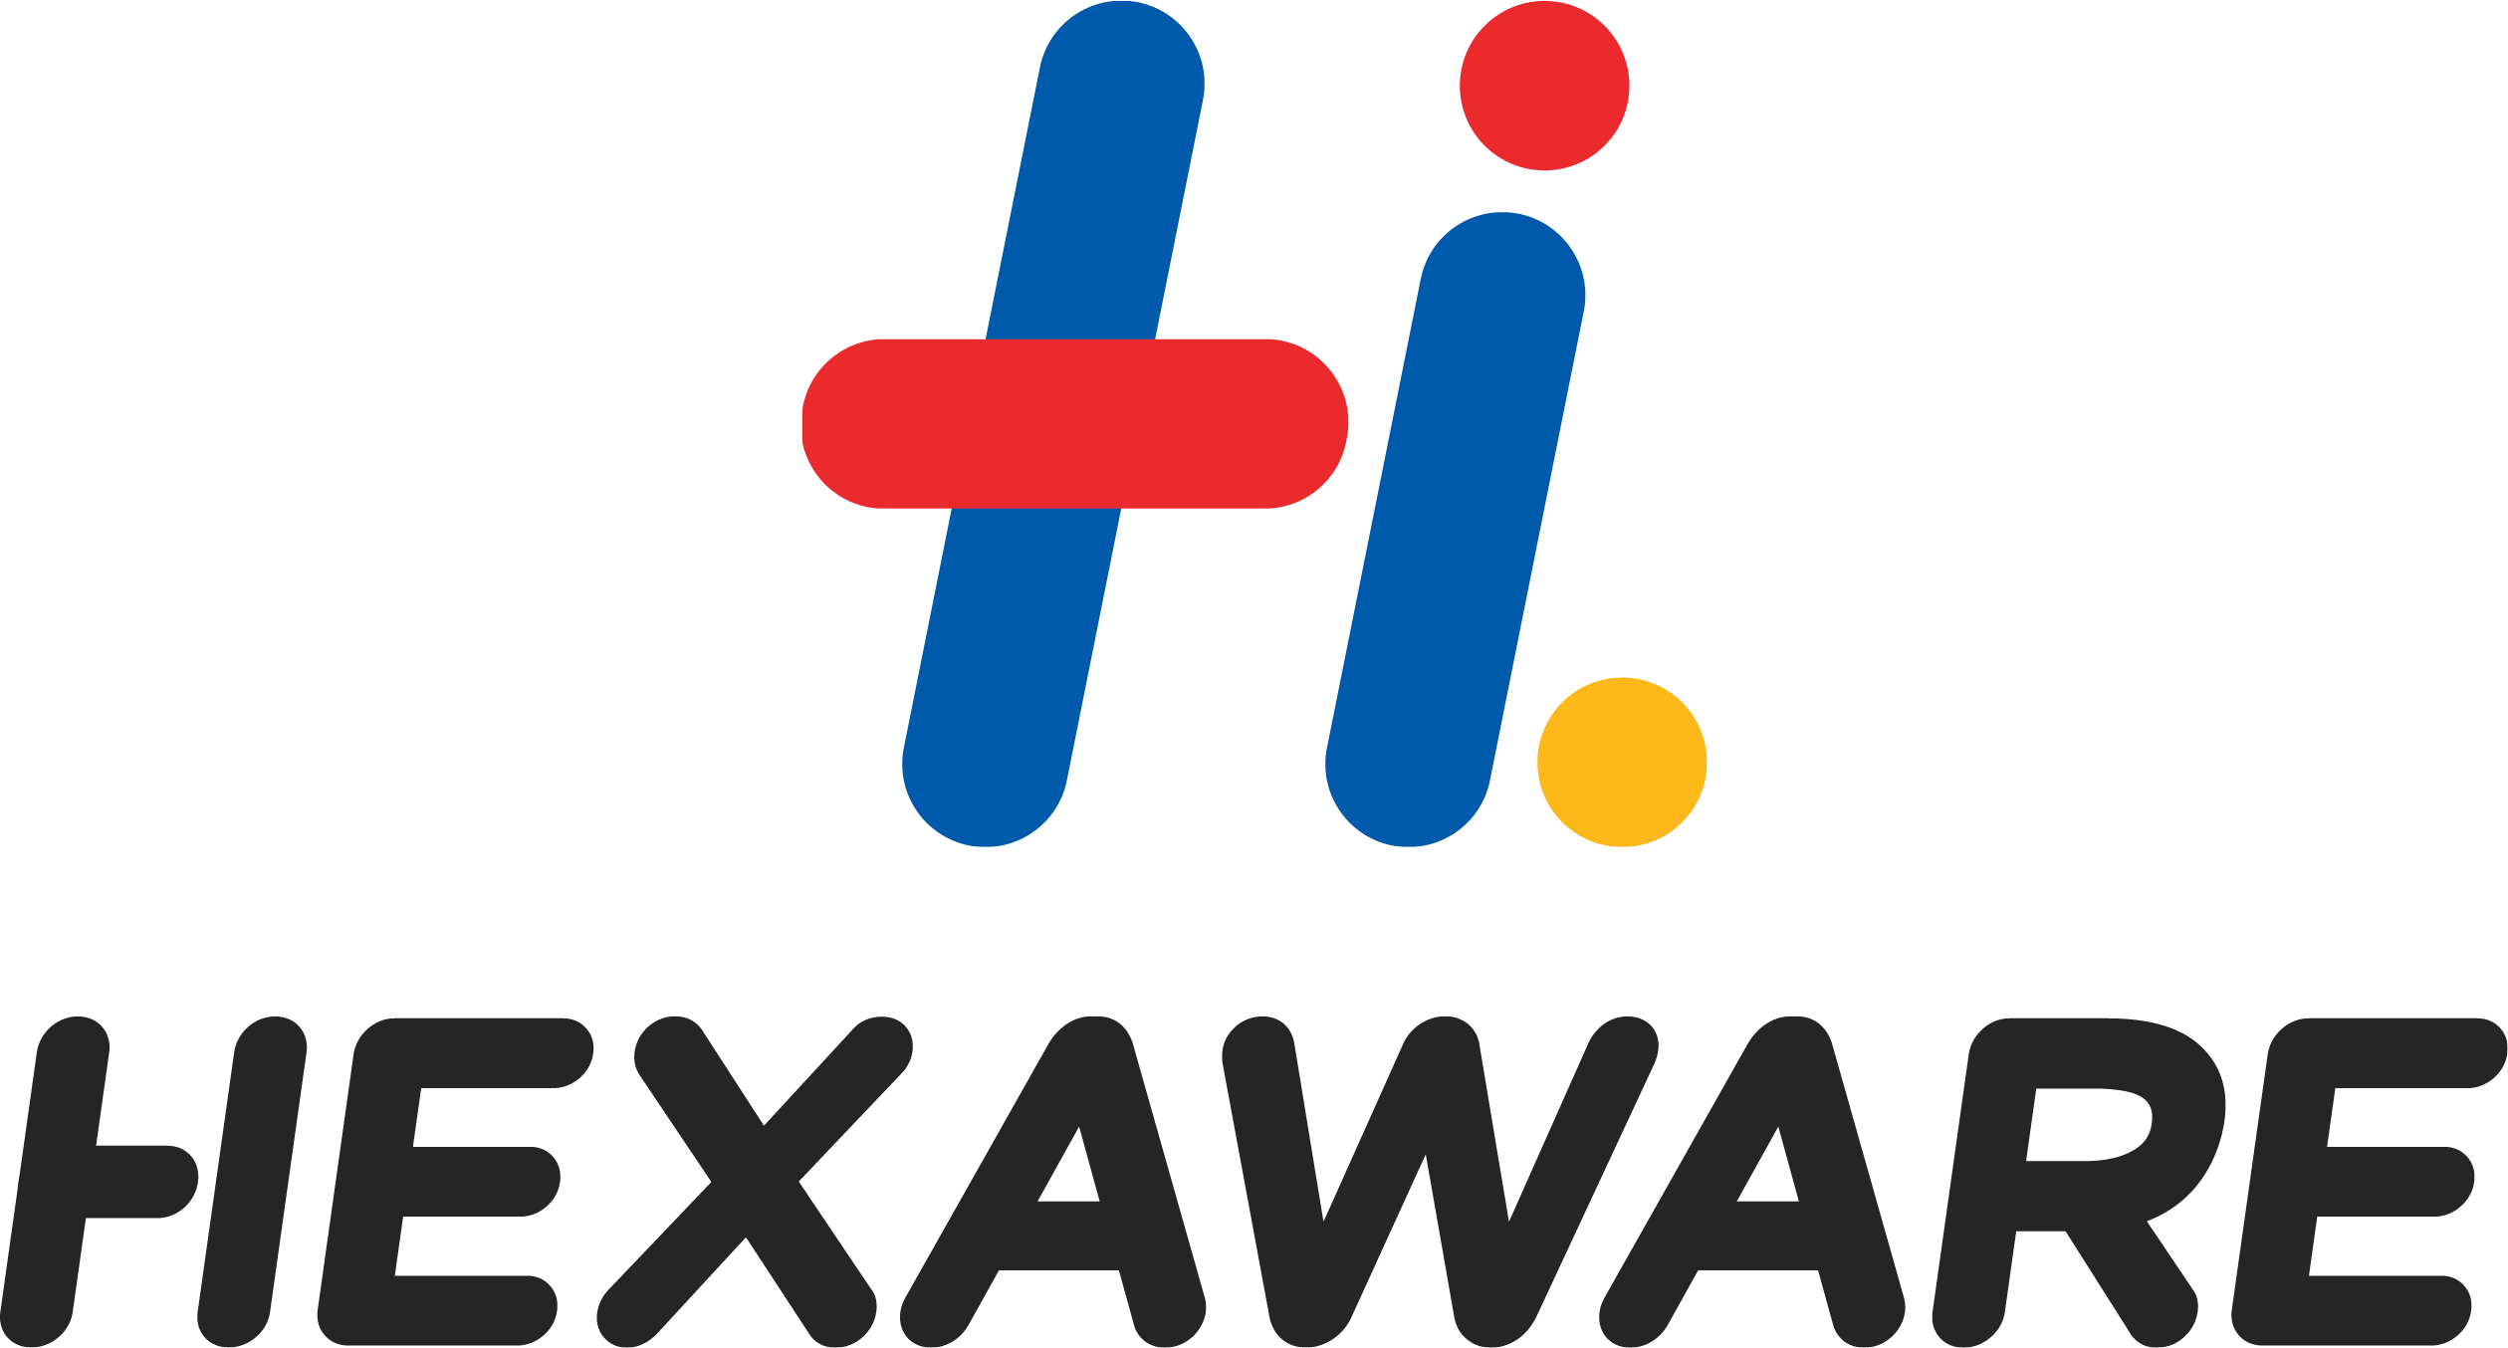

HR / December 03/ 49559 December 03, 2021

SERVICE CERTIFICATE

1. **Name of Employee : Vinayak Anvekar**
2. **Employee No. : 49559**
3. **Designation at the time of leaving : System Analyst**
4. **Date of Joining : 09 Oct 2019**
5. **Date of leaving : 09 Jul 2021**
6. **Last drawn Salary (Per Annum) : 1400000.00 INR**
7. **Reason for leaving : Personal Reason**
8. **Conduct : Good**
9. **Remarks : Nil**

Yours sincerely,

For Hexaware Technologies Limited

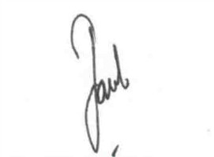

Jacob P.U.

Vice President - HR

