The user interface looks and behaves in the following way:

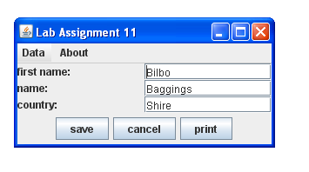

JLabel

JTextField

JButton

* The application has six String values:
  + three constants that save the initial values of the first name, the name and the country.
  + three strings that save the values of the first name, the name and the country.
* The text in the JTextField fields can be modified.
* After pushing the **save** button the text of the JTextField fields is read and saved in the three strings.
* After pushing the **cancel** button, the text in the JTextField fields is replaced by the values in the saved strings. (not the initial values!)
* After pushing the **print**button the text in the JTextField fields is saved to the strings and printed on the Terminal window of BlueJ (System.out.println()).

The menu item **Data** has a sub menu:

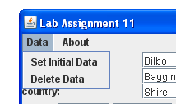

* With **Set Initial Data** the initial string values of first name, name and country are copied to the strings and displayed.
* With **Delete Data** the three strings are set to null.
* With **About** the following message box is displayed (write your own text):

