WRANGLE AND ANALYZE DATA PROJECT 3

Act Report

**Introduction**

We will analyze the tweets of the WeRateDogs account, and trying to find out some insights and create some visualizations to communicate our findings.

**Analysis and Visualizations**

**1.**

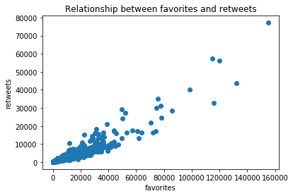

As we can see in the plot that there is a strong positive relationship between the favorites and retweets of a tweet. And that means that they have direct proportional or correlation between them. So, whenever one of them increase the other will increase also and vice versa.

**2.**

The pie chart shows that the most popular stage of dogs is pupper with ratio of more than a half. Coming after it doggo stage. And in the third place is puppo stage. And finally, in the last place is floofer.

**3.**

We can figure out that the highest rating among dog stages is floofer and puppo. And after that by small difference doggo stage. And it’s not expected that pupper stage will have the least rating. Since it’s the most popular dog stage.

**4.**

We can observe that it usually the favorites of a tweet go up whenever you upload more images. Since as it shown in figure that the tweets that have only one image of the dog have the least number of favorites. As opposed to that,

whenever you upload more images with the tweet it’s more likely to get more favorites.