Predicting Traffic Congestion in Riyadh and Estimating Its CO2 Cost
Faisal Almusallam  ID: 223110267  College of Computer and Information Sciences  Prince Sultan University  Riyadh, Saudi Arabia | Abdulrahaman bin Saeed  ID: 223110148  College of Computer and Information Sciences  Prince Sultan University  Riyadh, Saudi Arabia
CS316 Introduction to AI and Data Science, Term 261

Abstract—Traffic congestion in Riyadh wastes time, but it also wastes fuel and adds CO2 to the air. Since we could not find a public dataset of Riyadh traffic over time, we built our own by asking the TomTom Traffic Flow API about 13 main roads and saving the answers with GitHub Actions. We collected 4,810 readings between 24 October and 8 November 2026. We used them to find the worst roads and hours, to predict the congestion level of each road (low, moderate, high, severe) and to estimate the extra CO2 per car. A simple baseline that repeats the last level already reaches 80.7% accuracy, and the best model (a random forest) was only a little better (81.7%). A random forest tuned with balanced class weights kept 80.8% accuracy and almost the same macro F1 as the baseline, but found 11 of the 16 severe cases instead of 9. Because TomTom does not give car counts, we also used the UCI Metro Interstate Traffic Volume dataset to predict hourly traffic (R² = 0.987, against 0.891 for a same-hour-last-week baseline), cluster days with K-means and simulate moving drivers out of the rush hour. Moving 20% of peak drivers to the hours around the peak reduced the extra CO2 by about 23%.
Index Terms—traffic congestion, machine learning, classification, random forest, K-means, CO2 emissions, Riyadh
I. Introduction
Anyone who drives in Riyadh knows the afternoon rush on the ring roads. Being stuck in traffic wastes time, but a car in stop and go traffic also burns more fuel than a car moving at a steady speed, so every jam puts extra CO2 into the air. Building more roads is expensive and often just brings more cars, so using the roads we already have in a better way is a cheaper option. To do that, we first need to know when and where the congestion happens and how much it costs.
In this project we use machine learning to answer three questions. Which roads and hours in Riyadh are the worst? Can we predict how congested a road will be in the next reading? And how much CO2 is wasted, and how much could be saved if some drivers left one hour earlier or later? The project is related to SDG 11 (sustainable cities), SDG 13 (climate action), SDG 3 (health) and SDG 9 (infrastructure) [1], and to the quality of life goals of Vision 2030.
Our main contribution is the Riyadh dataset itself, which we collected and shared on GitHub. The rest of the report reviews related work (Section II), explains the data (Section III) and the methodology (Section IV), gives the results (Section V) and summarizes the main insights and limitations (Section VI).
II. Related Works
Short-term traffic prediction has been studied for a long time. Williams and Hoel [2] modelled highway traffic flow as a seasonal ARIMA process and showed that the daily and weekly patterns make the flow very predictable. Later work used machine learning and deep learning on large sensor datasets, for example the stacked autoencoder model of Lv et al. [3], and found that models with recent and seasonal history beat simple statistical models. Our UCI regression follows the same idea with lag features of 1, 24 and 168 hours.
On emissions, Barth and Boriboonsomsin [4] showed that CO2 per kilometre is high in stop and go traffic and that reducing severe congestion can cut emissions noticeably. Most of these studies use loop detectors in the US or Europe. For Riyadh we found no public time series of road speeds, which is why we collected our own data from TomTom.
III. Data
A. Riyadh Data (Collected by Us)
The Riyadh Municipality open data only has yearly and monthly totals like the number of roads and traffic signs [5], so it could not be used to study congestion by hour. Instead we wrote a small Python script (riyadh_collector.py) that asks the TomTom Traffic Flow API [6] about one point on each of 13 main roads: King Fahd Rd, the Northern, Eastern, Southern and Western ring roads, Makkah Rd, Khurais Rd, King Abdullah Rd, King Abdulaziz Rd, Prince Turki Rd, King Khalid Rd, Takhassusi St and Olaya St. For each road it saves the time, the current speed, the free-flow speed (the normal speed with no traffic), the current and free-flow travel times, a confidence value and a road closure flag. A GitHub Actions workflow runs the script on a schedule and commits the new rows to data/riyadh_traffic.csv.
We set the schedule to every 15 minutes, but GitHub does not keep to it for free accounts. From 24 October to 2 November it ran about every 30 to 45 minutes (around 35 runs a day), and from 3 November it only ran about 4 times a day (Fig. 1). We stopped the collection after 8 November, so in total we have 370 runs and 4,810 rows. We used all of them for the analysis, but for the prediction models we only used readings that come less than 70 minutes after the previous one, which is mostly 25 October to 2 November. Fig. 2 shows where the 13 measurement points are.
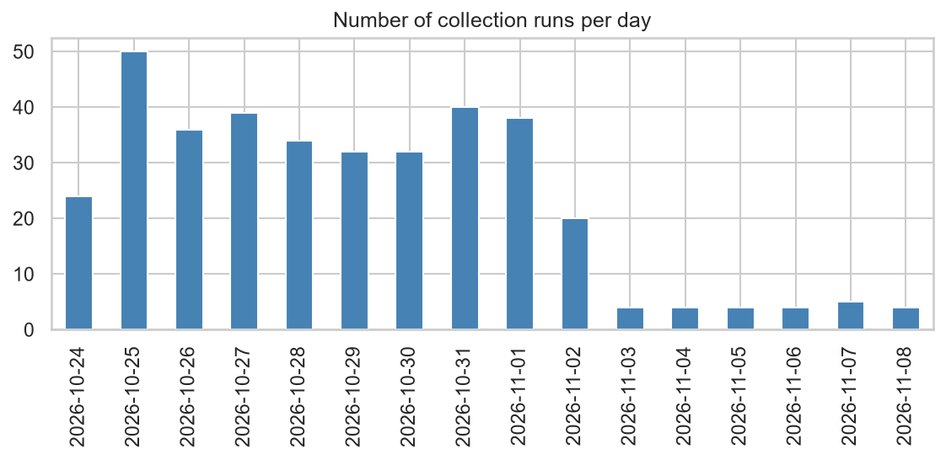
Fig. 1. Number of collection runs per day. After 2 November GitHub only ran the workflow about 4 times a day.
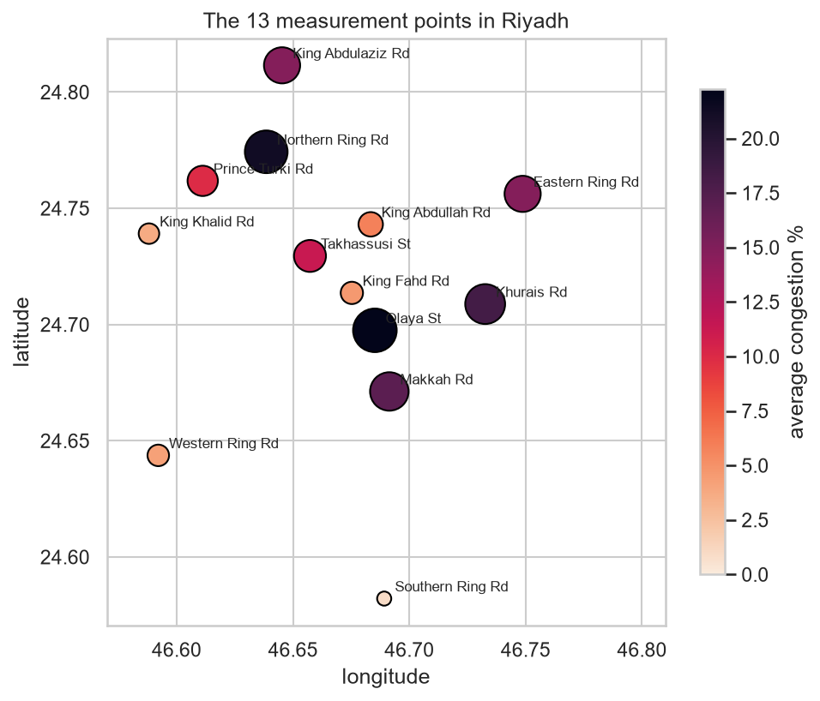
Fig. 2. The 13 measurement points in Riyadh. The size and color of each dot show the average congestion.
B. UCI Metro Interstate Traffic Volume
TomTom gives speeds but not the number of cars. For the parts that need car counts and a long history we used the Metro Interstate Traffic Volume dataset from the UCI repository [7]. It has 48,204 hourly rows from 2012 to 2018 for the westbound I-94 highway in the US, with the traffic volume, holidays, temperature, rain, snow, clouds and weather type.
C. Cleaning
In the Riyadh data there were no repeated rows and no readings with zero speed. TomTom marked 744 readings as closed even though the cars were moving normally (we think these are lane closures, for example for the metro works), so we kept them. Congestion was calculated as 100 × (1 − current speed / free-flow speed) and the delay as the current travel time minus the free-flow travel time. Negative values were set to 0. The weekend in Saudi Arabia is Friday and Saturday.
The UCI data needed more work. The holiday name was only written on the midnight row, so we copied it to the whole day. Ten rows had a temperature of 0 K and one row had 9,831 mm of rain in one hour, which are sensor errors. There were 7,629 repeated hours (one row for each weather type) and 11,976 missing hours. We kept one row per hour and put the data on a full hourly grid, so the lag features really mean one hour or one day before. Using smaller data types (float32, int16, int8 and category) and reading the file in chunks reduced the memory from 11.7 MB to 1.2 MB (the code is in the Appendix).
IV. Methodology
A. Features and Congestion Levels
For each Riyadh reading we used these features: the hour (also as sine and cosine, so 23:00 and 00:00 are close), the day of the week, a weekend flag, the road (one hot), the congestion in the last two readings of the same road, the change between them (trend), the congestion about 24 hours before, and the usual congestion of that road at that hour. We calculated the usual congestion from the training days only. For training rows we also left out the row’s own day, because otherwise the feature already contains the answer. The target is the level: Low (less than 15% slower than free-flow), Moderate (15–35%), High (35–60%) and Severe (more than 60%). Most readings are Low (about two thirds) and only 1.4% are Severe.
B. Models and Validation
We compared logistic regression, a decision tree, KNN (k = 15), a random forest [8] and histogram gradient boosting from scikit-learn [9]. The baseline simply says the level will stay the same as the previous reading. We split the data by time: 25–30 October for training (2,535 rows) and 31 October to 2 November for testing (1,261 rows). A random split would let the model learn from readings that come after the test readings. We report accuracy and the macro precision, recall and F1, because accuracy alone looks good even if the model ignores the small classes. The random forest was tuned with GridSearchCV using TimeSeriesSplit (4 folds), so every validation fold comes after its training part, and macro F1 as the score. To see which features matter we used permutation importance.
C. Extra CO2 per Car
Without car counts we can only estimate CO2 for one car. We assumed a car in congestion uses 0.4 gallons of fuel per hour of delay, and used the EPA value of 8.887 kg of CO2 per gallon [10]. This gives about 59 g of CO2 for every minute of delay. For every road we found the worst hour on workdays and compared it with going one hour earlier or later.
D. UCI Models and Peak Shift Simulation
On the UCI data we predicted the number of cars in the next hour with linear regression, random forest and gradient boosting, training on 2012–2017 and testing on 2018. We added lags of 1, 24 and 168 hours. For the weather we used the previous hour, because the weather of the hour being predicted is not known in advance. We compared the models with two baselines: the count of the last hour and the count of the same hour one week before. For clustering, every day became a vector of 24 hourly counts, and we chose k for K-means using the elbow method and the silhouette score, then plotted the days with PCA.
To turn car counts into delay we used the BPR function [11], t = t₀(1 + 0.15(v/c)⁴), with an assumed capacity c of 7,500 cars per hour and t₀ for one mile at 65 mph. Then for every weekday in 2018 with all 24 hours measured (182 days, holidays excluded) we moved a share of the real cars in the 3 morning and 3 evening peak hours to other hours, in two ways. In the naive way half go one hour earlier and half one hour later. In the smart way they are spread over the two hours before and the two hours after the peak, and hours with more free capacity get more cars. The total number of cars stays the same.
V. Results
A. When and Where Riyadh Is Congested
The average congestion over all readings was 11.5%. The roads with the highest average were Olaya St (22%), Northern Ring Rd near KAFD (21%) and Khurais Rd (18%), and the lowest was Southern Ring Rd (1%). Northern Ring Rd and Eastern Ring Rd were more than 40% slower than normal about 20% of the time. Fig. 3 shows that on workdays the evening is much worse than the morning. The morning peak is at 9 AM (15%) but the evening peak at 5 PM reaches 29%. The single worst road and hour was Eastern Ring Rd at 5 PM (about 80% slower than normal, Fig. 4).
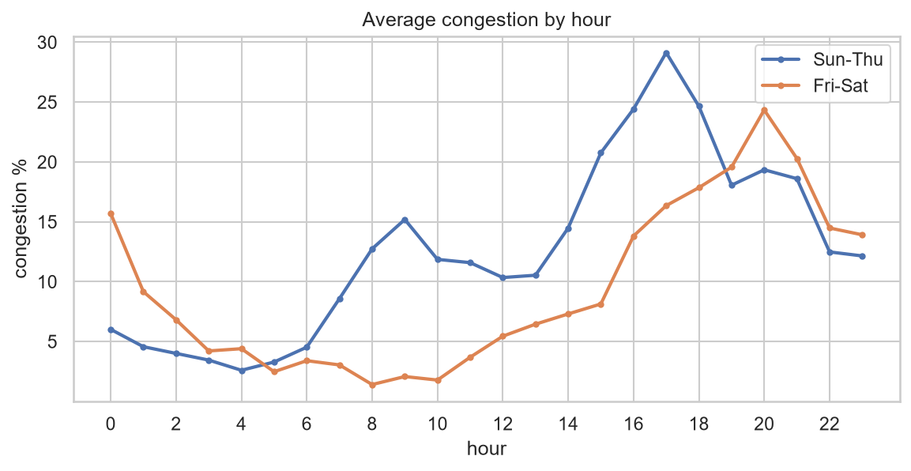
Fig. 3. Average congestion by hour for workdays and weekends.
Something we did not expect was that weekends have almost the same average congestion as workdays (11.1% vs 11.6%). The traffic does not go away, it moves to the night. On Friday and Saturday the roads are empty in the morning, the peak is around 8 PM (24%) and it is still busy at midnight.
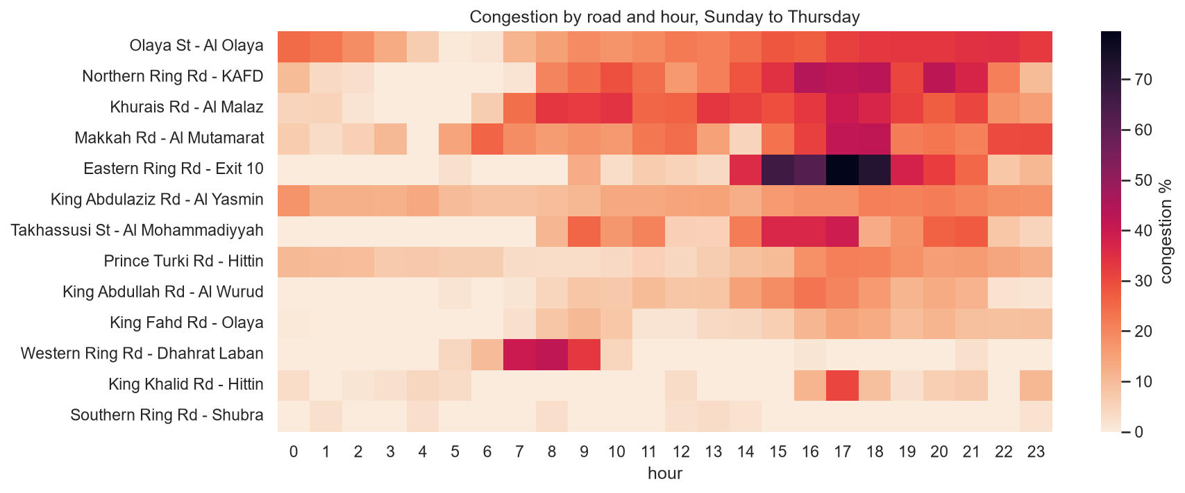
Fig. 4. Congestion by road and hour, Sunday to Thursday.
B. Predicting the Congestion Level
Table I shows the results on the test days. The untuned random forest had the highest accuracy (81.7%), which meets the 80% target from our proposal, but the baseline already gets 80.7% and has the highest macro F1 of all (0.685). So, measured by F1, no model clearly beats the baseline. Congestion does not change much in 30 to 45 minutes, so the last reading is a very strong guess, and the models can only help when the level is about to change. With about six training days there are few examples of such changes, and the test set has only 16 Severe readings.
TABLE I
Congestion level results on the test days (31 Oct – 2 Nov)
Model | Accuracy | Precision | Recall | F1
Baseline (last level) | 0.807 | 0.690 | 0.680 | 0.685
Logistic regression | 0.810 | 0.713 | 0.624 | 0.648
Decision tree | 0.792 | 0.708 | 0.623 | 0.658
KNN (k = 15) | 0.810 | 0.693 | 0.606 | 0.638
Random forest | 0.817 | 0.715 | 0.633 | 0.661
Gradient boosting | 0.807 | 0.700 | 0.617 | 0.652
Random forest (tuned) | 0.808 | 0.654 | 0.713 | 0.679

The grid search chose balanced class weights, a maximum depth of 10, at least 3 samples per leaf and 400 trees. This tuned model keeps 80.8% accuracy, has almost the same F1 as the baseline (0.679) and the highest recall (0.713). As Fig. 5 shows, it found 11 of the 16 Severe readings, while the baseline and the untuned forest found 9. For a system that warns drivers, missing a severe jam is worse than a false alarm, so we think the tuned model is the most useful one.
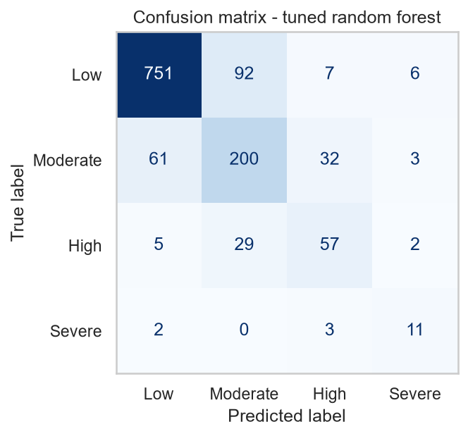
Fig. 5. Confusion matrix of the tuned random forest on the test days.
Permutation importance showed that the previous reading was the most important feature, followed by the road and the usual congestion of the road at that hour. The congestion the day before and the hour by itself added almost nothing, because the usual value already includes the hour.
C. Extra CO2 per Car in Riyadh
Fig. 6 shows the delay at the worst workday hour of each road and one hour away. The biggest delays on our road sections were on King Abdulaziz Rd at 8 PM (5.5 minutes, about 320 g of CO2 per car), King Abdullah Rd at 4 PM and Prince Turki Rd at 5 PM. On average a driver saves 45 g of CO2 per trip by going one hour earlier or later, and up to 83 g on Northern Ring Rd. These numbers are only for the short section that TomTom measures, a full trip across the city would cost more.
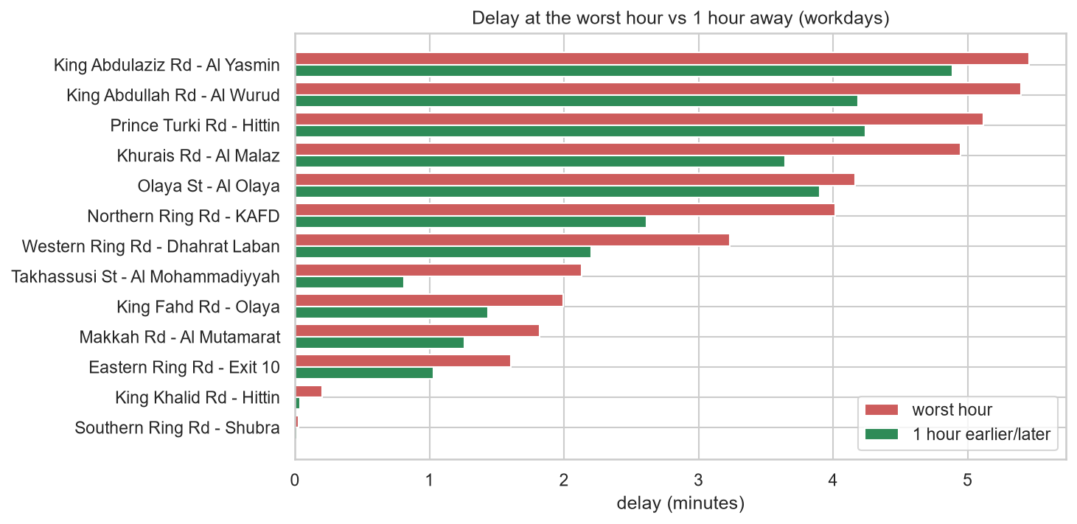
Fig. 6. Delay at the worst workday hour compared with one hour earlier or later.
D. UCI Results
Table II shows that gradient boosting predicted the next hour of traffic with R² = 0.987 and an MAE of 144 cars per hour. This is less than half the error of linear regression and much better than the two baselines (MAE of 591 for the last hour and 339 for the same hour last week), so the model learns more than copying the recent past. K-means picked k = 3 (k = 2 only splits weekdays from weekends): normal weekdays with two peaks, weekends with one wide peak in the middle of the day, and a small group of cold days and holidays with low traffic (22% of them are holidays).
TABLE II
UCI next hour traffic prediction (test year 2018)
Model | MAE | RMSE | R²
Baseline (last hour) | 591 | 816 | 0.828
Baseline (same hour last week) | 339 | 648 | 0.891
Linear regression | 311 | 460 | 0.945
Random forest | 149 | 237 | 0.985
Gradient boosting | 144 | 223 | 0.987

Because of the power of 4 in the BPR function, the busiest 25% of hours produce 77% of the extra CO2, so the peaks are where the savings are. Table III and Fig. 7 show the simulation. The smart way saved more at every share, with the best result at 20% of peak drivers (23.5% less extra CO2, about 10.6 tonnes per mile of highway per year). The naive way only works for small shares. At 30% it just creates a new peak one hour later and the extra CO2 goes up by 53%.
TABLE III
Extra CO2 saved by moving peak drivers
Shifted | Naive | Smart | Smart (t/year/mile)
5% | 8.2% | 11.3% | 5.1
10% | 10.3% | 18.8% | 8.5
15% | 6.0% | 22.8% | 10.3
20% | −5.3% | 23.5% | 10.6
30% | −52.7% | 16.0% | 7.2

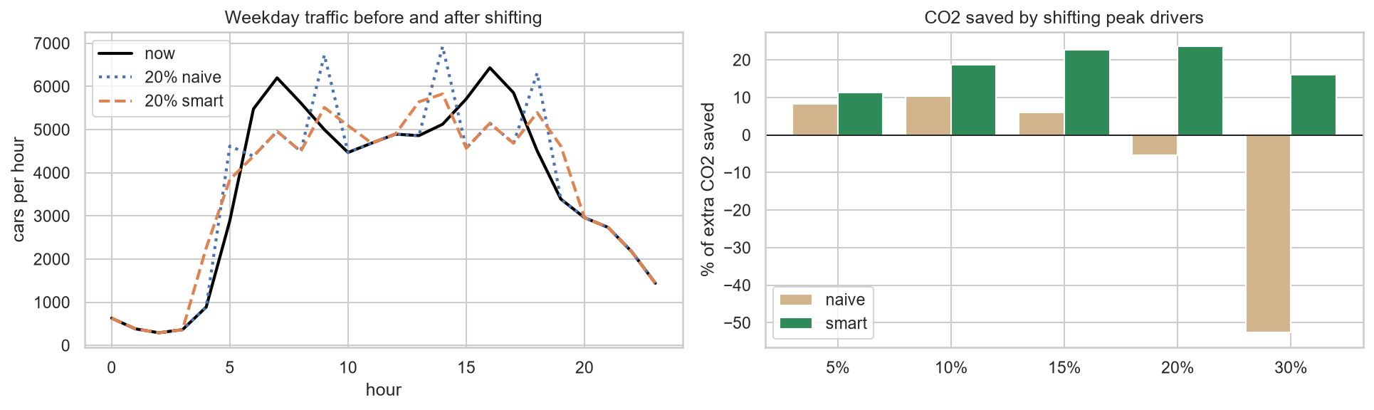
Fig. 7. Left: weekday traffic before and after moving 20% of peak drivers. Right: extra CO2 saved for each share.
VI. Summary of Main Insights
The clearest result for Riyadh is that the evening is the problem. On workdays the congestion at 5 PM (29%) is about twice the morning peak at 9 AM (15%). We expected the weekend to be lighter, but it is not, the traffic just moves to the night and the peak is around 8 PM. Most of the congestion is on a few points: Northern Ring Rd near KAFD, Eastern Ring Rd at Exit 10, Olaya St and Khurais Rd.
For prediction, the last reading is already a very good guess, so the models did not add much accuracy. What the tuned model adds is that it catches more severe jams (11 of 16, the baseline catches 9). From the UCI simulation we learned that 77% of the extra CO2 comes from the busiest quarter of the hours. Flexible work hours can help with that, but only if people spread over a few hours. If everyone just comes one hour later, the jam moves with them.
The project has some clear limitations:
• We only have about ten good days of Riyadh data, so there is no Ramadan, no summer holiday and no rain, and the test set has only 16 Severe readings.
• GitHub did not run the workflow every 15 minutes, so the time between readings is not regular.
• We measure one point on each road. TomTom speeds come from GPS of many cars, so they may be less accurate at night when there are few cars.
• The CO2 numbers depend on our assumptions (0.4 gallons per hour of delay and a capacity of 7,500 cars per hour), so the percentages are more reliable than the grams and tonnes.
• The UCI data is from one highway in the US, so the simulation is an example of the idea and not a result for Riyadh.
On ethics, both datasets have no personal information, only speeds, travel times, car counts and weather. One thing we have to be careful about is that moving work hours is not possible for everyone. Many people, for example in shops, hospitals and schools, cannot pick their hours, so a policy like this should not make things harder for them.
VII. Conclusion
We built our own Riyadh traffic dataset for 13 main roads and used it to find the worst roads and hours, predict the congestion level (about 81% accuracy, with the tuned model finding 11 of 16 severe jams) and estimate the extra CO2 per car. We were honest that a simple baseline is very hard to beat with so few days of data. With the UCI data we showed that traffic volume can be predicted very well and that spreading peak drivers in a smart way can cut the extra CO2 by about a quarter. In the future we would run the collector on our own server so it really runs every 15 minutes, collect for several months, add weather and events, and combine TomTom speeds with car counts from the city if they become available.
VIII. Team Contributions
Faisal Almusallam set up GitHub and the data collection, and did the cleaning, the EDA and the CO2 and simulation parts. Abdulrahaman bin Saeed did the features, the classification models, the UCI models and the feature importance. We did the tuning, the report and the presentation together. The code and the data are at https://github.com/Faisal-Almusallam/GreenFlow.
IX. Use of AI
We used AI (Claude) during the project. It guided us with parts of the code (for example the time-based validation and the peak shift simulation) and helped us find bugs. In the report it helped with the formatting and the English, and it helped us draft some parts (the Related Works, the Appendix and parts of the Summary of Main Insights), which we then checked and edited. All the numbers come from running our notebook, and we checked them ourselves.
Appendix: Memory Optimization
This appendix shows the parts of GreenFlow.ipynb that reduce memory and run time. The full code with comments is on GitHub.
A. UCI Data: Smaller Types and Chunks (Section 9)
Text columns with few values become category, numbers become float32, int16 or int8, and the file is read in chunks of 10,000 rows. The first full load is deleted and the garbage collector is called.
raw = pd.read_csv(path) # only to measure
mem1 = raw.memory_usage(deep=True).sum() / 1024**2
del raw
gc.collect()

types = {'holiday': 'category', 'temp': 'float32',
'rain_1h': 'float32', 'snow_1h': 'float32',
'clouds_all': 'int8',
'weather_main': 'category',
'weather_description': 'category',
'traffic_volume': 'int16'}
chunks = []
for ch in pd.read_csv(path, dtype=types,
parse_dates=['date_time'],
chunksize=10000):
chunks.append(ch)
df = pd.concat(chunks, ignore_index=True)
del chunks

# output: 11.71 MB -> 1.20 MB (about 90% less)
B. Riyadh Data (Sections 1, 2 and 4)
The road name and road class are read as category, the computed columns are stored as float32, and the weekend flag and the 13 one-hot road columns as int8.
ry = pd.read_csv('data/riyadh_traffic.csv',
parse_dates=['timestamp'],
dtype={'road': 'category', 'frc': 'category'})
ry['congestion'] = ry['congestion'].astype('float32')
ry['delay_min'] = ry['delay_min'].astype('float32')
ry['weekend'] = ry['dayofweek'].isin([4, 5])\
.astype('int8')
roads = pd.get_dummies(data['road'], prefix='road',
dtype='int8')
C. Models
All feature matrices are converted to float32 before training (half the memory of float64). The random forests and the grid search use n_jobs=-1 to train on all CPU cores, and the gradient boosting models are the histogram versions in scikit-learn, which put the features into bins and are much faster on large data.
X_train = train[features].astype('float32')
RandomForestClassifier(n_estimators=300, n_jobs=-1)
HistGradientBoostingRegressor(max_iter=400)
References
[1] United Nations, “The 17 Sustainable Development Goals.” [Online]. Available: https://sdgs.un.org/goals
[2] B. M. Williams and L. A. Hoel, “Modeling and forecasting vehicular traffic flow as a seasonal ARIMA process: Theoretical basis and empirical results,” J. Transp. Eng., vol. 129, no. 6, pp. 664–672, 2003.
[3] Y. Lv, Y. Duan, W. Kang, Z. Li and F.-Y. Wang, “Traffic flow prediction with big data: A deep learning approach,” IEEE Trans. Intell. Transp. Syst., vol. 16, no. 2, pp. 865–873, 2015.
[4] M. Barth and K. Boriboonsomsin, “Real-world carbon dioxide impacts of traffic congestion,” Transp. Res. Rec., vol. 2058, no. 1, pp. 163–171, 2008.
[5] Riyadh Municipality, “Floods, roads, and assets” open data. [Online]. Available: https://alriyadh.gov.sa/en/new/data-sets/torrents-roads-and-assets
[6] TomTom, “Traffic Flow API, Flow Segment Data.” [Online]. Available: https://developer.tomtom.com/traffic-api/documentation/traffic-flow/flow-segment-data
[7] J. Hogue, “Metro Interstate Traffic Volume,” UCI Machine Learning Repository, 2019, doi: 10.24432/C5X60B.
[8] L. Breiman, “Random forests,” Machine Learning, vol. 45, no. 1, pp. 5–32, 2001.
[9] F. Pedregosa et al., “Scikit-learn: Machine learning in Python,” J. Mach. Learn. Res., vol. 12, pp. 2825–2830, 2011.
[10] U.S. EPA, “Greenhouse gas emissions from a typical passenger vehicle.” [Online]. Available: https://www.epa.gov/greenvehicles/greenhouse-gas-emissions-typical-passenger-vehicle
[11] Bureau of Public Roads, Traffic Assignment Manual. Washington, DC, USA: U.S. Dept. of Commerce, 1964.

