1.Compleate MOSTLY SEARCHED CAR BRAND LIST with car brands we have send previously.

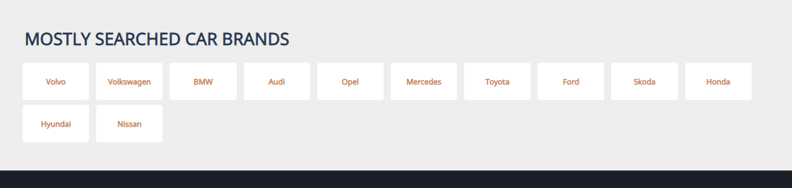

Like this:  
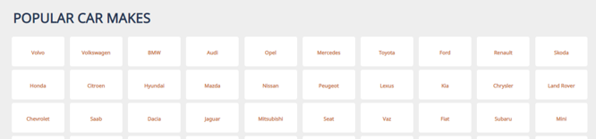

2. Something is wrong with location

Attēls, kurā ir teksts

Apraksts ģenerēts automātiski

1. When posting an add, in field LOCATION seller needs to see his – **Address, City, Country**

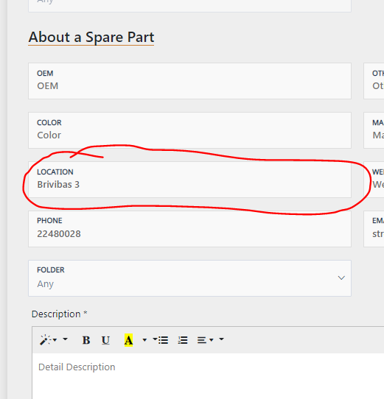

1. Remove arrows in Phone bar and add drop down menu for number codes

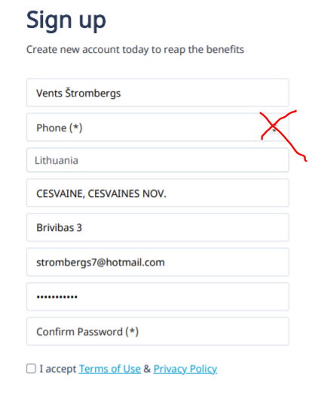2222  
Change phone like this:  
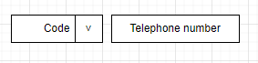  
And copy all the codes with + in front from: <https://en.wikipedia.org/wiki/Telephone_numbers_in_Europe>

1. Under profile section, add one more field - Country

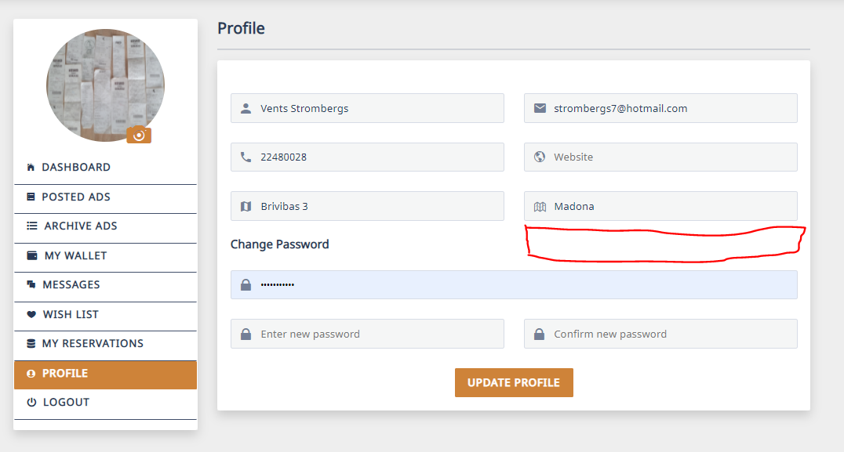

1. Change button MESSAGE to **RESERVE.** Also when you press RESERVE once, button needs to become inactive for client who has reserved the item.

Attēls, kurā ir teksts

Apraksts ģenerēts automātiski

1. Can you please change rim spoke color to black ?

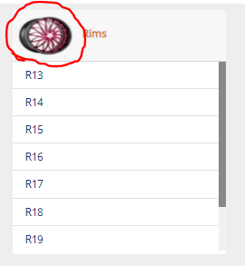

1. Currently POSTED ADS are mixed together with ARCHIVE ADS. To avoid that:

* Remove all ARCHIVE ADS from POSTED ADS section
* For ARCHIVE ADS remove folders
* Make all ARCHIVE ADS in light gray color, so it would be visualy clear that these ads are no longer active.

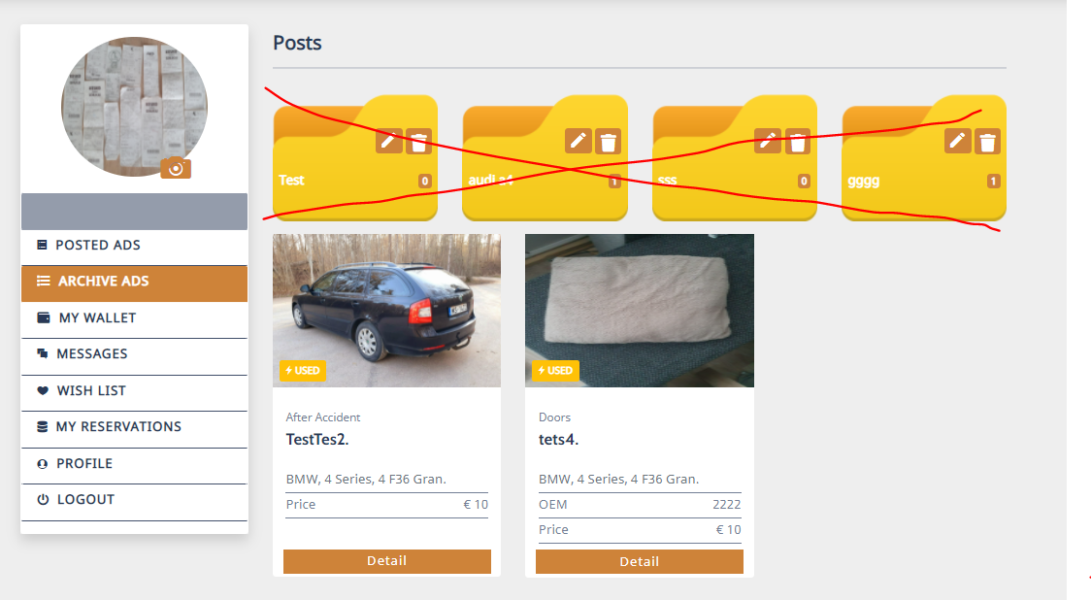

1. Please make SOLD button a bit bigger and in red color.

Also why there is gap between Reserved by and Manufacturer ?

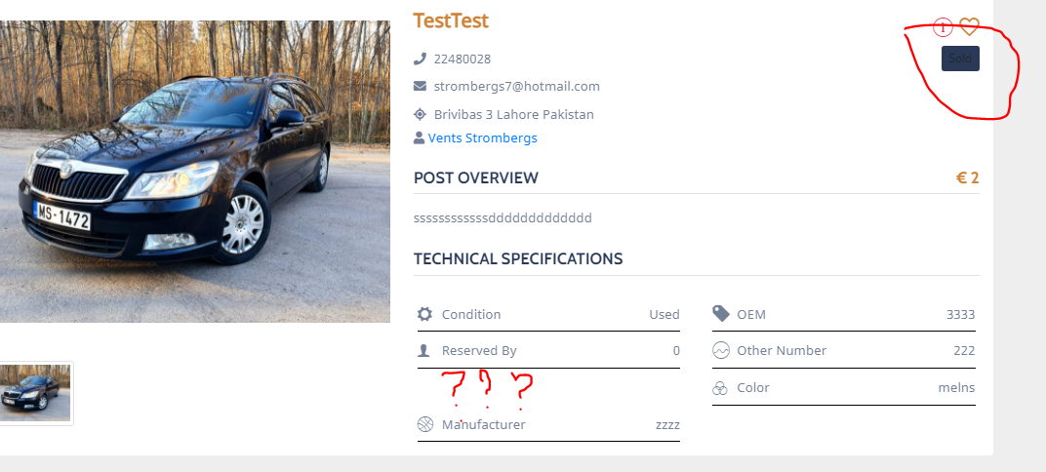

1. When I click on Recent chat profile im redirected to strange widow.

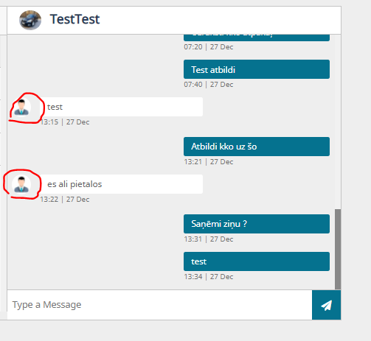

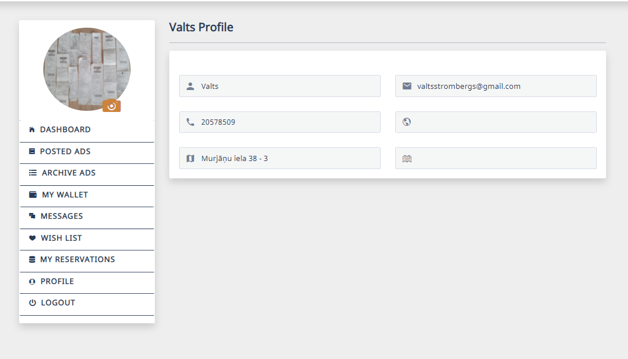

Redirec needs to be to this page:

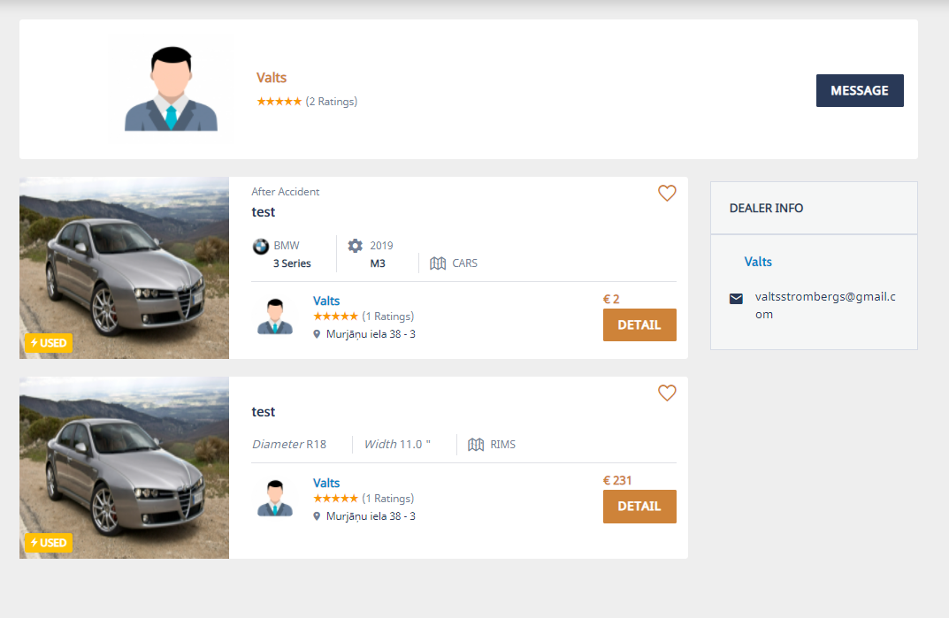

1. Please add to search bar all car brands we have send to you previously.

Attēls, kurā ir teksts

Apraksts ģenerēts automātiski

1. Add zero right after 2

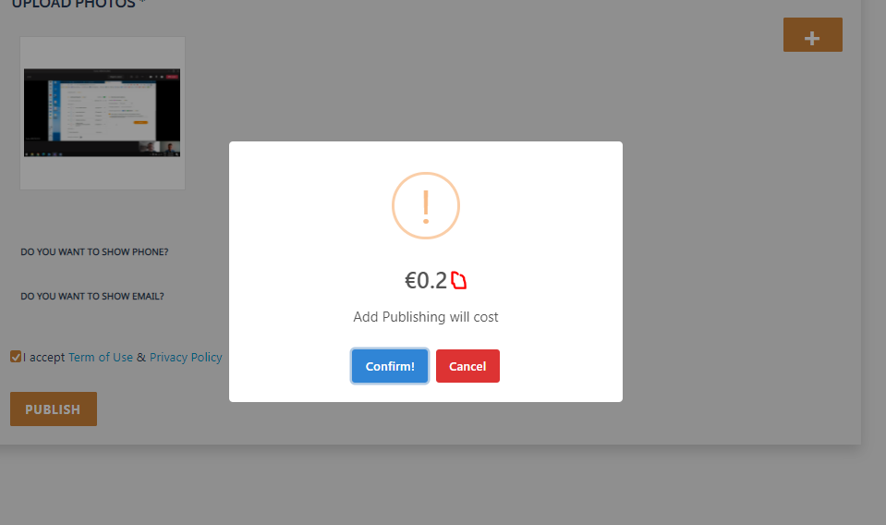

1. Add zero right after 1

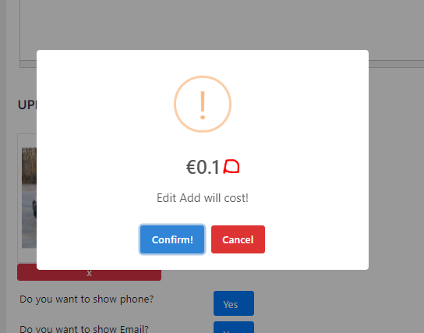

1. While updating post, selected CATEGORY field doesnt provide related SUB CATEGORIES

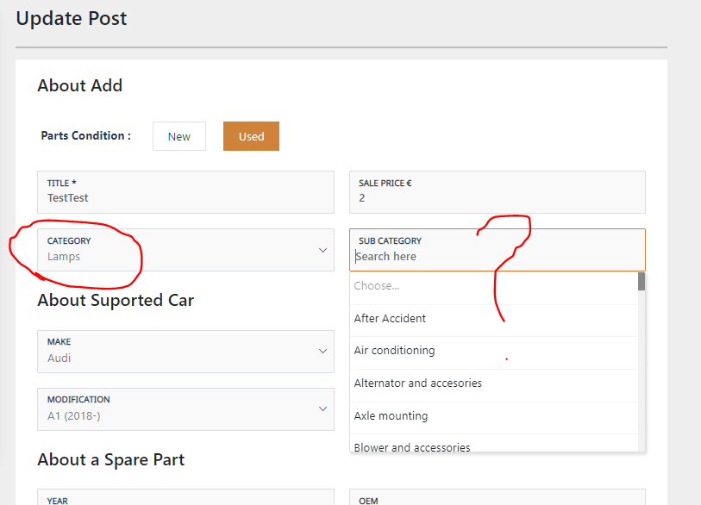

1. It would be good if there is an option to open bigger image or zoom it.

Attēls, kurā ir teksts, automašīna

Apraksts ģenerēts automātiski

1. If someone leaves a review it not visible

Answer: Consumer reviews will be shown when it will be set reviews status active from admin side.

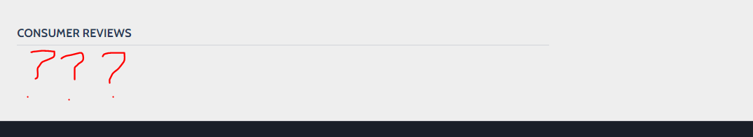

1. Image you see below is an ad witch was marked as SOLD, but by sending ads link to other person, he was still able to apply for it.

When button SOLD is pressed, then all ad needs to become light gray and display a text „Item has been sold“, also remove APPLY button from sold ads.

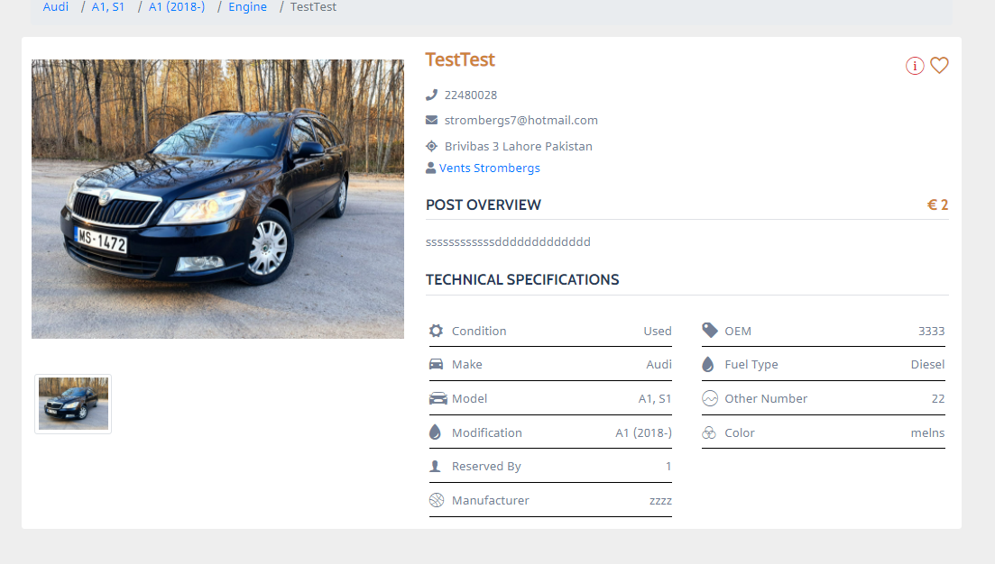

1. Time differs by 2h

Attēls, kurā ir teksts

Apraksts ģenerēts automātiski

1. There is compleate mess with chat when I try to apply for different ads from one seller.

To avoid this please:

* In Recent Chat field we need to see Ads logo and name. (There could be a situation that Ads name is long and to avoid word sorting in multiple lines, MAX visible characters needs to be 20)
* In Chat window we need to see sellers image and name (These field needs to be active)
* On top of chat window can stay Ads logo and name

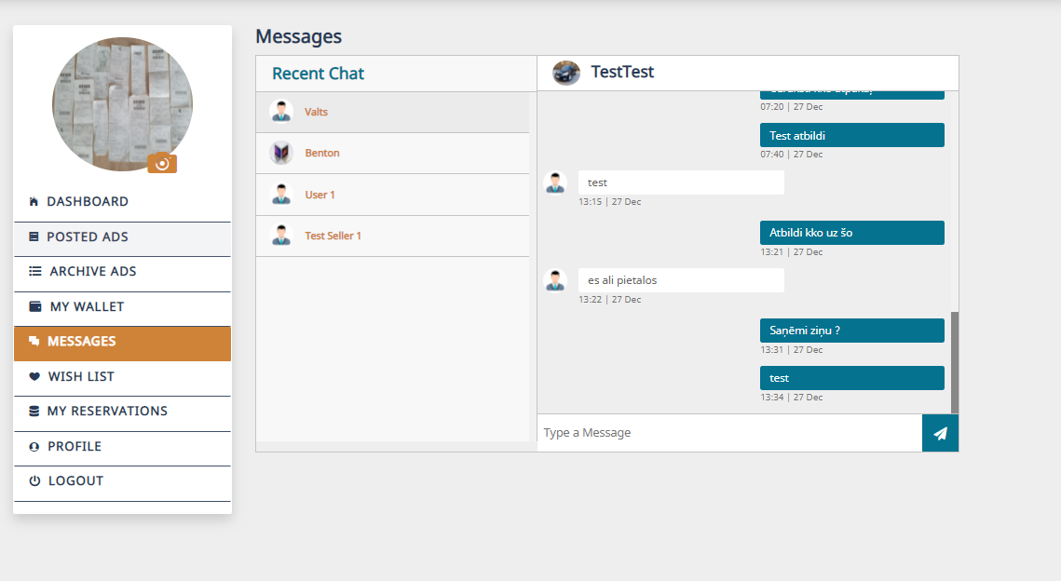

1. To avoid any issues with chat, please remove button MESSAGE on sellers profile view.

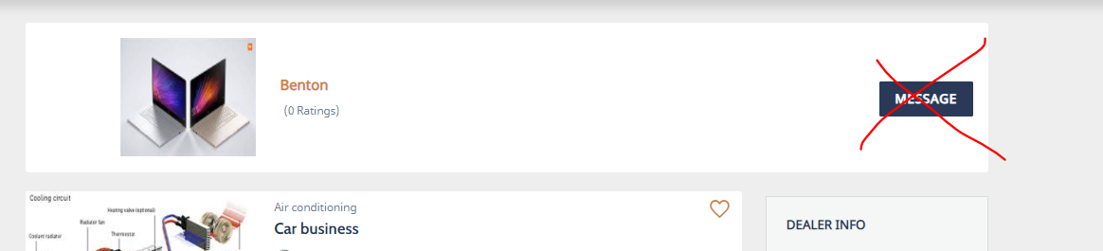

1. We are not able to translate this:  
   When you try to accept cookies:  
     
   When you chose something in the category filter:

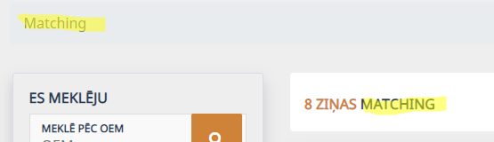  
when you chose colors in „Post an ad“  
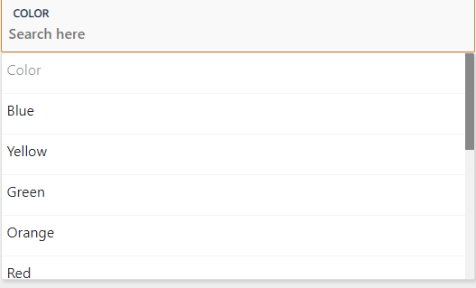

1. Please make this exportable as pdf or csv file  
   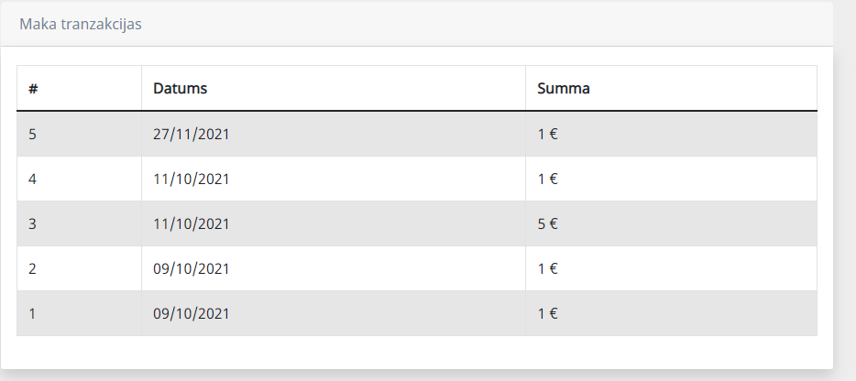
2. We need to merge this two sections „About us“ and „Contacts“ together  
     
   merged section should call „About us“ and it should contain things like:  
   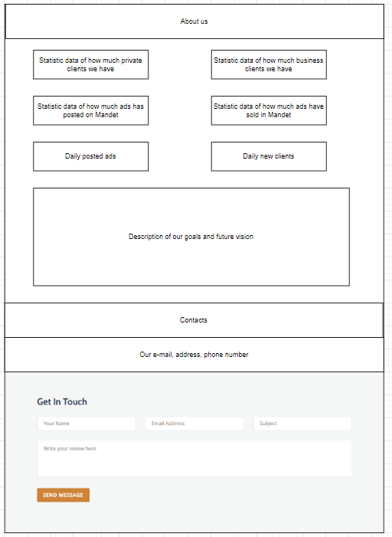
3. Please remove this effect when you refresh the page (ads loads from small to big):  
   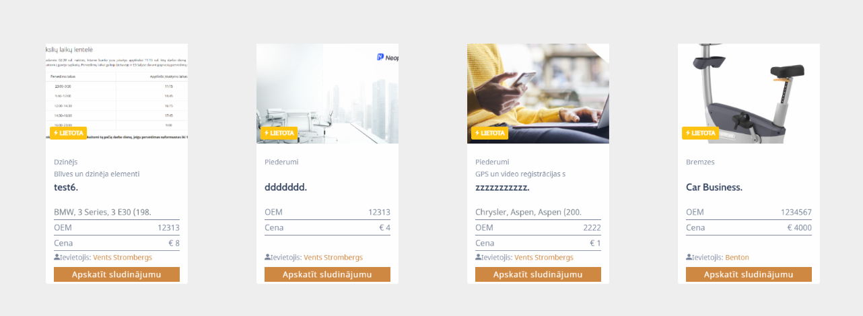
4. We need to change this „Choose...“ to more specific information:

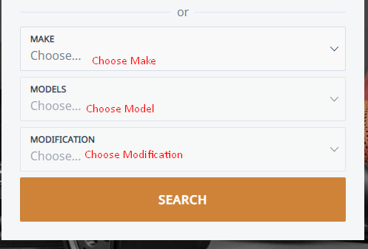

1. Fuel types section shows error:  
   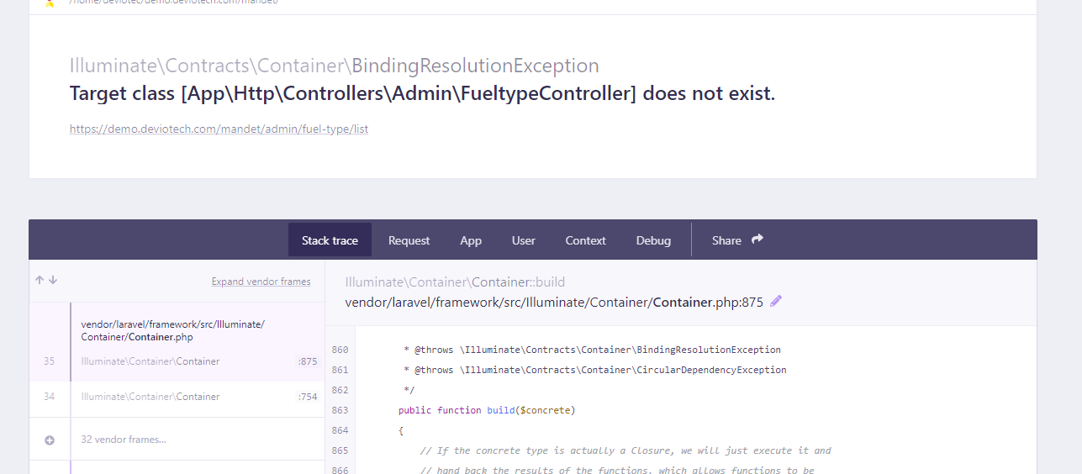
2. When you are logged off and try to press on any ad the error shows up:  
   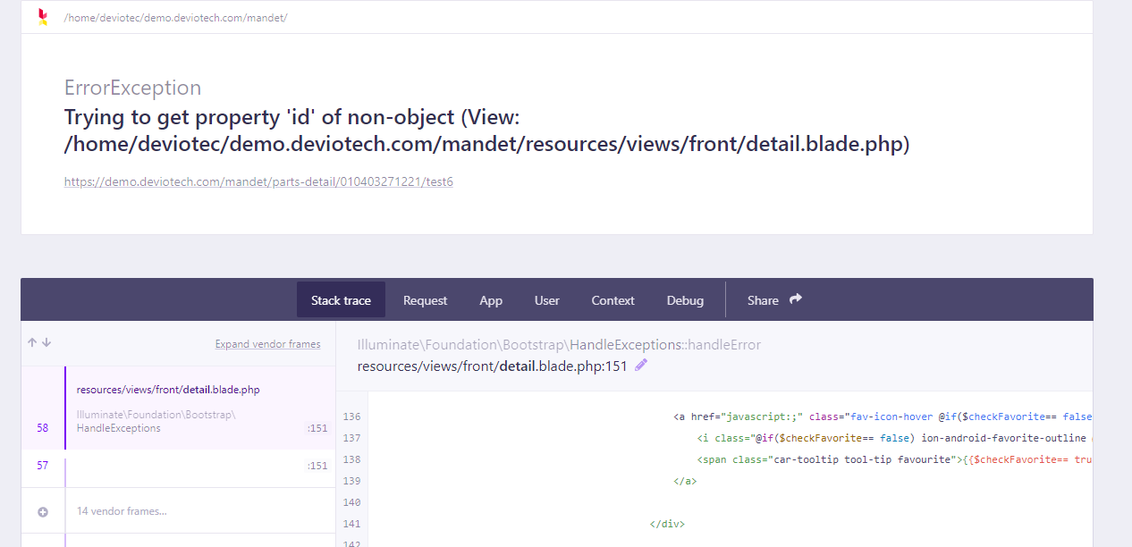
3. Pictures still not look good  
   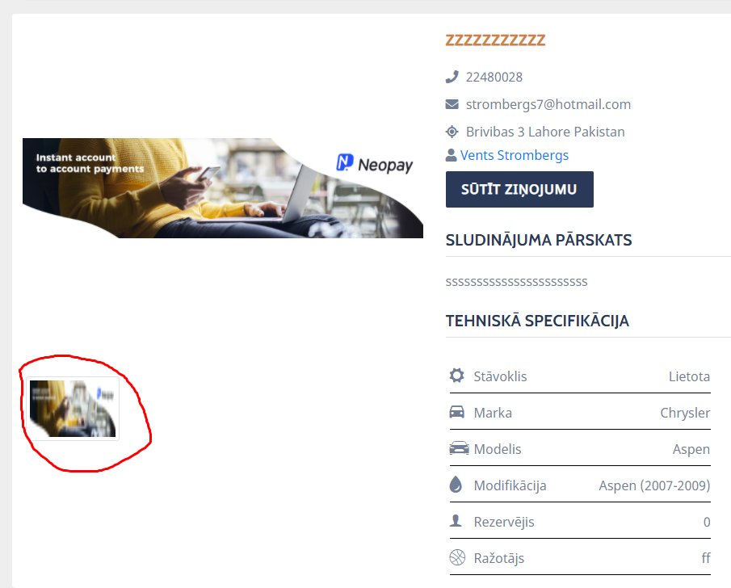
4. We are not able to translate this also  
   