🧩 Senior Backend Engineer Case Study
Overview: Our platform is a next-generation e-commerce platform that tracks and updates product information from Trendyol in real-time. Your mission is to build a scalable microservices-based backend architecture that ensures reliable syncing, intelligent update prioritization, and real-time user notification for favorited product price drops.

📌 Challenge Brief
You are required to build a mini system that continuously fetches, analyzes, and updates product data from Trendyol into a PostgreSQL database. It must identify new, existing, and inactive products, update critical fields such as stock and price, and prioritize user’s favorited products in the update cycle. Additionally, users should be notified when a favorited product's price drops.
1- All available product data from Trendyol must be inserted or updated into the current PostgreSQL database. This includes (but is not limited to):
- Product category path (full tree structure)
- Product name, images, and video (if available)
- Seller (merchant) and brand information
- Product rating score, number of favorites, comments, add-to-cart events, views, and orders
- Top reviews (if available)
- Customer size recommendation (e.g., "Most users recommend ordering your usual size")
- Estimated delivery date and time window
- Full stock information including all variants (size, color, etc.)
- Full price and installment options
- Links to similar/complementary products
- Detailed product attributes (e.g., material, fit, cut, color, waist type, length, etc.)
- Other sellers offering the same product with their respective details
2-Out-of-stock or removed products (for any variant) from Trendyol.com must be marked as is_active = false in the database.
3-New products must be detected and inserted into the database automatically.
4-Favorited products of our platform’s customers must be prioritized for updates. Their stock and price information (for any variant) will be updated more frequently than others.
5- All stock and price changes must be logged. When a price drop is detected, a "price dropped" push notification must be sent to the user who favorited the product.
Example Microservice Diagram:
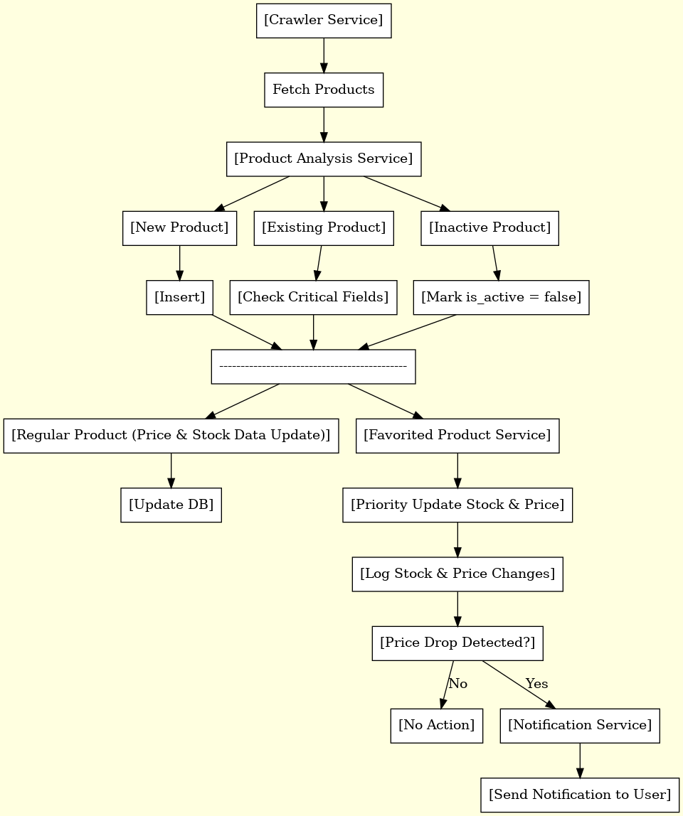
Hint: You can design a scraper to fetch product categories as a pre-step for the crawler. Then, the crawler can visit these category links.

✅ Core Requirements
• Develop the system using Go (Echo)
• Use PostgreSQL as the main database
• Microservice architecture must be used (at least 3 separate services: crawler, product analyzer, notification)
• gRPC must be used for internal service communication
• Either Kafka or RabbitMQ must be used for event-driven processing
• Use GORM as the ORM layer
• Architecture must match the logic outlined in the attached microservice diagram above
• Only one unified database is acceptable (no need for DB-per-service)

🔧 Must-Have Functionalities
• Fetch and analyze product data from Trendyol
• Detect and insert new products
• Detect and mark inactive/out-of-stock products
• Update critical fields (price, stock, etc.) for existing products
• Prioritize updates for favorited products
• Log all stock and price changes
• Trigger and send a notification to users upon a price drop

✨ Bonus Points
• Include unit and integration tests
• Handle edge cases like rate limits or IP bans from Trendyol

📣 Final Note
The person hired for this position will take part in a comprehensive performance optimization effort and in managing the retrieval of billions of product records. Therefore, beyond the strategies and user stories mentioned above, it is essential to fully understand and enhance the system after hiring. Please make sure you showcase your full capabilities.

