Climate change analysis using World bank data

Link: <https://github.com/Faisal-Zulfiqar786/Applied-Data-Science-Assignment-2.git>

*Abstract*—

This report utilized the word bank climate change data and perform the critical analysis. For the analysis purpose five different factors are extracted for different countries and impact of these factors and relation with time has been observed. Different charts have been created to visualize the finding from given data.

# data Description:

In this section major components of the data are discussed. Key features of the climate change data are described in the table 1.

|  |  |
| --- | --- |
| **Feature name** | **values** |
| Total Countries | 266 |
| Total Factors | 76 |
| Years | 1960-2021 |
| Data Updating date | 01/03/2023 |
| Source | World Development Indicators |

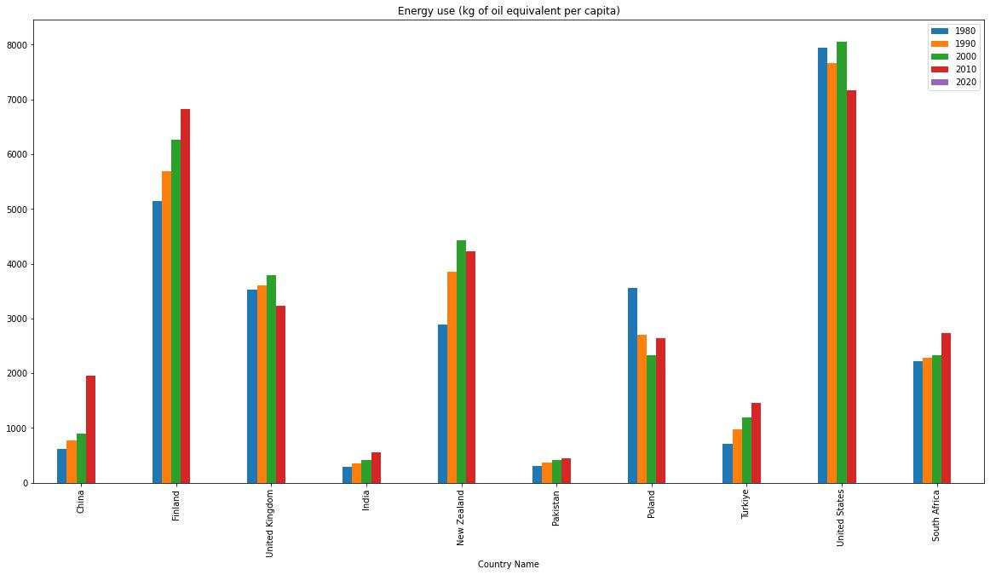Table I‑1: Data set features

To perform the analysis and extract the finding from given data report we have selected 10 different countries and analysis the impact of 4 different factors over time in these countries. Data analysis criteria is following.

Figure 2 : Energy use (kg of oil equivalent per capita)

|  |  |
| --- | --- |
| **Features** | **values** |
| **Selected countries** | Finland,Poland,United Kingdom, Pakistan,India,NewZealand,Turkiye,South Africa, China, United States |
| **Selected Factors** | Urban population |
| Electric power consumption (kWh per capita) |
| Energy use (kg of oil equivalent per capita) |
| CO2 emissions (kg per PPP $ of GDP) |
| **Year** | Last 50 year with 10-year gap |

Table I‑2: Selected Features for Analysis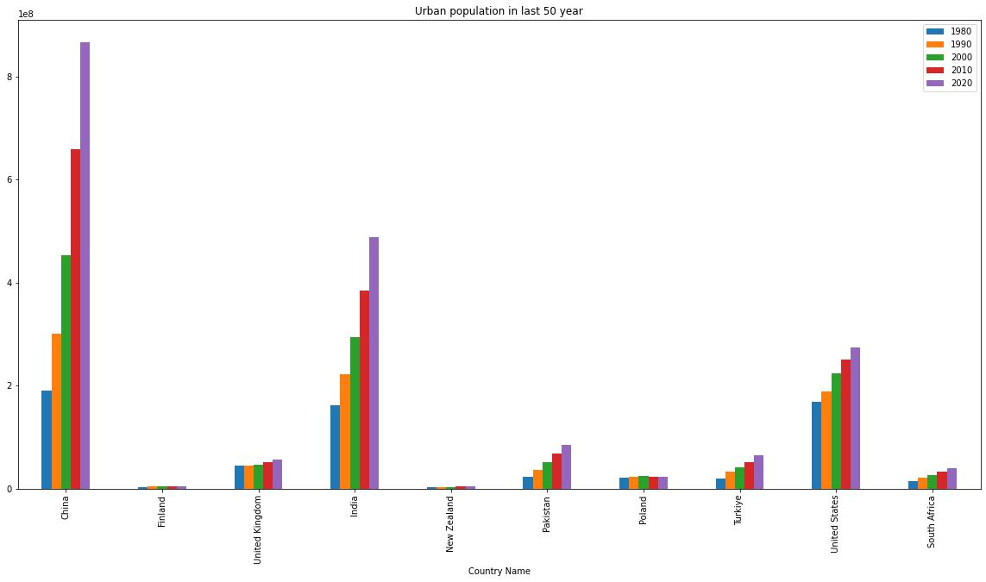

Figure 1:Urban population

The fig 1 shows a bar chart that displays the urban population of 10 countries from the years 1980 to 2020. To understand the percentage increase of urban population, we need to compare the urban population of a country in 1980 to that of 2020. In 1980, China had the highest urban population of 189,947,471, which increased to 866,810,508 in 2020, marking a significant percentage increase. Similarly, India's urban population increased from 160,953,420 in 1980 to 487,702,168 in 2020, indicating a substantial increase over the four decades. United States' urban population also rose from 167,551,171 in 1980 to 274,032,053 in 2020, representing a noticeable increase. On the other hand, Finland's urban population showed a small percentage increase, growing from 3,428,217 in 1980 to 4,728,699 in 2020, whereas Poland's urban population decreased slightly from 20,663,601 in 1980 to 22,755,739 in 2020.

Looking at the results for the energy used from Fig 2, China had the largest percentage difference with a staggering increase of 220.08%, reflecting the country's rapid economic growth over the last three decades. Other countries such as India and Turkey also experienced significant increases in their energy used, with percentage differences of 94.32% and 104.64%, respectively.

On the other hand, some countries such as Poland and the United States experienced a decrease in their energy used, with percentage differences of -25.76% and -9.85%, respectively. The United Kingdom also had a slight decrease with a percentage difference of -8.31%.

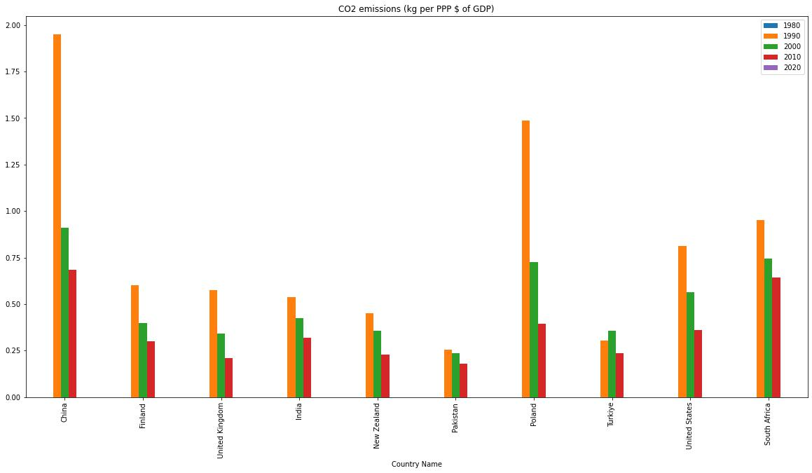The finding about the CO2 emission shown in Fig 3. is The results show that all countries experienced a decrease in their values during 1960 to 2010. China had the largest percentage decrease at -64.97%, followed by Poland at -73.44%. The United Kingdom and the United States both had percentage decreases greater than 50%. Pakistan had the smallest percentage decrease at -29.45%. It is worth noting that some data is missing for 1980 and 2020, with all the values being zero for 1980 and China having a zero value for 2020. This missing data limits the accuracy of the analysis and makes it difficult to draw conclusions about the trends over time.

The electric power consumption percentage difference for various countries is a measure of the change in electric power consumption over time. China has seen a tremendous increase of 945.17% in its electric power consumption from 1980 to 2010. Finland has also witnessed a significant rise of 98.39% in its electric power consumption during this period. The United Kingdom has experienced a moderate increase of 21.72% in its electric power consumption from 1980 to 2010. India has seen a substantial growth of 348.76% in its electric power consumption over the past four decades. New Zealand has also witnessed a significant increase of 51.35% in its electric power consumption over the same period. Pakistan has experienced a remarkable rise of 210.35% in its electric power consumption during this period. Poland has seen a moderate increase of 23.38% in its electric power consumption from 1980 to 2010. The United States has experienced a moderate increase of 35.89% in its electric power consumption during this period.

Heat map for 4 selected factors for 10 countries for the data of 2010 is shown in the figure 5. Notably China has highest urban population followed by India and United states. While United States have highest energy used followed by Finland. It is notable that less developed countries such as India and Pakistan have low Energy use (kg of oil equivalent per capita).

Figure 4: Electric power consumption (kWh per capita)

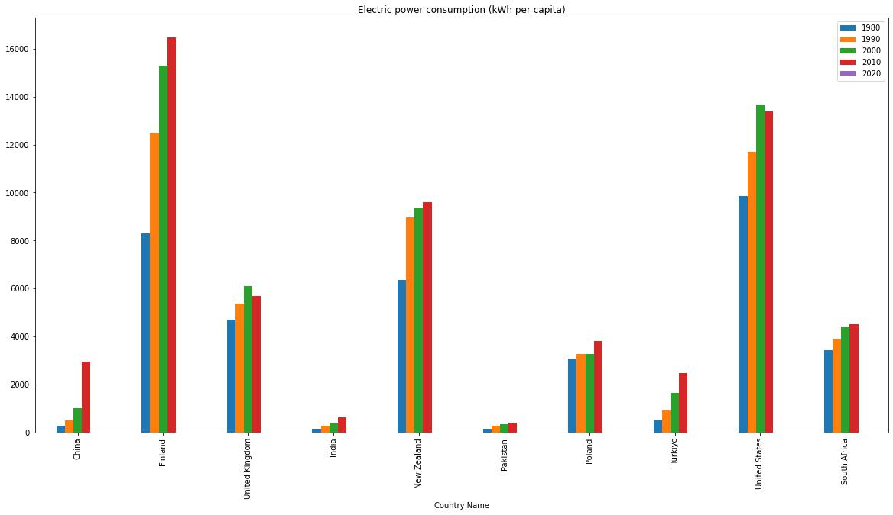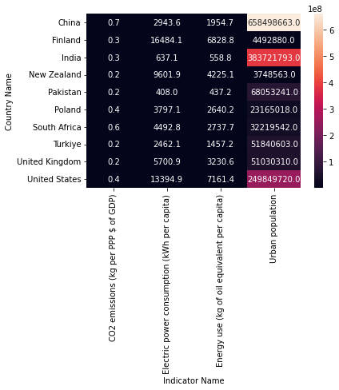Finland have highest Electric power consumption (kWh per capita) followed by United States compared to other selected countries. Notably less developed countries such as Pakistan and very low Electric power consumption (kWh per capita).

Figure 3: CO2 emissions (kg per PPP $ of GDP)

Figure 5: Heat map for 4 factors for 2010 data

China has highest CO2 emissions (kg per PPP $ of GDP) compared to other countries. however, it is notable that most of the countries decrease their CO2 emission in last few years.

# Conclusion:

it is notable that most of the factors for selected countries has been increased over the time in past 50 years, however some of the factors such as CO2 emissions has been decreased in past few years that could be helpful for climate change control.