0.Vytvorenie dodatočnej tabuľky
CREATE TABLE main.Switches( id SERIAL PRIMARY KEY, user_id INT, produkt VARCHAR(50), cena NUMERIC(8,2) );
Naplnenie tabuľky dátami
INSERT INTO main.Switches (user_id, produkt, cena) VALUES (1, 'Bratislava->Praha', 2500.00), (2, 'Presov->Kosice', 500.00), (2, 'Presov->BB', 450.00), (6, 'Kosice->Brno', 1000), (8, 'Poprad->Presov', 600.00);
1. SELECT name, lastname, produkt, cena FROM main.usr u INNER JOIN main.switches s ON u.id = s.user_id;
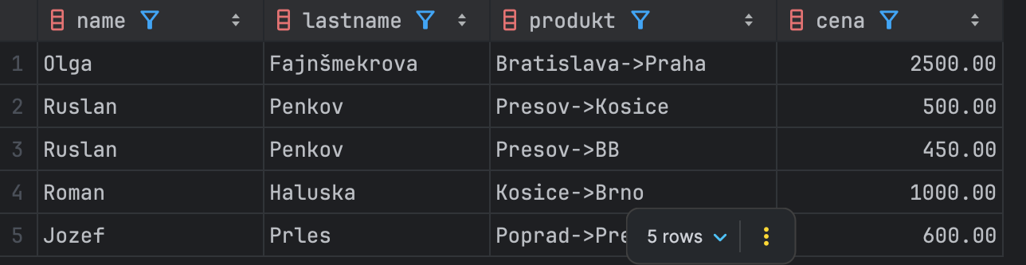
2. SELECT u.name, s.produkt
FROM main.usr u
LEFT JOIN main.switches s ON u.id = s.user_id;
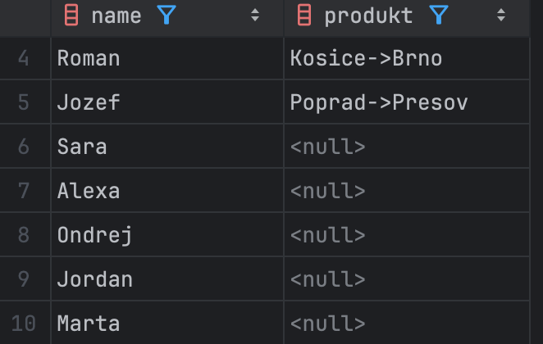
3. SELECT u.name, u.city
FROM main.usr u
LEFT JOIN main.switches s ON u.id = s.user_id
WHERE s.id IS NULL;
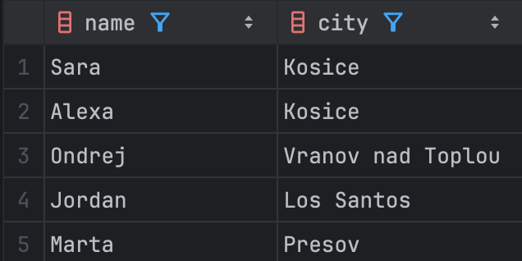
4. SELECT s.produkt, s.cena, u.name
FROM main.usr u
RIGHT JOIN main.switches s ON u.id = s.user_id;
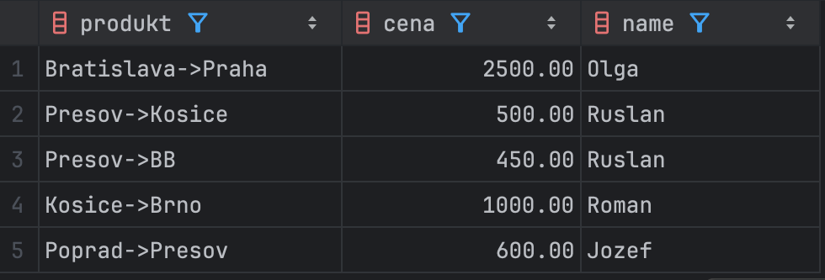
5. SELECT a.name AS osoba1, b.name AS osoba2, a.city
FROM main.usr a
JOIN main.usr b ON a.city = b.city AND a.id < b.id;
