**Evidence for Project Unit**

Faisal Ali

Cohort 13

22/05/2017

**P- 1 Github Contributors page**

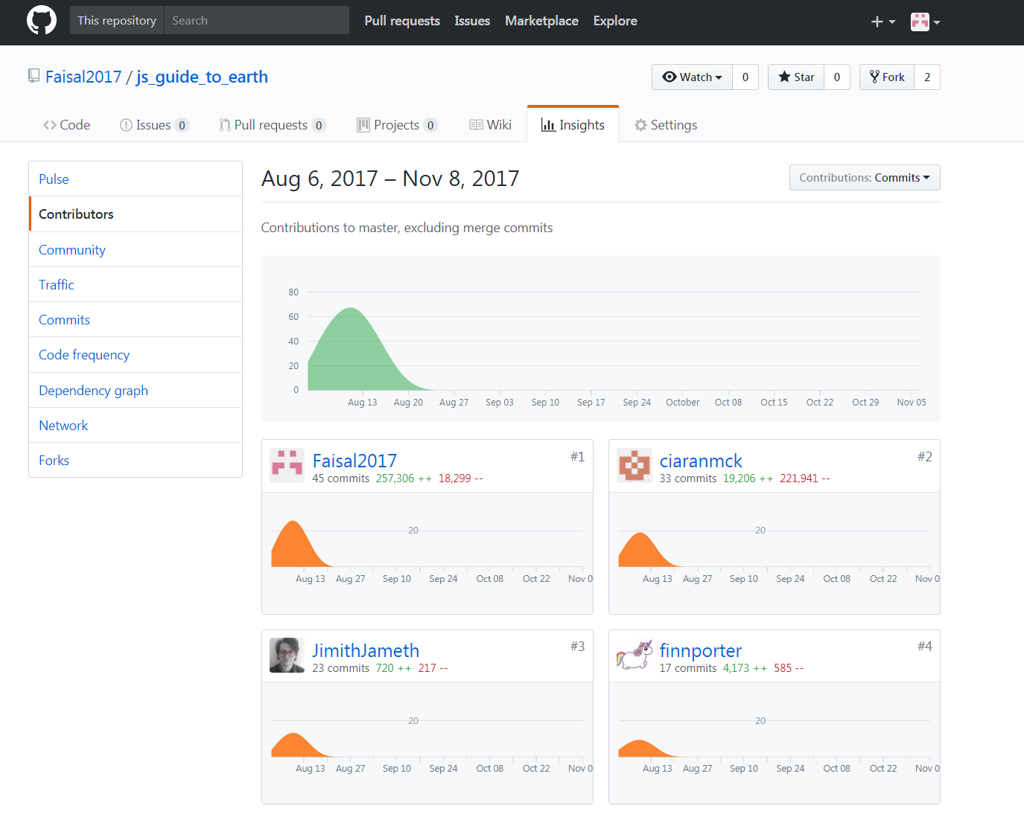

**P- 2 Project Brief**

#### The BBC are looking to improve their online offering of educational content by developing some interactive apps that display information in a fun and interesting way.

#### Your task is to make an MVP to put forward to them - this may only be for a small set of information, and may only showcase some of the features to be included in the final app. You might use an API to bring in content or a database to store facts. The topic of the app is your choice, but here are some suggestions you could look into:

#### Interactive timeline, e.g. of the history of computer programming Interactive map of a historical event - e.g. World War 1, the travels of Christopher Columbus MVP

#### Display some information about a particular topic in an interesting way

#### Have some user interactivity using event listeners, e.g to move through different sections of content

**P-3 Use of Trello**

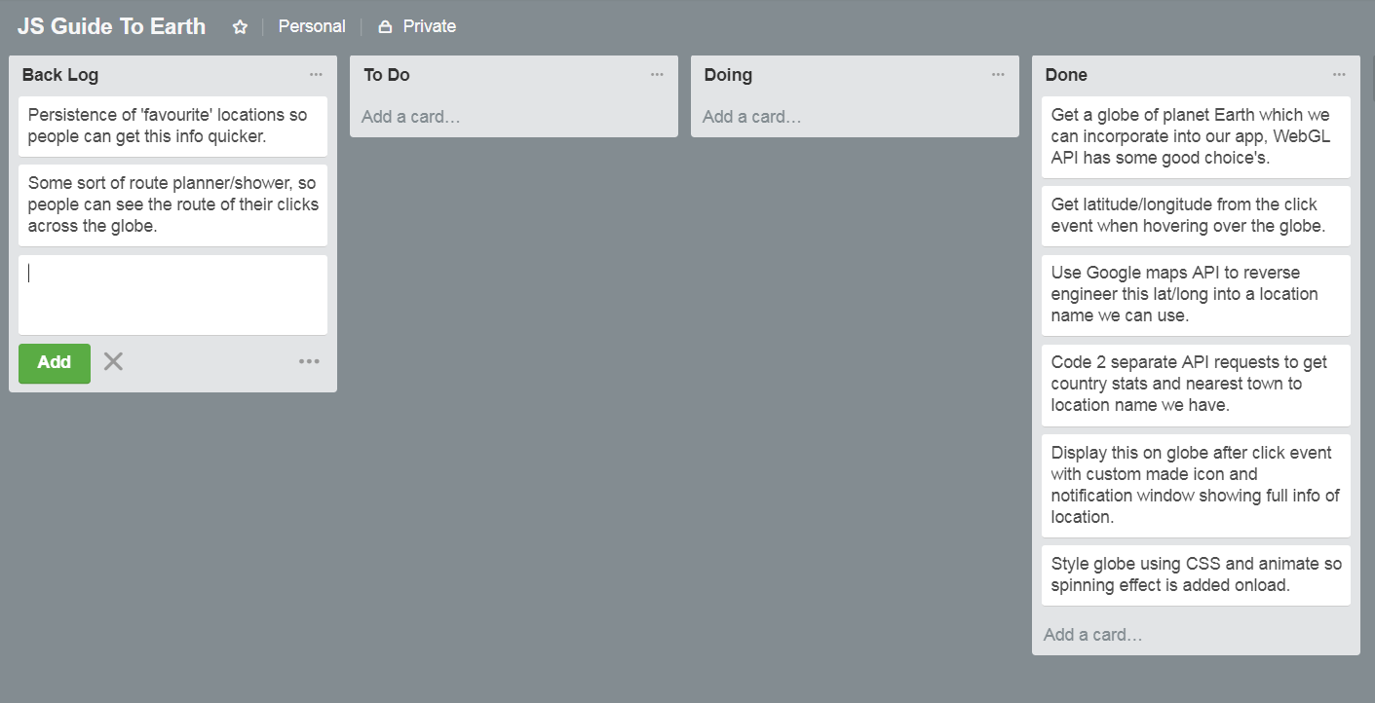

**P-4 Acceptance Criteria**

|  |  |  |
| --- | --- | --- |
| **Acceptance Criteria** | **Expected Result** | **Pass/Fail** |
| **User can zoom in and out to adjust globe settings.** | **Globe is centered and can use the mouse scroll to get a close up view as required.** | **Pass.** |
| **User can click on globe and get country information.** | **Custom icon and info window is displayed at click location with the relevant information.** | **Pass.** |
| **User can zoom into a specific country.** | **Dropdown menu incorporated so user can select a specific country.** | **Pass.** |
| **User can stop and start spin of the globe.** | **Button was added so that this feature can be adjusted as required.** | **Pass.** |
| **User can see a route of where they clicked across the globe.** | **This was a feature we did not have time to implement.** | **Fail.** |

**P-5 User sitemap**

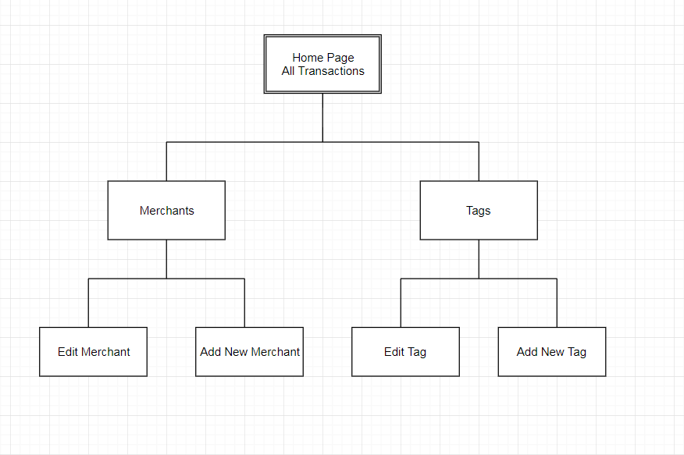

**P-6 Wireframes designs**

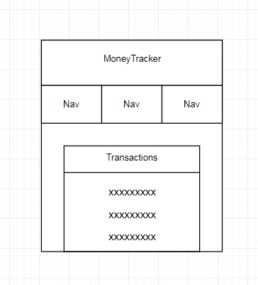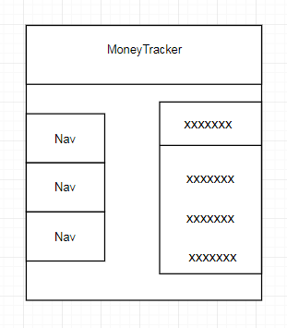

**P-7 System interactions diagrams**

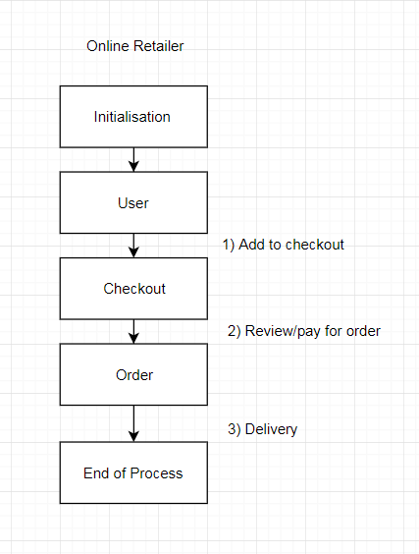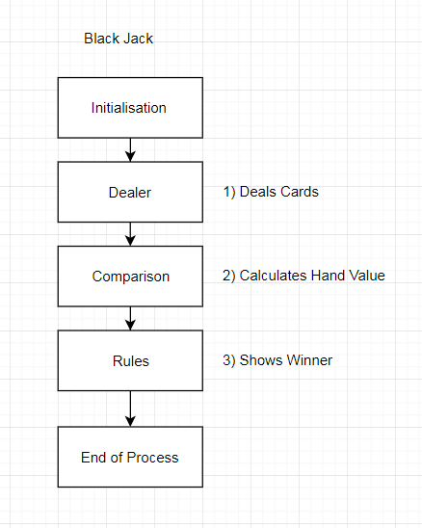

**P-8 Two Object Diagrams**

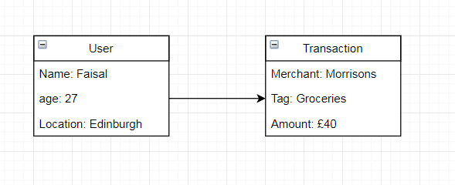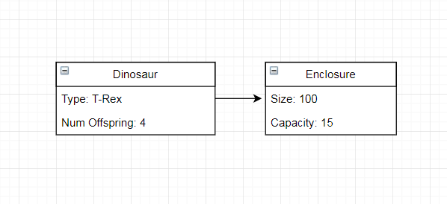

**P- 9 D.T.- a Choice of two algorithms (find the algorithms on a program you might have written, show the code you have used. )**

**For my black jack game, this algorithm helped populate my deck of cards with 52 unique cards by looping over the enums for Rank and Suit.**

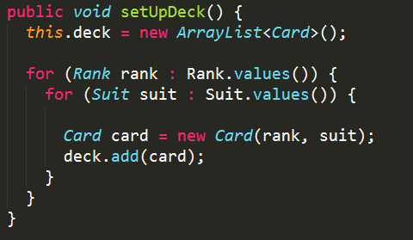

**In the same project, this algorithm would calculate the value of a players hand after a card had been dealt which then fed into who was winning/who had won.**

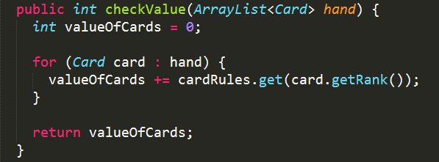

**P - 10 Example of Pseudocode**

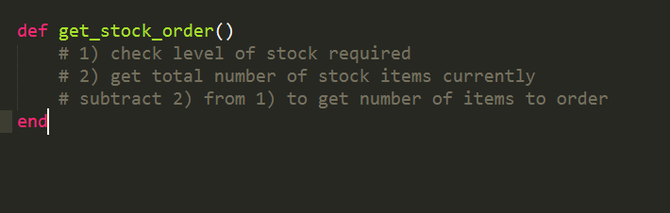

**P - 11 Github link to one of your projects**

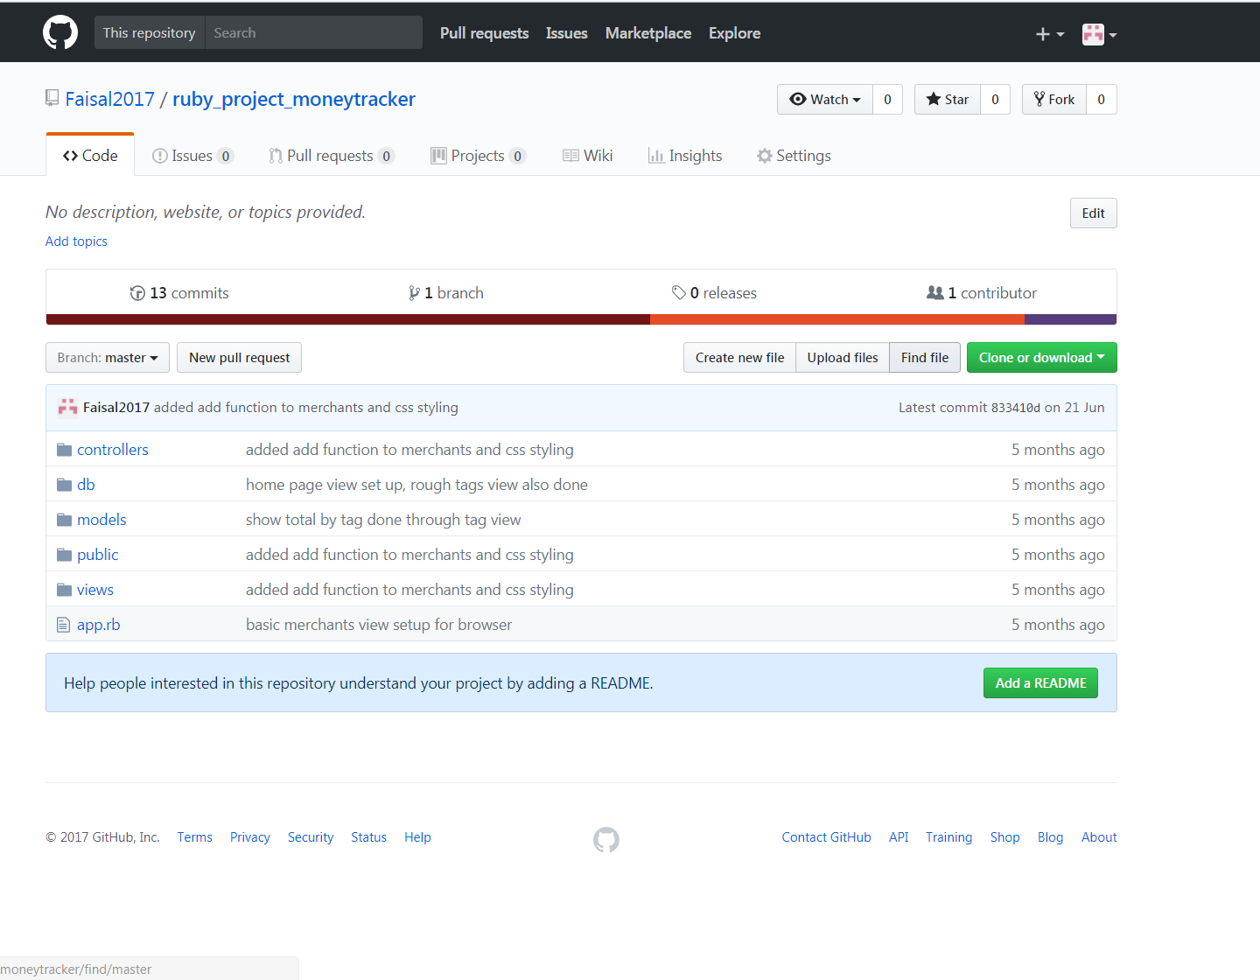

**P - 12 Screenshot of your planning and the different stages of development to show changes.**

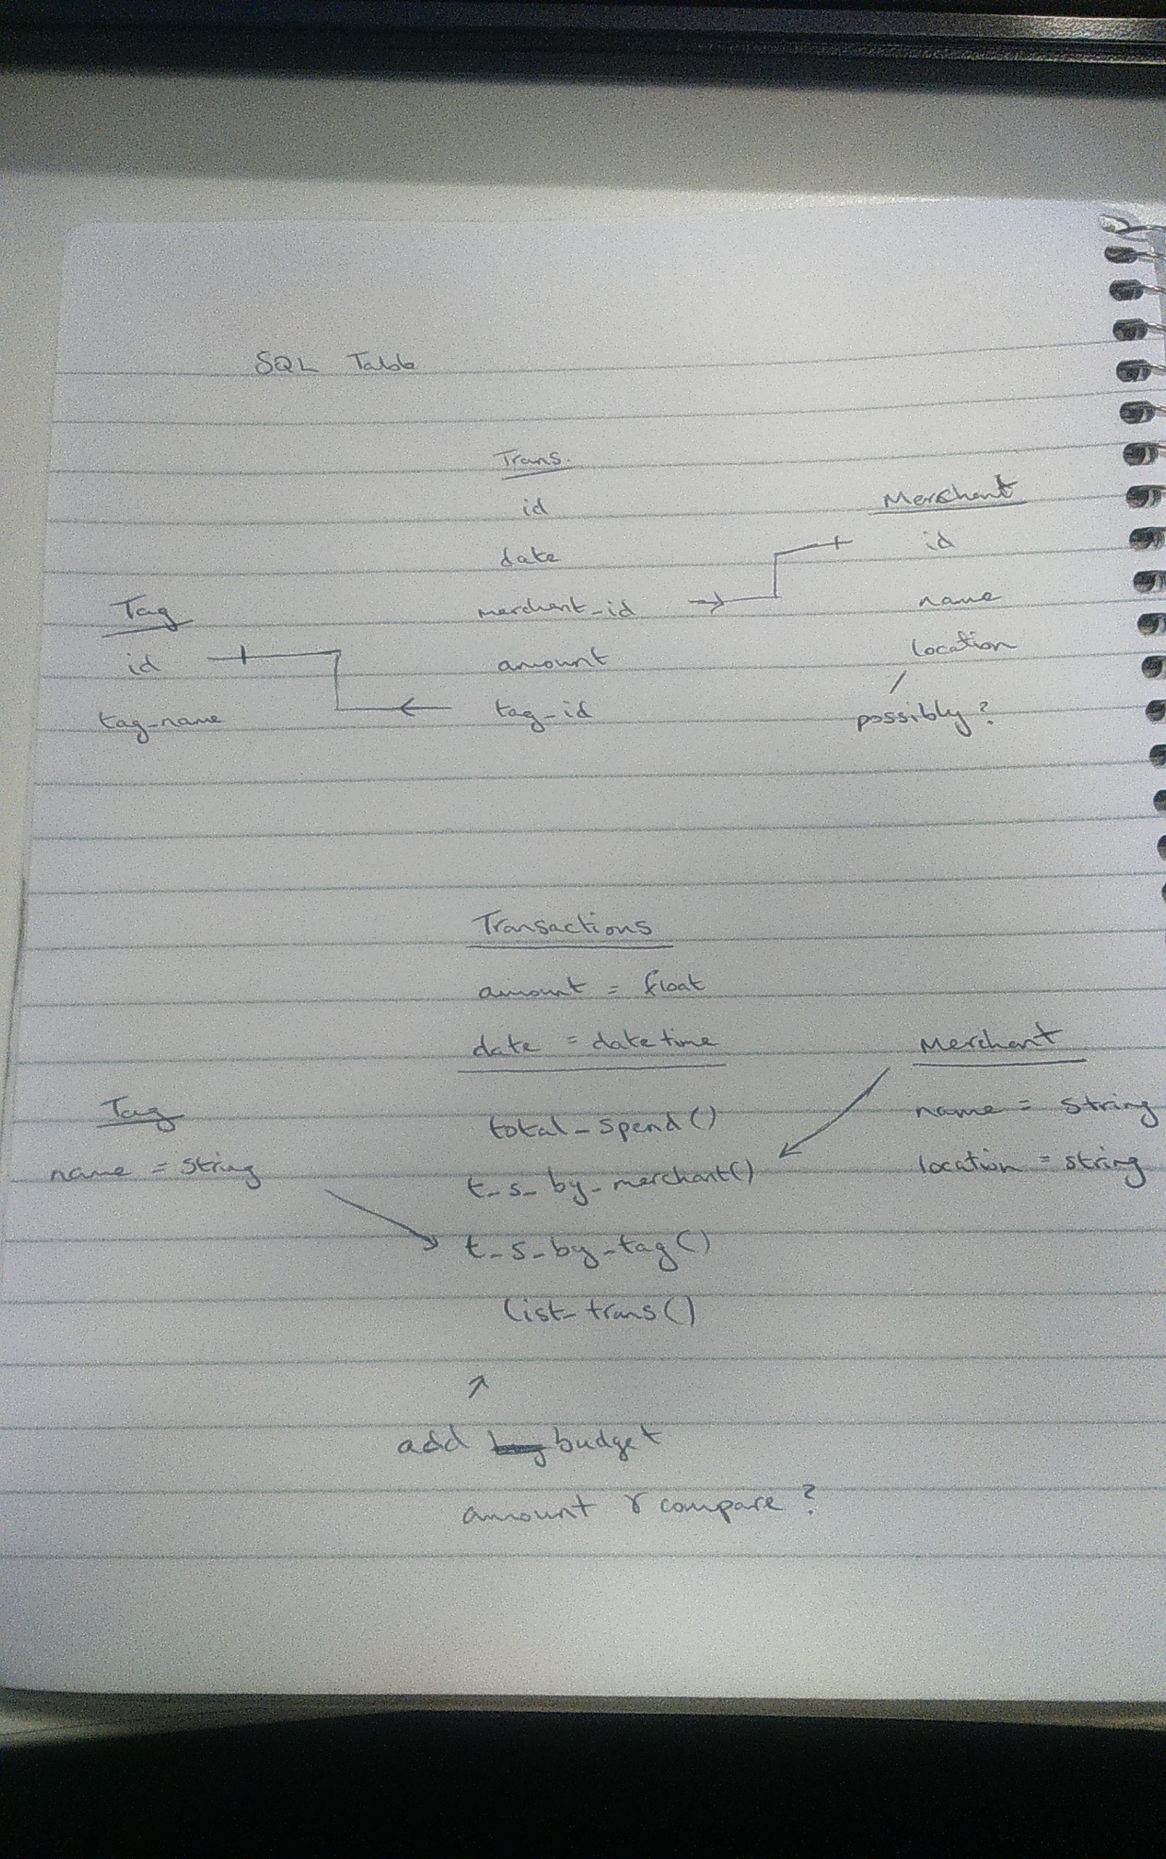

**P - 13 User input**

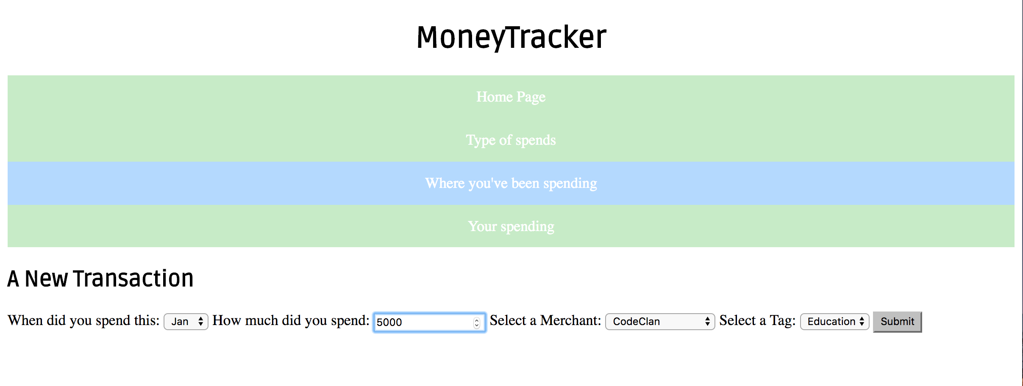

**P - 14 Interaction with data persistence (Showing full spending by tag, education)**

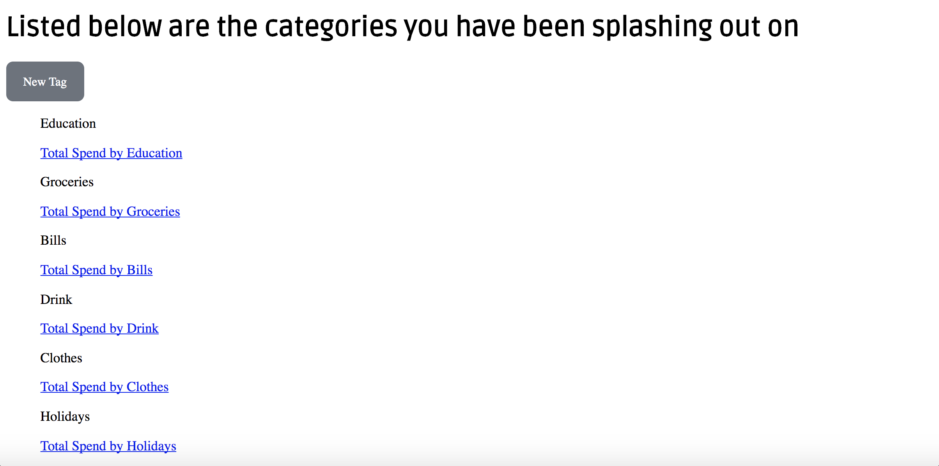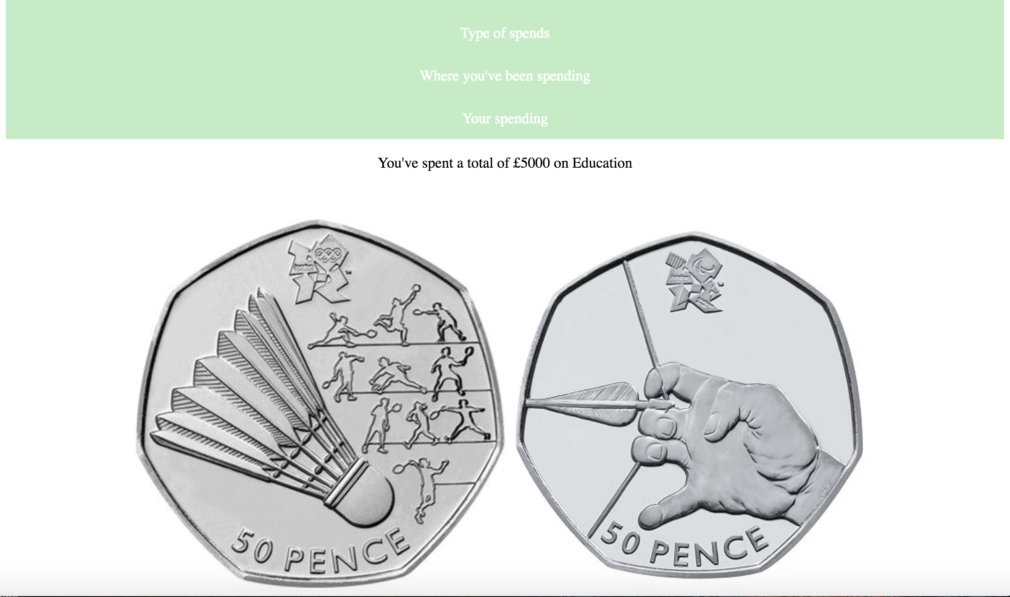

**P - 15 User output result (A new merchant being added)**

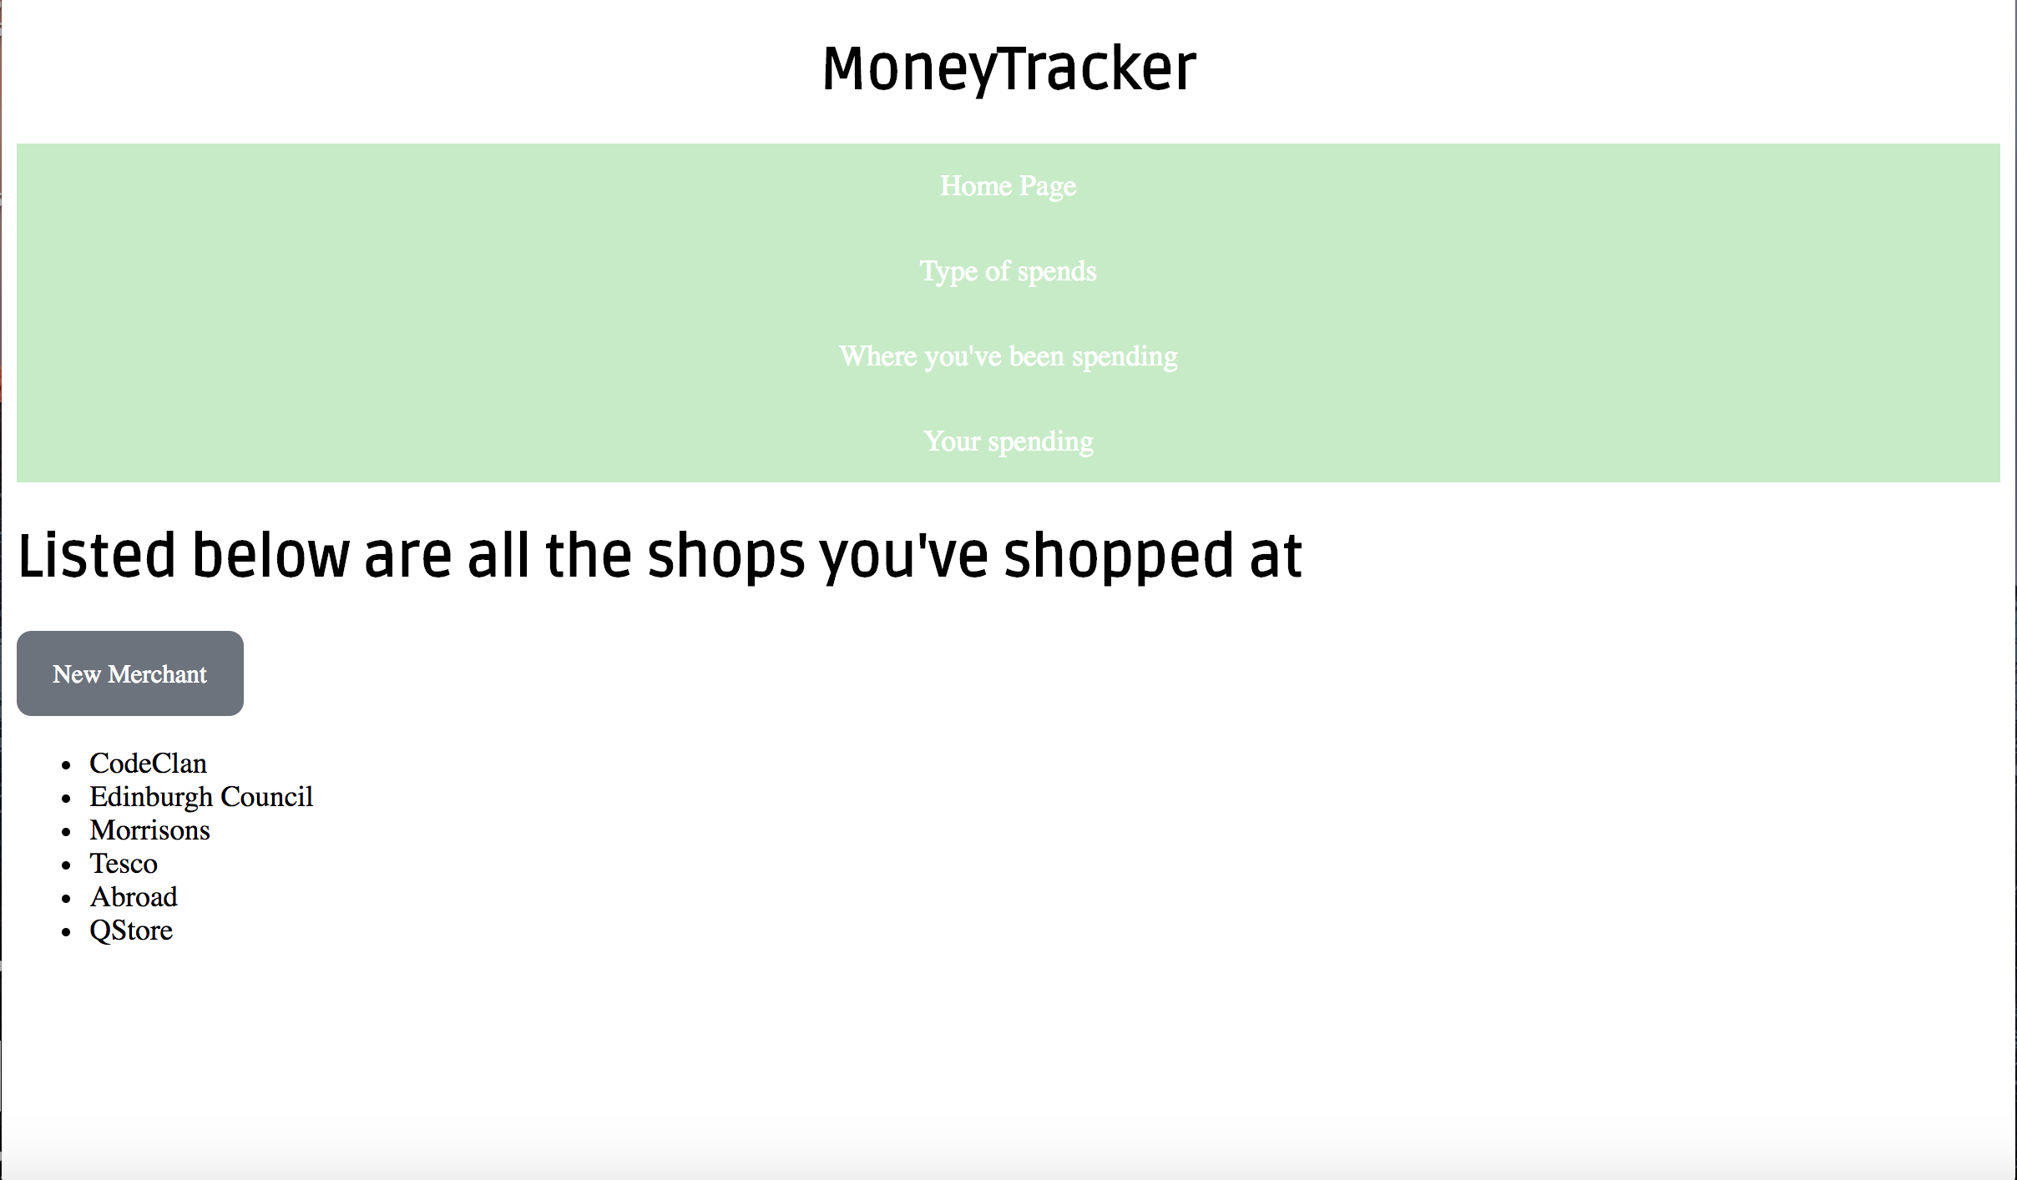

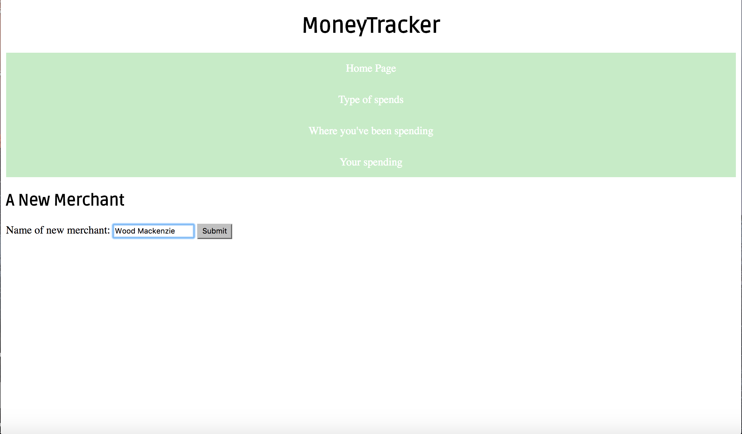

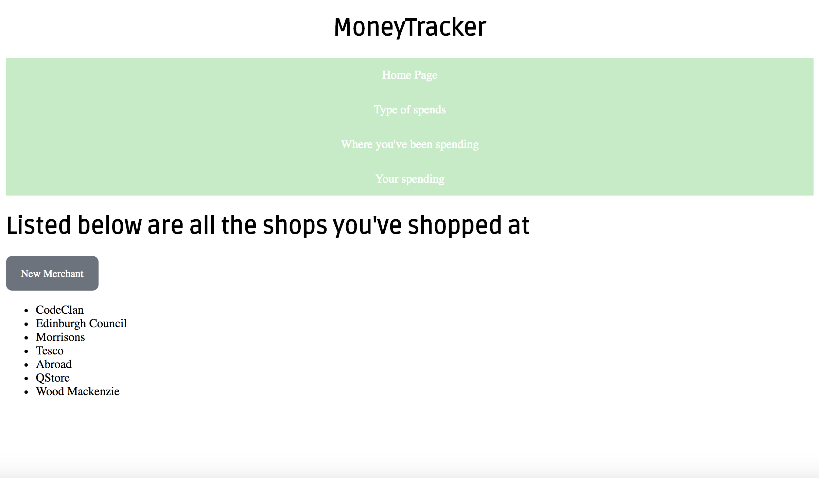

**P - 16 Bug tracking report showing the errors diagnosed and corrected.**

|  |  |  |  |
| --- | --- | --- | --- |
|  |  |  |  |
| When app starts, the globe of the Earth should slowly spin. | Failed. | App would load with no movement. By adding using JS HTML DOM animation, we were able to adjust this so on-load, app would start as desired. | Passed. |
| **When user clicks on globe, an icon appears to show where click event happened.** | **Failed.** | **Click event was tied to the globe settings, manually overriding this using CSS gave the icon we wanted.** | **Passed.** |
| A click on the globe should give us the longitude and latitude of location. |  | This was handled by the globe itself, which only required us to extract the relevant info from click event. | Passed. |
| **User should get details of the country when click on the globe.** | **Failed.** | **Asynchronous JavaScript issues meant we were getting results dependant on when the API call had completed. Solved by changing the order of API calls so only once all had completed was the info displayed to user.** | **Passed.** |

**P -17 Testing your program**

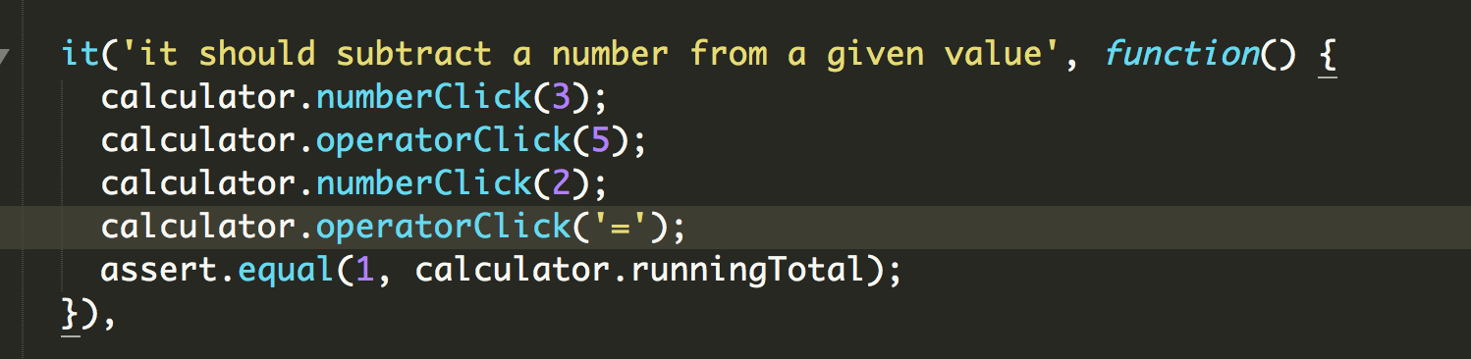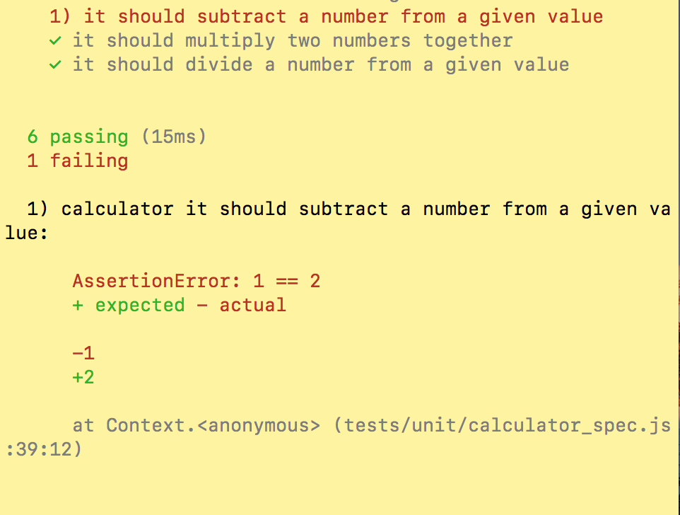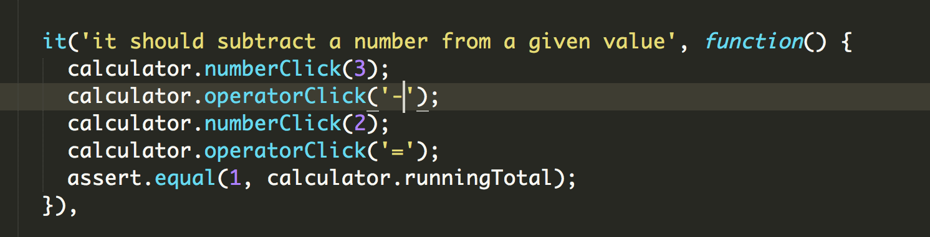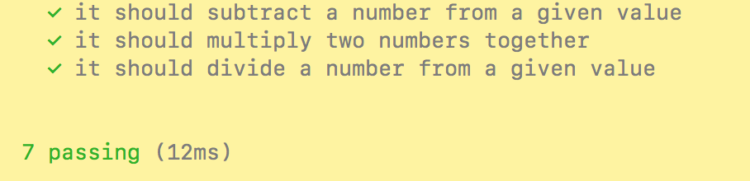

**P - 18 Acceptance test plan.**

|  |  |  |
| --- | --- | --- |
| **Acceptance Criteria** | **Expected Result** | **Pass/Fail** |
| **User can zoom in and out to adjust globe settings.** | **Globe is centered and can use the mouse scroll to get a close up view as required.** | **Pass.** |
| **User can click on globe and get country information.** | **Custom icon and info window is displayed at click location with the relevant information.** | **Pass.** |
| **User can zoom into a specific country.** | **Dropdown menu incorporated so user can select a specific country.** | **Pass.** |
| **User can stop and start spin of the globe.** | **Button was added so that this feature can be adjusted as required.** | **Pass.** |
| **User can see a route of where they clicked across the globe.** | **This was a feature we did not have time to implement.** | **Fail.** |