**Evidence for Implementation and Testing Unit.**

Faisal Ali

Cohort 13

22/05/2017

**I.T 1- Demonstrate one example of encapsulation that you have written in a program.**

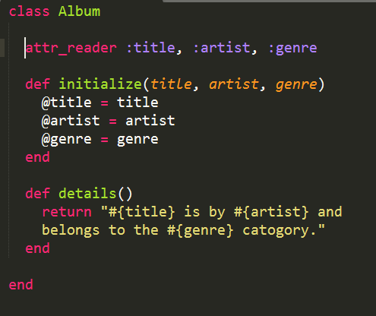

**I.T 2 - Example the use of inheritance in a program.**

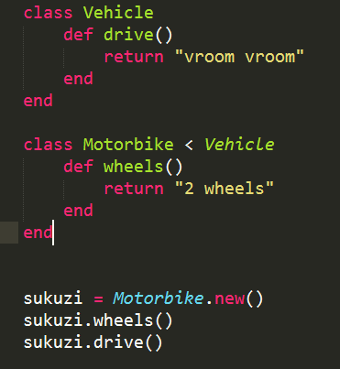

=

**I.T 3 & 4 - Example of searching and sorting data.**

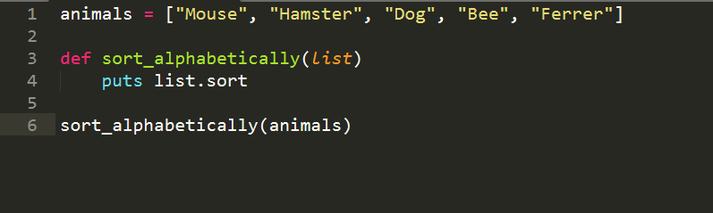 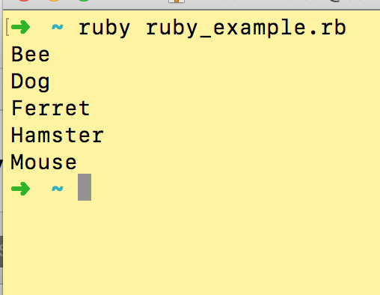

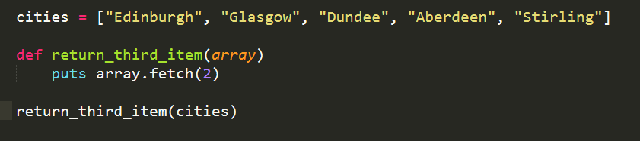

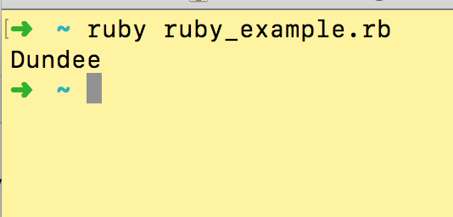

**I.T 5 - Example of an array, a function that uses an array and the result**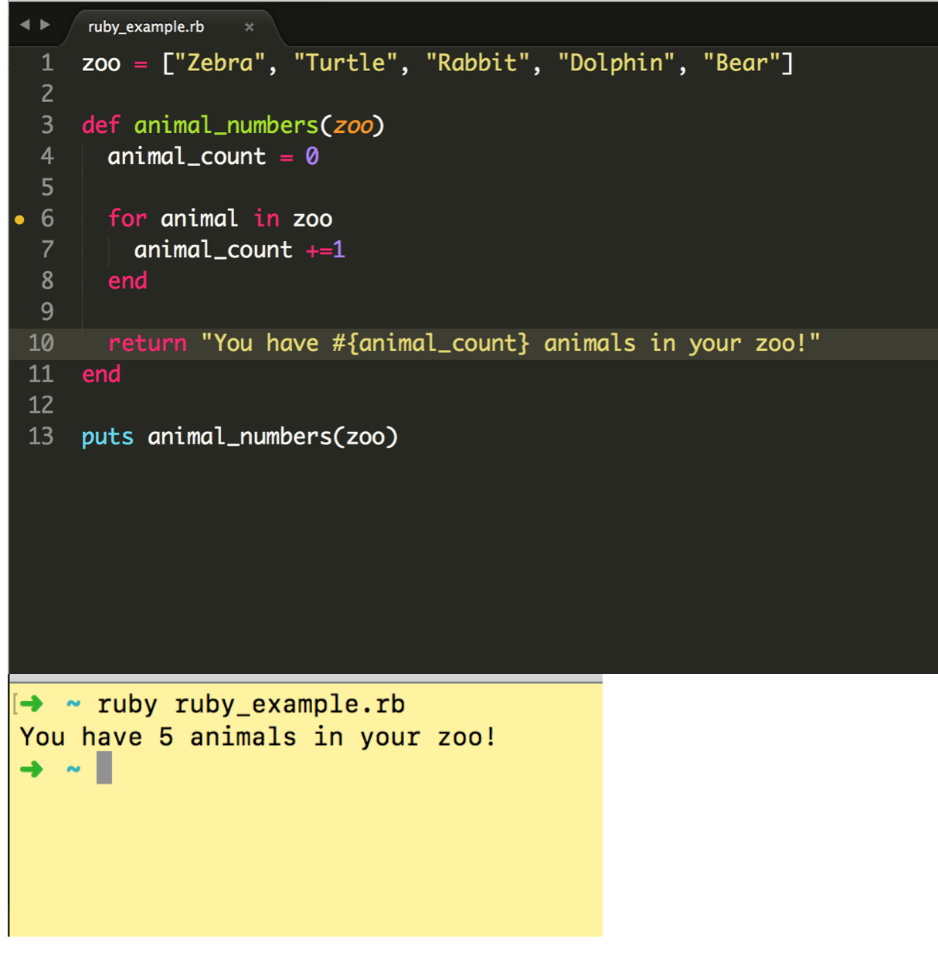

**I.T 6 - Example of a hash, a function that uses a hash and the result**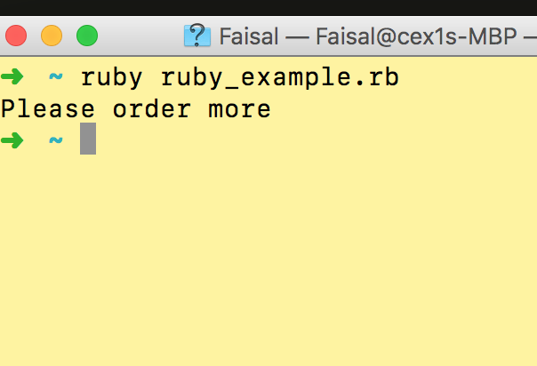

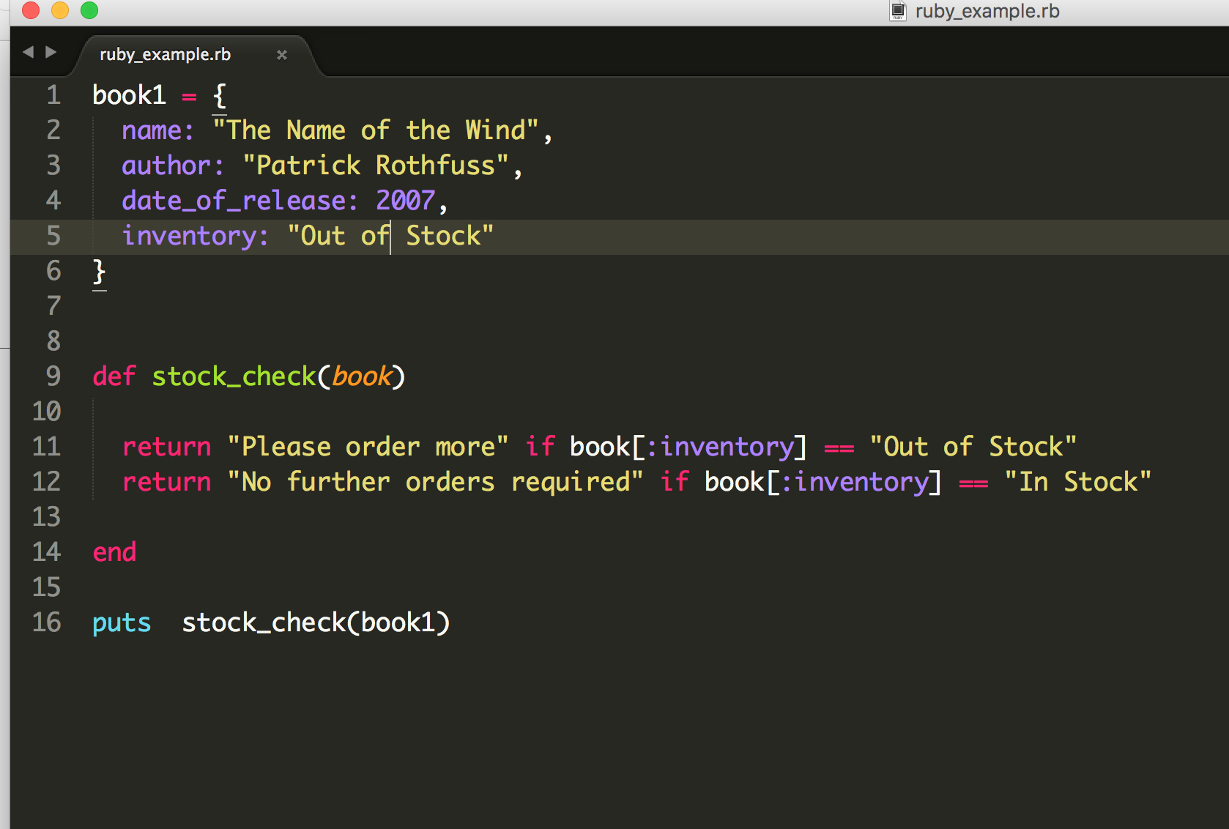

**I.T 7 - Example of polymorphism in a program**

