[Date]
Faisal A
[Company name]
[Company address]
BIPVT Solar COllector
Capstone Design & Thermal Performance Analysis
Contents
1. Capstone Overview 2
2. Problem Definition & Context 2
3. System Description 2
4. Engineering Objectives & Requirements 3
5. Design Concepts Explored 3
6. Modeling & Analysis Approach 3
7. Key Calculations & Performance Metrics 4
8. Results & Performance Evaluation 4
9. Design Tradeoffs & Decisions 4
10. Limitations & Future Improvements 4
11. Tools, Skills & Engineering Methods 5
12. My Role & Team Contributions 5
13. Links & Deep Dives 5

1. Capstone Overview
This capstone project investigated the design and thermal optimization of a building-integrated photovoltaic/thermal (BIPV/T) solar collector intended for residential heating applications. The primary goal was to recover waste heat from photovoltaic (PV) panels while simultaneously lowering panel operating temperature to enhance electrical efficiency.
The system was evaluated using a simulation-based air-channel model to analyze airflow behavior, turbulence generation, and heat transfer performance within the BIPV/T configuration. Several passive, cost-effective airflow enhancement strategies were explored to improve convective heat transfer between the PV panel surface and the air stream.
Key design configurations included:
- Baseline system with no airflow enhancements
- Guiding wall concepts to redirect airflow
- Fin-based internal enhancements for increased surface area and flow disruption
- Porous media (metal mesh) for promoting uniform turbulence and mixing
The final design combined fin baffles with a porous metal mesh and achieved sustained turbulence, and a measurable outlet air temperature increase under simulated design conditions.
[Insert Figure 1: Schematic of BIPV/T system airflow through the under-panel air channel]
[Insert Figure 2: Real-world photo of BIPV/T installation or test site]
This project demonstrates how relatively simple, passive design modifications can significantly improve thermal performance and energy utilization in residential BIPV/T systems, providing both improved heating potential and enhanced PV electrical efficiency.

2. Problem Definition & Context
Residential space heating in Ontario is largely supplied by natural gas systems due to historical cost advantages and established infrastructure. However, rising energy prices, carbon pricing mechanisms, and increasingly stringent climate targets are expected to increase both the financial and environmental costs of fossil-fuel-based heating. These trends highlight the need for low-carbon, energy-efficient residential heating solutions.
Conventional photovoltaic (PV) systems convert only a fraction of incident solar radiation into electricity, with the remainder dissipated as heat. Elevated panel temperatures reduce electrical efficiency and accelerate material degradation, particularly under peak solar conditions. Typically, this waste heat is lost to the environment, representing an underutilized energy resource.
*note make sun rays yellow but outlined with black so shows – same with heat waves
CURRENT: making two images similar to below but my own, then add Kortright centre images at the start – for now just putting them in as rectangle, later can edit/format it on website or cut image or something.

[Simplified Thermal Loss Illustration: PV panel with heat arrows escaping upward]+ [Simplified Thermal Loss Illustration: BIPV/T panel with arrows redirected into a duct]
Side by side to show contrast

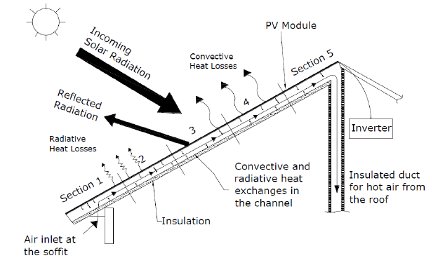
https://www.researchgate.net/figure/Schematic-of-a-BIPV-T-applied-on-a-roof-6_fig5_273774906

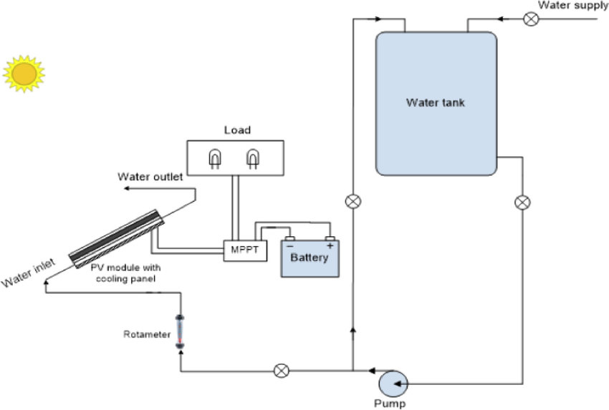

https://www.researchgate.net/figure/Schematic-of-the-PV-T-module-combined-with-water-cooling-system_fig1_330867642
Building-integrated photovoltaic/thermal (BIPV/T) systems offer a solution by enabling simultaneous generation of electrical and thermal energy from a single roofing system. By extracting heat from the underside of PV panels and transferring it to a working fluid (air in this case), BIPV/T systems can:
- Lower PV panel operating temperatures to improve electrical efficiency
- Provide preheated air for residential space heating or for integration with an air-source heat pump (ASHP)
The effectiveness of heat recovery in BIPV/T systems is strongly influenced by airflow behavior within the thermal duct. Insufficient turbulence and uneven airflow reduce convective heat transfer, limiting thermal recovery potential. Without practical airflow enhancements, the full benefits of BIPV/T systems remain constrained.
[Simplified Thermal Loss Illustration: BIPV/T panel with arrows redirected into a duct]
Core Problem Addressed in This Project:
- Limited convective heat transfer between the PV panel surface and airflow in conventional air-channel designs
- Low turbulence intensity and poor mixing restrict the recoverable thermal energy
This project investigated passive, residential-scale airflow enhancement strategies to improve turbulence, increase heat transfer, and maximize thermal energy recovery while remaining cost-effective and simple to implement.
[Insert Figure 3: Illustration of conventional vs. enhanced airflow patterns in BIPV/T duct]
[Insert Figure 4: Graph showing effect of panel temperature on PV electrical efficiency]

3. System Description
The BIPV/T system consists of photovoltaic roof panels mounted above a sealed air channel. Outdoor air is drawn through the channel by a fan, allowing heat from the underside of the PV panels to be transferred to the airflow. The heated air can then be supplied directly for space heating or used as preheated intake air for an air-source heat pump (ASHP), improving overall system efficiency.
The air channel geometry, inlet configuration, and internal flow features are critical design parameters that govern airflow distribution, turbulence generation, and thermal performance. Key components include:
- Air Channel – A narrow duct beneath the PV panels that guides airflow.
- Fan / Airflow Supply – Provides consistent flow through the channel.
- Enhancement Features – Passive modifications such as fin baffles or porous metal mesh that promote turbulence and mixing.
- Inlet & Outlet Configuration – Influences flow uniformity and pressure distribution.
The system was designed to maximize heat extraction without significantly increasing airflow velocity or pressure losses, ensuring compatibility with residential-scale applications.
[Insert Figure 5: Schematic of BIPV/T system showing PV panels, air channel, fan, and airflow path]
[Insert Figure 6: Real-world photo of the BIPV/T system at the test site]
*Interactive Idea: A clickable toggle where the schematic image can switch to the real-world photo to show design vs. implementation

4. Engineering Objectives & Requirements
The BIPV/T system was designed to achieve the following key objectives:
- Increase convective heat transfer between the PV panels and airflow to maximize recoverable thermal energy.
- Maintain turbulent flow throughout the air channel to enhance mixing and heat transfer efficiency.
- Maximize outlet air temperature rise without significantly increasing fan power or airflow velocity.
- Minimize pressure losses within the air channel to ensure stable system operation.
- Ensure residential applicability, prioritizing simplicity, low cost, and ease of integration with standard rooftop installations.
To meet these objectives, the design incorporated passive airflow enhancements, including fin baffles and porous media, selected to improve thermal performance without requiring active controls.
[Insert Figure 7: Conceptual diagram showing target objectives and corresponding airflow enhancements]
[Insert Figure 8: Graph or table of design requirements vs. target performance metrics]
*Interactive Idea: A hover or clickable element showing before/after effect of enhancements on flow or temperature could be added later.

5. Design Concepts Explored
Several airflow enhancement concepts were developed and evaluated to improve heat transfer within the BIPV/T air channel. These concepts aimed to promote turbulence, mixing, and uniform airflow while remaining feasible for residential implementation:
- Baseline Configuration
No internal airflow enhancements were used. This configuration served as a reference for evaluating the effect of other design strategies.
[Insert Figure 9: Baseline airflow schematic / CFD contour]
- Guiding Wall Concept
Internal walls were introduced to redirect airflow and reduce stagnation zones. This promoted more uniform flow distribution across the channel.
[Insert Figure 10: Guiding wall concept schematic / CFD airflow simulation]
- Fin-Based Enhancement
Longitudinal fins were incorporated to increase surface area and disrupt laminar flow, improving heat transfer between the panel surface and air.
[Insert Figure 11: Fin-based enhancement schematic / CFD airflow & temperature contour]
- Porous Media (Mesh) Enhancement
A porous metal mesh was added to promote turbulence and mixing throughout the air channel without significantly increasing fan power.
[Insert Figure 12: Porous mesh schematic / CFD simulation of airflow]
Each concept was simulated under consistent boundary conditions, enabling direct comparison of performance metrics such as Reynolds number, velocity distribution, and temperature rise. The results informed the selection of a final design that combined fin baffles with a porous metal mesh for optimal performance.
*Interactive Idea: A slider comparing baseline vs final enhanced design airflow could visually highlight the effect of each concept.

6. Modeling & Analysis Approach
A computational airflow model was developed to evaluate the performance of the BIPV/T air channel under different design concepts. The model captured internal flow behavior, turbulence generation, and convective heat transfer along the duct length.
Key modeling features included:
- Airflow Analysis: Steady-state simulations were performed to identify velocity profiles, flow distribution, and stagnation zones.
- Turbulence Evaluation: Reynolds number and turbulence intensity were computed to quantify the effect of airflow enhancement features.
- Thermal Performance: Temperature rise along the duct was calculated to evaluate heat transfer from the PV panel surface to the air stream.
Simulations were conducted under consistent boundary conditions to enable direct comparison of design concepts. Performance metrics were extracted at selected duct locations to analyze trends along the channel.
Figures & Visuals:
- [Insert Figure 13: Air channel CFD model schematic] – shows geometry, inlet/outlet, and placement of enhancement features.
- [Insert Figure 14: Sample CFD result of airflow velocity distribution]
- [Insert Figure 15: Sample CFD result of temperature rise along the duct]
This modeling approach allowed rapid iteration of design concepts within the capstone project timeline and provided insight into which features most effectively enhanced turbulence and heat transfer.
*Interactive Idea: Hover-over or clickable figures that show velocity vs temperature contours for each concept.

7. Key Calculations & Performance Metrics
The performance of each BIPV/T design concept was evaluated using key engineering calculations and metrics derived from airflow and thermal simulations. These metrics provided insight into turbulence generation, heat transfer effectiveness, and overall system performance.
Primary calculations included:
- Reynolds Number ($Re$) – calculated at multiple duct locations to quantify turbulence intensity:
$$Re=\frac{ρ V D_{h}}{μ}$$
where $ρ$is air density, $V$is average velocity, $D_{h}$is hydraulic diameter, and $μ$is dynamic viscosity.
- Temperature Rise ($ΔT$) – the difference between inlet and outlet air temperature, indicating convective heat transfer performance.
- Energy Balance ($Q=\dot{m}c_{p}ΔT$) – used to determine the amount of thermal energy recovered by the airflow.
- Effective Thermal Transmittance ($U_{eff}$) – represents heat transfer from the PV panel surface to the air:
$$U_{eff}=\frac{Q}{AΔT_{avg}}$$
Figures & Visuals:
- [Insert Figure 16: Table of Reynolds number, velocity, and temperature at selected duct locations – Baseline Design]
- [Insert Figure 17: Table of Reynolds number, velocity, and temperature at selected duct locations – Final Design]
- [Insert Figure 18: Sample energy balance calculation diagram or flow chart]
These calculations were used primarily to compare design concepts rather than predict absolute field performance. The results guided selection of the final design configuration and highlighted trade-offs between turbulence, heat extraction, and flow resistance.
*Idea: A hover-over tooltip showing $ΔT$, $Re$, and $Q$values for each design concept on a table or chart.

8. Results & Performance Evaluation
The final design combined fin baffles with a porous metal mesh distributed throughout the air channel. This configuration achieved measurable improvements in both turbulence and heat transfer compared to baseline and intermediate designs.
Key findings include:
- Sustained turbulent flow along the full duct length, promoting efficient heat transfer.
- Outlet air temperature increase from approximately 0 °C (baseline) to 8.7 °C.
- Significantly higher Reynolds numbers than baseline and intermediate designs, indicating improved turbulence.
- Enhanced heat extraction without increasing airflow velocity, avoiding unnecessary energy consumption.
- Improved PV electrical efficiency, as heat removal reduces panel temperature. Electrical efficiency typically decreases by ~0.4% per °C increase in panel temperature.
Figures & Visuals:
- [Insert Figure 19: Comparison of airflow and temperature profiles – Baseline vs Final Design]
- [Insert Figure 20: Outlet air temperature along duct length – Baseline, Intermediate, Final]
- [Insert Figure 21: Reynolds number distribution along duct length for final design]
- [Insert Figure 22: Optional schematic overlay showing flow patterns and heat extraction zones]
*Idea: A slider or toggle allowing the viewer to switch between baseline, intermediate, and final designs to visually see airflow/temperature differences.
Summary:
The results demonstrate that simple, passive airflow enhancement features can significantly improve the thermal performance of BIPV/T systems while remaining compatible with residential-scale implementation. These findings highlight the trade-off between turbulence generation and pressure loss and provide a defensible foundation for further experimental validation and design optimization.

9. Design Tradeoffs & Decisions
During the project, several tradeoffs were considered to balance thermal performance, system complexity, manufacturability, and residential applicability.
Key tradeoff considerations included:
- Passive vs. Active Enhancement: Passive airflow enhancements (fins, porous mesh) were favored over increasing fan power to avoid additional energy consumption and complexity.
- Turbulence vs. Pressure Loss: Porous media improved turbulence and mixing, but introduced additional pressure drop. Fin geometry and placement were optimized to enhance turbulence while minimizing pressure penalties.
- Manufacturability & Cost: Enhancement geometries were simplified for ease of fabrication and compatibility with standard PV panel dimensions. Exotic or complex shapes were avoided to ensure practical implementation.
- Flow Uniformity vs. System Simplicity: Design choices were made to maintain relatively uniform airflow distribution without requiring adaptive control or additional instrumentation.
Figures & Visuals:
- [Insert Figure 23: Illustration of design tradeoffs between turbulence and pressure drop]
- [Insert Figure 24: Final enhancement geometry with annotated features and dimensions]
- [Insert Figure 25: Conceptual comparison table showing pros and cons of each design concept]
Summary:
The final design decisions reflect a balanced approach, prioritizing practical improvements that can realistically be deployed in residential BIPV/T systems. These tradeoffs were essential to achieve measurable thermal gains without introducing unnecessary complexity or cost.

10. Limitations & Future Improvements
Limitations of the current study include:
- Simulation-Only Analysis: The project relied entirely on computational models; no experimental validation was conducted.
- Steady-State Assumptions: Transient effects such as fluctuating solar irradiance, ambient temperature variations, and system startup were not included.
- Simplified Material and Geometry Models: Fins and porous media were represented with idealized geometries; detailed manufacturing-level variations were not considered.
- Pressure Loss Assessment: Pressure losses were evaluated qualitatively, without high-fidelity CFD or fan system integration.
Future work could address these limitations and further enhance system performance:
- Experimental Validation: Conduct on-site or laboratory testing to confirm airflow distribution, turbulence, and temperature rise trends.
- Enhanced Modeling: Incorporate transient solar and ambient conditions, refined turbulence models, and detailed material properties.
- Optimization of Enhancement Geometry: Adjust fin shapes, mesh porosity, and spacing for improved heat transfer with minimal pressure loss.
- Adaptive Airflow Control: Investigate dynamic airflow strategies, including variable fan speeds or automated dampers, to maximize performance under varying conditions.
- Integration with Heat Pump Systems: Evaluate system performance when directly coupled with air-source heat pumps for full residential applications.
Figures & Visuals:
- [Insert Figure 26: Flowchart showing limitations and potential future improvements]
- [Insert Figure 27: Example conceptual layout for adaptive airflow or optimization scenario]
Summary:
While the current design demonstrates effective passive airflow enhancement, addressing the outlined limitations could further improve thermal performance, validate simulation predictions, and expand the system’s applicability to real-world residential deployments.

11. Tools, Skills & Engineering Methods
Engineering Tools and Software:
- Computational Fluid Dynamics (CFD) / Simulation Software: Analyzed airflow patterns, turbulence, and temperature distribution within the BIPV/T duct.
- CAD Software: Developed system geometry, internal flow features, and enhancement configurations.
- Data Analysis Tools: Processed simulation results, generated plots, and performed comparative evaluations.
Technical Skills Applied:
- Fluid Mechanics & Internal Flow Analysis: Assessed Reynolds number, flow separation, and turbulence intensity.
- Heat Transfer & Thermal Systems Analysis: Calculated temperature rise, energy balances, and effective convective heat transfer.
- Performance Metrics Evaluation: Compared multiple design configurations using quantitative metrics.
Engineering Practices:
- Concept Generation & Comparative Design Evaluation: Iteratively developed and compared multiple airflow enhancement concepts.
- Assumptions & Constraint Management: Applied steady-state, simplified material, and geometric assumptions to maintain tractable simulations.
- Technical Reporting & Communication: Documented methods, results, and decisions in clear technical reports and presentations.
Figures & Visuals:
- [Insert Figure 28: Screenshot of CFD airflow results showing turbulence and temperature]
- [Insert Figure 29: Example CAD geometry of BIPV/T duct with fin baffles and porous mesh]
Summary:
This project leveraged advanced engineering tools and methods to analyze, optimize, and communicate the design of the BIPV/T system, integrating both technical and professional engineering skills.

12. My Role & Team Contributions
This capstone project was completed as a collaborative team effort. My contributions focused on the airflow simulation, thermal analysis, and comparative evaluation of enhancement strategies. Key responsibilities included:
Simulation & Modeling:
- Developed the air-channel CFD model to predict airflow patterns, turbulence intensity, and temperature rise.
- Implemented enhancement geometries including fin baffles and porous media.
- Conducted parametric studies to compare baseline, intermediate, and final designs.
Analysis & Evaluation:
- Analyzed Reynolds number, airflow velocity, and temperature trends along the duct.
- Evaluated thermal performance metrics to identify the most effective design strategies.
- Synthesized results into comparative tables and figures for clear communication.
Collaboration & Integration:
- Coordinated with team members to integrate simulation results into final system design.
- Contributed to technical reporting and presentation materials, ensuring clarity and consistency.
Figures & Visuals:
- [Insert Figure 30: Annotated flow simulation showing key airflow paths and turbulence zones]
- [Insert Figure 31: Table comparing baseline, intermediate, and final design performance metrics]
Summary:
My role was primarily technical, focused on simulation, data analysis, and design evaluation, with the goal of supporting informed team-based design decisions. The results of my work were instrumental in guiding the final enhancement strategy.
.

13. Links & Deep Dives
This section provides direct access to the full technical outputs, supporting materials, and project code for deeper exploration of the BIPV/T system design and analysis.
- Full Technical Project Report (PDF): [Insert link to final PDF report here] – contains detailed methodology, calculations, simulation results, and design discussions.
- Conference Paper: [Insert link to conference paper or proceedings here] – summarizes key findings and highlights contributions for peer-reviewed presentation.
- Simulation Files / GitHub Repository: [Insert link to GitHub repository] – includes CFD models, scripts, CAD files, and example data for reproducing analyses.
- Portfolio Summary Page: [Optional] [Insert link to portfolio overview or project webpage here] – provides a high-level summary and visual walkthrough of the project.
*Optional Visuals / Interactive Features ideas:
- a grid of icons or cards with hover tooltips for each link to show a brief description.
- For GitHub/Simulation Files, optionally include a preview screenshot of the repository or simulation workflow.
- For the PDF and conference paper, optionally add a thumbnail of the report cover or first page.

