CHEPTER - 5
.
6.Difference between waterfall model and USDP?
Q1. What is a Model? Why a model is used? Example of model?
Answer: In IS development, the main focus of both analysis and design activities is on models. A model is an abstraction of a system or sub-system from a particular perspective or view. A model provides a view of a system or sub-system at a particular stage in IS development activities. A model is complete and consistent at the chosen level of abstraction.
Usefulness of models:
- A model is quicker and easier to build
- A model can be used in a simulation
- A model can evolve as we learn
- We can choose which details to include in a model
- A model can represent real or imaginary things from any domain

Example of model
- Requirements Model
- complete view of requirements
- may include other models, such as a Use Case Model
- includes textual description as well as sets of diagrams

Q2. What is a diagram? Why a diagram is used?
Answer: Abstract shapes are used to represent things or actions from the real world. Diagrams follow rules or standards. A single diagram is used to illustrate or document some aspect of system and one more diagrams collectively form a model to represent a complete view of a system from a particular viewpoint.
Diagrammatical models are used in order to:
- communicate idea
- generate new ideas and possibilities
- test ideas and predictions
- understand structures and relationships

Q3. Write down the difference between a model and a diagram? ***
Answer: Differences between diagrams and models
- A diagram illustrates some aspect of a system.
- A model provides a complete view of a system at a particular stage and from a particular perspective.
- A model may consist of a single diagram, but most consist of many related diagrams and supporting data and documentation

Q4. Why standard are important in diagrams?
Diagrams follow rules or standards. What shapes should be used in a particular diagram are laid down in standards.
Importance of standards:
The standards make sure that different people will interpret the diagram in the same way. They promote communication in the same way as a common language. They also promote communication over time.
UML standards are laid down in the OMG Open Modeling Language Specification (OMG, 2001).

Q5. What is the notation for each of the following: package, sub-system and model?
Answer: UML has notation for showing sub-systems and models, and also for packages, which are a mechanism for organising models
Use Cases
Use Case
Model
Campaign
Management
Package
Model
Sub-system

Q6. Name the elements that make up a UML diagram. ***
Answer: Elements are:
- Icons
- Two-dimensional symbols
- Paths
- Strings

Q7. What is a UML package? What is its purpose?
Answer: A package is a mechanism for grouping UML elements, usually classes, into groups. Packages can be nested within other packages.
Usefulness:
A UML package provides a way of organizing model elements. It does not represent things in the system that is being modeled, but is a convenience from grouping together elements that do not represent things in the system.

Q8. What is an activity? What is an Activity diagram? What are its purposes?
Answer: An activity is some behaviour that may persist for duration of a state.
An activity diagram focuses on a flow activity driven by internal processing within an object. In an activity diagram most sates are action states and each of them represents an execution of an operation.

Q9. What is the notation used for an activity in UML activity diagram?
A rectangle with rounded ends is used to represent an action.
An activity

Q10. In what two ways decisions can be represented in a UML activity diagram?
One Way of decision:
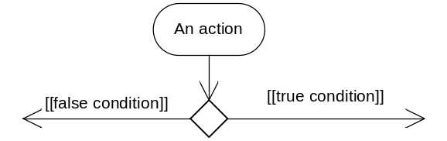
Alternative way:

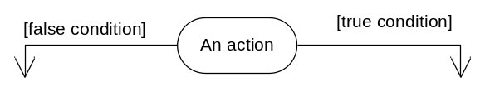

Q11. What is a guard condition? What is an object flow?
Answer:
Guard condition: A guard condition is a Boolean expression associated with a transition that is evaluated at the time the event fires. The transition is take place if the condition is true.
Object flow: An object is a dependency between an object and an activity that results in a change to the state of that object.
[Use figure of notations for Guard condition and Object flow]
Q12 four phase of Unified Software Development process ?
Answer:.
- Inception
- Elaboration
- Construction
- Transition
Q13. What is a porpuse of Activity Diagram?
Answer: Porpuse of Activity Diagram
  - to model a task (for example in business modelling)
  - to describe a function of a system represented by a use case
  - to describe the logic of an operation
  - to model the activities that make up the life cycle in the Unified Process

