Secure Messaging Application - Project Report
Faisal Al-Saadi
Student Number 101267

Abstract
With the advent of social media and smart phone technology, the need for instant communication has become more crucial than ever. By extension, the need for secure and trustworthy platforms has become necessary for both private use and, to a greater extent, in corporate use. With controversies surrounding popular platforms such as WhatsApp and Telegram, which, while ostensibly appearing to be secure and claiming as such, Zak Doffman (2024) reveals how they are surrounded by controversies in relation to data harvesting. Moreover, news of them being compromised due to political scandals and intelligence agency backdoors (Ortutay, 2024), which has left little doubt as to their untrustworthiness as instant messaging platforms. To this end, this project aims to develop an alternative platform which offers security and ease of mind to users and hopes to offer users complete control over their data and eliminate the possibility of the misuse and theft of it. With the implementation of end-to-end encryption, as well as Firebase provided security tools on the backend, this project aims to satisfy minimal security concerns, while in future iterations hopes to implement zero-knowledge storage or possibly a self-hosted option for corporations to have complete control over their data.
For the sake of cross-platform compatibility and ease of producing a highly performing minimum viable product, the Dart framework Flutter was chosen as the development technology, with Firebase for backend functionality. Furthermore, the project aims to offer a user-friendly experience by using stylish and modern tools provided by the Flutter framework.
The application offers technologies which enhance security, such as peer-to-peer encrypted messages, media transmission encryption, and the ability for messages to self-erase through the SafeSpace feature. Moreover, quality of life features has been included, such as emoji reactions to messages, as well as regular health reminders to promote user well-being.
This report showcases the full development process as well as a demo use of the application, and details the planning and design and testing stages of development. Additionally, it explains the problems present in current messaging apps and proposes a lightweight and robust solution which offers users greater control over their data. Early testing suggests the app performs well under typical use cases, with efficient performance and minimal latency issues, and no hardware performance issues were found. Due to a short development cycle, not all features which are needed for a truly secure and modular instant messaging platform could be implemented. However, the developer hopes to iteratively introduce such enhancements in the future versions and to offer it as an open-source alternative to popular platforms.

Table of Contents
- Introduction
  - Background
  - Problem Statement
  - Project Objectives
  - Scope and Limitations
  - Report Structure
- Problem Analysis
  - User Needs Assessment
  - Security Requirements
  - Usability Requirements
  - Technical Constraints
  - Market Gap Analysis
- System Design
  - Architecture Overview
  - Component Diagram
  - Database Schema
  - UI/UX Design Principles
  - Security Model
  - Scalability Considerations
- Feature Details
  - Peer-to-Peer Encryption
  - Emoji Reactions
  - Health Reminders
  - SafeSpace Self-Erasing Messages
  - Feature Integration and Interaction
- Testing and Evaluation
  - Performance Testing Methodology
  - Application Launch and Authentication
  - Message Operation
  - Feature Interaction
  - Performance Assessment
  - Optimization Opportunities
- Conclusion and Future Work
  - Achievement of Objectives
  - Key Innovations
  - Project Impact
  - Limitations
  - Lessons Learned
  - Short-Term Enhancements
  - Medium-Term Enhancements
  - Long-Term Enhancements
  - Research Direction
  - Final Reflections
- Literature Review
  - Evolution of Instant Messaging
  - Current Messaging Applications Analysis
  - Security Concerns in Modern Messaging
  - The Future of Messaging
- References
- User Manual and Testing

Introduction
Instant messaging has become one of the most widely used means of communication in the modern world, ranging from casual chats between friends to business-critical communication. As the go-to mode of communication for the vast majority of one-on-one digital communication, concerns over privacy, data security, and trustworthiness of popular platforms have been raised. While these platforms claim to offer end-to-end security, their nature of centralized service providers, as well as being commercially inclined, casts doubt on their claims. Applications like WhatsApp, while encrypted, still collect metadata and process it. (Kolobrodova, 2024)
Furthermore, its status as the most used instant messaging application in the world makes it a prime target for bad actors. (Al-Jazeera, 2025)
Other applications, like Telegram and Signal, have their fair share of controversy as well. (Gerken, 2025)( France-Presse, 2024) Fears of government overreach, surveillance, data breaches, are thus quite justified, which necessitates the creation of more secure and trustworthy platforms.
This project is a response to that demand: a lightweight, modern instant messaging app which aims to provide seamless experience while holding steadfast to strong privacy principles and its implementations, putting the user’s security and safety at the top of their concerns.
Background
The digital communication landscape has evolved dramatically over the past few decades. From the early days of SMS messages and basic Usenet and IRC chats, to today’s feature-rich messaging apps, users across the world have gained the ability to communicate seamlessly with increasingly sophisticated tools for connecting to one another. However, this progress has brought about growing concern regarding digital privacy and security.
The 2013 Edward Snowden whistle blowing incident has revealed the existence of mass surveillance programs which includes information sharing between the “Five Eye” countries, as well as global surveillance which collects data from telecommunication providers, tech companies, internet service providers, and undersea cables which carry global internet traffic. (Amnesty International, 2015)
Due to the worries the arose due to these findings, many applications and services responded to these concerns by implementing encryption and privacy features, but questions remain as to their true incentives and business models, especially with the rise of data harvesting and data being referred as a ‘currency’ in recent times. These commercial interests, as well as government overreach, which is likely to target the most popular platforms, casts doubt on whether they are truly secure.
Problem Statement
Despite the proliferation of messaging applications available today, users face persistent problems and challenges in regards to private and secure communication. Major platforms like Meta’s WhatsApp, as well as Telegram and Signal, have been involved in controversies and political scandals which create a trust deficit with users concerned about privacy. Even end-to-end encrypted applications collect and process metadata, which can reveal significant information about users’ behavior and relationships. (Kolobrodova, 2024) Moreover, the centralized nature of data storage and opaque claims of secure communication, and the limited control of users over their data once it is sent, leads users to further doubt.
The fundamental problem this project seeks to address is the lack of transparent, user controlled, and truly private messaging solution that puts the users’ needs and benefit at the forefront of its design principles.
Project Objectives
The primary objective of this project is to develop a messaging application that addresses the aforementioned problems while maintaining a focus on usability. Specifically, the project aims to:
- Create a cross-platform messaging application using Flutter that provides a seamless user experience across all platforms
- Implement robust end-to-end encryption to ensure message content remains private and inaccessible to third parties, including the service provider.
- Develop innovative privacy features, including self-erasing messages (SafeSpace), that give users greater control over their communications.
- Design a user interface that prioritizes simplicity and ease of use while incorporating modern features like emote reactions.
- Integrate wellbeing considerations through health reminders to promote healthy digital habits.
- Minimize metadata collection and provide transparent information about any data that is collected.
- Create a foundation that could support future enhancements, including the possibility of self-hosting and zero-knowledge protocols.

Scope and Limitations
This project seeks to develop a minimum viable product which demonstrates the core functionalities and key features. The scope includes:
- User registration and authentication
- One-to-one text messaging
- End-to-end encryption for messages
- Emoji reactions to messages
- Periodic health reminder notifications
- SafeSpace self-erasing message feature
- Basic user profile management
- Cross-platform compatibility through Flutter
The project intentionally excludes certain aspects that are commonplace within such applications, including:
- Group messaging functionality
- Voice and video calling
- Media sharing
- Message searching and archive
- Advanced user settings
- Self-hosting options (planned for future version)
- Full offline functionality
These limitations are due to the constraints of a final year project timeline and resources, with the understanding that many will hopefully be address in future development iterations.

Report Structure
The report is structured to provide a comprehensive overview of the project from conception to completion. This includes:
- The literature review, which examines existing messaging applications, their approaches to security, and relevant research in their history and in secure communication.
- The problem analysis section details the needs and requirements of users, which informed application design.
- The methodology section outlines the approach take to application development, including technology choices and development practices.
- The system design portion provides an overview of the architecture and design of the application.
- The implementation section describes how the system was built, including challenges encountered.
- The feature details section offers in-depth explanations of the key features: end-to-end encryption, emoji reactions, health reminders, and SafeSpace self-erasing messages.
- The results and discussion section analyzes the outcomes of the project against its objects.
- The future work section discusses potential future features and improvements.
- The conclusion summarizes the project’s achievements and lessons learned.
The report seeks to offer a clear narrative through this structure of how the project identified and addressed a significant gap in the current instant messaging application landscape.

Problem Analysis
In order to offer a robust solution, it was necessary to examine the problems inherent in currently existing messaging applications and to identify the specific needs that remain unfulfilled by them. This section presents a detailed analysis of user needs, security requirements, ease-of-user considerations, technical constraints, and the resulting market gap this project aims to address.
User Needs Assessment
A comprehensive assessment of user needs was conducted through literature review and analysis of existing messaging solution, which revealed several vital needs:
- Assurance of Privacy: Increasingly, users seek robust security and trustworthy service providers not motivated by financial gain to guarantee the security of their communications, not just from external threats but also from the service providers themselves.
- Message Control: Users seek greater control over their messages after sending, including the ability to delete messages from recipients’’ devices or have the message automatically expire
- Transparency: Users desire clear, easy to understand information regard how their data is handled, stored, protected, without technical jargon or being buried within terms of service.
- Ease of Use: Despite increasing security concerns and, users still desire a convenient and easy to use application.
- Cross-Platform Functionality: Users expect messaging applications to seamlessly operate across different operating systems and device.
- Feature Richness: Modern users have come to expect certain a features from the apps they use, such as emoji reactions, media sharing, and other quality-of-life features.
- Digital Wellbeing: An emerging concern among social media users is the effect of constant connectivity, or what is referred to as “Zombie Scrolling.” (Sinha et al., 2023) As such, users express an interest in features which promote healthy usage.

Security Requirements
Expanding on the security requirement listed above, several security requirements were identified:
- End-to-End Encryption: All messages must be encrypted and decrypted on the users’ devices with no possibility of server-side access to their contents.
- Forward Secrecy: The compromising of current encryption keys should not allow for decryption of past messages.
- Minimal Metadata: The system should only collect the bare minimum required metadata required for functionality
- Secured Authentication: Authentication of users must be robust while respecting their privacy.
- Message Persistence Control: The system must support deletion of messages both locally and remotely.
- Transparency: Security mechanisms should be documented and open for review.
- Resilient Security: The system must be designed to resist common attack vectors, including man-in-the-middle attacks, brute force attempts, and replay attacks.
The listed requirements formed the foundational principles which informed design of the security model of the application, with a particular focus on the requirements that offer users control over message persistence, both locally and remotely.
Usability requirements
Security features that are not used correctly (or at all) due to poor usability will ultimately fail in protecting users. (Zak Doffman, 2024) Furthermore, minimalism is currently the most widely adopted trend in app design. (Gumber, 2023) Therefore, the following usability requirements were established:
- Intuitive Interface: Secure usability and security features must be presented in an intuitive manner so as to guide users towards correct usage even if they lack technical knowledge.
- Minimal Friction: Security measures should add minimal extra steps to the user experience
- Default Security: Security must be strong from the onset, and requiring explicit action from the user to reduce rather than the other way around.
- Consistent Experience: Security and usability features should be implemented consistently across all platforms.
- Error Recovery: The system should provide users clear guidance when errors are encountered, especially those related to security.
The requirements were combined with security requirements to ensure the app provides effective security in real world scenarios.
Technical Constraints
Numerous technical constraints exist which influence the design and implementation of the application:
- Cross-Platform Development: The requirement for cross-platform functionality with a single code-base limited the pool of available development technologies, with Flutter coming out on top in terms of performance, but also has its drawbacks such as the difficulty of access to native device features without relying on third party packages.
- Mobile Device Limitations: The application’s primary use case is for mobile device communication, including devices with limited processing power, memory, and battery life.
- Network Variability: The system is required to handle varying network conditions, including low bandwidth and intermittent connectivity.
- Backend Infrastructure: As a student project, there were limitations for backend technologies to choose from, necessitating the reliance on third-party services like Firebase.
- Development Timeline: The constraints of a final year project timeline limited the scope of features that could be implemented and tested.
- Testing Resources: Limited access to diverse testing scenarios and large user groups constrained the breadth of achievable testing.
These limitations shaped the design and technical decisions made during the project, particularly the choice of Flutter as the development technology with Firebase as the backend service provider.

Market Gap Analysis
A thorough analysis of existing instant message applications revealed several gaps in the market that this project could help fill.
Strengths and Weaknesses of Existing Solutions:
WhatsApp:
- Strengths: Wide adoption, ease of use, richness of features
- Weakness: Owned by Meta (privacy concern), limited message deletion options, requires phone number, collects significant metadata.
Telegram:
- Strengths: Feature-rich, cloud-based, supports large groups
- Weaknesses: E2E encryption not enabled by default, centralized architecture, founder recently arrested and released shortly after raising questions regarding independence. (France-Presse, 2024)
Signal:
- Strengths: Strong security, open-source, non-profit, minimal metadata collection
- Weaknesses: Less feature rich, requires phone number, limited control over message persistence
Identified Market Gaps:
- User Control Gap: None of the major platforms provide comprehensive user control over message lifecycles, with an emphasis on automatic message expiration based on message viewing status.
- Transparency Gap: Most platforms offer limited transparency regarding their security implementations and usage of data and metadata.
- Wellbeing Gap: Few messaging platforms promote digital wellbeing through inherent features.
- Trust Gap: Commercial interests and past cases of identified government overreach, as pointed to by Hunt (2023), eroded privacy-conscious users’ trust in major platforms.
- Adoption Barrier: The most secure options often lack features or have usability issues which drives down adoption among general users.
This project seeks to target these gaps, with an emphasis on the user control gap, through the SafeSpace feature, the wellbeing gap through health reminders, and addressing the adoption barriers by implementing emoji reactions and secure-by-default design.
Conclusion
The problem analysis revealed clear needs for messaging applications which provide stronger privacy guarantees, greater user control, and openness by service providers, while maintaining usability and features at a level which are expect from modern communication tools. Existing solutions, while providing for one gap, lack in another, and simply do not factor digital wellbeing in their design.
These insights directly informed the objectives and design of this project, guiding the development of the proposed application which addresses these unmet needs while working within previously identified technical constraints. The result of focusing on the previously stated features demonstrates a response to the gaps identified in this analysis.

System Design
This section outlines the design of the secure messaging application, including its architecture, system flow, database schema, UI design principles, and security model considerations. The design choices were guided by the requirements and constraints identified in the problem analysis phase.
Architecture Overview
The application follows a client-server architecture with several key components:
- Client Application: Built using Flutter for cross-platform compatibility, the client handles user interface, local data storage, message encryption/decryption, notification management, and communication with the server.
- Firebase Backend: Provides authentication, real-time database, cloud messaging, and cloud functions services, serving as the infrastructure layer without access to unencrypted message content.
- Security Layer: Implements end-to-end encryption, ensuring that messages are encrypted on the sender's device and can only be decrypted on the recipient's device.
- Notification System: Manages push notifications through Firebase Cloud Messaging (FCM), providing real-time alerting for new messages and interactions.
- Local Storage: Manages cached messages, user preferences, and encryption keys on the user's device.
The design of the architecture includes clear separation of concerns, in order to ensure that no unencrypted message content is accessible by server components, while still providing the necessary mechanism for delivery of messages, notification dispatching, and authentication of users.

Component Diagram
The application’s major components and their interactions are illustrated in the following diagram:

Application Architecture

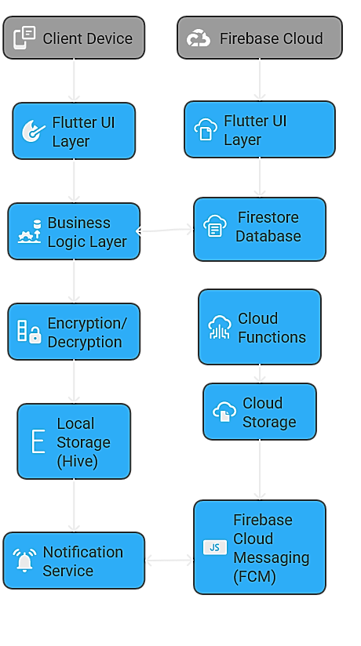
This architecture makes certain that:
- The client application handles sensitive operations such as encryption and decryption.
- Provides access to Firebase infrastructure without exposing user data
- Local storage maintains user preferences and cached data for offline capabilitiy
- Communication between server and client is secured via HTTPS

This funnel diagram depicts the stages of secure chat message delivery. It will be explained in more detail later in the report:

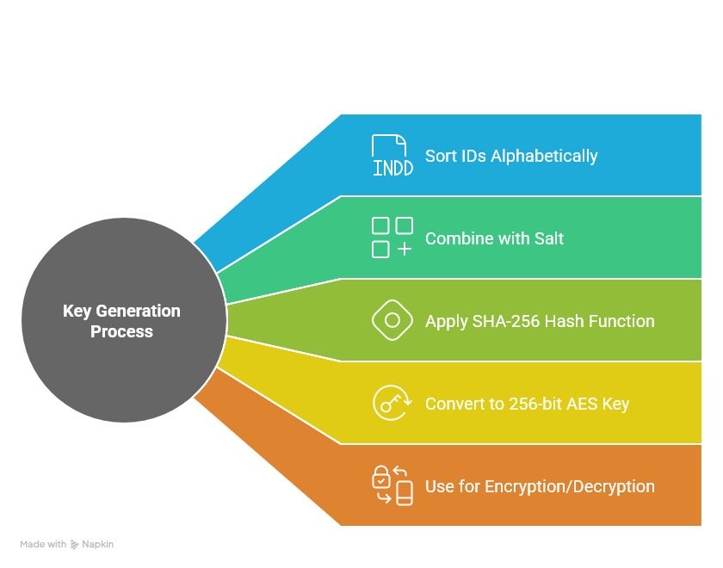

The following flowchart illustrates the lifecycle of the creation of a secure chat message:
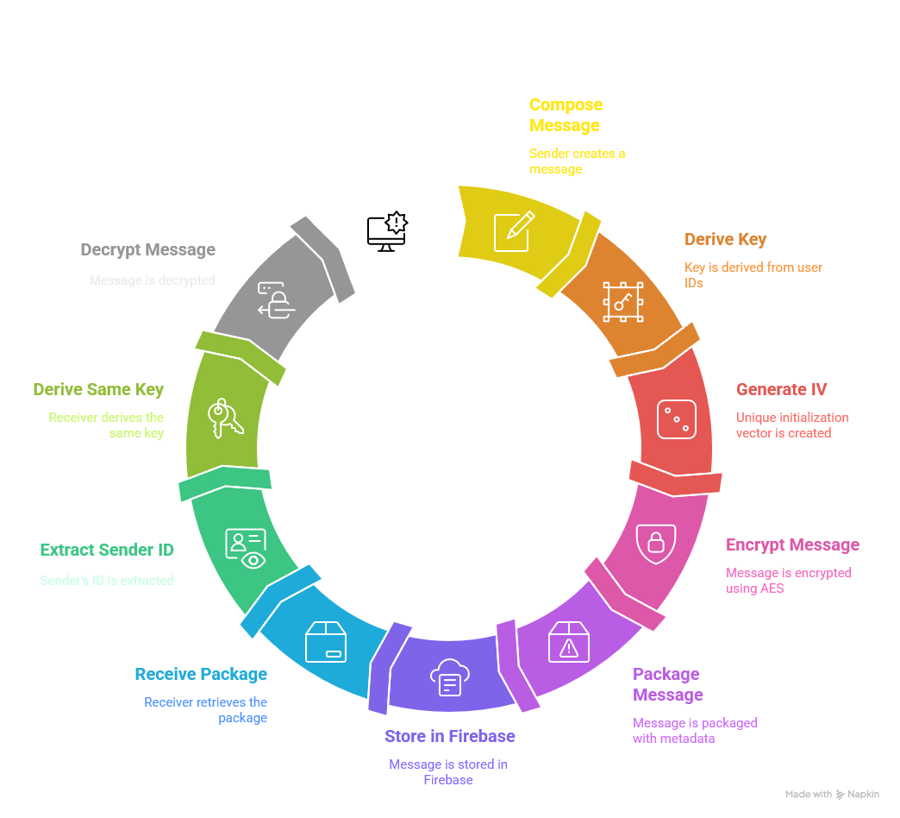

This flowchart depicts the handling of SafeSpace messages, demonstrating how it differs from normal message in that it is marked for deletion upon viewing and user exits the chat.
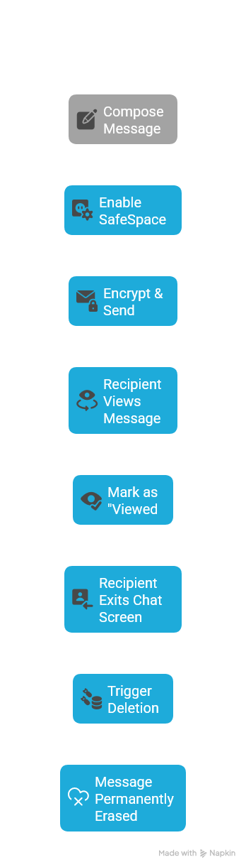
Database Schema
Since the application uses Firebase’s Firestore as its primary database, a schema was designed to support message delivery while minimizing storage of information unnecessary for functionality. The collections include:

Users Collection
users/{userID}
├ uid: String
├ email: String
└ [No personal information stored]

Chat Rooms Collection
chat_rooms/{chatRoomID}
└ messages/{messageID}
├ senderID: String
├ senderEmail: String
├ receiverID: String
├ message: String (encrypted)
├ timestamp: Timestamp
├ reactions: Map<String, List<String>>
├ isSafeSpace: Boolean
└ hasBeenViewed: Boolean

This schema is intentionally minimal, storing only necessary information for message delivery and the special features of the app, which will be discussed in the next section in more detail. Note that chatRoomID is generated based on the concatenation of the two participants’ IDs, which in itself is generated through Firebase authentication upon registration, ensuring the same chat room being always used between two users regardless of who initiates the chat.

UI/UX Design Principles
The user interface was designed with the following principles in mind:
  - Simplicity: The interface prioritizes clarity and ease of use, thus eliminating clutter and complex layouts which may confuse and turn off some users.
  - Familiarity: The application design follows established ubiquitous in messaging application interfaces where appropriate, thus reducing the learning curve for new users.
  - Default Security: As specified in the security requirements portion, security is provided by default and is presented contextually so as to not overwhelm users.
  - Visual Feedback/Interactivity: Clear visuals cues upon interaction, such as the auto-scrolling when a message is posted, or the distinct color when enabling SafeSpace, with the intention of boosting interactivity.
  - Accessibility: Design considerations include adequate contrast ratios for users with color blindness, support for text scaling for users with weak sight, and compatibility with screen readers.
  - Consistent Styling: The application supports both light and dark themes, maintaining a sleek and consistent visual language across both.

The UI architecture follows Flutter’s widget-based approach to development, featuring reusable components for common elements like message bubbles, user tiles, and more. This approach, on top of ensuring consistency across the application and facilitating an object-oriented approach, enables ease of development, which is part of the reason Flutter was chosen as the development framework.

Security Model
The security design considerations of the application were made to accommodate several principles:

End-to-End Encryption
The implementation of end-to-end encryption in the application ensures that message content can only be accessed by the sender and intended recipient. The implementation uses the following approach:
- Key Derivation: The application uses a deterministic approach wherein both sender and receiver can independently derive the same encryption key based on their IDs which generated upon account creation.
- Message Encryption: Before transmission of message, messages are encrypted using AES (Advanced Encryption Standard) with the derived key and a unique initialization vector.
- Message Decryption: Upon receipt, the messages are decrypted using the same key and the initialization vector which accompanies the encrypted message.
- Metadata Packaging: The encrypted message is packaged with the necessary metadata (sender ID, receiverID, initialization vector) to facilitate proper decryption.

This process ensures that the server components never have access to unencrypted message content nor are involved in the encryption and decryption operations.

Authentication Security
The application uses Firebase authentication services for email and password, which implements best practices:
- Secure Storage: User credentials are never stored in plaintext on the device.
- Rate Limiting: Failed login attempts are rate-limited to prevent brute force attacks.
- Validation: Email addresses are validated for format, and optionally existence, although this was not implemented in this application for the sake of expedited testing.
- Password Requirements: Passwords must meet a minimum complexity requirement (alphabets and digits in the application’s case).

Message Lifecycle Management
The application provides users with control over message persistence:
- SafeSpace Messages: Messages marked as SafeSpace are automatically deleted after being viewed by the recipient and the recipient’s exit of the chat room.
- Viewing Tracking: The application tracks when messages have been viewed, triggering the deletion process for SafeSpace messages.
- Secure Deletion: When a message is deleted, it is removed from both local storage and the Firebase database.
Data Minimization
Following privacy-by-design principles, the application minimizes the data it collects and stores:
- Minimal User Data: Only essential user information is stored (email and autogenerated UID).
- Encrypted Content: Message content is always stored in encrypted form.
- Local Preferences: User preferences, including settings for health reminders, are stored locally on the device.
Threat Model Considerations
The security model addresses several threat vectors:
- Server Compromise: Even if Firebase servers were compromised, message content remains encrypted.
- Network Interception: All communication uses HTTPS, and message content is additionally encrypted, constituting a multi-layered security approach.
- Client Compromise: Local storage is encrypted where possible, though a fully compromised device would potentially allow access to decrypted messages.
- Social Engineering: Clear visual indicators help users understand the security status of their communications.
Scalability Considerations
While the current implementation is focused on producing a minimum viable product, several design decisions support future scalability:
- Firebase Backend: Firebase provides built-in scalability for authentication and database services.
- Modular Architecture: The clear separation between UI, business logic, and data layers facilitates future enhancements.
- Stateless Design: Where possible, components are designed to be stateless, supporting easier scaling.
- Efficient Data Queries: Database queries are designed to be efficient and selective, retrieving only the necessary data.
- Performance Optimization: The application implements strategic caching to reduce server load and improve responsiveness by using Flutter functionality of make objects reusable in memory instead of being needlessly recreated, as well as partial/conditional rendering of data based on usage.
Future versions would need to address additional scalability concerns, particularly around real-time message delivery at scale and potential self-hosting options.
Conclusion
The system design reflects a careful balance between security, usability, and feature requirements, and performance optimization, as identified in the problem analysis. The architecture utilizes Firebase's scalable infrastructure while implementing end-to-end encryption to ensure message privacy. The UI design prioritizes usability while clearly communicating security states, and the data schema minimizes stored information while supporting the application's unique features like SafeSpace messages and emoji reactions.
This design forms the foundation for an application that addresses the formerly identified market gaps by providing users with greater control over their messages, transparent security, and features that promote digital wellbeing, all while maintaining the usability expected in modern messaging applications.

Feature Details
This section provides a detailed explanation of the key features implemented in the application which were previously listed, which are End-to-end encryption, emoji reactions, health reminders and the SafeSpace feature. Each feature is examined in terms of concept, technical implementation, security design considerations, and user experience design.
Peer-to-Peer Encryption
Peer-to-peer encryption, also referred to as end-to-end encryption (E2EE), is the cornerstone of secure messaging. It is a mechanism by which only users can read messages between each other, preventing third parties from accessing message content, including the service provider itself. This feature is directly related to the core problem discussed in the problem statement, namely, security and lack of trust in current service providers.
The implementation of peer-to-peer encryption in this application aims to provide the following:
- Confidentiality of message contents during transmission and storage
- Authentication of identities of both sender and receiver
- Protection against tampering with message content
- Ensuring only the intended recipient can read message content
Technical Implementation
The peer-to-peer encryption system was implemented using a symmetric encryption approach with deterministic key derivation. The process works in the following way:
- Key Derivation:
  - Instead of managing public/private key pairs, the application uses a deterministic key derivation function
  - Each pair of users has a unique encryption key derived from their user IDs
  - The derivation process uses SHA-256 hashing of a combination of both user IDs to create a consistent encryption key
  - This approach ensures that both sender and receiver generate the identical key for encryption and decryption
- Message Encryption Process:
  - When a user sends a message, the application derives the encryption key using both the sender's and recipient's IDs
  - The message is encrypted using AES (Advanced Encryption Standard) with the derived key
  - A unique initialization vector (IV) is generated for each message to ensure encryption security
  - The encrypted message, along with the IV and metadata about the sender and recipient, is packaged together
  - This package is then stored in Firebase and delivered to the recipient
- Message Decryption Process:
  - When receiving a message, the application extracts the sender's ID from the message package
  - The same key derivation function is used to recreate the encryption key
  - The message is decrypted using the derived key and the stored initialization vector
  - The decrypted content is then displayed to the user
This ensures the message contents are protected throughout the transmission process and can only be decrypted on user devices.
Here is a simplified representation of the encryption and decryption process:

// Key derivation function
Key deriveKey(String senderID, String recipientID) {
// Sort IDs to ensure the same key regardless of who is sender/receiver
final sortedIDs = [senderID, recipientID]..sort();

// Create a deterministic string from the IDs
final combined = "${sortedIDs[0]}_SECURE_KEY_${sortedIDs[1]}";

// Generate a hash of the combined string
final bytes = utf8.encode(combined);
final digest = sha256.convert(bytes);

// Create an encryption key from the hash
return createAESKey(digest.bytes);
}

// Encryption process
String? encryptMessage(String message, String recipientID) {
try {
// Get the sender's ID (current user)
final senderID = currentUserID;

// Derive encryption key from both user IDs
final key = deriveKey(senderID, recipientID);

// Generate a random initialization vector
final iv = generateRandomIV();

// Encrypt the message using AES
final encryptedMessage = encryptWithAES(message, key, iv);

// Package everything together
final encryptionPackage = {
'senderID': senderID,
'recipientID': recipientID,
'iv': encodeBase64(iv),
'ciphertext': encodeBase64(encryptedMessage)
};

return jsonEncode(encryptionPackage);
} catch (e) {
return null;
}
}

// Decryption process
String? decryptMessage(String encryptedData, String senderID) {
try {
// Parse the encryption package
final package = jsonDecode(encryptedData);

// Extract necessary components
final recipientID = currentUserID;
final ivData = decodeBase64(package['iv']);
final ciphertext = decodeBase64(package['ciphertext']);

// Derive the same encryption key
final key = deriveKey(senderID, recipientID);

// Decrypt the message
final decryptedMessage = decryptWithAES(ciphertext, key, ivData);

return decryptedMessage;
} catch (e) {
return null;
}
}

Security Analysis
The implementation of the encryption system provides several security properties:
    - Confidentiality: Message contents are encrypted using AES, a strong symmetric encryption algorithm.
    - Key Security: Encryption keys are never transmitted or stored, only derived from two users IDs when needed.
    - Authentication: The including of sender and recipient IDs in the message package helps to authenticate the source of message.
    - Separation of Concerns: The encryption and decryption process is entirely divorced from the message delivery mechanism.
While this encryption system provides adequate security of a messaging application, it does have drawbacks compared to more sophisticated systems:
- No forward secrecy in case of compromised keys, all past messages will be accessible.
- No key rotation or refreshing.
- The mechanism of key derivation means all messages between any two users use the same base encryption key.
These limitations are acceptable for the current scope of this project, and will hopefully be addressed in future iterations to introduce more enhanced security.

Emoji Reactions
Emoji reactions represent the epitome of the current instant communication zeitgeist, replacing past bloviation and unnecessary lengthiness in wording to succinct symbol-based communication, allowing the users to convey full phrases and concepts in a single or few pictograms. The inclusion of this feature was made to satisfy the needs of our times, by enhancing this rich yet simple form of communication that users have come to expect from all platforms they utilize.
The implementation of emoji reactions aims to:
- Provide a familiar and expected feature from mainstream messaging apps.
- Reduce response requirements by offering a succinct often-used method response.
- Add emotionally expressive communication to enhance quality of user exchange.
- Maintain security while offering this quality-of-life feature.

Technical Implementation
The emoji reaction feature was implemented with consideration to both function and security:
    - Data Structure:
// In the Message model
final Map<String, List<String>> reactions;

// Structure:
// {
// "👍": ["userID1", "userID2"],
// "❤️": ["userID3"]
// }
This structure couples emojis with user IDs who have performed the reaction allowing for efficient storage, counting of reaction by type, and checking if user has already reacted before.

    - User Interface Component:

// EmojiReactions widget (comparable to a Java class)
class EmojiReactions extends StatelessWidget {
const EmojiReactions({
required this.reactions,
required this.currentUserID,
required this.messageID,
required this.onReactionTapped,
});

final Map<String, List<String>> reactions;
final String currentUserID;
final String messageID;
final Function(String emoji) onReactionTapped;

// emoji options
static const List<String> emojis = ['❤️', '👍', '👎', '😂', '😮', '😢'];

@override
Widget build(BuildContext context) {
return Column(
children: [
// Display existing reactions
if (reactions.isNotEmpty) _buildExistingReactions(context),

// reaction button
GestureDetector(
onTap: () => _showReactionPicker(context),
child: Container(
// UI styling
child: Text('+ Add reaction'),
),
),
],
);
}

// Additional methods for UI rendering and interaction
}
    - Reaction Processing:
// In ChatServices class
Future<void> toggleReaction(String messageID, String chatRoomID, String emoji) async {
// Get current user ID
final String currentUserID = _auth.currentUser!.uid;

// Get the document ref
final DocumentReference messageRef = _firestore
.collection("chat_rooms")
.doc(chatRoomID)
.collection("messages")
.doc(messageID);

// Get current message
final DocumentSnapshot messageSnapshot = await messageRef.get();
final messageData = messageSnapshot.data() as Map<String, dynamic>?;

if (messageData == null) return;

// Create a Message object from the data
Message message = Message.fromMap(messageData);

// Create a Mutable copy of the reactions
Map<String, List<String>> updatedReactions = {...message.reactions};

// Toggle logic for the emoji reaction
if (updatedReactions.containsKey(emoji)) {
List<String> users = [...updatedReactions[emoji] ?? []];

// Toggle off if user already reacted
if (users.contains(currentUserID)) {
users.remove(currentUserID);

if (users.isEmpty) {
updatedReactions.remove(emoji);
} else {
updatedReactions[emoji] = users;
}
}
// Add user to this emoji reaction
else {
users.add(currentUserID);
updatedReactions[emoji] = users;
}
}
// Create new emoji reaction element
else {
updatedReactions[emoji] = [currentUserID];
}

// Update the document in Firestore
await messageRef.update({'reactions': updatedReactions});
}
    - Real-time Updates:
The application utilizes Firebase capabilities to ensure real-time database updating so that reactions appear instantly for all users. The SteamBuilder widget in Flutter is used to update the UI with new elements when a new reaction is added or remove.

User Experience Design
The emoji reaction feature was design with several UX considerations:
    - Familiarity: The reaction
    - Intelligibility: UI additions to increase intelligibility include:
        - Reaction number
        - The reaction of the current user is made visually clear
        - The visual picker is accessible yet not intrusive
    - Interaction:
        - Tapping an established reaction toggles current user’s choice
        - Dedicated “Add reaction” button opens an emoji picker
        - The reaction sheet is presented in a similar fashion to a show modal bottom sheet stylish and reactive reaction
    - Efficiency:
        - Emojis are presented in a list for quick access
        - Reactions are processed and transmitted in real-time for immediate feedback
        - The UI is performance optimized for minimum redraws when reactions change i.e., separation of concerns

Security
While it may appear a purely aesthetic feature, there are security features to consider in the emoji reaction feature:
    - Data Privacy: Reactions are stored within the data of the message package itself, which ensures user communications remain private.
    - Identity Protection: Reactions are stored using user ID rather than personally identifiable information, minimizing exposure if data were to be exposed.
    - DDoS protection: The rate limiting system which is part of the Firebase ecosystem prevent abuse of the reaction feature for malicious purposes.
    - Secure Transmission: Reaction updates are transmitted using the same established security protocols for messages.

Health Reminders
Previously mentioned in the Problem Analysis portion, technology misuse and addiction has become rampant, with social phenomena as Zombie Scrolling becoming widespread (Sinha et al., 2023) and this is especially pronounced among children, which are the most susceptible demographic. (NPR, 2024) As such, the health reminder system represents an attempt to promote more healthy usage of the messaging app and more broadly all technology. The health reminder system consists of periodic reminders which appear to users every 24-hour period, reminding them of dangers of extended screen type, dehydration etc. The messages themselves are placeholders currently.
This feature is a response to the “wellbeing gap” pointed to in the market analysis, where few messaging platforms, or even social media platforms as a whole, attempt to address user health concerns, despite increasing discoveries of the harmful effects of excessive screen time and social media presence.
Psychology Behind Health Reminders
The implementation of health reminders is based on several principles:
    - Habit Formation: Regular reminders help users develop healthier habits around technology use.
    - Break Scheduling: The system promotes the concept of microbreaks, which research suggests can reduce eye strain and mental fatigue.
    - Autonomy Support: Users maintain control through customization options and the ability to disable reminders, supporting psychological

Technical Implementation
The health reminder system is comprised of a multitude of components:
    - Preferences Service:
// PreferencesService class for managing health reminder settings
class PreferencesService {
// Keys for SharedPreferences
static const String healthReminderEnabledKey = 'health_reminder_enabled';
static const String lastReminderShownKey = 'last_reminder_shown';

// Get SharedPreferences instance
Future<SharedPreferences> _getPrefs() async {
return await SharedPreferences.getInstance();
}

// Check if health reminders are enabled
Future<bool> isHealthReminderEnabled() async {
final prefs = await _getPrefs();
// Default to true if not set
return prefs.getBool(healthReminderEnabledKey) ?? true;
}

// Set health reminder enabled status
Future<void> setHealthReminderEnabled(bool value) async {
final prefs = await _getPrefs();
await prefs.setBool(healthReminderEnabledKey, value);
}

// Get when the last reminder was shown
Future<DateTime?> getLastReminderShown() async {
final prefs = await _getPrefs();
final timestamp = prefs.getInt(lastReminderShownKey);
if (timestamp == null) {
return null;
}
return DateTime.fromMillisecondsSinceEpoch(timestamp);
}

// Set when the last reminder was shown
Future<void> setLastReminderShown() async {
final prefs = await _getPrefs();
final now = DateTime.now().millisecondsSinceEpoch;
await prefs.setInt(lastReminderShownKey, now);
}

// Check if reminder should be shown
Future<bool> shouldShowReminder() async {
// If reminders are disabled, don't show
final enabled = await isHealthReminderEnabled();
if (!enabled) return false;

// Get the last time reminder was shown
final lastShown = await getLastReminderShown();

// If never shown or shown over 24 hours ago, show reminder
if (lastShown == null) return true;

final now = DateTime.now();
final difference = now.difference(lastShown);

// Show if 24 hours have passed
return difference.inHours >= 24;
}
}
    - Reminder Dialog:
class HealthReminderDialog extends StatelessWidget {
const HealthReminderDialog({super.key});

@override
Widget build(BuildContext context) {
return Dialog(
shape: RoundedRectangleBorder(
borderRadius: BorderRadius.circular(16),
),
elevation: 0,
backgroundColor: Colors.transparent,
child: _buildDialogContent(context),
);
}

Widget _buildDialogContent(BuildContext context) {
return Container(
padding: const EdgeInsets.all(20),
decoration: BoxDecoration(
color: Theme.of(context).colorScheme.surface,
shape: BoxShape.rectangle,
borderRadius: BorderRadius.circular(16),
boxShadow: [
BoxShadow(
color: Colors.black26,
blurRadius: 10.0,
offset: const Offset(0.0, 10.0),
),
],
),
child: Column(
mainAxisSize: MainAxisSize.min,
children: [
// Health reminder contents
Icon(
Icons.favorite,
color: Colors.red,
size: 60,
),
const SizedBox(height: 16),

Text(
"Health Reminder",
style: TextStyle(
fontSize: 22,
fontWeight: FontWeight.w700,
),
),
const SizedBox(height: 16),

Text(
"Remember to take care of yourself while chatting:\n\n"
"• Take regular screen breaks\n"
"• Maintain good posture\n"
"• Stay hydrated\n"
"• Stretch occasionally\n"
"• Protect your eyes with proper lighting",
style: TextStyle(fontSize: 14),
),
const SizedBox(height: 24),

// Action buttons
Row(
mainAxisAlignment: MainAxisAlignment.spaceEvenly,
children: [
ElevatedButton(
onPressed: () {
// Record that we showed the reminder
PreferencesService().setLastReminderShown();
Navigator.of(context).pop();
},
child: const Text("Close"),
),

OutlinedButton.icon(
onPressed: () async {
// Disable health reminders
await PreferencesService().setHealthReminderEnabled(false);
Navigator.of(context).pop();
},
icon: const Icon(Icons.check),
label: const Text("Don't show again"),
),
],
),
],
),
);
}

// Static method to show the dialog
static Future<void> show(BuildContext context) async {
// Check if we should show the reminder
final shouldShow = await PreferencesService().shouldShowReminder();

if (shouldShow) {
return showDialog(
context: context,
barrierDismissible: false,
builder: (BuildContext context) => HealthReminderDialog(),
);
}
}
}
    - Reminder Triggering:
// In the HomePage class
@override
void initState() {
super.initState();

// Schedule the check for health reminder after the widget is built
WidgetsBinding.instance.addPostFrameCallback((_) {
_checkAndShowHealthReminder();
});
}

// Check and show health reminder if needed
Future<void> _checkAndShowHealthReminder() async {
await HealthReminderDialog.show(context);
}
    - Settings Integration:
// In the SettingsPage
// Health Reminder Setting
Container(
decoration: BoxDecoration(
color: Theme.of(context).colorScheme.secondary,
borderRadius: BorderRadius.circular(12),
),
margin: const EdgeInsets.symmetric(horizontal: 25),
padding: const EdgeInsets.all(15),
child: Row(
mainAxisAlignment: MainAxisAlignment.spaceBetween,
children: [
Column(
crossAxisAlignment: CrossAxisAlignment.start,
children: [
const Text("Health Reminders"),
const SizedBox(height: 4),
Text(
"Show periodic health tips",
style: TextStyle(
fontSize: 12,
color: Theme.of(context).colorScheme.primary.withOpacity(0.7),
),
),
],
),
CupertinoSwitch(
value: _healthReminderEnabled,
onChanged: (value) async {
await _preferencesService.setHealthReminderEnabled(value);
setState(() {
_healthReminderEnabled = value;
});
},
),
],
),
),

Technical Implementation
The health reminder feature includes several operations which ensure users maintain control over their experience:
    - Frequency Control: Reminders are shown at a sparse frequency (every 24 hours) to avoid intrusiveness.
    - Session-Based Timing: Reminders are triggered at junctures which are commonplace in apps, such as when users first open the application, rather than in peculiar stages of app usage, such as during chatting.
    - Immediate Dismissal: Users can quickly and effectively dismiss reminders with a single tap.
    - Permanent Dismissal: A “Don’t show again” option allows users to disable the feature permanently if they feel it is intrusive or unneeded.
    - Settings Toggle: The settings page in the upper left drawer includes a toggle to enable or disable health reminders, allowing users to re-enable them if they change their mind after disable.
SafeSpace Self-Erasing Messages
The SafeSpace feature represents the most unique and innovative aspect of the application, directly addressing the gap in user control over message persistence, as specified earlier in the report. It allows users to mark messages for automatic deletion after they have been viewed by the recipient, ensuring that sensitive or temporary information does not persist indefinitely.
This feature responds to several user needs:
- Ephemeral Communications: Many conversations contain information that's only relevant temporarily but persists in chat histories indefinitely.
- Sensitive Content Control: Users may need to share sensitive information that they don't want permanently stored on recipients' devices.
- Digital Footprint Reduction: Growing privacy consciousness has increased desire for communications that don't leave permanent digital trails.
- Context-Specific Security: Not all messages require the same level of persistence, making message-level control valuable.
Technical Implementation
The SafeSpace feature required modifications to several components of the application:
- Message Model Enhancement:
class Message {
// Existing message object fields
final String senderID;
final String senderEmail;
final String receiverID;
final String message;
final Timestamp timestamp;
final Map<String, List<String>> reactions;
// SafeSpace fields
final bool isSafeSpace;
final bool hasBeenViewed;

Message({
required this.senderID,
required this.senderEmail,
required this.receiverID,
required this.message,
required this.timestamp,
this.reactions = const {},
this.isSafeSpace = false,
this.hasBeenViewed = false,
});

// To map and from map methods
// ...
}
Chat Services Extensions:
// Toggle SafeSpace for a message
Future<void> toggleSafeSpace(String messageID, String chatRoomID) async {
// Get the document reference
final DocumentReference messageRef = _firestore
.collection("chat_rooms")
.doc(chatRoomID)
.collection("messages")
.doc(messageID);

// Get current message data
final DocumentSnapshot messageSnapshot = await messageRef.get();
final messageData = messageSnapshot.data() as Map<String, dynamic>?;

if (messageData == null) return;

// Create a Message object from the data
Message message = Message.fromMap(messageData);

// Toggle the SafeSpace flag
bool newSafeSpaceValue = !message.isSafeSpace;

// Update the document in Firestore
await messageRef.update({'isSafeSpace': newSafeSpaceValue});
}

// Mark message as viewed
Future<void> markMessageAsViewed(String messageID, String chatRoomID) async {
// Get the document reference
final DocumentReference messageRef = _firestore
.collection("chat_rooms")
.doc(chatRoomID)
.collection("messages")
.doc(messageID);

// Update the document in Firestore
await messageRef.update({'hasBeenViewed': true});
}

// Delete viewed SafeSpace messages
Future<void> deleteViewedSafeSpaceMessages(String chatRoomID) async {
// Get all messages in the chat room
final QuerySnapshot messagesSnapshot = await _firestore
.collection("chat_rooms")
.doc(chatRoomID)
.collection("messages")
.where('isSafeSpace', isEqualTo: true)
.where('hasBeenViewed', isEqualTo: true)
.get();

// Delete each message that meets the criteria
for (var doc in messagesSnapshot.docs) {
await doc.reference.delete();
}
}
Chat Bubble Enhancement:
class ChatBubble extends StatelessWidget {
// Constructor with SafeSpace parameters
const ChatBubble({
// Existing parameters
required this.message,
required this.isCurrentUser,
required this.messageID,
required this.reactions,
required this.currentUserID,
required this.onReactionTapped,
// SafeSpace parameters
required this.onToggleSafeSpace,
required this.isSafeSpace,
});

// Fields
final String message;
final bool isCurrentUser;
final String messageID;
final Map<String, List<String>> reactions;
final String currentUserID;
final Function(String emoji, String messageID) onReactionTapped;
final Function(String messageID) onToggleSafeSpace;
final bool isSafeSpace;

// SafeSpace options menu
void _showOptionsMenu(BuildContext context) {
showModalBottomSheet(
context: context,
builder: (context) {
return Wrap(
children: [
ListTile(
leading: Icon(
isSafeSpace ? Icons.security_off : Icons.security,
color: isSafeSpace ? Colors.grey : Colors.green,
),
title: Text(isSafeSpace
? 'Disable SafeSpace'
: 'Enable SafeSpace (self-erasing)'
),
subtitle: isSafeSpace
? const Text('Message will be permanent')
: const Text('Message will erase after being viewed'),
onTap: () {
onToggleSafeSpace(messageID);
Navigator.pop(context);
},
),
// Additional options could be added here
],
);
},
);
}

@override
Widget build(BuildContext context) {
return Column(
crossAxisAlignment: isCurrentUser ? CrossAxisAlignment.end : CrossAxisAlignment.start,
children: [
GestureDetector(
onLongPress: isCurrentUser ? () => _showOptionsMenu(context) : null,
child: Container(
decoration: BoxDecoration(
color: isSafeSpace
? (isCurrentUser ? Colors.purple : Colors.purple.shade300)
: (isCurrentUser ? Colors.green : Colors.grey.shade500),
borderRadius: BorderRadius.circular(12),
),
padding: const EdgeInsets.all(16),
margin: const EdgeInsets.symmetric(
vertical: 5,
horizontal: 25,
),
child: Column(
crossAxisAlignment: CrossAxisAlignment.start,
children: [
Text(
message,
style: const TextStyle(color: Colors.white),
),
if (isSafeSpace) ...[
const SizedBox(height: 4),
Row(
mainAxisSize: MainAxisSize.min,
children: [
Icon(
Icons.visibility_off,
size: 12,
color: Colors.white.withOpacity(0.7),
),
const SizedBox(width: 4),
Text(
'SafeSpace',
style: TextStyle(
color: Colors.white.withOpacity(0.7),
fontSize: 10,
fontStyle: FontStyle.italic,
// ...
Chat Page Lifecycle Management:
class _ChatPageState extends State<ChatPage> with WidgetsBindingObserver {
// Fields
Set<String> _viewedSafeSpaceMessages = {};
late String _chatRoomID;

@override
void initState() {
super.initState();

// Setup observer to detect when app goes to background
WidgetsBinding.instance.addObserver(this);

// Initialize chat room ID
final String currentUserID = _authService.getCurrentUser()!.uid;
_chatRoomID = _chatServices.getChatRoomID(currentUserID, widget.receiverID);

// ...
}

@override
void dispose() {
// Clean up observer
WidgetsBinding.instance.removeObserver(this);

// Process any viewed SafeSpace messages before leaving
_processSafeSpaceMessages();

// Rest of dispose
super.dispose();
}

@override
void didChangeAppLifecycleState(AppLifecycleState state) {
// When app is paused or inactive, process SafeSpace messages
if (state == AppLifecycleState.paused || state == AppLifecycleState.inactive) {
_processSafeSpaceMessages();
}
}

// Process SafeSpace messages
Future<void> _processSafeSpaceMessages() async {
// Mark all viewed SafeSpace messages as viewed in Firestore
for (String messageID in _viewedSafeSpaceMessages) {
await _chatServices.markMessageAsViewed(messageID, _chatRoomID);
}
// Clear local tracking set
_viewedSafeSpaceMessages.clear();

// Delete all viewed SafeSpace messages
await _chatServices.deleteViewedSafeSpaceMessages(_chatRoomID);
}

// Message item building with SafeSpace tracking
Widget _buildMessageItem(DocumentSnapshot doc) {
Map<String, dynamic> data = doc.data() as Map<String, dynamic>;
String messageID = doc.id;

// Is current user
bool isCurrentUser = data['senderID'] == _authService.getCurrentUser()!.uid;

// Check if this is a SafeSpace message not sent by current user
bool isSafeSpace = data['isSafeSpace'] ?? false;
if (isSafeSpace && !isCurrentUser) {
// Track that we've viewed this SafeSpace message
_viewedSafeSpaceMessages.add(messageID);
//…

Security Considerations
The SafeSpace feature introduces security features:
    - Deletion: The system makes a best-effort attempt to deleted view SafeSpace marked messages, but cannot guarantee deletion if the recipient takes a screenshot or make copies of message contents. In the case of the recipient device being compromised or Network issues preventing service synchronization, the feature might become compromised or faulty in terms of security application.
    - Network: The implementation includes mechanisms to retry incase of network failure and the deletion operation failure.
    - Visibility: Clear visual confirmation of marking messages as SafeSpace (with purple colored “SafeSpace” label as well as an eye icon) ensures users understand when messages have been marked for the ephemeral property.
    - Control: Only senders can mark the SafeSpace feature, preventing receiver from deleting messages that are not their own.

Limitations and Future Enhancements
Several limitations of the current SafeSpace implementation could be addressed in future versions:
- Verification Mechanisms: Adding cryptographic verification that messages were truly deleted would enhance trust in the feature.
- Screenshot Detection: Implementing screenshot detection and notification could enhance the security model.
- Timed Expiry: Adding the option for messages to expire after a specific time period, regardless of viewing status.
- Partial Viewing: Implementing mechanisms to handle cases where messages are partially viewed before the user exits.
- Group Chat Support: Extending the SafeSpace concept to group conversations with appropriate modifications to the viewing and deletion logic.

Feature Integration and Interaction
These four key features—peer-to-peer encryption, emoji reactions, health reminders, and SafeSpace messages—were designed to work together cohesively, creating a secure and user-friendly messaging experience. Several aspects of their integration deserve special mention:
- Security: The features create layered security, with peer-to-peer encryption providing baseline protection and SafeSpace adding temporal security for selected messages.
- Consistent Visuals: All features follow a consistent visual design, making them intuitive parts of a congruent experience rather than appearing disjointed and haphazardly designed.
- Functionality: The features address different aspects of the identified problems, with encryption addressing trust issues, SafeSpace addressing control concerns, reactions enhancing usability, and health reminders addressing wellbeing.
- Performance Considerations: Feature interactions were carefully designed to avoid performance degradation, with asynchronous processing for heavy operations and efficient UI updates which only changes state for moving parts.
- Privacy-by-Default: All features were designed with privacy as the default setting, requiring explicit action to reduce privacy rather than to enhance it.
Together, these features address the core problems identified in the analysis phase, providing users with enhanced control, transparency, and wellbeing support within a secure messaging framework.

Testing and Evaluation
In order to provide users with a seamless experience, performance testing was deemed essential. This section will detail the testing methodology, as well as the results, of the application.

Performance Testing Methodology
The performance of the application was tested using tools provided by the Flutter framework such as DevTools and the performance debugging overlay in the Android Studio’s emulator, using the Google Pixel 6 phone as the emulated device. This device was chosen as it is a mid-range android device to represent a typical usage scenario.
The performance testing methodology employed testing techniques to measure various aspects of the performance of the application. Tests were designed to measure UI responsiveness, framerate analysis, resource utilization, as well as feature specific performance. The test was segmented into three portions:
- Application Launch and Authentication:
  - Raster average: 4.3 ms/frame
  - Maximum frame time: 78.7ms/frame
  - UI thread average: 1.5 ms/frame
During the initial launch and authentication phase, the application demonstrated good average performance with most frames rendering at below a 16ms. Occasional UI thread spikes were observed during cryptographic operations related to user authentication. Despite these spikes, the UI remained responsive with the text fields showing no perceptible lag.
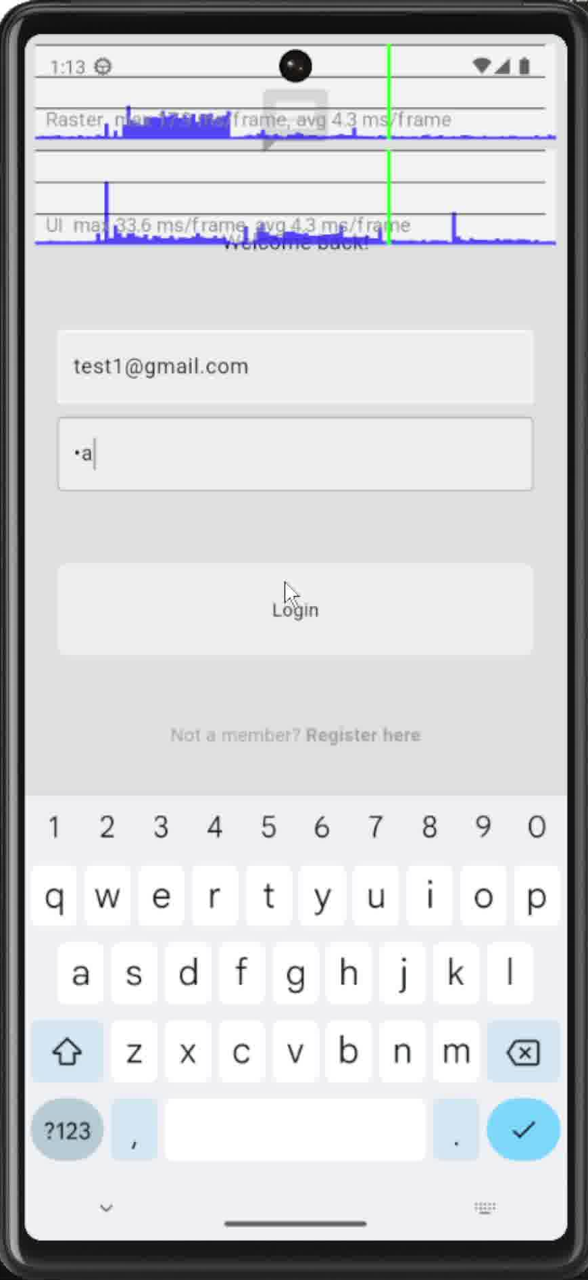
- Message Operation:
  - Raster average: 3.2 ms/frame
  - Raster maximum: 223 ms/frame
  - UI thread maximum: 33.6 ms/frame
  - UI thread average: 3.8 ms/frame
This segment of testing demonstrated the application performance during core messaging functionality. While average overall performance remained excellent, maximum frames showed some spikes during encryption/decryption processes and message transmission.
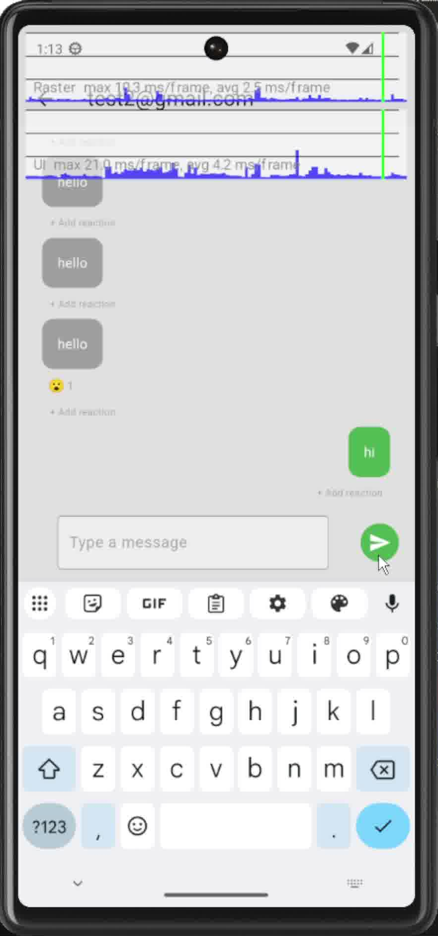

- Feature Interaction:
- Raster average: 2.6 ms/frame
- Raster maximum: 223 ms/frame
- UI thread maximum: 58.9 ms/frame
The final performance testing segment focused on the usage of interactive features such as emoji reactions and SafeSpace. The application performance stayed consistent throughout these functionalities. The maximum raster time shows that complex operations, such as the SafeSpace feature, created occasional frame rendering delays, but remained within acceptable thresholds in terms of responsiveness. However, some isolated interactions reveal that some improvements to performance optimization can be potentially made.
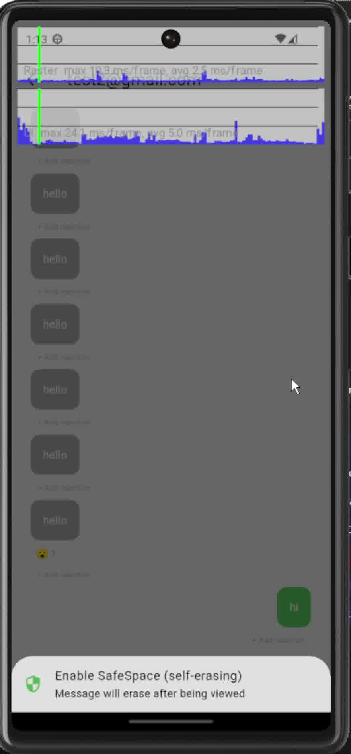

Performance Assessment
The performance testing revealed several key points:
- Excellent Average Performance: Across all three test segments, the application demonstrated an average frame rendering time of (2.6-4.3 ms/frame), well below the 16.67ms threshold required for 60 FPS performance. This indicates that for the majority of user interactions, the application provides a fluid and responsive experience.
- Security-Performance Balance: Occasional performance spikes were observed during encryption operations as well as SafeSpace activation, which is an expected computational cost of implementation of robust features. They are deemed acceptable trade-offs for the price of enhanced security benefits.
- UI Thread Optimization: The UI thread's average performance remained excellent throughout testing, with averages consistently below 4ms, indicating effective implementation of Flutter's widget rebuilding patterns. This ensures that the application remains responsive to user input even during intensive operations.
- Reactive Feature Performance: Features like emoji reactions demonstrated efficient implementation, with minimal impact on overall performance. This validates the design decision to include quality-of-life features alongside security-focused functionality.
- Resource Efficiency: Throughout testing, the application demonstrated efficient resource utilization, with memory and CPU usage remaining within expected parameters even during intensive operations like encryption and message processing.

Optimization Opportunities
While the application's performance is generally strong, the testing identified several areas for potential optimization in future iterations:
- Encryption Operation Optimization: Further optimization of the encryption and decryption processes could reduce maximum frame times during message sending and viewing operations.
- SafeSpace Visual Rendering: The distinctive visual styling of SafeSpace messages occasionally impacts rendering performance. Optimizing these visual elements could improve consistency in frame times.
- Initial Loading: Application launch and initial data loading showed some performance spikes that could be mitigated through improved resource preloading and lazy initialization strategies.
- Authentication Flow: The authentication process demonstrated occasional UI thread spikes that could be addressed by moving more cryptographic operations off the main thread.

Conclusion of Performance Testing
The performance testing results validate that the application achieves its goal of providing a secure messaging platform without significantly compromising on user experience or interface responsiveness. The excellent average performance metrics across all test segments demonstrate that the application can deliver a smooth, responsive experience while implementing robust security features.
The occasional performance spikes observed during specific security operations represent an acceptable trade-off between absolute performance and security, particularly given that these spikes are momentary rather than sustained issues. Future optimization efforts will focus on reducing these occasional spikes to further enhance the user experience while maintaining the application's strong security foundation.
Overall, the performance testing confirms that the Flutter framework, combined with the implemented architecture and security model, provides an effective foundation for building a secure messaging application that delivers on both performance and security requirements.

Conclusion and Future Work
The aims of this project are to develop a secure messaging platform which addresses key gaps in existing platforms, in particular regarding user control over data, transparency in security implementation, and integration of user-first features which promote digital wellbeing. Through careful analysis of the problem, particularity in design, and systematic design, the project has successfully delivered a working application which demonstrates unique answers to these challenges.
Achievement of Objectives
Reflecting on the original objectives of this project, which are outlined at the beginning of the report, the project has achieved:
    - Creation of a Cross-Platform Messaging Application: Using Flutter, the application provides a consistent, responsive, and visually sleek experience across Android and iOS devices, using the same code-base, with the potential to expand into web and desktop environments.
    - Implementation of End-to-End Encryption: The application successfully implemented peer-to-peer encryption which ensures message contents remain private, with encryption and decryption occurring exclusively on user devices.
    - Development of SafeSpace Self-Erasing Messages: The unique SafeSpace feature gives users control over message persistence, allowing them to mark messages for automatic deletion upon being viewed.
    - User-Friendly User Interface Design: The application maintains a simple and easy-to-use user interface while incorporating modern features such as emoji reactions.
    - Health Reminders: The health reminder component addresses an overlooked aspect in many digital communication platforms, encouraging healthy habits without intruding upon the user’s experience.
    - Minimum Metadata Collection: The application collects only bare-minimum metadata essential for operation, and has no financial or political incentive to use that information for anything other than application functionality.
    - Foundation for Future work: The modular design of the application architecture and clearly defined separation of concerns provides a solid stepping stone for future development, including a potential self-hosting option.

Key Innovations
This project makes several notable contributions to the field of secure messaging:
    - Message Ephemerality: Unlike other platforms which apply message ephemerality on the conversation level, the SafeSpace feature allows control over individual messages, granting more granular control.
    - Integrated Digital Wellbeing: The health reminder system demonstrates a novel and unique approach to addressing digital wellness within a messaging context, acknowledging the relationship between digital communication, and technology more broadly, and between user health.
    - Balance of Security and Responsiveness: The project represents a successful balance between enhanced security features without sacrificing the responsiveness of user experience.
    - Transparent Security Model: The clear visual indicators and straightforward controls for security features promote user understanding and engagement with privacy mechanisms.

Project Impact
The potential impact of this project could potentially extend beyond the developed application:
    - Educational value: The project serves as a case study in applying security-by-design and privacy-by-design principles to modern mobile application.
    - Industry Influence: The innovative features demonstrated in this project could influence mainstream messaging platforms to adopt similar approaches to user control and wellbeing.
    - Open-source Contribution: As the project moves toward open-source release, it will contribute to the ecosystem of secure communication tools available to privacy-conscious users.
    - Empowerment: By providing greater control over message persistence and clear security indicators, the application empowers users to make informed decisions about their digital communications.

Limitations
Despite the successful development of the application and inclusion of the discussed features, the project has several limitations that should be acknowledged:
    - Early Development Stage: As a minimum viable product, the application lacks some features that would be expected in a production-ready messaging platform, including group chats, voice/video calling, and media sharing.
    - Limited Security Audit: While the security model is sound in design, the implementation would benefit from a comprehensive security auditing, which is beyond the scope of this project.
    - Dependency on Firebase: The current reliance on Google’s Firebase introduces some unwanted centralization that will hopefully be address in future iterations with self-hosting options.
    - Limited User Testing: While functional testing was thorough, more extensive testing would be valuable, including on multiple hardware mobile phones with different operating systems.
    - Mobile-Centric Design: While the current implementation is focused on mobile experiences, later development could potentially be expanded to include desktop and web applications.
Lessons Learned
The development process yielded several important insights:
    - Technical Lessons:
      - Utilizing the Flutter development tools such as hot reload and DevTools significantly accelerated development.
      - Firebase provided tools provided a robust foundation for authentication and real-time data synchronization.
      - Separating encryption logic from UI concerns facilitated expedited testing.
      - Managing complex state across asynchronous operations required careful consideration of Flutter’s widget lifecycle. More focus on incorporating advanced state management will be required as more features are included.
    - Process Insights:
      - Starting with a clearly defined problem coupled with user-needs assessment provided crucial development focus.
      - Implementing core functionality before moving on to advanced features provided a good method to separate concerns.
      - Regular testing throughout development and creating development branches was essential.
      - Documenting design and code facilitated methodical development implementation across features.
    - Security:
  - Implementing security features requires balance between user experience and protection.
  - Visual indicators of security state are essential for user understanding.
  - Security is as much about user usage patterns as it is about technical protection.
  - Even ostensibly simple features such as message ephemerality requires deliberation regarding overall application security and design.
These lessons will inform future iterations of the project and could benefit other developers working on secure communication applications.
Future Work
While the current application represents minimum viable product that was successfully developed as outlined in the project’s objectives, several areas for enhancement have been identified for future development.
Short-Term Enhancements
      - Message Search and Filtering
          - Implement secure client-side message searching
          - Add filtering options for media, reactions, and links
          - Ensure search functionality respects user privacy by only indexing content on the client device
      - Media Sharing
          - Expand functionality by adding media sharing option, including documents, audio, video, and location
          - Implement encrypted media transfer
          - Add preview capabilities
          - Extend SafeSpace to be applicable to media
      - User Profile
          - Add avatars to user profiles
          - Implement presence indicators
          - Add status to messages (sent/read)
          - Develop contact management features
      - Interface Refinement
          - Implement accessibility features for users with disabilities
          - Add theming beyond light/dark options
          - Refine animations and transition smoothness
          - Optimize layouts for different screen sizes
      - Offline Functionality
          - Enhance offline message queueing
          - Implement robust sync mechanisms for when connectivity is restored
          - Add conflict resolution for simultaneous edits

Medium-Term Enhancements
      - Group messaging
          - Develop secure group creation and management, with perhaps advanced features for organizations and a more elaborate hierarchy structure
          - Extend end-to-end encryption to include group chats
          - Extend SafeSpace and reaction features to include group chats
      - Audio/Video Communication
          - Implement encrypted voice and video calling
          - Add video capabilities with privacy control
          - Develop screen sharing functionality for collaborative-type interaction
      - Advanced Security Features
          - Implement two-factor authentication
          - Add login alerts for new device access
          - Develop secure key back and recovery processes
      - Cross-Platform Expansion
          - Introduce web and desktop clients
          - Develop applications for Windows/macOS/Linux
          - Ensure consistent experience and security model across platforms
          - Optimize UI for different form factors and input methods
      - Analytics and Diagnostics
          - Develop a voluntary analytic and system diagnostic reporting system
          - Opt-in crash reporting
          - Bug reporting and feedback

Long-Term Enhancements
      - Self-Hosting Option
          - Develop server components for self-hosting
          - Create easy deployment options for organizations
          - Implement administration tools for enterprise environments
      - Zero-knowledge Architecture
          - Transition to a full zero-knowledge protocol
          - Implement client-side encryption of all metadata
          - Develop secure multi-device synchronization without server access to keys
          - Create verifiable security proofs for the encryption implementation
      - Expend Wellbeing feature
          - Develop customizable health reminder content
          - Add integration with existing wellbeing mobile frameworks, such as Samsung Health and Apple Health
          - Create tools to manage communication with communication boundaries which promote mental health

Research Direction
Beyond specific feature development, several research directions could inform future iterations
      - Once analytics are collected, usable security studies on how users interact with security features could inform more congruent design with usage patterns.
      - The impact of promoting digital wellbeing could be made more effective once user behavior is analyzed to inform future development.
      - Secure messaging in a group chat scenario could present more challenges to a truly secure design.
      - Methods of collecting analytics could be investigated to discover a way in which facilitates the privacy of user information.
      - Cross-platform security must be scrutinized on a by-platform basis, which presents a testing challenge.

Final Reflections
This project has demonstrated the possibility to create messaging application that addresses key privacy and control concerns while maintaining usability and modern features. The innovative SafeSpace feature, in particular, represents a novel approach to user control over message persistence, while the integration of health reminders acknowledges the broader impact of digital communication tools on user wellbeing.
The fundamental principle which guided the development of this project, namely, that users should be provided with transparent information and meaningful control over their digital communications, remains a relevant point regardless of any specifically used technology. As messaging platforms continue to evolve, this principle should remain the guiding beacon of design. Should platform providers veer from this principle, they ought to be aware that they are easily replaceable by more altruistically minded platforms.
While the current application has limitations and substantial work remains to be done for a fully-featured alternative messaging platform to be completed, this project provides a solid foundation and proof of concept for a more user-centered approach to secure messaging. The open-source future of the project offers the potential for community-driven development and wider impact beyond what could be achieved in a single academic project.
In an era of increasing concern about digital privacy and wellbeing, this project contributes to the ongoing dialogue on how communication tools can better serve and respect users’ needs and values, rather than pursue political or monetary gain. By presenting concrete implementations of features that enhance user control and transparency, the project moves beyond critique to offer a constructive alternative that could influence the broader messaging ecosystem.

Literature Review
This section explores the existing research and market landscape relevant to secure messaging applications. It explores the progress of instant messaging, analyzes current mainstream applications, reviews key issues in security in them, and examines research related to user privacy.
Evolution of Instant Messaging
The development of instant messaging (IM) technology represents a significant technological leap in digital communication, progressing from simple text exchanges to sophisticated multimedia platforms with advanced security features.
Historical Development
Instant messaging has roots in the early days of computing, with notable milestones including:
      - Early Systems (1960s-1980s): Systems like PLATO’s TERM-talk and early Unix “talk” command enabled rudimentary real-time communication between users on the same system (Bruin, 2018). These command-line interfaces typically used split-screen formats where messages from different users appeared in a separate portion of the screen.
      - Bulletin Board Systems (1990s): Bulletin Board Systems (BBS) had chat functionality similar to IM communication. According to Bruin, “Systems operators or SYSOPs owned these personal computer systems that sat idle connected to a phone waiting for users to call via a terminal program.” While real-time communication was possible, BBS systems were primarily designed for asynchronous communication (Bruin, 2018).
      - Service Provider Era (1980s-1990s): As home computers gain in popularity, online service providers such as Quantum Link and America Online (AOL) offered proprietary instant messaging systems. “AOL instant messaging or (AIM) was seen as a major value for AOL service,” as noted by Bruin (2018). These systems helped catapult adoption of IM technology to the mainstream.
      - Standalone IM Clients (1990s): As internet access became more widely available, standalone IM clients not tied to any online service began to appear. ICQ, created by Israeli firm Mirabilis, pioneered several innovations including “multi-user chat capability, the ability to search for other users using a directory, and file exchange” (Bruin, 2018). AOL acquired Mirabilis in 1998 and enhanced AIM with the first series of “bots,” non-human chat participants which people could interact with.
      - Technology Enterprises Enter the Market (1998-2000): Major technology companies who have recognized the importance of messaging, with Yahoo launching Yahoo Messenger (originally Yahoo Pager) and Microsoft releasing MSN messenger in 1998-1999 (Bruin, 2018). This period saw the emergence of multi-protocol IM clients like Jabber, which could communicate across different IM systems.
      - Social Media Integration (2005-2008): Social networking platforms began integrating instant messaging into their services, with the like of Google Talk, MySpaceIM, and Facebook Chat launching during this period (Bruin, 2018). This integration significantly increased the user base of instant messaging beyond the more technical demographic.
      - Mobile Messaging Era (2010-Present): With the proliferation of smartphones, messaging has shifted to primarily mobile platforms, with apps like Facebook Messenger, WhatsApp, Telegram, and Signal dominating the global market. (Bruin, 2018)
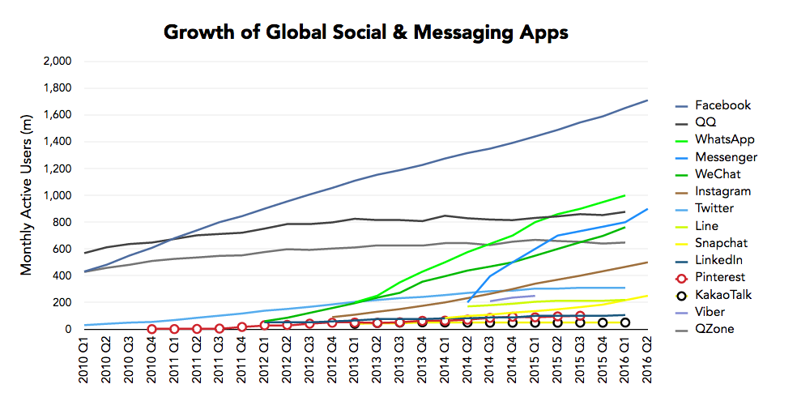
Line chart of monthly messaging app users from 2010 Q1 – 2016 Q2 (Wang , 2016)
Post-Snowden Era (2013-present): Following Edward Snowden’s whistleblowing revelations regarding global surveillance programs, there has been an increased focus on security and privacy in messaging applications, with end-to-end encryption becoming a standard feature in many platforms. As Johansen et al. (2021) note, "When Edward Snowden published the secret papers about NSA, people finally understood that mass surveillance was an issue, and secure mobile messengers became more critical and popular." This period has witnessed end-to-end encryption becoming a standard feature in many platforms, with applications rushing to implement this technology to address user privacy concerns.
The surveillance revelations continued beyond Snowden, as Johansen et al. (2021) point out: "No need to look further than the first quarter of 2017, when WikiLeaks leaked documents from the U.S. Central Intelligence Agency (CIA)... [with] information on how to get access to mobile phones or personal computers without the user's knowledge and how the CIA did mass surveillance." These ongoing revelations further accelerated the adoption of secure messaging.

Technological Shifts
Numerous technological shifts occurred that have shaped modern messaging:
      - Progress in Protocol: From propriety protocols to standardized approaches and customized protocols optimized for mobile environments and encryption. As Johansen et al. (2021) documents, the Signal protocol emerged as an especially influential standard, being adopted by multiple applications, including WhatsApp.
      - Encryption Adoption: The gradual adoption of encryption has improved from being optional and user-initiated to being a standard practice and enabled by default in most platforms. As Bruin (2018) warns, users are the most common attack vectors for cyber-attacks. This cognizance has driven application of encryption of features, though Johansen et al. (2021) found only half of the applications notified the user regarding end-to-end encryption.
      - Architecture Diversification: Messaging services have taken a myriad of approaches towards balancing security and usability. Johansen et al. (2021) elucidates that applications like Signal prioritize security by limited users to one device, while others like Matrix/Riot support multiple devices without efficiency of conversations being affected. Bassey (2025) notes the performance implications of these architectural choices, finding that different frameworks excel in different contexts. He points to XMPP, a dated proprietary protocol, as a protocol well-suited to large-scale real-time and dynamically changing environments, while non-XMPP approaches remain efficient and cost-effective for smaller, less dynamic configurations.
      - Growing Threats: Bruin (2018) highlights that as instant messaging applications have proliferated all sections of society and have become ubiquitous, the opportunities for cyber-crime also proportionally increases. This makes security features much more important for messaging applications.
      - Mobile Optimization: The adaptation of messaging apps for mobile devices, with consideration for battery life, data usage, and touch interfaces (Bruin, 2018). Bruin notes that carrying smart phone technology and the need to have constant access to it has become an essential part of daily lives of many. This shift has influenced protocol choices, with Bassey (2025) finding that different protocols have distinct performance profiles on resource-constrained devices.
These technological shifts create a need to balance between feature introduction, usability, and security design considerations that must be made by modern messaging applications. The centrality of messaging in modern communication makes these considerations that much more important.
Current Messaging Applications Analysis
The analysis of currently popular messaging apps reveals different approaches to balancing safety, security, functionality, and usability.
WhatsApp
WhatsApp is the one of the mostly widely used secure messaging platforms. According to Bruin (2018), WhatsApp was the most popular application in 2016, with 950 million active monthly users. More recently, data from Lamriji et .al (2023) shows this growth has continued unabated, with more than 2.44 billion monthly active users worldwide as of 2022, representing over 40% of global population.
      - Security Mode: Uses the Signal Protocol for end-to-end encryption, implemented by default since 2016. As Johansen et al. (2021) point out, in April 2016, a complete shift from nonsecure messaging to full end-to-end encryption was made. Lamriji et al. (2023) provider further elaboration, explaining that this implementation in collaboration with Open Whisper Systems in 2013, and that from version 2.12.556 onwards, all text as well as audiovisual messaging and calls is end-to-end encrypted by default.
      - Technical Implementation: Lamriji et al. (2023) explain that WhatsApp’s application of the Signal protocol uses several cryptographic mechanisms:
          - Elliptic Curve Diffie-Hellman (ECDH) key exchange using Curve25519
          - Double Ratchet Algorithm (DRA) for deriving unique encryption keys for each message
          - Advanced Encryption Standard (AES) for message encryption
          - Ed25519 signature scheme for message authentication
      - Key Findings:
          - Johansen et al. (2021) found that WhatsApp “immediately re-encrypts a lost message when it finds out that the cryptographic keys have change,” creating a potential security vulnerability that could allow unauthorized access to private messaging.
          - Lamriji et al. (2023) note that WhatsApp uses Short Authenticated Strings (SAS) as part of the E2EE protocol for providing additional layers of security and prevent man-in-the-middle attacks.
          - Limitations revealed by Lamriji et al. (2023) is that t his verification process requires users to meet physically in order to verify their messages and calls are E2EE.
      - Computational Considerations: Lamriji et al. (2023) highlight that E2EE can be computationally costly and post challenges to low-end devices or low networks. Their research demonstrates optimization techniques for scalar multiplication and coordinate systems can significantly reduce processing time and energy consumption on mobile devices.
      - User Control Limitation: Users have been observed to have limited control over message persistence, with “delete for everyone” feature having time limitations and no automatic ephemeral messaging until recently.
Signal
Signal represents the golden standard for security-focused messaging:
      - Security Model: Open-source implementation of the Signal Protocol, with E2EE for all communications and minimal metadata collection. Johansen et al. (2021) states that the fact that it is open-source is what set it apart completely from other applications.
      - User Base: Gerken (2025) reports that Signal garnered an estimated 40-70 million monthly users, which is not a lot compared to other platforms such as WhatsApp and Messenger, whose numbers are in the billions.
      - Key Findings:
          - E2EE for all communication (Gerken, 2025)
          - Open-source code that can be accessible by anybody to check for vulnerabilities (Gerken, 2025)
          - Minimal data collection, with no storage of usernames, profile pictures, or groups that a user is a member of (Gerken, 2025)
          - Non-profit ownership model that relies on donations rather than ad revenue, which removes financial incentives which may compromise security (Gerken, 2025)
          - Johansen et al. (2021) found that Signal effectively blocks messages when cryptographic keys change, requiring verification before communication can continue
      - Limitations:
          - Requires a phone number for registration, which compromises anonymity
          - Limit number of users to one per mobile device, which, according to Johansen et al. (2021), is done to strengthen security and keep private cryptographic keys on one device only.
          - Messaging is only as secure as user behavior (Gerken, 2025)
          - Disappearing messages feature may cause issues with record-keeping in more official contexts (Gerken, 2025)
      - Notable Usage: Signal has gained attention for high-profile use cases. Gerken (2025) reports it "emerged it had been used to discuss war plans at the highest levels of the US government," creating controversy when a journalist was inadvertently added to a secure group chat about military operations.
Security Concerns in Modern Messaging
There are multiple much talked about security concerns regarding modern messaging applications in the research field:

End-to-End Encryption
End-to-end encryption (E2EE) has become an industry standard:
      - Technical approaches: The Signal Protocol has emerged as the most widely adopted standard. Lamriji et al. (2023) provides a detailed overview of how WhatsApp implements E2EE using the Signal Protocol:
          - Three types of key pairs: Identity Key Pair (long-term), Sign Pre-Key (medium-term), and One-Time Pre-Keys
          - ECDH key exchange for deriving shared secrets from public and private keys
          - Double Ratchet Algorithm to generate unique AES secret keys for each message or call
          - Ed25519 for strengthened message authentication and verification
      - Implementation Challenges:
          - Key verification remains an issue. Lamriji et al. (2023) explains WhatsApp’s approach using Short Authenticated Strings (SAS) where users can verify security codes through QR codes or 60-digit numeric codes.
          - Performance considerations are notable. Lamriji et al. (2023) found that "performing scalar multiplication (SM) in ECC schemes is computationally complex" and proposes a variety of optimization methods to conserve and extends battery life on handheld devices.
      - Policy Controversy: Gerken (2025) brings to the foreground recent and ongoing tensions between encryption providers and governments. In the article, he explains that various governments have sought to create backdoors into messaging services so that they are able to monitor conversations for the sake of “national security.” Apps have struggled against attempts of creating such backdoors, claiming that it will be eventually used by bad actors. One such example is in 2023, when Signal threatened to pull the app from the UK if its security was undermined by lawmakers.
Security in Official Contexts
The recent controversy involving Signal usage by U.S government officials leads to important considerations:
      - Appropriate Security Levels: Gerken (2025) quotes data expert Caro Robson, who noted that it was "very, very unusual" for high-ranking security officials to communicate on a messaging platform like Signal. Standard practice would involve "a very secure government system that is operated and owned by the government using very high levels of encryption," typically requiring devices kept in "very secure government-controlled locations."
      - Secure Communication Facilities: For highly classified information, governments typically use Sensitive Compartmented Information Facilities (SCIFs), which are "ultra-secure enclosed area[s] in which personal electronic devices are not allowed" (Gerken, 2025). These facilities are "repeatedly swept for bugs or any listening devices" and use systems that are "massively encrypted and secured using the government's own highest standards of cryptography."
      - Human Factor: Gerken (2025) emphasizes that damage caused by human error cannot be avoided by any forms of security, quoting a critic who bluntly stated: "Encryption can't protect you from stupid."
      - Compliance w/ Record-Keeping: Disappearing message features in apps like Signal may create legal issues. Gerken (2025) remarks that there may be laws regarding record-keeping which are infringed upon when officials use such features, unless those users forward their messages to an official government account.
The Future of Messaging
As messaging becomes an ever-present part of daily life, several key factors will shape the trajectory of its development:
      - Security-Privacy Balance: There remains an ongoing tension between user privacy and so-called national security concerns. Gerken (2025) reports that in the case of Apple, it pulled its E2EE cloud storage feature altogether in the UK after government demands of access to the data stored in this way.
      - User Education: As illustrated by recent controversies, even the most secure systems are vulnerable to oversight by non-technical users. The growing use case of secure messaging in sensitive information communication will require user education regarding appropriate usage and best practices.
      - Technical Progress: As messaging becomes more central to how people communicate, technical considerations also grow in importance. Lamriji et al. (2023) stresses the need for performant cryptographic implementations which do not adversely affect mobile device battery life. Moreover, they argue that future challenges to cryptographic approaches exist once quantum computing is achieved.
Conclusion
The advancement of secure messaging applications represents a remarkable feat in digital privacy and security for common users. From the early days of basic instant messaging to today’s sophisticated end-to-end platforms, these technologies have transformed how we communicate whilst addressing growing privacy concerns.
The literature review established that while secure messaging has been profoundly refined, notable gaps remain in balancing security with usability, as well as user control. Current applications take different approaches to this trade-off, with none fully addressing all identified user needs. Signal stands as the “gold standard” for security-focused messaging, but has a smaller user base than WhatsApp, both of which successfully brought end-to-end encryption to billions.
Recent political scandals surrounding the use of Signal by American government officials highlights that even the most secure messaging platform is not immune to information leaks. As Gerken (2025) points out, certain official contexts require more specialized secure facilities rather than mere commercial apps, regardless of encryption strength. This underscores the critical importance of matching security design with appropriate settings.
The technical aspects of secure messaging continue to evolve. Lamriji et al. (2023) demonstrate that implementation choices considerably impact system performance and energy efficiency on mobile devices, while Bassey (2025) shows how different protocols excel in different operational environments. Meanwhile, the human element remains the most vulnerable link in security chains, with even the strongest encryption unable to protect against its follies.
As messaging applications become increasingly central to both professional and personal communication, addressing the aforementioned challenges becomes increasingly essential. Future developments will likely focus on improving performance, with the introduction of quantum computing, post-quantum cryptographic approaches must be developed to address emerging threats.
Ultimately, the field of secure messaging attests to an ongoing struggle of balancing competing priorities: privacy versus accessibility, security versus convenience, and individual rights versus collective security. As Bruin (2018) aptly concluded "IM is positioned to be a major communication mechanism in both the near and the long-term and may well become the user interface of the future." Ensuring this interface is both secure and usable remains a crucial challenge for develops, researchers, and policymakers alike.

References
Al-Jazeera (2025). WhatsApp says its users targeted by Israeli spyware company Paragon. [online] Al Jazeera. Available at: https://www.aljazeera.com/news/2025/1/31/whatsapp-says-its-users-targeted-by-israeli-spyware-company-paragon [Accessed 27 Apr. 2025].
Amnesty International. (2015). Two years after Snowden governments resist calls to end mass surveillance. [online] Available at: https://www.amnesty.org/en/latest/news/2015/06/two-years-after-snowden/.
Bassey, C. (2025). Performance Analysis of Xmpp-Based vs Non-Xmpp Centralized Test Frameworks. Preprints. [online] doi:https://doi.org/10.20944/preprints202504.1993.v1.
Bruin, N. (2018). The Evolution of Instant Messaging. [online] doi:https://doi.org/10.13140/RG.2.2.22305.10085.
France-Presse, A. (2024). Telegram’s Pavel Durov announces new crackdown on illegal content after arrest. [online] the Guardian. Available at: https://www.theguardian.com/technology/2024/sep/23/telegram-illegal-content-pavel-durov-arrest.
Gerken, T. (2025). What is messaging app Signal and how secure is it? BBC. [online] 25 Mar. Available at: https://www.bbc.com/news/articles/c1kjd091019o.
Hunt, S. (2023). WhatsApp is right to be angry about the UK’s encryption mess. [online] The Spectator. Available at: https://www.spectator.co.uk/article/whatsapp-is-right-to-be-angry-about-the-uks-encryption-mess/ [Accessed 27 Apr. 2025].
Johansen, C., Mujaj, A., Arshad, H. and Noll, J. (2021). The Snowden Phone: A Comparative Survey of Secure Instant Messaging Mobile Applications. Security and Communication Networks, 2021, pp.1–30. doi:https://doi.org/10.1155/2021/9965573.
Kolobrodova, A. (2024). Metadata 102 — What is communications metadata and why do we care about it? [online] Freedom of the Press. Available at: https://freedom.press/digisec/blog/metadata-102/.
NPR (2024). The consequences of a smartphone-centered childhood. [online] NPR. Available at: https://www.npr.org/2024/03/27/1241116105/the-consequences-of-a-smartphone-centered-childhood.
Ortutay, B. (2024). What is Telegram, and why was CEO Pavel Durov arrested? [online] AP News. Available at: https://apnews.com/article/telegram-pavel-durov-arrest-2c8015c102cce23c23d55c6ca82641c5.
Sinha, S., Manoj Kumar Sharma, Ashwini Tadpatrikar, Anand, N. and Kumar, R. (2023). Scrolling Mindlessly: Emerging Mental Health Implications of Social Networking Sites. Journal of public health and primary care, 4(3), pp.179–181. doi:https://doi.org/10.4103/jphpc.jphpc_41_22.
Wang , J. (2016). The Future of Social and Messaging Apps — Predictions for 2020. [online] Ark Invest. Available at: https://www.ark-invest.com/articles/analyst-research/social-messaging-apps [Accessed 27 Apr. 2025].
Youssef Lamriji, Khalid El Makkaoui, Maleh, Y., Abderrahim Beni-Hssane and Ibrahim Ouahbi (2023). A LIGHTWEIGHT WHATSAPP END-TO-END ENCRYPTION. Edpacs, 67(6), pp.1–24. doi:https://doi.org/10.1080/07366981.2023.2212491.
Zak Doffman (2024). Elon Musk Fights Back As WhatsApp Denies Harvesting His Data Every Night. [online] Forbes. Available at: https://www.forbes.com/sites/zakdoffman/2024/05/28/elon-musk-fights-back-as-whatsapp-denies-harvesting-his-data-every-night/ [Accessed 27 Apr. 2025].

User Manual and Testing
For instructions on using and testing the application please see the project’s GitHub page:
https://github.com/FaisalAlsaadi/chatApp

