**King Abdulaziz University**

**College of Engineering (CoE)**

**Winter 2023 – Operating Systems (EE463)**



**EE463 – Operating Systems**

**LAB #2**

**Tutorials on the Unix Shell & vim editor**

|  |  |  |
| --- | --- | --- |
| Student Name | ID | Submission Date |
| Faisal Abushanab | **1945603** | **2022/1/1** |

**Instructor: Dr. A. M. Al-Qasimi**

**Eng. Turki Gary**

**The vim Text Editor:**

**10. Find word under cursor, * and #)**

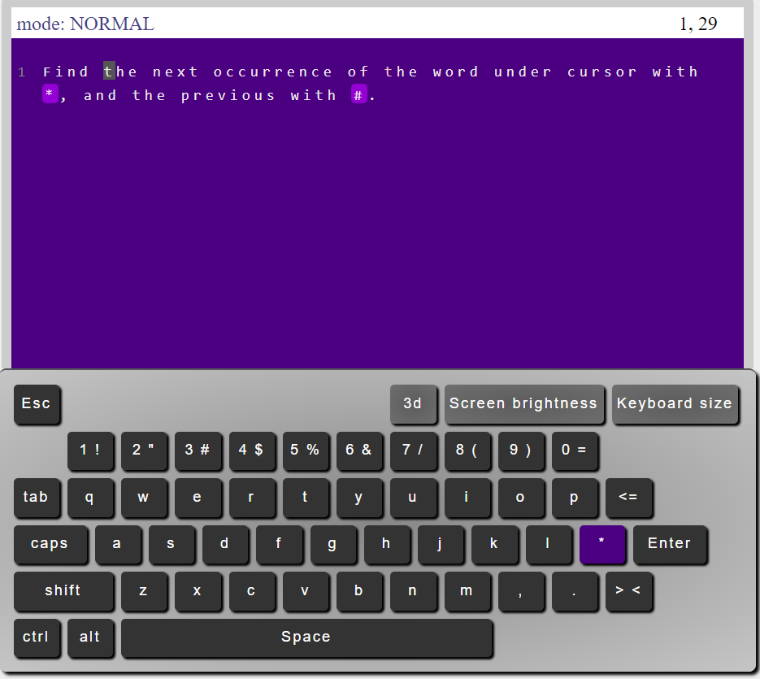

To find the next occurrence of the word under the curser we use the “*” button, while finding the previous occurrence is done by the “#” button

**11. Goto line, g and G)**

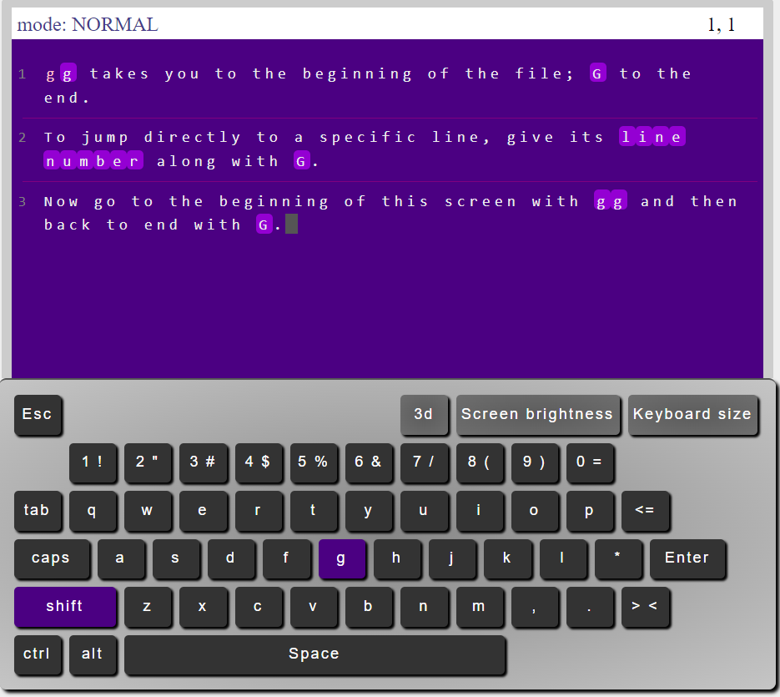

Use gg command to go to the beginning of the file, while using G command will put the cursor into the end of the file

When you want to go to specific line you can type line number followed by G

**12. Search, /text with n and N)**

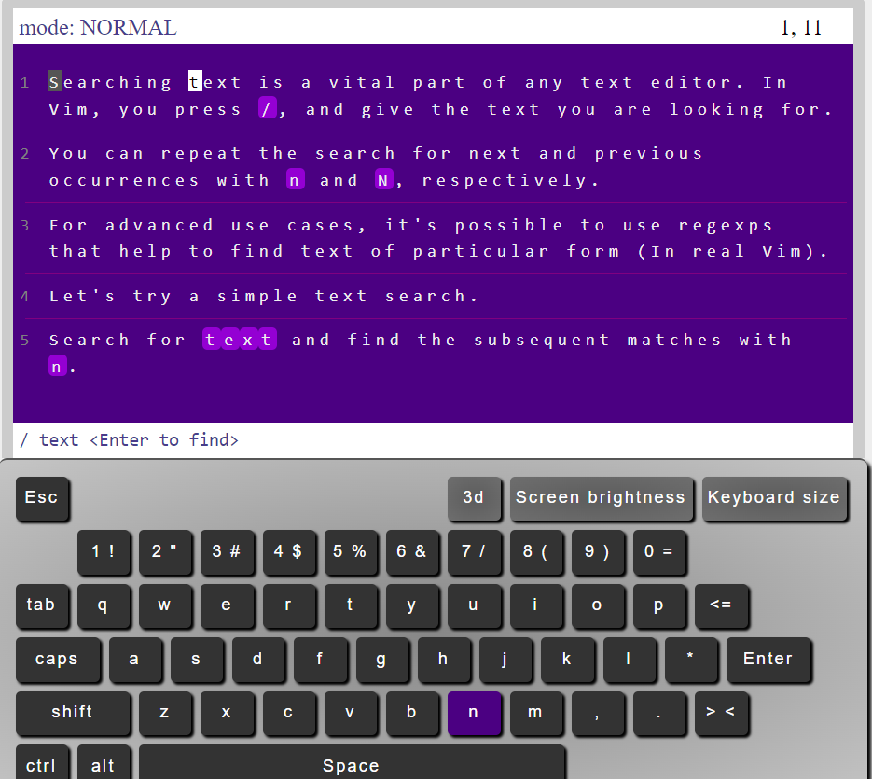

To search for specific keyword press / button then type the desired string, if you want to find the next occurrence press n button.

**13. Insert new line, o and O)**

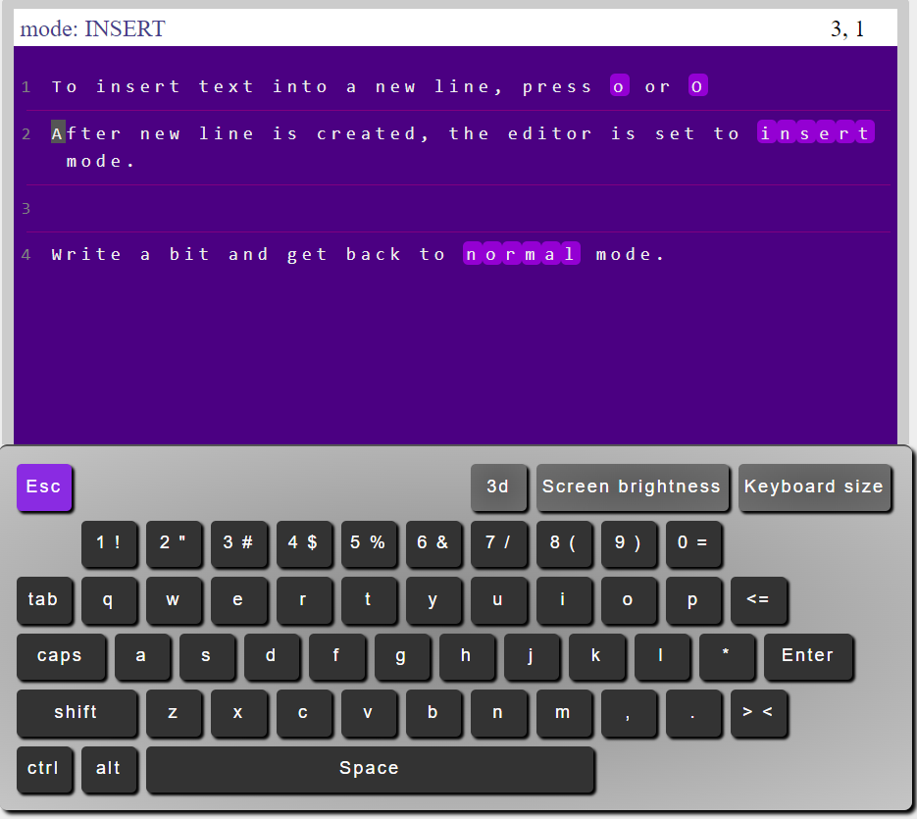

When you want to insert new line press the o button or O which will append a new line and switch to insert mode.

**14. Removing a character, x and X)**

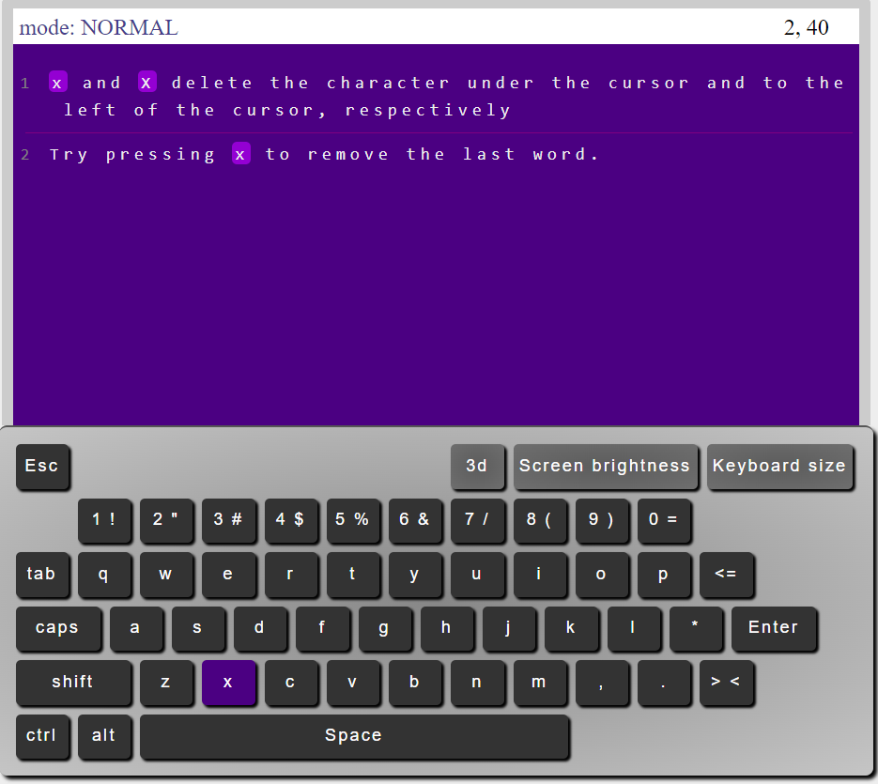



If you want to delete the character under the cursor then press x button, pressing x repeatedly will delete the characters in the left.

**15. Replacing letter under cursor, r)**

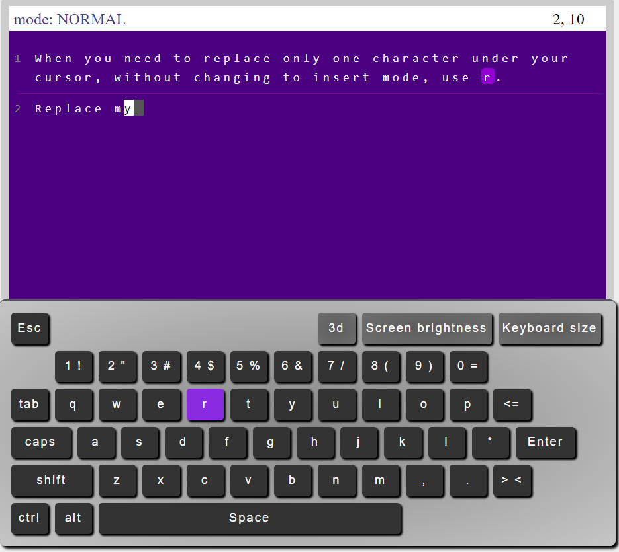

If you want to replace the character under the cursor, just press r then the letter to replace.

**16. Deleting, d)**

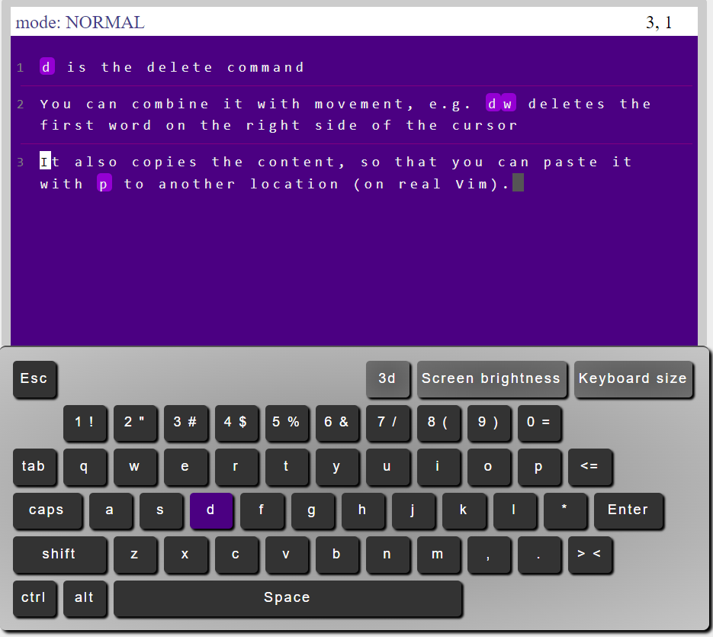

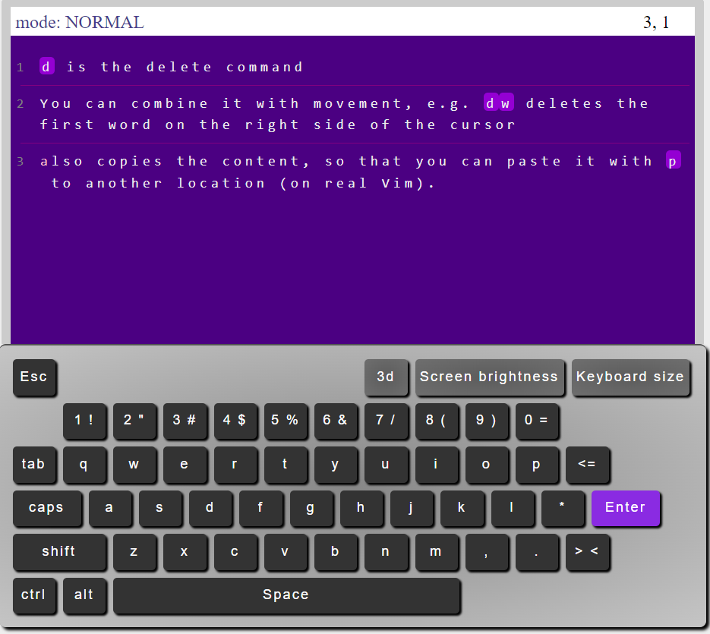

In order to delete a word just press d then w, if you want to delete more than one word just press dne; where n is the number of words you want to delete

**17. Repetition with .)**

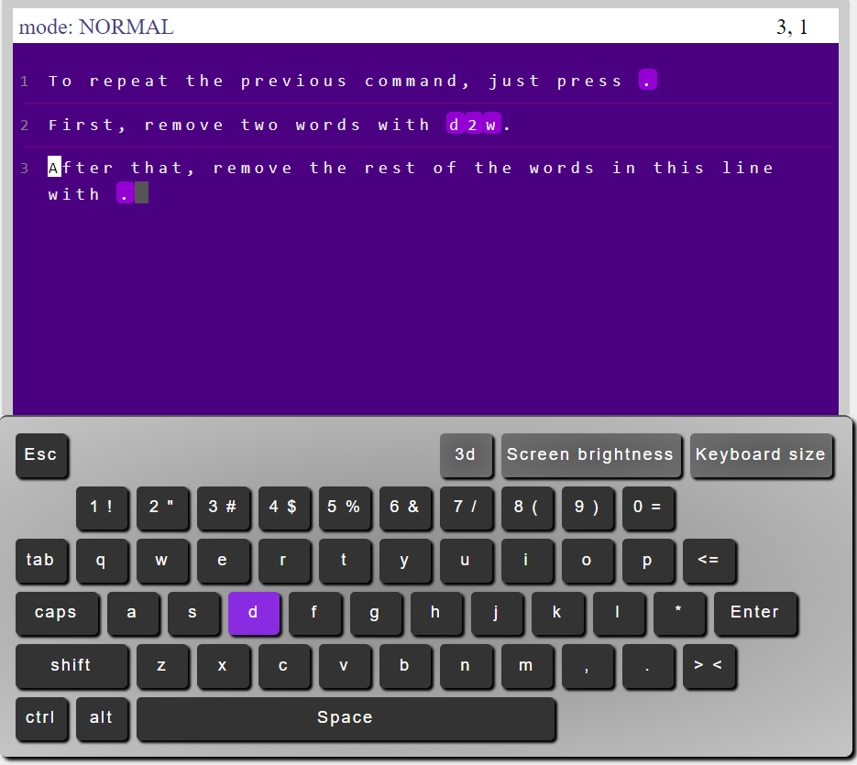

To repeat the previous command just press “.” Button.

**18. Visual mode, v)**

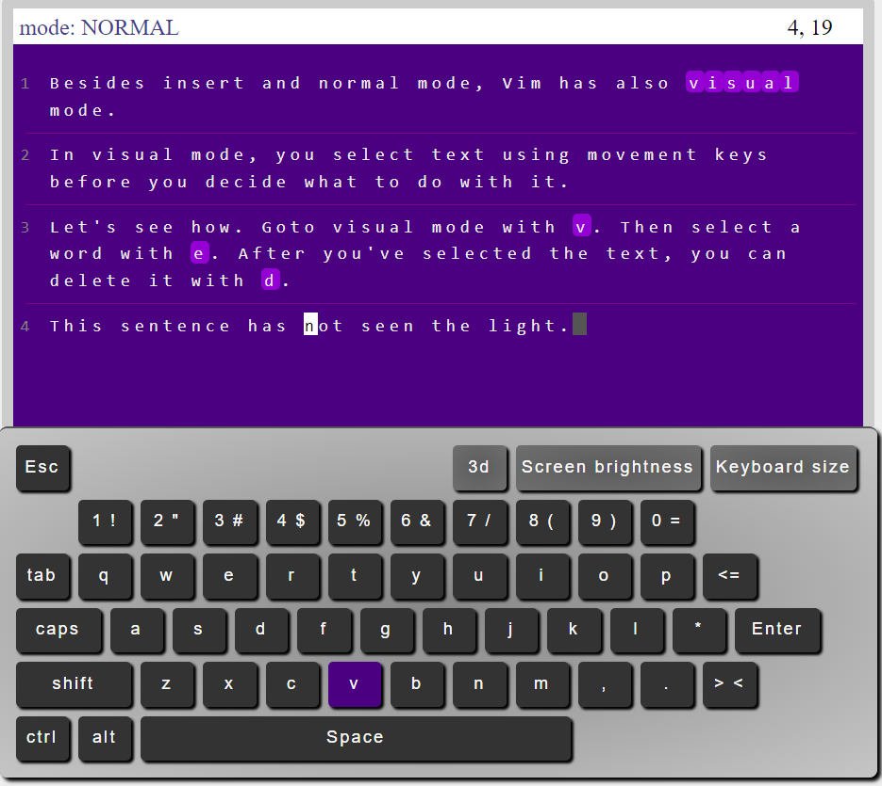

Visual mode helps you to select text before you perform other operations such as deleting, and inserting, you can switch t visual mode by pressing “V” button. **19.Real Vim awaits)**

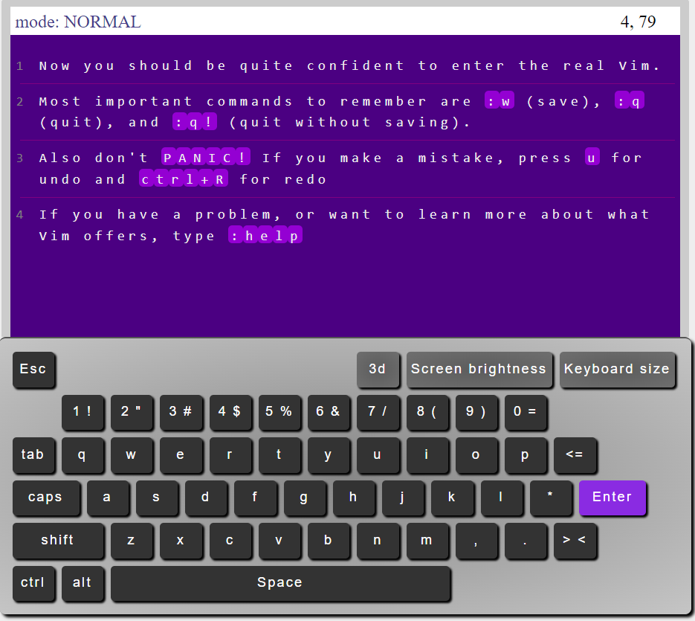

Vim has powerful commands. For example, if you want to quit and save the changes press :wq, if you want to undo press u and ctrl + R for redo. For further help press :help

**More Unix Commands:**

**3.1 Redirection**

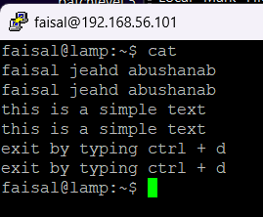

Cat without specifying file

## 3.2 Redirecting the Output

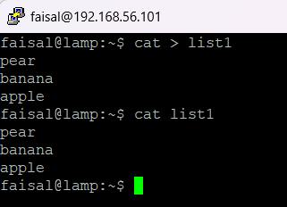

Redirect the output of cat into list1 file

**Exercise 3a**

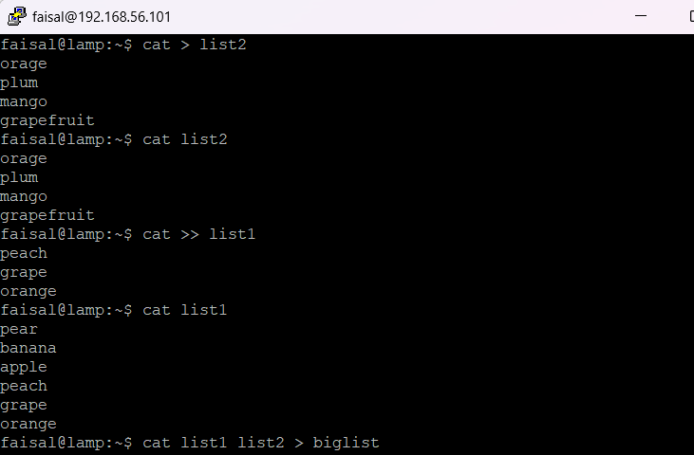

## 3.3 Redirecting the Input

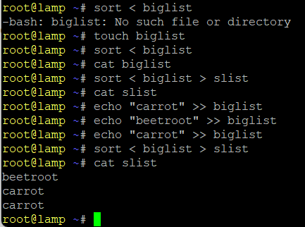

## 3.4 Pipes

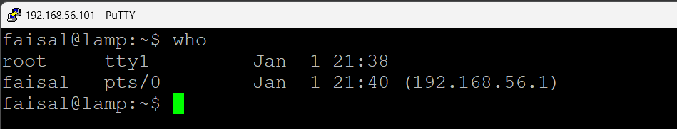

**Exercise 3b**

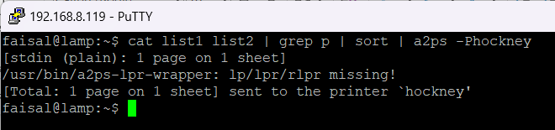

## 4.1 Wildcards

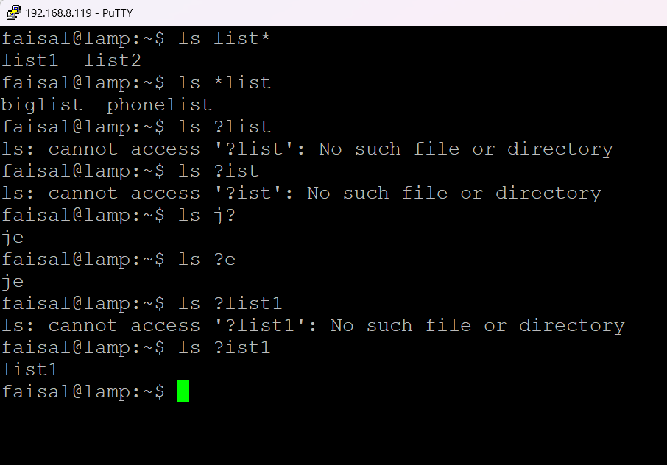

## 4.3 Getting Help

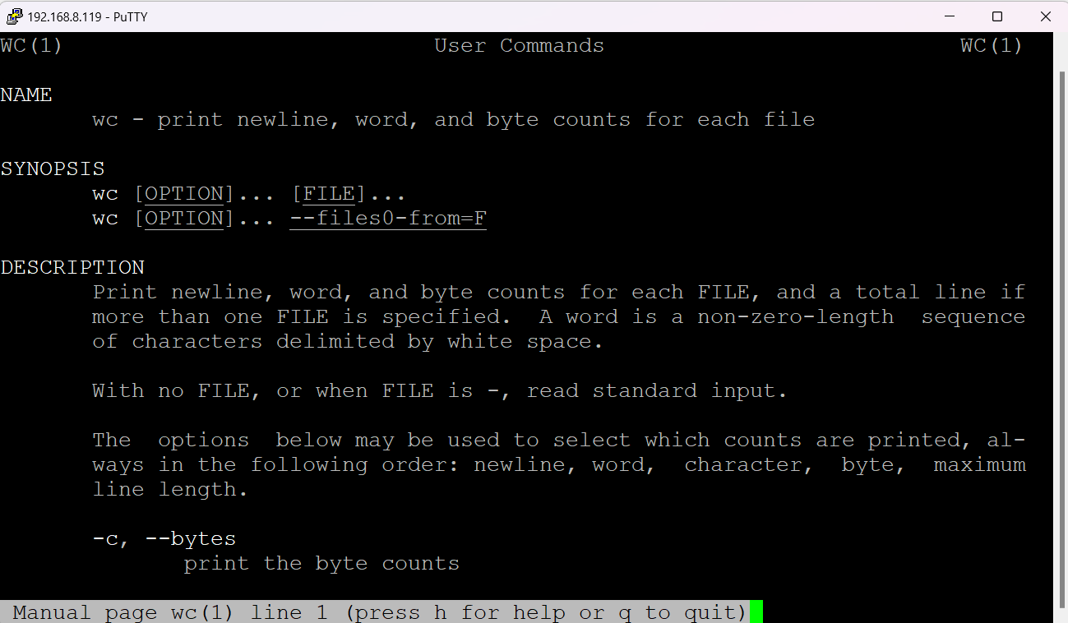



## 5.1 File system security (access rights)

## 5.2 Changing access rights

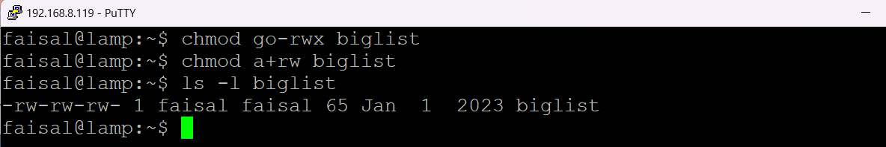

**Exercise 5a**

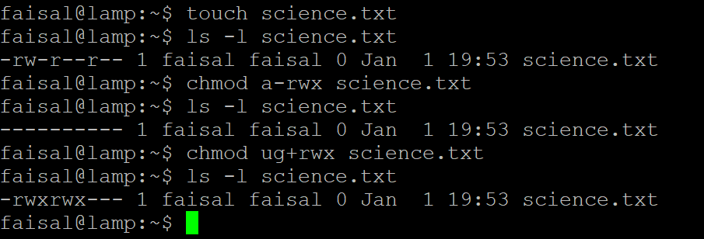



**Chmod u+rw backups**



## 5.3 Processes and Jobs

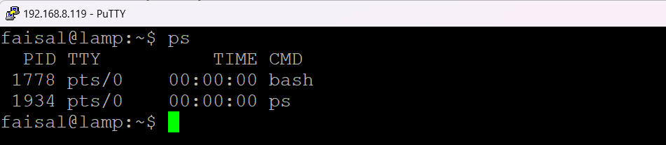

## 5.4 Listing suspended and background processes

## 5.5 Killing a process

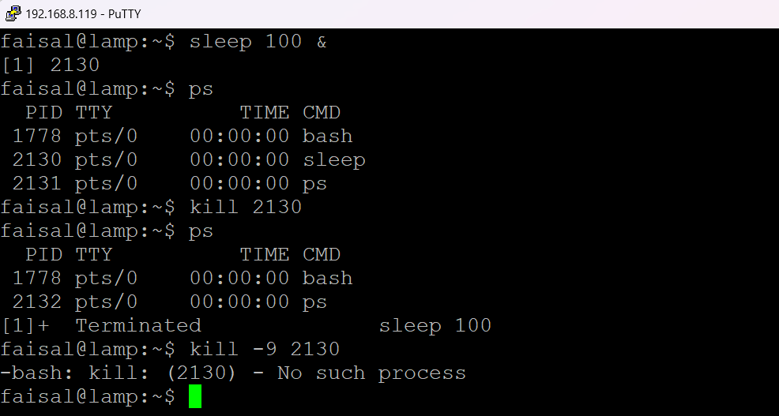

**Shell Script Programming Example:**

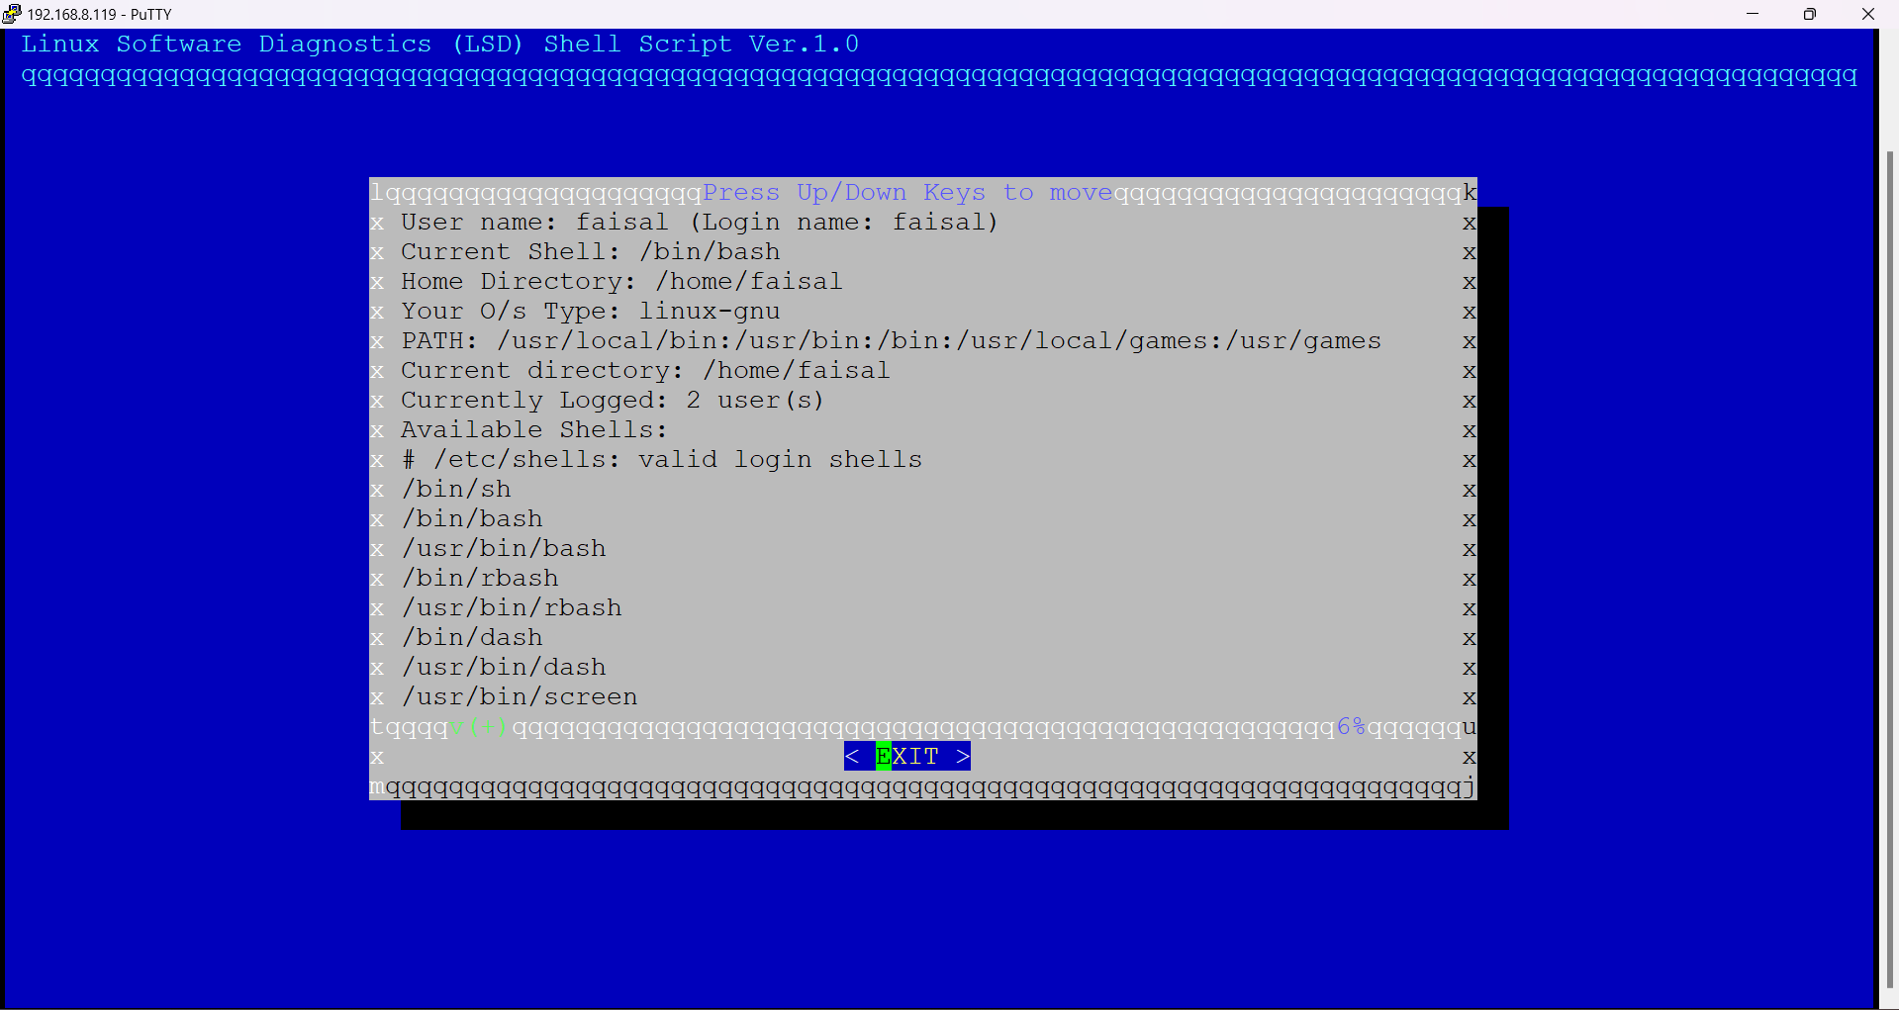

**A Shell Script Exercise:**

As seen from the tests the program works as required