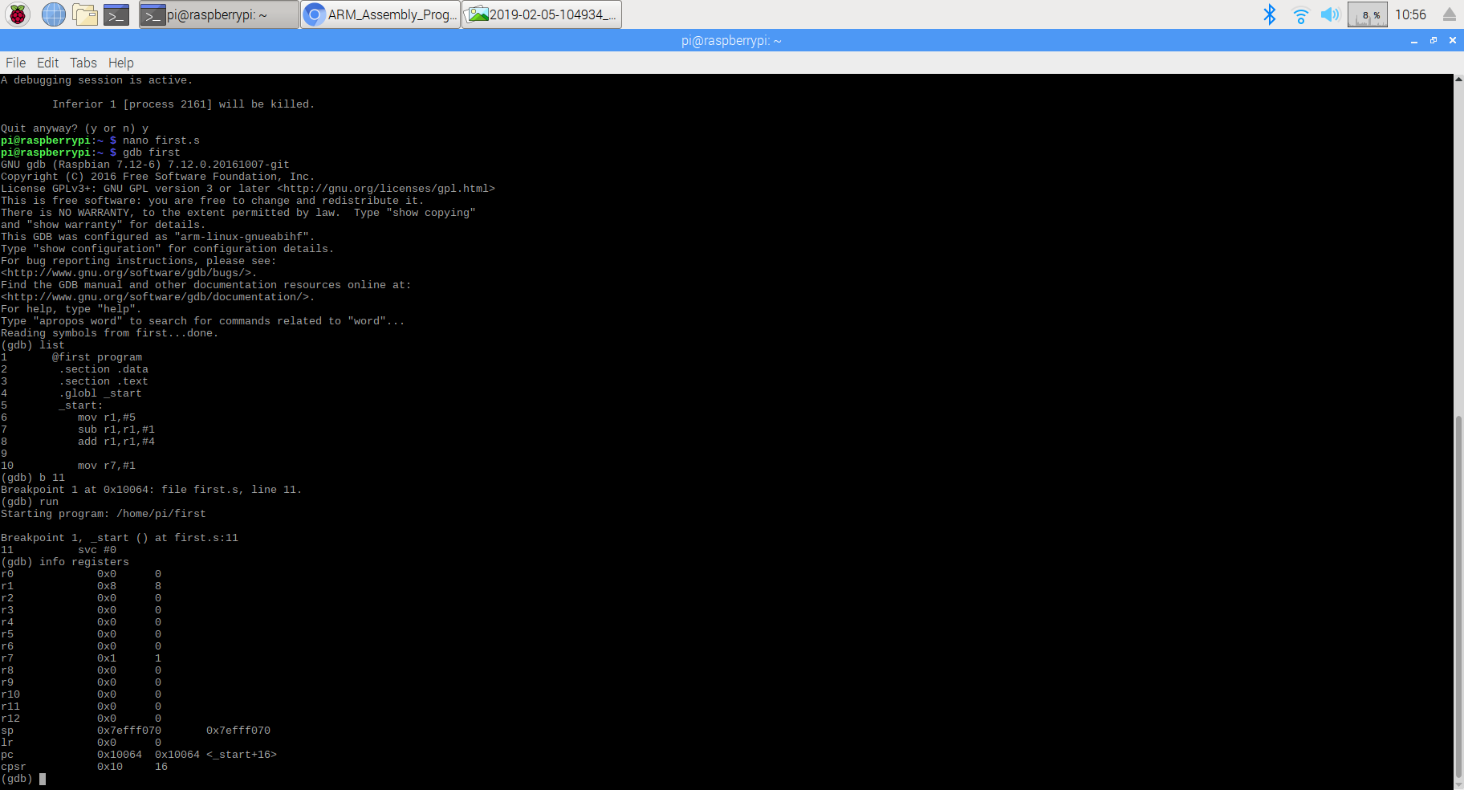

By debugging with breakpoint at line 6 and stop at line 11, we can see from the “info registers” that r1 has value of 8 in decimal, which is calculated by the program: Load r1 with 5(r1=5), subtract 1 from r1(r1=r1-1=5-1=4), add 4 to r1(r1=r1+4=4+4=8).

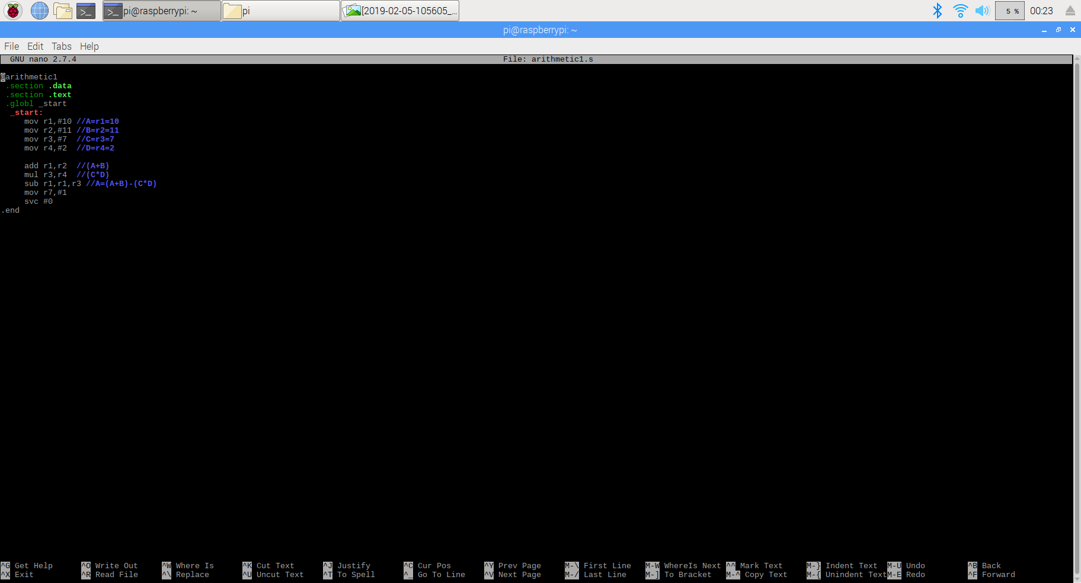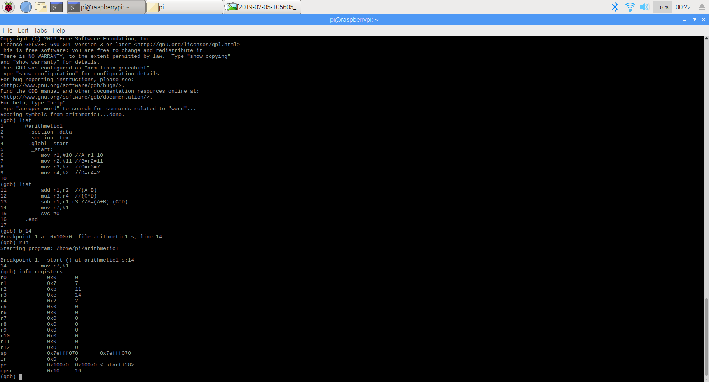

In this program, i load r1(A) with 10, r2(B) with 11, r3(C) with 7, r4(D) with 2. Then i add r1 and r2, store the result in r1(r1=r1+r2=10+11=21). Multiple r3 and r4, store the result in r3(r3=r3\*r4=2\*7=14). Finally, i use r1 to subtract r3, store the result in r1(r1=r1-r3=21-14=7). After debugging with breakpoint at line 6 to line 14. As we can see from the CPU registers, r1 now has value of 7 in decimal, which is the result of calculation(A=(A+B)-(C\*D). r2 has its original value of 11,because we did not store any result in it, r3 has value of 14, which is updated by line 12(mul r3,r4), r4 has its original value just like r2.