**E-learning Management System**

**Description:**

The e-learning management system main objective is to provide quality education online .Now a days everything based on online .With the help of the e-learning system student can attend in exam, access course, and access result online. Teacher can provide course material online. A learning system based on formalized teaching but with the help of electronic resources is known as E-learning**.** While teaching can be based in or out of the classrooms, the use of computers and the Internet forms the major component of E-learning. E-learning can also be termed as a network enabled transfer of skills and knowledge, and the delivery of education is made to a large number of recipients at the same or different times. Knowledge can also be shared via the Internet, which is accessible 24/7, anywhere, anytime.

Characteristics:

1. E-learning app contains admin panel, student panel, teacher panel.

2. Student can take part in quiz.

3. Teacher can take exam, publish result, publish course module

4. Admin can edit, delete, update quiz.

5. Student can enroll into any course module

6. Guardian can view his child result.

7. Student can view tutorial on their interested subject like php, MySQL.

8. Teacher can upload course tutorial, course video lecture chapter wise.

9. Admin can control all course tutorial.

10. Student can attend in the exam online.

11. Student can download course material, pdf and video.

Functional Requirement:

1. Admin add new student, teacher, staff to the system

2. Teacher can edit, delete add new result of the student.

3. Teacher can edit, delete, add own subject’s course material.

4. Admin can add new course material in the system.

5. Admin can edit /add/delete new course module into the system.

6. Student enroll in a course.

7. Student can download class lecture, course video ,class material.

**Non Functional Requirement:**

1.The system must be online 24*7 .

2.The system will be secured.

3.Non authorized person should no be able to access the system.

Er Diagram:

Teacher(teacherid,name,address,telephone,department_id,photo,password)

Student(studid, name,address,phone,semester,password,photo)

Course(course_id,course_name)

Lesson(lesson_id,lesson_name,fk_course_id,link)

Enrollment(course_id,course_id_fk,student_id_fk,course_name)

Admin(Adminid,name,password,email,phone)

Quizans()

Quizquestion()

DFD:

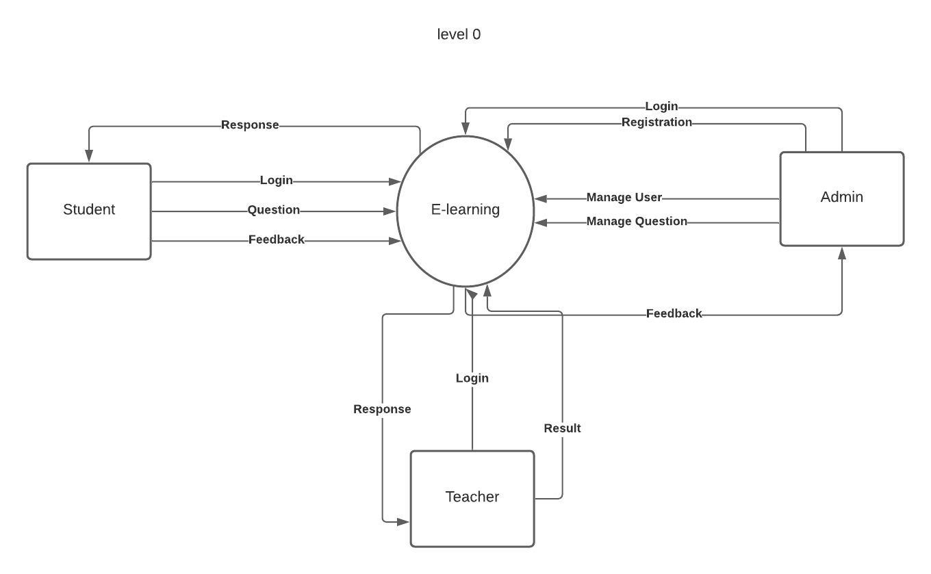

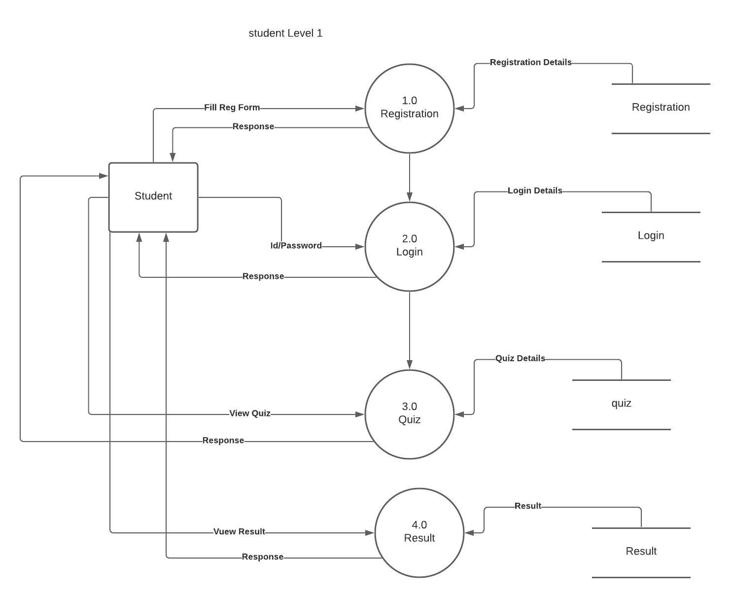

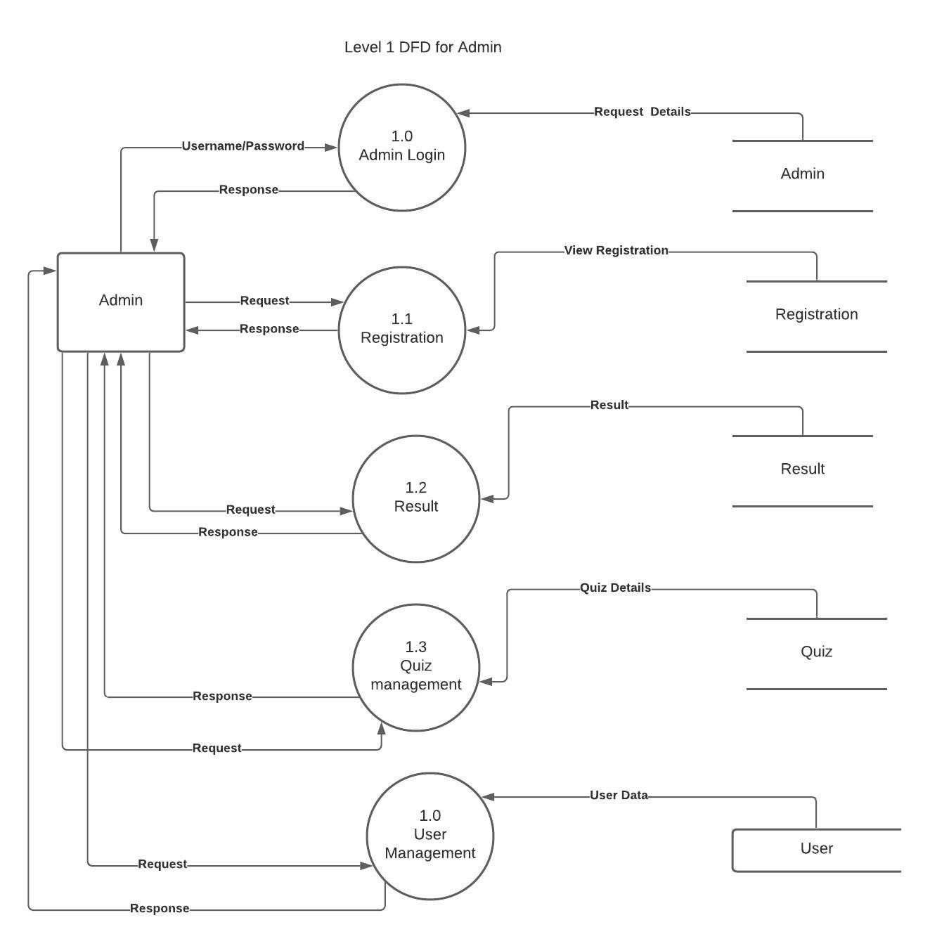

|  |  |  |
| --- | --- | --- |
| USE CASE 1 | Student Login | |
| Goal in Context | Student will log into the system after giving their id and password | |
| Preconditions | We know Password, userid etc. | |
| Success End Condition | Student Successfully Logged into the system. | |
| Failed End Condition | Student cannot log into the system. Their will shown error message from the system. | |
| Primary,  Secondary Actors | Student | |
| Trigger | Login request comes in. | |
| DESCRIPTION | Step | Action |
|  | 1 | After clicking into login button a log in from will be shown |
|  | 2 | Student Enter his userid ,password |
|  | 3 | System will validate userId,password.If userId and password is match with database student will get approved to enter into portal |

|  |  |  |
| --- | --- | --- |
| USE CASE 2 | Student Registration | |
| Goal in Context | Student will register into system by giving their name,address,details .After Student Enter all his details it will save into database admin will verify .Then He will approved. | |
| Preconditions | Student have all the requested information | |
| Success End Condition | Student Successfully registered into the system. | |
| Failed End Condition | Student cannot register if he enter wrong information. Their will shown error message from the system. | |
| Primary,  Secondary Actors | Student  Admin | |
| Trigger | Register request comes in. | |
| DESCRIPTION | Step | Action |
|  | 1 | After clicking register button a registration from will be shown |
|  | 2 | Student Enter his all requested data like name,father name,mother Name,Address |
|  | 3 | System will validate all given data.After that a success message will be shown that he is registered into the system… |

|  |  |  |
| --- | --- | --- |
| USE CASE 3 | Student Enroll a course | |
| Goal in Context | Student will enroll a course from course page.When he press the enroll button ,system will request UserId and Password.after giving their id and password ,Student will Logged into the system.Then he can enroll a course. | |
| Preconditions | Student know Password, userid etc. | |
| Success End Condition | Student Successfully enrolled a course the system. | |
| Failed End Condition | Student cannot enroll a course. Their will shown error message from the system because of entering wrong user Id /Password | |
| Primary,  Secondary Actors | Student | |
| Trigger | Enroll a course | |
| DESCRIPTION | Step | Action |
|  | 1 | After clicking enroll button a login form will be shown |
|  | 2 | Student Enter his userid ,password |
|  | 3 | System will validate userId,password.If userId and password is match with database student will get approved to enter into portal .Then he successfully enrolled a course.So he can view a course…. |

|  |  |  |
| --- | --- | --- |
| USE CASE 4 | Student Attend into Quiz | |
| Goal in Context | Student will log into the system after giving their id and password .Then he attend in a quiz .After Quiz he can see his result | |
| Preconditions | We know Password, userid etc. | |
| Success End Condition | Student Successfully Logged into the system. | |
| Failed End Condition | Student cannot log into the system. Their will shown error message from the system. | |
| Primary,  Secondary Actors | Student  Teacher | |
| Trigger | Attend in the Quiz | |
| DESCRIPTION | Step | Action |
|  | 1 | After clicking into login button a log in from will be shown |
|  | 2 | Student Enter his userid ,password |
|  | 3 | System will validate userId,password.If userId and password is match with database student will get approved to enter into portal .Then he attend in the Quiz |

|  |  |  |
| --- | --- | --- |
| USE CASE 5 | Student Attend into the exam | |
| Goal in Context | Student will log into the system after giving their id and password .Then he can submit his assignment .After that he can see his question.After answering he will submit answers… | |
| Preconditions | We know Password, userid etc. | |
| Success End Condition | Student Successfully attend in exam and submitted his answer sheets. | |
| Failed End Condition | Student cannot log into the system. Their will shown error message from the system. | |
| Primary,  Secondary Actors | Student  Teacher | |
| Trigger | Submit his answer script. | |
| DESCRIPTION | Step | Action |
|  | 1 | After clicking into login button a log in from will be shown |
|  | 2 | Student Enter his userid ,password |
|  | 3 | System will validate userId,password.If userId and password is match with database student will get approved to enter into portal .Then he attend in the exam.he will view question.After that he willl submit his assignment.. |

|  |  |  |
| --- | --- | --- |
| USE CASE 6 | Student Attend into Quiz | |
| Goal in Context | Student will log into the system after giving their id and password .Then he attend in a quiz .After Quiz he can see his result | |
| Preconditions | We know Password, userid etc. | |
| Success End Condition | Student Successfully Logged into the system. | |
| Failed End Condition | Student cannot log into the system. Their will shown error message from the system. | |
| Primary,  Secondary Actors | Student  Teacher | |
| Trigger | Attend in the Quiz | |
| DESCRIPTION | Step | Action |
|  | 1 | After clicking into login button a log in from will be shown |
|  | 2 | Student Enter his userid ,password |
|  | 3 | System will validate userId,password.If userId and password is match with database student will get approved to enter into portal .Then he attend in the Quiz |

|  |  |  |
| --- | --- | --- |
| USE CASE 7 | Student View his result | |
| Goal in Context | Student will log into the system after giving their id and password .Then he see his result . | |
| Preconditions | We know Password, userid etc. | |
| Success End Condition | Student Successfully View his result | |
| Failed End Condition | Student cannot log into the system. Their will shown error message from the system. | |
| Primary,  Secondary Actors | Student  Teacher | |
| Trigger | View Result | |
| DESCRIPTION | Step | Action |
|  | 1 | After clicking into login button a log in from will be shown |
|  | 2 | Student Enter his userid ,password |
|  | 3 | System will validate userId,password.If userId and password is match with database student will get approved to enter into portal .Then he view his result |

|  |  |  |
| --- | --- | --- |
| USE CASE 8 | Teacher Login | |
| Goal in Context | teacher will log into the system after giving their id and password . | |
| Preconditions | We know Password, userid etc. | |
| Success End Condition | Teacher Successfully Logged into the system. | |
| Failed End Condition | teacher cannot log into the system. Their will shown error message from the system. | |
| Primary,  Secondary Actors | Teacher | |
| Trigger | Teacher Login to the system | |
| DESCRIPTION | Step | Action |
|  | 1 | After clicking into login button a log in from will be shown |
|  | 2 | Teacher Enter his userid ,password |
|  | 3 | System will validate userId,password.If userId and password is match with database student will get approved to enter into portal .Then he entered into system/ |

|  |  |  |
| --- | --- | --- |
| USE CASE 9 | Teacher assigned student for a quiz | |
| Goal in Context | Teacher will log into the system after giving their id and password .Then he submit Quiz question and answer.. | |
| Preconditions | We know Password, userid etc. | |
| Success End Condition | Teacher successfully submit quiz into the system. | |
| Failed End Condition | Teacher cannot log into the system. Their will be shown error message from the system. | |
| Primary,  Secondary Actors | Student  Teacher | |
| Trigger | Submit new Quiz | |
| DESCRIPTION | Step | Action |
|  | 1 | After clicking into login button a log in from will be shown |
|  | 2 | Student Enter his userid ,password |
|  | 3 | System will validate userId,password.If userId and password is match with database student will get approved to enter into portal .Then submitted Quiz answer and questions |

|  |  |  |
| --- | --- | --- |
| USE CASE 10 | Teacher Publish course materials. | |
| Goal in Context | Teacher will log into the system after giving their id and password .Then he submit course material like pdf ,slide,doc,video,picture into the system as student can download and view . | |
| Preconditions | We know Password, userid etc. | |
| Success End Condition | Teacher successfully submit course material into the system. | |
| Failed End Condition | Teacher cannot log into the system. Their will be shown error message from the system. | |
| Primary,  Secondary Actors | Teacher | |
| Trigger | Submit new course material | |
| DESCRIPTION | Step | Action |
|  | 1 | After clicking into login button a log in from will be shown |
|  | 2 | Student Enter his userid ,password |
|  | 3 | System will validate userId,password.If userId and password is match with database student will get approved to enter into portal .Then submitted course material into the system |

|  |  |  |
| --- | --- | --- |
| USE CASE 11 | Teacher Publish result. | |
| Goal in Context | Teacher will log into the system after giving their id and password .Then he submit course result. | |
| Preconditions | We know Password, userid etc. | |
| Success End Condition | Teacher successfully submit course result into the system. | |
| Failed End Condition | Teacher cannot log into the system. Their will be shown error message from the system. | |
| Primary,  Secondary Actors | Teacher  Admin | |
| Trigger | Submit course result | |
| DESCRIPTION | Step | Action |
|  | 1 | After clicking into login button a log in from will be shown |
|  | 2 | Student Enter his userid ,password |
|  | 3 | System will validate userId,password.If userId and password is match with database student will get approved to enter into portal .Then submitted course result into the system |

|  |  |  |
| --- | --- | --- |
| USE CASE 12 | Teacher Publish course materials. | |
| Goal in Context | Teacher will log into the system after giving their id and password .Then he submit course material like pdf ,slide,doc,video,picture into the system as student can download and view . | |
| Preconditions | We know Password, userid etc. | |
| Success End Condition | Teacher successfully submit course material into the system. | |
| Failed End Condition | Teacher cannot log into the system. Their will be shown error message from the system. | |
| Primary,  Secondary Actors | Teacher | |
| Trigger | Submit new course material | |
| DESCRIPTION | Step | Action |
|  | 1 | After clicking into login button a log in from will be shown |
|  | 2 | Student Enter his userid ,password |
|  | 3 | System will validate userId,password.If user ID and password is match with database student will get approved to enter into portal .Then submitted course material into the system.. |

|  |  |  |
| --- | --- | --- |
| USE CASE 10 | Teacher Publish course materials. | |
| Goal in Context | Teacher will log into the system after giving their id and password .Then he submit course material like pdf ,slide,doc,video,picture into the system as student can download and view . | |
| Preconditions | We know Password, userid etc. | |
| Success End Condition | Teacher successfully submit course material into the system. | |
| Failed End Condition | Teacher cannot log into the system. Their will be shown error message from the system. | |
| Primary,  Secondary Actors | Teacher | |
| Trigger | Submit new course material | |
| DESCRIPTION | Step | Action |
|  | 1 | After clicking into login button a log in from will be shown |
|  | 2 | Student Enter his userid ,password |
|  | 3 | System will validate userId,password.If userId and password is match with database student will get approved to enter into portal .Then submitted course material into the system |

|  |  |  |
| --- | --- | --- |
| USE CASE 13 | Teacher create new Assignment. | |
| Goal in Context | Teacher will log into the system after giving their id and password .Then he create assignment for students | |
| Preconditions | We know Password, userid etc. | |
| Success End Condition | Teacher successfully created course assignment into the system. | |
| Failed End Condition | Teacher cannot log into the system. Their will be shown error message from the system. | |
| Primary,  Secondary Actors | Teacher | |
| Trigger | Submit new course assignment | |
| DESCRIPTION | Step | Action |
|  | 1 | After clicking into login button a log in from will be shown |
|  | 2 | Student Enter his userid ,password |
|  | 3 | System will validate userId,password.If user ID and password is match with database student will get approved to enter into portal .Then submitted course assignment into the system… |
|  |  |  |

|  |  |  |
| --- | --- | --- |
| USE CASE 14 | Admin Login to system | |
| Goal in Context | Admin will log into the system after giving their id and password .Then he create assignment for students | |
| Preconditions | We know Password, userid etc. | |
| Success End Condition | Admin successfully created course assignment into the system. | |
| Failed End Condition | admin cannot log into the system. Their will be shown error message from the system. | |
| Primary,  Secondary Actors | admin | |
| Trigger | Admin log in the system…. | |
| DESCRIPTION | Step | Action |
|  | 1 | After clicking into login button a log in form will be shown |
|  | 2 | Admin Enter his userid ,password |
|  | 3 | System will validate userId,password.If user ID and password is match with database student will get approved to enter into portal . |

|  |  |  |
| --- | --- | --- |
| USE CASE 13 | Teacher manage users. | |
| Goal in Context | Teacher will log into the system after giving their id and password .Then he create assignment for students | |
| Preconditions | We know Password, userid etc. | |
| Success End Condition | successfully created course assignment into the system. | |
| Failed End Condition | Teacher cannot log into the system. Their will be shown error message from the system. | |
| Primary,  Secondary Actors | Teacher | |
| Trigger | Submit new course assignment | |
| DESCRIPTION | Step | Action |
|  | 1 | After clicking into login button a log in from will be shown |
|  | 2 | Student Enter his userid ,password |
|  | 3 | System will validate userId,password.If user ID and password is match with database student will get approved to enter into portal .Then submitted course assignment into the system… |
|  |  |  |