High-Level Design
Standalone AI Chatbot | Python A2A + Calian AI Core
Version 1.0 • 27 October 2026 • Status: As-built baseline with explicitly identified integration assumptions
Purpose: Describe the standalone Java Swing client and its integration with dynamically discovered Python and AI Core agents. This document reflects supplied Java sources and the reported successful end-to-end test; the exact final runtime artifacts and AI Core execution contract were not independently inspected.

1. Executive Summary
The solution is a standalone Java 21 desktop chatbot. A Swing user interface provides manual agent choice and Auto Select. A Python FastAPI service exposes an agent registry, an automatic-selection API, and A2A 1.0 streaming execution. AI Core agents are discovered through the Calian Paradigm integration and, where configured, an HTTP registry. A unified in-memory registry presents both families of agents with friendly labels while retaining command identifiers for routing.

2. Scope and Design Goals
In scope | Out of scope / not established
Swing chat UI, discovery, agent selection, request dispatch | Cloud deployment, distributed scaling, HA
Python A2A v1.0 streaming and shared context | Long-term conversation persistence
AI Core/Paradigm discovery and HTTP-capable execution | Guaranteed RabbitMQ execution for every discovered agent
Local capability matching with router fallback | LLM-based planning or multi-agent orchestration

3. Logical Architecture
Layer | Components | Responsibilities
Presentation | ChatApp (JFrame); agent dropdown; transcript; prompt; shared context | Collect input, display agents and responses, manage session UI
Orchestration | ChatApp.submit(); Auto Select matcher; registry snapshot | Choose target, preserve IDs, select transport, record conversation turns
Discovery | Python GET /agents; ParadigmAgentDiscovery; AICoreHttpDiscovery | Aggregate dynamic agents, names, command IDs and optional endpoints
Routing | Local capability matcher; Python POST /router/select | Choose agent based on request and available capabilities
Execution | Python A2A SendStreamingMessage; AI Core HTTP POST where endpoint exists | Deliver user request and parse result
External | Python FastAPI/A2A service; AI Core/Paradigm; RabbitMQ | Host agents and return discovery/execution results
Logical data flow: User → Swing ChatApp → unified agent registry → Auto Select / manual choice → [Python A2A 1.0 OR AI Core HTTP endpoint] → response parser → transcript. AI Core discovery callbacks and optional HTTP registry populate the same registry; they are not themselves proof of a usable execution endpoint.

4. Component Design
Component | Primary interface / behavior
ChatApp.java | Application entry point; UI; GET /agents; POST /router/select; A2A SSE; AI Core HTTP dispatch; history/context.
ParadigmAgentDiscovery.java | acceptResponse(commandList, agentURLs); immutable Agent(commandId, name, endpoint, commands); synchronized snapshot; UI callback.
ChatAgentResponseHandler.java | Paradigm IFRREnabled callback; maps AISGetCommandsRequest command list and URL map into ChatApp.
AICoreHttpDiscovery.java | Optional HTTP JSON registry adapter; supports agents array/object and commandList/commandData + agentURLs variants.
AICoreAgentRegistry.java | Thread-safe map of nonempty AI Core endpoint URLs; supplied but not shown wired into ChatApp.
ChatUIComponent / ChatUIDelegate | Paradigm UI adapter scaffolding; delegate UI provider remains unsupported in supplied code.

5. Agent Discovery and Identity
At refresh, the Python service returns agents with IDs, names and types. AI Core discovery returns command IDs mapped to friendly labels, plus an optional endpoint URL map. The UI shows “Friendly name [AI Core]”; internally it retains the command ID (for example GET_TRANSLATION) separately from the display name (translation-agent). Discovery is asynchronous; updates rebuild the dropdown without replacing Python agents.
Key invariant: never use the friendly label as a transport command identifier. Do not invent an AI Core URL when discovery returns only a command name. Duplicate display names require disambiguation by command ID.

6. Auto Select Design
Auto Select evaluates the current user message against discovered agent names, command IDs and capabilities. A clear translation request should resolve to the translation agent (GET_TRANSLATION); other specialist intents can be matched using discovered metadata. Where no suitable local match is available, the Python /router/select endpoint provides a fallback. The router response must identify an agent that is present in the current registry; unsupported agent types must be rejected clearly.
Scenario | Expected route | Notes
“Translate the word sun into Russian” | translation-agent / GET_TRANSLATION | Capability match; execution requires reachable transport
“Roll two dice” | Dice Agent / ROLL_DICE | Only when discovered and supported
General prompt | Python router fallback | Do not arbitrarily send to first discovered specialist
Unknown / unavailable capability | Explain no matching agent | Avoid false success or silent misrouting

7. Runtime Interaction Sequences

7.1 Startup / Refresh
1. User launches ChatApp. 2. UI requests GET /agents from Python. 3. Optional AI Core HTTP registry and/or Paradigm callback contributes agent metadata. 4. Registry is merged by source. 5. Swing event thread refreshes agent dropdown and count.

7.2 Auto Select and Execution
1. User enters prompt and selects Auto Select. 2. ChatApp captures registry snapshot, session context and prompt. 3. Local matching selects a specialist, or /router/select is invoked. 4. Selected agent type determines transport. 5. Python agents receive A2A JSON-RPC SendStreamingMessage with A2A-Version: 1.0 and Accept: text/event-stream. AI Core HTTP agents receive a JSON POST at their discovered endpoint. 6. Parsed response is displayed and conversation history is updated.

8. External Interface Contracts
Interface | Method / protocol | Representative fields
Python registry | GET /agents | agents[]: id, name, type, description/capabilities
Python router | POST /router/select | message, contextId, previousAgentId, context, agents[]; result.agent or reason
Python A2A | POST /; JSON-RPC + SSE | method=SendStreamingMessage; params.message with messageId, role, parts, contextId, metadata
AI Core discovery callback | Paradigm response | commandList; agentURLs; friendly name list per command ID
Optional AI Core registry | GET configured registry URL | agents array/object OR commandList/commandData + agentURLs
AI Core HTTP execution | POST discovered endpoint | message, contextId, context; response text or structured JSON
Important: The AI Core HTTP request/response shape is the client implementation observed in supplied sources, not a verified universal AI Core protocol. RabbitMQ/Paradigm message execution would require its own documented command invocation contract.

9. Session and Data Model
Object | Purpose / lifecycle
contextId (UUID) | Created for each chat; reset on New Chat; propagated to routing and execution
previousAgentId | Optional routing hint for continuity; cleared on New Chat
userContext / shared context | User-supplied text plus task/system placeholders, recent conversationHistory and agentResults array
history | In-memory user and assistant turns; latest 12 included in request context
registry / pythonAgents | In-memory display-label → agent metadata; rebuilt after discovery

10. Deployment Topology
Desktop workstation: Java 21 runtime + Maven-built Swing application; local configuration for Python base URL (example http://127.0.0.1:9999) and optional AICORE_REGISTRY_URL. External processes: Python FastAPI A2A service and Calian AI Core/Paradigm environment, potentially communicating through RabbitMQ. The supplied sources do not establish production hosting, broker addresses, TLS configuration or network segmentation.

11. Reliability, Security and Operations
UI operations should run on SwingWorker/background threads; Swing state updates must execute on the event-dispatch thread. Timeouts and HTTP failures should surface clearly. Discovery errors must not erase previously working agent families unintentionally. Avoid logging prompts, credentials, access tokens or sensitive context in production. Configure endpoints externally, validate HTTP(S) destinations, and apply authentication/TLS for nonlocal deployments. These are recommended controls; their deployment status is not verified.

12. Validation and Acceptance Criteria
Test | Pass condition
Build | mvn clean compile succeeds
Discovery | Python and AI Core agents visible with friendly labels
Manual selection | Selecting a supported agent dispatches and displays a reply
Auto translation | Translation prompt selects GET_TRANSLATION and produces expected reply
A2A streaming | SSE result is parsed without losing conversation context
New Chat | contextId and history reset
Unavailable endpoint | Clear error; no fabricated endpoint or silent fallback

13. Risks and Open Design Decisions
Item | Status / action
AI Core execution transport | Clarify whether all agents expose HTTP endpoints or require Paradigm/RabbitMQ command invocation.
Python router coverage | Confirm whether router accepts and selects AI Core candidates or only Python agents.
Persisted context | Not implemented in supplied code; evaluate client store vs PostgreSQL if required.
Security / authorization | Confirm endpoint authentication, TLS, secret management and audit requirements.
Final working source verification | Reported end-to-end success; exact deployed class revision and selected agent response should be captured as test evidence.

14. Design Status
As-built HLD baseline. User reported the application working end to end on 27 October 2026 and provided a screenshot of the running Swing application with discovered agents. This establishes a successful user-observed run, but does not independently prove every agent type or fallback path. Proposed operational controls and unresolved interface contracts are marked as recommendations or open decisions above.

15. Running the Application (Local Development)
The following procedure reflects the documented local Java Swing, Python A2A and Paradigm/RabbitMQ setup. Paths and service entry points must match the developer workstation. Do not publish credentials or broker connection details in this document.

15.1 Prerequisites
- Java Development Kit 21 available in PATH (verify with java -version).
- Apache Maven installed (verify with mvn -version).
- Python environment and dependencies for the existing FastAPI A2A service.
- Access to the existing Calian AI Core/Paradigm environment and RabbitMQ broker.
- Existing config/aiconfig.json in the standalone chatbot project root, populated from the authorized environment (do not commit secrets).
- Python A2A service base URL configured for the client; the local development example is http://127.0.0.1:9999.

15.2 Start and Verify Dependent Services
1. Start or connect to the existing Calian AI Core/Paradigm and RabbitMQ services using your environment’s approved procedure. Their startup commands are not established by the supplied sources.
2. In the Python AI service project, activate its environment and start the FastAPI application. Example only (replace <module> with the actual module that defines app):
python -m uvicorn <module>:app --host 127.0.0.1 --port 9999
3. Confirm the Python agent registry responds before launching the Swing client:
Invoke-RestMethod http://127.0.0.1:9999/agents
If the Python service uses a different port or entry point, update the client configuration accordingly. The HLD does not establish a single universal FastAPI startup module.

15.3 Build and Launch the Java Swing Chatbot
1. Open PowerShell in the standalone chatbot Maven project root (the directory containing pom.xml and config/aiconfig.json).
2. Compile the application:
mvn clean compile
3. Launch the application:
mvn exec:java "-Dexec.mainClass=com.calian.chat.ChatApp"
Note: The Java package and main-class identifier remain com.calian.chat.ChatApp in the working source. Rebranding the document to Calian does not rename Java packages or alter imports.

15.4 Functional Smoke Test
- Click Refresh Agents. Confirm Python and AI Core agents populate the dropdown with friendly names.
- Select Auto Select; enter “Translate the word sun into Russian”; click Send.
- Confirm the selected translation agent and inspect the response or any transport-specific error.
- Select a supported agent manually and verify the request/response path.
- Click New Chat and verify a fresh session/context is created.
Troubleshooting: If discovery is empty, verify the Python service, broker connectivity and authorized configuration. If an AI Core agent is listed but execution fails, verify its actual execution transport and endpoint; do not fabricate a URL.

16. Consolidated Architecture Diagram
Figure 1. Standalone Java Swing client, Python A2A service, Calian AI Core agents, Paradigm Framework and RabbitMQ.
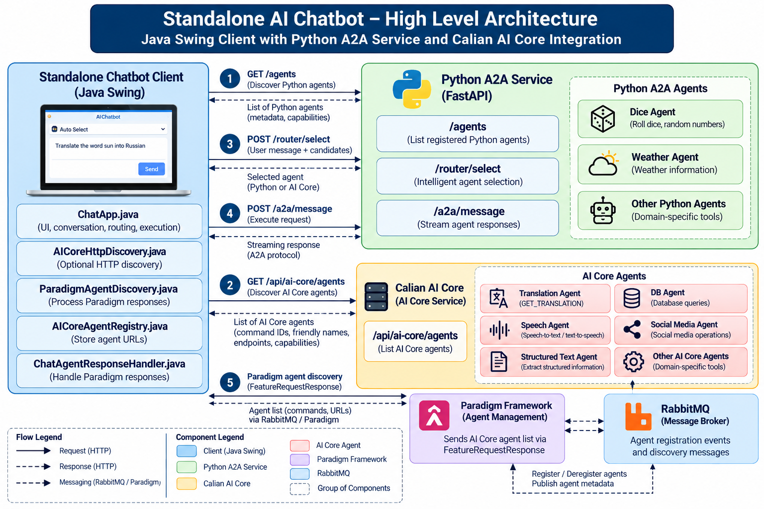

17. Python Service Modules and Responsibilities
This section describes the Python-side logical modules implied by the FastAPI/A2A integration. The actual Python source files were not provided; module names below are functional labels, not verified filenames.

17.1 Logical Python Components
Logical module | Primary responsibility | Interface / evidence
FastAPI application / entry point | Creates the API application, registers HTTP routes and starts the Python service (example local port 9999). | FastAPI app and server startup; actual filename not verified.
Agent registry / discovery | Maintains or aggregates the Python agents available to the client, including IDs, names and capability metadata. | GET /agents; actual implementation not inspected.
Automatic agent router | Evaluates user message, context and candidate-agent metadata and returns a suitable agent or an explicit no-match reason. Complements Java-side local capability matching. | POST /router/select; request includes message, contextId and agents[] per HLD.
A2A protocol handler | Receives A2A 1.0 JSON-RPC requests, validates protocol/version information, delegates to a selected agent and streams responses. | SendStreamingMessage; A2A-Version: 1.0; Accept: text/event-stream.
Agent implementations / adapters | Expose domain-specific skills to the Python service and produce task responses; the diagram illustrates Dice and other Python agents. | Agent-specific modules; exact agent inventory and filenames unverified.
Context / conversation adapter | Carries contextId and any supplied shared context/history between router, A2A request and agent execution; persistence is not established. | Logical responsibility; client holds in-memory history.
Response streaming / serialization | Serializes A2A results and event-stream payloads so the Swing client can display streamed output. | SSE / JSON-RPC; internal module boundary unverified.
Configuration and dependency wiring | Loads service settings such as host/port, agent registration and external integrations; handles service initialization. | Exact environment variables, configuration files and packages not supplied.

17.2 Python Request Flow
- 1. FastAPI starts and makes registered agents discoverable through GET /agents.
- 2. The Swing client retrieves agent metadata and merges it with discovered Calian AI Core agents.
- 3. On Auto Select, Java first attempts local capability matching; when needed, POST /router/select evaluates the prompt and candidate list.
- 4. When a Python agent is selected, the client sends an A2A 1.0 SendStreamingMessage request to the configured service/agent endpoint.
- 5. The A2A handler invokes the agent and emits streaming results; the Swing client updates the transcript and its in-memory conversation context.
- 6. AI Core agent discovery and any AI Core execution use separate Calian/Paradigm or configured HTTP integrations; they are not Python agent modules.

17.3 Source Verification Checklist
Before treating this section as a file-level module inventory, review the Python repository to identify: the FastAPI app file, router implementation, registry implementation, A2A handler, concrete agent modules, context storage, and service launch command. Replace these logical labels with exact filenames, classes and dependencies after source inspection.

