MDM Developer Workstation Setup
Install DB2 9.7 Enteprise Edition – Full DB Server on the Workstation
Note: Db2 Community Edition can also be used
- Follow doc Server Build MDM DB Server for W2k8.doc – On Win 7 use DB2_ESE_97_Win_x86.exe.
- Need to have local db2admin account
- Using a remote DB2 database is not supported.

MDM Server 10.1 Advanced Edition Development tool Installation and Configuration
- Install RSA 8.0.4 and Websphere Application Server 8.0.0.3 including Test Tools.
Step 1 – Install MDM 10.1 Workbench RSA Repository
- Copy com.ibm.im.mdm.workbench.offering.zip to C:\Apps\MDM 10.1 Workbench.
- Run IBM Installation Manager (Run as Administrator).
- Click Install and select the repositories link. Browse to C:\Apps\MDM 10.1 Workbench and select com.ibm.im.mdm.workbench.offering.zip and click OK
- Select to install MDM 10.1 Workbench per below
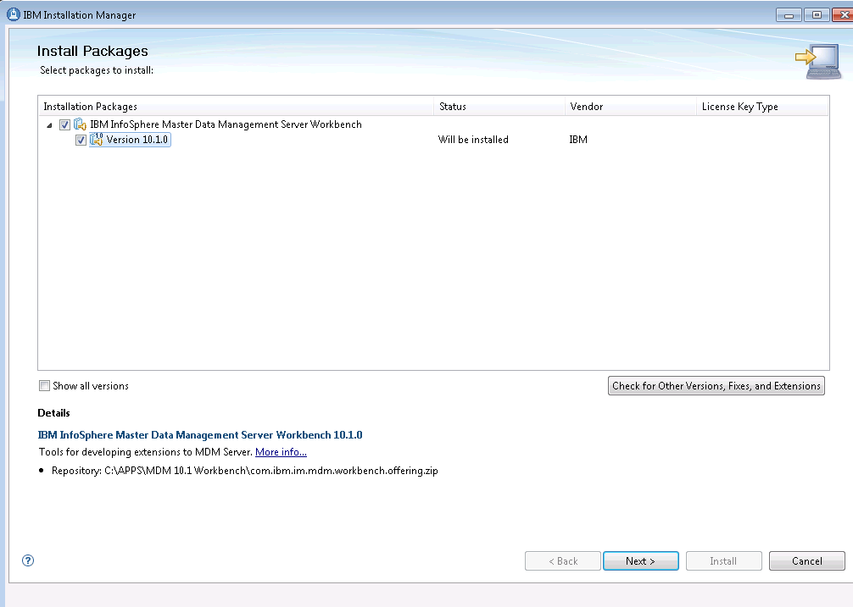
- Accept the license terms and click next
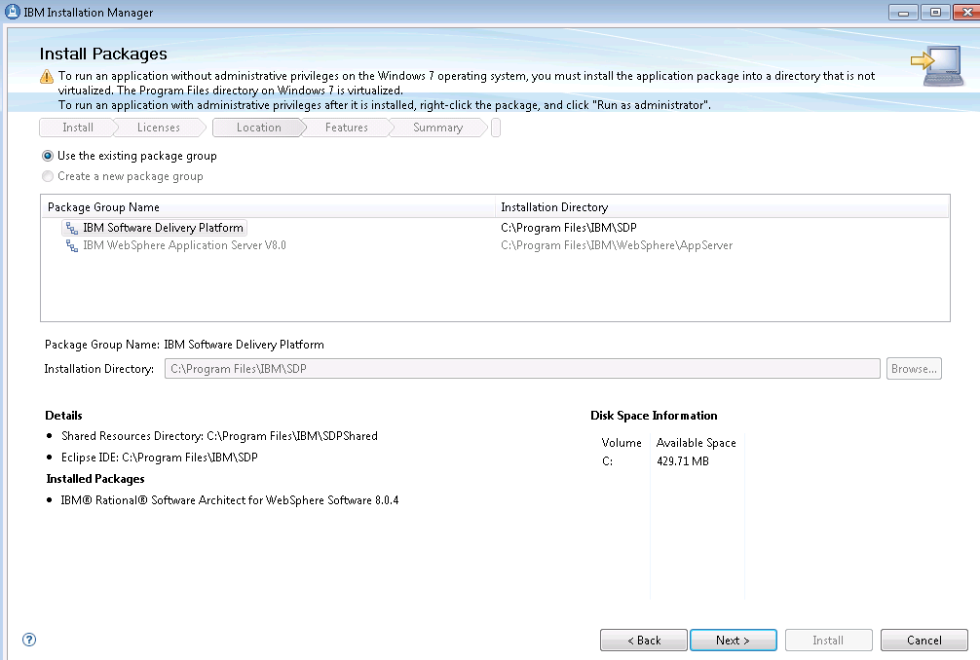
- Click Next
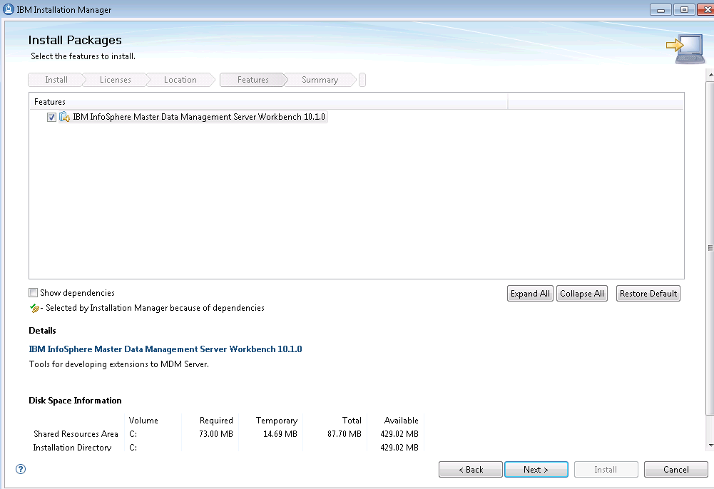
- Click Next
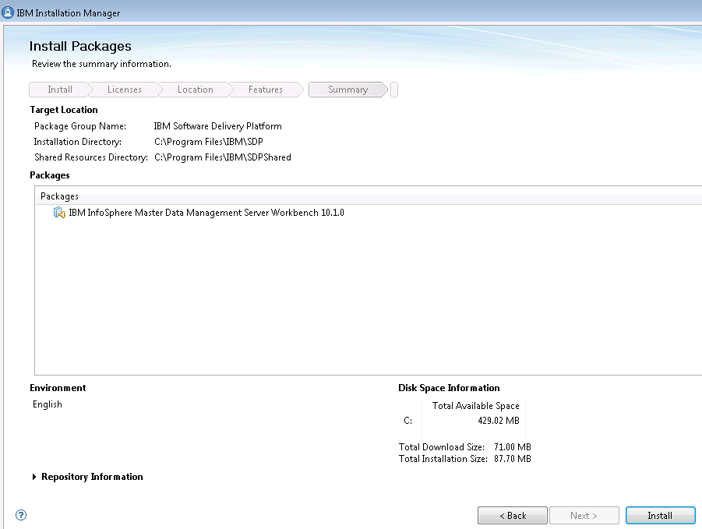
- Click Install
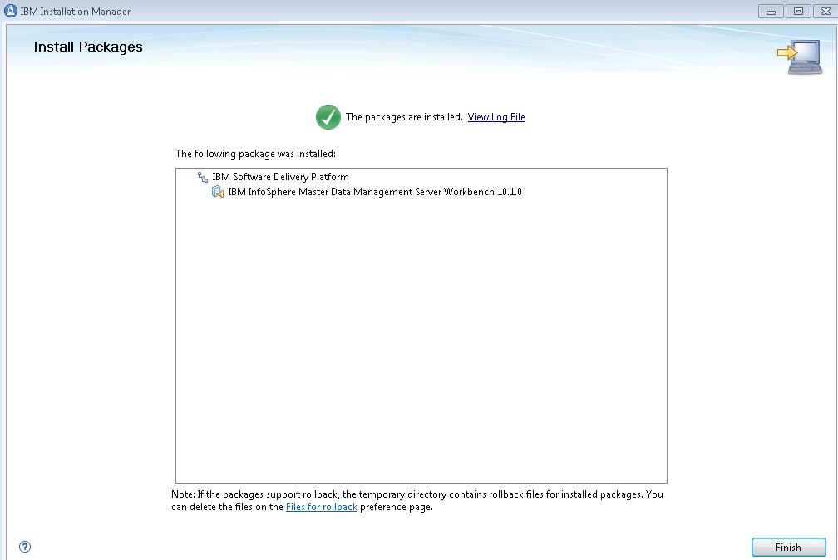
- Click Finish

- To set up Websphere 8 App Server profiles I had to change permissions on the following folder:

Step 1 – Create Websphere Profile
- To set up Websphere 8 App Server profiles I had to change permissions on the following folder:
  - Create folder profiles under :\Program Files\IBM\WebSphere\AppServer\
  - C:\Program Files\IBM\WebSphere\AppServer\profiles to allow TST\FXS024 to have full control. Also had to uncheck the read only attribute – Don’t have to do this if you run RSA and Websphere using “Runas Administrator”
- Launch the Websphere 8 Propfile Management tool from the Start Menu – use “Runas Administrator” . Click the “Create” button
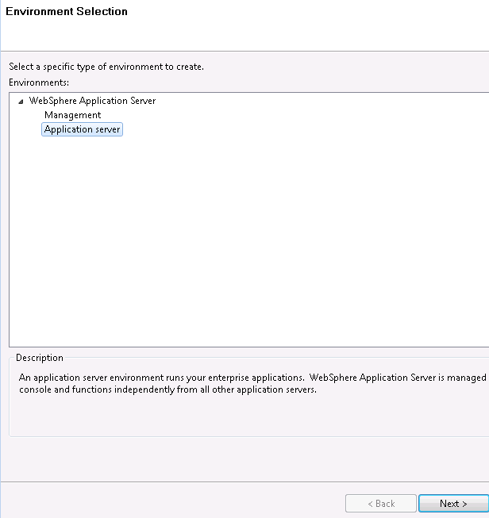
Select “Application Server” and Click Next
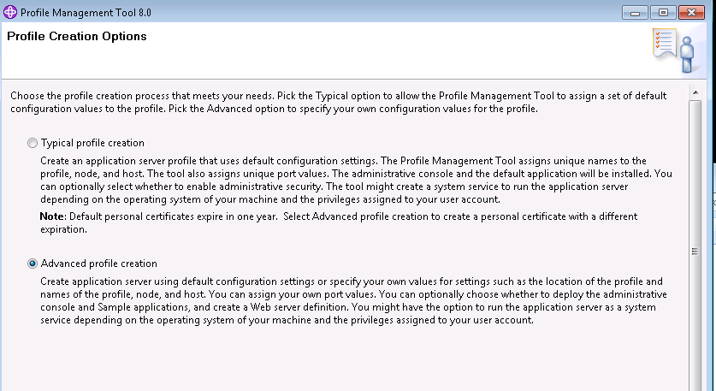
Select “Advanced Profiel Creation” and click Next

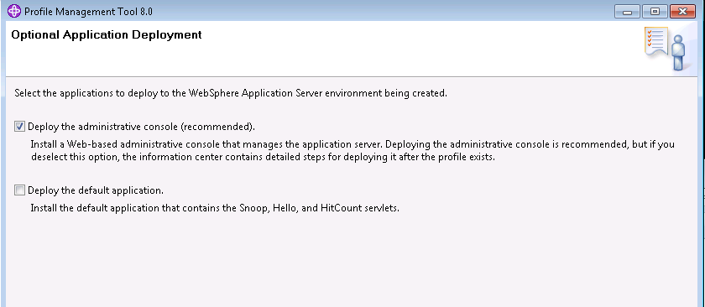
Check the “Deploy Administrative Console” option and uncjeck the “Deploy the default Application” option. Click Next
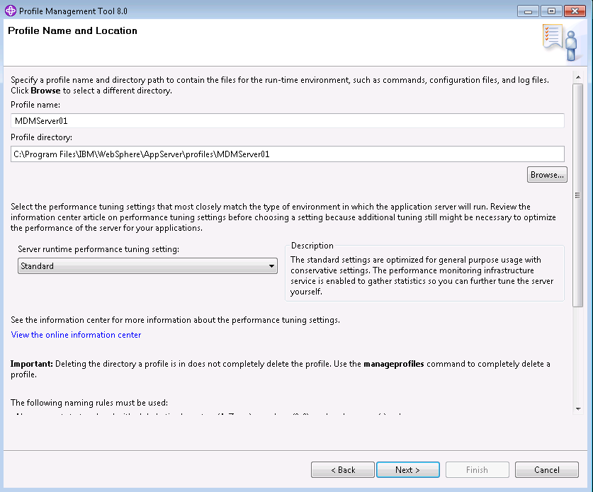
User MDMServer01
- 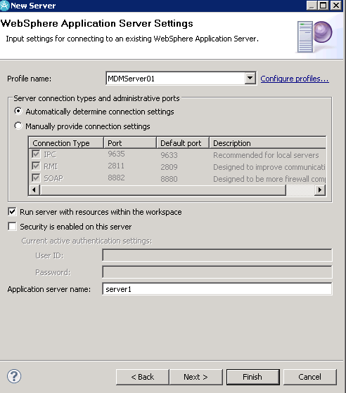
- 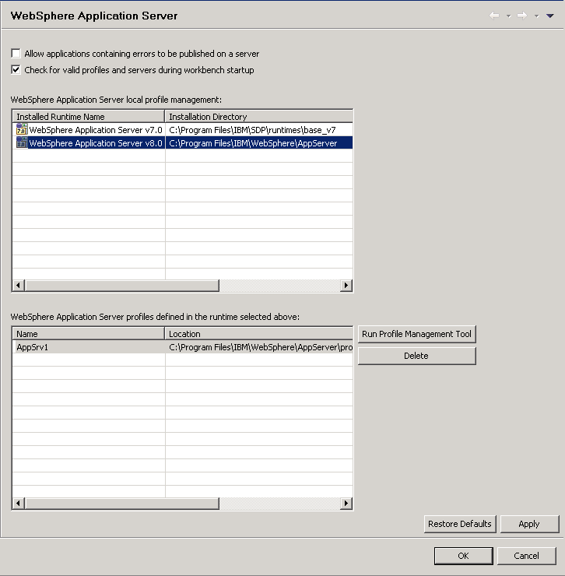
- Select the Websphere Application Server v8.0 entry
- If there are no profiles set up then click the “Run Profile Management Tool” button.
- In the Profile Management tool window click “Create”. Select “Application Server”. Click next. Select Advanced Profile Creation
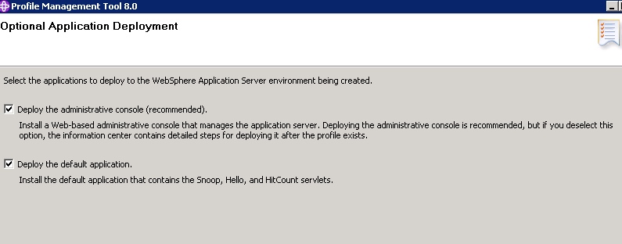
- Click next
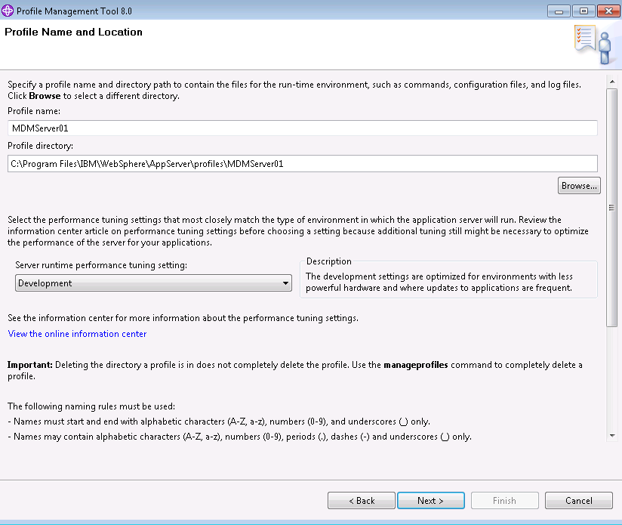
- Check Make this profile the default and Call the profile MDMServer01 and use path C:\Program Files\IBM\WebSphere\AppServer\profiles\MDMServer01. Pick the Development runtime.
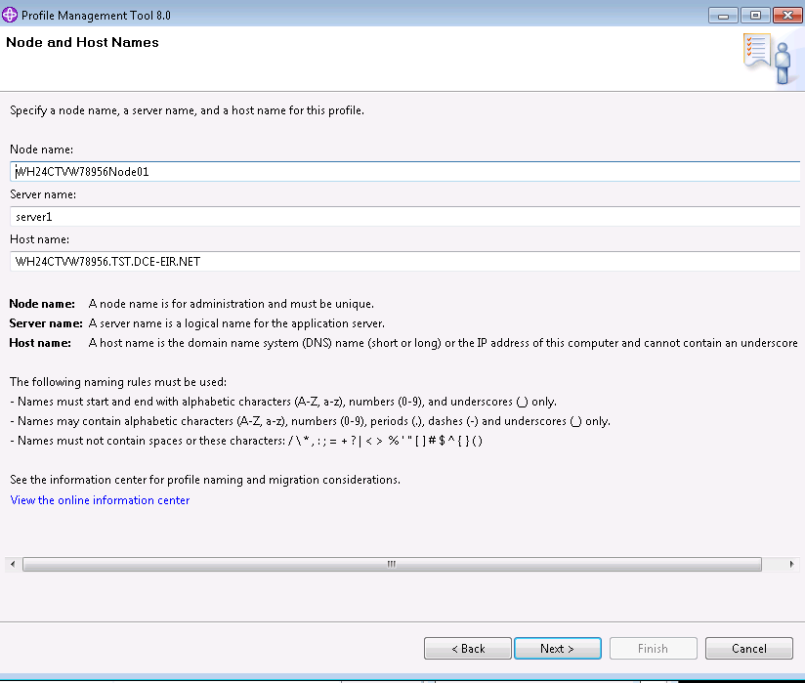
- Make sure to leave the server name as server1. Click Next
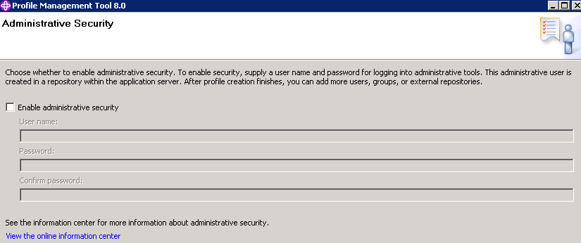
- Un check the Enable Administrative Security
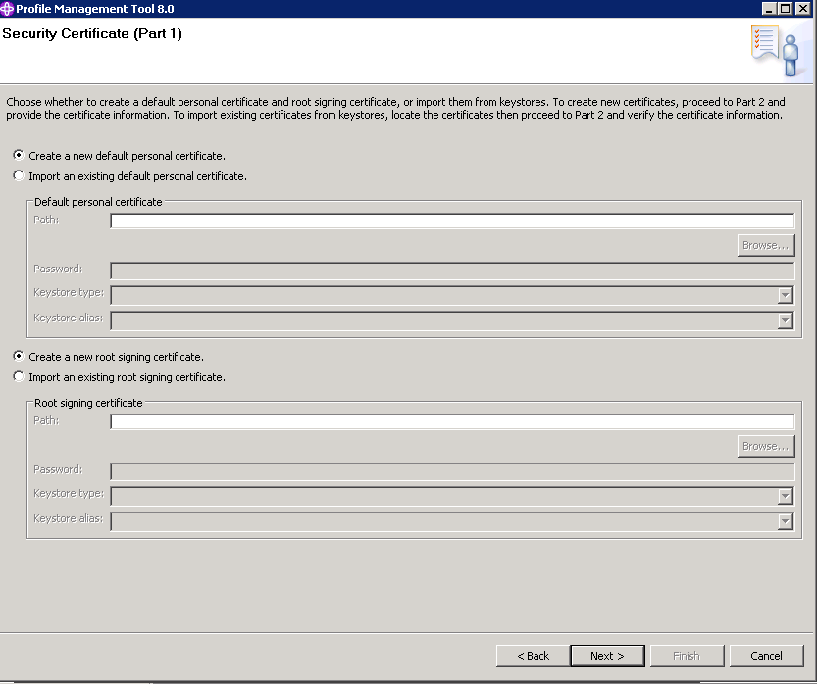
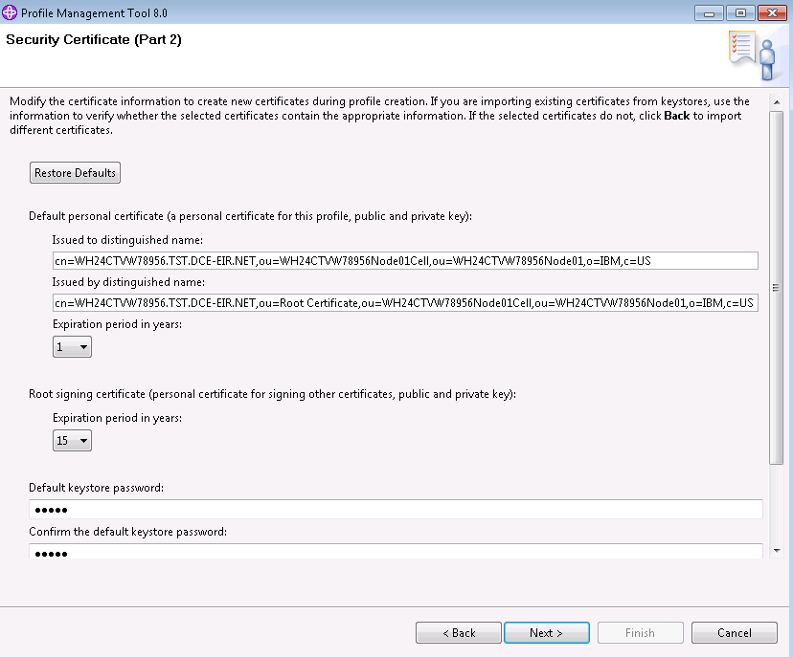
- Click Next
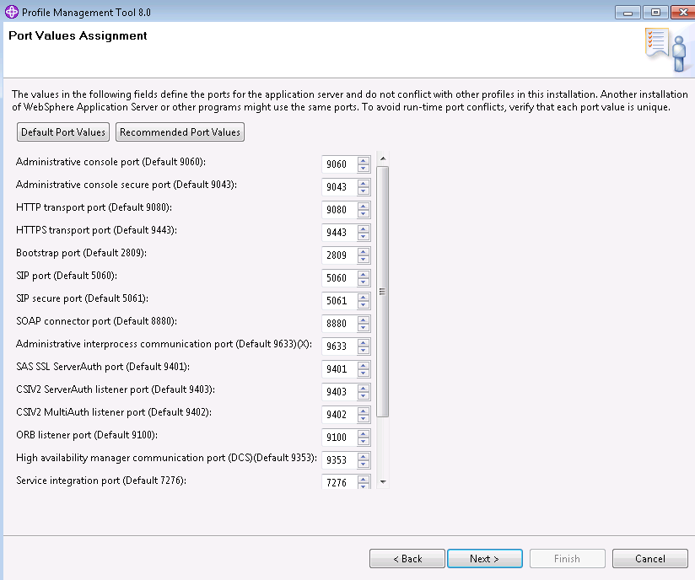
- Click the “Recommended Port Values” button and click Next
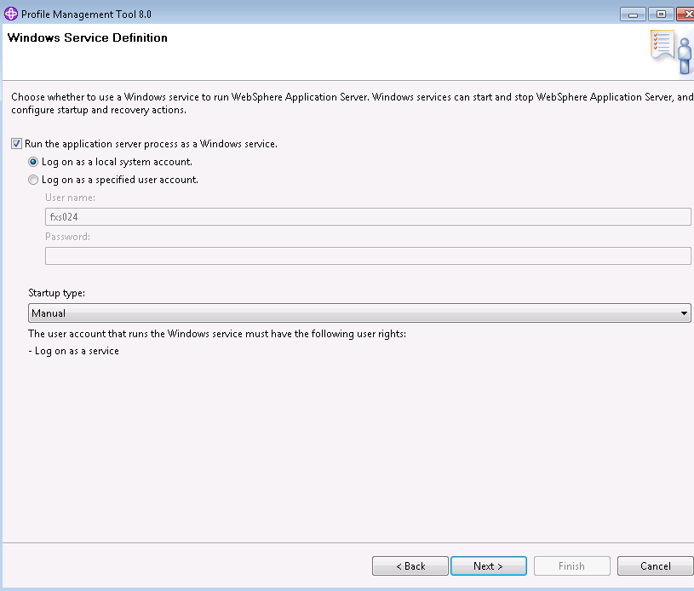
- Check run as a Windows Service and use local System. Select Manual Startup. Click next
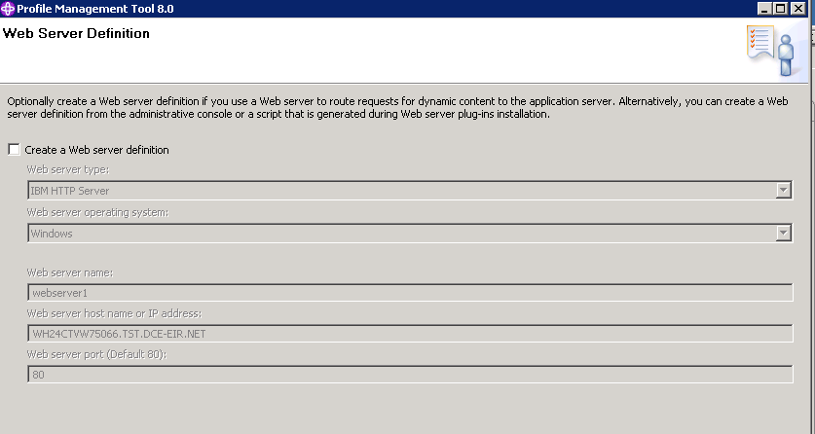
- Uncheck Create a web server definition and click Next

- Click Create
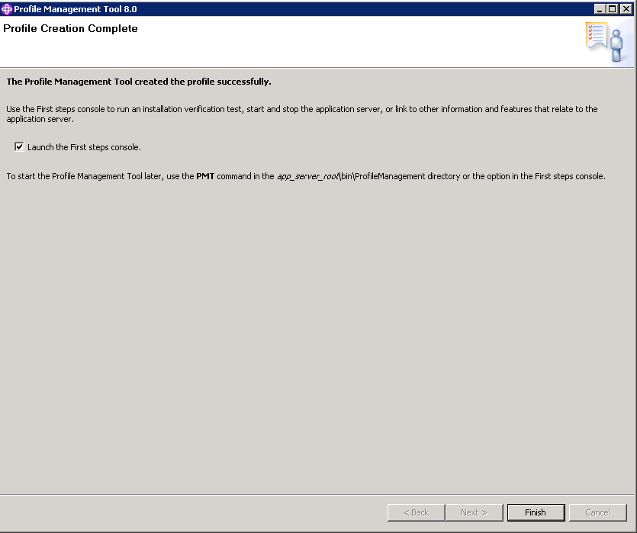
- Make sure the “Launch First Steps console” is checked. Click Finish
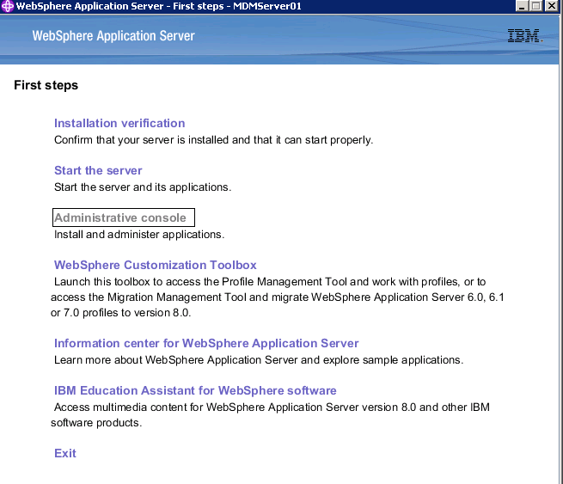
- Click “Installation Verification”
- You should get all tests passed. See attached listing
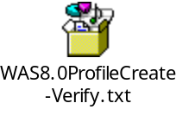
- Click the “Stop the Server” link

Step 2 – Configure RSA
- Create a new blank Workspace in RSA
- In RSA Select File > New > Other and Select Server
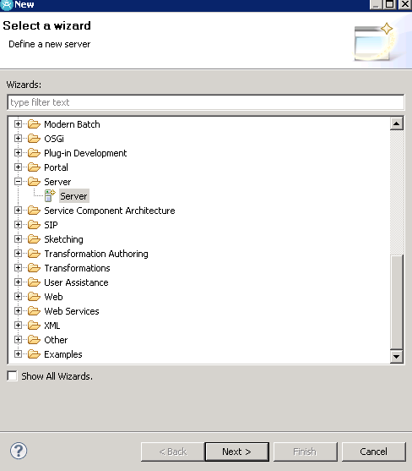
- Select Next.

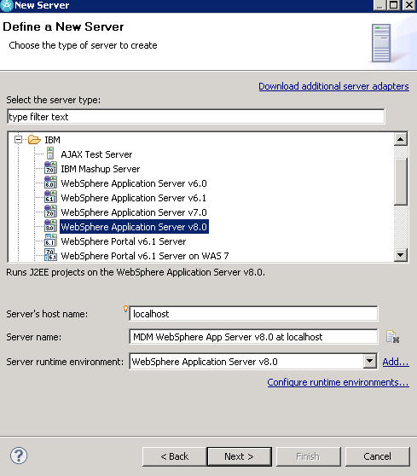
- Select Webspahere Application Server v8.0 and enter MDM Websphere App Server v8.0 at Localhost for the Server Name
- Select Next
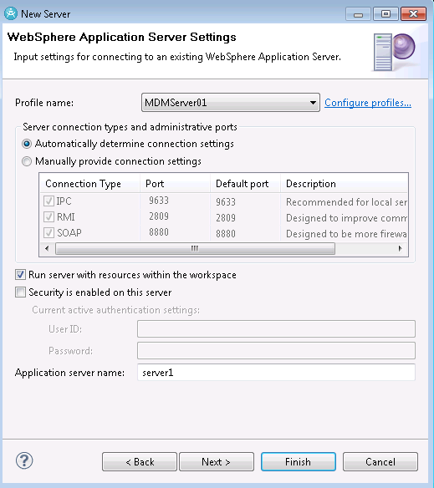
Enter server1 as the Application Server Name and if there are no profiles listed then Click the “Configure Profiles” link otherwise select the MDMServer01 profile.

- Configure Websphere Settings for MDM Server
  - In RSA select the “Servers” tab - See below
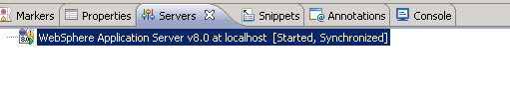
  - Right Click on the Websphere 8 Application Server and select “Administration” > Run Administrative Console.
  - Navigate to Servers -> Websphere Application Servers -> Server1
  - Select “Session Management” and on the next page ensure “Enable Cookies” is checked.
  - Click on “Enable Cookies” and on the next page make sure “Restrict cookies to HTTPS cookies” is unchecked.
  - Apply the changes and save configuration
  - Restart Websphere.

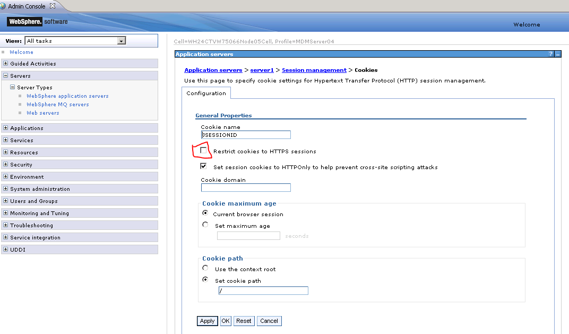
Step 2 – Configure MDM DEST Setup

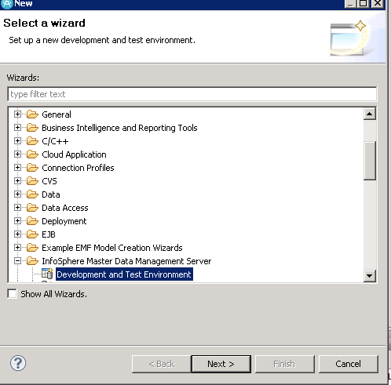
Pick only the Prepare activities in the first execution of the DEST Setup

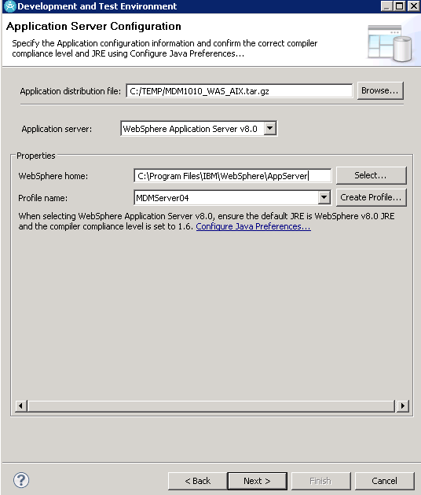

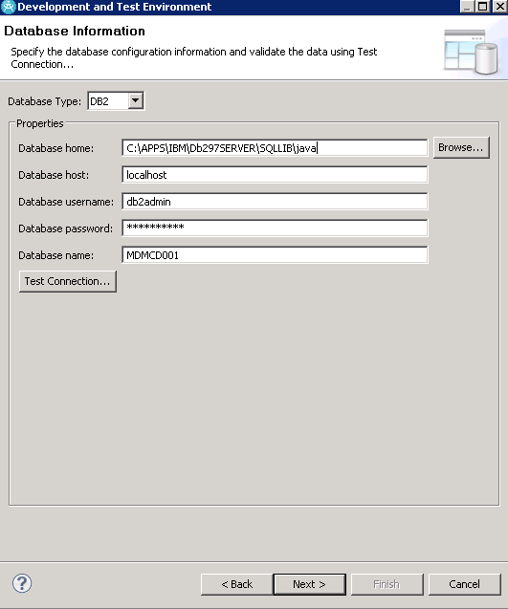

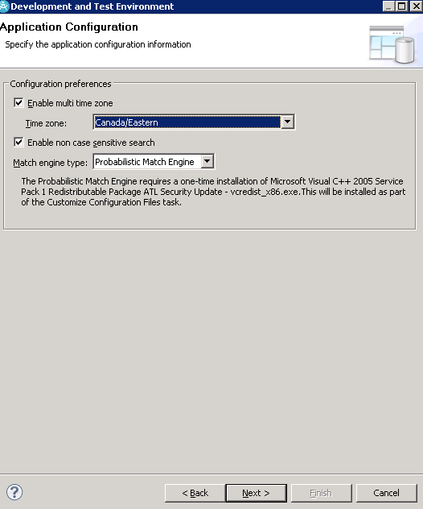

Summary Log

Selected Operations :

1. Import Application Projects into Workspace
2. Customize Configuration Files
3. Create an Application Database
4. Configure Application Resources
---------------------------------------
---------------------------------------

User Input Values :
Application server : WebSphere Application Server v8.0

Application distribution file : C:/TEMP/MDM1010_WAS_Solaris.tar.gz
Additional Details :

Host machine name : wh24ctvw75066
Temporary output folder : C:\Users\fxs024\AppData\Local\Temp\DEST\ear\MDM.ear
Deployment name : MDMServer
Unpack distribution file to : C:\Users\fxs024\AppData\Local\Temp\DEST\unpack
---------------------------------------

Database Type : DB2
Database home : C:\APPS\IBM\SQLLIB\java
Database host : <workstation host name>.TST.DCE-EIR.NET
Database username : db2admin
Database password : *****
Database name : MDMCD001
---------------------------------------

Enable multi time zone : true
Time zone : Canada/Eastern
Enable non case sensitive search : true
Match engine type : Probabilistic Match Engine

vcredist.exe error – The error below is caused by a bug in DEST. I installed a Win32 version of vcredits.exe manually but IBM support later told me the error can be ignored. However, I did not verify it. To get DEST to continue past the error you have to run RSA as administrator by doing “Runas administrator” even if you have local admin rights on the workstation.

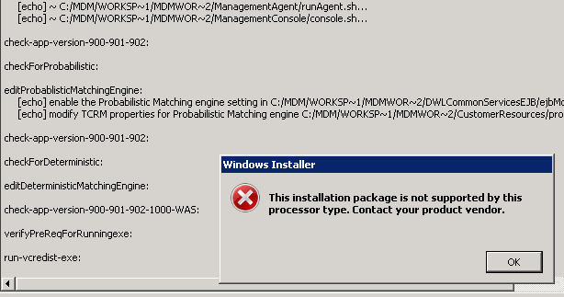

Step 3 - Run DEST Setup again – Build Application

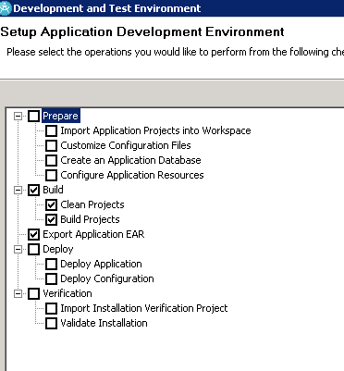

Use same responses for Websphwere and DB Info as previously
After these steps are completed use Websphere Admin console to change the port on the DWLConfig and DWLCustomer data sources from 5 to 50000. DEST uses DB2 command line to find the port but it looks like it doesn’t work properly – Here is what I got from IBM support on PMR 37345 072 649.
db2 get database manager configuration | findstr /i svce and then cat the windows service file(e.g /windows/system32/driver/etc) will get the port number the DB instance is using
Step 4 - Run DEST Setup again – Deploy Application
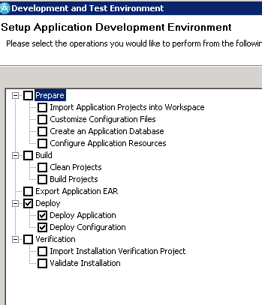

After this completes you have to copy mad.dll from
C:\Users\<user name>\AppData\Local\Temp\DEST\unpack\MDM\eME\native\windows32
To
- C:\Program Files\IBM\WebSphere\AppServer\profiles\MDMServer04\installedApps\WH24CTVW75066Node05Cell\MDMServer.ear\META-INF\eME\Windows32
- C:\MDM\Workspaces\MDMWorkbench2\MDM\META-INF\eME\Windows32

Step 4 – Run DEST Again
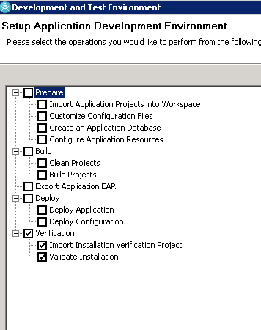
Step 3 – Deploy MDM Server Administration UI and Data Steward UI and Evergreen Console

- Deploy Administration UI
  - Retrieve the MDMBusinessAdmin.ear file from folder:: and copy to a temp folder : C:\Users\<UserID>\AppData\Local\Temp\DEST\unpack\MDM\installableApps
Note: You may have to adjust windows explorer settings to make the “AppData” folder visisble
  - Extract the propertiesUI.jar from the MDMBusinessAdmin.ear file
  - Extract the mdmUIConfiguration.properties file from the propertiesUI.jar file
  - Edit the mdmUIConfiguration.properties per the sample below. You should just need to change the workstation hostname.
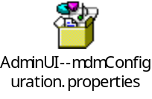
  - Update the mdmUIConfiguration.properties file in the propertiesUI.jar and update the priopertiesUI.jar in the MDMBusinessAdmin.ear file
  - Deploy the MDMBusinessAdmin.ear file using Websphere Administration console. Click “Install” and
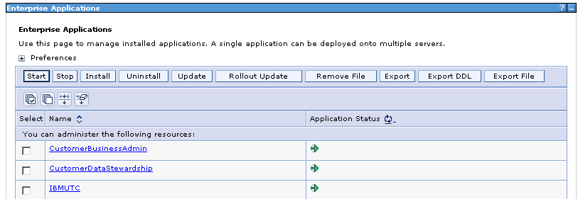
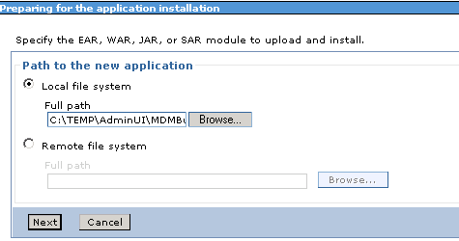

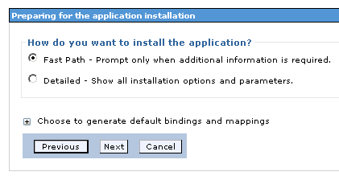
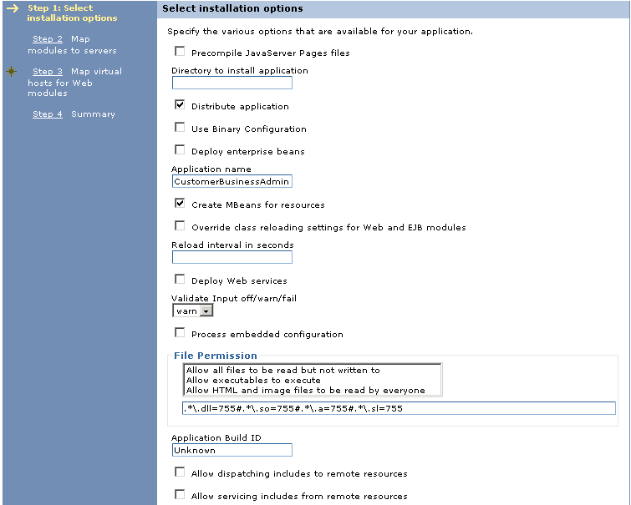
  - Pick Defaults for all subsequent prompts
  - Navigate to “Applications” -> Application Types -> Websphere Enterprise Applications” > CustomerBusinessAdmin
  - Select “JSP and JSF Options” and make sure the JSF Implementation is set to “SunRI1.2” per below
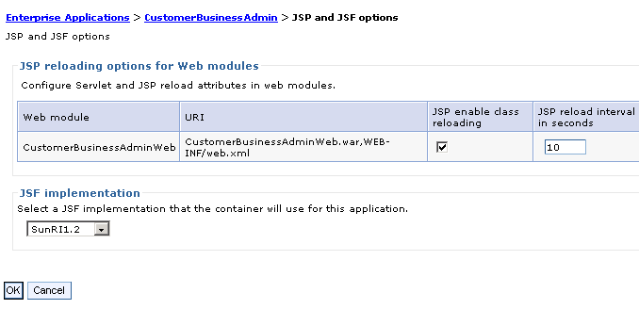

- Deploy DataSteward UI
  - Retrieve the MDMDataStewardship.ear file from folder:: and copy to a temp folder : C:\Users\<UserID>\AppData\Local\Temp\DEST\unpack\MDM\installableApps
Note: You may have to adjust windows explorer settings to make the “AppData” folder visisble
  - Extract the propertiesUI.jar from the MDMDataStewardship.ear file
  - Extract the mdmUIConfiguration.properties file from the propertiesUI.jar file
  - Edit the mdmUIConfiguration.properties per the sample below. You should just need to change the workstation hostname.
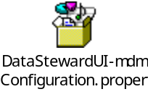
  - Update the mdmUIConfiguration.properties file in the propertiesUI.jar and update the priopertiesUI.jar in the MDMDataStewardship.ear file
  - Deploy the MDMDataStewardship.ear file using Websphere Administration console. Click “Install” and

  - Pick Defaults for all subsequent prompts
  - Navigate to “Applications” -> Application Types -> Websphere Enterprise Applications” > CustomerDataStewardship
  - Select “JSP and JSF Options” and make sure the JSF Implementation is set to “SunRI1.2” per below

- Deploy Evergreen Console UI
  - Retrieve the Evergreen.ear file from folder:: and copy to a temp folder : C:\Users\<UserID>\AppData\Local\Temp\DEST\unpack\MDM\installableApps
Note: You may have to adjust windows explorer settings to make the “AppData” folder visisble
  - Extract the propertiesUI.jar from the Evergereen.ear file
  - Extract the mdmUIConfiguration.properties file from the propertiesUI.jar file
  - Edit the mdmUIConfiguration.properties per the sample below. You should just need to change the workstation hostname.
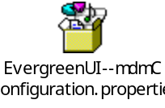
  - Update the mdmUIConfiguration.properties file in the propertiesUI.jar and update the priopertiesUI.jar in the Evergreen.ear file
  - Deploy the Evergreen.ear file using Websphere Administration console. Click “Install” and follow the same instructions as for deploying the Data Steward UI.
  - Insert default cusadmin user information into MDM Database:
    - insert into db2admin.userprofile ( user_profile_id, user_id, LAST_UPDATE_DT ) values10000, 'cusadmin', CURRENT TIMESTAMP );
insert into DB2ADMIN.usergroupprofile ( USER_GRP_PROF_ID, GROUP_PROFILE_ID, USER_PROFILE_ID,
LAST_UPDATE_DT, ACTIVE_IND ) values (10000, 1001, 10000,CURRENT TIMESTAMP, 'Y' );

Install MDM Initiate Workbench 10.1 – For Managing PME Configuration
Reference: G:\ISTB-DGIST\SD-DGS\ECS-SIC\Master Data Management\IBM MDM SW + Docs\10.1\Initiate MDS\MDS\ MDS_WorkbenchInstallationGuide.pdf
- Copy IBM_Initiate_Workbench_10.1.0.113_win32.exe to a temp folder
- Run IBM_Initiate_Workbench_10.1.0.113_win32.exe
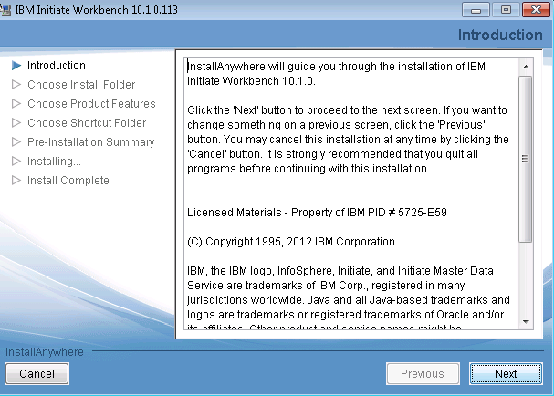
- Click next
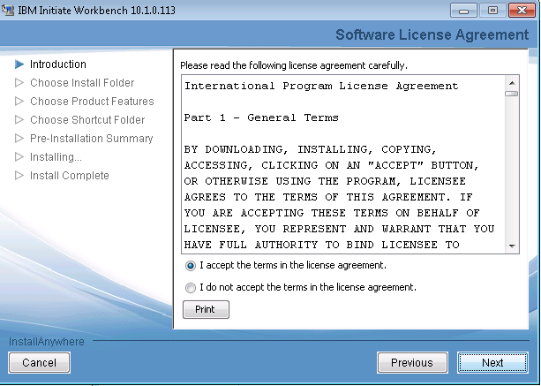
- Select “I Accept” … and click next
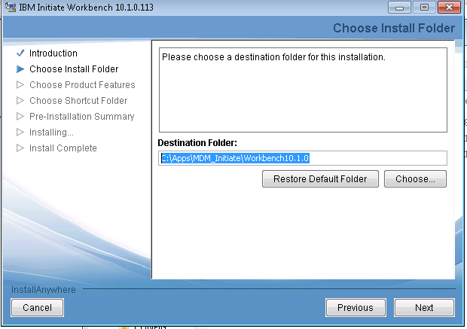
- Enter the path - C:\Apps\MDM_Initiate\Workbench10.1.0. Click next
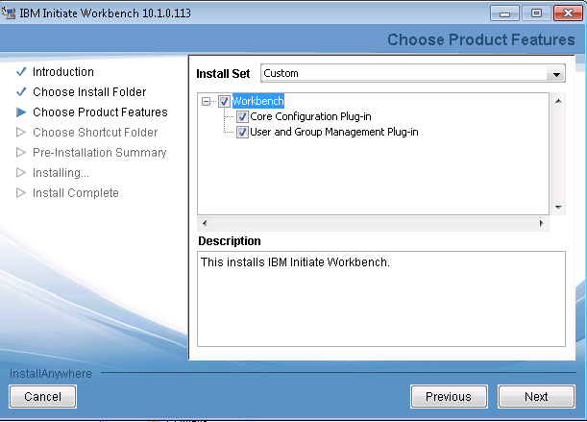
- Select Custom Install option and install components per screen shot above.
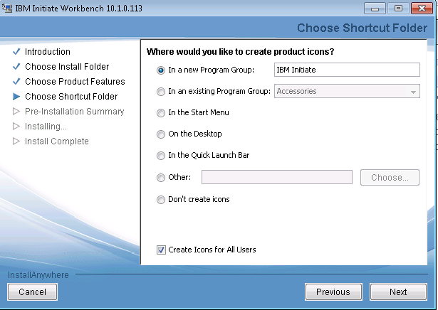
- Select Options per screen shot above and click Next
- Click next at the summary screen
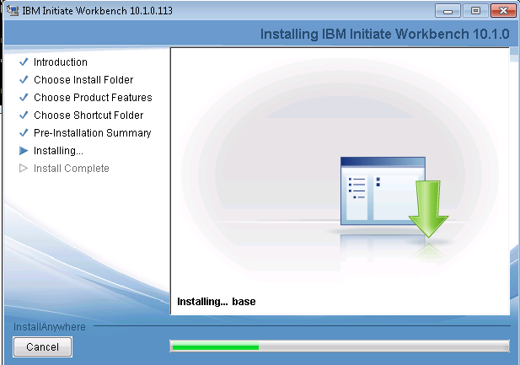
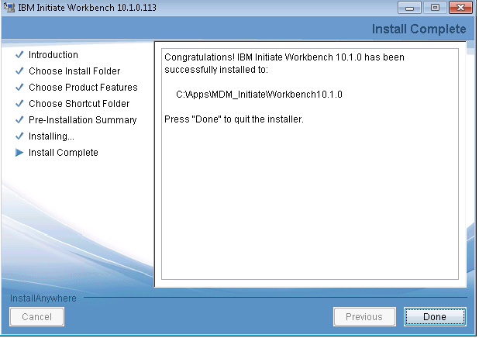
- Click Done

Install MDM Web Application Toolkit
- Need ISMDM_APPLICATION_TOOLKIT_10.1.tar.gz
- Unpack this file and store in a staging folder (e.g. D:\Apps\MDMAppToolkit
- Note: Had some problems with files eclipse_plugin.xml and eclipse_feature.xml in the com.ibm.mdm.at.repository\atoc\nq folder . A separate copy of these is in the MDM Application toolkit folder on the shared drive. Replace the unpacked versions with the versions from the shared folder. Alternatively use the contents of the unpacked folder already on the shared drive at :
G:\ISTB-DGIST\SD-DGS\ECS-SIC\Master Data Management\IBM MDM SW + Docs\10.1\Software\MDM 10.1 Application Toolkit\MDMApplicationToolkit\com.ibm.mdm.at.repository
- Point the IBM Installation manager repository configuration to the MDm Application toolkit folder using “preferences “ option. See below. Test the repository connection
- Click to Install packages and install the package below.

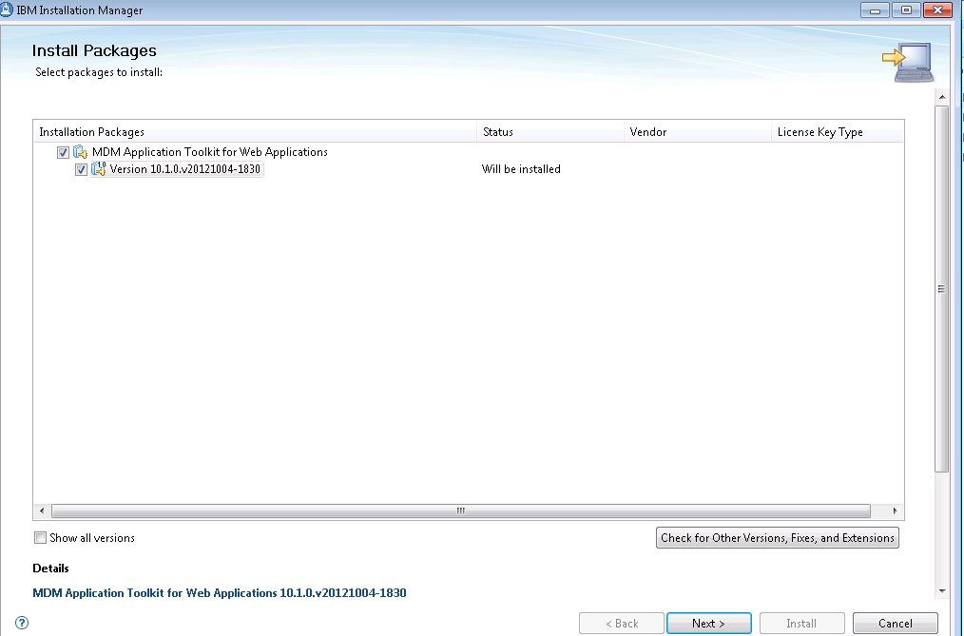

- On next screen accept license agreement
- Install in the IBM SDP Package folder per below
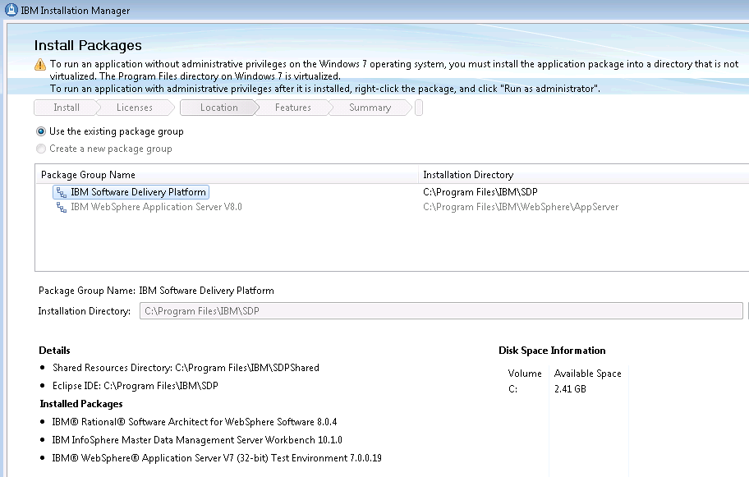
- Click Next. Install per below
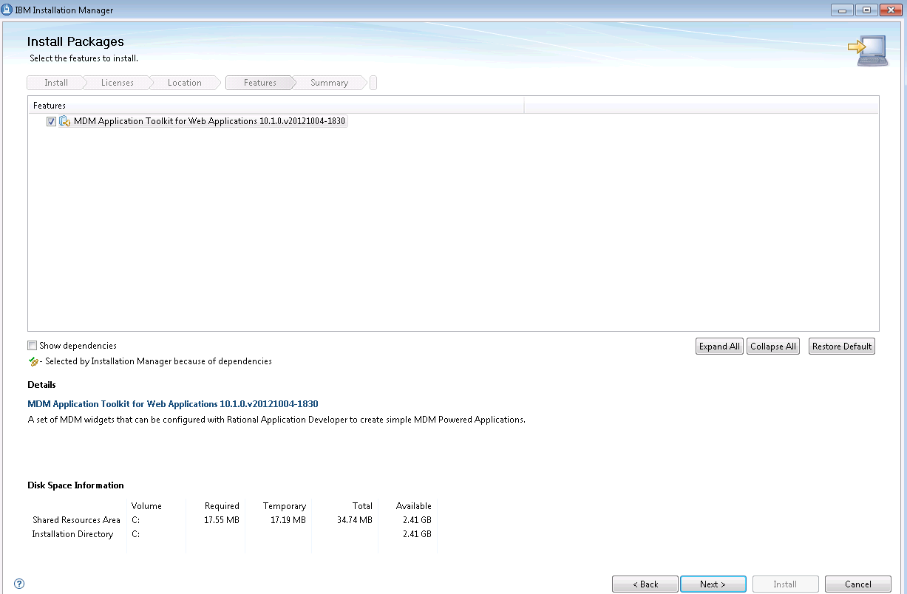
- Click Next
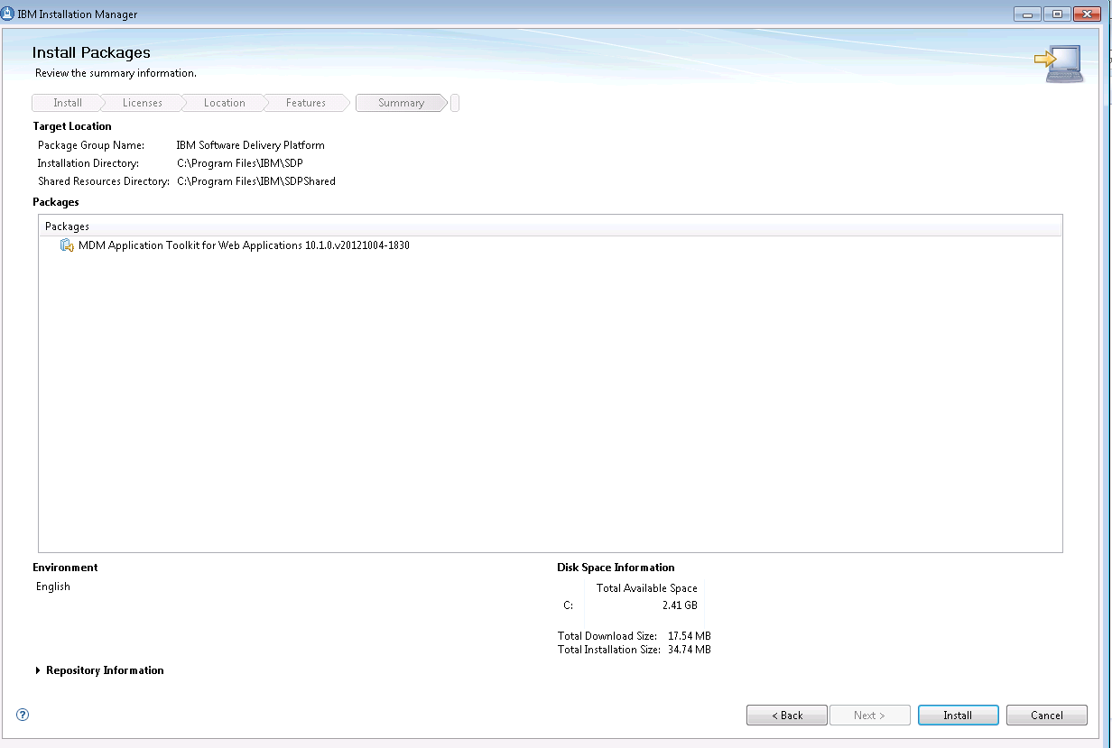
- Click Install
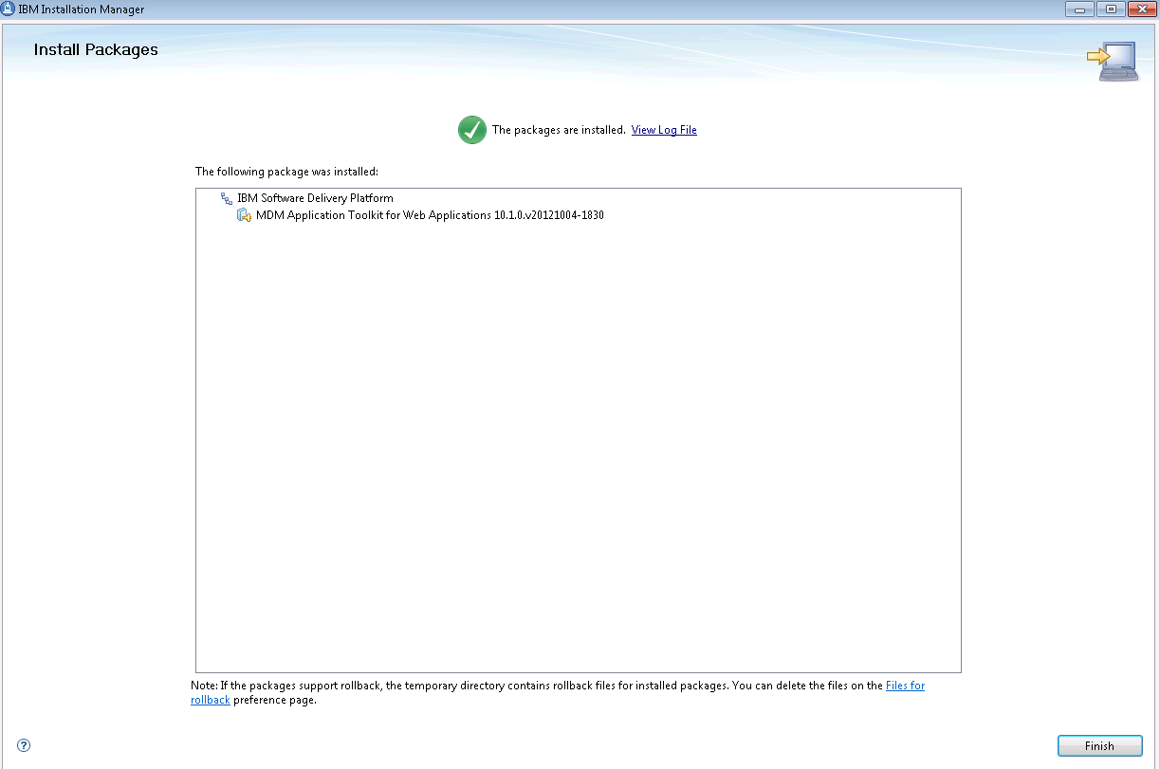
- Click Finish

