|  |  |  |
| --- | --- | --- |
| **Project Title** |  | |
| **Section** | **Registration Number** | **Name** |
| A | 25-BSCS-19 | Isha Kanwal |
| A | 142-RE-BSCS-18-A | Faisal Rasheed |

## **Installation Requirement (if any)**

Python 3.9 (Language)

Python IDE( PyCharm or VS Code)

NumPy and Random

**Why you choose this algorithm (Advantage of Algorithm that you had use in your project**)

We have used the A* search algorithm in our project since it’s the most optimized and efficient algorithm in comparison to BFS and DFS

**Step by step visualization of Project.**

Our project Is built on Python 3.9 version .The project is Maze Escape ,in VS Code we have static maze (can be dynamic also) .First we have setup maze in which we have Goal and End state.

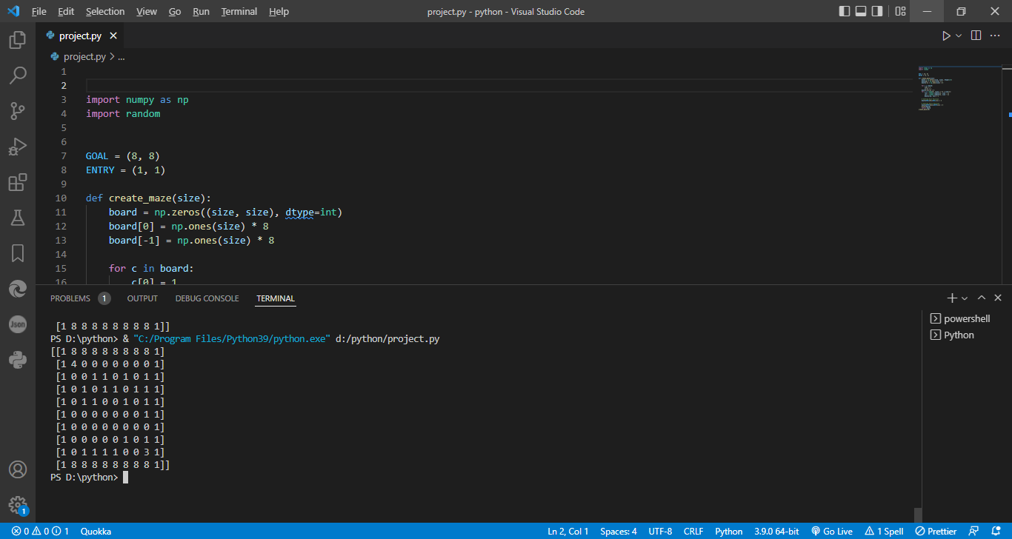

This will create a Maze . Similarly we have the traversing ,move making and other functions in it.

There also some constraints as such if the maze generated are closed then it will generate “Not Possible” Solution otherwise it will solve the maze .

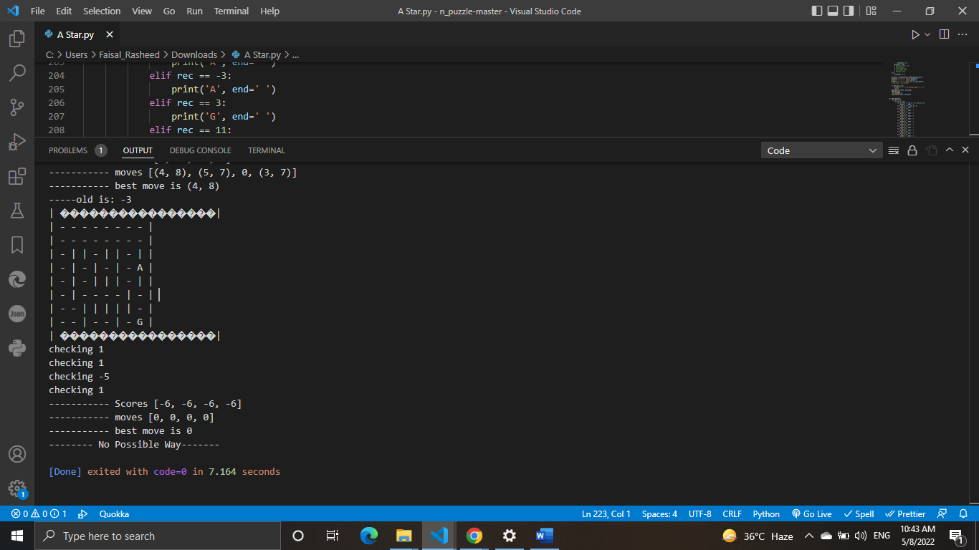

**Write challenges of project that you had face while implementation.**

The challenge that we faced selecting the most optimize algorithm for this project .There are also other algorithm such as BFS and DFS .

**What are the limitation of the Project?**

The algorithm will fail when maze will be closed and algorithm will reach it maximum height .It can be made better with some expert advices

**Submission Guideline:**

You are required to submit Python files of project with Word Document (As per given template) in a single zip file (Attach .txt file or .csv file if there is any). Name of zip file should be the registration number. Registration Number should be as per university format.