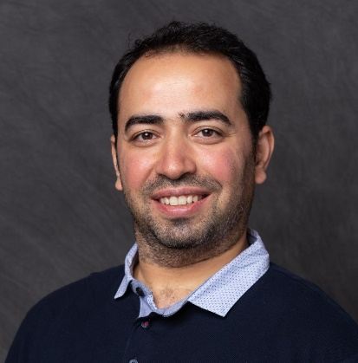Mohamad Hussam Al Khatib

Riyadh, Saudi Arabia | +966 550 482 316 | [mhussamkh@gmail.com](mailto:mhussamkh@gmail.com)

# Objective

Results-driven, highly accomplished, and focused Education Consultant with experience of more than 12 years, Currently, I am seeking a Management Consulting position in a leading Management Consulting company where I can grow and prospect in a mature environment.

# Accomplishments

* Lead a team of 15 consultants to implement and developed TVTC Admission portal, this portal is one of the largest admission portal in Saudi Arabia, served more than 500K Applicant in its first year.
* Product Manager for 2 solutions: a Native SaaS SIS for Higher Education institutes and a Native SaaS Mobile and eService Portal for Higher Education institutes.
* Lead a team of Higher Education Consultants to build a comprehensive Data Model Ontology for Higher Education using OWL standard via Protégé.
* Help univeirries deliver 50 KPIs as per to MoE requirements and developed the needed dashboard to deliver these KPIs
* Construct a data warehouse model and extracts data from multiple systems through different endpoints.
* Implement different projects in different sites:
  + Technical and Vocational Training Corporation (TVTC)
  + North Border University(NBU)
  + Princess Nora Univeirsty (PNU)
  + Prince Mohamad Bin Fahad University (PMU)
  + University of Jeddah (JU)
  + Public Authority for Applied Education and Training (PAAET) in Kuwait
  + Bahrain Polytechnic (BP) in Bahrain
  + American University in Beruit (AUB)
  + And others….

# Experience

## Product Manager | Naseej | 1/12/2019 – NOw

* Managed concept-to-launch of Student Information System that enables a real-time managing of Students' information, actions, and analytical reporting.
* Managed concept-to-launch of cutting-edge SaaS solution for university Service Mobile and Portal.
* Managed and enhance Data Model Ontology for Higher Education using Protégé.
* Design ETL models to enhance business processes and automate data extraction from HED Systems
* Ensured products met or exceeded client expectations. Excelled at gathering feedback and requirements; communicating needed changes to the development team; and overseeing seamless, high-quality rollouts to on-time and on-budget conclusions.
* Developed a deep understanding of the business objectives of internal and external stakeholders; evangelized the product vision and built trust by maintaining an accurate and achievable roadmap.

## Higher Education business development | Naseej | 1/1/2018 - 30/11/2019

* Define and develop the company’s Service Catalog in alignment with Vendor's strategic partner program.
* Answer public tenders with a detailed proposal through comprehensive and sophisticated technical details and competitive price including the scope of work, assumptions, and out-of-scope sections.
* Plan system environment, Hardware sizing, and license requirements as per vendor standards and recommendations.
* Build Case studies on successful implementation and new solutions/offerings.
* Attend Quarterly meetings with C-Level Executives and present overall presentation on activities and sales.
* Participating develop vendor renewal contracts and negotiating the terms and conditions.

## Technical Team Leader | Naseej | January 2016 – decmber 2017

* Lead the technical team in implementing SIS solution in multiple sites.
* Conducat session with decision makers to analyze their requirement and provide a solution design with nessery docuemnats.
* Review and recoment Hardware sizing and perform benchmark testing.
* Building and deploying rich analytic data models and reports.

## Techno-functional Consultant | Naseej | January 2013 – decmber 2015

* Provide Consulting services to clients in the matter of deploying & implementing Enterprise solutions such as Student Information systems, Analytical and Reporting solutions, Identity Management, and Integrations Services.
* Deploy and implement a hybrid solution based on proven practices.
* Developed reports and dashboard as per to clients needs and requirmnets.
* Build training materials and documentation for clients.

# Education

## Master in Artificial intelligence | (on-going) | university Technology of Malaysia - Malaysia

* On-going, preparing for the research.

## Bachelor OF Information Technology| 2009 | university of Kalamoon - Syria

* Graduate with Honor Degree, Ranking 4th

# Training & Certificate

* Certified SAFe® 5 Product Owner/Product Manager <https://www.credly.com/badges/194258f3-ff96-4893-b445-44b7c63adeb8>
* Digital Transformation online course from the University of Virginia through Coursera.
* Machine Learning in Production - by DeepLearning.AI through Coursera.
* Digital Product Management - the University of Virginia through Coursera.
* Google IT Automation with Python by Google through Coursera.
* Red Hat Red Hat Certified System Administrator: EX200 RHCSA: <https://www.redhat.com/rhtapps/services/verify/?certId=140-085-630>
* And others..