Faisal I Saqallah

202045600

Sec:54

**Used data structures:**

AVLTREE.

**Methods:**

* findWord(String s): Searches the dictionary to find a specified word.

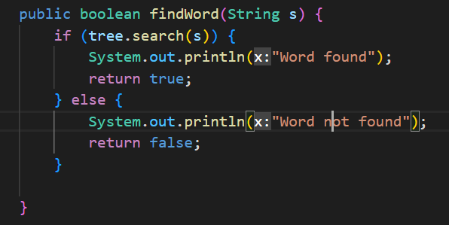

* addWord(String s): Adds a new word to the dictionary. A screen shot of a computer program

  Description automatically generated with low confidence
* deleteWord(String s): Deletes a word from the dictionary. A screen shot of a computer code

  Description automatically generated with low confidence
* findSimilar(String s): searches the dictionary for similar words.

* saveDict(String dictName): Saves dictionary content to a .txt file.

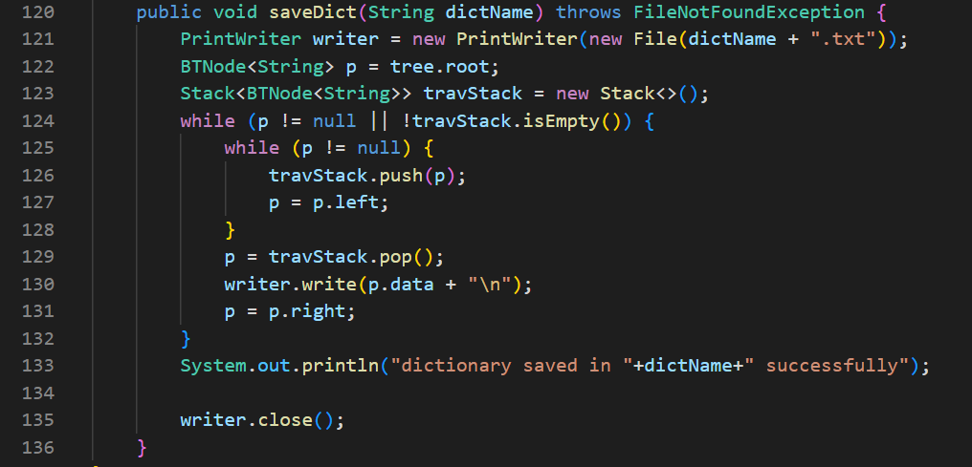

**Output :**



