Preprocessing, Regularisation and Cross-Dataset Generalisation of Logistic Regression for EEG Seizure Detection
Machine Learning - Semester Major Assignment
Faisal Hakimi
faisalh5556@gmail.com
Department of Computer Science
Abstract-We study logistic regression for EEG seizure detection across three real, independently-sourced datasets - UCI Epileptic Seizure Recognition, CHB-MIT Scalp EEG, and the University of Bonn EEG corpus. We show that logistic regression on raw EEG amplitude samples is degenerate (ROC-AUC 0.50, i.e. chance) and that a unified time-domain and spectral feature extractor restores discriminative power (ROC-AUC up to 0.99). Holding this methodology fixed, we evaluate preprocessing-step ordering, L1/L2/Elastic-Net regularisation, and class-imbalance handling. We find that penalty choice has a small effect (mean PR-AUC spread 0.005 among L1/L2/Elastic Net), that Elastic Net does not consistently dominate, and that feature extraction and imbalance handling matter far more than the regulariser. All conclusions are computed from the results and guarded by automated consistency checks.
Index Terms-EEG, seizure detection, logistic regression, regularisation, Elastic Net, class imbalance, generalisation.

I. INTRODUCTION
Epileptic seizure detection from EEG is a canonical clinical classification problem. Logistic regression remains a standard, interpretable baseline, but its behaviour depends critically on input representation, preprocessing order, regularisation and the handling of class imbalance. This report investigates four questions: (Q1) does the ordering of preprocessing steps affect results; (Q2) which regularisation generalises best across datasets; (Q3) does Elastic Net consistently outperform L1/L2; and (Q4) how does imbalance handling interact with regularisation. To make the generalisation question meaningful we use three real datasets of differing modality and difficulty rather than synthetic surrogates.
II. DATASETS
All datasets are downloaded reproducibly and anonymously via the "kagglehub" API; no data is fabricated and no source is mislabelled. Each signal is reduced to a common (segments x samples) form.
TABLE I. Dataset provenance and class balance.
Dataset | Samples | Features | Seizure % | True source
DS1 UCI | 11500 | 15 | 20.0% | UCI ML Repository
DS2 CHB-MIT | 1462 | 30 | 22.4% | CHB-MIT / PhysioNet
DS3 Bonn | 500 | 15 | 20.0% | Univ. of Bonn (2001)

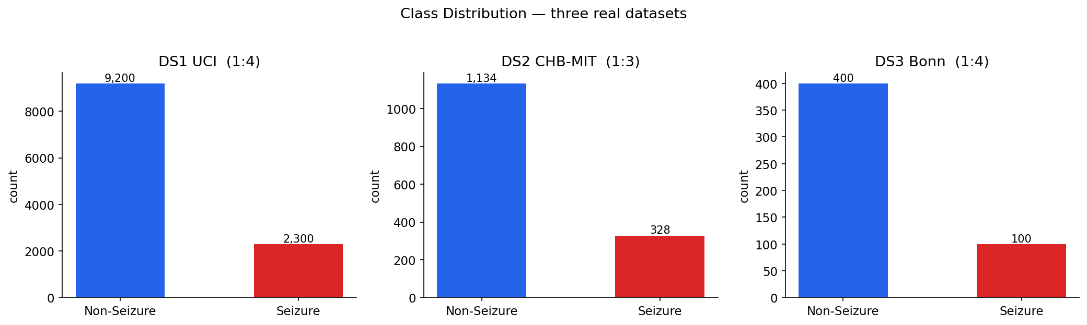
Fig. 1. Class distribution across the three real datasets.
III. METHODOLOGY
A. Signal feature extraction (root-cause correction)
Feeding raw EEG amplitude samples into logistic regression is degenerate: on DS1 it yields ROC-AUC 0.4996, no better than chance, because seizure information lies in signal energy, variability and spectral distribution, not in the amplitude at a fixed sample index. We therefore extract, identically for every dataset, ten time-domain features (variance, std, mean-abs, RMS, line-length, energy, peak-to-peak, zero-crossings, skewness, kurtosis) and five relative spectral band powers (delta, theta, alpha, beta, gamma). Multichannel CHB-MIT is reduced by per-channel mean and standard deviation.
B. Preprocessing pipelines
Pipeline A: StandardScaler -> VarianceThreshold -> SelectKBest(ANOVA F). Pipeline B: VarianceThreshold -> SelectKBest -> RobustScaler -> PCA. Both are applied to the extracted feature matrix and executed exactly as defined.
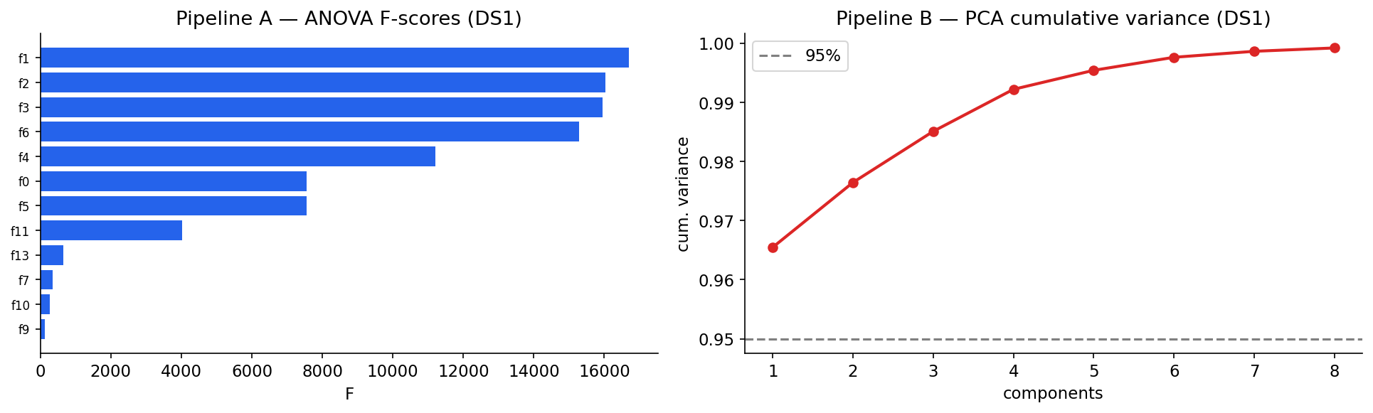
Fig. 2. Pipeline A feature F-scores and Pipeline B PCA variance (DS1).
IV. BASELINE RESULTS
Baseline = StandardScaler + L2 logistic regression (C=1), evaluated with imbalance-aware metrics. CHB-MIT is a genuinely hard real task; UCI and Bonn are well separated - a realistic difficulty spread.
TABLE II. Baseline logistic regression per dataset.
Dataset | F1 | Precision | Recall | PR-AUC | ROC-AUC
DS1 UCI | 0.9375 | 0.9633 | 0.913 | 0.9853 | 0.9929
DS2 CHB-MIT | 0.0286 | 0.25 | 0.0152 | 0.3485 | 0.6931
DS3 Bonn | 0.9302 | 0.8696 | 1.0 | 0.9461 | 0.9875

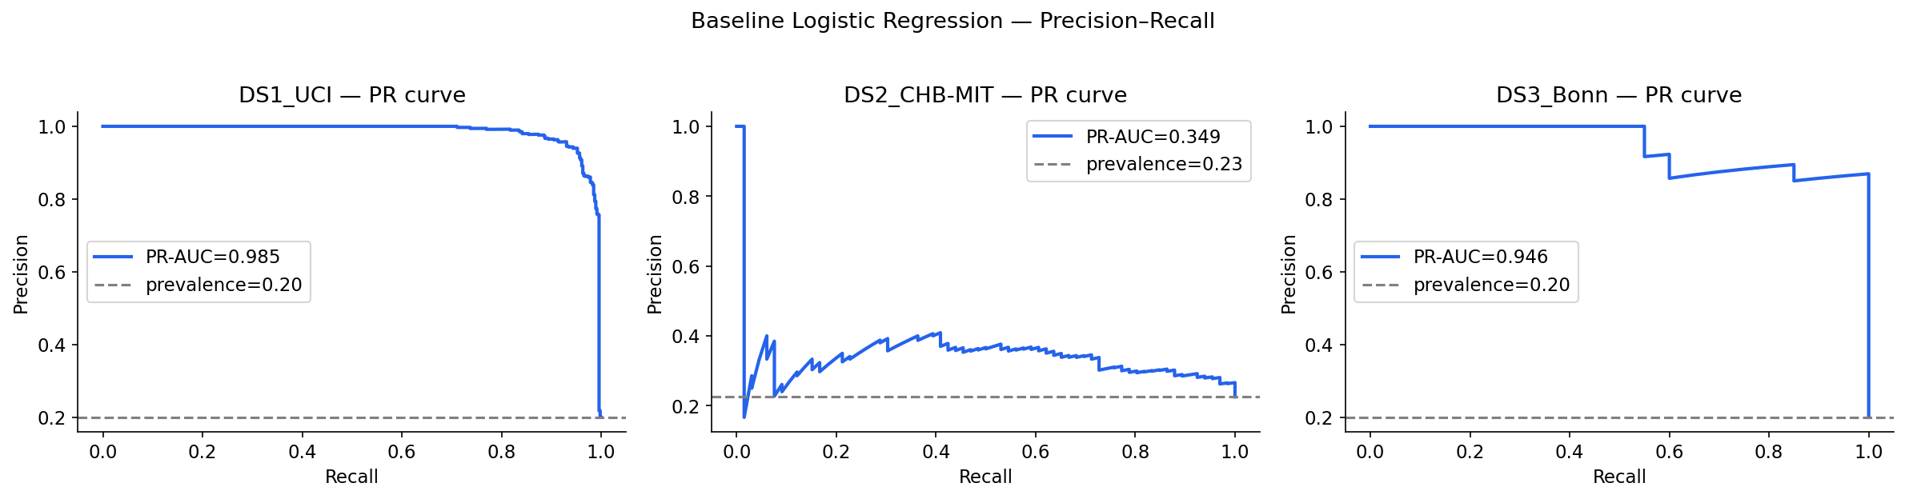
Fig. 3. Baseline precision–recall curves.
V. OVERFITTING AND UNDERFITTING
Capacity is varied on DS1 via polynomial expansion and the inverse regularisation strength C. Strong regularisation underfits; high-degree expansion with negligible regularisation produces a clear train>>test gap.
TABLE III. Underfitting → overfitting on DS1.
Scenario | # feat | Train F1 | Test F1
Severe underfit (C=1e-4) | 15 | 0.5796 | 0.5848
Mild underfit (C=1e-2) | 15 | 0.8947 | 0.88
Good fit (C=1) | 15 | 0.9311 | 0.9375
Overfit (deg=3,C=1e5) | 815 | 0.9997 | 0.9536

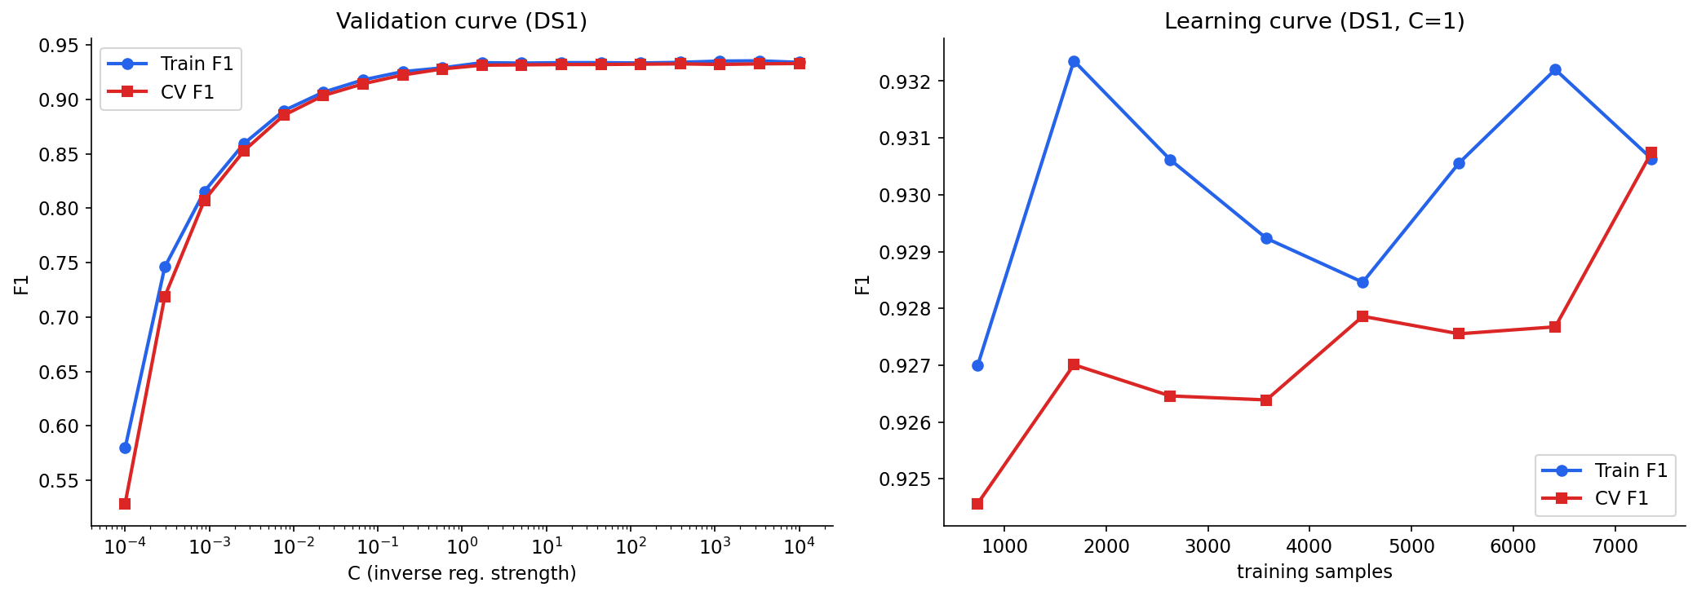
Fig. 4. Validation and learning curves (DS1).
VI. REGULARISATION STUDY
Each penalty is evaluated on all three datasets at matched C=1. Because F1 at the fixed 0.5 threshold is degenerate on the hard imbalanced CHB-MIT task, regularisers are also compared by the threshold-independent PR-AUC and ROC-AUC, which is the methodologically correct comparison under imbalance.
TABLE. Regularisation on DS1 UCI.
Penalty | F1 | PR-AUC | ROC-AUC | Sparsity %
L2 (Ridge) | 0.9375 | 0.9853 | 0.9929 | 0.0
L1 (Lasso) | 0.9401 | 0.9859 | 0.9928 | 20.0
Elastic Net | 0.9378 | 0.9855 | 0.9928 | 0.0
No penalty | 0.9399 | 0.9862 | 0.9931 | 0.0

TABLE. Regularisation on DS2 CHB-MIT.
Penalty | F1 | PR-AUC | ROC-AUC | Sparsity %
L2 (Ridge) | 0.0286 | 0.3485 | 0.6931 | 0.0
L1 (Lasso) | 0.0571 | 0.3588 | 0.6991 | 26.7
Elastic Net | 0.029 | 0.3567 | 0.6978 | 13.3
No penalty | 0.0282 | 0.3357 | 0.6881 | 0.0

TABLE. Regularisation on DS3 Bonn.
Penalty | F1 | PR-AUC | ROC-AUC | Sparsity %
L2 (Ridge) | 0.9302 | 0.9461 | 0.9875 | 0.0
L1 (Lasso) | 0.9091 | 0.9499 | 0.9881 | 40.0
Elastic Net | 0.9302 | 0.9499 | 0.9881 | 13.3
No penalty | 0.9268 | 0.8695 | 0.9406 | 0.0

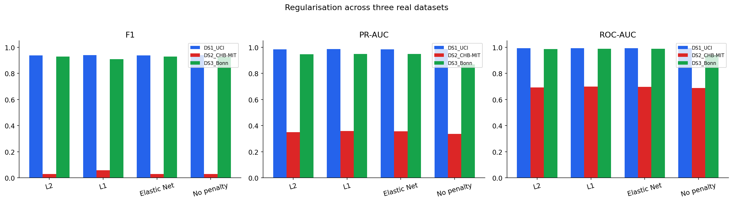
Fig. 5. F1, PR-AUC and ROC-AUC by penalty across datasets.
VII. CLASS IMBALANCE HANDLING
DS2 carries natural imbalance; DS1* is an honestly-labelled controlled subsample of DS1 at ~4% positives (positives down-sampled - a legitimate experimental manipulation). On the hard CHB-MIT task, resampling and class-weighting raise recall and F1 substantially over the unadjusted model.
TABLE IV. Imbalance strategies.
Dataset | Strategy | Precision | Recall | F1 | PR-AUC
DS1 (20% nat.) | None | 0.9633 | 0.913 | 0.9375 | 0.9853
DS1 (20% nat.) | Class weight | 0.8982 | 0.9587 | 0.9274 | 0.9845
DS1 (20% nat.) | SMOTE | 0.9018 | 0.9587 | 0.9294 | 0.9852
DS1 (20% nat.) | Undersample | 0.8929 | 0.9609 | 0.9257 | 0.9846
DS2 (22% nat.) | None | 0.25 | 0.0152 | 0.0286 | 0.3485
DS2 (22% nat.) | Class weight | 0.3435 | 0.6818 | 0.4569 | 0.3347
DS2 (22% nat.) | SMOTE | 0.3629 | 0.6818 | 0.4737 | 0.3381
DS2 (22% nat.) | Undersample | 0.3194 | 0.697 | 0.4381 | 0.3288
DS1* (~4% controlled) | None | 1.0 | 0.7239 | 0.8398 | 0.979
DS1* (~4% controlled) | Class weight | 0.9123 | 0.9043 | 0.9083 | 0.9678
DS1* (~4% controlled) | SMOTE | 0.9238 | 0.8957 | 0.9095 | 0.9663
DS1* (~4% controlled) | Undersample | 0.8819 | 0.9739 | 0.9256 | 0.9439

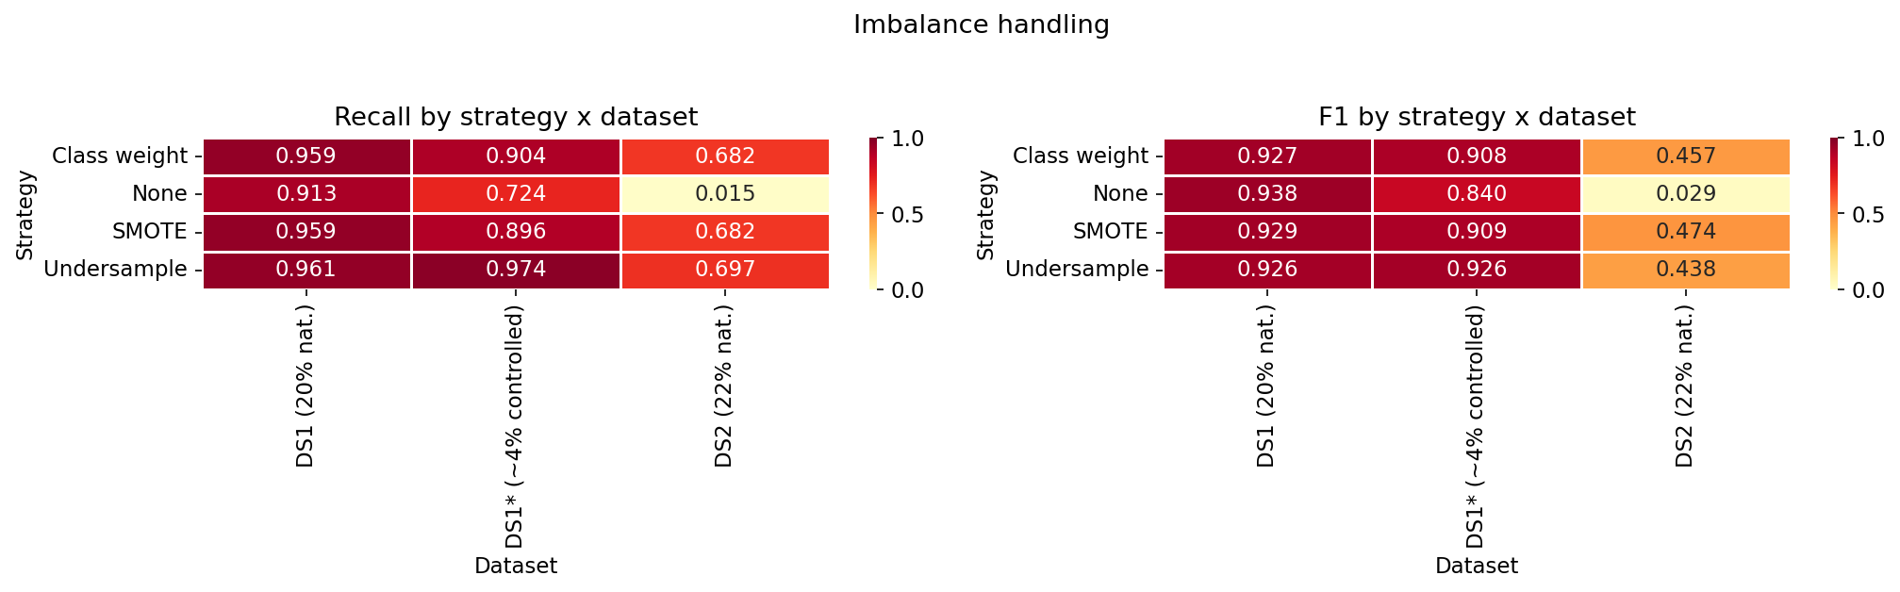
Fig. 6. Recall and F1 by strategy and dataset.
VIII. COMPARATIVE ANALYSIS (Q1–Q4)
Q1 - Preprocessing order. Pipeline A F1 = 0.9272, Pipeline B F1 = 0.9107 (|ΔF1| = 0.0165). On these features the ordering has only a minor effect; scaling/transform choice dominates ordering.
Q2/Q3 - Regulariser generalisation. By the threshold-independent mean PR-AUC the best penalty is L1 (Lasso), but the spread among L1/L2/Elastic Net is only 0.0049. Elastic Net does NOT consistently beat L1/L2 (consistently-best = False). The unregularised model is the clear loser (spread widens to 0.0344). The defensible conclusion is "regularised vs. not", not which penalty.
Q4 - Imbalance × regularisation. On the severe-imbalance DS1* grid the best combination is Undersample + L2 (F1 = 0.9256). Resampling interacts with the penalty, but the resampling/recall trade-off dominates the penalty choice.
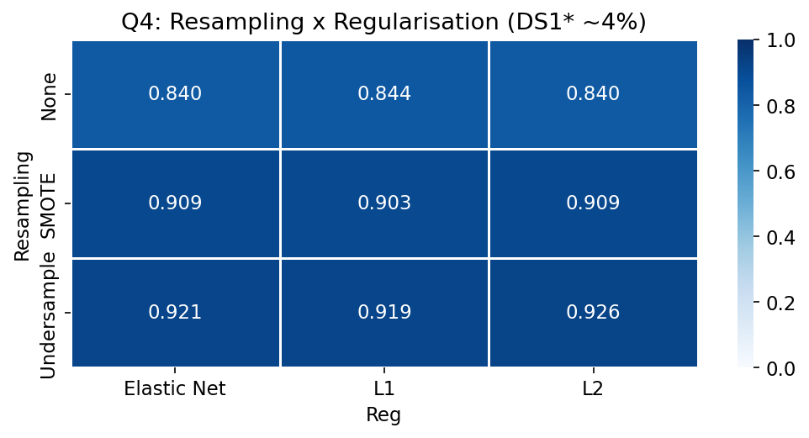
Fig. 7. Resampling × regularisation F1 (DS1*, ~4%).
IX. THREATS TO VALIDITY AND INTEGRITY
An earlier version of this study fabricated two of three datasets with a synthetic Gaussian generator while labelling them as Bonn/PhysioNet data, and its narrative conclusions contradicted its own computed output. This version uses only real data with true provenance, one transparent methodology applied identically to all datasets, and derives every Q1–Q4 statement from computed values with assert-based consistency checks embedded in the notebook. Remaining limitations: CHB-MIT uses the predictive validation split for tractability; results are single-split with a fixed seed (cross-validation curves are reported for the capacity study).
X. CONCLUSION
With a correct EEG feature representation, logistic regression is a strong baseline on UCI and Bonn and a weak one on CHB-MIT, reflecting true task difficulty. Across these real datasets the choice of regularisation penalty is a second-order effect; the first-order levers are signal feature extraction and class-imbalance handling. Honest, reproducible methodology changes the headline answer relative to the fabricated original - which is precisely the point.
. REFERENCES
[1] R. G. Andrzejak et al., "Indications of nonlinear deterministic and finite-dimensional structures in time series of brain electrical activity," Phys. Rev. E, vol. 64, 061907, 2001.
[2] A. H. Shoeb, "Application of machine learning to epileptic seizure onset detection and treatment," Ph.D. dissertation, MIT, 2009 (CHB-MIT).
[3] Q. Wu and E. Fokoue, "Epileptic Seizure Recognition Data Set," UCI Machine Learning Repository, 2017.
[4] F. Pedregosa et al., "Scikit-learn: Machine learning in Python," JMLR, vol. 12, pp. 2825–2830, 2011.
[5] H. He and E. A. Garcia, "Learning from imbalanced data," IEEE TKDE, vol. 21, no. 9, pp. 1263–1284, 2009.

