**Heaven’s Light is Our Guide**

**RAJSHAHI UNIVERSITY OF ENGINEERING &TECHNOLOGY, BANGALDESH**



Course No: CSE 3202

Course Title: Sessional based on CSE 3201

**Experiment No:** 2

**Experiment Name:** Basic Arithmatic operation, condition and loop in Linux Shell

|  |  |
| --- | --- |
| **Submitted to**  Mohiuddin Ahmed  Lecturer, CSE  RUET | **Submitted by**  Md Faisal Karim  Roll No: 1803092  Section: B  Department: CSE |

Date of Experiment**:** 17/10/22

Date of Submission**:** 31/10/22

|  |  |
| --- | --- |
| **Program No** | **Topic** |
| **1.** | Demonstrate Basic Arithmetic Operations |
| **2.** | Condition in Linux shell |
| **3.** | Loop in Linux shell |

**INDEX**

**Experiment Name:** Working with variable, input and output system and variable operations.

**Theory:**

As the name implies, Linux is based on the Unix operating system. The Linux system's terminal is where all of the Linux/Unix commands are entered and executed. This terminal is identical to the Windows command prompt. Linux/Unix commands are case-sensitive. All administrative tasks can be completed on the terminal. Depending on the type of result we want to achieve with our scripts, we may need to use arithmetic operators. They, like variables, are relatively simple to apply. We can perform arithmetic operations on numeric values in the bash script to obtain the desired result.

**Commands:**

**1. Open nano editor:**

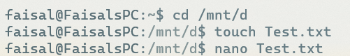

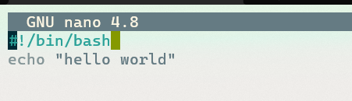

**2. Sum:**

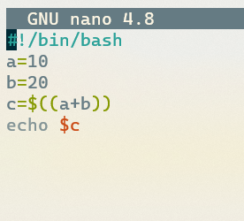



**3. Float number precision:**

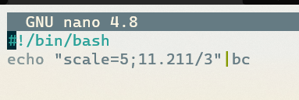



**4. Power:**

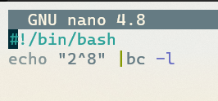



**5.Square Root:**

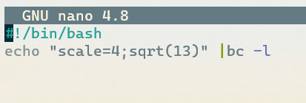



**6. User input:**

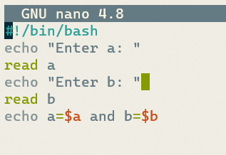

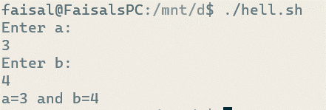

**Discussion:** We already demonstrate the simplest and most fundamental command of arithmetic operation discussed in theory section. Once a file has been opened and edited in vim editor, and insert by I and it can be saved by pressing ctrl + x and : wq command enter. The rest of the program just works and shows the output only with the given command.

**Experiment Name:** Working with if, else in Linux shell.

**Theory:**

The if... elif ...else...fi statement is a higher-level control statement that enables Shell to make the correct decision in the face of multiple conditions. Typically, this type of code is composed of a series of if statements, where each if is part of the else clause of the previous statement. Here, depending on the true condition, statement(s) are executed; if none of the conditions are true, an else block is executed.

**Commands:**

**1. Condition:**

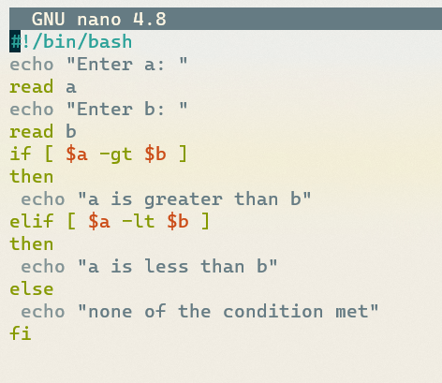

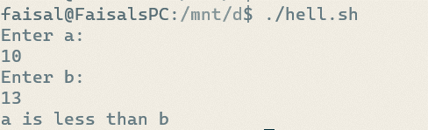

**2.String matching:**

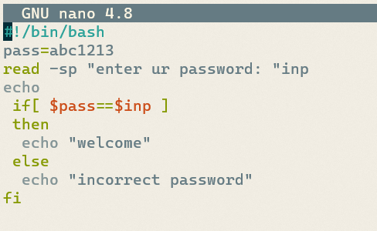

**Discussion:**

We already demonstrate the simplest and most fundamental command of if else condition discussed in theory section. Once a file has been opened and edited in vim editor, insert by I and it can be saved by pressing ctrl + x and :wq command enter to back into terminal . The rest of the program just works and shows the output only with the given command.

**Experiment Name:** Working with loop in Linux shell.

**Theory:**

A loop is a powerful programming construct that enables you to repeatedly execute a series of commands. Linux have following types of loops available to its shell programmers:

1. while loop

2. for loop

3. until loop

4. select loop

We'll use a variety of loops depending on the situation. For instance, the while loop executes the specified commands until the specified condition is true; the until loop executes the specified commands until the specified condition becomes true.

**Commands:**

**1.While loop:**

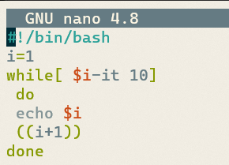

**2. For loop:**

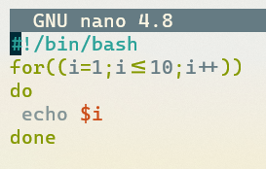

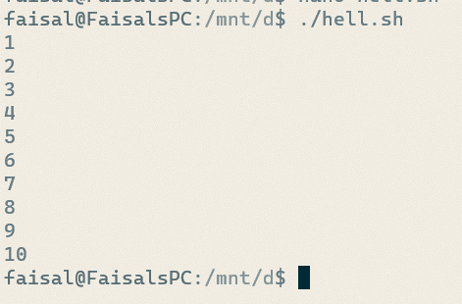

**Discussion:** We already demonstrate the simplest and most fundamental command of arithmetic operation discussed in theory section. Once a file has been opened and edited in vim editor, and insert by I and it can be saved by pressing ctrl + x and : wq command enter. The rest of the program just works and shows the output only with the given command.