**Heaven’s Light is Our Guide**

**RAJSHAHI UNIVERSITY OF ENGINEERING &TECHNOLOGY, BANGALDESH**



Course No: CSE 3202

Course Title: Sessional based on CSE 3201

**Experiment No:**

**Experiment Name:**

|  |  |
| --- | --- |
| **Submitted to**  Mohiuddin Ahmed  Lecturer, CSE  RUET | **Submitted by**  Md Faisal Karim  Roll No: 1803092  Section: B  Department: CSE |

Date of Experiment**:**

Date of Submission**:**

**Experiment Name:** Basic Linux Commands implementation.

**Theory:** Linux began in 1991as a personal project by Finnish student Linus Torvalds, to create a new free operating system kernel. The resulting linux kernel has been marked by constant growth throughout its history.

Linux is based on the Unix operating system. The Linux system's terminal is where all of the Linux/Unix commands are entered and executed. This terminal is identical to the Windows command prompt. Linux/Unix commands are case-sensitive. All administrative tasks can be completed on the terminal.

**Commands:** Linux based systems have over 100 unix commands. We have implemented some of the most common commands.

1. ls : Listing directory contents



1. cd : To change directory



1. mkdir<directoryname> : Creating directories

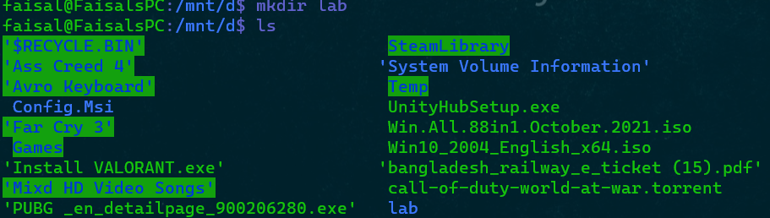

1. touch<filename.extension>: Creating files

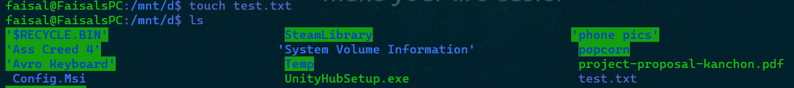

1. cat : Displaying file contents



1. pwd : To find out the path of the path of the current working directory



7. rm-r : Removes files and directories

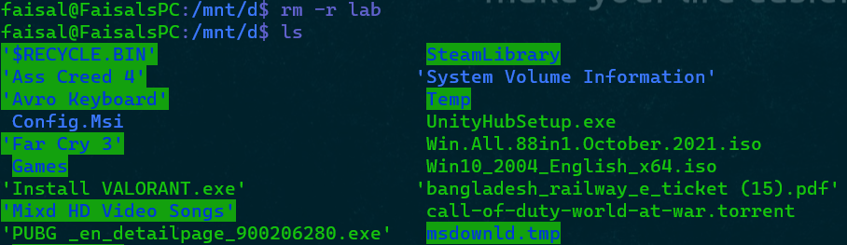

8. rm-i : Removes files only.

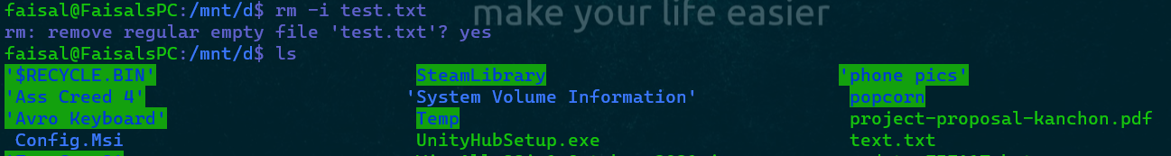

9. clear : To clear the terminal

10. cp : Copying files and directories

**Discussion:**

We already demonstrate the simplest and most fundamental command discussed in theory section. Once a file has been opened and edited in Nano Editor, it can be saved by pressing ctrl + x then => y then => enter. The rest of the program just works only with the given command.

**Experiment No:** 2

**Experiment Name:** Checking and changing permission of directory in Linux.

**Theory:**

Access to files in Linux is controlled by file permissions, attributes, and ownership. Only authorized users and processes can access files and directories as a result of this. Each file in Linux is assigned an owner and a group, as well as permission access rights for three different types of users:

a) The owner of the file b) Members of the group c) Everyone else is out

Each class has three types of permissions:

a) Read b) Write c) Execute

This concept enables us to specify which users are allowed to read, write, or execute a file. The file permission syntax used in Linux system can be obtain by ls -al command is given below-

**Command:**

We will use following commands to execute our desired file permission test:

1. ls -al : Listing directory contents with their permissions

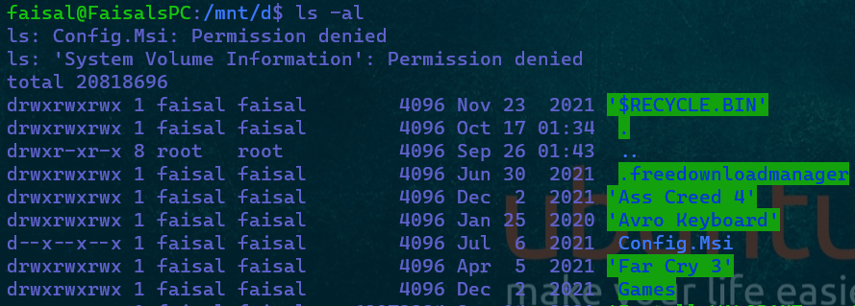

2. chmod: To change directory permissions

a. chmod -permission: to remove specified permission from all users. Here permission might be: read (r) or write(w) or execute(x)

b. chmod +permission : to add specified permission from to users. Here permission might be: read (r) or write(w) or execute(x)







**Discussion:** Changing permission may cause inconsistency, so that it is kind of tricky to change if we do not have admin permission. In case of wsl, we have to follow more steps than a dedicated ubuntu system.