SLIDER SECTION

SIDEBAR

        <li class="{{($route == 'manage.slider') ?  'active' : '' }}"><a href="{{route('manage.slider')}}"><i class="ti-more"></i>Manage Slider</a></li>

ROUTE

*//SLIDER SECTION*

Route::prefix('slider')->group(function(){

Route::get('manage',[SliderController::class,'IndexSlider'])->name('manage.slider');

});

Controller

public function IndexSlider()

    {

        $slider_data = Slider::latest()->get();

*return* view('admin.slider.Manage_Slider',compact('slider_data'));

    }

Maintain the view

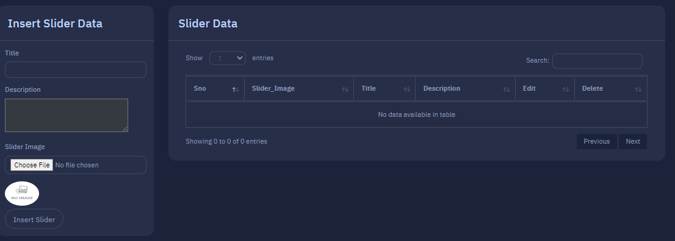

C:\xampp\htdocs\faisal\resources\views\admin\slider\Manage_Slider.blade.php

FORM ROUTE

                <form action="{{route('slider.store')}}" method="post" enctype="multipart/form-data" >

Route

Route::post('store',[SliderController::class,'SliderStore'])->name('slider.store');

Controller

 public function SliderStore(Request $request)

    {

        $image = $request->file('slider_img');

        $name_gen = hexdec(uniqid()).'.'.$image->getClientOriginalExtension();

        Image::make($image)->resize(370,370)->save('upload/slider/slider_img/'.$name_gen);

        $save_url = 'upload/slider/slider_img/'.$name_gen;

        Slider::insert([

                'title' => $request->title,

                'description' => $request->description,

                'status' => 1,

                'slider_img' => $save_url,

        ]);

        $notification = array(

            'message' => 'Slider Data with Image Inserted Successfully',

            'alert-type' => 'success'

        );

*return* redirect()->back()->with($notification);

    }

EDIT SLIDER VIEW

                              <a href="{{route('edit.slider',$data->id)}}" class="btn btn-sm  btn-outline bg-info" title="Edit Slider"><i class="bi bi-pencil-fill"></i></a>

Route

Route::get('edit/{id}',[SliderController::class,'SliderEdit'])->name('edit.slider');

Controller

  public function SliderEdit($id)

    {

        $data = slider::findOrFail($id);

*return* view('admin.slider.edit_slider_view',compact('data'));

    }

}

Maintain the view

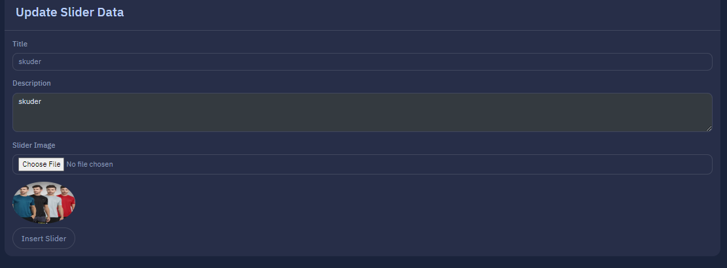

Link

C:\xampp\htdocs\faisal\resources\views\admin\slider\edit_slider_view.blade.php

UPDATE

Form Route

                <form action="{{route('slider.update',$data->id)}}" method="post" enctype="multipart/form-data" >

Route

Route::post('update/{id}',[SliderController::class,'SliderUpdate'])->name('slider.update');

Controller

 public function SliderUpdate(Request $request, $id)

    {

*//with image*

        $data = Slider::findOrFail($id);

*if* ($request->file('slider_img')) {

            unlink($data->slider_img);

            $image = $request->file('slider_img');

        $image = $request->file('slider_img');

        $name_gen = hexdec(uniqid()).'.'.$image->getClientOriginalExtension();

        Image::make($image)->resize(370,370)->save('upload/slider/slider_img/'.$name_gen);

        $save_url = 'upload/slider/slider_img/'.$name_gen;

        Slider::findOrFail($id)->update([

                'title' => $request->title,

                'description' => $request->description,

                'slider_img' => $save_url,

        ]);

        $notification = array(

            'message' => 'Slider Data with Image Update Successfully',

            'alert-type' => 'success'

        );

*return* redirect()->route('manage.slider')->with($notification);

        }

*// without image*

                Slider::findOrFail($id)->update([

                    'title' => $request->title,

                    'description' => $request->description,

            ]);

            $notification = array(

                'message' => 'Slider Data without Image Update Successfully',

                'alert-type' => 'success'

            );

*return* redirect()->route('manage.slider')->with($notification);

    }

DELETE SLIDER

                                <a id="delete" href="{{route('delete.slider',$data->id)}}" class="btn btn-sm  btn-outline bg-danger" title="Delete Slider"><i class="bi bi-trash"></i></a>

Route

Route::get('delete/{id}',[SliderController::class,'SliderDelete'])->name('delete.slider');

Controller

 public function SliderDelete(Request $request,$id)

    {

        $data = slider::findOrFail($id);

        $img = $data->slider_img;

        unlink($img);

        Slider::findOrFail($id)->delete();

        $notification = array(

            'message' => 'Slider Deleted Successfully',

            'alert-type' => 'success'

        );

*return* redirect()->route('manage.slider')->with($notification);

    }

SLIDER INACTIVE

                            <a href="{{ route('slider.inactive',$data->id) }}" class="btn btn-danger btn-sm" title="Inactive Now"><i class="fa fa-arrow-down"></i> </a>

ROUTE

Route::get('inactive/{id}',[SliderController::class,'SliderInactive'])->name('slider.inactive');

CONTROLLER

    public function SliderInactive($id)

    {

        Slider::findOrFail($id)->update(['status' => 0]);

        $notification = array(

            'message' => 'Slider Inactive Successfully',

            'alert-type' => 'warning'

        );

*return* redirect()->back()->with($notification);

    }

Product Active

                            <a href="{{ route('slider.active',$data->id) }}" class="btn btn-success btn-sm" title="Active Now"><i class="fa fa-arrow-up"></i> </a>

Route

Route::get('active/{id}',[SliderController::class,'SliderActive'])->name('slider.active');

Controller