SUB ->SUBCATEGORY

Model

Php artisan make:model SubSubCategory -m

Sidebar

        <li class="{{($route == 'all.sub_subcat') ?  'active' : '' }}"><a href="{{route('all.sub_subcat')}}"><i class="ti-more"></i>All Sub -> SubCategory</a></li>

Route

Route::get('/all/sub_subcat',[SubCategoryController::class,'AllSub_SubCat'])->name('all.sub_subcat');

Schema::create('sub_sub_categories', function (Blueprint $table) {

            $table->id();

            $table->integer('category_id');

            $table->integer('sub_subcategory_id');

            $table->string('sub_subcategory_name_en');

            $table->string('sub_subcategory_name_hindi');

            $table->string('sub_subcategory_slug_en');

            $table->string('sub_subcategory_slug_hindi');

            $table->timestamps();

        });

class SubSubCategory extends Model

{

    use HasFactory;

    protected $guarded = [];

    public function category()

    {

*return* $this->belongsTo(Category::class,'category_id','id');

    }

    public function sub_subcategory()

    {

*return* $this->belongsTo(SubCategory::class,'sub_subcategory_id','id');

    }

Controller

*//  All Sub -> SubCategory Portion Here*

      public function AllSub_SubCat()

      {

          $cat = Category::orderby('category_name_en','ASC')->get();

          $sub_subcat = SubSubCategory::latest()->get();

*return* view('admin.subcat.allsub_subcat',compact('sub_subcat','cat'));

      }

Maintain the view

C:\xampp\htdocs\faisal\resources\views\admin\subcat\allsub_subcat.blade.php

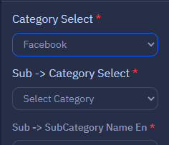

Here we will use javascript because when we select the any category below it automatically select the subcategory of the related above selected category

So for that we need some javascript cdn

<script src="https://ajax.googleapis.com/ajax/libs/jquery/3.6.3/jquery.min.js"></script>

These two scripts are important

*{{-- jquery cdn for selecting automatically subcategory  --}}*

<script src="https://ajax.googleapis.com/ajax/libs/jquery/3.6.3/jquery.min.js"></script>

<script type="text/javascript">

  $(document).ready(function() {

    $('select[name="category_id"]').on('change', function(){

        var category_id = $(this).val();

*if*(category_id) {

            $.ajax({

                url: "{{  url('/category/subcategory/ajax') }}/"+category_id,

                type:"GET",

                dataType:"json",

                success:function(*data*) {

                   var d =$('select[name="subcategory_id"]').empty();

                      $.each(data, function(*key*, *value*){

                          $('select[name="subcategory_id"]').append('<option value="'+ value.id +'">' + value.subcat_name_en + '</option>');

                      });

                },

            });

        } *else* {

            alert('danger');

        }

    });

});

</script>

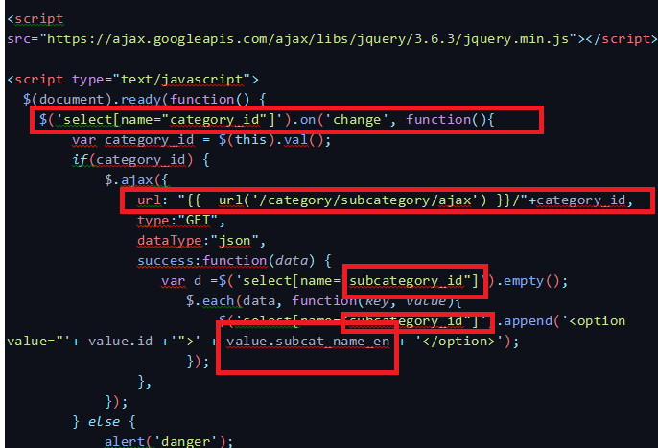

Create the route for fetching the subcat

Route::get('/category/subcategory/ajax/{category_id}', [SubSubCategoryController::class, 'GetSubCategory']);

Controller

 public function GetSubCategory($category_id){

        $subcat = SubCategory::where('category_id',$category_id)->orderBy('subcat_name_en','ASC')->get();

*return* json_encode($subcat);

    }

}

Form route

                <form action="{{route('store.sub_subcat')}}" method="post"  >

Route

Route::post('/store/sub/subcategory',[SubSubCategoryController::class,'StoreSubSubCategory'])->name('store.sub_subcat');

Controller

*//validation*

         $request->validate(

            [

                'category_id' => 'required',

                'subcategory_id' => 'required',

                'sub_subcategory_name_en' => 'required',

                'sub_subcategory_name_hindi' => 'required',

            ],

            [

                'category_id.required' => 'Please select any Option',

                'subcategory_id.required' => 'Please select any Option',

                'sub_subcategory_name_en.required' => 'Sub-> subcategory English name is required',

                'sub_subcategory_name_hindi.required' => 'Sub-> subcategory Hindi name is required',

            ]

        );

        SubSubCategory::insert([

            'category_id' => $request->category_id,

            'subcategory_id' => $request->subcategory_id,

            'sub_subcategory_name_en' => $request->sub_subcategory_name_en,

            'sub_subcategory_name_hindi' => $request->sub_subcategory_name_hindi,

            'sub_subcategory_slug_en' => strtolower(str_replace('','-',$request->sub_subcategory_name_en)),

            'sub_subcategory_slug_hindi' => strtolower(str_replace('','-',$request->sub_subcategory_name_hindi)),

            'created_at' => Carbon::now(),

        ]);

        $notification = array(

        'message' => 'Sub -> SubCategory Data Inserted Successfully',

        'alert-type' => 'success'

    );

*return* redirect()->back()->with($notification);

Edit

Edit row

                              <a href="{{route('edit.sub_subcat',$data->id)}}" class="btn btn-sm  btn-outline bg-info"><i class="bi bi-pencil-fill"></i></a>

Route

Route::get('/edit/sub/subcategory/{id}',[SubSubCategoryController::class,'EditSubSubCategory'])->name('sub_subcat');

Controller

 public function EditSubSubCategory($id)

    {

        $cat = Category::orderby('category_name_en','ASC')->get();

        $subcat = SubCategory::orderby('subcat_name_en','ASC')->get();

        $sub_subcat = SubSubCategory::findOrFail($id);

*return* view('admin.subcat.edit_allsub_subcat',compact('sub_subcat','subcat','cat'));

    }

Maintain the view

C:\xampp\htdocs\faisal\resources\views\admin\subcat\edit_allsub_subcat.blade.php

UPDATE PART

                <form action="{{route('update.sub_subcat')}}" method="post"  >

ROUTE

Route::post('/update/sub/subcategory/{id}',[SubSubCategoryController::class,'UpdateSubSubCategory'])->name('update.sub_subcat');

Controller

public function UpdateSubSubCategory(Request $request,$id)

    {

        SubSubCategory::findOrFail($id)->update([

            'category_id' => $request->category_id,

            'subcategory_id' => $request->subcategory_id,

            'sub_subcategory_name_en' => $request->sub_subcategory_name_en,

            'sub_subcategory_name_hindi' => $request->sub_subcategory_name_hindi,

            'sub_subcategory_slug_en' => strtolower(str_replace('','-',$request->sub_subcategory_name_en)),

            'sub_subcategory_slug_hindi' => strtolower(str_replace('','-',$request->sub_subcategory_name_hindi)),

            'created_at' => Carbon::now(),

        ]);

        $notification = array(

        'message' => 'Sub -> SubCategory Data Updated Successfully',

        'alert-type' => 'success'

    );

*return* redirect()->route('all.sub_subcat')->with($notification);

    }

DELETE

                                <a id="delete" href="{{route('delete.sub_subcat',$data->id)}}" class="btn btn-sm  btn-outline bg-danger"><i class="bi bi-trash"></i></a>

Route

Route::get('/delete/sub/subcategory/{id}',[SubSubCategoryController::class,'DeleteSubSubCategory'])->name('delete.sub_subcat');

Controller

   public function DeleteSubSubCategory($id)

    {

        SubSubCategory::findOrFail($id)->delete();

         $notification = array(

            'message' => 'Sub -> SubCategory Deleted Successfully',

            'alert-type' => 'success'

        );

*return* redirect()->back()->with($notification);

    }

////////////

<script type="text/javascript">

  $(document).ready(function() {

    $('select[name="category_id"]').on('change', function(){

        var category_id = $(this).val();

*if*(category_id) {

            $.ajax({

                url: "{{  url('/category/subcategory/ajax') }}/"+category_id,

                type:"GET",

                dataType:"json",

                success:function(*data*) {

                    $('select[name="subsubcategory_id"]').html('');

                   var d =$('select[name="subcategory_id"]').empty();

                      $.each(data, function(*key*, *value*){

                          $('select[name="subcategory_id"]').append('<option value="'+ value.id +'">' + value.subcat_name_en + '</option>');

                      });

                },

            });

        } *else* {

            alert('danger');

        }

    });

    $('select[name="subcategory_id"]').on('change', function(){

            var subcategory_id = $(this).val();

*if*(subcategory_id) {

                $.ajax({

                    url: "{{  url('/category/sub_subcategory/ajax') }}/"+subcategory_id,

                    type:"GET",

                    dataType:"json",

                    success:function(*data*) {

                       var d =$('select[name="subsubcategory_id"]').empty();

                          $.each(data, function(*key*, *value*){

                              $('select[name="subsubcategory_id"]').append('<option value="'+ value.id +'">' + value.sub_subcategory_name_en + '</option>');

                          });

                    },

                });

            } *else* {

                alert('danger');

            }

        });

});

</script>