composer require intervention/image

**Integration in Laravel**

After you have installed Intervention Image, open your Laravel config file config/app.php and add the following lines.

In the $providers array add the service providers for this package.

Intervention\Image\ImageServiceProvider::class

Add the facade of this package to the $aliases array.

'Image' => Intervention\Image\Facades\Image::class

**PUBLISH**

php artisan vendor:publish --provider="Intervention\Image\ImageServiceProviderLaravelRecent"

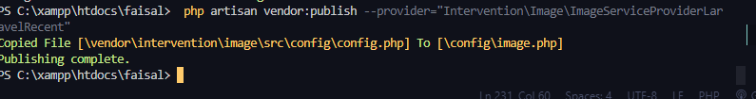

[**https://laracasts.com/index.php/index.php/discuss/channels/general-discussion/gd-library-extension-not-available-with-this-php-installation**](https://laracasts.com/index.php/index.php/discuss/channels/general-discussion/gd-library-extension-not-available-with-this-php-installation)**?**

[**https://www.geeksforgeeks.org/how-to-install-php-gd-in-windows/**](https://www.geeksforgeeks.org/how-to-install-php-gd-in-windows/)

# How to Install PHP GD in Windows?

* **Difficulty Level :** [Basic](https://www.geeksforgeeks.org/basic/)
* **Last Updated :** 30 Jan, 2022

• Read

• Discuss

• Courses

• Practice

• Video

GD is an open-source code library that is required to create and manipulate images in PHP. It is used for creating PNG, JPEG, and GIF images. It is commonly used to create charts, graphics, thumbnails, etc, and website development is the most common application of GD. It was originally developed by Thomas Boutell and is now maintained by Pierre-A. Joye under the umbrella of PHP.net. The GD library support should be enabled for working with image functions in PHP. In this article we will learn how to install PHP GD in windows:

### Installing PHP GD in Windows

To install the PHP GD follow the following steps:

**Step 1:**Install [XAMPP](https://www.geeksforgeeks.org/how-to-install-xampp-on-windows/) in your windows system.

**Step 2:**Verify if GD is already installed or not. So to verify GD we need to follow the following steps:

* Open XAMPP and click on the start button in front of Apache and MySQL to start php server, and go to the admin.

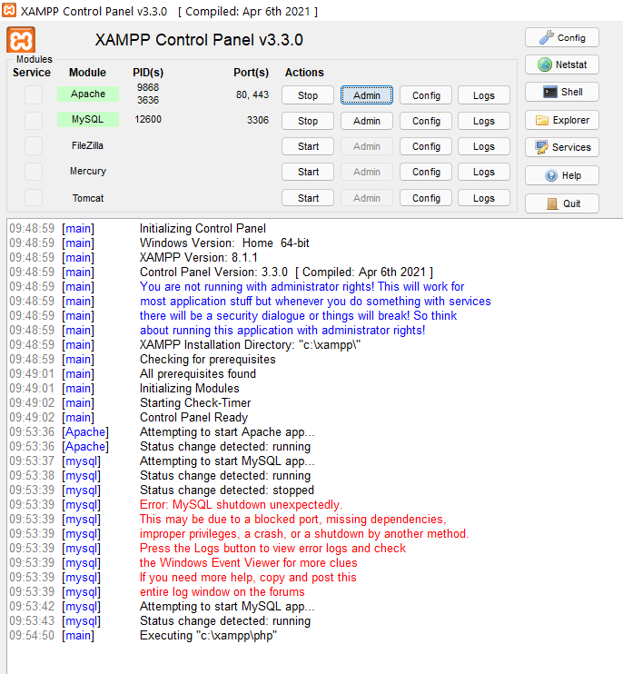

* A web page will open. Go to the ‘PHPInfo’ option on the top of the page.

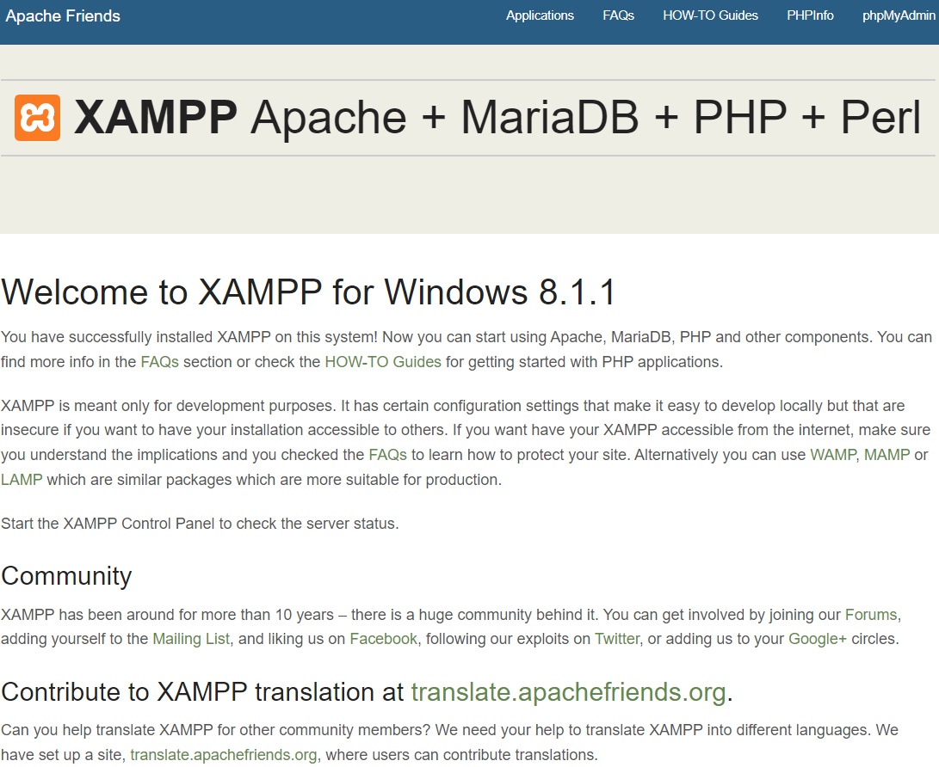

* A PHPInfo dashboard will open up.

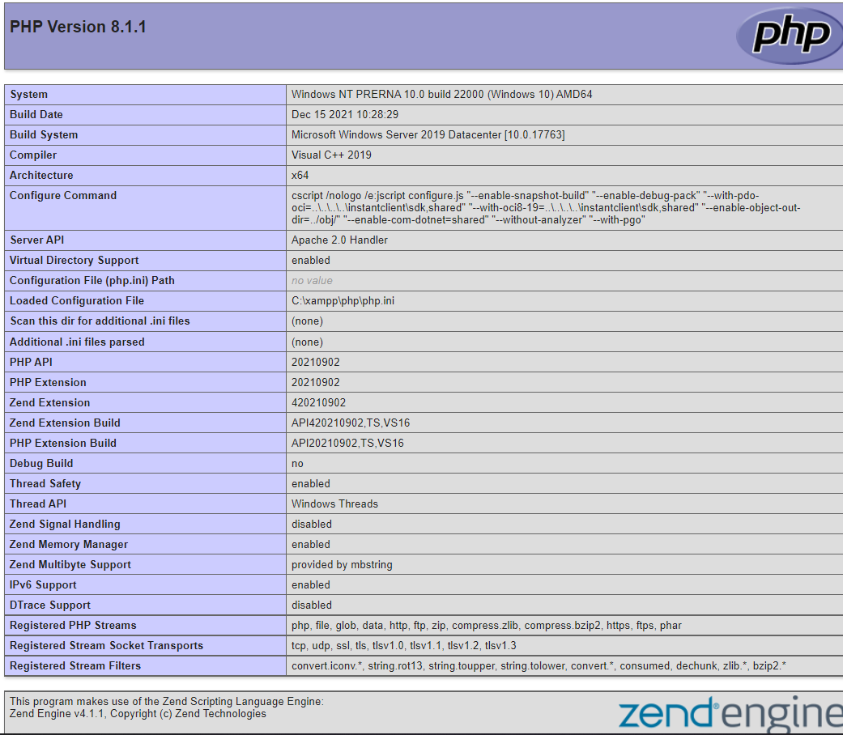

[](https://practice.geeksforgeeks.org/courses/Data-Structures-With-Python?utm_source=geeksforgeeks&utm_medium=inarticle_dsapython_picked&utm_campaign=inbound_promotions)

* Scroll down the page and search for ‘gd’. If present, GD is already installed.

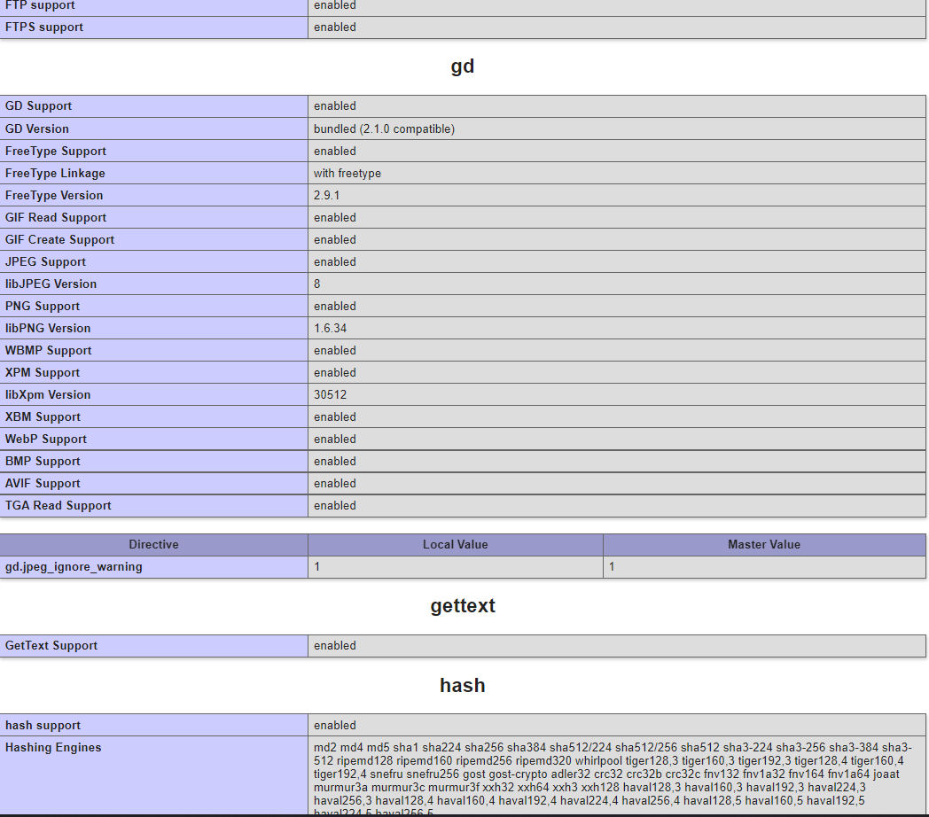

If ‘gd’ is not present on the phpinfo page, you can follow the next to install GD.

**Step 3:** Locate and open php.ini in your editor.

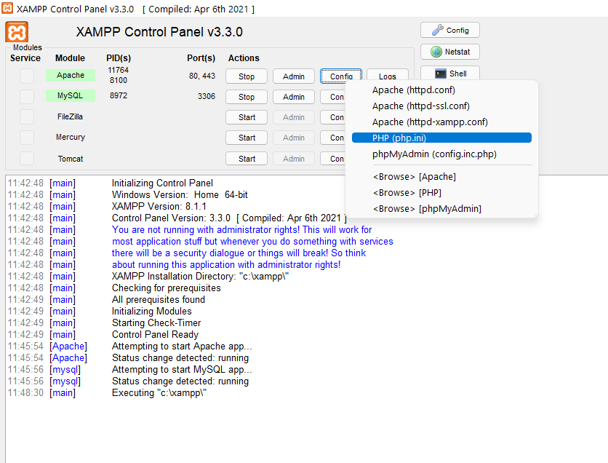

**Step 4:**Find **;extension=gd.**

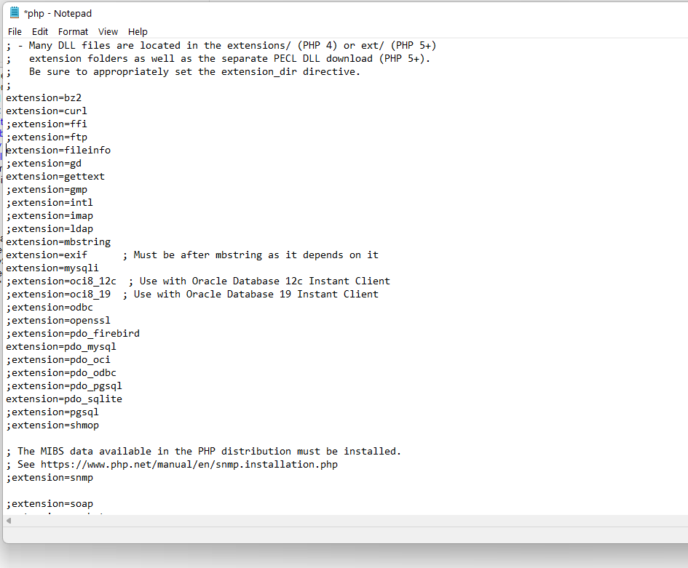

**Step 5:**Remove semicolon from **;extension=gd** and save the file.

**Step 6**: Go to php folder. It is usually present in **C:\xampp**.



**Step 7:**Look for **php_gd.dll** in the ext folder.



**Step 8:** Copy php_gd.dll and paste it into the following folder.

*C:\Windows\System32*

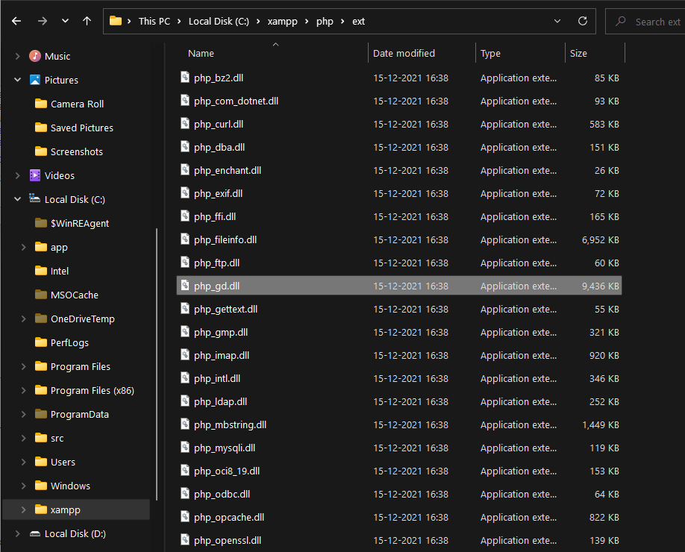

**Step 9:**Restart the XAMPP server. Now use the phpinfo() method as mentioned in step 2 to check whether the GD library is installed in the PHP server. It will show information about the PHP’s configuration.

