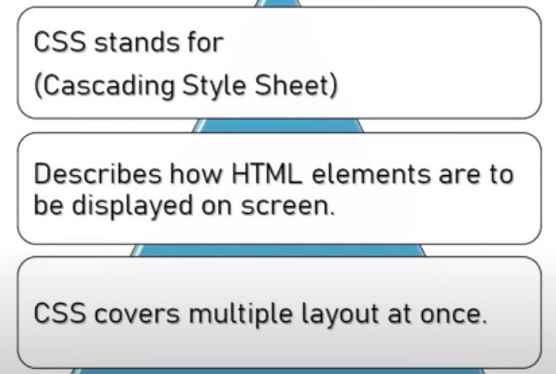

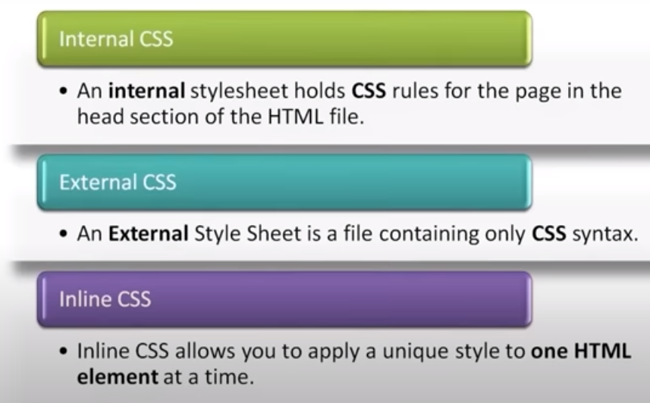

**SELECTORS**

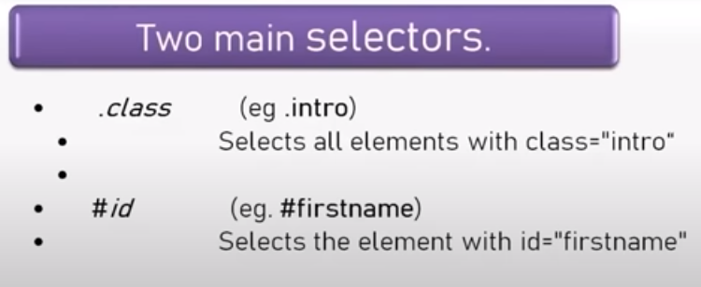

Example

.class_name{

}

#id_name{

}

Class can be used multiple times and id will be used once