MYNTRA
E-COMMERCE PRODUCT DATA ANALYSIS
Data Analyst Report

Dataset: Myntra | 81,366 cleaned product listings | 2,371 brands | 305 categories

Prepared by: ANASH MOHMAD

1. Business Problem
Myntra is one of India's largest fashion and lifestyle e-commerce platforms, listing products across hundreds of categories and thousands of brands. With such a large and fragmented catalog, business stakeholders need a clear, data-driven understanding of pricing, discounting, brand performance, and customer engagement patterns in order to make informed push and revenue decisions.
The raw scraped catalog data (168,029 records) contained duplicate listings, unrated/placeholder products, and inconsistent brand and category labels — making it unsuitable for direct analysis. The business problem this project addresses is twofold:
- Clean and structure the raw Myntra catalog data into a reliable, analysis-ready dataset.
- Use that cleaned dataset to answer key business questions: Which brands and categories drive the most revenue? How are products priced and discounted? Is there a relationship between price, discount, rating, and customer engagement? What actionable steps can improve catalog and pricing strategy?
The end goal is to provide the merchandising, pricing, and category management teams with clear insights and recommendations to optimize brand partnerships, discount strategy, and inventory focus.

2. Exploratory Data Analysis Insights
Exploratory Data Analysis (EDA) was performed on the cleaned dataset (Sheet V4, 81,366 rows) to understand the distribution, relationships, and quality of the data before drawing business conclusions.

a. Summary Statistics
The table below summarizes the central tendency and spread of all numeric columns in the cleaned dataset.
Column | count | mean | std | min | 25% | 50% | 75% | max
rating | 81,366 | 4.17 | 0.45 | 1.00 | 4.00 | 4.20 | 4.40 | 5.00
rating_count | 81,366 | 222.55 | 1087.94 | 1 | 10 | 27 | 104 | 55,900
marked_price (₹) | 81,366 | 2,319.87 | 1,975.43 | 50 | 1,199 | 1,899 | 2,799 | 44,900
discounted_price (₹) | 81,366 | 1,232.14 | 1,336.63 | 49 | 599 | 888.50 | 1,424 | 44,900
Discount % | 81,366 | 43.60 | 23.05 | 0.00 | 30.00 | 50.02 | 60.05 | 90.02
Revenue (₹) | 81,366 | 1,85,802.75 | 9,87,501.70 | 348 | 10,183 | 27,944 | 1,00,480.25 | 6,44,78,500

Categorical fields: product_name (30,742 unique values), brand_name (2,371 unique brands), Product_category (305 unique categories) — all fields are fully populated with zero missing values in the cleaned dataset.

b. Data Filtering
The dataset went through a structured, multi-stage filtering and cleaning pipeline before analysis:
- Raw Data (V1) — 168,029 records scraped directly from the platform, including 21,419 exact duplicate rows and 3 missing product names.
- Deduplication (V2) — Duplicate rows were removed and unrated (0.0 rating) placeholder listings were filtered out, reducing the dataset to 81,366 unique, genuinely-rated products. product_category and a standardized brand_tag were added at this stage.
- Cleaning & Enrichment (V4) — Columns were renamed for consistency (Product_category, Product_id), and two calculated fields were added: Discount% = (marked_price − discounted_price) / marked_price, and Revenue = discounted_price × rating_count (used as a proxy for sales volume/customer spend).
- Outlier handling — The most extreme raw marked price (₹1,13,999) was excluded during cleaning; the cleaned dataset caps at a more representative ₹44,900.
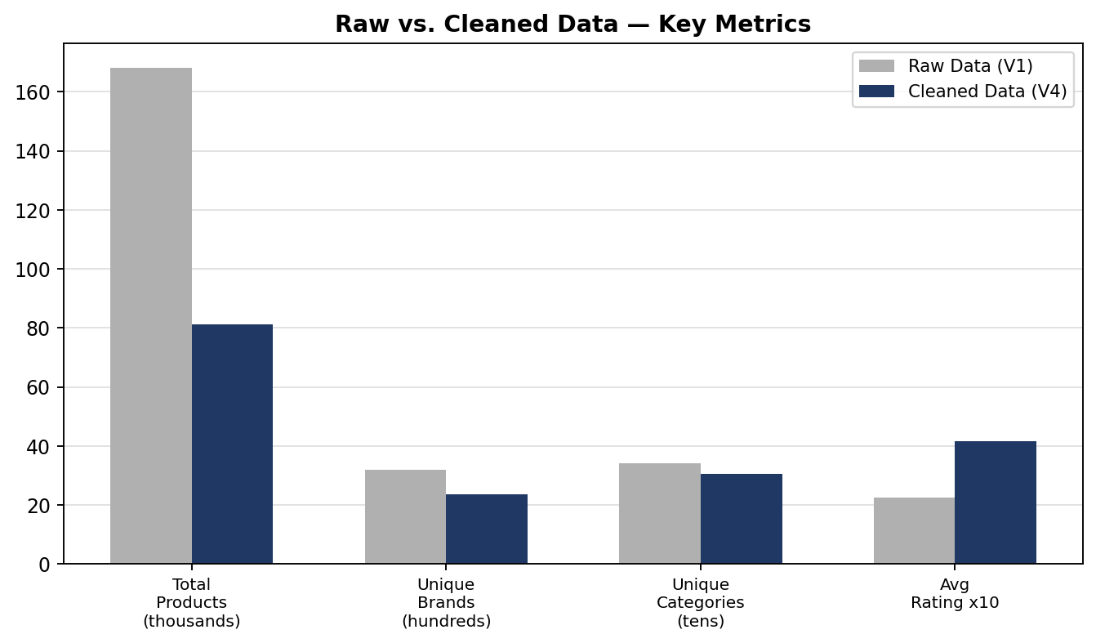
Figure 1: Raw vs. Cleaned dataset — key metrics before and after filtering.
This filtering step was essential: it removed disruption (duplicates, unrated products, and one extreme outlier) while preserving the full diversity of brands (2,371) and categories (305), ensuring subsequent analysis reflects real, rated customer-facing listings.

c. Correlation Insights (Correlation Heatmap)
A correlation heatmap was generated across all key numeric fields to identify linear relationships between pricing, ratings, discounting, and revenue.
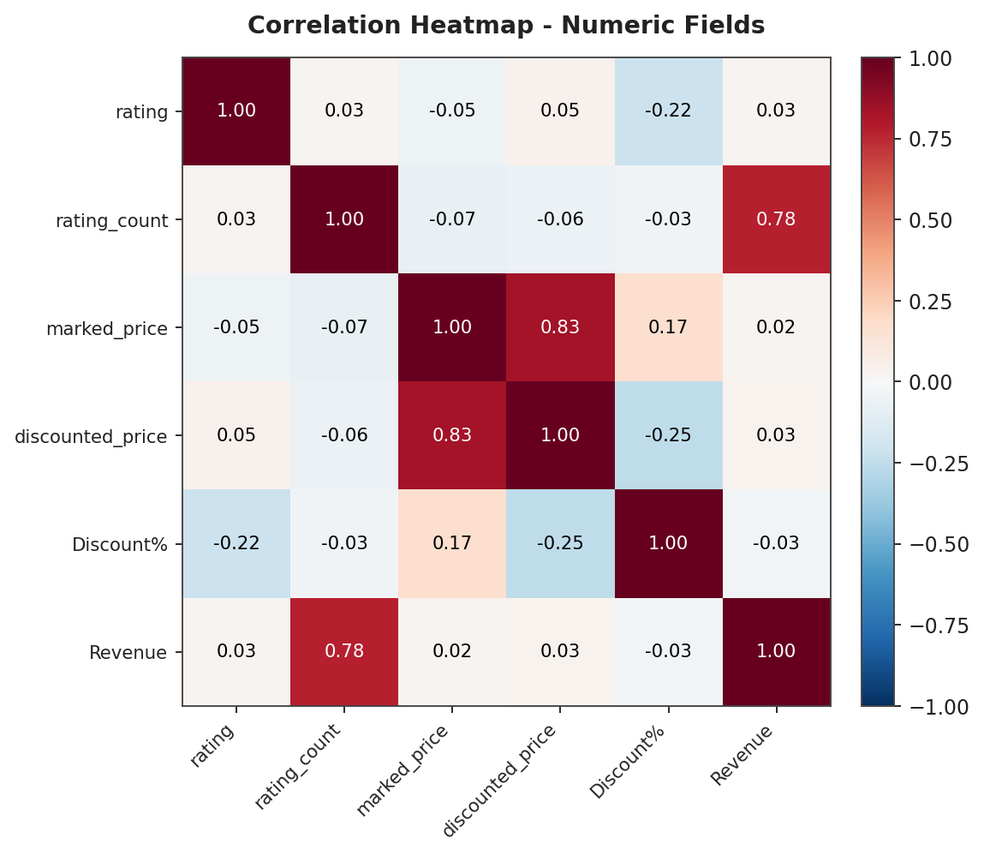
Figure 2: Correlation heatmap of numeric fields in the cleaned dataset.
- Revenue and rating_count are strongly correlated (0.78) — expected, since Revenue is directly derived from rating_count. This confirms rating_count is a reliable proxy for a product's popularity/sales volume.
- marked_price and discounted_price are highly correlated (0.83) — discounts are broadly proportional to list price rather than randomly assigned.
- Discount% has a mild negative correlation with rating (−0.22) — products with steeper discounts tend to have slightly lower ratings, suggesting heavy markdowns are sometimes used to move weaker-performing stock.
- Discount% correlates negatively with discounted_price (−0.25) — cheaper items tend to carry proportionally larger discounts.
- rating and rating_count show almost no correlation (0.03) — a product's star rating is independent of how many people have rated it; popularity and quality perception are not linked in this dataset.

d. Research Questions & Key Findings
The following research questions were investigated, each supported by a visual, to surface actionable business insight.
Q1: Which product categories dominate the catalog?
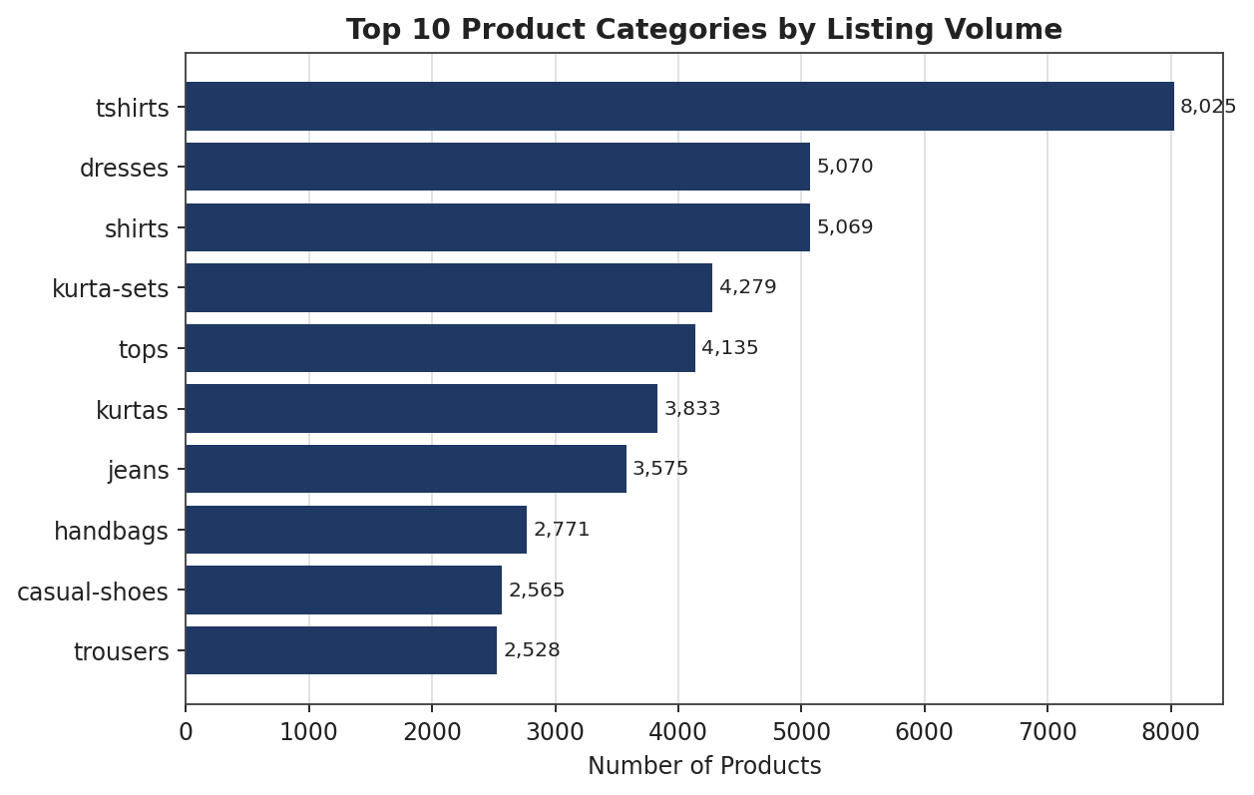
Figure 3: Top 10 categories by number of listings.
Finding: Apparel dominates the catalog — tshirts (8,025 listings), dresses (5,070), shirts (5,069), kurta-sets (4,279), and tops (4,135) are the five largest categories, together accounting for roughly a third of all products. Myntra's catalog is fundamentally apparel-led rather than accessory- or lifestyle-led.
Q2: Which brands generate the most revenue?
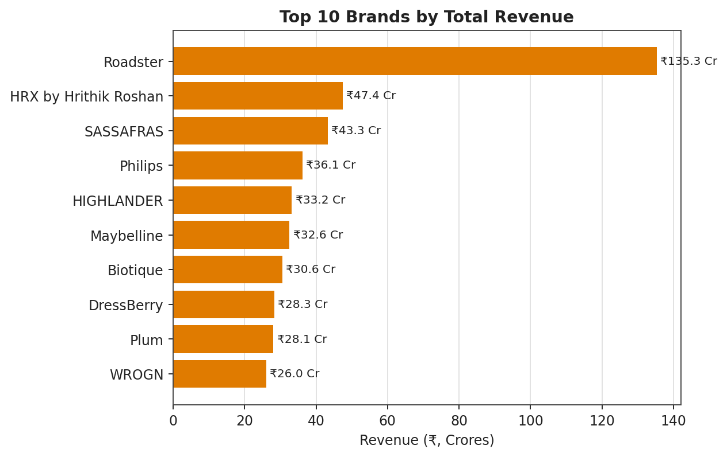
Figure 4: Top 10 brands by total revenue (₹ crores).
Finding: Roadster is the clear market leader, generating ₹135.3 crore in revenue — nearly 3x more than the second-placed brand, HRX by Hrithik Roshan (₹47.4 crore). SASSAFRAS, Philips, and HIGHLANDER round out the top five. Revenue is highly concentrated in a small set of house/generalist brands.
Q3: How are discounts distributed across the catalog?
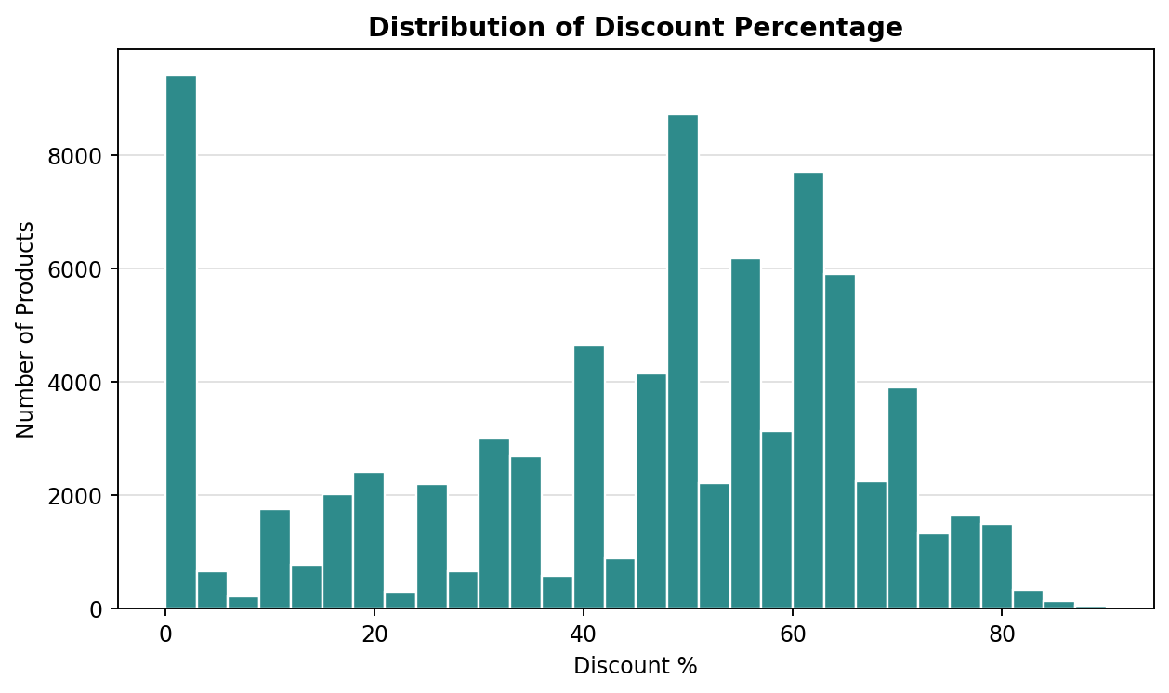
Figure 5: Distribution of discount percentage across all products.
Finding: The bulk of products sit between 40–80% discount, with average discount at 43.6%. Discounts cluster at fixed tiers (e.g., 50%, 55%, 60%, 65%) rather than varying continuously, indicating discount slabs are applied systematically rather than item-by-item. Notably, 9,212 products (~11.3%) carry zero discount, sold at full marked price.
Q4: How are customer ratings distributed, and does price influence rating?
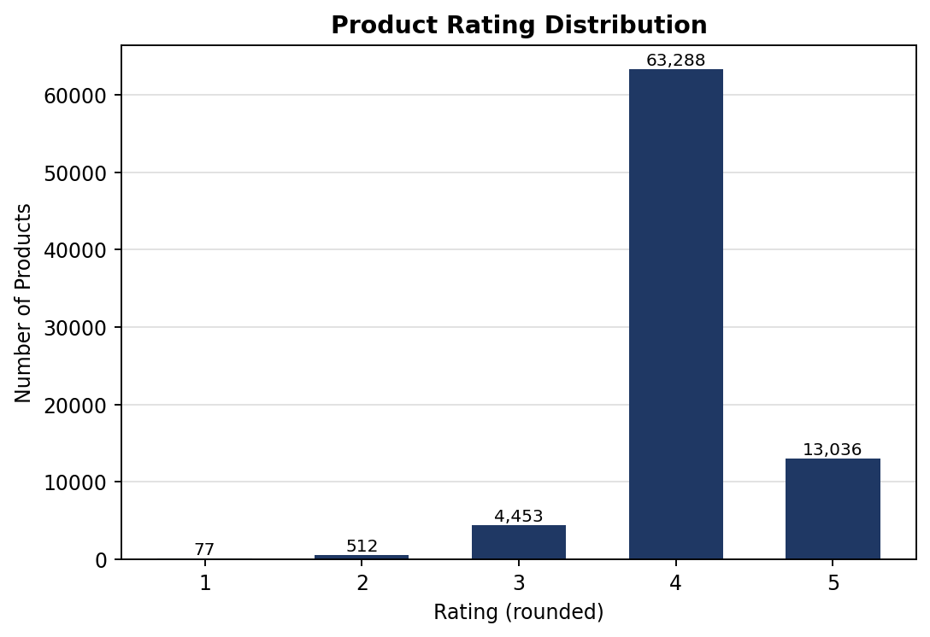
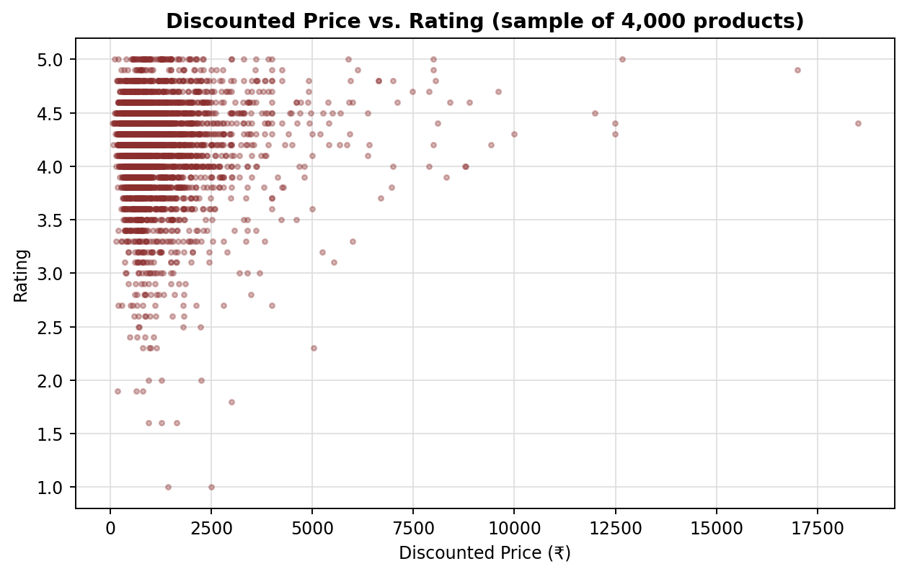
Figure 6 & 7: Rating distribution (left) and Discounted Price vs. Rating scatter (right).
Finding: The overwhelming majority of rated products (78%) fall into the 4-star band, with very few 1- or 2-star products (589 combined) — customers rating on Myntra skew positive. The price-vs-rating scatter shows no strong pattern: products across all price bands, from budget to premium, achieve similar rating levels, confirming rating is not primarily price-driven — it more likely reflects product quality and fit consistency.
Q5: Is revenue concentrated among a small number of products (Pareto effect)?
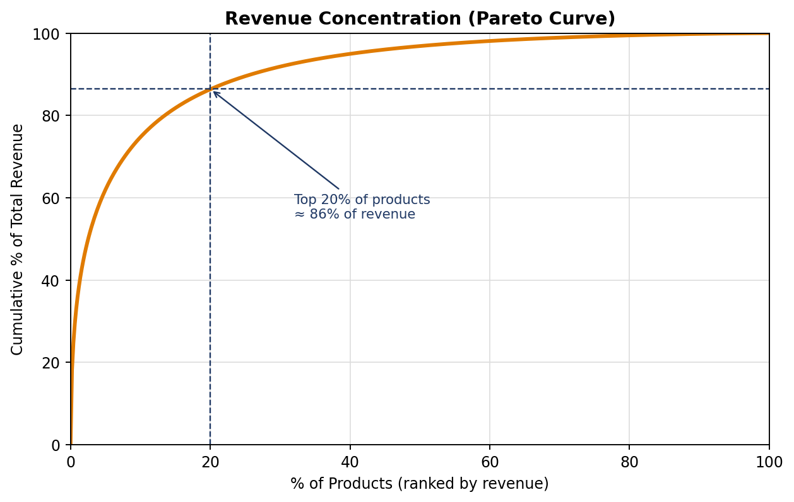
Figure 8: Cumulative revenue concentration (Pareto curve).
Finding: Revenue is extremely concentrated — the top 1% of products (813 SKUs) generate 35.9% of total revenue, the top 5% generate 62%, and the top 20% generate 86.4%. A small set of high-performing SKUs carries the majority of the platform's revenue, a classic Pareto (80/20) pattern that has direct implications for inventory and marketing prioritization.
Q6: Which categories are discounted most aggressively?
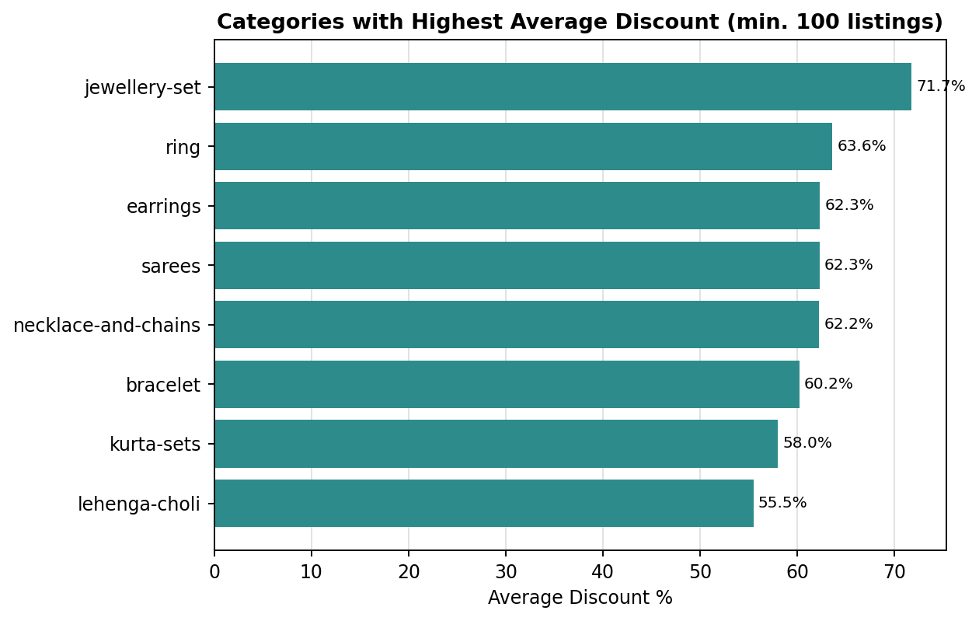
Figure 9: Categories with the highest average discount (minimum 100 listings).
Finding: Jewelry and ethnic-wear categories carry the steepest average discounts — jewellery-set (71.7%), ring (63.6%), earrings (62.3%), sarees (62.3%), and necklace-and-chains (62.2%). This suggests these categories are priced with a larger markup buffer before discount, or face stronger competitive/seasonal markdown pressure than everyday apparel.

e. Final Recommendation
Based on the EDA findings above, the following actions are recommended:
- Double down on top-performing brands: Prioritize inventory depth, promotional placement, and negotiation leverage with Roadster, HRX by Hrithik Roshan, SASSAFRAS, Philips, and HIGHLANDER, which together account for a disproportionate share of revenue.
- Protect and expand the core apparel categories (tshirts, dresses, shirts, kurta-sets, tops) that drive the bulk of catalog volume, while auditing whether long-tail, low-volume categories are worth the listing overhead.
- Standardize discount governance: Since discounts already cluster around fixed slabs, formalize a discount-tier policy tied to category and price band rather than ad-hoc discounting, and investigate the mild negative link between heavy discounting and lower ratings.
- Focus growth efforts on the Pareto-critical top 20% of SKUs: Since this segment drives ~86% of revenue, ensure these products are never out of stock, are prioritized in search/recommendation ranking, and are monitored closely for rating or supply issues.
- Review jewelry and ethnic-wear pricing strategy: The unusually high average discounts in jewellery-set, rings, earrings, and sarees warrant a pricing audit to confirm markups are sustainable and not simply inflating the 'discount' perception.
- Leverage rating data for merchandising, not just pricing: Since rating is largely independent of price, promote well-rated budget items alongside premium ones rather than assuming higher price signals higher quality to customers.
Together, these steps translate the cleaned Myntra catalog data into a focused strategy: protect the revenue-critical core, formalize discount policy, and use data-backed rating and category insight to guide future assortment and pricing decisions.

