|  |  |
| --- | --- |
| **Chapter 3:** Testing and Evaluation | **Assignment 3**  Implement your queries using SQL under the MYSQL environment. **Provide the screen shot.**  **SINGLE TABLE**  Write **ONE (1)** select statement involving below keywords.   1. where 2. update 3. delete 4. sum 5. count 6. avg 7. max 8. min 9. not 10. between 11. group by 12. having 13. distinct 14. order by 15. like 16. in 17. and 18. or 19. alias 20. any **ONE (1)** SQL function (e.g: ISNULL, etc)   **MULTIPLE TABLES**  Write **ONE (1)** select statement involving the following below.   * **JOIN**    + two tables.   + three or more tables. * **Subquery**   + IN   + ANY   + ALL |

select*from Manager;

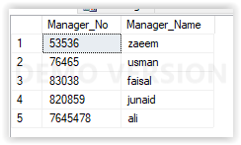

**WHERE Clause:**

select*from Manager where Manager_No=53536;

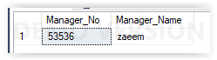

select*from Manager where Manager_No=820859;

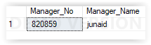

**update statement:**

update Manager set Manager_Name='zaeem-uz-zafar' where Manager_No=53536;

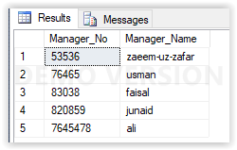

**delete statement:**

delete from Manager where Manager_No=7645478;

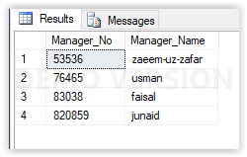

**Count:**

select COUNT(*) "manager table"from Manager;

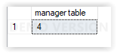

**Not statement:**

select*from Manager where Manager_No!=53536;



**Between statement:**

select*from Manager where Manager_No between 76465 and 83038;

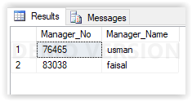

**Order by statement:**

select*from Manager order by Manager_No;

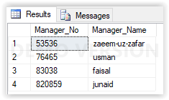

Distinct

select distinct Manager_Name from Manager;

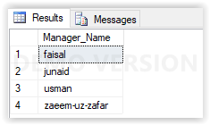

Like:

select*from Manager where Manager_Name like('f%');

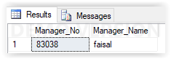

select*from Manager where Manager_Name like('%r');

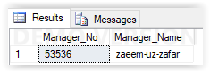

select*from Manager where Manager_Name like('%uz%');



select*from Manager where Manager_Name like('_aisal');



select*from Manager where Manager_Name like('______');

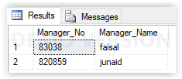

select*from Manager where Manager_Name like('junai_');

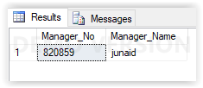

In Statement :

select*from Manager where Manager_Name in('faisal' , 'junaid','usman');

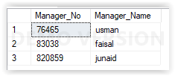

**Or** condition:

select*from Manager where Manager_No=76465 or Manager_Name='usman';

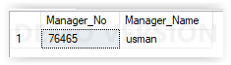

**And** condition:

select*from Manager where Manager_No=820859 and Manager_Name='junaid';

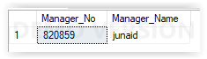

Alias

select Manager_name as "managerName1" from Manager

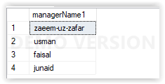

select*from Branch;

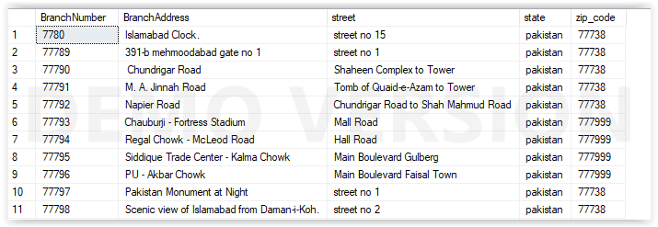

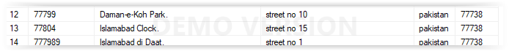

**WHERE Clause:**

select*from Branch where BranchNumber=7780;

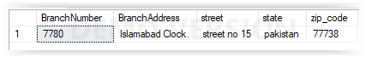

select*from Branch where BranchNumber=77789;

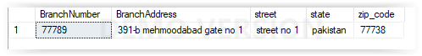

select*from Branch where BranchNumber=77790;

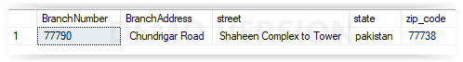

Update Statement:

update Branch set BranchAddress='karachi clock' where BranchNumber=7780;

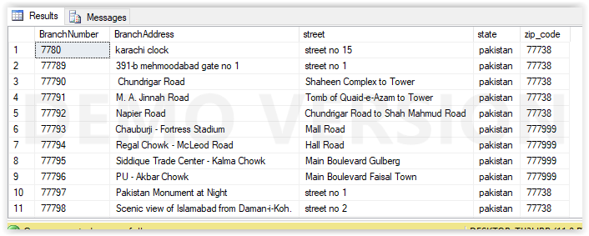

update Branch set BranchAddress='391-b mehmoodabad no 5' where BranchNumber=77789;

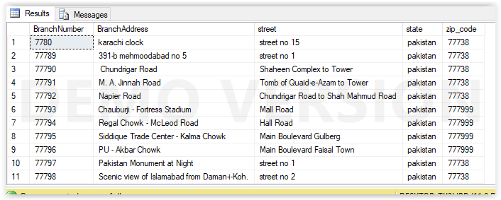

Delete Statement:

delete from Branch where BranchNumber=7780;

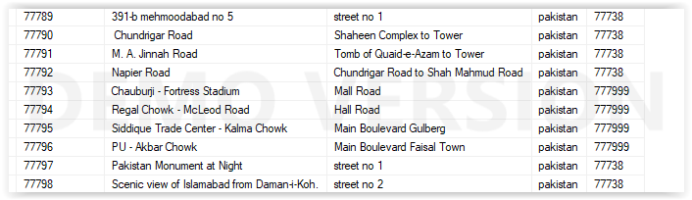

**Count:**

select count(*) from Branch;

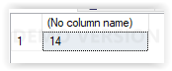

**Not Statement:**

select*from Branch where BranchNumber not between 7780 and 77789;

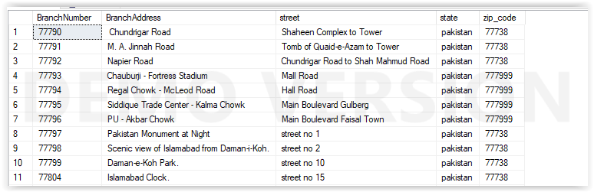

**Between Statement:**

select*from Branch where BranchNumber between 7780 and 77789;

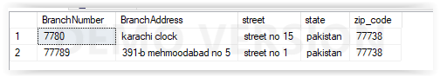

**Distinct Statement:**

select distinct BranchAddress from Branch;

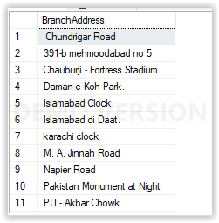

**Order by Statement:**

select*from Branch order by BranchNumber asc;

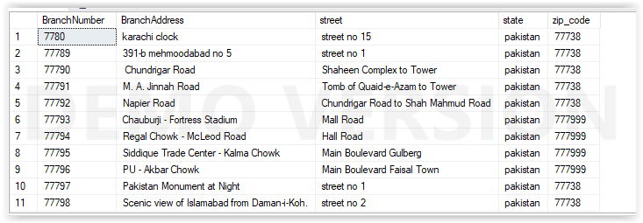

select*from Branch order by BranchNumber desc;

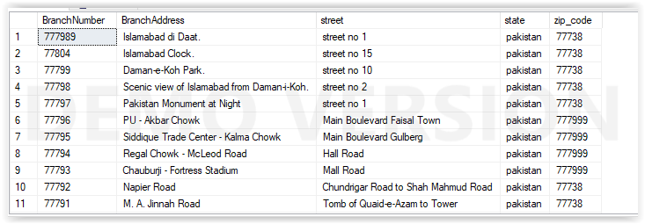

**Like operator:**

select*from Branch where BranchAddress like('D%');

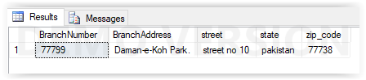

select*from Branch where BranchAddress like('%d');

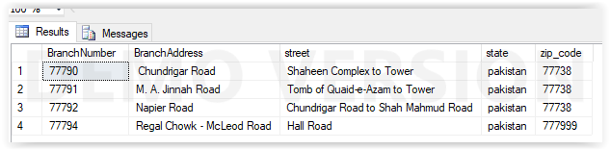

select*from Branch where BranchAddress like('%M%');

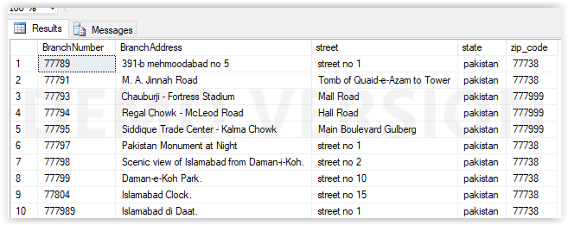

select*from Branch where BranchAddress like('N__________');

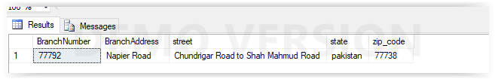

select*from Branch where BranchAddress like('___________');



**In statement:**

select*from Branch where BranchAddress in('karachi clock','391-b mehmoodabad no 5');

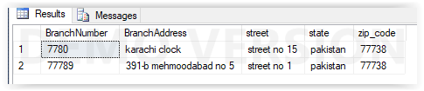

**Or operator:**

select*from Branch where BranchNumber=7780 or BranchAddress='M. A. Jinnah Road';

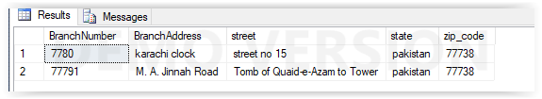

**And operator:**

select*from Branch where BranchNumber=7780 and BranchAddress='karachi clock';

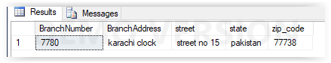

Alias

select BranchNumber as "Branch_No" from Branch;

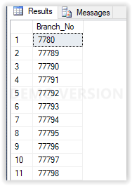

ISNULL:

select*from Branch where BranchAddress is null;

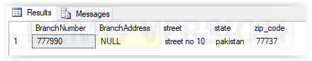

select*from City;

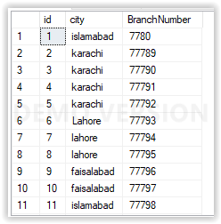

Where clause:

select*from City where id=1;

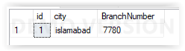

select*from City where id=2;

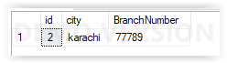

select*from City where id=10;

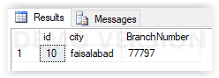

update statement:

update City set city='karachi' where id=1;

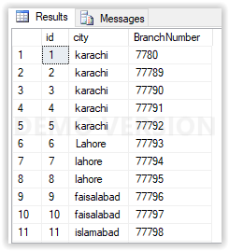

delete statement:

delete from City where id=2;

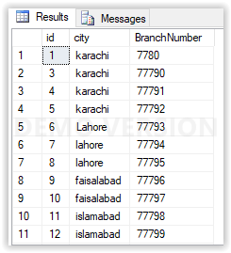

Count Function:

select count(*) from City;

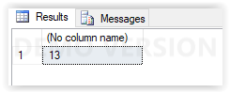

Not Operator:

select*from City where city not in ('karachi','lahore');

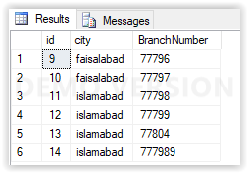

Between operator:

select*from city where id between 1 and 5;

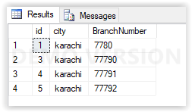

Distinct:

select distinct City from City;

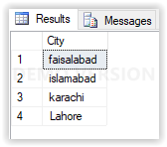

Order by :

select*from City order by id asc;

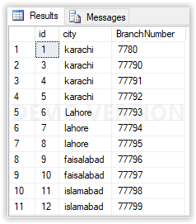

select*from City order by id desc;

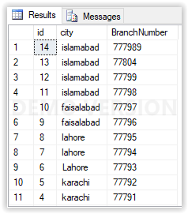

Like operator:

select*from City where city like('i%');

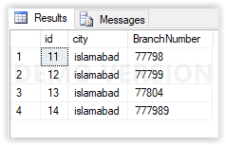

select*from City where city like('%d');

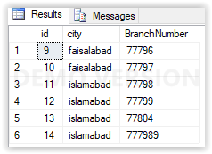

select*from City where city like('%ra%');

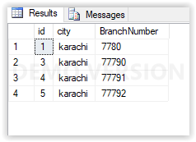

select*from City where city like('k______');



select*from City where city like('_______');



In operator:

select*from City where city in('karachi','lahore');

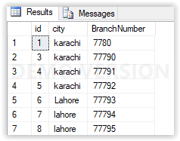

And operator:

select*from city where id=1 and city='karachi';

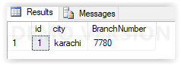

Or operator:

select*from City where id=1 or city='karachi';

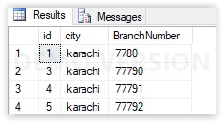

Alias:

select city as "CityName" from City;

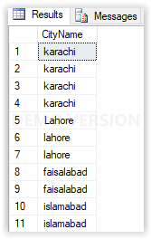

Is Null:

select*from City where city is null;

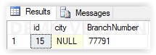

select*from Videos

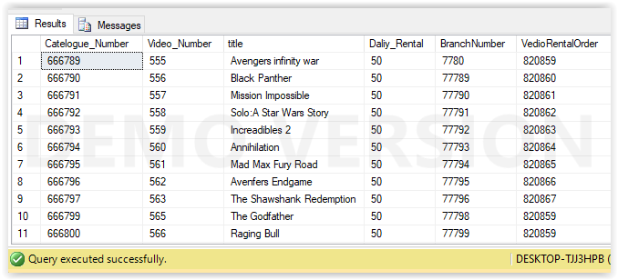

Sum:

select sum(Daliy_Rental) as "SUM OF DALIY RENTAL" FROM Videos;

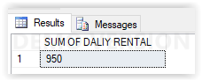

Avg:

select AVG(Daliy_Rental) as "AVERAGE OF DALIY RENTAL" FROM Videos;

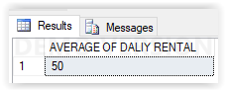

Max:

select max(Daliy_Rental) as "Maximum OF DALIY RENTAL" FROM Videos;

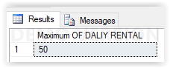

Min:

SELECT MIN(Daliy_Rental) as "MIN OF DALIY RENTAL" FROM Videos;

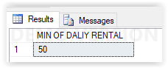

Group by:

select VedioRentalOrder,sum(Daliy_Rental) as "SUM OF DALIY RENTAL" from Videos group by VedioRentalOrder;

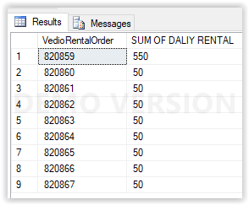

select VedioRentalOrder,avg(Daliy_Rental) as "AVERAGE OF DALIY RENTAL" from Videos group by VedioRentalOrder;

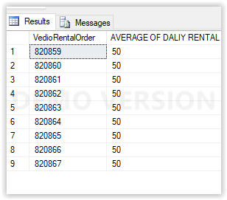

select VedioRentalOrder,max(Daliy_Rental) as "MAXIMUM OF DALIY RENTAL" from Videos group by VedioRentalOrder;

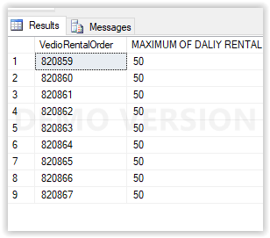

select VedioRentalOrder,min(Daliy_Rental) as "MINIMUM OF DALIY RENTAL" from Videos group by VedioRentalOrder;

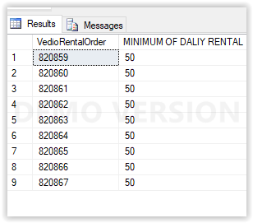

select VedioRentalOrder,count(Daliy_Rental) as "Count OF DALIY RENTAL" from Videos group by VedioRentalOrder;

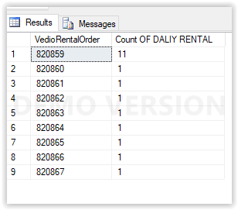

Having:

select VedioRentalOrder,avg(Daliy_Rental) as "AVERAGE OF DALIY RENTAL" from Videos group by VedioRentalOrder having avg(Daliy_Rental)>10;

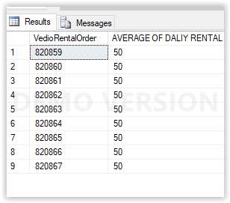

select VedioRentalOrder,max(Daliy_Rental) as "MAXIMUM OF DALIY RENTAL" from Videos group by VedioRentalOrder having MAX(Daliy_Rental)>10;

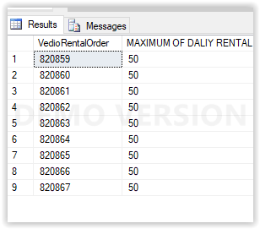

select VedioRentalOrder,min(Daliy_Rental) as "MINIMUM OF DALIY RENTAL" from Videos group by VedioRentalOrder having MIN(Daliy_Rental)>10;

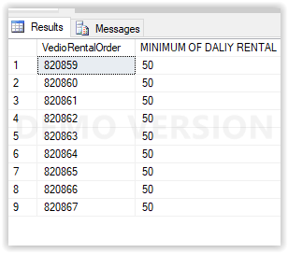

select VedioRentalOrder,sum(Daliy_Rental) as "SUM OF DALIY RENTAL" from Videos group by VedioRentalOrder having sum(Daliy_Rental)>10;

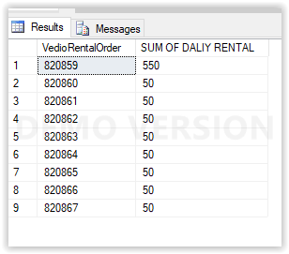

**MULTIPLE TABLES**

Write **ONE (1)** select statement involving the following below.

* **JOIN** 
  + two tables.
  + three or more tables.

Inner join:

select Videos.Catelogue_Number,Videos.title,Videos.Daliy_Rental,Actor.Actor_No,Actor.Actor_Name,Director.director_No,Director.director_Name,Category.CategoryNumber,Category.CategoryName FROM Videos

INNER JOIN Category ON Videos.Catelogue_Number=Category.Catelogue_Number INNER JOIN Actor ON Videos.Catelogue_Number=Actor.Catelogue_Number INNER JOIN

Director ON Videos.Catelogue_Number=Director.Catelogue_Number;

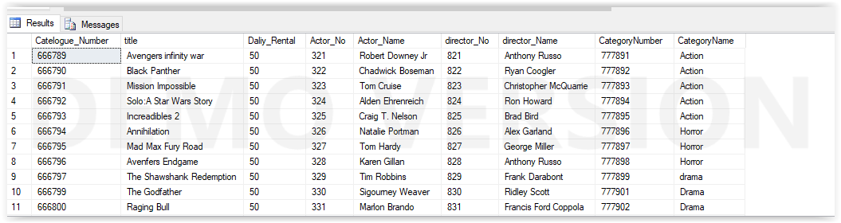

Left outer join:

select Videos.Catelogue_Number,Videos.title,Videos.Daliy_Rental,Actor.Actor_No,Actor.Actor_Name,Director.director_No,Director.director_Name,Category.CategoryNumber,Category.CategoryName FROM Videos

left join Category ON Videos.Catelogue_Number=Category.Catelogue_Number left JOIN Actor ON Videos.Catelogue_Number=Actor.Catelogue_Number left JOIN

Director ON Videos.Catelogue_Number=Director.Catelogue_Number;

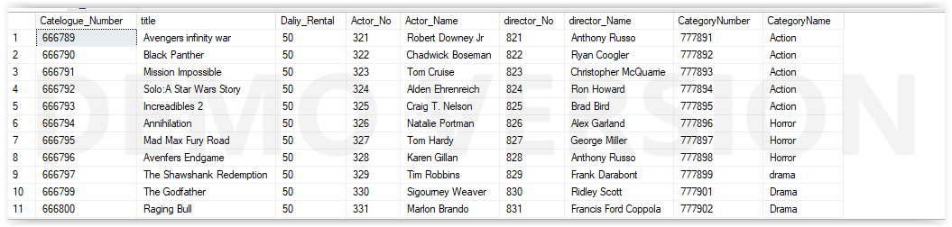

right outer join:

select Videos.Catelogue_Number,Videos.title,Videos.Daliy_Rental,Actor.Actor_No,Actor.Actor_Name,Director.director_No,Director.director_Name,Category.CategoryNumber,Category.CategoryName FROM Videos

right join Category ON Videos.Catelogue_Number=Category.Catelogue_Number right JOIN Actor ON Videos.Catelogue_Number=Actor.Catelogue_Number right JOIN

Director ON Videos.Catelogue_Number=Director.Catelogue_Number;

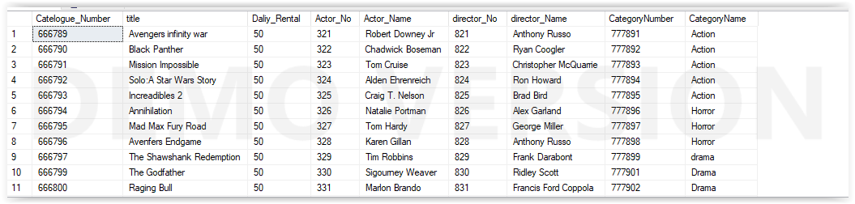

Full join:

select Videos.Catelogue_Number,Videos.title,Videos.Daliy_Rental,Actor.Actor_No,Actor.Actor_Name,Director.director_No,Director.director_Name,Category.CategoryNumber,Category.CategoryName FROM Videos

full join Category ON Videos.Catelogue_Number=Category.Catelogue_Number full JOIN Actor ON Videos.Catelogue_Number=Actor.Catelogue_Number full JOIN

Director ON Videos.Catelogue_Number=Director.Catelogue_Number;



Cross join

select*from Videos cross join Category;

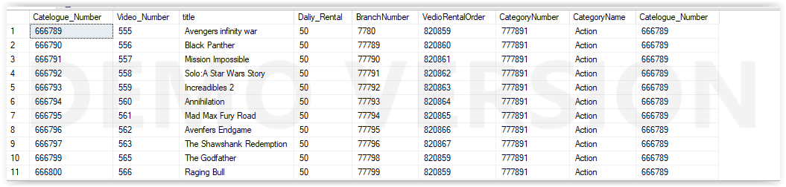

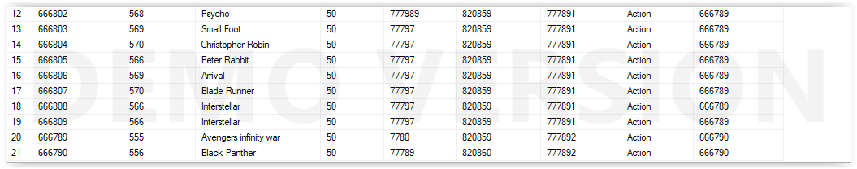

Inner join:

select Manager.Manager_Name,Staff.Staff_No,Staff.name,Staff.position,Staff.salary from Manager inner join Staff on Manager.Manager_No=Staff.Manager_No;

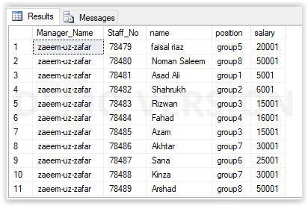

left join:

select Manager.Manager_Name,Staff.Staff_No,Staff.name,Staff.position,Staff.salary from Manager left outer join Staff on Manager.Manager_No=Staff.Manager_No;



right join:

select Manager.Manager_Name,Staff.Staff_No,Staff.name,Staff.position,Staff.salary from Manager right join Staff on Manager.Manager_No=Staff.Manager_No;



full join:

select Manager.Manager_Name,Staff.Staff_No,Staff.name,Staff.position,Staff.salary from Manager full join Staff on Manager.Manager_No=Staff.Manager_No;

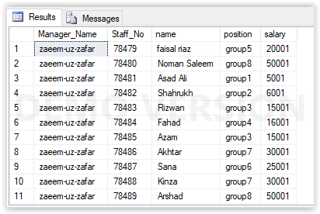

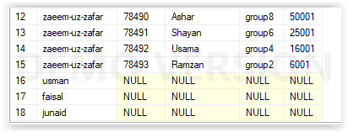

Cross join:

select*from Manager cross join Staff;

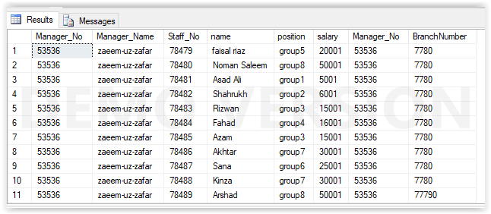

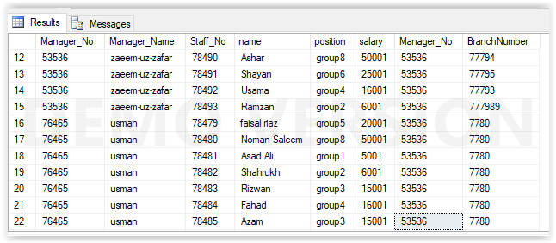

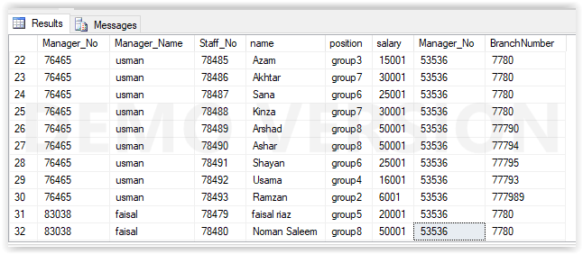

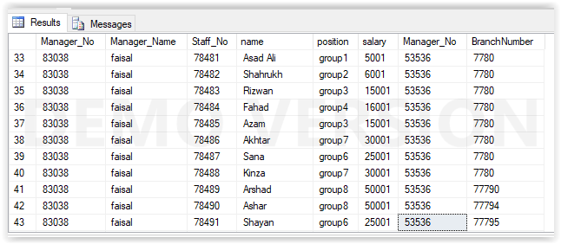

Inner join:

select Branch.BranchNumber,Branch.BranchAddress,Branch.street,Branch.state,Staff.Staff_No,Staff.name,Staff.position,Staff.salary,

telephone.telephonenumber,Customer.MemberNumber,Customer.First_Name,Customer.Date_Register from Branch inner join Staff on Branch.BranchNumber=Staff.BranchNumber

inner join telephone on Branch.BranchNumber=telephone.BranchNumber inner join Customer on Branch.BranchNumber=Customer.BranchNumber;

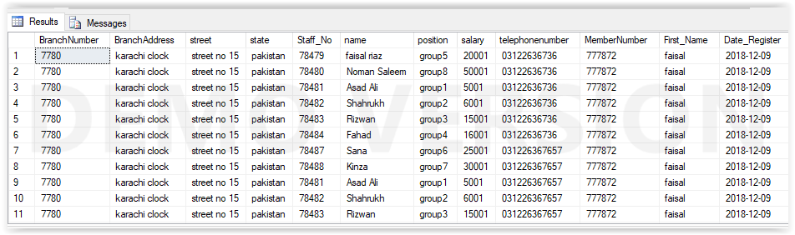

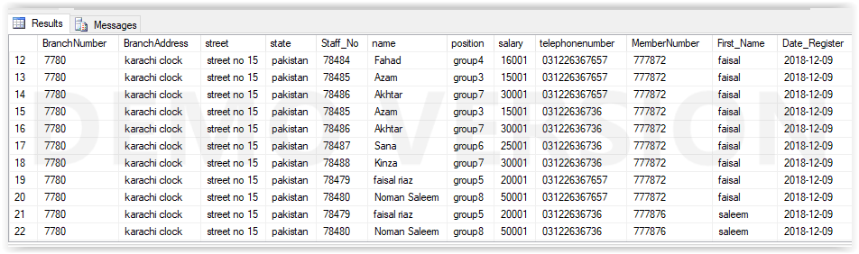

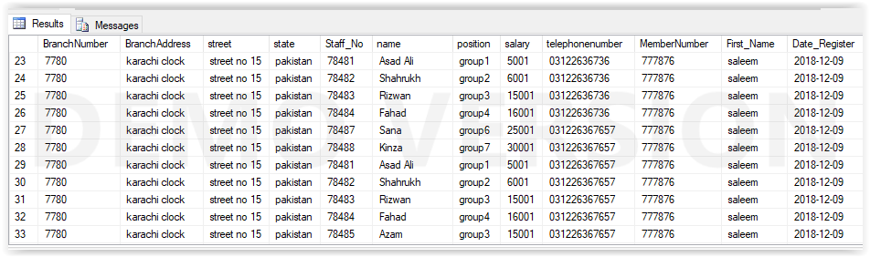

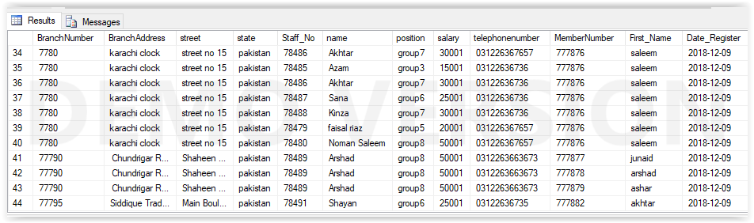

Left outer join:

select Branch.BranchNumber,Branch.BranchAddress,Branch.street,Branch.state,Staff.Staff_No,Staff.name,Staff.position,Staff.salary,

telephone.telephonenumber,Customer.MemberNumber,Customer.First_Name,Customer.Date_Register from Branch left join Staff on Branch.BranchNumber=Staff.BranchNumber

left join telephone on Branch.BranchNumber=telephone.BranchNumber left join Customer on Branch.BranchNumber=Customer.BranchNumber;

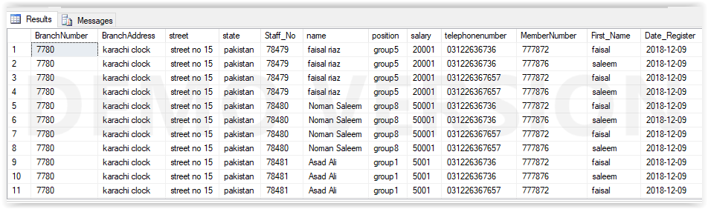

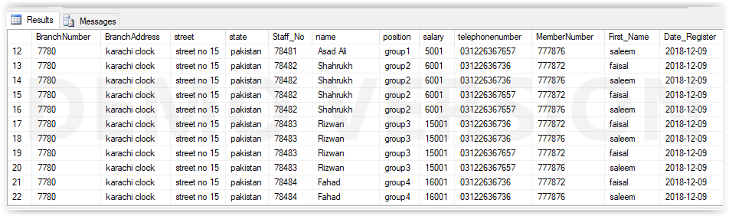

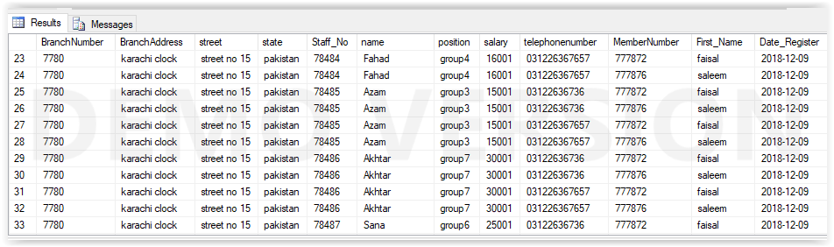

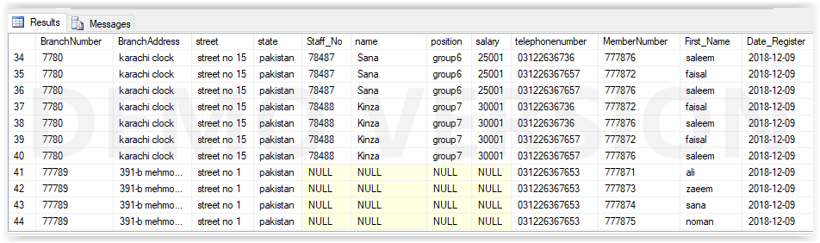

Right outer join:

select Branch.BranchNumber,Branch.BranchAddress,Branch.street,Branch.state,Staff.Staff_No,Staff.name,Staff.position,Staff.salary,

telephone.telephonenumber,Customer.MemberNumber,Customer.First_Name,Customer.Date_Register from Branch right join Staff on Branch.BranchNumber=Staff.BranchNumber

right join telephone on Branch.BranchNumber=telephone.BranchNumber right join Customer on Branch.BranchNumber=Customer.BranchNumber;

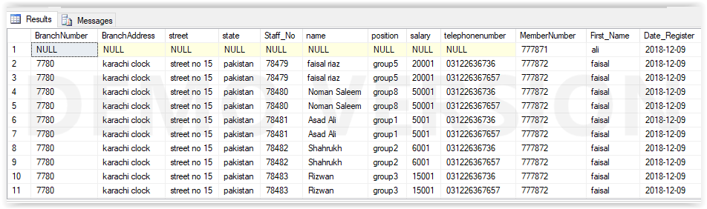

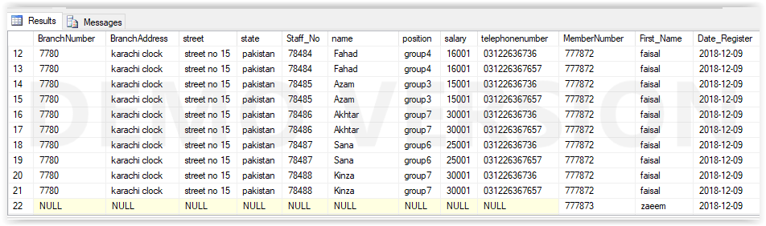

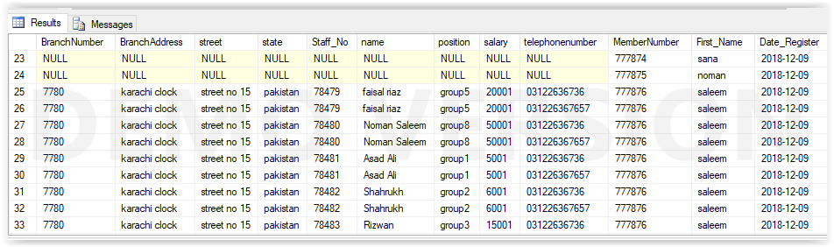

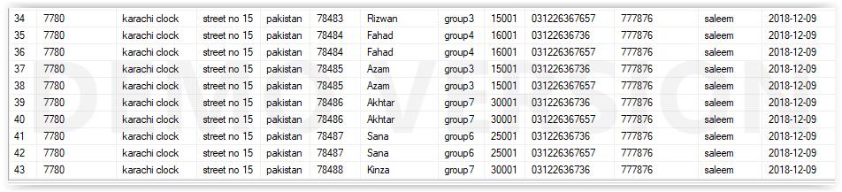

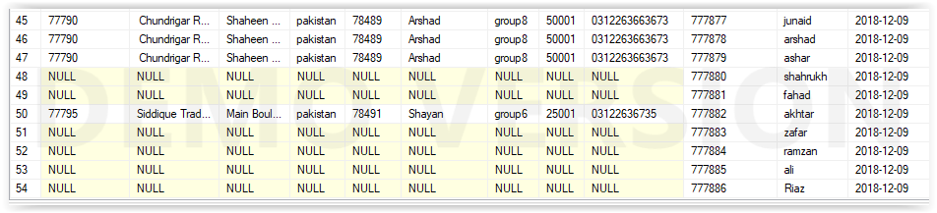

full outer join:

select Branch.BranchNumber,Branch.BranchAddress,Branch.street,Branch.state,Staff.Staff_No,Staff.name,Staff.position,Staff.salary,

telephone.telephonenumber,Customer.MemberNumber,Customer.First_Name,Customer.Date_Register from Branch full outer join Staff on Branch.BranchNumber=Staff.BranchNumber

full outer join telephone on Branch.BranchNumber=telephone.BranchNumber full outer join Customer on Branch.BranchNumber=Customer.BranchNumber;

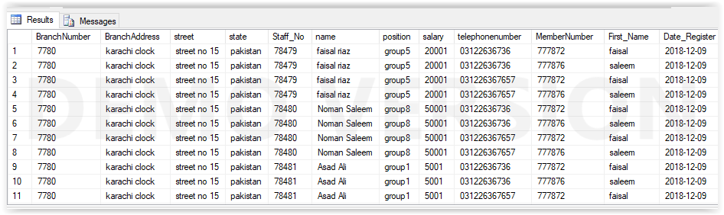

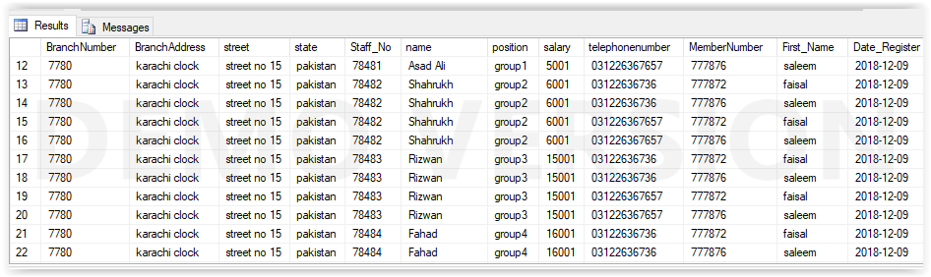

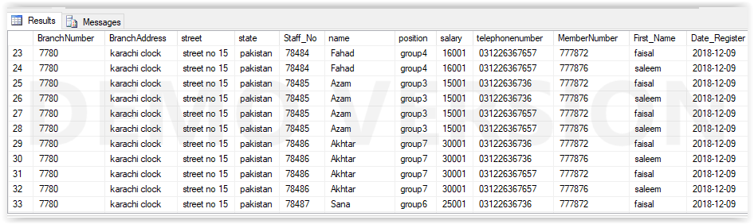

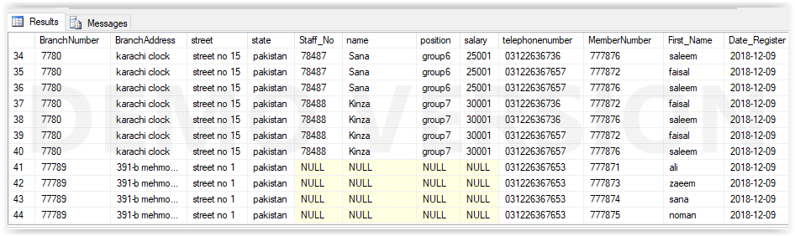

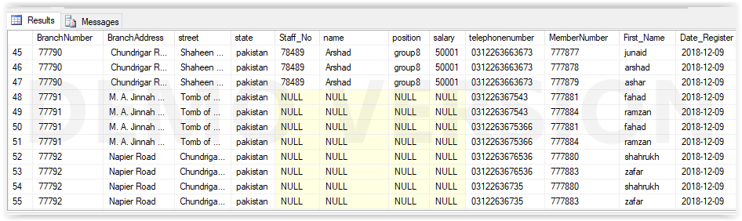

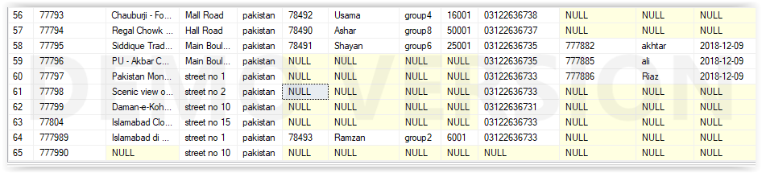

Cross join:

select*from Branch cross join Staff;

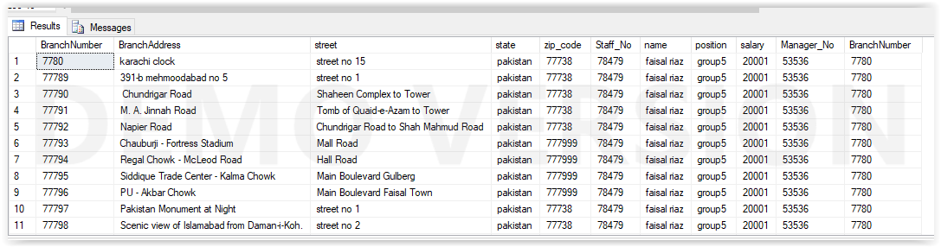

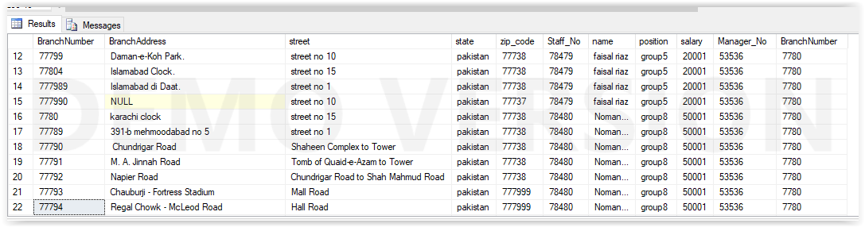

select*from branch cross join Customer;

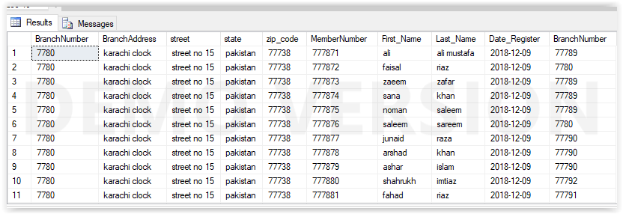

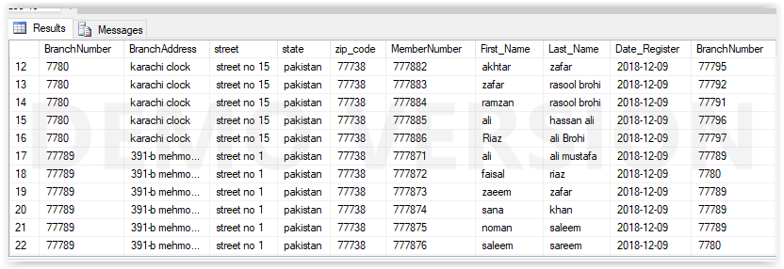

Inner join:

select VedioRentalOrder.Rental_Number,VedioRentalOrder.Full_Name,VedioRentalOrder.Video_Number,VedioRentalOrder.Title,VedioRentalOrder.Dates_Rented_Out

,VedioRentalOrder.Dates_Rented_Returned,Videos.Catelogue_Number from VedioRentalOrder inner join Videos on VedioRentalOrder.Rental_Number=Videos.VedioRentalOrder;

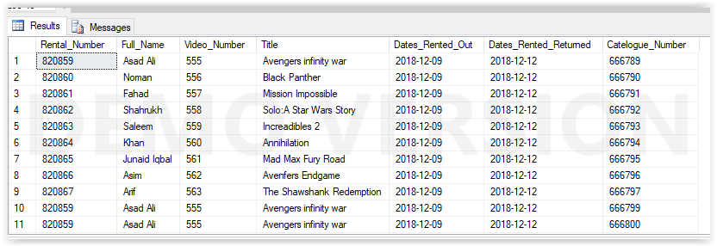

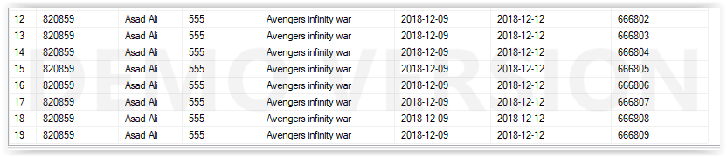

Left join:

select VedioRentalOrder.Rental_Number,VedioRentalOrder.Full_Name,VedioRentalOrder.Video_Number,VedioRentalOrder.Title,VedioRentalOrder.Dates_Rented_Out

,VedioRentalOrder.Dates_Rented_Returned,Videos.Catelogue_Number from VedioRentalOrder left join Videos on VedioRentalOrder.Rental_Number=Videos.VedioRentalOrder;

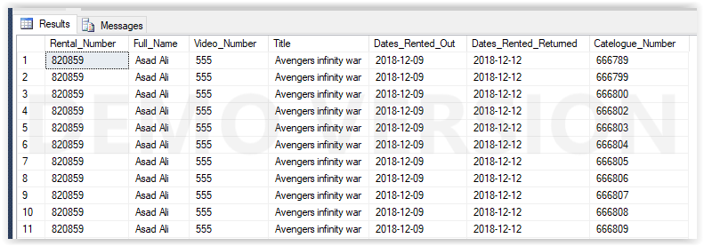

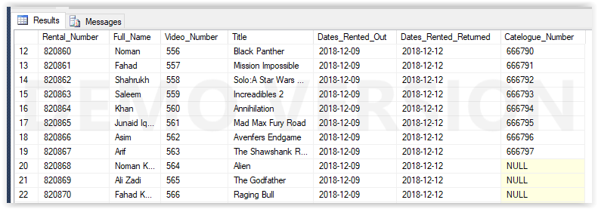

Right join:

select VedioRentalOrder.Rental_Number,VedioRentalOrder.Full_Name,VedioRentalOrder.Video_Number,VedioRentalOrder.Title,VedioRentalOrder.Dates_Rented_Out

,VedioRentalOrder.Dates_Rented_Returned,Videos.Catelogue_Number from VedioRentalOrder right join Videos on VedioRentalOrder.Rental_Number=Videos.VedioRentalOrder;

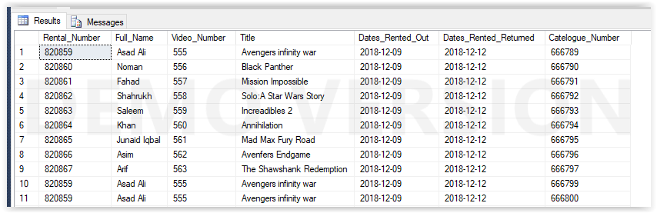

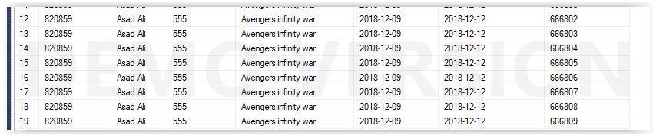

Full outer join:

select VedioRentalOrder.Rental_Number,VedioRentalOrder.Full_Name,VedioRentalOrder.Video_Number,VedioRentalOrder.Title,VedioRentalOrder.Dates_Rented_Out

,VedioRentalOrder.Dates_Rented_Returned,Videos.Catelogue_Number from VedioRentalOrder full join Videos on VedioRentalOrder.Rental_Number=Videos.VedioRentalOrder;

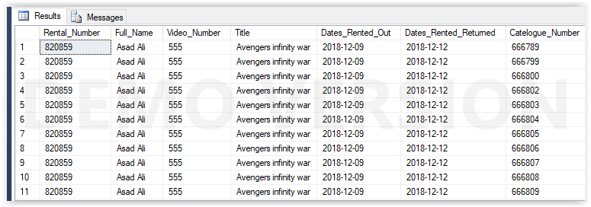

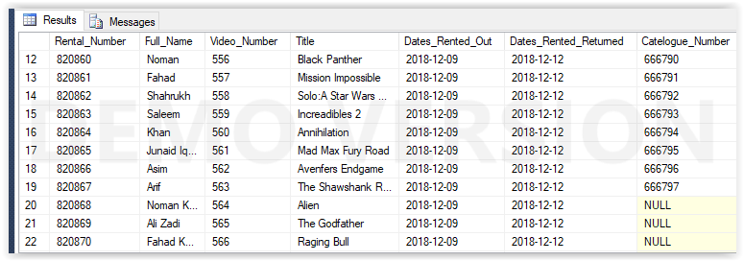

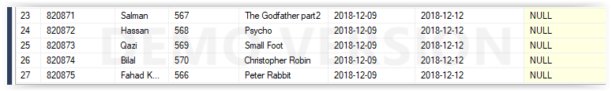

**Subquery:**

select*from Staff

where BranchNumber in

(select BranchNumber from Branch where Branch.state='pakistan');

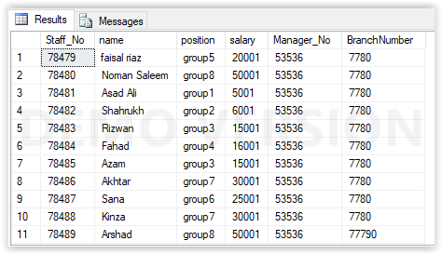

select*from Staff

where BranchNumber not in

(select BranchNumber from Branch where Branch.street='street no 1');

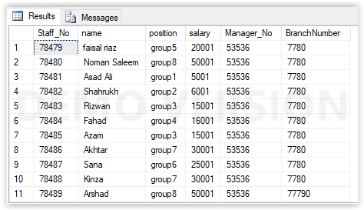

select Staff.Staff_No,Staff.name,Staff.position,Staff.salary from Staff

where Manager_No in

(select Manager.Manager_No from Manager where Manager_Name='zaeem-uz-zafar');

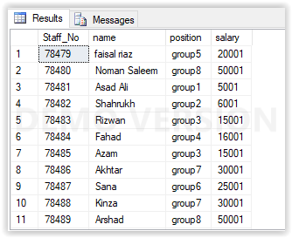

select Branch.BranchNumber,Branch.BranchAddress from Branch

where BranchNumber in

(select Branch.BranchNumber from Branch where BranchAddress='karachi clock');

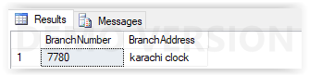

select Videos.Catelogue_Number,Videos.Video_Number,Videos.title,Videos.Daliy_Rental from Videos

where Catelogue_Number in

(select Catelogue_Number from Videos where Videos.BranchNumber=7780);



Update sub queries:

update Videos set Daliy_Rental=Daliy_Rental*2

where Catelogue_Number in

(select Catelogue_Number from Videos where Catelogue_Number=666789);

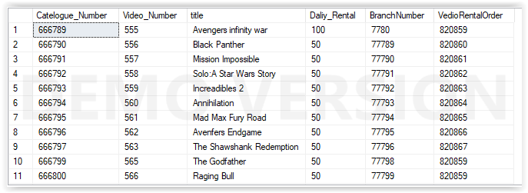

select Videos.Catelogue_Number,Videos.Video_Number,Videos.title,Videos.Daliy_Rental from Videos

where Daliy_Rental>=any

(select MAX(Daliy_Rental) from Videos group by Catelogue_Number);

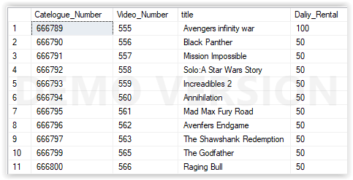

select Videos.Catelogue_Number,Videos.Video_Number,Videos.title,Videos.Daliy_Rental from Videos

where Catelogue_Number=any

(select Catelogue_Number from Videos where title='Avengers infinity war');



select Videos.Catelogue_Number,Videos.Video_Number,Videos.title,Videos.Daliy_Rental from Videos

where Catelogue_Number= all

(select Catelogue_Number from Videos where title='Avengers infinity war');



select Videos.Catelogue_Number,Videos.Video_Number,Videos.title,Videos.Daliy_Rental from Videos

where Catelogue_Number<>all

(select Catelogue_Number from Videos where title='Avengers infinity war');

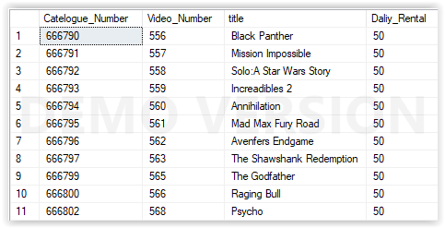

select Videos.Catelogue_Number,Videos.Video_Number,Videos.title,Videos.Daliy_Rental from Videos

where Catelogue_Number<>any

(select Catelogue_Number from Videos where title='Avengers infinity war');

