

MILITAY COLLEGE OF SIGNALS

NATIONAL UNIVERSITY OF SCIENCE AND TECHNOLOGY

MADE BY:

FAISAL RIAZ WATTOO

AGE DIVERSITY AND ITS IMPACT ON EMPLOYEE PERFORMANCE TO ORGANIZATION

Introduction:

Age diversity has been identified as one of the strategic capabilities that will add value to organizations over their competition.

In order to create performance chart based on their Age we have create a table with dummy data where each employee belongs to different age group and on the basis their No of project and working hours we calculated their performance

Key Attributes to calculate performance:

1)Working hours(W_hours)

2)No of Projects(NOP)

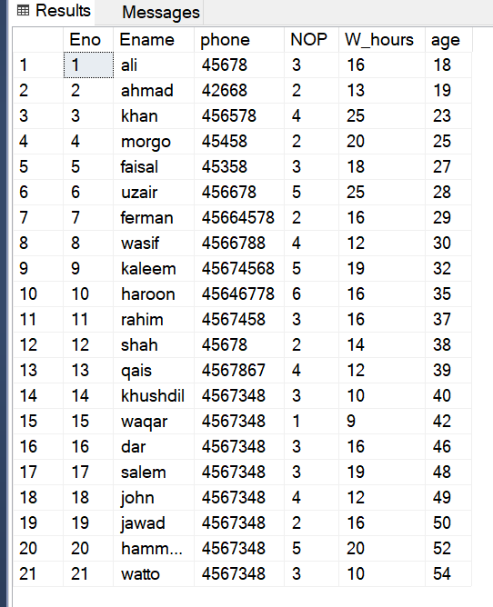

Working :

Connection of java frontend to SQL Server :

To connect java with sql server first of all we have to add jar file called mssql-jdbc.jre 18

Performance calculation :

To calculate performance level of different age group we have calculated their sum of project and total working hours:

select sum(W_hours) as Working_hours

from employees

where age between Range1 and Range2

and their total No of projects like:

select sum(NOP) as NOOFPROJ

from employees

where age between Range1 and Range2

Now dividing this age group total No of projects and total No of working hours by total No of project of company and Total No of Working hours of Company so that we can draw bar Chart in Jframe

Mathematical calculations:

float percent1 = (((float)nop1/total_proj)*100) + (((float)hours1/total_hours)*100);

float percent2 = (((float)nop2/total_proj)*100) + (((float)hours2/total_hours)*100)

float percent3 = (((float)nop3/total_proj)*100) + (((float)hours3/total_hours)*100)

float percent4 = (((float)nop4/total_proj)*100) + (((float)hours4/total_hours)*100);

and then,

float total = percent1+percent2+percent3+percent4;

float f1 = (percent1/total)*100;

float f2 = (percent2/total)*100;

float f3 = (percent3/total)*100;

float f4 = (percent4/total)*100;

We have 4 different age groups so each fs will give us some value out of 100 so that we can draw Pie chart .

Similary of all other age groups we have to do same procedure.

In End we have to plot these percents in pie chart using JFreechart Library.

RESULT BY PIE CHART :

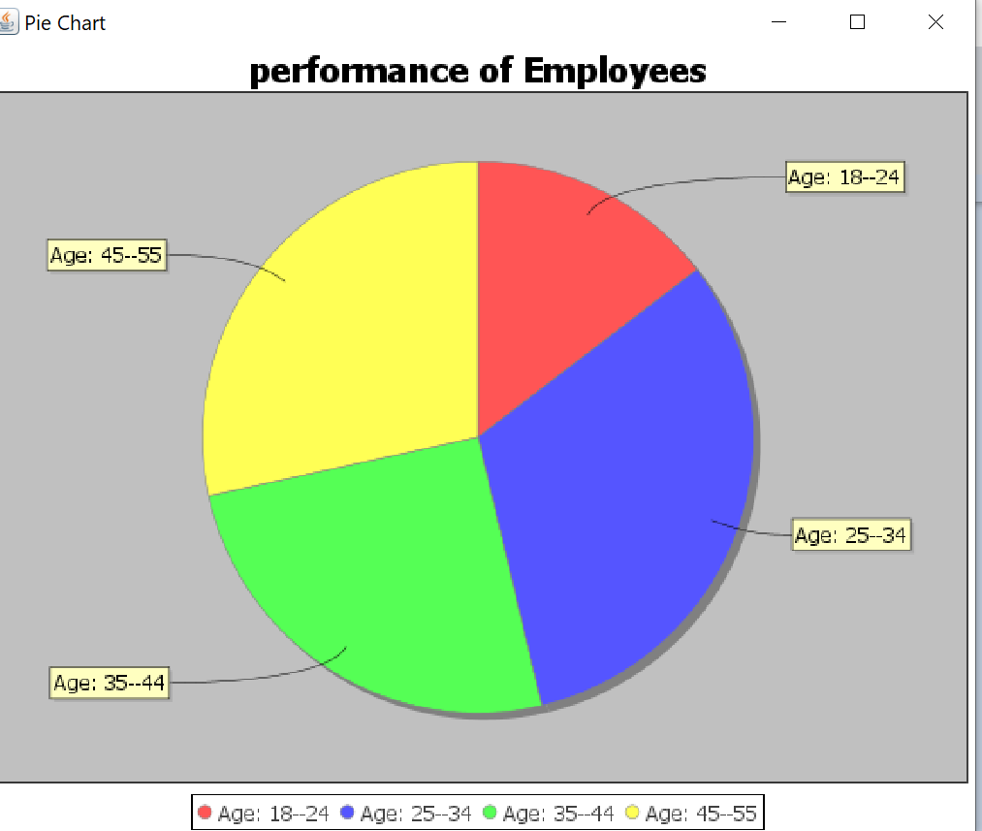

Conclusion:

The study reveals that the age diversity of the workforce does not significantly impact the performance of employees. Thus it is concluded that the performance of employees in organization depends opun their working hours on project and No of project on which that particular employee worked. Impact of variables(NOP, W_hours) on the employee performance is shown in above Bar chart.

THE END