ARTI 404: Image Processing

Image Denoising Using Spatial and Frequency Domain Methods
Student Name: Faisal Alzahrani
Assignment

Abstract
This report presents an image denoising experiment using two restoration approaches: a spatial-domain median filter and a frequency-domain Gaussian low-pass filter. Five noisy images were analyzed, denoised, tuned using multiple parameter settings, and evaluated using PSNR and SSIM. The clean images were used only as references for quantitative evaluation. The experiment shows that median filtering produced the strongest average performance for this dataset because most images contain impulse or salt-and-pepper noise.

1. Noise Identification
Each noisy image was visually inspected to determine the most likely noise type. The observations are summarized below.
Image | Noise Type | Justification
camera | Gaussian noise | Fine grain appears across the whole image, which is typical of additive Gaussian noise.
coins | Salt-and-pepper / impulse noise | Many isolated bright and dark dots appear on coins and background, indicating impulse noise.
text | Salt-and-pepper noise | Random black and white pixels corrupt the paper and handwriting.
rice | Salt-and-pepper noise | Strong isolated bright/dark dots appear over the textured image.
astronaut | Colored salt-and-pepper / impulse noise | Random colored pixel corruption appears across RGB channels.

2. Method Selection

2.1 Spatial-domain method: Median filter
The selected spatial-domain method is median filtering. Median filtering replaces each pixel with the median value in a local neighborhood. It is effective for impulse and salt-and-pepper noise because isolated corrupted pixels are removed without averaging them into the surrounding area. Kernel sizes 3x3, 5x5, 7x7, and 9x9 were tested.

2.2 Frequency-domain method: Gaussian Low-Pass Filter
The frequency-domain method applies a Fourier Transform to the image, shifts the zero-frequency component to the center, multiplies the spectrum by a Gaussian low-pass filter, then applies the inverse Fourier Transform. Cutoff values 10, 20, 40, and 80 were tested. Low-pass filtering reduces high-frequency noise but can also blur edges and fine details.

3. PSNR and SSIM Explanation
PSNR (Peak Signal-to-Noise Ratio) measures the pixel-level difference between the clean reference image and the denoised image. A higher PSNR means the denoised image is closer to the reference image. SSIM (Structural Similarity Index) measures perceptual similarity based on luminance, contrast, and structure. SSIM ranges from 0 to 1, where values closer to 1 indicate better structural similarity. In this experiment, the best parameter configuration was selected based on the highest SSIM.

4. Results Table
The table below reports the best spatial and frequency-domain configurations for every image.
Image | Noise Type | Spatial Best Parameters | Spatial PSNR | Spatial SSIM | Frequency Best Parameters | Frequency PSNR | Frequency SSIM
camera | Gaussian noise | median, kernel=9x9 | 24.41 | 0.6469 | Gaussian LPF, cutoff=40 | 25.04 | 0.6879
coins | Salt-and-pepper / impulse noise | median, kernel=3x3 | 28.07 | 0.8536 | Gaussian LPF, cutoff=40 | 23.38 | 0.5748
text | Salt-and-pepper noise | median, kernel=3x3 | 32.01 | 0.9043 | Gaussian LPF, cutoff=20 | 25.59 | 0.6524
rice | Salt-and-pepper noise | median, kernel=7x7 | 23.34 | 0.5659 | Gaussian LPF, cutoff=40 | 24.14 | 0.6168
astronaut | Colored salt-and-pepper / impulse noise | median, kernel=3x3 | 30.32 | 0.9375 | Gaussian LPF, cutoff=40 | 22.33 | 0.6044

Average performance across the full dataset:
Method | Average PSNR | Average SSIM
Spatial Median | 27.63 | 0.7816
Frequency Gaussian LPF | 24.10 | 0.6273

5. Visual Results
The following figures show clean reference, noisy input, best spatial output, and best frequency-domain output for each image.

Camera
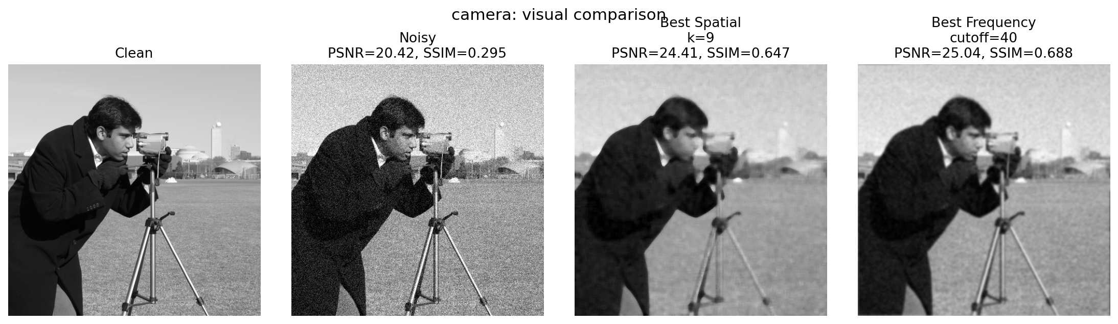

Coins
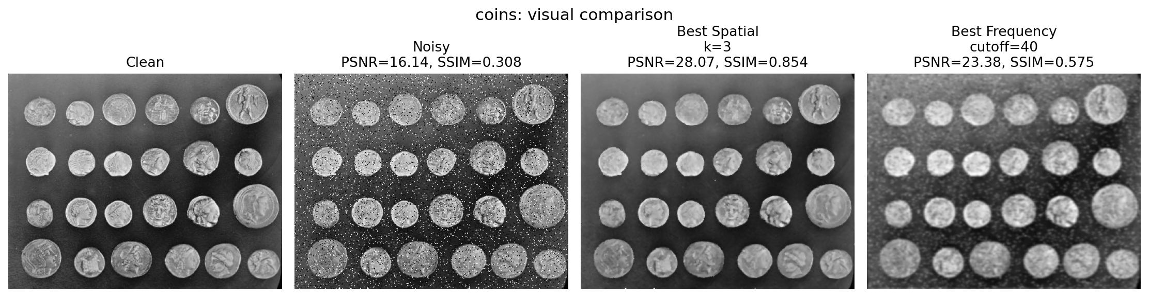

Text
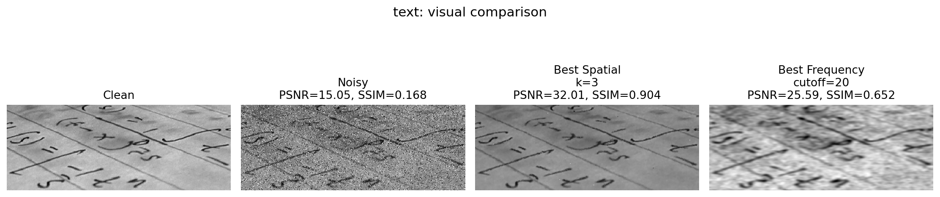

Rice
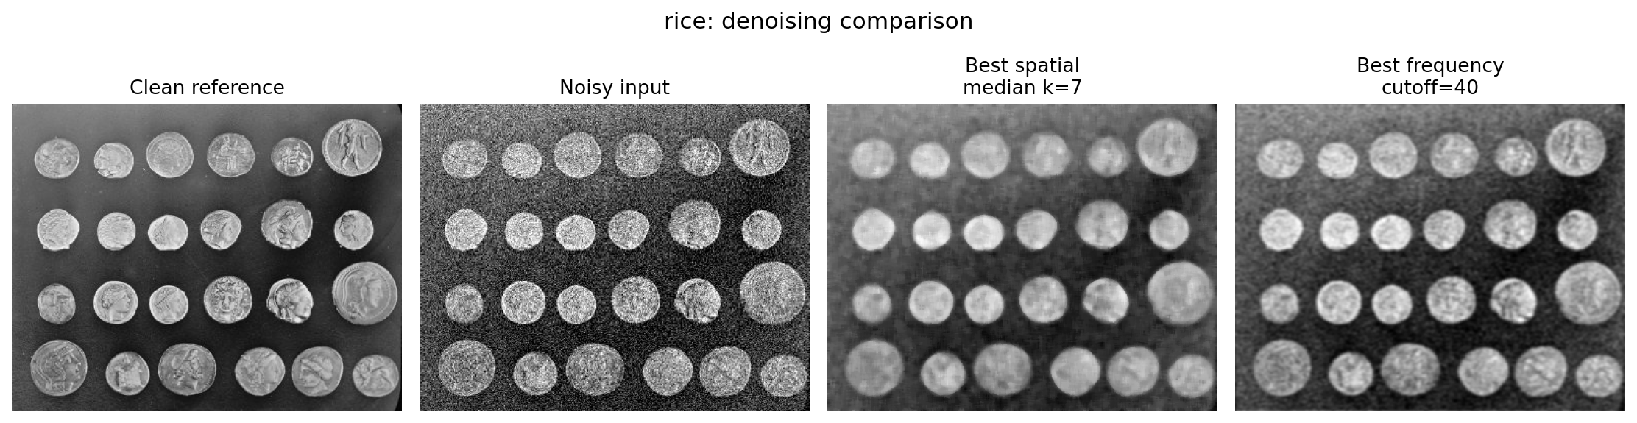

Astronaut
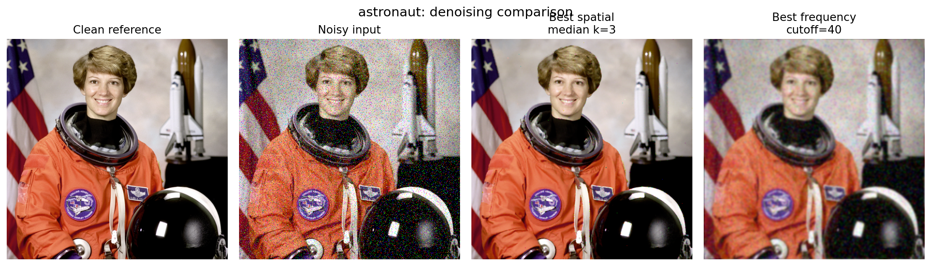

6. Discussion
Based on the average results, the spatial median filter achieved an average PSNR of 27.63 and an average SSIM of 0.7816. The frequency-domain Gaussian low-pass filter achieved an average PSNR of 24.10 and an average SSIM of 0.6273. Median filtering performed better overall because the dataset contains several images with salt-and-pepper or impulse noise. The frequency-domain method was useful for smoothing, but its low-pass nature reduced high-frequency details such as edges and texture.

7. Conclusion
The assignment requirements were completed by implementing and comparing a spatial median filter and a Fourier-domain Gaussian low-pass filter. Multiple parameter settings were tested for both methods, and the best configuration was selected using SSIM. Overall, the spatial median filter provided the best denoising performance for this dataset.

Appendix A: Full Parameter Tuning Table
Image | Method | Parameters | PSNR | SSIM
camera | Noisy baseline | nan | 20.42 | 0.2951
camera | Spatial Median | kernel=3x3 | 25.71 | 0.4939
camera | Spatial Median | kernel=5x5 | 26.21 | 0.6040
camera | Spatial Median | kernel=7x7 | 25.48 | 0.6442
camera | Spatial Median | kernel=9x9 | 24.41 | 0.6469
camera | Frequency Gaussian LPF | cutoff=10 | 20.54 | 0.5714
camera | Frequency Gaussian LPF | cutoff=20 | 22.57 | 0.6268
camera | Frequency Gaussian LPF | cutoff=40 | 25.04 | 0.6879
camera | Frequency Gaussian LPF | cutoff=80 | 26.94 | 0.6403
coins | Noisy baseline | nan | 16.14 | 0.3079
coins | Spatial Median | kernel=3x3 | 28.07 | 0.8536
coins | Spatial Median | kernel=5x5 | 26.17 | 0.7710
coins | Spatial Median | kernel=7x7 | 25.12 | 0.7262
coins | Spatial Median | kernel=9x9 | 24.30 | 0.6936
coins | Frequency Gaussian LPF | cutoff=10 | 19.40 | 0.4628
coins | Frequency Gaussian LPF | cutoff=20 | 21.61 | 0.5585
coins | Frequency Gaussian LPF | cutoff=40 | 23.38 | 0.5748
coins | Frequency Gaussian LPF | cutoff=80 | 22.50 | 0.4816
text | Noisy baseline | nan | 15.05 | 0.1681
text | Spatial Median | kernel=3x3 | 32.01 | 0.9043
text | Spatial Median | kernel=5x5 | 28.51 | 0.8240
text | Spatial Median | kernel=7x7 | 25.48 | 0.7166
text | Spatial Median | kernel=9x9 | 23.76 | 0.6270
text | Frequency Gaussian LPF | cutoff=10 | 23.71 | 0.5779
text | Frequency Gaussian LPF | cutoff=20 | 25.59 | 0.6524
text | Frequency Gaussian LPF | cutoff=40 | 25.33 | 0.5466
text | Frequency Gaussian LPF | cutoff=80 | 21.26 | 0.3501
rice | Noisy baseline | nan | 17.39 | 0.2941
rice | Spatial Median | kernel=3x3 | 23.03 | 0.4602
rice | Spatial Median | kernel=5x5 | 23.78 | 0.5393
rice | Spatial Median | kernel=7x7 | 23.34 | 0.5659
rice | Spatial Median | kernel=9x9 | 22.75 | 0.5644
rice | Frequency Gaussian LPF | cutoff=10 | 19.69 | 0.4630
rice | Frequency Gaussian LPF | cutoff=20 | 22.02 | 0.5731
rice | Frequency Gaussian LPF | cutoff=40 | 24.14 | 0.6168
rice | Frequency Gaussian LPF | cutoff=80 | 23.75 | 0.5054
astronaut | Noisy baseline | nan | 14.56 | 0.2424
astronaut | Spatial Median | kernel=3x3 | 30.32 | 0.9375
astronaut | Spatial Median | kernel=5x5 | 27.59 | 0.8926
astronaut | Spatial Median | kernel=7x7 | 25.71 | 0.8461
astronaut | Spatial Median | kernel=9x9 | 24.36 | 0.8019
astronaut | Frequency Gaussian LPF | cutoff=10 | 17.13 | 0.4188
astronaut | Frequency Gaussian LPF | cutoff=20 | 19.82 | 0.5283
astronaut | Frequency Gaussian LPF | cutoff=40 | 22.33 | 0.6044
astronaut | Frequency Gaussian LPF | cutoff=80 | 22.84 | 0.5150

