**Test-Sharing App**

**User manual**

1. **Database Configuration**

Requirement:

* Postgres Database: test-sharing

After the App started successfully, please enter your database username and password.  
Than press Save.

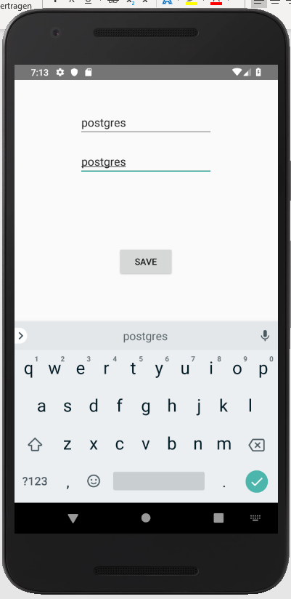Example with username: postgres and password: postgres

1. 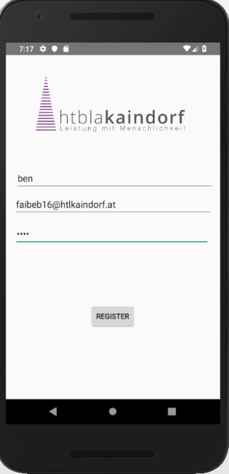**Registration**Please enter a username, an email and a password.  
   Than press Register.

You receive a message if registration was successful.

Example:

Username = ben

E-Mail = [faibeb16@htlkaindorf.at](mailto:faibeb16@htlkaindorf.at)

Password = 1234