LIGHTHOUSE FELLOWSHIP PRESENTS
Certificate of Entry

1st Annual Dry Dock Freedom
CAR SHOW
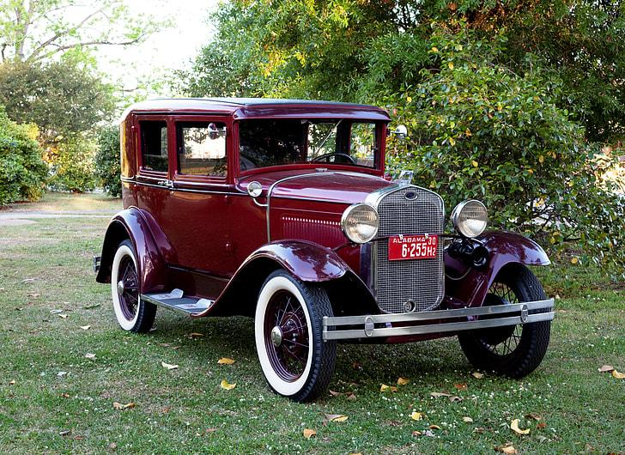
Saturday • August 29th, 2026

ENTRY NO. ______________
Owner ____________________________________________________
Vehicle (Year / Make / Model) __________________________________

