HealthConnect Clinic Experience Lab
Week 4 — Machine Learning Engineering Track
ML System Design Document
AnalystLab Africa — Experience Lab Internship Programme
Version 1.0

1. ML Problem Overview
HealthConnect Clinic loses appointment capacity and staff time when patients miss scheduled appointments without cancelling in advance. The Machine Learning Engineering track is responsible for designing the system that will reliably turn a no-show prediction model into a repeatable, versioned, production-style service — not for finalising the model itself, which sits with the Data Science track.
System objective:
Design a reproducible ML system that scores each newly booked appointment with a probability of becoming a no-show, early enough for clinic staff to intervene (e.g. extra reminder, phone confirmation, or overbooking that slot).
Framing:
- Primary framing: binary classification — will this appointment end in a No-Show (1) or be Attended (0)?
- Cancelled appointments are a separate operational event (the patient proactively frees the slot) and will be excluded from the core no-show model target, then revisited as a possible secondary model if the Data Science track's exploration supports it.
- This framing will be confirmed jointly with the Data Science track output, since both tracks work from the same dataset and must agree on one target definition for the shared HealthConnect project.

2. Input and Output Definition

2.1 System Input
The system consumes one appointment record at the point it is booked (or the morning of a daily batch run for all upcoming appointments), using only fields that are genuinely known before the appointment takes place.
Category | Fields (from Data Dictionary) | Available before appointment?
Patient profile | gender, age, age_group | Yes
Appointment details | appointment_type, appointment_day, appointment_time | Yes
Booking behaviour | booking_date, appointment_date, booking_lead_days | Yes
History | previous_appointments, previous_no_shows | Yes
Reminders | reminder_sent, reminder_channel | Yes (at scoring time, may need a 'reminder not yet sent' state for early scoring)
Logistics | distance_to_clinic_km | Yes
Excluded | waiting_time_minutes | No — only known once the patient has already checked in, so it leaks information from the future and must not be used as a model input
Excluded (label only) | appointment_id, patient_id | Identifiers — not predictive features, retained for traceability only

2.2 System Output
- A no-show probability score between 0 and 1 for each appointment.
- A derived risk tier (e.g. Low / Medium / High) using thresholds agreed with clinic operations, to keep the output actionable rather than a raw number.
- appointment_id carried through untouched, so the score can be joined back to the clinic's scheduling data.
- A model version / run identifier attached to every prediction, for auditability.
Consumers of the output: a staff-facing dashboard (Data Analytics track) and, in later phases, an automated reminder workflow that prioritises high-risk appointments.

3. High-Level System Architecture
The architecture separates an offline training pipeline (produces and versions a model) from an online batch inference pipeline (applies the latest approved model to upcoming appointments). This split keeps training experimentation isolated from the operational path that clinic staff depend on.
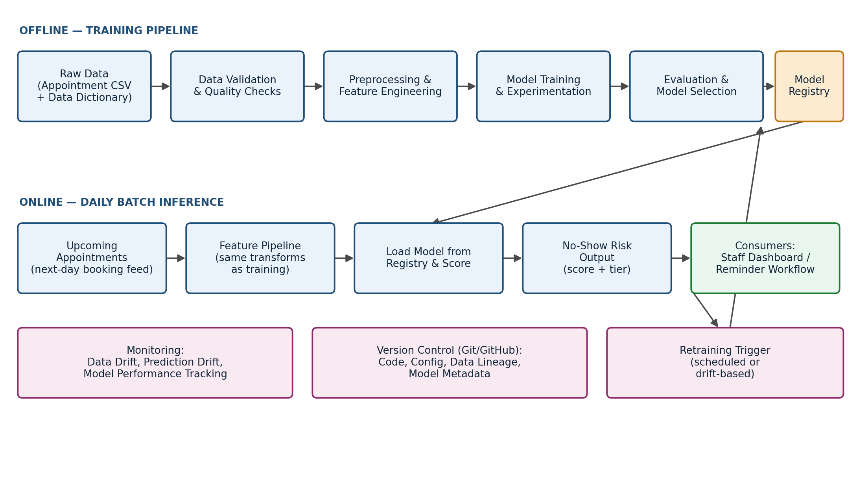

3.1 Component Summary
Component | Responsibility
Data validation | Checks schema against the Data Dictionary, flags missing values in distance_to_clinic_km / waiting_time_minutes, and rejects malformed records before they reach the pipeline.
Feature pipeline | Deterministic transforms (encoding, imputation, derived fields) shared between training and inference so the two never drift apart.
Training pipeline | Runs experiments, evaluates candidate models, and is only triggered manually or on a schedule — never on every new appointment.
Model registry | Stores each trained model artefact with its version, training data snapshot reference, metrics, and approval status.
Inference job | Loads the latest approved model and scores the next batch of upcoming appointments, on a daily schedule at this stage.
Monitoring | Tracks data drift (e.g. shifting appointment_type mix) and prediction/performance drift once ground-truth outcomes are available.
Version control | Git/GitHub holds pipeline code, configuration, and model metadata; raw data is never overwritten in place.

4. Proposed ML Workflow
- 1. Data ingestion & validation — load the appointment CSV against the Data Dictionary schema; log any violations.
- 2. Exploratory data quality review — confirm the extent and pattern of missingness in distance_to_clinic_km and waiting_time_minutes, and check class balance of appointment_outcome.
- 3. Preprocessing & feature engineering — encode categorical fields, impute or flag missing values, derive features such as no_show_rate_history from previous_no_shows / previous_appointments.
- 4. Time-aware train/validation/test split — split by booking_date or appointment_date rather than randomly, so the model is always evaluated on appointments that are chronologically after its training data.
- 5. Model training & experimentation — owned jointly with the Data Science track; the ML Engineering track provides the pipeline scaffolding and experiment logging, not the final algorithm choice.
- 6. Evaluation against agreed metrics — since no-shows are expected to be the minority class, prioritise recall/F1/ROC-AUC over raw accuracy.
- 7. Model registration — approved models are saved with a version tag, metrics snapshot, and the exact feature list used.
- 8. Batch inference — score upcoming appointments daily and publish results for the dashboard/reminder consumers.
- 9. Monitoring & retraining trigger — scheduled re-evaluation (e.g. monthly) or drift-triggered retraining, both logged rather than automatic in this initial design.

5. Key Dependencies

5.1 Data Dependencies
- HealthConnect_Appointment_Data.csv and HealthConnect_Data_Dictionary as the single source of truth for schema.
- Consistent target-variable and feature definitions with the Data Science track, since both tracks work from the same shared dataset.

5.2 Model Dependencies
- A frozen feature list per model version — inference must never silently accept a differently-shaped feature set than the model was trained on.
- A held-out, time-ordered evaluation set that is refreshed each retraining cycle rather than reused indefinitely.

5.3 System / Tooling Dependencies
- Python, Git and GitHub, as specified for the track.
- A lightweight model registry approach at this stage — versioned model files with a metadata log (JSON/CSV of run parameters and metrics) rather than a dedicated MLOps platform, unless the internship provides one later.
- A scheduler for daily batch inference (e.g. a simple cron job or notebook run in this phase; the choice of orchestration tool is deferred until Week 5+).

6. Reproducibility, Version Control & Model Management
- Git/GitHub repository with a clear structure separating data/raw, data/processed, notebooks, src (pipeline code), and models.
- Raw data is never edited in place — all cleaning happens into data/processed, per the assignment's resource-handling instructions.
- Fixed random seeds and a requirements file (requirements.txt) so experiments can be re-run with the same environment.
- Each trained model is saved with a version identifier, training data reference, hyperparameters, and evaluation metrics — enough to reproduce or audit any prediction after the fact.
- README.md updated to reflect the Week 4 system design and repository structure, as required by the professional development section of the brief.

7. Initial Implementation Approach
Week 4 is scoped to design, not build. The following is the intended starting point for Week 5 implementation:
- Set up the repository skeleton (folders above) and a requirements file.
- Implement data validation and the feature pipeline as reusable functions/modules, so the same code path serves both training and inference.
- Build the training pipeline as a notebook first, then refactor shared logic into src/ once an approach is confirmed with the Data Science track.
- Introduce a simple model registry (a models/ folder with versioned filenames plus a metrics log) before attempting batch inference.
- Defer real orchestration, a REST API, or a live dashboard integration to a later week, once the core pipeline is stable.

8. Assumptions, Limitations, Risks and Dependencies

8.1 Assumptions
- The dataset, though synthetic, is assumed to be structurally representative of real HealthConnect appointment patterns for the purposes of this exercise.
- Appointments are booked far enough in advance that a daily batch scoring cadence is operationally sufficient; true real-time scoring is not assumed to be required at this stage.

8.2 Limitations
- distance_to_clinic_km and waiting_time_minutes contain missing values; the extent has not yet been quantified and will need a documented imputation or exclusion decision.
- waiting_time_minutes cannot be used as a predictive feature since it is only known after check-in — it is a data-leakage risk if used naively.
- appointment_outcome bundles Cancelled together with Attended/No-Show; without a clear operational definition, Cancelled records could either be dropped or treated as a separate flow.

8.3 Risks
- Class imbalance: no-shows are likely a minority outcome, which can make a naive model look accurate while missing most true no-shows — needs class-aware evaluation, not just accuracy.
- Fairness/ethical risk: gender and age are available as features; predictions must be used to prioritise outreach and support, never to deny or deprioritise care, and should be checked for disparate impact across demographic groups.
- Feature/training skew: if the inference feature pipeline drifts from the training feature pipeline (e.g. different encoding logic), predictions silently degrade — mitigated by sharing one feature-pipeline codebase.

8.4 Dependencies / Coordination Risk
- This track's system design depends on the Data Science track's target and feature definitions; a mismatch would require rework of the pipeline scaffolding.
- Dashboard/reminder integration depends on output formats agreed with the Data Analytics and Generative AI tracks in later weeks.

Prepared for: AnalystLab Africa — HealthConnect Experience Lab, Week 4 (Machine Learning Engineering Track)

