

**EGERTON UNIVERSITY**

**PROPOSAL DOCUMENT**

**FOR**

**ONLINE CLASSROOM**

**PREPARED BY: MATARA FAITH NYASUGUTA**

**REG. NO.: S13/02353/19**

**PROJECT SUPERVISOR: MR. PETER KEMEI**

**PROJECT COORDINATOR: DR. BOSIRE**

**DATES:MARCH 2023**

**VERSION 1.1.0**

**ACKNOWLEDGEMENT**

Heartfelt gratitude to my father Francis Matara for his unwavering support and encouragement in this project. His insightful identification of the problem faced by traditional classrooms in our society and his belief in my abilities to make a difference has been the drive behind this noble initiative.

I thank my coordinator Dr. Bosire and the entire Egerton University Computer Science department for allowing me to undertake this project.

I would also like to thank my friends and classmates for all the skills and the experiences we built together over the period of the four years. Most of the skills that will be required to undertake this project we learnt together.

**TABLE OF CONTENTS**

ABSTRACT 1

Key Words 1

Chapter 1 1

1.0 INTRODUCTION 1

1.1 LITERATURE REVIEW 1

1.2 PROBLEM STATEMENT 2

1.3 JUSTIFICATION 2

1.4 RESEARCH QUESTION 3

1.5 RESEARCH OBJECTIVE 4

4

Chapter 2 4

2.0 PROPOSED SOLUTION 4

2.1 REQUIREMENT ANALYSIS 5

2.2 PLANNING 6

Method of Collecting Information 6

Project Scope 7

2.3 ARCHITECTURAL DESIGN 7

2.4 SOFTWARE DEVELOPMENT 8

Technologies 9

2.5 TESTING 9

2.6 DEPLOYMENT 10

Chapter 3 10

PRELIMINARY RESULTS 10

10

Chapter 4 11

CHALLENGES, OBSTACLES, RISKS 11

Chapter 5 12

SCHEDULE AND BUDGET 12

Schedule 12

Budget 12

Chapter 6 14

CONCLUSION 14

FUTURE WORKS 14

Chapter 7 15

REFERENCES 15

**2.1 Introduction 17**

2.1.1 Purpose 17

Document Conventions 18

Intended Audience and Reading Suggestions 18

Project Scope 19

**2.2 Overall Description 20**

Product Perspective 20

Product Features 20

User Problem statement 21

User Objectives 21

Operating Environment 23

Design and Implementation Constraints 23

User Documentation 24

Assumptions and Dependencies 25

User Constraints 25

**2.3 System Features 26**

**2.4 External Interface Requirements 27**

User Interfaces 27

Hardware Interfaces 28

Software Interfaces 28

Communications Interfaces 29

**2.5 Other Nonfunctional Requirements 29**

Performance Requirements 29

Safety Requirements 30

Security Requirements 30

Software Quality Attributes 31

Other requirements Attributes 32

There are no other requirement attributes. 32

**2.6 Preliminary Object-Oriented Domain Analysis 32**

Identify key stakeholders 32

Identify key objects and concept 32

Relationship between object and concept 33

Define attribute and behavior of objects 34

**3.1 INTRODUCTION 41**

3.1.1 Purpose and Scope 41

3.1.2 Project Executive Summary 41

3.1.3 Document Organization 41

3.1.4 Glossary 41

**3.2 SYSTEM ARCHITECTURE 41**

3.2.1 System Hardware Architecture 41

3.2.2 System Software Architecture 42

**3.3 FILE AND DATABASE DESIGN 44**

Database Management System Files 44

Non-Database Management System Files 46

**3.4 HUMAN-MACHINE INTERFACE 46**

Inputs 46

1.1.1 Login screen 46

1.1.2 Register page 46

1.1.3 Course creation screen 47

1.1.4 Quiz addition screen 48

1.1.5 Feedback addition screen 48

**3.5 DETAILED DESIGN 48**

Hardware Detailed Design 48

Software Detailed Design 49

Student 49

Instructor 50

Administrator 51

sequence diagram 51

Activity diagram 52

Internal Communications Detailed Design 53

User communication with the system is as shown below; 53

**EXTERNAL INTERFACES 56**

Interface Architecture 56

Interface Detailed Design 56

**3.6 SYSTEM INTEGRITY CONTROLS 57**

**4.1 INTRODUCTION 60**

4.1.1 Goals and Objectives 60

4.1.2 Statement of Scope 60

4.1.2.1 In Scope 60

4.1.2.2 Results 61

4.1.2.3 Out of Scope 62

4.1.3 Major Constraints 62

**4.2.0 TESTING PLAN 62**

4.2.1 Software to be tested 62

4.2.1.1 Interfaces 62

4.2.2 Testing Strategy 63

4.2.2.1 Unit testing 63

4.2.2.2 Integration testing 63

4.2.2.3 Validation testing 64

4.2.2.4 End to end testing 64

4.2.2.5 High order testing 64

4.2.3 Bug triage 64

**4.3.0 TEST PROCEDURE 65**

4.3.1Software to be tested 65

4.3.2 Testing procedure 65

4.3.2.1 Unit test cases 65

3.2.2 Integration testing cases 65

3.3 Validation testing 65

3.4 End-to-end testing case 65

4.3.5 Test criteria 66

4.3.5.1 Suspension criteria 66

4.3.5.2 Test completeness/ Exit criteria 66

**4.4.0 RESOURCE PLANNING 67**

4.4.1 System resources 67

4.4.2 Human resources 67

**4.5.0 TEST ENVIRONMENT 68**

**4.6.0 TESTING SCHEDULE AND ESTIMATION 69**

4.6.1 All project task and estimation 69

4.6.2 Schedule to complete the tasks 69

**4.7.0 TEST DELIVERABLES 70**

4.7.1 Before testing phase 70

4.7.2 During the test 70

4.7.3 After the testing cycles is over 70

5.1 SYSTEM OVERVIEW 72

5.1.1 Introduction 72

5.1.2 Overview of the system 72

5.2 SYSTEM REQUIREMENT 73

5.2.1 Hardware and software requirements 73

5.3 SYSTEM FEATURES 73

5.3.1 Registration feature 73

5.3.2 User Login 73

5.3.3 Student Dashboard 74

5.3.4 Instructor Dashboard 74

5.3.4 Admin Dashboard 75

5.4 SYSTEM SUPPORT 75

5.4.1 Overview 75

5.4.2 Online help 76

5.4.3 Feedback support 76

# **ABSTRACT**

The purpose of this online classroom project is to develop a comprehensive solution that provides the students and instructors a flexible, accessible and secure way to access educational material and track progress.This platform will include features such as course content management, multimedia presentations, online assessment and a feature for tracking students' performance.This platform will be designed to meet the needs of modern learners and educators and incorporates features to protect sensitive information.This online classroom platform represents a significant step forward in the delivery of education and training and provides a solution for addressing challenges of traditional classroom settings.

# **Key Words**

*online learning, instructor*

# **Chapter 1**

## **1.0 INTRODUCTION**

## 

Education has always been an integral part of human society, and over time, it has evolved significantly. With the advent of the internet, the world has become a global village, and information is just a click away. The traditional classroom setting has always been the cornerstone of education, but it has its limitations. The COVID-19 pandemic has highlighted the need for an alternative mode of education delivery that is flexible, accessible and secure. This is where the online classroom project comes in

The online classroom project is a comprehensive solution designed to provide students and instructors with a flexible, accessible and secure way to access educational material and track progress. This platform will include features such as course content management, multimedia presentations, online assessment and a feature for tracking students' performance. It will be designed to meet the needs of modern learners and educators and incorporate features to protect sensitive information.

The goal of this project is to provide a platform that is user-friendly and engaging, allowing learners to interact with the content and be able to track their progress.

The online classroom platform represents a significant step forward in the delivery of education and training, providing a solution for addressing the challenges of traditional classroom settings. It is my hope that this platform will bridge the gap between students and educators, providing a space for meaningful interaction and learning.

### **1.1 LITERATURE REVIEW**

The use of online platforms for education delivery has been gaining popularity over the past few years, not only in the United States but also in other countries around the world. In Kenya, for example, there has been a significant increase in the number of students and professionals opting for online courses.

According to [1], the number of Kenyan students enrolled in online courses stood at approximately 4,500 in 2015. By 2016, this number had grown to 9,000, representing a 100% increase from the previous year [2]. In 2017, a report by Jumia Travel Kenya [3] revealed that online education had become increasingly popular among Kenyan professionals seeking to upgrade their skills, and noted that Kenyan universities were offering more online courses than ever before. In 2018, a survey by the Research Solutions Africa Group [4] revealed that 57% of Kenyan university students preferred online learning to traditional classroom-based learning.

The use of technology in education has been increasing rapidly in recent years, as educators and institutions seek to provide students with more flexible and accessible learning environments [5]. Online learning platforms, in particular, have seen significant growth, as they offer students the ability to access educational material from anywhere, at any time [6]

To sum it up, this online platform is aligned with the current trend in education technology and there is a growing body of research and best practices to support its development and implementation.By leveraging the latest technologies and best practices, the platform has a potential to provide a flexible, accessible, and effective learning environment for students and instructors.

### **1.2 PROBLEM STATEMENT**

Problem: Traditional classroom setting limits the students’ access to education and provides a less engaging learning experience. Additionally, there is a need for a secure and efficient platform to manage the administration and delivery of online education.

Context: The increasing demand for flexible and accessible education, as well as the rise of remote learning, has created a need for a platform that can effectively support online education and provide a positive learning experience for students and instructors.

Goal: The goal is to develop a comprehensive online classroom platform that addresses the challenges of traditional classroom settings and provides flexible, accessible, and secure solutions for education and learning. A platform that will enable students and instructors to access educational material, track progress, and communicate effectively, while also providing the admin with the necessary tools to manage the platform to ensure the security of sensitive information.

### **1.3 JUSTIFICATION**

The traditional classroom model does not meet the needs of modern learners and educators who require a flexible and accessible learning environment. This online classroom platform provides a solution that meets those needs, by offering a convenient and efficient way to access educational materials.

The online classroom platform enhances student engagement and interaction through multimedia presentations, a feature that can help create a more dynamic and engaging learning experience for students.

With increased need for remote learning, the online classroom platform provides a solution that allows students to access educational material from anywhere provided there is internet connection.

By providing a comprehensive course management system for instructors. Instructors can easily create and deliver course content, monitor students progress, provide feedback and grades all from one platform.This improves efficiency and effectiveness of education and learning:

The online classroom platform provides valuable analytics and insights for instructors to evaluate the effectiveness of their courses and make data driven decisions about their teaching strategies.

By offering courses and certifications, the online classroom platform supports continuous learning and professional development, helping individuals to enhance their skills and knowledge throughout their careers.

In general, the online classroom platform project provides significant benefit for both students and instructors, making it a worthwhile investment for educational institutions and organizations.

### **1.4 RESEARCH QUESTION**

* How does the virtual learning environment provided by the platform affect the access to educational materials and the learning experience of students?
* How effective is the course management system in helping instructors create and deliver course content, monitor student progress, provide feedback and grades, and overall manage their courses?
* In what ways do multimedia presentations enhance student engagement and interaction on the online learning platform?
* How does the platform ensure the security and privacy of sensitive information, such as students' personal data, and what measures are in place to prevent data breaches?
* What impact does offering continuous learning and professional development opportunities through courses and certifications have on the career development of learners?
* How do the analytics and insights provided by the platform help instructors evaluate the effectiveness of their courses and make data-driven decisions about their teaching strategies?
* What features of the super user role facilitate the easy administration and management of the online learning platform?

### **1.5 RESEARCH OBJECTIVE**

**General objective**

## To provide a flexible and accessible virtual learning environment that enhances student engagement and interaction through multimedia presentations, and supports continuous learning and professional development through courses and certifications.

**Specific objective**

* To define the requirement of the online classroom as per user needs
* To design the classroom
* To develop according to the design
* To deploy the build system

# **Chapter 2**

## **2.0 PROPOSED SOLUTION**

The proposed solution for the traditional classroom setting is to develop an online classroom which is a web-based platform that provides students and instructors with a convenient and efficient way to access educational material and track progress. The platform will include the following key features:

* User registration and management: The platform will include a system for managing user registration and authentication, with the ability of the super user to approve, revoke or dismiss users.
* Course management: The platform will include a comprehensive course management system that allows instructors to create and manage courses, as well as monitor student progress and provide feedback and grades
* Multimedia presentations: The platform will support multimedia presentations, including the ability to upload and view a video, audio, and images.
* Learning materials: The platform will include learning materials such as course notes and quizzes that students can access at any time.
* Analytics and reporting: The platform will provide valuable analytics and reporting features that allows instructors to evaluate the effectiveness of their courses and make data-driven decisions about their teaching strategy
* User feedback and support: The platform will include a system for collecting and responding to user feedback as well as providing support for technical and administrative issues.
* Security and privacy: The platform will include robust security and privacy features to protect the confidentiality and privacy of user data.

This proposed solution will provide a comprehensive and flexible solution for education and learning while also ensuring the security of sensitive information. By developing a platform that is accessible, secure and easy to use, we will help to improve the learning experience for students and instructors and provide a valuable solution for addressing the challenges of a traditional classroom setting.

### **2.1 REQUIREMENT ANALYSIS**

### 

Functional Requirements:

User registration and authentication: The platform should have a system for managing user registration and authentication, with the ability of the super user to approve, revoke or dismiss users.

Course management: The platform should provide a comprehensive course management system that allows instructors to create and manage courses, as well as monitor student progress and provide feedback and grades.

Multimedia presentations: The platform should support multimedia presentations, including the ability to upload and view videos, audios, and images.

Learning materials: The platform should include learning materials such as course notes and quizzes that students can access at any time.

Analytics and reporting: The platform should provide valuable analytics and reporting features that allow instructors to evaluate the effectiveness of their courses and make data-driven decisions about their teaching strategies.

User feedback and support: The platform should include a system for collecting and responding to user feedback as well as providing support for technical and administrative issues.

Security and privacy: The platform should include robust security and privacy features to protect the confidentiality and privacy of user data.

Non-functional Requirements:

Usability: The platform should be user-friendly and easy to use for both students and instructors.

Performance: The platform should have good performance and response time to ensure a seamless learning experience.

Availability: The platform should be available 24/7 and accessible from any device with an internet connection.

Scalability: The platform should be scalable to accommodate a growing number of users and courses.

Reliability: The platform should be reliable, with minimal downtime and system failures.

Compatibility: The platform should be compatible with different browsers, operating systems, and devices.

By meeting these functional and non-functional requirements, the proposed online classroom system will provide a reliable, efficient, and user-friendly solution for education and learning.

### **2.2 PLANNING**

This will include the methods of collecting information and project scope.

### **Method of Collecting Information**

The data collection method for this project will include:

1. Surveys: Surveys will be used to gather information from both students and instructors about their needs and preferences for the online classroom platform. The information will be used to inform the design and development of the platform.
2. Interviews: Interviews with key stakeholders, including educators, instructional designers and IT professionals will provide valuable insights into the needs and requirements for the online classroom platform
3. User Testing: This will be used to gather feedback from students and instructors about the functionality and usability of the online classroom platform. This can be done using various methods such as usability testing and beta testing.
4. Data analysis: Data analysis will be used to gather information about the usage patterns and behavior of students and instructors on the online classroom platforms.This information will be used to inform the design and development of the platform, and to measure its effectiveness over time.

### **Project Scope**

The project scope for this online classroom platform includes all the activities, deliverables, and the outcomes that are necessary to deliver a working and functional platform. This depends on the requirements and the goals of the project as well as the resources and available budget. Below are the elements included in the project scope for this online classroom:

* User registration and management: This platform will include a system for managing user registration and authentication, with the ability of the super user to approve, revoke or dismiss users.
* Course management: This platform will include a comprehensive course management system that allows instructors to create and manage courses, as well as monitor student progress and provide feedback and grades
* Multimedia presentations: This platform will support multimedia presentations, including the ability to upload and view a video, audio, and images.
* Learning materials: This platform will include learning materials such as course notes and quizzes that students can access at any time.
* Analytics and reporting: This platform will provide valuable analytics and reporting features that allows instructors to evaluate the effectiveness of their courses and make data-driven decisions about their teaching strategy
* User feedback and support: This platform will include a system for collecting and responding to user feedback as well as providing support for technical and administrative issues.
* Security and privacy: This platform will also include robust security and privacy features to protect the confidentiality and privacy of user data

### **2.3 ARCHITECTURAL DESIGN**

The architectural design will include the following components:

User Interface: This component deals with the design of the user interface that will be used by students and instructors to interact with the system. The user interface should be easy to use, visually appealing, and accessible on different devices such as desktops, laptops, tablets, and smartphones.

Application Server: This component deals with the backend of the system that will handle the business logic and data storage. The application server should be scalable, reliable, and secure to ensure that the system can handle a large number of users.

Database Management System: This component deals with the storage and retrieval of data. The database management system should be able to handle large volumes of data, provide high performance, and ensure data consistency and integrity.

Security: This component deals with the security of the system, which is critical to protect sensitive information such as student data and personal information. The security component should include measures such as access control, encryption, and auditing to ensure the confidentiality, integrity, and availability of data.

Communication Protocols: This component deals with the protocols that will be used to enable communication between different components of the system. The communication protocols should be reliable, secure, and efficient to ensure the smooth functioning of the system.

Multimedia Integration: This component deals with the integration of multimedia elements such as videos, audios, and images into the system. The multimedia integration component should be designed to handle different types of media files, provide high-quality streaming, and ensure compatibility with different devices.

Analytics and Reporting: This component deals with the analytics and reporting features that will be used by instructors to evaluate the effectiveness of their courses and make data-driven decisions about their teaching strategies. The analytics and reporting component should provide easy-to-use tools for generating reports and visualizations based on data collected from the system.

### **2.4 SOFTWARE DEVELOPMENT**

Software Resources:

Code editor

The following software will be used as code editor:

Vs code

Version Control:

Git by GitHub.

### 

### **Technologies**

Programming languages:

1. Front End

The front-end of the platform using HTML, CSS, jQuery, and Bootstrap to provide a user-friendly and responsive interface.

1. Backend

The back-end functionalities of the platform will be developed using PHP and MySQL to support user management, course management, learning materials, analytics, and reporting.

1. Database

This project will be implemented using the MySQL database. As it is a powerful and widely used relational database known for its reliability, security and support for advanced data management features.

### **2.5 TESTING**

Unit testing: It is a testing method in which individual components of the software are tested in isolation to ensure that they meet their intended functionality. In this project, unit testing will involve testing individual functions and modules of the software, such as registration and authentication, course creation and management, and multimedia presentation.

Integration testing: It is a testing method in which multiple components of the software are tested together to ensure that they function correctly when combined. In this project, integration testing will involve testing the interaction and communication between different modules of the software, such as course management and multimedia presentation, to ensure seamless integration.

System testing: It is a testing method in which the entire system is tested as a whole to ensure that it meets its intended functionality and performance requirements. In this project, system testing will involve testing the online learning platform as a complete system, including all the modules, features, and functionalities to ensure that they work together effectively and efficiently to provide a quality user experience.

### **2.6 DEPLOYMENT**

Configuring the server environment: The server environment must be configured to support the PHP version and other dependencies required by the application.

Setting up the database: The database server must be set up and configured to support the application's database schema.

Copying the application files: The application files must be copied to the server's file system.

Configuring the application: The application must be configured to use the correct database connection details and other settings such as email server details, API keys, etc.

Testing the application: The application must be tested thoroughly in the production environment to ensure that it works as expected.

Continuous deployment: To ensure that the application remains up-to-date, a continuous deployment process can be set up where updates to the code are automatically deployed to the production environment after passing through a series of tests.

# **Chapter 3**

## **PRELIMINARY RESULTS**

## These are the interim findings of the project and they are typically generated early on in the research process and provide a snapshot of the progress and potential outcomes of the project. These results may help to guide further research or provide a basis for decision-making and prioritization of resources. For this online classroom platform, preliminary results refers to data on user engagement and satisfaction, educational outcomes and any other metrics used to evaluate the effectiveness and impact of this platform.

As this online classroom platform is still in development, it is not possible to provide preliminary results at this time. However, based on the expected outcomes and benefits of the platform, it can be assumed that the results will be positive and impactful. The platform aims to improve the learning experience for both students and instructors, by providing a flexible and accessible environment that can be used from anywhere, at any time..

This platform is expected to provide significant benefits, such as improved engagement and participation, better outcomes for students, and increased access to education and training opportunities. Additionally, the platform's security features are expected to provide peace of mind and build trust among users, helping to ensure the protection of sensitive information.

Overall, it is expected that this online classroom platform will have a positive impact on education and learning, and will be well received by students, instructors, and educational institutions. Once the platform is fully developed and implemented, its results can be evaluated and any necessary adjustments will be made to ensure its continued success.

# **Chapter 4**

## **CHALLENGES, OBSTACLES, RISKS**

Every project comes with its own set of challenges, obstacles and risks. This online classroom is no exception as elaborated below;

Technical challenge: Building an online classroom platform that is both user-friendly and technically sound can be a complex undertaking.There might be challenges in integrating different technologies and in ensuring the platform is scalable and reliable.

Data security and privacy: Storing and managing sensitive student and instructor data such as personal information and grades requires a high level of security and privacy. There may be challenges in ensuring the platform meets the industry standards for data protection and privacy and in responding to any security breaches or data loss incidents.

User adoption: Even the best learning platform will be of little use if the students and instructors do not adopt it and use it effectively. There may be challenges in encouraging users to adopt the platform, in providing training and support to users and ensuring the platform meets their needs and expectations.

Time and budget constraints: Developing and implementing this online learning platform can be time consuming and expensive and there may be constraints on time and budget that impact the scope and quality of the platform.

# **Chapter 5**

## **SCHEDULE AND BUDGET**

### Schedule

| Duration | Octo  2022 | Nov  2022 | Dec  2022 | Jan  2023 | Feb  2023 | Mar  2023 | April  2023 |
| --- | --- | --- | --- | --- | --- | --- | --- |
| Problem definition and proposal |  |  |  |  |  |  |  |
| Feasibility Study and requirement analysis |  |  |  |  |  |  |  |
| System design |  |  |  |  |  |  |  |
| Implementation and coding |  |  |  |  |  |  |  |
| System integration |  |  |  |  |  |  |  |
| Testing |  |  |  |  |  |  |  |
| Presentation and deployment |  |  |  |  |  |  |  |

### Budget

The budget will be between Ksh. 2,000 and Ksh.5,000. The money will be mainly used to access reading material and tutorials that may not be for free. This will, however, vary depending on the availability of research material.

| Item | Approximated cost |
| --- | --- |
| Printing | 500 |
| Research materials and tutorials | 700 |
| Internet | 1000 |

# **Chapter 6**

## **CONCLUSION**

This solution has the potential to revolutionize the way education is delivered, allowing for more flexible and accessible learning environments for students and instructors alike. This platform provides a wealth of features and tools that can improve the learning experience, such as course content management, multimedia presentations, interactive discussions, online assessments, and a feature for tracking student performance.

Furthermore, this platform's security features ensure that sensitive information is protected and that data is safe and recoverable in the event of a technical issue. This provides peace of mind for both students and instructors, and helps to build trust in the platform.

In conclusion, this online classroom platform represents a major step forward in the delivery of education and training and has the potential to positively impact the lives of millions of people. Its development and implementation will help to provide a more flexible, accessible, and secure learning environment for students and instructors alike.

## **FUTURE WORKS**

Some potential future works and features for an online classroom system:

1. Direct Messaging between Users: Adding a direct messaging feature within the online classroom system can enable students and instructors to communicate more easily and quickly with each other, enhancing the learning experience.
2. Live Class: Incorporating a live class feature within the online classroom system can allow instructors to deliver live lectures or conduct live discussions with students in real-time, creating a more engaging and interactive learning environment.
3. Payment Models: Implementing various payment models, such as subscription-based or pay-per-course, can provide more flexible payment options for students and generate additional revenue streams for the online classroom platform.
4. Notifications from the System: Incorporating a notification system within the online classroom system can alert users to important events or deadlines, such as upcoming assignments, quizzes, or class sessions.
5. Gamification: Introducing gamification elements, such as badges, rewards, or leaderboards, can motivate and engage students, making learning more fun and interactive.
6. Augmented and Virtual Reality: Incorporating augmented and virtual reality technologies can provide immersive and interactive learning experiences, allowing students to visualize and explore complex concepts in new and exciting ways.
7. Social Learning: Incorporating social learning features, such as group discussions, collaborative assignments, or peer reviews, can foster a sense of community and collaboration within the online classroom, enhancing the learning experience.

By incorporating these future works and features, an online classroom system can continue to evolve and adapt to the changing needs of students and instructors, providing a more engaging and effective learning environment.

# **Chapter 7**

## **REFERENCES**

[1] Business Daily Africa, "Online Courses Draw More Kenyans," 2015. [Online]. Available:<https://www.businessdailyafrica.com/markets/marketnews/Online-courses-draw-more-Kenyans/3815534-2860720-44p09g/index.html>. [Accessed: Apr. 24, 2023].

[2] Business Daily Africa, "Kenya Sees Online Education Growth," 2016. [Online]. Available:<https://www.businessdailyafrica.com/markets/marketnews/Kenya-sees-online-education-growth/3815534-3411618-12fq28fz/index.html>. [Accessed: Apr. 24, 2023].

[3] Jumia Travel Kenya, "Jumia Travel Kenya Reveals Online Education is on the Rise," 2017. [Online]. Available:<https://travel.jumia.com/blog/kenya/jumia-travel-kenya-reveals-online-education-is-on-the-rise/>. [Accessed: Apr. 24, 2023].

[4] Research Solutions Africa Group, "Online Learning Gains Popularity among Kenyan University Students," 2018. [Online]. Available:<https://www.researchsolutionsafrica.com/online-learning-gains-popularity-among-kenyan-university-students/>. [Accessed: Apr. 24, 2023].

[5] J. Jones, "The impact of technology on education: A review of the literature," Journal of Education and Learning, vol. 9, no. 2, pp. 125-140, 2020.

[6] A. Smith, "The growth of online learning: A review of current trends and future directions," Educational Technology Research and Development, vol. 67, no. 3, pp. 671-690, 2019.



**EGERTON UNIVERSTY**

**SOFTWARE SPECIFICATION DOCUMENT**

**FOR**

**ONLINE CLASSROOM**

**PREPARED BY: MATARA FAITH NYASUGUTA**

**REG. NO.: S13/02353/19**

**PROJECT SUPERVISOR: MR. PETER KEMEI**

**PROJECT COORDINATOR: DR. BOSIRE**

**DATES:MARCH 2023**

**VERSION 1.1.0**

**Overview**

The Software Requirements Specification (SRS) is a complete and detailed description of the behavior of a software system that is being developed. It defines the functional and non-functional requirements of the software, and serves as the official statement of what the system developers should implement. The SRS is developed in collaboration with stakeholders, including customers, users, and developers, and includes both a definition of user requirements and a specification of the system requirements.

The SRS provides a comprehensive understanding of what the software will do and how it will be expected to perform. It precisely defines the software product that will be built and provides guidance for the development team. The SRS is used to know all the requirements for the software development, and helps in designing the software. It serves as a reference point throughout the software development lifecycle, and is used to ensure that the final product meets the expectations of the customer.

Overall, the SRS is a critical document that is used to ensure that the software product is developed to meet the needs of the users and the customer. It provides feedback to the customer and guides the development team throughout the software development lifecycle. The SRS is carefully reviewed and approved by all stakeholders to ensure that everyone is aligned with the project goals and the final product meets the expectations of the customer.

# **2.1 Introduction**

## **2.1.1 Purpose**

The purpose of this document is to provide a complete and detailed description of the software requirements for this Online Classroom project. The document specifies the requirements for version 1.0.0 of the software, including all functional and non-functional requirements. It also includes a description of the database requirements for the system, as well as all integration with external systems. This document serves as the official statement of what the software development team should implement, and provides a clear and comprehensive understanding of the expected behavior of the system. It is also intended to guide the development team throughout the software development lifecycle, and to ensure that the final product meets the expectations of the project stakeholders.

## **Document Conventions**

The purpose of this section is to provide a detailed description of the conventions used in this document. The document is written using the IEEE style of writing, which is a standard format used for academic papers submitted to our institution. The font size used is 12, and the font family is Times New Roman. The line spacing is 1.5 to ensure easy readability.

The document contains headings in the prescribed order, with major topics being of higher precedence than inner headings. A table of contents is included to show the order of the headings and which ones are under which ones. Tables are used where necessary to communicate certain concepts.

The page numbering starts from the second page in Roman numerals, and there is a break so that the content of the document will have a different numbering scheme which will be Arabic. This is to ensure consistency with previously generated documents and to make it easy for readers to locate specific information within the document.

Overall, the conventions used in this document are intended to ensure that it is clear, organized, and easy to read. The use of the APA style of writing and the inclusion of a table of contents, headings, and tables will help to make the content of the document more accessible and understandable for its intended audience.

## **Intended Audience and Reading Suggestions**

The document is meant to be read in a sequential manner, from the overview to the conclusion by any interested person.

The main audience for this document are:

1. The project supervisor.

The supervisor will be a reader and reviewer of all versions of the document until the best version of the document is produced.

1. The project coordinator

Once the supervisor has approved the final and best version of this document, it will then be submitted to the project coordinator for reading.

1. The developer

The developer of the system will use this document as a point of reference throughout the development period.

## **Project Scope**

The project scope for this online classroom platform project includes all the activities, deliverables, and the outcomes that are necessary to deliver a working and functional platform. This depends on the requirements and the goals of this online classroom as well as the resources and budget available. Below are the elements included in the project scope for the online classroom:

1. User registration and management: The platform will include a system for managing user registration and authentication, with the ability of the super user to approve, revoke or dismiss users.
2. Course management: The platform will include a comprehensive course management system that allows instructors to create and manage courses, as well as monitor student progress and provide feedback and grades
3. Multimedia presentations: The platform will support multimedia presentations, including the ability to upload and view a video, audio, and images.
4. Learning materials: The platform will include learning materials such as course notes and quizzes that students can access at any time.
5. Analytics and reporting: The platform will provide valuable analytics and reporting features that allows instructors to evaluate the effectiveness of their courses and make data-driven decisions about their teaching strategy
6. User feedback and support: The platform will include a system for collecting and responding to user feedback as well as providing support for technical and administrative issues.
7. Security and privacy: The platform will also include robust security and privacy features to protect the confidentiality and privacy of user data

# **2.2 Overall Description**

## **Product Perspective**

The product perspective of this online classroom platform is that of a comprehensive, user-friendly, and accessible platform for education and learning. The platform will provide a single place for students and instructors to access and manage educational content and track progress. The system will be designed to meet the needs of modern learners and educators, who require a flexible and accessible learning environment, and will be a valuable solution for addressing the challenges of traditional classroom settings.

Compared to other existing online education platforms, the online classroom platform will offer a more robust set of features, including a user-friendly interface and multimedia presentation. The platform will also include a personal dashboard for each student and instructor, providing real-time feedback and analysis on performance and progress. Additionally, this platform will offer robust security features to protect sensitive information and data, ensuring the privacy and confidentiality of user data.

In conclusion, this online classroom platform represents a new and innovative solution for the delivery of education and learning that will help improve the learning experience of learners and instructors alike. It will provide a valuable solution for addressing the flexibility issues faced by modern learners and educators, and will set a new standard for online education platforms.

## **Product Features**

Product features of this online classroom platform includes a comprehensive set of tools and functionalities that aim to deliver a flexible, accessible, and secure learning environment. It includes a user registration and management system, which allows for the approval, revocation, and dismissal of users by a super user. This ensures that the platform is secure and only accessible to authorized users.

Instructors have the ability to create and manage courses through a comprehensive course management system, which also allows for the monitoring of student progress and the provision of feedback and grades.

The platform supports multimedia presentations, including the upload and viewing of video, audio, and images, providing a more engaging and interactive learning experience for students. It also includes learning materials such as course notes and quizzes that students can access at any time, helping them stay on track and achieve their educational goals.

The platform provides valuable analytics and reporting features, which allows instructors to evaluate the effectiveness of their courses and make data-driven decisions about their teaching strategy. Additionally, the platform includes a system for collecting and responding to user feedback and providing support for technical and administrative issues, ensuring that users have the support they need to make the most of the platform.

Finally, the platform has features for robust security and privacy, including measures to protect the confidentiality and privacy of user data. This ensures that users' sensitive information is protected, and they can feel confident using the platform for their education and learning needs.

## **User Problem statement**

The problem statement of the online classroom platform project is that traditional classroom settings limit students' access to education and provide a less engaging learning experience. Additionally, there is a need for a secure and efficient platform to manage the administration and delivery of online education. The increasing demand for flexible and accessible education and the rise of remote learning have created a need for a platform that can effectively support online education and provide a positive learning experience for students and instructors. The goal of this project is to develop a comprehensive online classroom platform that addresses these challenges and provides flexible, accessible, and secure solutions for education and learning.

## **User Objectives**

The learners' objectives in this online classroom include:

1. Accessing educational material and course content: Learners will be able to easily access and view the educational material and course content provided by instructors.
2. Tracking progress: Learners will be able to track their progress through the course and monitor their understanding of the material.
3. Receiving feedback: Learners will be able to receive feedback from instructors on their progress and performance.
4. Engaging in multimedia presentations: Learners will be able to engage with multimedia presentations, including video, audio, and images.
5. Participating in quizzes and assessments: Learners will be able to participate in quizzes and assessments to test their understanding of the material.
6. Accessing learning materials: Learners will be able to access learning materials, such as course notes, at any time.

In summary, the learners' objectives include having a flexible and engaging learning experience that allows them to access, engage with and understand educational material and receive support and feedback from instructors.

The instructors' objectives include:

1. Create and manage courses effectively
2. Monitor student progress and provide feedback and grades
3. Use multimedia presentations to deliver course material
4. Access analytics and reporting features to evaluate the effectiveness of their courses
5. Receive and respond to user feedback
6. Enhance the overall learning experience for their students.

The objectives of the super user or admin are to:

1. Manage user registration and authentication by approving, revoking or dismissing users as necessary.
2. Monitor and maintain the overall functionality and performance of the platform.
3. Ensure the security and privacy of user data by implementing robust security and privacy features.
4. Provide technical and administrative support to users.
5. Generate valuable analytics and reporting to evaluate the effectiveness of the platform and make data-driven decisions.
6. Manage and maintain the platform to ensure smooth and efficient operation.

## **Operating Environment**

The operating environment for this online classroom platform is designed to be flexible and accessible to a wide range of users. As it is a web application, the system will be hosted on cloud servers, which offers scalability and cost savings compared to purchasing and maintaining physical servers. This hosting solution also provides increased security for sensitive user data.

The system can be accessed from any device with a web browser installed, including mobile phones, computers, and tablets. This platform is designed to run seamlessly on any of the popular web browsers, such as Mozilla Firefox, Google Chrome, Internet Explorer, Microsoft Edge, Safari, Opera Mini, and others.

It is also designed to run on a variety of operating systems, including Windows, Android, Mac, and Linux, without encountering any difficulties. This means that users can access the platform from a range of devices and operating systems, providing greater flexibility and accessibility.

## **Design and Implementation Constraints**

Design implementation:

1. The online classroom platform will be developed using a web-based architecture, allowing for access from any device with an internet connection and web browser.
2. The platform will utilize cloud hosting services to ensure scalability and efficient performance.
3. The platform will be developed using responsive design principles to ensure optimal user experience across different devices and screen sizes.
4. The platform will incorporate user-friendly interfaces and navigation to enhance the overall user experience.
5. The platform will be integrated with multimedia presentation capabilities, including video, audio, and image support.

Constraints:

1. Limited budget: The platform development will be subject to budget constraints, which may impact the scope and features of the project.
2. Time constraints: The project timeline may be limited, which could impact the speed of development and the overall quality of the platform.
3. Technical limitations: There may be technical limitations that could impact the performance and functionality of the platform.
4. Privacy and security: Ensuring the privacy and security of user data is a high priority and the platform must be designed with robust security measures to protect sensitive information.
5. Integration with existing systems: The platform needs to be integrated with data analytics tools thus there may be additional constraints or challenges that need to be addressed.
6. User adoption: The success of the platform will depend on the adoption and usage by both students and instructors, which may be influenced by factors such as the usability of the platform, the availability of relevant courses, and the overall user experience.

## **User Documentation**

A comprehensive user manual will be provided to assist users in understanding the system functionalities and accessing the various features offered by the online classroom platform. The user manual will be available on the homepage of the application and will be divided into two distinct versions: one for end users and another for administrators. This distinction is important due to the difference in expertise levels between these two user groups.

The user manual will include the following key elements:

1. Introduction: A brief overview of the online classroom platform and its purpose.
2. System Installation Guide: Step-by-step instructions on how to install the platform.
3. Functional Description: A detailed description of the system's functions and features, including user registration and management, course management, multimedia presentations, learning materials, analytics and reporting, user feedback and support, and security and privacy measures.

The user manual will be based on the guidelines and standards set forth by Sommerville in his descriptions of user manual standards (Sommerville, 2001). By following these standards, the user manual will provide clear, concise, and accessible information to assist users in effectively utilizing the online classroom platform.

## **Assumptions and Dependencies**

Assumptions and dependencies are important factors to consider when planning and implementing a project, as they can have a significant impact on the success of the project. Here are some of the assumptions and dependencies that are relevant to this online classroom platform project:

Technical Assumptions: This includes assumptions about the availability of certain technologies, such as data analysis, and the ability to integrate these technologies into our platform. Other assumptions involve the scalability and reliability of the platform, and its ability to manage data security and privacy.

User Adoption Assumptions: It includes assumptions about the willingness of students and instructors to adopt and use the platform, and the level of training and support they will require. Also the assumptions about the level of user engagement and satisfaction with the platform.

Time and Budget Assumptions: It includes assumptions about the amount of time and resources required to develop and implement the platform, and the availability of these resources.

Dependencies: The success of this online classroom platform depends on several factors, including the availability of required technologies and resources, the willingness of users to adopt and use this platform, and the ability to integrate the platform with data analysis tools.

Having identified these assumptions and dependencies and communicated them to the stakeholders involved in this project, this will help in ensuring that the project is well-planned, that risks are identified and managed, and that the project is delivered on time, within budget, and to the desired quality.

## **User Constraints**

Technical Limitations: Some users may have limited access to technology, such as a stable internet connection, a modern browser, or a device with sufficient processing power. These technical limitations may impact the user's ability to access and use the platform effectively.

User Requirements: This platform must meet the needs and expectations of both students and instructors, and there exists constraints on the types of features and functionality that can be included in the platform. It is important to understand and respond to the needs and expectations of both user groups.

Data Privacy and Security: Users may have concerns about the privacy and security of their personal and educational data, and there may be constraints on the platform's ability to meet these privacy and security requirements.

Time Constraints: Both students and instructors may have limited time to use the platform, and there are constraints on the amount of time available for training and support. The platform will be designed to be efficient and accessible, even for users with limited time.

# **2.3 System Features**

The online classroom system has a number of key features to support the delivery and management of education. These features include:

1. User Management: This feature allows the administrator to manage user accounts, including the registration of students and instructors, account activation, and the assignment of user roles and permissions. This helps to ensure the security of sensitive information and the efficient management of user accounts.
2. Course Management: This feature provides a comprehensive course management system, allowing instructors to create and manage courses, including course content and enrolment. This provides a flexible and accessible solution for instructors to deliver and manage their courses.
3. Learning Management: This feature provides a system for tracking student progress, managing assessments and quizzes, and providing feedback and grades to students. This helps instructors to evaluate student progress and make data-driven decisions about their teaching strategy.
4. Resource Management: This feature provides access to learning resources, such as course materials, videos, and presentations, that students can access at any time. This supports student learning and provides a flexible and accessible solution for education.
5. Reporting and Analytics: This feature provides valuable analytics and reporting features that allow instructors to evaluate the effectiveness of their courses and make data-driven decisions about their teaching strategy. This helps to ensure the quality of education and support the continuous improvement of the platform.
6. Security and Privacy: This feature provides robust security and privacy features to protect the confidentiality and privacy of user data, including data encryption, secure data storage, and user authentication. This helps to ensure the security of sensitive information and the protection of user privacy.

# **2.4 External Interface Requirements**

## **User Interfaces**

The user interface (UI) of this online classroom platform is a critical aspect of its overall design and functionality. The UI will need to be designed in a way that makes it easy for users to access and use the platform, regardless of their technical abilities. This will be achieved by incorporating several key design requirements, including:

1. User-Friendly Design: The UI will be intuitive and easy to navigate, with clear and concise menus, buttons, and labels. This makes it simple for users to find the features and tools they need, and reduces the risk of confusion and frustration.
2. Responsive Design: The UI will be optimized for different devices, including desktop computers, laptops, tablets, and smartphones. This means that the platform should automatically adjust its layout and display to fit the screen size of the device being used.
3. Integration with Other Tools: The UI will be able to integrate with other tools and resources, such as the data analysis tools. This makes it easy for users to access the tools and resources they need, without having to switch between multiple applications.
4. User Feedback: The UI will include a mechanism for users to provide feedback and suggestions, allowing the platform to be improved over time based on user feedback. This helps to ensure that the platform continues to meet the evolving needs of its users, and provides a more enjoyable and productive experience.

## **Hardware Interfaces**

This system will not have any hardware specification requirement as it will be operating on top of the underlying operating system and will not be directly interacting with the device's hardware. The web application will be hosted on cloud servers, allowing for scalability and cost-effectiveness, as the hosting space will be rented instead of purchasing servers and security. The system's reliance on the cloud servers means that it will only require a web browser installed on any device, such as mobile phones, computers, etc. to run the application. The application will be able to run on any of the main browsers, such as Mozilla Firefox, Google Chrome, Internet Explorer, Microsoft Edge, Safari, Opera mini, and other popular browsers, without any difficulties. Additionally, the system will run on any operating system, such as Windows, Android, Mac, Linux, etc. without any difficulties. This design allows for maximum accessibility and usability, making the system available to a wide range of users.

## **Software Interfaces**

The software requirements for this online classroom platform includes:

1. Learning management system (LMS) software for managing and delivering course content, assignments, and assessments.
2. Content authoring tools for creating and uploading multimedia materials, such as videos, audios, and images.
3. Student information system (SIS) software for managing student records, enrollment, and performance data.
4. Secure authentication and authorization protocols to ensure the privacy and security of users.
5. Cloud-based hosting to enable easy and scalable access to the online classroom platform.
6. Analytics and reporting tools for monitoring and analyzing student performance and engagement.
7. Mobile-friendly design to enable access to the online classroom platform from mobile devices.

## **Communications Interfaces**

1. The system will be an online application and will therefore use HTTP protocol to communicate with the server.
2. There will be a feature that uses emails to confirm the identity and to be used when renewing passwords.
3. Forms will be used to collect user data and the data will be posted to the server using the POST method.
4. The communications to and from the website will be encrypted by the help of SSL. This will be acquired from a third party, preferably the hosting company.

# **2.5 Other Nonfunctional Requirements**

## **Performance Requirements**

Response Time: The platform will be able respond quickly to user requests, with minimal delays or lag times.

Scalability: The platform will be able to handle increasing numbers of users and course offerings, without experiencing significant performance degradation.

Availability: The platform will be available to users on a 24/7 basis, with minimal downtime for maintenance or upgrades.

Reliability: The platform will be reliable, with minimal errors or technical issues, to ensure that users can complete their courses and access their educational content without interruption.

Security: The platform will protect the privacy and security of user data, including personal information, course materials, and communication between users.

Bandwidth Requirements: The platform will be designed to work efficiently with a range of network bandwidths, to accommodate users with varying levels of internet connectivity.

Mobile Optimization: The platform will be optimized for use on mobile devices, including smartphones and tablets, to allow users to access their educational content and participate in learning from anywhere.

## **Safety Requirements**

Data Privacy: The platform will be able protect the privacy of user data, including personal information, course materials, and communication between users. This includes measures to secure data storage and transmission, and to prevent unauthorized access to user data.

User Authentication: The platform will include measures to authenticate users, such as user login credentials, to ensure that only authorized users have access to the platform and its features.

Incident Response: The platform will have a plan in place for responding to security incidents, such as data breaches or unauthorized access, to minimize harm to users and ensure a rapid and effective response.

User Awareness: The platform will be able educate users about the importance of online safety, including measures to protect their personal information such as passwords.

Compliance: The platform will be able comply with relevant laws and regulations, including data protection and privacy laws, to ensure that it is used in a responsible and ethical manner.

## **Security Requirements**

Data Encryption: The platform will encrypt sensitive data, such as user login credentials and personal information, to prevent unauthorized access and protect against data breaches.

Access Controls: The platform will implement role-based access controls, such as user permissions, to ensure that only authorized users have access to sensitive data and features.

Network Security: The platform will implement measures to secure the network, such as secure protocols, to prevent unauthorized access.

Vulnerability Management: The platform will regularly assess and address vulnerabilities in the system, such as software vulnerabilities, to reduce the risk of security incidents.

Compliance: The platform will comply with relevant security standards, such as ISO 27001, to ensure that it is used in a secure and responsible manner.

## **Software Quality Attributes**

Usability: The platform will be user-friendly and easy to use, with a clear and intuitive interface that allows users to access and use the platform effectively.

Reliability: The platform will be reliable and dependable, with high availability and low downtime to ensure that users can access the platform when they need to.

Performance: The platform will be fast and responsive, with low latency and high throughput, to ensure that users can access and use the platform efficiently.

Scalability: The platform will be scalable, with the ability to accommodate growth and handle increased user traffic, to ensure that it can meet the demands of a growing user base.

Security: The platform will be secure, with measures in place to protect the confidentiality, integrity, and availability of the platform and its data.

Maintainability: The platform will be easy to maintain, with a clear and well-documented codebase that allows developers to quickly and effectively update and improve the platform.

Compatibility: The platform will be compatible with a range of devices and platforms, including desktop and mobile devices, to ensure that users can access the platform from a range of locations and devices.

## **Other requirements Attributes**

## There are no other requirement attributes.

# **2.6 Preliminary Object-Oriented Domain Analysis**

A preliminary Object-Oriented Domain Analysis is a key step in the development of this online classroom platform, as it helps to identify and define the core objects and concepts that make up the platform's domain. The following steps are followed to perform a preliminary Object-Oriented Domain Analysis for this project:

## **Identify key stakeholders**

The key stakeholder for this project include:

1. Learners
2. Instructors
3. Super user/Admin

They are the ones who will use the platform and be impacted by its development.

## **Identify key objects and concept**

The next step is to identify the key objects and concepts in the domain, such as courses, certifications, user profiles, and assignments as depicted below:

User profiles: This object represents the profiles of students and instructors who use the platform. Each profile includes information such as the user's name, email address, password address, Registration date, gender and date of birth.

Courses: This object represents the courses that are available on the platform. Each course includes information such as its title, description, and instructor start and end dates, prerequisites, list of students pursuing the course, lessons, quizzes, final exams and its status either pending, rejected or approved.

Certifications: This object represents the certifications that students can earn by completing courses. Each certification includes information such as its title and the courses that are required to earn it and the students’ name.

Assignments: This object represents the assignments that students can complete as part of their coursework. Each assignment includes information such as its title, description, and due date.

Grades: This object represents the grades that students receive for their assignments. Each grade includes information such as the assignment title and the student's score and its general contribution to the grade.

Conduct System: This object represents the system that governs user behavior on the platform. It includes rules and regulations, as well as the process for revoking user rights or dismissing users.

Super User: This object represents the user who has the responsibility of reviewing and approving user registrations, courses, certifications, and the conduct system.

These objects and concepts form the core of this online classroom platform, and understanding them is crucial for designing and developing a high-quality platform that meets the needs of students and instructors.

## **Relationship between object and concept**

Once the objects and concepts have been identified, the next step is to define the relationships between them. The following are the relationships that exists between the key objects in this online classroom:

User profiles and courses: Each user profile will be associated with one or more courses. For example, a student will be enrolled in several courses, while an instructor will teach multiple courses.

Courses and certifications: Each course will be associated with one certification.Example, on completion of a single course one is given a single certificate.

Courses and assignments: Each course will have multiple assignments associated with it. For example, a course on programming will have assignments on topics such as object-oriented programming, data structures, and algorithms.

Assignments and grades: Each assignment has a grade associated with it. For example, a student will receive a grade of 95% for an assignment on data structures.

User profiles and the conduct system: Each user profile will be governed by the conduct system. For example, a user who violates the conduct system will have their rights revoked or be dismissed from the platform.

Super User and user profiles: The super user will be responsible for reviewing and approving user registrations, courses, certifications, and the conduct system.

## **Define attribute and behavior of objects**

The final step is to define the attributes and behaviors of the objects, such as the fields in a student profile or the methods that can be performed on a course.

Here are the attributes and behaviors that can be associated with the key objects in an online classroom platform:

User profiles:

Attributes:

1. User name
2. Email address
3. Profile type (student or instructor)
4. Password
5. Address
6. Registration date
7. Gender
8. Date of birth

Behaviors:

1. Register a new profile
2. Update profile information

Student:

Attributes:

1. Student ID number
2. Enrolled courses
3. Completed certification
4. Progress status
5. Grades for completed assignment

Behavior:

1. Enroll in a course
2. Complete an assignment
3. View grades and progress

Instructor:

Attributes:

1. Employers’ ID
2. Speciality

Behavior:

1. Create a new course
2. Update course information
3. Add course material
4. Create a new assignment
5. Update assignment information
6. Grade an assignment
7. Track students progress

Courses:

Attributes:

1. Course name
2. Course description
3. Course instructor
4. Course material (e.g. videos, reading material, assignments)
5. Course certification
6. Number of enrolled students
7. Course status (open, closed, pending approval)

Behaviors:

1. Create a new course
2. Update course information
3. Add course material
4. Approve a course
5. Dismiss a course
6. Enroll in a course

Assignments:

Attributes:

1. Assignment name
2. Assignment description
3. Assignment due date
4. Assignment grade

Behaviors:

1. Create a new assignment
2. Update assignment information
3. Grade an assignment
4. View grades for completed assignments

Certifications:

Attributes:

1. Certification name
2. Certification description
3. Required courses
4. Number of certified students

Behaviors:

1. Create a new certification
2. Update certification information
3. Approve a certification
4. Dismiss a certification

Conduct System:

Attributes:

1. Conduct rules
2. User conduct history

Behaviors:

1. Create conduct rules
2. Update conduct rules
3. Monitor user conduct
4. Revoke user rights
5. Dismiss a user

Super User:

Attributes:

1. Super User name
2. Super User email address
3. Super User profile status (active or inactive)

Behaviors:

1. Review and approve user registrations
2. Review and approve courses
3. Review and approve certifications
4. Monitor the conduct system
5. Revoke user rights
6. Dismiss a user



**EGERTON UNIVERSITY**

**SOFTWARE DESIGN DOCUMENT**

**FOR**

**ONLINE CLASSROOM**

**PREPARED BY: MATARA FAITH NYASUGUTA**

**REG. NO.: S13/02353/19**

**PROJECT SUPERVISOR: MR. PETER KEMEI**

**PROJECT COORDINATOR: DR. BOSIRE**

**DATES:MARCH 2023**

**VERSION 1.1.0**

*Overview*

*The System Design Document describes the system requirements, operating environment, system and subsystem architecture, files and database design, input formats, output layouts, human-machine interfaces, detailed design, processing logic, and external interfaces.*

# **3.1 INTRODUCTION**

## **3.1.1 Purpose and Scope**

This document provides a description of how the online classroom system will be implemented to satisfy the system requirements as specified in the SRS. The document will act as a primary point of reference in the implantation phase of the development. It describes the overall system architecture and the data required for the implementation of this system.

## **3.1.2 Project Executive Summary**

The online classroom is a web-based application that aims at providing comprehensive solutions for learners and instructors. It will enable learners to access educational material in a flexible and secure manner while enabling the instructors to track their learners’ progress. The system will be designed to meet the needs of a modern day learner and instructor and incorporate features to protect their sensitive data.

## **3.1.3 Document Organization**

This document is written using IEEE style of writing. This is where the font size is 12 and the font family used is Times New Roman. This is the standard format used for the academic papers that have been submitted to our institution. This is also to allow for consistency with the previously generated documents. The line spacing will be 1.5 for easy readability.

There will be headings in the prescribed order with major topics being of higher precedence than inner headings. There will be a table of contents showing the order of the headings and which ones are under which ones. This document contains tables where necessary to communicate certain concepts. The page numbering will start from the second page in roman numbers and there will be a break so that the content of the document will have a different numbering scheme which will be Arabic.

## **3.1.4 Glossary**

API – Application Programming Interface

SRS – Software Requirements Specification

# **3.2 SYSTEM ARCHITECTURE**

## **3.2.1 System Hardware Architecture**

The hardware architecture for this online classroom will involve several components including:

* Web Client: The web client is the interface that learners and instructors will use to access the online classroom platform. This can be a desktop or mobile device such as a laptop, tablet, or smartphone. The web browser used to access the online classroom system needs to support HTML, CSS, JavaScript, and AJAX to ensure a seamless experience for the users. Additionally, the use of Bootstrap makes the online classroom system responsive and compatible with various screen sizes.
* Cloud Servers: The cloud servers will be responsible for hosting and delivering the online classroom platform to users. The cloud servers typically use virtualization technology to provide scalable and flexible computing resources that can handle the growing demand of users. The cloud servers are located in data centers around the world and managed by a third-party hosting company.
* Database: The database will store all the user data, course materials, and other information related to the online classroom platform. This will include learner profiles, course content, assessment data, and other metadata. The database will typically be hosted on the cloud servers and use an object relational database management system (postgreSQL).
* File Storage: The file storage component of this architecture will be used to store multimedia files, such as videos, audios, and images. These files are typically too large to store in the database and are instead stored in a separate file storage system. The file storage will use a cloud-based storage service ie. Google Cloud Storage.

Below is the hardware architecture of this system

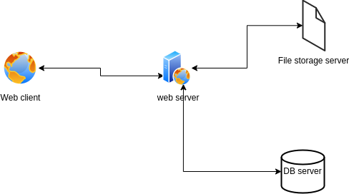

## **3.2.2 System Software Architecture**

The online classroom platform software architecture involves:

* Presentation Layer: That will be responsible for rendering the user interface of the online classroom platform. In this architecture, Bootstrap will be used to design the user interface.
* Application Layer: This will provide the business logic and functional components of the online classroom platform. In this architecture, Php will be used to build the application layer.
* Microservices: The online classroom platform will use microservices, which are small, independent services that will work together to form a larger system. In this architecture, microservices will be used to handle specific tasks, such as user authentication, course,grading,notifications and analytics management.
* Data layer: In the data layer of this online classroom platform, the main database used will be mySQL. The data layer will also include file storage.

Below is the system software architecture

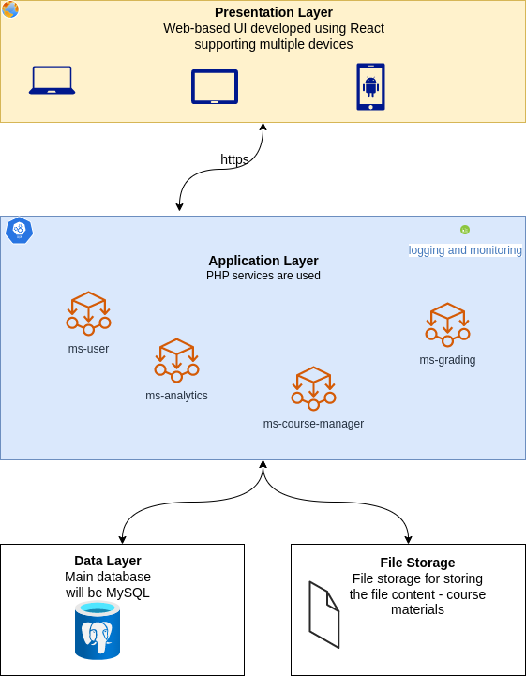

# **3.3 FILE AND DATABASE DESIGN**

The system will use a MySQL database for storing data. The database will store user’s information and course information. All other uploaded files and images for the system will be stored in a file system on the server. All the database tables will be normalized up to the third normal form.

## **Database Management System Files**

The system will use the MySQL database engine. The database will contain the following tables.

The following diagram shows the conceptual model of the database entities and relationships

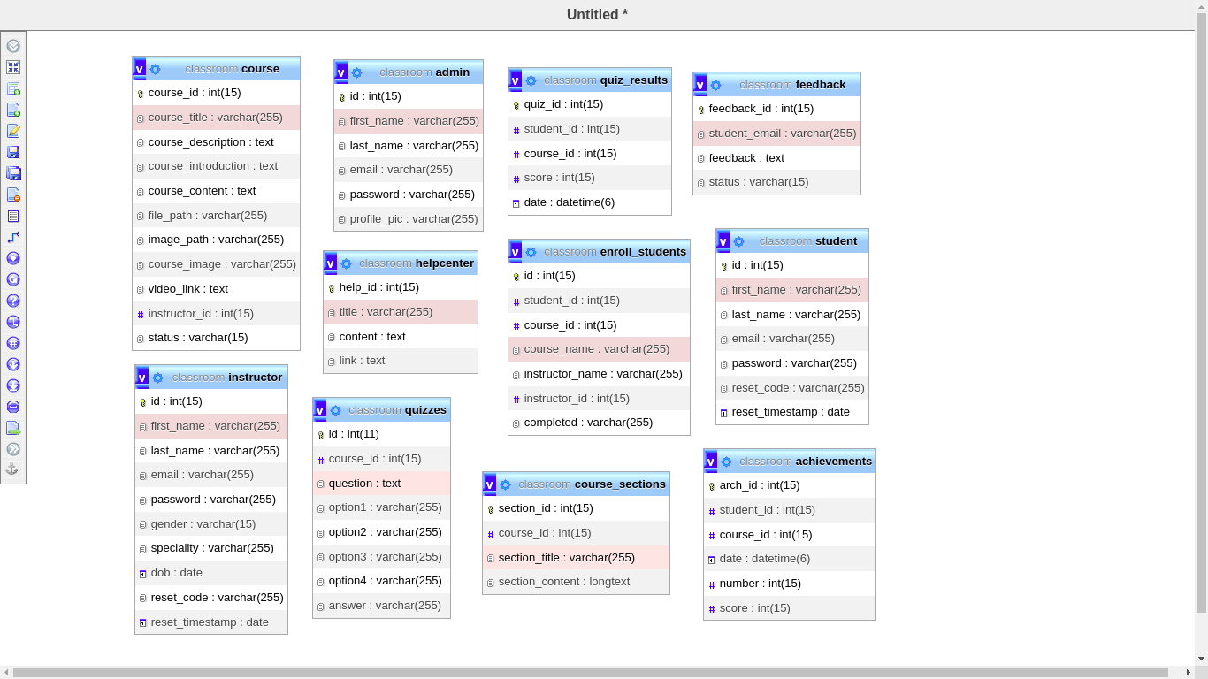

Entity relational diagram

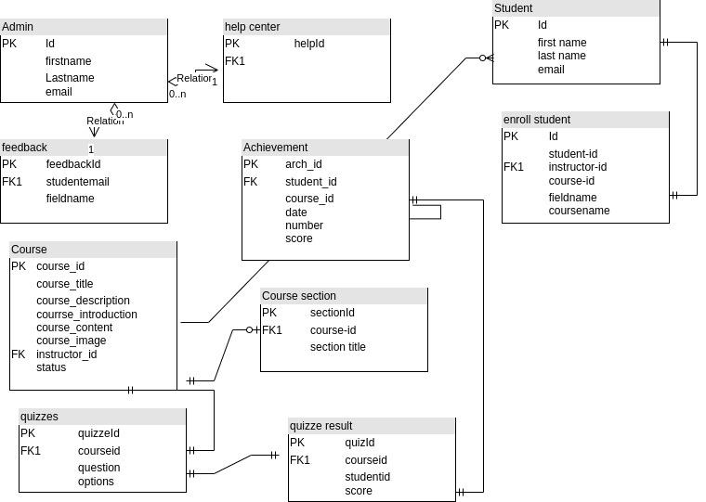

## **Non-Database Management System Files**

This system will use Google Cloud storage, a cloud-based file storage service offered by Google Cloud Platform. As it is a highly scalable and durable object storage service that will allow storage and retrieval any amount of data from anywhere in the world.

# **3.4 HUMAN-MACHINE INTERFACE**

## **Inputs**

User inputs will be captured using Angular’s reactive forms.

### Login screen

The login screen will capture the login details of the user (username and password) for authentication into the system.

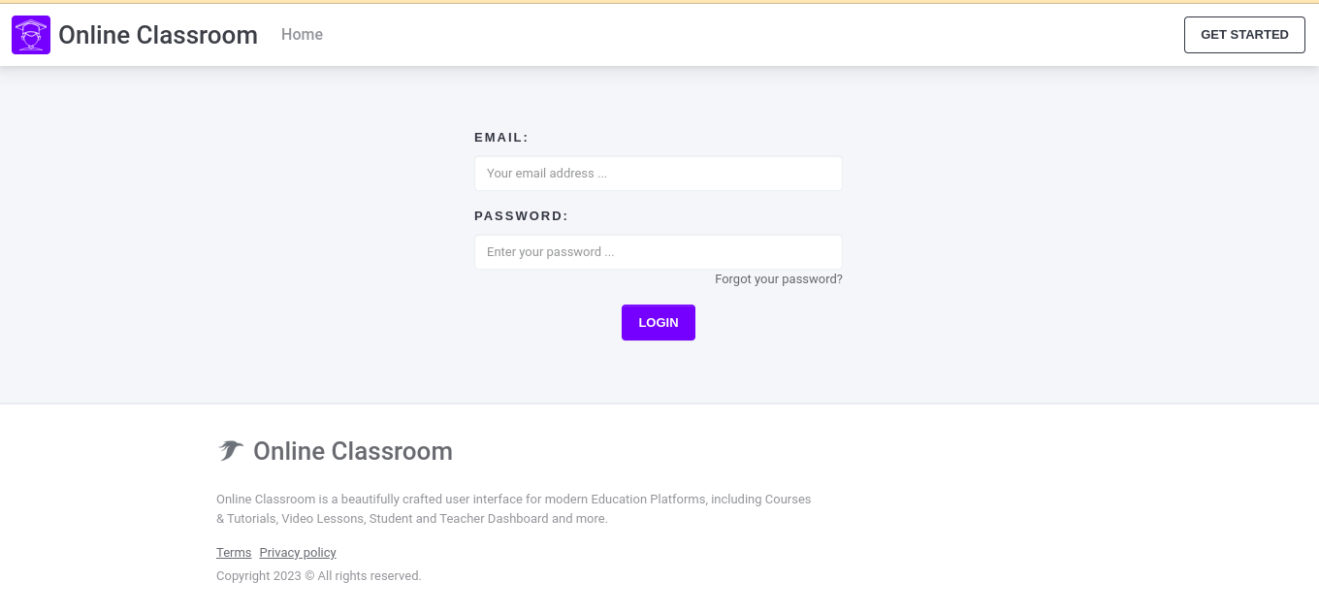

### Register page

This screen will capture the user details to create a new user account.

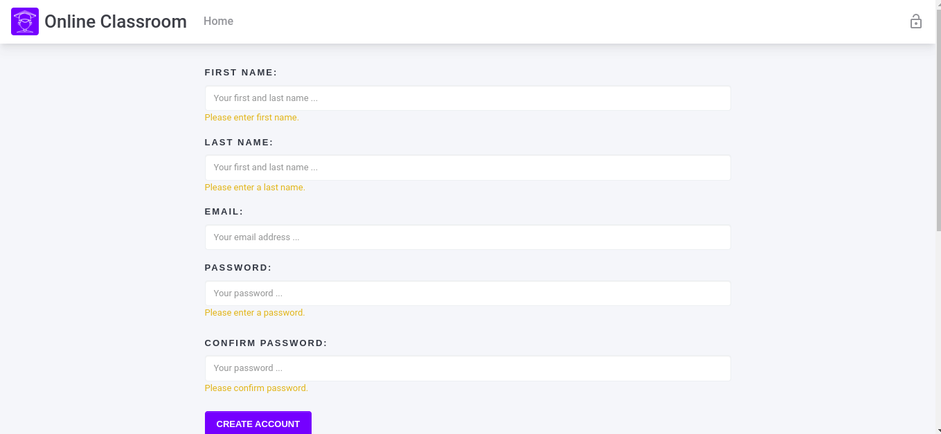

### Course creation screen

This screen will be used to input the details about the course

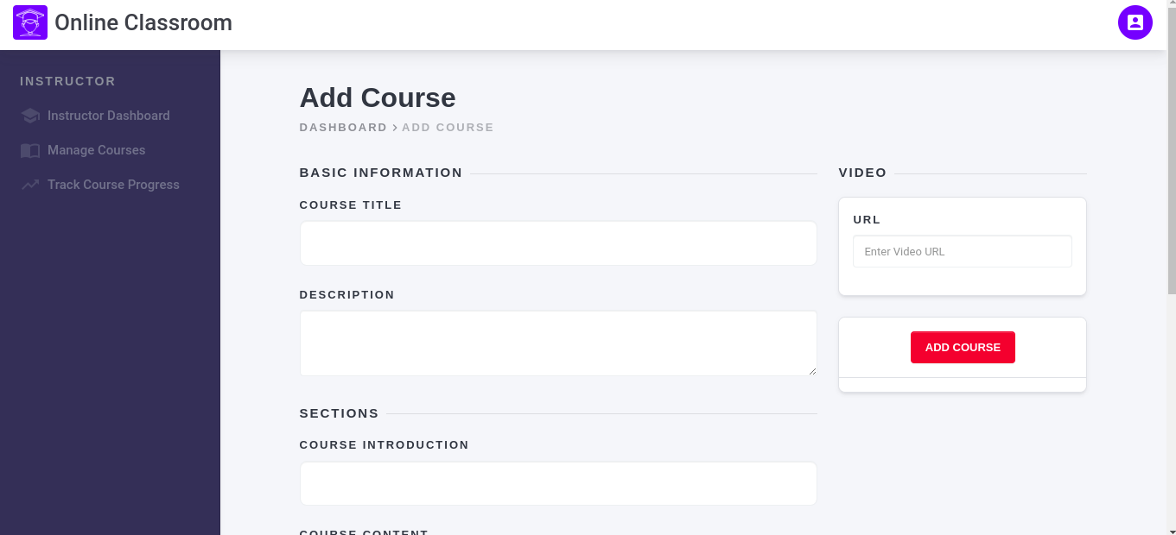

### Quiz addition screen

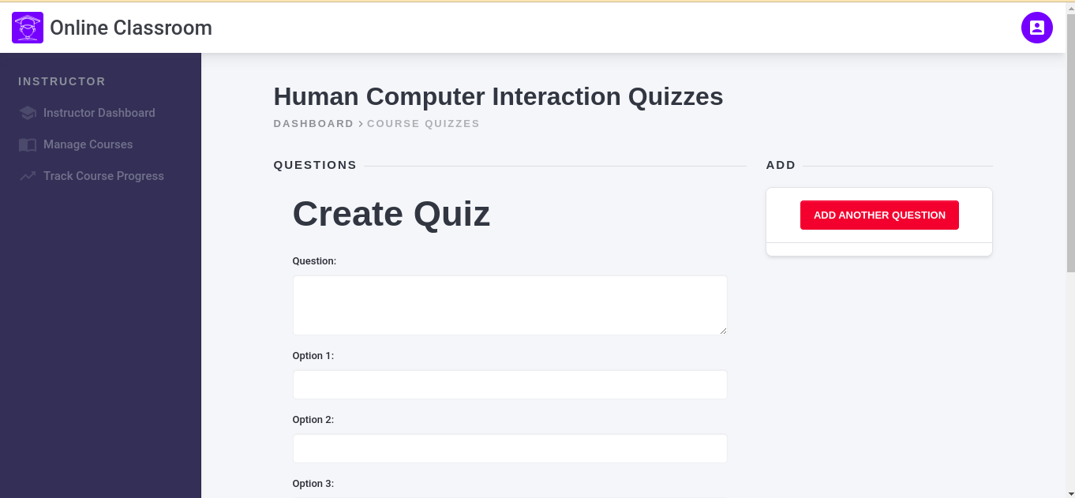

### Feedback addition screen

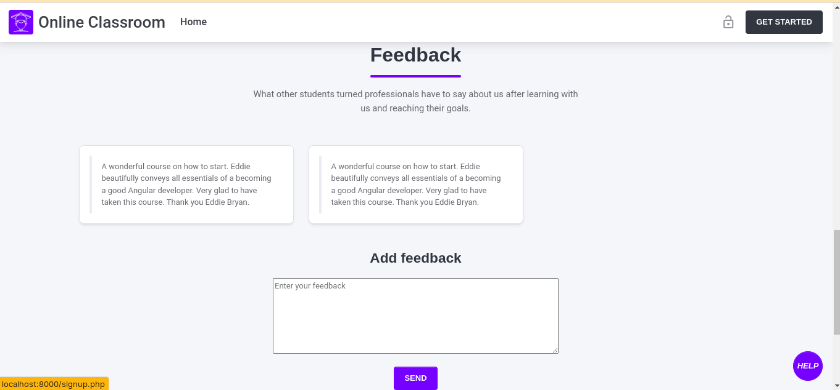

# **3.5 DETAILED DESIGN**

## **Hardware Detailed Design**

It consists of the machines used and the servers as show in the diagram below;

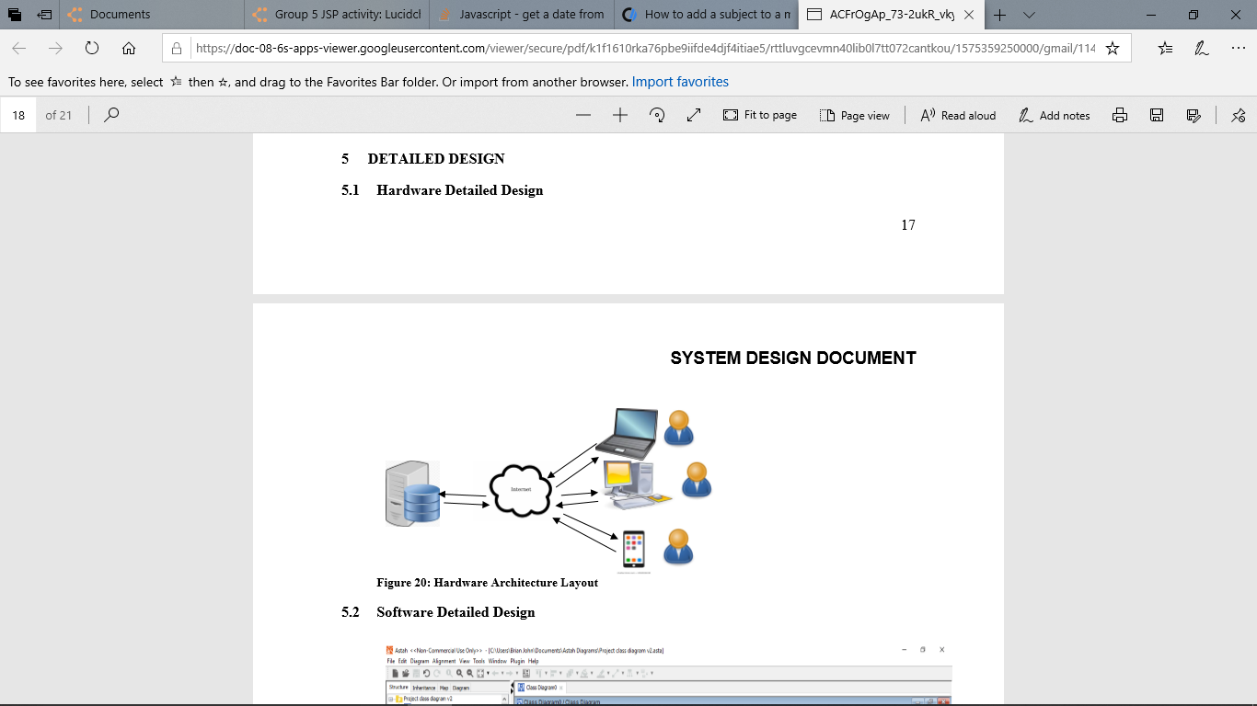

## **Software Detailed Design**

### Student

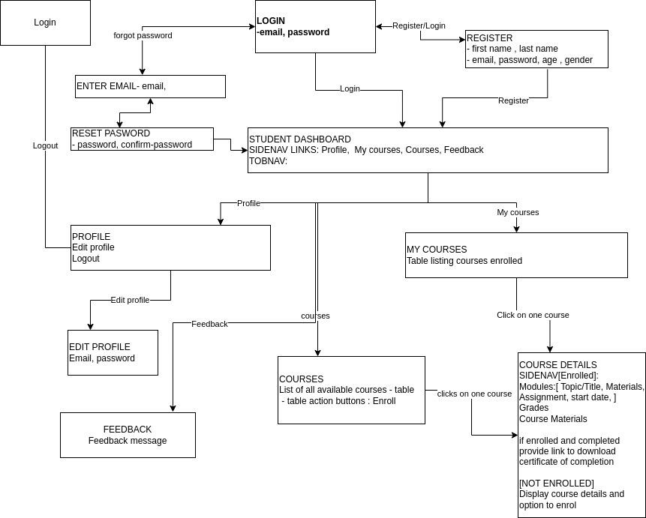

### Instructor

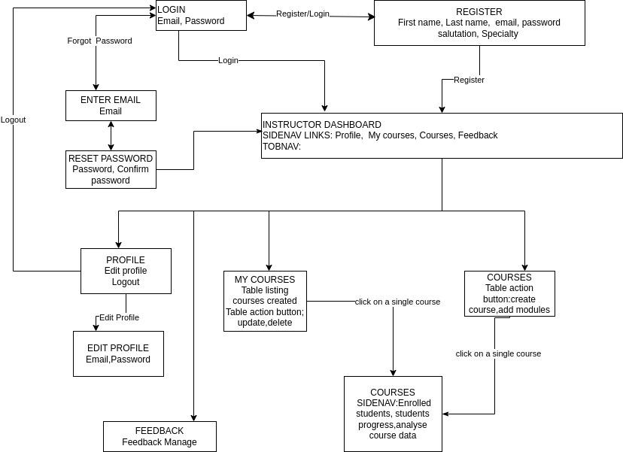

### Administrator

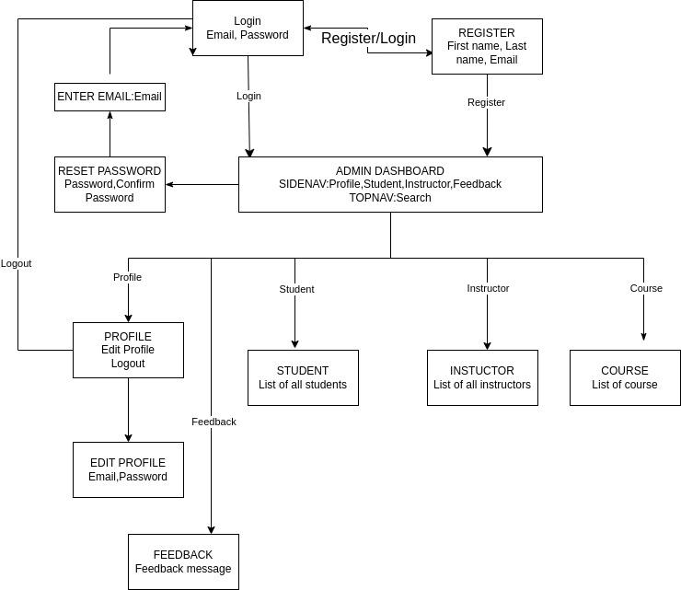

### sequence diagram

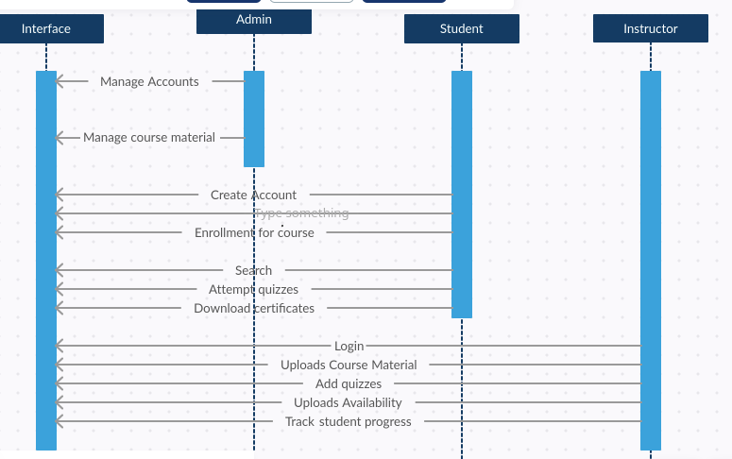

### Activity diagram

Admin login activity diagram

## 

## **Internal Communications Detailed Design**

### User communication with the system is as shown below;

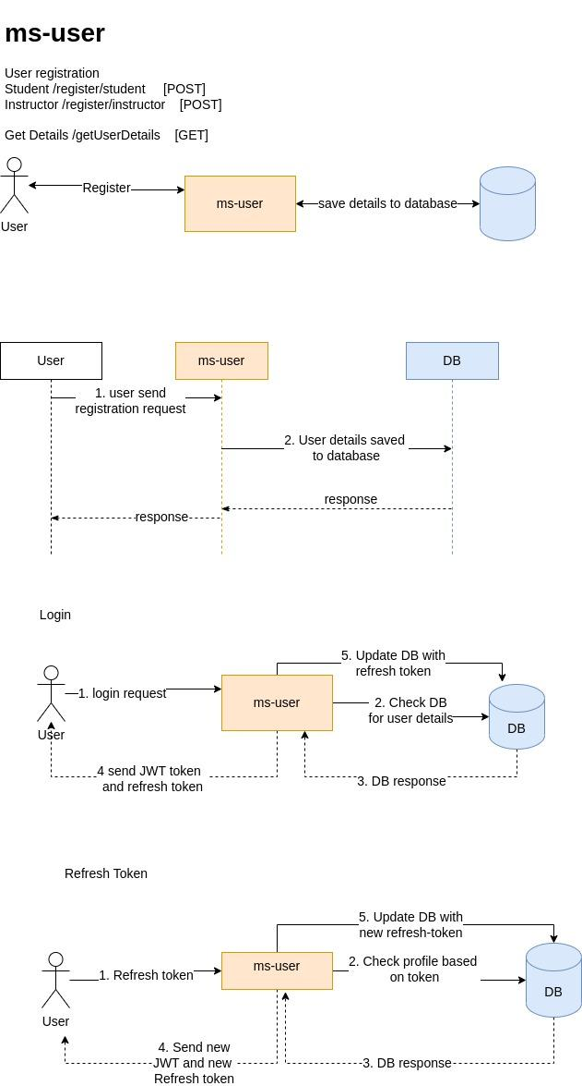

# **EXTERNAL INTERFACES**

## **Interface Architecture**

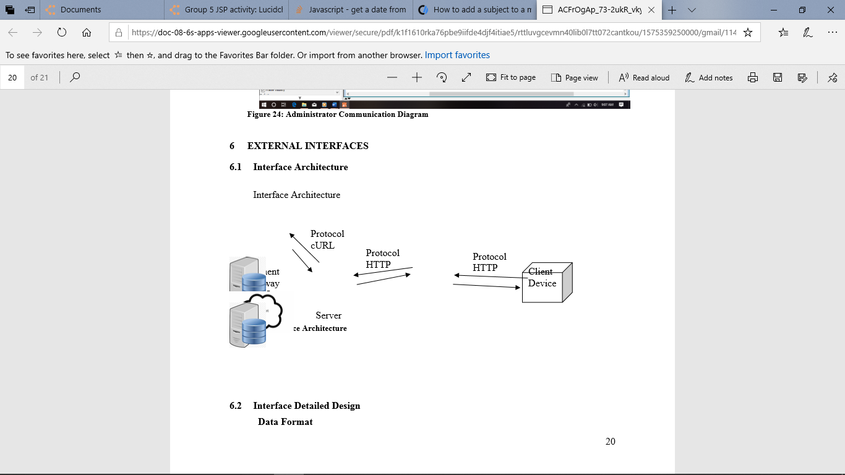

## **Interface Detailed Design**

**Data Format**

Data communication between the backend and the front end of the application will be in JSON format since the communication will be based on RESTful API.

**Hand Shaking**

For every transaction, the system needs to obtain an access token which is obtained by sending the system credentials to the API and the API responds with the access token that will be used for the transaction.

Also, the files to be used to receive the API response are defined by sending their URL.

**Errors**

Errors will be received during each transaction in the response file defined during the hand-shaking process. From here they can be decoded and appropriate action taken.

# 

# **3.6 SYSTEM INTEGRITY CONTROLS**

These are the measures put in place to ensure the accuracy, completeness, and consistency of data within a system. These controls are designed to prevent data loss, corruption, or unauthorized access, which can compromise the integrity of the system and the data it contains. They include:

1. Access Controls: Access controls limit the ability of unauthorized users to access the system or data within the system. Access controls can include password protection, user permissions
2. Backup and Recovery: Backup and recovery controls ensure that system data is regularly backed up and can be recovered in the event of a system failure or other data loss.
3. Data Validation: Data validation controls check the accuracy and completeness of data entered into the system, ensuring that only valid and complete data is accepted and processed.
4. Audit Trail: Audit trail controls record system activity and changes, providing a record of who accessed the system and when, as well as any changes made to the data.
5. Version Control: Version control controls track changes made to the system and data over time, ensuring that previous versions of the system or data can be accessed and restored if needed.

By implementing system integrity controls, the system can maintain data integrity and ensure that the system and data remain secure and reliable over time.



**EGERTON UNIVERSITY**

**TEST PLAN DOCUMENT**

**FOR**

**ONLINE CLASSROOM**

**PREPARED BY: MATARA FAITH NYASUGUTA**

**REG. NO.: S13/02353/19**

**PROJECT SUPERVISOR: MR. PETER KEMEI**

**PROJECT COORDINATOR: DR. BOSIRE**

**DATES:MARCH 2023**

**VERSION 1.1.0**

# **4.1 INTRODUCTION**

This test plan for an online classroom outlines the scope, approach resources and schedule of all testing activities involved during the development of the system. The test plan states the items and features to be tested, the types of testing to be performed, the testers, the resources and schedules required to complete testing and the risks associated with testing the system.

## **4.1.1 Goals and Objectives**

The objective of testing the system is to verify that it is functioning correctly. It ensures that the system meets the users’ requirements as specified in the online classroom system SRS.

Before the system can be deployed, all bugs and issues must be identified and fixed. The operations of the system to be tested include admin and user accounts.

The aim of testing is to guarantee that the online classroom features of the system can work efficiently.

## **4.1.2 Statement of Scope**

### **4.1.2.1 In Scope**

All features described in the SRS need to be tested. The table below indicates all these features, applicable roles and the description of each.

| Functional  Requirement No. | Test  Case No. | Test-Case Short Description |
| --- | --- | --- |
| FR01 | TC01 | To test the Login/Authentication interface for the Admin |
|  | TC02 | To test the Login/Authentication interface for the users |
| FR03 | TC03 | To test,if students can enroll for courses |
| FR06 | TC04 | To test, Admin can manage courses. |
|  | TC05 | To test, Admin can manage users. |
| FR07 | TC06 | To test, Admin canmanage feedback |
| FR08 | TC07 | To test, instructor can upload courses material |
| FR09 | TC08 | To test that instructor can add courses. |
| FR10 | TC09 | To test that students can download certificate upon sucessful completion. |
| FR11 | TC010 | To test that instructor can track student progress. |

### **4.1.2.2 Results**

This section lists the results that were produced by running the test cases. Table 3 lists the test cases that were used while testing the interface along with the expected result and the actual results for each test case.

**Table 3.** List of Test-Case Results.

| Test Case Number | Expected Result | Actual Result |
| --- | --- | --- |
| TC01 | Pass | Pass |
| TC02 | Pass | Pass |
| TC03 | Pass | Pass |
| TC04 | Pass | Pass |
| TC05 | Pass | Pass |
| TC06 | Pass | Pass |
| TC07 | Pass | Pass |

### **4.1.2.3 Out of Scope**

The features listed below are not tested because they are included in the software specs.

**Hardware Interfaces** – the hardware interfaces that will interface with this system will not be included as part of the testing.

## **4.1.3 Major Constraints**

* The testing team does not have a large group of users who can simultaneously use the system and perform real stress related tests.
* The testing team has limited time to test the product at the client’s facility. However, the system will be tested by viable users in a similar environment.
* The developer does not know any hacker who can help in testing the security of the system.

# **4.2.0 TESTING PLAN**

The testing team will use agile methodology to test the system. This methodology allows the testing of the software as the developer progresses with the building of the system. Once any bug is identified at any stage of development then it is fixed before proceeding.

## **4.2.1 Software to be tested**

### **4.2.1.1 Interfaces**

* **Login Window**

The testing team will use different emails to log into the system. The team will also test whether the system accepts wrong passwords. The login button will be tested to ensure that it functions properly by sending data to the server.

* **Forgot Password**

The testers will check whether the system can send a reset password token code. Only valid emails will get this token code.

The system should reset the password of the selected user category.

* **User registration**

The system should have a registration form where all users can register.

The email address and mobile phone number should be valid.

The registered details should allow the user to log in afterwards.

* **Adding an course**

A modal form will be available for instructor to add a course and its details.

The edit button should allow the user to edit properties Any error experienced should have an accompanying error message to direct the user on what to change.

## **4.2.2 Testing Strategy**

### **4.2.2.1 Unit testing**

In this case, the testers will be testing the separate modules of the system. White box testing will be done first where each module of the system is tested individually. This testing includes testing the logic of the different parts of a specific module. This test will be done through passing data through the different components and monitoring their behaviors for any errors. In this case, the testers will be checking for the conditions of entry and exit of data with an aim of ensuring that all components work without any trouble.

### **4.2.2.2 Integration testing**

In this test, the testers will check whether all the modules work correctly as a whole. The different logic of modules are combined to test whether they can work together and produce the desired outcome. Users will need to access the system for it to be tested and therefore the system will be tunneled through a a secure localhost tunnel. The testers will check whether the system saves users data and if there is any collision between the system’s components and that of users.

### **4.2.2.3 Validation testing**

In this case, the testers will work with the clients in order to find out if the system is effective for them. This is to make sure that the system has captured all the client’s requirements. In case of any misunderstandings or conflicts, then the SRS will be used to confirm with the requirements stated. All components and subcomponents will be tested at this point. If there is any issue then a deficiency list will be made where all the problems encountered will be recorded.

### **4.2.2.4 End to end testing**

### **4.2.2.5 High order testing**

Several tests will be carried in this case including:

* **Security testing**

During security testing, the testers will ensure that security checks are working and that no one is able to tamper with the system or its data. This is crucial since the system should be able to track any abnormal activity.

* **Recovery testing**

In this case, the testers will check the system’s ability to retrieve lost data. The developer has to ensure that the system is fault tolerance and does not lose data in case of shutdown or if the system ceases.

* **Stress testing**

The testers will monitor the stress that the system experiences when used simultaneously by many users. This test is for ensuring that the system does not break under extreme use conditions.

* **Performance testing**

During the software development, performance bounds of the system have to be set. It is these bounds that determine the effectiveness of the software. Performance testing ensures that a user of the system experiences minimal stress level when using the system.

## **4.2.3 Bug triage**

The bugs that users are likely to experience and their resolutions include:

Inability to log in – ensure the system is connected to a web server.

Wrong input – all inputs must be valid since the system only accepts valid inputs.

Incorrect results within the system – the logic behind the module should be corrected so that the desired output is produced.

Unable to make enquiries – users should log in to the system before making an inquiry.

# **4.3.0 TEST PROCEDURE**

## **4.3.1Software to be tested**

The software to be tested is online classroom system. Alongside this system, any other components or systems that the online classroom system will interact with will also be tested.

## **4.3.2 Testing procedure**

### **4.3.2.1 Unit test cases**

The components that will be unit tested include:

* **Log in**

The procedure used to do unit test on the login module include:

A user provides an email address and a password.

If the details entered are valid then the system allows the user to log in.

If password is wrong, the system should deny the user from logging in to the system and specify the reason for failure.

If the email provided does not exist, the system will notify the user.

* **Adding an item/category**

admin can add a category/item to the system.

To test the system, invalid details are entered to check if the system accepts such.

### **3.2.2 Integration testing cases**

## **3.3 Validation testing**

In this case the testers will ensure that the system does not accept any invalid inputs. For instance, names should be written in alphabetical characters, and numbers should be integers.

## **3.4 End-to-end testing case**

. End-to-end testing of the online classroom system should focus on testing the system's functionality and performance from start to finish, including all user interactions and system integrations. Here are some key areas that should be included in an end-to-end testing plan for the online classroom system:

1. User Registration and Login: Test the registration and login process for students, instructors, and admins, ensuring that user information is securely stored and authenticated.
2. Course Enrollment: Test the process for enrolling in courses, verifying that students are properly enrolled and can access the course materials.
3. Course Materials: Test the functionality of the course materials, ensuring that students can view and access the materials, including notes, quizzes, and other resources.
4. Quizzes and Assignments: Test the functionality of quizzes and assignments, verifying that they are properly configured and that students can complete and submit them.
5. Instructor Tools: Test the functionality of the instructor tools, ensuring that instructors can easily create and manage courses, upload course materials, and track student progress.
6. System Integration: Test the integration of the online classroom system with other systems, such as email, verifying that data is properly synchronized and shared.
7. Performance: Test the performance of the online classroom system, verifying that it can handle high volumes of traffic and user activity without experiencing significant downtime or slowdowns.
8. Security: Test the security of the online classroom system, verifying that it is protected against common security threats such as hacking, phishing, or malware attacks.

By conducting thorough end-to-end testing of the online classroom system, organizations can ensure that the system is functioning properly and meeting the needs of students, instructors, and admins.

## **4.3.5 Test criteria**

### **4.3.5.1 Suspension criteria**

During the testing stage, if the system fails 30% of the test cases, then testing will be suspended until the developer fixes all the issues found. After the issues have been fixed then testing can resume.

### **4.3.5.2 Test completeness/ Exit criteria**

The testing phase will only be termed as complete if the system passes all the tests. No issues or bugs should be allowed in the system since they can cause serious implications to the users and their data. The pass rate for the testing stage is 96% and it is mandatory to achieve this pass rate.

# **4.4.0 RESOURCE PLANNING**

## **4.4.1 System resources**

Before the testing phase begins, the following key resources should be available.

| No | Resources | Descriptions |
| --- | --- | --- |
| 1 | Server | Need a Database server which install MySQL server  Web server which install Apache server |
| 2 | Test tool | Generate a test tool which can auto generate the test report to the defined form and automated test execution |
| 3 | Network | Network access which can either be cable based(LAN) or wireless (WIFI) with at least 5 Mb/s |
| 4 | Computer | At least 6 computers that run windows 7, 2GB Ram, and 2.0 GHZ CPU |

## **4.4.2 Human resources**

The members who will make the testing team include:

| No. | Member | Task |
| --- | --- | --- |
| 1 | Test manager | Manage the whole project  Define project directions  Acquire appropriate resources |
| 2 | Test | Identifying and describing appropriate test techniques, tools, or automation architecture verify and assess the test approach, execute the tests, log results and report the defects |
| 3 | Developer in test | Implement the test cases and test program |
| 4 | Test administrator | Builds up and ensures the test environment and assets are managed and maintained.  Support tester to use the test environment for test execution. |
| 5 | SQA members | Take in charge of quality assurance.  Check to confirm whether the testing process is meeting the specified requirements. |

# **4.5.0 TEST ENVIRONMENT**

The test environment for the online classroom platform will be set up as shown below.

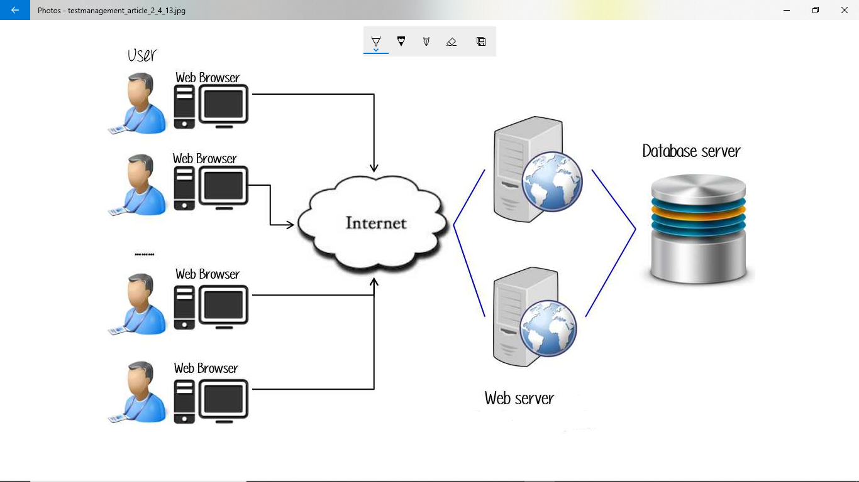

# **4.6.0 TESTING SCHEDULE AND ESTIMATION**

## **4.6.1 All project task and estimation**

| Task | Members | Estimation |
| --- | --- | --- |
| Create the test plan | Test designer | 72 hours |
| Perform test execution | Testers, Test administrator | 48 hours |
| Test report | Testers | 8 hours |
| Test delivery | Testers | 24 hours |
| Total |  | 152 hours |

## **4.6.2 Schedule to complete the tasks**

| Task | 01/3/2023-  03/3/2023 | 5/3/2023-  7/3/2023 | 10/3/2023-  13/3/20213 | 16/3/2023-  26/3/2023 |
| --- | --- | --- | --- | --- |
| Create test plan |  |  |  |  |
| Perform test execution |  |  |  |  |
| Test report |  |  |  |  |
| Test delivery |  |  |  |  |

# **4.7.0 TEST DELIVERABLES**

## **4.7.1 Before testing phase**

* Test plan document.
* Test cases document.
* Test design specifications.

## **4.7.2 During the test**

* Test tool.
* Simulators.
* Test data.
* Error logs and execution logs.

## **4.7.3 After the testing cycles is over**

* Test results/reports
* Defect report
* Installation/rest procedures guidelines
* Release notes.

**EGERTON UNIVERSITY**

**DEPARTMENT OF COMPUTER SCIENCE**

**[FACULTY OF SCIENCE]**

**USER MANUAL DOCUMENT**

**FOR**

**ONLINE CLASSROOM**

**PREPARED BY: MATARA FAITH NYASUGUTA**

**REG. NO.: S13/02353/19**

**PROJECT SUPERVISOR: MR. PETER KEMEI**

**PROJECT COORDINATOR: DR. BOSIRE**

**DATES:MARCH 2023**

**VERSION 1.1.0**

# **5.1 SYSTEM OVERVIEW**

## **5.1.1 Introduction**

**About the system**

The online classroom is a web based application meant to be used by students, instructors and administrators. THe students can register/login and enroll for a course of choice, study the course material and attempt the quiz upon successful completion the student is awarded a certificate. While the instructor is able to add courses and its materials and can track students progress. The administrator manages the course, instructors, students and feedback.

**About this manual**

This manual covers most of the system's functionalities and possible errors that may be encountered by the users. It helps the users of the system to better understand the system.

**Feedback**

Feedback can be submitted by the users of the system as they interact with it. It can either be the difficulties encountered or any suggestions they have that can be implemented.

## **5.1.2 Overview of the system**

The home screen that welcomes the users is as shown below;



# **5.2 SYSTEM REQUIREMENT**

## **5.2.1 Hardware and software requirements**

The system requirements include both the hardware and software that will enable one to operate efficiently.

To use the Online Classroom Platform, one will need the following:

* A computer device with internet access
* A web browser (Chrome, Firefox, Safari, or Edge)
* JavaScript and Cookies enabled on your browser
* An email address for registration and communication with the system

These requirements are necessary to ensure that you can access and use the Online Classroom Platform effectively.

# **5.3 SYSTEM FEATURES**

## **5.3.1 Registration feature**

The diagram below show the registration feature where new users register;



## **5.3.2 User Login**

This features enables registered users to login to the system;



## **5.3.3 Student Dashboard**

From the student dashboard the student can navigate around the courses and system in general and show in the interface below;

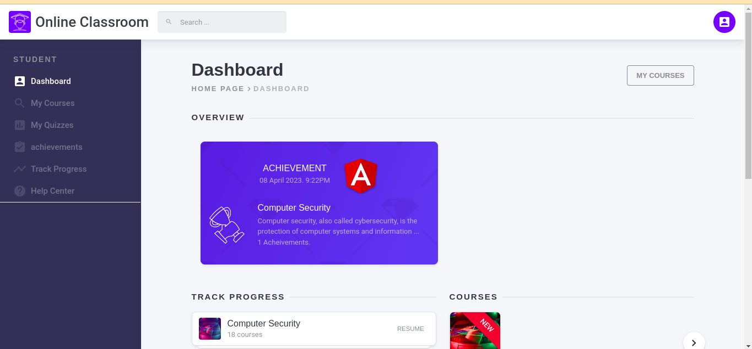

## **5.3.4 Instructor Dashboard**

The instructor can add and manage courses from this interface and navigate around the system as shown in the diagram below:

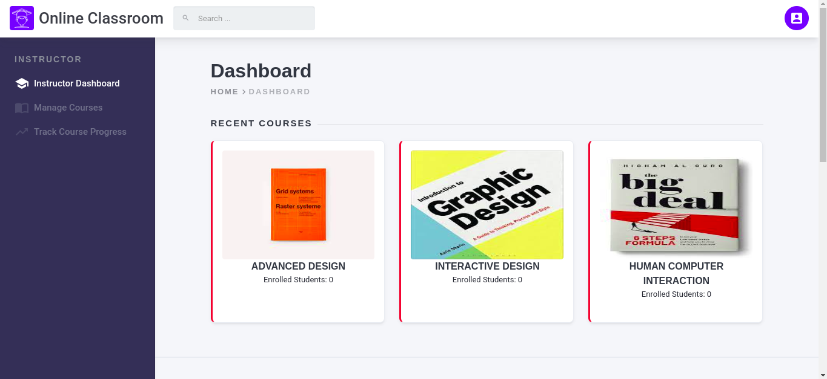

## **5.3.4 Admin Dashboard**

It is from this system feature where the administrator is able to manage courses, manage instructors and manage the students together with feedback and help center. This is illustrated in the diagram below;

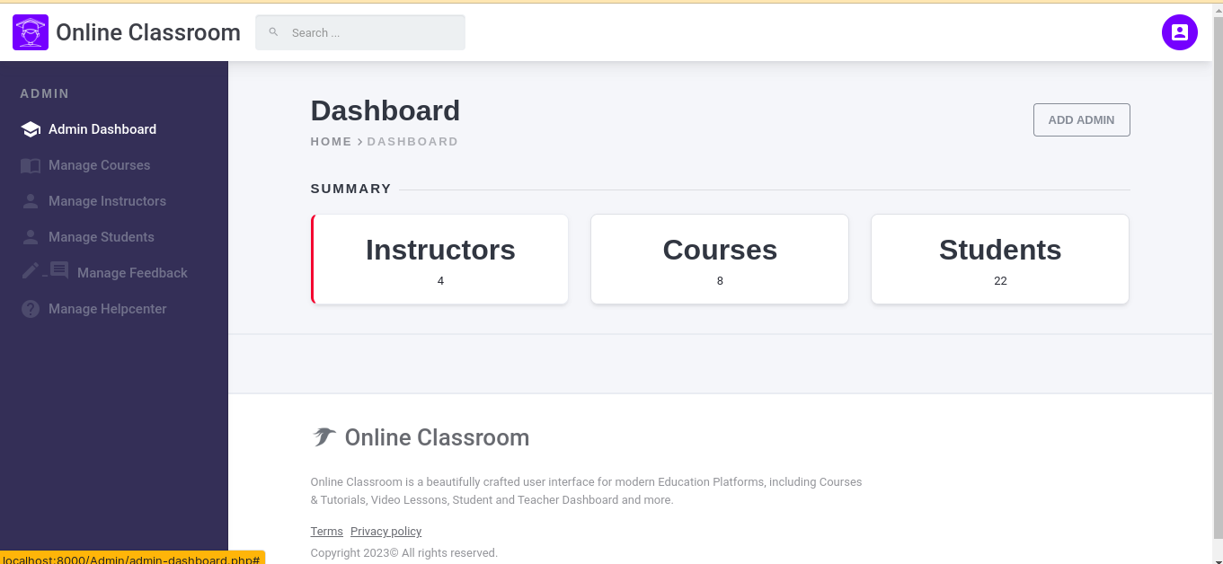

# **5.4 SYSTEM SUPPORT**

## **5.4.1 Overview**

System support are the resources and assistance provided to users to help them use and troubleshoot the online classroom application. These resources can include documentation, online help,email or feedback support. The goal of system support is to provide users with the necessary resources and assistance to ensure they can effectively use and navigate the system. This support can be provided by the system's developers or a dedicated support team that is trained to assist users with any issues or questions they may have.

## **5.4.2 Online help**

The online help is in the form of frequently asked questions and they are clear and concise instructions that help the users of the system navigate seamlessly. The diagram below shows the online help center;

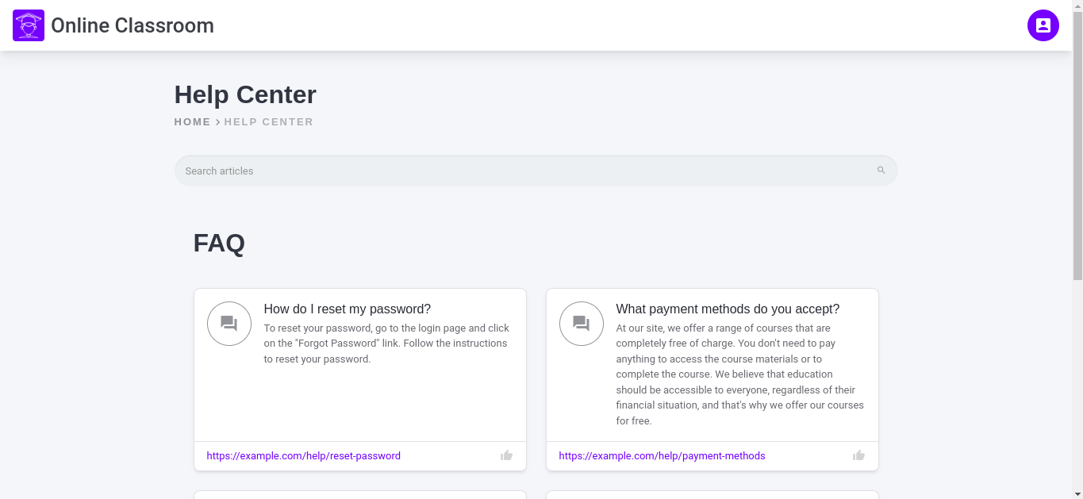

## **5.4.3 Feedback support**

Users can provide feedback, thus helping to identify issues and provide suggestions for improving the system, which can ultimately make the system more user-friendly and easier to use.

It can also serve as a form of validation for the system, as it provides insight into how users are using and perceiving the system. This can be useful in determining whether the system is meeting the needs of its users and in identifying areas for future development and improvement. The diagram below shows the feedback support;

