# Problem-Solving (75 points):

1. 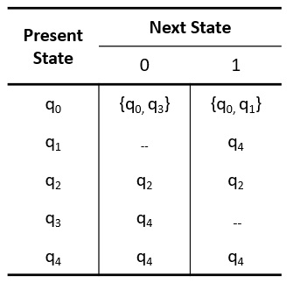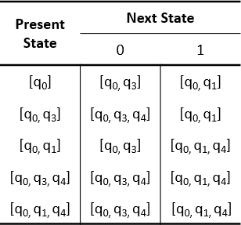Convert the given transition table of a nondeterministic finite automaton (NFA) to its corresponding transition table as a deterministic finite automata (DFA). Show the transition function, δ', for each state. (50 points)

# Solution:

**NFA Transition Table Resulting DFA Transition Table**

* **3 points**
* **3 points**
* **3 points**
* **3 points**
* **3 points**
  + Obtain the transition function, δ', for each state:

δ' for q0: δ'([q0], 0) = [q0, q3] – **New generated state**

δ'([q0], 1) = [q0, q1] – **New generated state**

**3 points**

δ' for q1: δ'([q1], 0) = [ ]

δ'([q1], 1) = [q4]

δ' for q2: δ'([q2], 0) = [q2]

δ'([q2], 1) = [q2]

δ' for q3: δ'([q3], 0) = [q4]

δ'([q3], 1) = [ ]

δ' for q4: δ'([q4], 0) = [q4]

δ'([q4], 1) = [q4]

**3 points**

**3 points**

**3 points**

**3 points**

δ' for [q0, q3]: δ'([q0, q3], 0) = δ(q0, 0) 𝖴 δ(q3, 0)

= {q0, q3} 𝖴 {q4}

= [q0, q3, q4] – **New generated state**

δ'([q0, q3], 1) = δ(q0, 1) 𝖴 δ(q3, 1)

= {q0, q1} 𝖴 { }

= [q0, q1]

δ' for [q0, q1]: δ'([q0, q1], 0) = δ(q0, 0) 𝖴 δ(q1, 0)

= {q0, q3} 𝖴 { }

= [q0, q3]

δ'([q0, q1], 1) = δ(q0, 1) 𝖴 δ(q1, 1)

= {q0, q1} 𝖴 {q4}

= [q0, q1, q4] – **New generated state**

δ' for [q0, q3, q4]: δ'([q0, q3, q4], 0) = δ(q0, 0) 𝖴 δ(q3, 0) 𝖴 δ(q4, 0)

= {q0, q3} 𝖴 {q4} 𝖴 {q4}

= [q0, q3, q4]

δ'([q0, q3, q4], 1) = δ(q0, 1) 𝖴 δ(q3, 1) 𝖴 δ(q4, 1)

= {q0, q1} 𝖴 { } 𝖴 {q4}

= [q0, q1, q4]

**5 points**

**5 points**

**5 points**

δ' for [q0, q1, q4]: δ'([q0, q1, q4], 0) = δ(q0, 0) 𝖴 δ(q1, 0) 𝖴 δ(q4, 0)

= {q0, q3} 𝖴 { } 𝖴 {q4}

= [q0, q3, q4]

δ'([q0, q1, q4], 1) = δ(q0, 1) 𝖴 δ(q1, 1) 𝖴 δ(q4, 1)

= {q0, q1} 𝖴 {q4} 𝖴 {q4}

= [q0, q1, q4]

**5 points**

1. 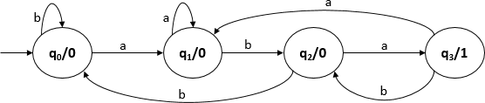Analyze the state diagram of a Moore machine below and answer the following items. (25 points)
   1. What are the elements of Σ based on the given FA? (2 points)

**Answer:** Σ = {a, b}

* 1. What are the elements of Q based on the given FA? (3 points)

**Answer:** Q = {q0, q1, q2, q3}

* 1. Will the machine count the occurrence of substring *aba* in a given string? Rationalize your answer. (Essay: 10 points)

**Answer:** Yes, the Moore machine illustrated above can count the occurrence of substring *aba* in a given string. The machine can be considered as a type of sequence detector, which detects the substring *aba* in a given input string. If the string *aba* occurs as a substring, then the output produced is 1. For all other cases, the output 0 is produced.

* 1. What will be the expected output if substring *aab* is used as an input? Rationalize your answer. (Essay: 10 points)

**Answer:** If substring *aab* is used as an input, then the expected output is 0. The output is already incorporated within the state, and will vary depending on the present state. The substring will yield a 0 output since in state q2, if we get 'b' as an input, then there is no chance to get 'aba'. The process then goes back to q0.

**Grading Rubric (Essay):**

|  |  |  |
| --- | --- | --- |
| **Criteria** | **Performance Indicator** | **Points** |
| Content | Provide pieces of evidence, supporting details, and factual scenarios. | 5 |
| Organization | Expressed the points in clear and logical  arrangement of ideas. | 5 |
|  | **Total** | **10** |

**Note:** DO NOT COPY AND PASTE. All students who copy and paste their work from any website or their classmate will automatically receive a failing mark for this activity.